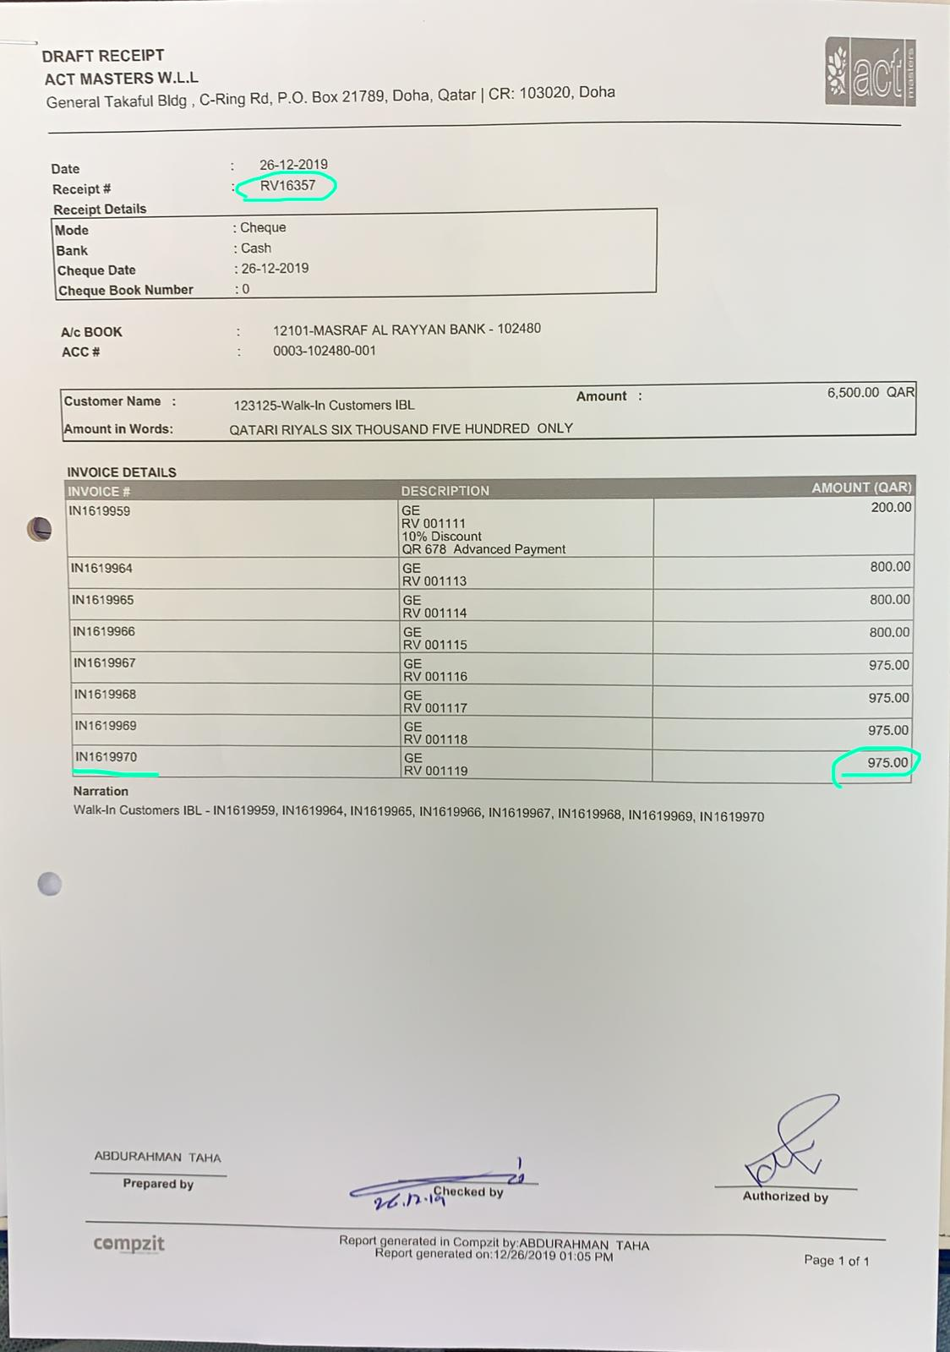**DATE: 25/02/2020**

|  |  |
| --- | --- |
| **SUPPORT TICKET#** |  |
| **CLIENT** | ADAMZ |
| **PROJECT** | FAS |
| **MODULE** | SETTLEMENT |
| **TYPE** | BUG |
| **PRIORITY** | HIG |
|  |  |

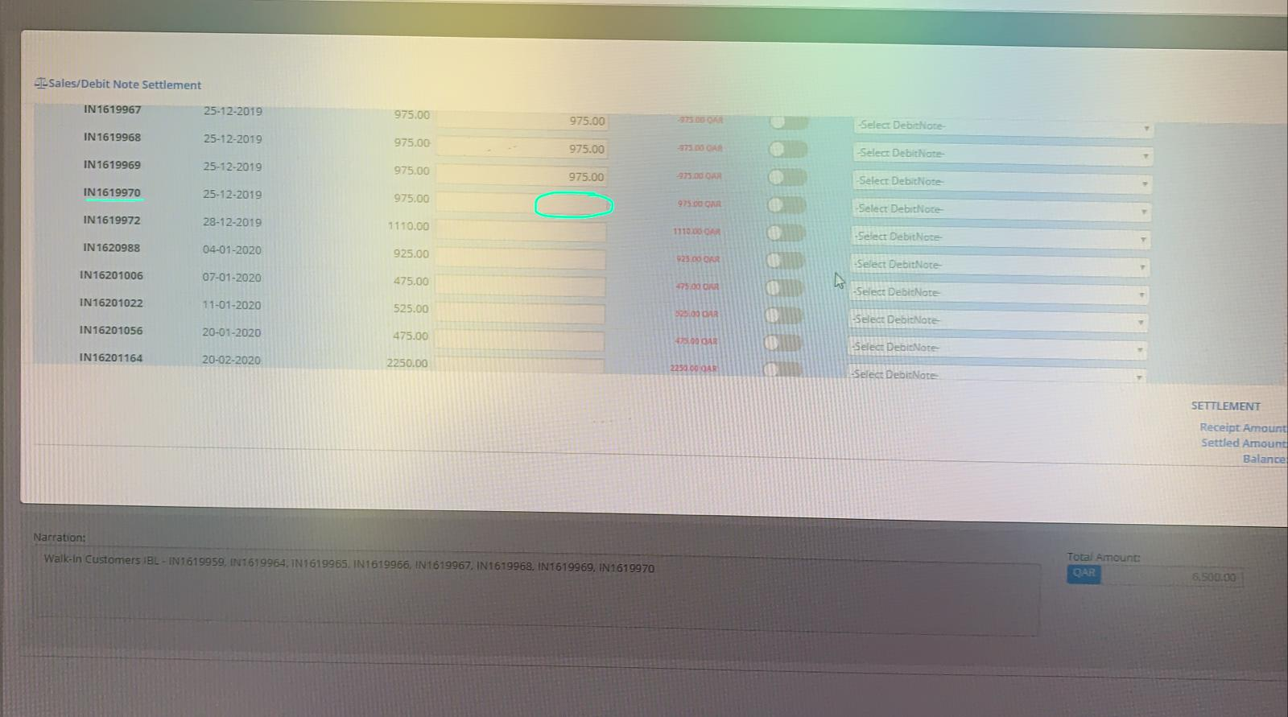

**Comments**:

1. Settlement was done earlier. But that settlement was cleared

through some bug. This should be solved.

|  |  |
| --- | --- |
| **SUPPORT TICKET#** |  |
| **CLIENT** | ADAMZ |
| **PROJECT** | FAS |
| **MODULE** | SETTLEMENT |
| **TYPE** | BUG |
| **PRIORITY** | HIG |

**Comments**:

1. If the same sales Invoice / purchase invoice settled in some other transaction entry, there is a question for removing the duplicate settlement. This should be avoided. Instead automatically removing, system should display settlement page by highlighting the duplicate settlement. Let the user to delete.