**SALES FORCE AUTOMATION**

**For**

****

***(Al-Balagh Trading & Contracting Co. WLL)***

**SYSTEM ANALYSIS AND DESIGN**

DOCUMENT NUMBER:**VABG1/PRCT1/SAD/001**

C:\Downloads\01.png

**JAISON LOUIS**

**21/01/2016**

**Release 1.0**

**Acceptance and Release Notice**

This is a managed document. All copies of this document preceding this release are obsolete and shall be destroyed. This document has not been released for use until authorized by the Project Manager or Business Analyst.

This is the Client Requirement Study Document Release 1.0

**Approved:** ........................................................................... Date: ....../......../........  
 Project Manager

**Authorized:** ......................................................................... Date: ......../........./........  
 Business Analyst

**Document History**

|  |  |  |
| --- | --- | --- |
| Release Number | Date | Reason for Release |
| 1 | 29-01-2016 | First Level Documentation |
|  |  |  |
|  |  |  |

**Distribution**

|  |  |  |  |
| --- | --- | --- | --- |
| Copy Number | Release Number | Date Issued | Issued To |
|  |  |  |  |
|  |  |  |  |

**Amendments**

|  |  |  |
| --- | --- | --- |
| Amendment Number | Amendment Date | Issued To |
|  |  |  |
|  |  |  |

**Table of Contents**

1) PARTICIPANTS IN REQUIREMENT ANALYSIS 2

2) SOLUTION SCOPE 2

3) SOLUTION AUDIENCE 2

4) HARDWARE SPECIFICATION 3

5) INFRASTRUCTURE & NETWORK ARCHITECTURE 3

PROJECT SOLUTION – PROCESS FLOW 4

6) ORGANIZATION ARCHITECTURE 4

6.1 Organization Level 4

7) TECHNOLOGY & TOOLS FOR SOLUTION 5

8) SYSTEM ARCHITECTURE 5

9) SYSTEM ANALYSIS & DESIGN 6

SOFTWARE ADMINISTRATION MANAGEMENT 6

STATIC CONFIGURATION SUB SYSTEM 6

GLOBAL CONFIGURATION SUB SYSTEM 7

AUTOMATED SUPPORT TRACKING SUB SYSTEM 8

LICENSE PACK SUB SYSTEM 8

CORPORATE PACK SUB SYSTEM 10

ORGANIZATION MANAGEMENT 11

COUNTRY SUB SYSTEM 12

STATE SUB SYSTEM 14

CITY SUB SYSTEM 15

ORGANIZATION TYPE SUB SYSTEM 16

ACTIVITIES WHILE LOGIN 17

‘ORGANIZATION REGISTRATION FOR PARKING’ SUB SYSTEM 19

ORGANIZATION REGISTRATION SUB SYSTEM 22

APP ADMINISTRATOR VERIFICATION TOOL 23

CORPORATE TYPE SUB SYSTEM 24

CORPORATE DEFINITION SUB SYSTEM 24

CORPORATE DIVISION SUB SYSTEM 26

CORPORATE DEPARTMENT SUB SYSTEM 28

PREMISE DEFINITION SUB SYSTEM 29

AREAS IN PREMISE SUB SYSTEM 31

WORKSTATION SUB SYSTEM 32

EMPLOYEE / USER MANAGEMENT & AUDIT TRAIL 34

USER ROLE SUB SYSTEM 34

CHILD ROLE SUB SYSTEM 35

DESIGNATION TYPE SUB SYSTEM 36

DESIGNATION SUB SYSTEM 38

‘MASTER ROLE DEFINITION FOR USER DESIGNATION’ SUB SYSTEM 39

‘CHILD ROLE DEFINITION FOR USER DESIGNATION’ SUB SYSTEM 40

EMPLOYEE SUB SYSTEM 41

‘MAIN ROLE DEFINITION FOR EMPLOYEE’ SUB SYSTEM 42

‘CHILD ROLE DEFINITION FOR EMPLOYEE’ SUB SYSTEM 43

‘CORPORATE DEFINITION FOR EMPLOYEE’ SUB SYSTEM 43

TEAM HIERARCHY SUB SYSTEM 45

FINANCIAL YEAR SUB SYSTEM 46

MAIL MANAGEMENT 47

EMAIL TEMPLATE TYPE SUB SYSTEM 48

EMAIL TEMPLATE SUB SYSTEM 49

EMAIL TEMPLATE ATTACHMENT SUB SYSTEM 49

EMAIL STORAGE MODULE 49

EMAIL STORAGE ATTACHMENT SUB SYSTEM 50

EMAIL STORAGE BACKUP MODULE 50

EMAIL STORAGE ATTACHMENT BACKUP SUB SYSTEM 50

INVENTORY MANAGEMENT 51

UOM (UNITS OF MEASURE) MASTER SUB SYSTEM 51

TAX MASTER SUB SYSTEM 52

ITEM TYPE SUB SYSTEM 53

ITEM GROUP SUB SYSTEM 55

MAIN-CATEGORY SUB SYSTEM 56

SUB-CATEGORY SUB SYSTEM 57

SMALL CATEGORY SUB SYSTEM 58

LEAST CATEGORY SUB SYSTEM 59

PRODUCT BRAND MASTER SUB SYSTEM 60

PRODUCT MASTER SUB SYSTEM 61

CUSTOMER MANAGEMENT 64

CUSTOMER GROUP SUB SYSTEM 64

CUSTOMER TYPE SUB SYSTEM 65

CUSTOMER SUB SYSTEM 66

CUSTOMER CONTACT DETAILS 66

Here shows the flow of a lead. From 71

10) CONCLUSION 85

11) INTELLECTUAL PROPERTY RIGHTS AND CONFIDENTIALITY ISSUES 85

12) ACCEPTANCE ACCORD 86

**ABBREVIATIONS AND DEFINITIONS**

|  |  |
| --- | --- |
| **ABBREVIATION** | **DESCRIPTION** |
| CRM | Customer Relationship Management |
| UI | User Interface |
| ERP | Enterprise Resource Planning |
| BOQ | Bill of Quantity |
|  |  |
|  |  |
|  |  |
|  |  |
|  |  |
|  |  |

|  |  |
| --- | --- |
| **WORD / PHRASE** | **DEFINITION** |
|  |  |
|  |  |
|  |  |

# PARTICIPANTS IN REQUIREMENT ANALYSIS

|  |  |  |  |
| --- | --- | --- | --- |
| **VOLVIAR TECHNOLOGIES** | | **AL-BALAGH TRADING & CONTRACTING CO. WLL** | |
| **PARTICIPANT** | **DESIGNATION** | **PARTICIPANT** | **DESIGNATION** |
| Jaison Louis | Business Analyst | FaizAbdu | Project Consultant |
|  |  | Ajo George | Administrator – IT Systems |
|  |  |  |  |

# SOLUTION SCOPE

The scope of this project is to define the enquiry activities of a sales department of various divisions of Al-Balagh such as Trading, Contracting and Medical etc. Enquiry will be received from customers through Email / Fax / Phone / Tender etc. These enquiries are to be linked with the solution for future tracking and planning. The hierarchy of employees is to be maintained for the proper tracking of enquiries. These enquires are to be monitored by the department through their BI dashboard. Fresh enquiries are to be allocated to respective sales employees. There will be a provision for doing proper follow-up of each enquiry by the sales department. Provision for creating Quotation should also be included in the solution. This Quotation should be approved by the Department head / Authorized Personnel and delivered to client. Successful enquiries are also to be marked in the solution for the analysis. There will be a provision for automatically as well as manual attaching of the email follow-ups to appropriate enquiry till closing. The important of this solution is to get maximum analysis area with less effort. Department-wise monthly analysis of enquiries will be helpful for management as well as various levels of employees in the defined hierarchy.

# SOLUTION AUDIENCE

|  |  |
| --- | --- |
| **Audience Category** | **Functional Areas** |
| Solution Administrator | Software Maintenance, updating metadata & hands-on training etc. |
| Secretary | Analyzing the Mails / Dashboard Inbox and allocating to Appropriate Divisions. |
| Division Manager | Get exact status of opened enquiries in their division, Quotation Approval etc. |
| Sales Assistant | Doing the Enquiry Follow-up, Status Updating etc. |
| General Manager | Major Role: Managerial Report Analysis |
| Finance Manager / Accounts Manager | Major Role: Managerial Report Analysis |
| CEO /MD | Major Role: Managerial Report Analysis |

# HARDWARE SPECIFICATION

**Application Server (Minimum Configuration)**

* Intel® processor
* 4 GB RAM
* 500 GB HDD
* OS: Windows Server to hold the Application
* Windows Server 2008 R2 and Above
* Internet Information Services (IIS 8.0 and Above)
* .NET Framework 4.5 and Above

**Database Server**

* Intel® processor
* 4 GB RAM
* 500 GB HDD
* OS: Windows / Linux Server to hold Database
* Oracle Database Setup

Notes: Deployment of system with Oracle 11g Express (11 DB Data, Single Database & 1GB RAM) and can be going for licensed Oracle when traffic / data storage exceeded than that of Oracle 11g express. If we are going to keep database in Linux, then we have to maintain separate database server. Otherwise we can go with Same Server for Application as well as Database.

**Other Hardware**

* Laser Printer

# INFRASTRUCTURE & NETWORK ARCHITECTURE

Web Browser:

Mozilla Firefox / Google Chrome / Microsoft Internet Explorer

# PROJECT SOLUTION – PROCESS FLOW

**INCOMING ENQUIRY**

**ENQUIRY CLOSING**

**QUOTE DELIVERY TO CUSTOMER**

**QUOTE PREPARATION & APPROVAL**

# 

# ORGANIZATION ARCHITECTURE

## Organization Level

**Departments**

**IT**

**HR & ADMIN**

**FINANCE**

# TECHNOLOGY & TOOLS FOR SOLUTION

|  |  |
| --- | --- |
| **Description** | **Technology / Tool Used** |
| Documentation | Microsoft Word |
| Design Diagram | Microsoft Word / Visio / UI Tool |
| Application Layer | Microsoft Visual Studio Express 2012 for Web |
| Database Layer | Oracle 11g |
| Windows Service | IIS 8.0 and Above |
| Development Framework | Microsoft .NET Framework 4.5 and Above |
| Project Management | Proprietary |

# SYSTEM ARCHITECTURE

This is the solution used for various CRM functionalities related to sales department to boost their enquiry tracking and graphical information about divisional performance.Either Division Manager / Secretary can login to the system for analyzing fresh enquiries generated through division’s common Mailbox. These standard mails will be populated into enquiry tracking module automatically.

**Steps**

* Secretary / Division Manager can do analysis on Fresh Enquiries.
* Allocating Enquiries to Respective Division.
* Sales Executive / Sales Person can also view these Enquiries and can bags to their Enquiry List for Tracking.
* Division Manager / Secretary can also view enquiries and allocate same to Sales Person.
* Do the enquiry follow-up by Sales Person till Closing the Enquiry.
* Preparing the Quotation by Sales Person.
* Quotation Approval by the Authorized Personnel.
* Delivery of Approved Quotation to Customer.
* Marking the Status of Enquiry for either Success / Loss.
* Whenever sending the Quote automatically, if it is delivered / not delivered from sender side, then it will be marked in database. If it is not delivered due to some technical issue / some other thing it will be delivered again using bulk mailing utility automatically. Delivered / Undelivered mails will be given as an alert for Corresponding Division Manager and Sales Person.
* Closing the Enquiry, if the status of this enquiry is Success.

# SYSTEM ANALYSIS & DESIGN

### SOFTWARE ADMINISTRATION MANAGEMENT

### STATIC CONFIGURATION SUB SYSTEM

Software will be having the configuration options for interacting with various sections. Fields used in this section should be linked with various other sections of the software. Some fields in this section are static until it is modified by the App Administrator and the same will not be changed during the execution of the software. These fields are used for the internal processing of software. Some fields are dynamic and the same will be constantly changed during the executing of the software without user intervention.

There will be no user interface for this module; all values are to be directly updated to database. Some values are static which will be updated while deploying the software, some fields are to be updated during an interval of time such as financial closing etc. and some fields are to be updated regularly while software execution.

**STATIC CONFIGURATION SUBSYSTEM**

**STATIC DATA UPDATION**

**SEMI-STATIC DATA UPDATION**

**DYNAMIC DATA UPDATION**

* **Static Data Updating:** Software may use some fields which are static until App Administrator changes the details in Configuration Wallet.
* **Semi-Static Data Updating:** Data will be updated in some conditions only and the same will be updated internally while software execution.
* **Dynamic Data Updating:** Data should be regularly updating while particular operation in the App.

### GLOBAL CONFIGURATION SUB SYSTEM

**Feature**

This can be used for the managing software generalization areas. This is the global configuration module. General parameters are to be defined through the module. These fields are to be fetched while starting the App and used for various purposes. There will be User Interface (UI) for this module. Corporate Administrator or an Assigned Personnel can update these configurations. Changes of these fields / values will be directly effects every modules of the software.

**GLOBAL CONFIGURATION SUBSYSTEM**

**MANUAL DATA INSERTING & UPDATING**

**MAINTAIN STATIC DATA**

* **Manual Data Inserting:** Data insertion to these fields is to be manually done user. There will be a user interface for updating these fields.
* **Maintain Static Data:** Some fields are static and those fields can’t be updated by the user. Application will fetch this information for maintaining various activities.

### AUTOMATED SUPPORT TRACKING SUB SYSTEM

**Feature**

This is the method of highlighting internal software issues from client location, if any. It will also difficult in some situation to regenerate. These tracking issues are to be automatically generated from client location through an effective method.

**AUTOMATED SUPPORT TRACKING SUB SYSTEM**

**UPDATE ISSUES TO SUPPORT TRACKING MODULE**

**IDENTIFY ISSUES, IF ANY**

**MAINTAIN SUPPORT TRACKING IN EVERY SECTIONS OF SOFTWARE**

* **Maintain Support Tracking in Every Sections of Source Code:** IssuesTracking Section should be defined in various methods of software.
* **Identify Issues, if Any:** There will be a common mechanism for identifying the module, section and appropriate issue after raising the same from software.
* **Update Issues To Support Tracking Module:** Appropriate issue record should be updated to this module after catching.

### LICENSE PACK SUB SYSTEM

**Feature**

Software should be licensed for the use for an organization. There may be various types of licenses formulated by various companies. This is the definition maintained internally for the purpose tracking the license selection while registering an organization. Details for this module should fed by the App Administrator and those details are to be selected while registering the organization. The license pack might be Premium / Small Enterprise / SME / Large Scale etc. The difference between these packs should be the limitation for the user license. Adding users should be limited in various packages.

*UI will not be given for this module but this will be created in the database.*

**Flow**

* This is the purpose of defining various packages for the customers those who are implementing Application. Adding the number of users can be restricted in Application using the various license packs.
* Adding number users in the user registration module will be limited as per the selected license pack. User registration module will give an alert message, if the number of users exceeded than selected pack.
* These packs are to be defined by the App Administrator in the database and the same will be displayed user side while organization registration.
* Provision for making the license pack as active / inactive in the database. All active packs are only displayed while defining the organization.
* There should be uniqueness for the license starting and license ending separately and the same to be managed in the database design itself.

**LICENSE PACK SUB SYSTEM**

**UPDATING LICENSE PACK**

**INSERTING LICENSE PACK**

**ACTIVATING / INACTIVATING LICENSE PACK**

* **Inserting License Pack:** List out the possible license packs and create this license pack in the database. There should be a unique name like Gold, Platinum, and Silver etc. for these License Packs.
* **Updating License Pack:** Generated License Pack should be modified by the App Administrator.
* **Activating / Inactivating License Pack:** If the license pack is inactivated, then the same will not be reflected while registering organization.

### CORPORATE PACK SUB SYSTEM

**Feature**

Software should be licensed for the use for an organization. There should also be a provision for defining number of branch offices / corporate offices allowed for an organization. Application will not allow adding more corporate offices than it is selected while registering an organization. It is the corporate pack definition as like user license pack. App administrator can define corporate pack. Corporate pack selection will be limiting for adding number of corporate offices under each organization. Whenever user try to add corporate office in Application by the Organization Administrator then App will give an alert message if the number of Corporate Offices exceeds than allowed in the selected corporate pack.

**Flow**

* Module allows defining the various corporate packages for the customers. There will be a provision for defining single or multiple corporate offices under one organization. Corporate offices might be branches / sister concerns / other verticals of enterprise etc. But these entities are functioning under same umbrella.
* Adding number of corporate entities in an organization can be restricted in Application using corporate pack definition.
* These packs are to be defined by App Administrator and the same will be displayed at user side while defining the organization.
* Provision for making the corporate pack as active / inactive in the solution. All active packs are only displayed while defining the organization.
* There will be no UI for this module. Details will be inserting to database by App Administrator while deploying the solution.

**CORPORATE PACK SUB SYSTEM**

**AMENDING CORPORATE PACK IN DATABASE**

**INSERTING CORPORATE PACK INTO DATABASE**

**ACTIVATING / INACTIVATING CORPORATE PACK**

* **Inserting Corporate Pack:** List out possible corporate packs and create this corporate pack in database. There should be a unique name like Standard, Extended, Unlimited etc. for these Corporate Packs.
* **Amending Corporate Pack:** Generated Corporate Pack should be amended by the AppAdministrator in database.
* **Activating / Inactivating Corporate Pack:** If the Corporate Pack is inactivated, then the same will not be reflected while registering organization.

### ORGANIZATION MANAGEMENT

The proper architecture structuring in every organization is important for its functioning. Hierarchy allocation for one organization can be varied from other organization and the same should be generally managed.

**Registering an Organization(Summary):**It isthe module for defining Group Companies.

**Flow:**

* Whenever an enterprise started functioning, then their basic information to be updated in the organization module.
* The solution administrator of an organization can’t directly enter their information to organization module.
* Responsible person from organization should enter primary information about their organization and these details will be maintained in organization parking module until it is approved by App Administrator.
* License pack should be selected by the organization. If license pack for the solution selected, then the number of users will be restricted as per selected license pack.
* Corporate pack selection will also incorporated in the solution; if corporate pack is selected while defining the organization, then adding number of corporate offices will be restricted as per the selection.
* Organization will be maintained in the ‘Parking Area’ during the initial setup. The App Administrator will be able to select parked organizations from dashboard. This method will be useful with generalized concept of an application definition. Information will be maintained in the parking module until it is approved by App Administrator.
* App Administrator could analyze parked organizations and give an approval for start working with Application. Once parked organization approved, then the details will be populated to organization module.
* Email ID and password should be entered by the organization administrator while defining the organization.
* Organization administrator user will be automatically generated to user management while approval. When an organization is approved by the App Administrator, then the email id and password will be createdautomatically in user registration module.
* Organization administrator can login to the solution after this approval from App Administrator.
* There will be a provision for adding the corporate entities under each organization by the organization administrator. The number of corporate entities will be restricted by the selected corporate pack.Eg. If an organization choosescorporate pack with Single Corporate Office then the organization administrator can add one corporate office entity only. If an organization selected corporate pack with 3 corporate offices then the organization administrator can add maximum of three corporate entities in that organization.
* Various departments in a corporate entity could be defined by the authorized user under particular corporate entity. There will be no restriction for defining the departments under each corporate office.

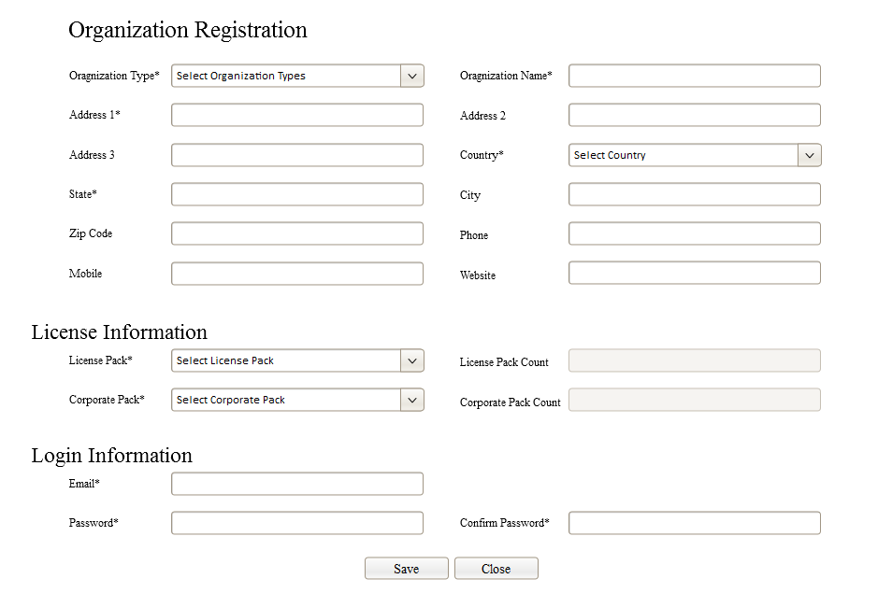

### COUNTRY SUB SYSTEM

**Feature**

Module should be used for defining countries; All Possible countries will be integrated while App implementation. User interface can also included in software, but existing countries are to be defined by App Administrator and the interface should be allowed for App Enterprise. If this App is implemented in customer environment then Corporate Administrator / Authorized Personnel could add / modify / inactivate countries as per their need.

**Flow**

* All countries will be generated by the App Administration while Implementation.
* Organization administrator could add / modify countries, if needed.
* There will be a field for identifying whether the country is pre-installed or not.
* Pre-installed countries can’t be cancelled by the organization.
* The pre-installed countries can be cancelled by the App Administrator only.
* Organization administrator can insert new countries and the same can be amended / cancelled.
* Countries can’t be cancelled, if the selected country is related to some other transactions.
* It can make the status of country to Active / Inactive even if there is any relation.

**COUNTRY SUB SYSTEM**

**MODIFYING COUNTRIES**

**ADDING COUNTRIES**

**ACTIVATING / INACTIVATING COUNTRIES**

**COUNTRY CANCELLATION**

* **Adding Countries:** List out the possible countries and create the same in country module. All countries will be pre-installed while implementing the software. Countries can be created / modified through the module.
* **Modifying Countries:** Generated Country should be modified by the Approved Person.
* **Activating / Inactivating Countries:** If the Country is inactivated, then the same will not be reflected in any other modules.
* **Country Cancellation:** There will be a provision for cancelling the countries by the authorized user. Cancellation will be locked if it is selected in some other modules.

**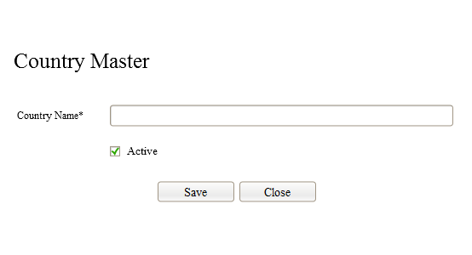**

### STATE SUB SYSTEM

**Feature**

This is the state definition module in Application. New state can be created by the authorized personnel.

**STATE SUB SYSTEM**

**ADDING STATES**

**MODIFYING STATES**

**STATE CANCELLATION**

**ACTIVATING / INACTIVATING STATES**

* **Adding States:** List out possible states and create the same in state module.
* **Modifying States:** Generated State can be modified by the Approved Person.
* **Activating / Inactivating States:** If the State is inactivated, then the same will not be reflected in any other modules.
* **Cancellation of State Master:** There will be a provision for cancelling the states by the authorized user. Cancellation will be restricted if it is selected in some other modules.

**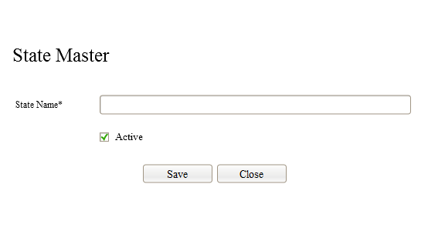**

### CITY SUB SYSTEM

**Feature**

This is the city definition module and this city can be selected in various modules such as customer definition, Lead Generation etc.

Flow

* Organization administrator / other authorized personnel could add new cities, if needed and the same can be amended / cancelled.
* It can make the status of city to Active / Inactive even if there is any relation.

**CITY SUB SYSTEM**

**ADDING CITY**

**MODIFYING CITY**

**ACTIVATING / INACTIVATING CITY**

**CITY CANCELLATION**

* **Adding City:** List out possible cities and create the same in city module.
* **Modifying City:** Generated City can be modified by the Approved Person.
* **Activating / Inactivating City:** If the City is inactivated, then the same will not be reflected in any other modules.
* **Cancellation of City Master:** There will be a provision for cancelling the cities by the authorized user. Cancellation will be restricted if it is selected in some other modules.
* **State Search:** Each city should be linked with corresponding state by searching the city from city master.

**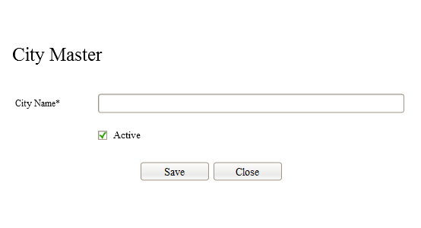**

### ORGANIZATION TYPE SUB SYSTEM

**Feature**

App Administration team should define various organization types in this module. Organization Type will be selected in organization definition module. This is the topmost level of organization architecture. Status should be ‘Active’ as default while creating an entry. Entry can be cancelled by App Administrator with proper reason.

* It is a categorization of organizations as per their industry which will be helpful for the analysis purpose of Application Enterprise.
* These types will be displayed in organization parking definition module. Cancelled & Inactive types are blocked while listing.

**ORGANIZATION TYPE SUB SYSTEM**

**ADDING ORGANIZATION TYPES**

**MODIFYING ORGANIZATION TYPE**

**ORGANIZATION TYPE CANCELLATION**

**ACTIVATING / INACTIVATING ORGANIZATION TYPE**

* **Adding Organization Type:** List out the possible types and create the same in Organization Type module.
* **Modifying Organization Type:** Generated typecan be modified by the Approved Person.
* **Activating / Inactivating Category:** If the Category is inactivated, then the same will not be reflected in any other modules.
* **Cancellation of Category Master:** There will be a provision for cancelling the type by the authorized user. Cancellation will be restricted if it is selected in some other modules.

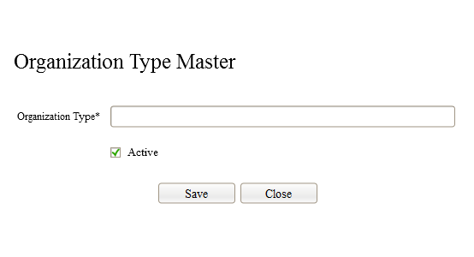

### ACTIVITIES WHILE LOGIN

1. **Following data existence will be checked while login to Application**
   * **CORPORATE PACK**
   * **LICENSE PACK**
   * **ORGANIZATION TYPES**
   * **COUNTRY MASTER**
   * **EMAIL TEMPLATE (For sending various type of emails)**

If these details are not exists, then application should give an error message and should not continue.

1. **Organization Registration Link While Login**

There should be a link on login page. “Not Registered Yet?Select this Link to Register Your Organization! It’s Easy and Free.”

If any organization tries to select this link then Organization Registration Page will be displayed for generating the organization for Parking (Before Verification & Approval). A mail will be delivered to registered organization mail ID for verification after successful registration.

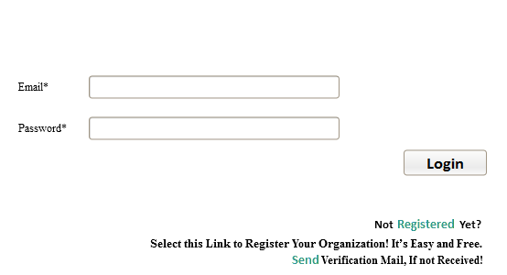

1. **Verification Mail Resending Link**

This is the link for resending the mail for registered organization if it is not delivered. Link will ask for entering the registered email ID. Solution will not allow sending any emails, if it is not registered email ID.

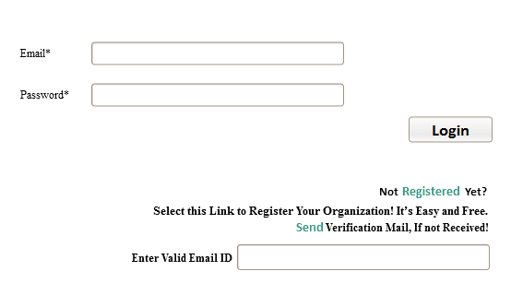

1. If organization parking maintains any record with registered email ID is in the Status of ‘New’, then email will be delivered.
2. If organization parking maintainsanyrecord with registered email ID in the Status of ‘Approval Pending’, then softwarewill give an alert as ‘Sorry, Cannot send Mail Again. This Mail ID is Already Verified!”
3. If organization parking maintainsanyrecord with registered email ID in the Status of ‘APPROVED’, then software will give an alert as ‘Sorry, Cannot send Mail Again. This is an Approval Pending Mail ID!”
4. If organization parking maintainsanyrecord with registered email ID in the Status of ‘REJECTED’, then software will give an alert as ‘Sorry, Cannot send Mail Again. This Mail ID is Already Rejected!”
5. If organization parking doesn’t maintains any record with specified email ID, then software will give an alert as ‘Sorry, This Email ID is not Registered. Select Registration Link for New Organization!”
6. **APP Administrator Login**

There will be a provision for login to the application by App Administrator. Possible menu roles for App Administrator will be defined in the Designation Roles for accessing various menu roles in the application. Following things will be checked while App Administrator Login.

* 1. This should check whether all templates are created in EMAILTEMPLATE module. Software should not allow login, if not done. These email templates will be defined before deploying the application.

### ‘ORGANIZATION REGISTRATION FOR PARKING’ SUB SYSTEM

**Feature**

Newly registered organization will be parked for an approval by the App Administrator. If an external user entering organization details in Application during initial setup, then those details will be updated to this module. Initial information will be displayed as ‘New’ status in Master Administrator dashboard. Mail ID verification is the next step after updating the initial information. An automated mail will be send to the parked organization for Mail ID verification. ‘New’ status will be changed to ‘Approval Pending’ status after verifying Mail ID. Authorized personnel from App Enterprise should either ‘approve’ / ‘reject’ this registration. Approved registration will be populated in the actual organization registration module as well as user registration. This is the process which is to be applicable for online environment. If it is the offline environment, organization can be registered by the external user. Mail will not be delivered to registered Mail ID. Status of this parked organization will be updated as ‘New’. An automated mail will be delivered to organization administrator as well as App Administrator, if there is internet connectivity. Authorized personnel from App Enterprise should either ‘approve’ / ‘reject’ this registration. The approved registration will be populated in the actual organization registration module as well as user registration.

**Flow – Organization Registration**

* Organization Name, Code, Address1, Country, Mobile, Email, Password, License Pack & Corporate Pack are mandatory.
* External user should access Application URL and update organization details.
* Mobile Number and Email ID validation will be done in the module
* Email Id should be unique in the module. Because this email Id should be used for login to Application.
* An automated mail will be send to this mail ID after successful registration. A message should be given to registered user for this page itself after registration saying that “Verification mail is send to your mail ID, Please verify your email after selecting appropriate link in your mail”.
* The automated mail will contain the information about Application and Validation Link.
* These parked registrations are to be approved by the authorized Personal from App Enterprise. Email Validated registrations are only displayed for the approval.
* Both New and Confirm Password are to be similar while registering the organization. This should be validated while submitting the page.
* There should be a password strength checking and the same to be displayed as separate color.
* The strength should be ‘Weak’, ‘Medium’ and ‘Strong’ and the same should be colored strip as ‘Red’, ’Yellow’ & ‘Green’ respectively
* License Pack and Corporate Pack should be selected before submitting the page.
* When license pack is selected then the maximum allowed users in this pack should be updated with separate field. When corporate pack is selected then the maximum allowed count for corporate offices to be updated in separate field.
* An external user of an organization generates the details in organization parking module. This will be maintained as ‘New’ status while generating the parked organization details. An automated mail will be send to the organization for verifying the email. The status of parked details of organization will be moved to ‘Approval Pending’ status after it is verified by the organization through email verification link in their email. An automated mail will be send to App Administrator after email verification. This will be parked at the dashboard for the App Administrator approval. The approval authority can either marked this organization registration as ‘Approved’ or ‘Rejected’. There should be a rejection reason by the App Administrator when the parked organization status is moved to ‘Rejected’. An automated mail will be send to External organization user after it is approved / rejected.
* Password will be encrypted in the database using HASH algorithm.

**‘ORGANIZATION REGISTRATION FOR PARKING’ SUB SYSTEM**

**ACCESSING APPLICATION URL**

**ADDING ORGANIZATION**

**SEARCH LICENSE PACK**

**SEARCH ORGANIZATION TYPE**

**EMAIL VERIFICATION**

**SEARCH CORPORATE PACK**

**REJECTION / APPROVAL BY APP ADMINISTRATOR**

* **Accessing Application URL:** Application Console can be accessed using valid URL either for login or registering an organization.
* **Adding Organization:** Create new Organization by the external user.
* **Search Organization Type:** Organization Type should be selected from the list while registering the organization.
* **Search License Pack:** Available License packs are to be listed and allow selecting one from list.
* **Search Corporate Pack:** Available Corporate packs are to be listed and allow selecting one from list.
* **Email Verification:** Email ID of an organization should be verified by the registered user in the case of hosting this application on Public IP / otherwise this verification should be done by App Administrator while deployment.
* **Rejection / Approval by App Administrator:** Parked organization should be approved or rejected by App Administrator.

### ORGANIZATION REGISTRATION SUB SYSTEM

**Feature**

There will be no interface for creating new organization. This module will be updated after successful approval of parked organization. All information about organization should be maintained in this module. Name of the organization should highlight in title area of solution. This will be possible for deploying the solution in cloud environment also. All user defining sections in the solution should be linked with this organization definition.

**Flow**

* This module will be updated while approval done for parked organization.
* Details will be copied to this module from organization parking.
* The email and password will also copied to user registration module for the purpose of user login. Password will be encrypted using HASH algorithm.
* The organization administrator can change all the fields except Organization Code, License Pack& Corporate Pack fields after fetching this module.
* Values of license pack and corporate pack should be displayed in this module, but it will be displayed as ‘Non Editable’.

**ORGANIZATION REGISTRATION SUB SYSTEM**

**CANCELLATION BY APP ADMINISTRATOR**

**MODIFY ORGANIZATION**

* **Modifying Organization:** Modify organization details by the organization administrator. Key information such as license pack & corporate pack cannot be amended.
* **Cancellation by App Administrator:** App Administrator can cancel the organization registration with proper cancellation reason.

**END OF SPRINT1 “SYSTEM ANALYSIS AND DESIGN” DOCUMENT**

### APP ADMINISTRATOR VERIFICATION TOOL

This is the tool for Email Verification by App Administrator, if it is not done by the Organization. If an organization is verified their email then such registrations are invisible for the users. Following provisions are to be given in this module.

1. Allow entering Registered Email ID by the APP Administrator.
2. There will be link next to Email ID – “Fetch Verification Code”
3. If user select this link, then corresponding verification code should be displayed in verification code entering textbox if the status of this Email ID is ‘NEW’
4. If organization parking record with registered email ID is in the Status of ‘Approval Pending’, then page will give an alert as ‘Sorry, Cannot send Mail Again. This Mail ID is Already Verified!”
5. If organization parking record with registered email ID is in the Status of ‘APPROVED’, then give an alert as ‘Sorry, Cannot send Mail Again. This is an Approval Pending Mail ID!”
6. If organization parking record with registered email ID is in the Status of ‘REJECTED’, then give an alert as ‘Sorry, Cannot send Mail Again. This Mail ID is Already Rejected!”
7. If organization parking record with registered email ID doesn’t exists, then give an alert as ‘Sorry, This Email ID is not Registered. Select Registration Link for New Organization!”

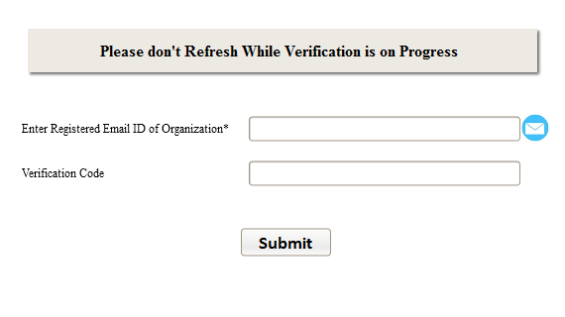

### CORPORATE TYPE SUB SYSTEM

**Feature**

There should be a provision for creating the corporate offices under particular organization but those corporate offices are to be categorized like HO, Branch etc. This will be helpful for future activity integration; if there is any specialty for HO / BO then the same can be defined in module. Master Administrator should define the category in this table.

*There will be no user interface for this module.*

**CORPORATE TYPE SUB SYSTEM**

**UPDATING CORPORATE TYPE**

**INSERTING CORPORATE TYPE**

* **Inserting Corporate Type:** List out the possible types and create this corporate type in the module.
* **Updating Corporate Type:** Generated Corporate Type can be modified by the Approved Person.
* These activities are to be done before deploying the solution.

### CORPORATE DEFINITION SUB SYSTEM

**Feature**

Basic Information about corporate entities should be maintained in this module. This is mandatory to update information about corporate entities under each organization before working with this solution. Minimum of one corporate office should be defined in the solution. Name of the corporate entity should highlight in title areas of solution. This will be possible for deploying the solution in cloud environment also. All user defining sections in the solution should be linked with this corporate definition. Corporate entities cannot be removed if it’s linked with other modules of solution. Corporate entities can be categorized as Head Office, Branch Office & Sister Concern etc. Organization should be selected under each corporate entity for linking. It is the responsibility of generating corporate offices by the Organization Administrator. This user role will not be available for other type of users.

**Flow**

* Organization Administrator can create corporate offices. These corporate offices are to be linked with corporate administrator user. Organization administrator will be able to create corporate administrator user.
* An organization could create any number of corporate offices depends on selected corporate pack.
* These corporate offices are treated as branches, sister concerns etc.
* All activities in corporate entity should be grouped under organization.
* An organization administrator can login to App after approval by App Administrator.
* This login information will be maintained in the user registration module also. Organization will also link with the user registration.
* Information about organization will be displayed while adding the new corporate entity and allows editing the same.
* There should be a provision for entering Short Company Name for printing / displaying in smaller areas such as Barcode Label Printing etc.
* There should be a provision for entering customer care number while creating corporate office.

**CORPORATE DEFINITION SUB SYSTEM**

**APP LOGIN**

**ADDING CORPORATE OFFICE**

**ACTIVATING / INACTIVATING CORPORATE OFFICE**

**MODIFYING CORPORTE OFFICE**

**COUNTRY SEARCH**

**CANCELLATION OF CORPORTE OFFICE**

**CITY SEARCH**

* **MOS Login:** Allow login to the solution by the organization administrator for administering corporate office module.
* **Adding Corporate Office:** List out the possible offices and create each corporate office in this module.
* **Modifying Corporate Office:** Generated Corporate office could be modified by the Organization Administrator / Approved Person.
* **Activating / Inactivating City:** Corporate Administrator / Authorized Person could activate / inactivate corporate office. If it is inactivated, then the same will not be reflected in any other modules.
* **Country Search:** Allow searching the Country and allocated to Corporate Office.
* **City Search:** Allow searching the City and allocated to Corporate Office.
* **Cancellation of Corporate Office:** There will be a provision for cancelling the corporate office by the authorized user. Cancellation will be restricted if it is selected in some other modules.

**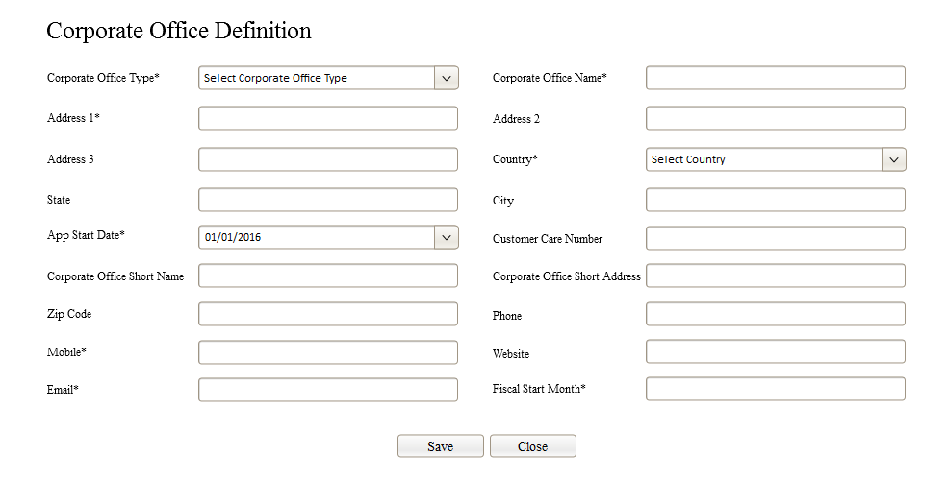**

### CORPORATE DIVISION SUB SYSTEM

**Feature**

Corporate divisions are to be created by corporate administrator. While Corporate administrator logins to App then corresponding corporate office will be fetched for that Login session.There should be a provision for defining the corporate divisions under each corporate office. Corporate divisions are independent entity, we can sort out the employees under these divisions, maybe a employee don’t have a division too.

**CORPORATE DIVISION SUB SYSTEM**

**MODIFY CORPORATE DIVISIONS**

**ADDING CORPORATE DIVISIONS**

**CANCELLATION CORPORATE DIVISIONS**

**ACTIVATING / INACTIVATING CORPORATE DIVISIONS**

* **Adding Corporate Divisions :**adding corporate divisions under corporate office by authorized person.
* **Modify Corporate Divisions :**Generated corporate divisions can be modified by authorized person. If it is not cancelled.
* **Activating/Inactivating Corporate Divisions :**Authorized Person could activate / inactivate corporate divisions. If it is inactivated, then the same will not be reflected in any other modules.
* **Cancellation of Corporate Divisions :**There will be a provision for cancelling the corporate divisions by the authorized user. Cancellation will be restricted if it is selected in some other modules.

**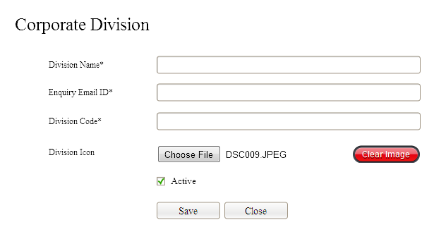**

* Here we collect enquiry email id per division , it is a mandatory field.
* Division email id can’t be duplicated.
* In this system division’s enquiry email id is very much important.
* Division code is mandatory here, division code will use to generate enquiry id based on divisions etc.
* Provision for add division icon for all divisions, provision for clear selected image.
* Maybe some changes will happen on ‘clear image’ button design.
* Clear image button need to show only any image selected.
* Remove the uniqueness of email id based on corporate office.
* stick on the length of corporate code to ‘3’.

### CORPORATE DEPARTMENT SUB SYSTEM

**Feature**

Corporate departments are to be created by the corporate administrator. While Corporate administrator logins to App then corresponding corporate office will be fetched for that Login session.There should be a provision for defining the corporate departments as well as sub departments under each corporate office.

**CORPORATE DEPARTMENT SUB SYSTEM**

**APP LOGIN**

**ADDING CORPORATE DEPARTMENT**

**ACTIVATING / INACTIVATING CORPORATE DEPARTMENT**

**MODIFYING CORPORTE DEPARTMENT**

**CANCELLATION OF CORPORTE DEPARTMENT**

**MAIN DEPARTMENT SEARCH**

**CORPORATE OFFICE SEARCH**

* **Login:** Allow login to the solution by the organization administrator for administering corporate department module.
* **Adding Corporate Department:** List out the possible departments in the corporate office and create each department in this module.
* **Modifying Corporate Department:** Generated Corporate department could be modified by the Corporate Administrator / Approved Person.
* **Activating / Inactivating Corporate Department:** Corporate Administrator / Authorized Person could activate / inactivate corporate department. If it is inactivated, then the same will not be reflected in any other modules.
* **Main Department Search:** This is the purpose of dividing departments as main-department and sub-department.
* **Cancellation of Corporate Department:** There will be a provision for cancelling the corporate department by the authorized user. Cancellation will be restricted if it is selected in some other modules.

**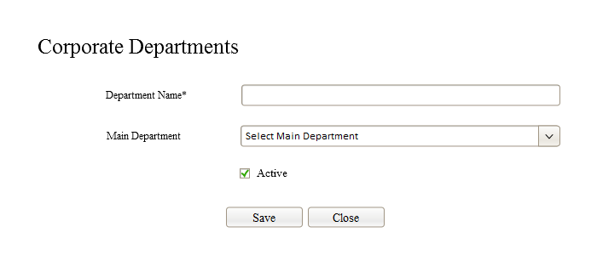**

### PREMISE DEFINITION SUB SYSTEM

**Feature**

Premise definition is used for splitting departments into multiple areas do the activities. This is the individual allocation mechanism for treating sales, purchase etc. for evaluating profitability, stock tracking and others. This is not relevant in the current SFA architecture. But it will be helpful when we develop other sections of an ERP Solution.

**Flow**

* Premise should be defined by the corporate administrator or authorized personnel.
* It is the module for defining the single / multiple premises in a department.
* Premise definition can be cancelled by the corporate administrator, if it is not linked with some other module.

**PREMISE DEFINITION SUB SYSTEM**

**ADDING PREMISE**

**MODIFYING PREMISE**

**DEPARTMENT SEARCH**

**ACTIVATING / INACTIVATING PREMISE**

**CANCELLATION OF PREMISE**

* **Adding Premise:** List out the possible premises of each department and create premises using this module.
* **Modifying Premise:** Generated Premise could be modified by the Corporate Administrator / Approved Person.
* **Activating / Inactivating Premise:** Corporate Administrator / Authorized Person could activate / inactivate premise. If it is inactivated, then the same will not be reflected in any other modules.
* **Department Search:** Allow searching the department and allocated to Premise.
* **Cancellation of Premise:** There will be a provision for cancelling the premise by the authorized user. Cancellation will be restricted if it is selected in some other modules.

### 011_Department_Premises.png

### AREAS IN PREMISE SUB SYSTEM

**Feature**

Premises can again sub-divide into different sections for smooth functioning, if needed. Let us call this as Premise Areas. These sections can also consider as cost centre. Eg. If the enterprise location is a 3 floor building and floor-1 can be considered as Premise. If the floor-1 is under sales department, then there can be a possibility of different cost centre points. So this floor (Premise) can be again divided for ‘Premise-Areas’.This module is also not necessary in the current SFA architecture. But it will be useful for the future expansion of enterprise solution.

**PREMISE-AREA SUB SYSTEM**

**ADDING PREMISE-AREA**

**MODIFYING PREMISE-AREA**

**CANCELLATION OF PREMISE-AREA**

**PREMISE SEARCH**

**ACTIVATING / INACTIVATING PREMISE-AREA**

* **Adding Premise-Areas:** List out possible premise-areas of each premise and create premise-area in module.
* **Modifying Premise-Areas:** Generated Premise-area could be modified by the Corporate Administrator / Approved Person.
* **Activating / Inactivating Premise-Areas:** Corporate Administrator / Authorized Person could activate / inactivate premise-areas. If it is inactivated, then the same will not be reflected in any other modules.
* **Premise Search:** Allow searching the premise and allocated to premise-area.
* **Cancellation of Premise-Areas:** There will be a provision for cancelling the premise-area by the authorized user. Cancellation will be restricted if it is selected in some other modules.

**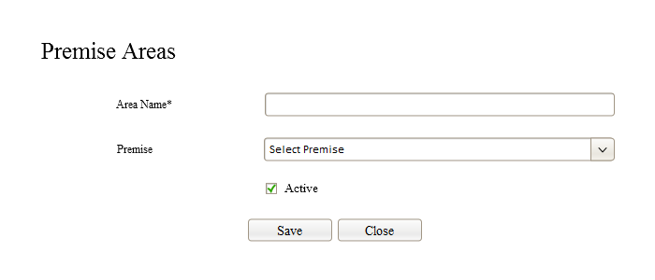**

### WORKSTATION SUB SYSTEM

**Feature**

This is the workstation definition in each premise area. It will be useful when we consider the report consolidation on various areas such as workstation-wise, user-workstation data analysis, profit center analysis etc. Each workstation should be linked with unique identification. There will be a utility for allocating workstation IDfor individual system using Cookies which should be defined as unlimited expiry. This module is also not necessary in the current SFA architecture. But it will be useful for the future expansion of enterprise solution.

**WORKSTATION SUB SYSTEM**

**ADDING WORKSTATION**

**MODIFYING WORKSTATION**

**ACTIVATING / INACTIVATING WORKSTATION**

**PREMISE-AREA SEARCH**

**CANCELLATION OF WORKSTATION**

* **Adding Workstation:** List out the possible premise-areas of each premise and create premise-area in the module.
* **Modifying Workstation:** Generated Premise-area could be modified by the Corporate Administrator / Approved Person.
* **Activating / Inactivating Workstation:** Corporate Administrator / Authorized Person could activate / inactivate premise-areas. If it is inactivated, then the same will not be reflected in any other modules.
* **Work/Premise Area Search:** Allow searching the premise and allocated to premise-area.
* **Cancellation of Workstation:** There will be a provision for cancelling the premise-area by the authorized user. Cancellation will be restricted if it is selected in some other modules.

**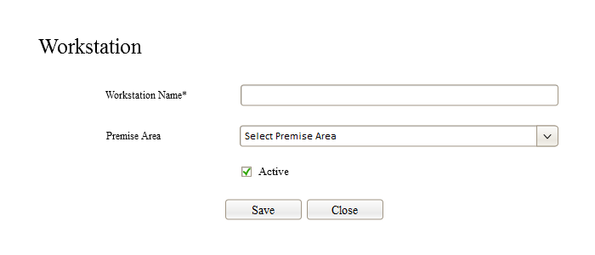**

**END OF SPRINT2 “SYSTEM ANALYSIS AND DESIGN” DOCUMENT**

### EMPLOYEE / USER MANAGEMENT & AUDIT TRAIL

In the overall view, complete solution will be consolidated among organization and its corporate offices. There will be anAppAdministration user which will be created during the initial implementation. Username of App Administrator user will be common for all the organizations. But password should be changed from one organization to another. All passwords are to be encrypted in the database. These passwords are to be maintained in the secured location for future reference. The Organization Administrator user will be automatically created while registering the organization.

Organization administrator can create corporate offices and corporate administrator user for accessing the various administrative activities. Number of corporate offices will be decided from the selected corporate pack during the organization definition. Corporate administrator can add additional users in the software. The number of user creation will be depends on the selected license pack by the organization administrator during organization setup. The audit trail for the users can also be defined in the system using this module. The user permission and role for accessing the various modules of App can also be defined and allocated through the system.

### USER ROLE SUB SYSTEM

**Feature**

It is the method of standardization for the role allocation for users, this master details can be used for defining user group and user registration modules. Parent and child permissions are to be fed into this table by the App Administrator while development. These permissions should be selected while allocating user designation.

**Flow**

* User role is the menu definition for identifying a module such as division, products etc.
* Possible modules such as item category, item definition etc. are to be listed in this section and allowed to select these modules and these are to be assigned for users later, if needed.
* This user role should be defined by the Development team in database.
* There will be no user interface given for defining this user role.
* Application will display possible activities at client side according to the roll allocation for users.
* Menu building will be initiated from this module. Actual page link for each module will be created in this section. Menu and sub-menu are also to be defined and assign the corresponding display priority.
* Main Roles are to be automatically created while loading Home Page / sub page. (Menus /Listing will be dynamically created while generating appropriate page.)
* There are two types of user roles, division based and common based.
* We check each designation on basis of division based or common based, if it is division based shows division and common menus, if it is common based shows only common based.

**USER ROLE SUB SYSTEM**

**UPDATING USER ROLE BY APP ADMINISTRATOR**

**INSERTING USER ROLE BY APP ADMINISTRATOR**

**COMMON BASED USER ROLE**

**DIVISION BASED USER ROLE**

* **Inserting User Role:** List out the possible user roles of Application and create the same directly in database.
* **Updating User Role:** Generated User Role could be modified by the development team.
* **Division Based User Role :** this user role only for division based designations/customers.
* **Common Based User Role :** this user role commonly for all designations/users

### CHILD ROLE SUB SYSTEM

**Feature**

It is the child role under main user role definition; this can be used for controlling the user permission for the various activities in each page such as Inserting, Updating, Cancellation, Report View, Report Export, Report Print etc. If the value for ‘Report Print’ child role is void then Printing Tool will be disabled for that module.

**Flow**

* Child roles should be defined by the development team while designing the solution as well as main role activities.
* These child roles are to be directly created in database.
* This will be a good practice to build an interface for defining these roles.
* The activities (Adding / Modify / Cancel etc.) in each module will be enabled / disabled depends on child role selection.

**CHILD ROLE SUB SYSTEM**

**INSERTING CHILD ROLE**

**UPDATING CHILD ROLE**

* **Inserting Child Role:** List out possible child roles of Main Role of Application and create it directly in database.
* **Updating Child Role:** Generated Child Role could be modified by the development team.

### DESIGNATION TYPE SUB SYSTEM

**Feature**

This is the static module for defining the various designation types. Such designation types are to be selected during the creation of user designation.

1. App Administrator (AUSER)
2. Organization Administrator (AUSER)
3. Corporate Administrator (OUSER)
4. Department User (CUSER)
5. Department Head (CUSER)
6. Department Manager (CUSER)
7. Department Group Manager (OUSER)
8. Other User (OUSER)

**Legends:**

**AUSER: APP USER; OUSER: ORGANIZATION USER; CUSER: CORPORATE USER**

**Explanation**

App Administrator:

User Designation under this type will be generated before implementing the solution. It is not possible to create designation by the interface for this designation type. Users under this designation are the App Administrator.

It is a good practice to keep common user name for App Administrator for all clients. But password should be different from one to another.

Organization Administrator:

User Designation under this type will be generated before implementing the solution. It is not possible to create designation by the interface for this designation type. Such designation will be inserted by the App Administrator before implementation.

Designation: OrganizationAdmin

Corporate Administrator:

User Designation under this type will be generated before implementing the solution.It is not possible to create designation by the interface for this designation type. Such designation will be inserted by the App Administrator before implementation.

Designation: CorporateAdmin

Department User:

It is the bottom layer position under designation type hierarchy for department user group. Organization Administrator / Corporate Administrator will be able to create designation under this designation type.

Eg: Accounts Assistant, Billing Assistant, Driver etc.

Department Head:

It is the 2ndlayerposition under designation type hierarchy for department user group. Organization Administrator / Corporate Administrator will be able to create designation under this designation type.

Eg: Accounts Head, Billing Head, Security Head etc.

Department Manager:

It is the 3rdlayer position under designation type hierarchy for department user group. Organization Administrator / Corporate Administrator will be able to create designation under this designation type.

Eg: Finance Manager, Floor Manager, Security Manager etc.

Department Group Manager:

It is the 4thlayer position under designation type hierarchy for department user group. Organization Administrator will be able to create designations under this designation type.

Eg: Group Finance Manager, Group Floor Manager, Group Security Manager etc.

Other User:

Any type of designation other than above should be defined under ‘Other User’ designation type.

**Flow**

* This module should be defined by Development team in the database.
* There are primary designation types in this module. Designations under primary designation type should also be created by development team in the database.
* The activities for various designations should be controlled either by an organization or by corporate. Another field should be used in the designation type for opting the control entity.

**DESIGNATION TYPE SUB SYSTEM**

**UPDATING DESIGNATION TYPE**

**INSERTING DESIGNATION TYPE**

* **Inserting Designation Type:** Above designation types of MOS App to be created in database.
* **Updating Designation Type:** Generated designation type could be modified by the development team.

### DESIGNATION SUB SYSTEM

**Feature**

This is the method of grouping the users in every organization, user’sdataretrieval or reporting will be easier if it is grouped. Dashboard data retrieval could be controlled by various types of designations in the hierarchy. If a user designation is selected in user registration module, then the alert should be given while cancelling that designation. User role allocation will be enabled in user designation. There should be a provision for copying the user designation actions from one designation to another. If the roles allocated for one designation can be copied to another designation. There should be a provision for reallocating new user designation with old user group for the corresponding users.

Following are the primary designation and these designations can’t be removed.

* App Administrator
* Organization Administrator
* Corporate Administrator

**Flow**

* This will be used for grouping the users.
* There are primary designations in the architecture and those are to be inserted by the development team in database.
* Users under ‘App Administrator’ will be created by the Development Team before implantation.
* Users under ‘Organization Administrator’ will be created by the External User while registering the organization. App Administrator should approve an Organization and this new organization will be inserted into user registration while approval.
* Organization Administrator should create ‘Corporate Administrators’
* Other designations under corporate control will be created by the Corporate Administrator.
* All designations under Organization control will be created by the Organization Administrator.

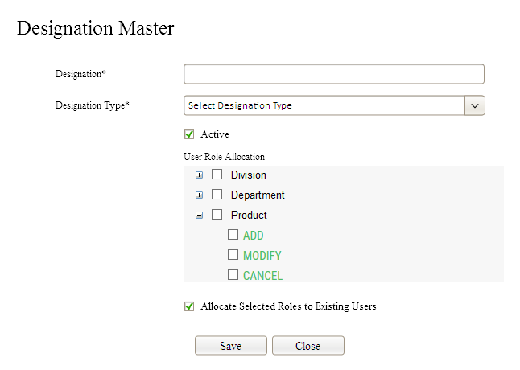

#### ‘MASTER ROLE DEFINITION FOR USER DESIGNATION’ SUB SYSTEM

**Feature**

Role Definition for User Designation can be defined through this table. If role definition is properly defined for the user designation, then the same role definition will be available for allocating to users. While defining the designation using designation module, then the corresponding roles for that designation should also be selected from the list. The purpose of this utility is for allocating the roles easily to users without selecting the roles separately for each user. All users under selected designation will be assigned.

**Flow**

* It is the linked module with designation master.
* It is the main role definition for the selected designation. These roles are to be allocated to the users under the designation.
* The roles which are selected for the designation will be copied to corresponding users while user registration.

#### ‘CHILD ROLE DEFINITION FOR USER DESIGNATION’ SUB SYSTEM

**Feature**

Child Role Definition for User Designation can be defined through this module. If a child role definition properly defined for the user designation, then the same role definition will be available for the role allocation while user registration. There will be a provision for defining the main user role under selected user designation. This module allows defining child roles under selected user role.

**Flow**

* It is the linked module with designation.
* It is the child role definition for a main role under particular designation. These child roles are also to be allocated to the users under the designation.
* The child roles which are selected for particular designation will be copied to corresponding users while user registration.

**DESIGNATION SUB SYSTEM**

**MODIFYING DESIGNATION**

**ADDING DESIGNATION**

**ACTIVATING / INACTIVATING DESIGNATION**

**DESIGNATION TYPE SEARCH**

**CANCELLATION OF DESIGNATION**

**CHILD ROLE ALLOCATION**

**MAIN ROLE ALLOCATION**

* **Adding Designation:** List out possible designations of organization and create the same in module.
* **Modifying Designation:** Generated designation except primary designation could be modified by the Approved Person.
* **Activating / Inactivating Designation:** Authorized Person could activate / inactivate Designation. If it is inactivated, then the same will not be reflected in any other modules.
* **Designation Type Search:** Allow searching the designation type and allocated to designation.
* **Cancellation of Designation:** There will be a provision for cancelling the designation by the authorized user. Cancellation will be restricted if it is selected in some other modules.
* **Main Role Allocation:**Role definition will be grouped into main role and child role. Main role permission allowed for the designation should be allocated.
* **Child Role Allocation:**Role definition will be grouped into main role and child role. Child role permission allowed for the designation should be allocated.

### EMPLOYEE SUB SYSTEM

**Feature**

This is the Employee registration module where all Employees of every registered & approved organization will be maintained. If a parked organization is approved by the App Administrator from app administration section, then approved organization will be copied to this Employee registration table. This Employee will be treated as the organization administrator. Organization administrator will be having ‘Organization Control’. Employee permission or the user role will be allocated for each user automatically as per the designation.

**Flow**

* Various types of Employees are to be generated through the registration module.
* App Administrator Employee should be created by the Development Team in employee master before deploying the application.
* An organization should be approved by App Administrator after successful email verification. User Login and password will be updated in Employee registration table while organization approval. Designation for that Employee should also be updated as ‘Organization Administrator’. There will be only one active organization administrator for an organization.
* Corporate Administrator user should be created by Organization Administrator.
* Corporate Employees will also created by corporate administrator.
* There should be a sub-module for maintaining the corporate offices of the selected employee having organization control. If designation having the organization control for an Employee, then there should be a provision for selecting single / multiple corporate offices for that Employee. But limitation is that designation should not be primary designation.
* Here is a provision for adding multiple divisions against a employee. ( if employee is not a division based employee then no need to add any divisions ).
* Here is provision for add user name and password ( must ), and if employee have email then add to the details for receiving details in email.
* There is a provision for add images against each employees.
* Maybe we can change the design of ‘clear image’.

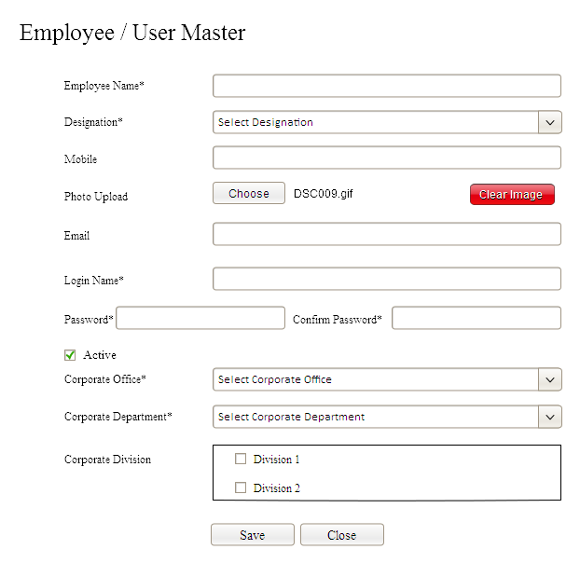

#### ‘MAIN ROLE DEFINITION FOR EMPLOYEE’ SUB SYSTEM

**Feature**

Role Definition for an employeewillbe automatically posted from selected designation. The allocated roles (modules) will only visible for the corresponding Employee while login to application.

**Flow**

* It is the linked module with Employee registration.
* There will be no Interface for this sub-section.
* There is a provision for allocating main roles to designation using designation module. Role defined for that designation will be automatically copied to Main Role module of Employee registration.

#### ‘CHILD ROLE DEFINITION FOR EMPLOYEE’ SUB SYSTEM

**Feature**

Child Role Definition for Employeewillbe automatically coped from corresponding designation.User child roles for that employee should be managed as per child role definition for the corresponding designation.

**Flow**

* It is the linked module with Employee registration.
* It is the child role definition selected under main role for particular designation. These child roles are also to be allocated to Employees under the designation.
* The child roles which are selected for particular designation will be copied to corresponding Employees while Employee registration.

#### ‘CORPORATE DEFINITION FOR EMPLOYEE’ SUB SYSTEM

**Feature**

Some type of Employees will be having the role for accessing all activities of organization in whole.But all corporate offices under that organization may not be permissible for thatEmployee. So that associated corporate offices are to be linked for anemployee. All other type of Employees will be permissible for the appropriate corporate office only. This employee-corporate linkingmodule should be updated with corresponding corporate office(s) while adding an Employee.

**Flow**

* Organization Administrator should create corporate Employees in the Employee registration module.
* Corporate Employee will be able to create other Employees of various designation types with corporate control.
* Organization Administrator will be able to create Employees with organization control.
* There should be a sub-module for maintaining the corporate offices of the Employee with organization control. If a designation having the organization control for an Employee, then there should be a provision for selecting single / multiple corporate offices for that Employee. But the designation should not be primary designation.
* Those corporate offices will be maintained in this module.

**EMPLOYEE REGISTRATION SUB SYSTEM**

**ADDING EMPLOYEE**

**MODIFYING EMPLOYEE**

**ACTIVATING / INACTIVATING EMPLOYEE**

**CORPORATE DEPARTMENT SEARCH**

**DESIGNATION SEARCH**

**EMPLOYEE CANCELLATION**

**CHILD ROLE ALLOCATION**

**MAIN ROLE ALLOCATION**

**DIVISION ALLOCATION**

**CORPORATE OFFICE ALLOCATION**

* **Adding Employee:** List out possible employees of an organization / corporate office and create the same in the module.
* **Modifying Employee:** Generated employee could be modified by the Organization Administrator / Approved Person.
* **Activating / Inactivating Employee:** Organization Administrator / Authorized Person could activate / inactivate employees. If it is inactivated, then the same will not be reflected in any other modules.
* **Corporate Department Search:** Allow searching the corporate department and allocated to employee.
* **Designation Search:** Allow searching the designation and allocated to employee.
* **Cancellation of Employee:** There will be a provision for cancelling an employee by the authorized user. Cancellation will be restricted if it is selected in some other modules.
* **Main Role Allocation:**Role definition will be grouped into main role and child role. Main permission allowed for the employee should be allocated.
* **Child Role Allocation:**Role definition will be grouped into main role and child role. Child permission under selected main role for an employee should be allocated.
* **Division Allocation:**There should be a provision for assigning corporate division to employee.
* **Corporate Office Allocation:**Provision for allocating a corporate office for an employee.

### TEAM HIERARCHY SUB SYSTEM

**Feature**

This is the module for defining team hierarchy. Here we can arrange each employee on a hierarchy manner. Majority organizations have team structure on their employees so this module will helpful. Here we select a employee as team lead and choose team member employees and this is a team it must have a name. There is no relation on designation to employees for sorting list. This hierarchy will helpful when monitoring works in future modules.

**TEAM HIERARCHY SUB SYSTEM**

**SELECT TEAM LEADER**

**SELECT TEAM MEMBERS**

* **Select Team Leader :** we can select one employee as team leader.
* **Select Team Members :** we can select zero/one/more employees as team members, so these members go under the team lead. There is no restriction to set team members on the basis of designations.

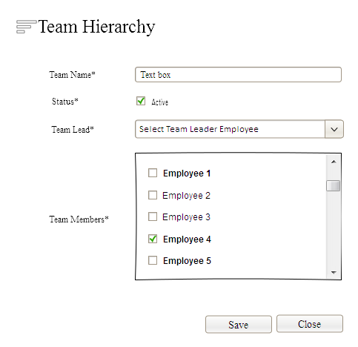

* Some of the employee name were bold , that means they not included any other team as member.
* Some of the employee name were lighter in character, that means they include some of other group/groups as members, but no restriction to add them.
* Allow duplication in the case of team lead. A employee can be the team lead of multiple teams.
* Each team have a name, and active status. In future we needs to monitor the performance against each team.
* There is no restriction on the basis of division as well as designation for choose employees.
* No duplication on Team Names.

### FINANCIAL YEAR SUB SYSTEM

**Feature**

This is the module for automatically generating the financial year during the initial creation of corporate office. Solution will ask for setting up the corporate office while login to Application by the organization administrator during initial setup. It is compulsory for adding financial year while creating the corporate office. User should update starting month of financial year while creating corporate office. Why solution is linking financial year to corporate office? Reason: Financial Year Period might be different from one Country to Other. So that corporate entity should be linked with financial year. This financial year master is also used for tracking the financial year in all transactions. There will be a financial year closing utility which will help enterprise to close every financial year and start new financial year. All transaction modules are to be checked before starting the functionalities whether the server date exceeded the current financial year end date. If server date exceeds than current financial year end date then Application should give an alert “Cannot do any transaction, because financial year is not closed!”. Whenever year closing activity happened, then system will update newly created financial year as active financial year and old financial year will be marked as closed. There should be a manual financial year creation module which caninitiate by Corporate Administrator.

* Generating the new financial year and make the same as ‘Active’ financial year.
* Updating corporate office wallet with active financial year Identification and this Id will be used for all the transaction tables.

**FINANCIAL YEAR SUB SYSTEM**

**FINANCIAL YEAR CANCELLATION**

**ADDING FINANCIAL YEAR**

**ACTIVATING / INACTIVATING FINANCIAL YEAR**

**FINANCIAL YEAR CREATION WHILE CORPORATE OFFICE DEFINITION**

* **Adding Financial Year:** Prepare new financial year details of a corporate office and create the same in the module.
* **Cancellation of Financial Year:** There will be a provision for cancelling financial year by the authorized user. Cancellation will be restricted if it is selected in some other modules.
* **Activating / Inactivating Financial Year:** Organization Administrator / Authorized Person could activate / inactivate Financial Year. If it is inactivated, then the same will not be reflected in any other modules.
* **Financial Year Creation While Corporate Office Definition:**There should be a provision for creating the financial year automatically while creating the corporate office, which will ask for updating starting month of financial year.

### 

### MAIL MANAGEMENT

This is the mail sending utility which will be maintained as part of Sales Force Automation for sending mails. Following things should happen in mail sending utility.

* Instant Mail Sending
* Bulk Mail Sending
* Instant Mail Sending should happen as soon as the activity happens. Eg. If enquiry module wants to send a follow-up mail then it should be happened as instant manner. Bulk mail sending will happen in two conditions. One is explicit bulk mail sending and fail-over mail sending.
* A utility will be designed for sending automatic mailsthat should maintain the methods for instant mail as well as bulk mail.
* Create a console application for sending the mail. This should be a recurring process, so that this console application will be configured as windows service.
* Email Template Type: This is the mail template type definition module before defining mail templates. It will be useful for analyzing various types of mail messages by identifying template type.
* Email Template: This is the mail template definition module and it will be used for sending messages from various sections in the application.
* Email Storage: This is the module for storing all emails delivered by Application. Instant as well as bulk mail delivery will also happen from this module. Application will store mailsinthis module and sends the same instantly or during the regular interval.
* Email Storage Backup: This is the module for storing all successful delivery emails for the purpose of tracking.
* Instant Mail Sending should happen as soon as the activity happens. Eg. If an application wants to send email-ID verification to recipient then it should happened instant manner. Bulk mail sending will happen in the two conditions. One is explicit bulk mail sending and fail over mail sending.

***Flow for Mail Sending***

* Instant Mailing Section should receive Template Id, From Mail, To Mail, Reply-To Mail and Subject
* Instant Mailing Section should insert information in Message Storingmodule
* Application will send this mail to recipient.
* Update status of message storage table with Yes for this message after successful delivery
* Bulk Mailing section should fetch mail storage table for delivery pending mails.
* Each mail should send in a short interval. It may trapped in SPAM for mail server / mail ID if it is continuous delivery.

### EMAIL TEMPLATE TYPE SUB SYSTEM

**Feature**

This is the mail template type definition module before defining templates. It will be helpful for analyzing the various mail messages by identifying the template type.

**Flow**

* User Interface is not needed for this module.
* Development Team should define the possible types in the module.
* Allow relating this module to Template Definition Sub System
* Template Name should be defined in the module and it is the unique field.

### EMAIL TEMPLATE SUB SYSTEM

**Feature**

This is the mail template definition module and it will be used for sending messages from various sections in the application.

**Flow**

* User Interface is not needed for this module.
* Development Team should define the possible templates in the module.
* Allow relating this module to Mail Storing Sub System
* Inactivated Templates should not be reflected while sending mails.
* Template should be selected in mail sending module depends on the template type.

#### EMAIL TEMPLATE ATTACHMENT SUB SYSTEM

**Feature**

There will be a provision for attaching the files while sending mails. Possible file names corresponding to each template should be defined in the module.

**Flow**

* User Interface is not needed for this module.
* Development Team should define possible file names in the module.
* Corresponding physical file will also store in the physical path.
* This physical path should be defined in the company master definition module specified in the next section
* Application should fetch this file and attached to email.

### EMAIL STORAGE MODULE

This is the module for storing all emails delivered by Application. Instant & bulk mail delivery will also happened from this module. Application will store each mail to this module and send the same instantly or during the regular interval.

**Flow**

* Application module will initiate mail sending utility and stores the information regarding mails.
* Template-ID, From Email, To Email and Reply-Mail ID will be passed to mail sending utility.
* Utility will fetch the corresponding template and generate appropriate mail.
* Stores the generated mail information to this module.
* Instant Mail Messaging Tool will send all pending emails stored in the module to recipient.
* Fail Overand Explicit Bulk Mails will also initiated by Mail Sending Utility.
* Bulk Mail Sending Utility should also be accessed by the following 2 methods
  + Console Application
  + Windows Service Application
* Bulk Mail Sending Utility should transfer emails to Backup Module for future tracking also after successful transfer.

#### EMAIL STORAGE ATTACHMENT SUB SYSTEM

**Feature**

This module will be used for storing attachment file names for mails.

**Flow**

* File names will be inserted to this module by the mail sending utility.

### EMAIL STORAGE BACKUP MODULE

This is the module for storing all successful delivery emails by the Application.

**Flow**

* Bulk mail sending utility will transfer mails from mail storage module to backup module after successful delivery.
* Successful mails will be removed from storage module after taking backup.
* This is the module for tracking mail delivery.

#### EMAIL STORAGE ATTACHMENT BACKUP SUB SYSTEM

**Feature**

This module will be used for storing attachment file names for the purpose of backup after successful mail delivery.

**END OF SPRINT3 “SYSTEM ANALYSIS AND DESIGN” DOCUMENT**

### INVENTORY MANAGEMENT

### UOM (UNITS OF MEASURE) MASTER SUB SYSTEM

**Feature**

This is the creation of units and allocating units to product master. These units can be selected in Quotation for each item.

**Flow**

* Allow updating the unique unit name such as Nos., Kg, Gm, Dz etc. These short codes can be displayed / printed in various sections.
* Another field will be used for specifying the Unit Description such as Number, Kilogram, Gram, Dozen etc.

**UOM MASTER SUB SYSTEM**

**MODIFYING UOM MASTER**

**ADDING UOM MASTER**

**UOM MASTER CANCELLATION**

**ACTIVATING / INACTIVATING UOM MASTER**

* **Adding UOM Master:** List out the possible units and create the same in UOM module.
* **Modifying UOM:** Generated UOMcan be modified by the Approved Person.
* **Activating / Inactivating UOM:** If UOM is inactivated, then the same will not be reflected in any other modules.
* **UOM Cancellation:** There will be a provision for cancelling UOM by the authorized user. Cancellation will be restricted if it is selected in some other modules.

**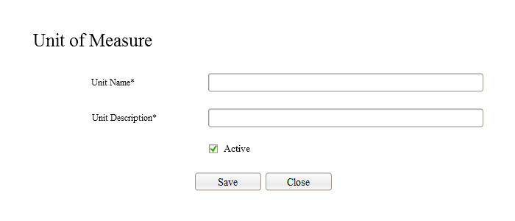**

* The field**UnitDescription**changed to **UnitCode**.

### TAX MASTER SUB SYSTEM

**Feature**

Module will be used for defining taxes; these taxes are to be selected while defining products. Tax calculation will be done in Quotation master. This will also allowed for generating tax reports as per the norms.

**Flow**

* Provision for defining standard taxes in the module.
* These taxes are to be listed in product definition module for easy allocation.
* Tax calculation will be maintained in quotation module.
* This will also allowed for generating the statutory tax reports for tax return.
* Tax calculation will be either Inclusive / Exclusive in nature. This should be decided from the item master definition.
* Tax amount calculation in quotation should be decided from the allocated % in item master.
* Tax amount calculation in quotation should also calculate as per Inclusive / Exclusive specification in item master.
* Tax amount should also Printed in Quotation.

**TAX MASTER SUB SYSTEM**

**MODIFYING TAXES**

**ADDING TAXES**

**ACTIVATING / INACTIVATING TAXES**

**TAX CANCELLATION**

* **Adding Taxes:** List out the possible taxes and create the same in tax module.
* **Modifying Taxes:** Generated tax should be modified by the Approved Person.
* **Activating / Inactivating Taxes:** If Tax is inactivated, then the same will not be reflected in any other modules.
* **Tax Cancellation:** There will be a provision for cancelling taxes by the authorized user. Cancellation will be restricted if it is selected in some other modules.

**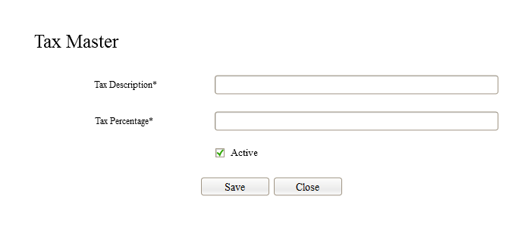**

### ITEM TYPE SUB SYSTEM

**Feature**

This is the item type module for creating various types in the database. There is no relevance for this master in the case of Application. But this master will be used for future sections.

* General Item

There will not be any user interface for creating the item type in Application. These types will be having different functionalities in Application. These details are to be inserted into the module by the development team. This item type should be selected while creating items.

**ITEM TYPE SUB SYSTEM**

**UPDATING ITEM TYPE**

**INSERTING ITEM TYPE**

**ACTIVATING / INACTIVATING ITEM TYPE**

* **InsertingItem Type:** Prepare an item type and create the same in the module by the development team.
* **Updating Item Type:** There will be a provision for updatingitem type by the development team.
* **Activating / Inactivating Item Type:** App Administrator / Development Team could activate / inactivate Item Type. If it is inactivated, then the same will not be reflected in any other modules.

**CATEGORY MANAGEMENT**

Category management is the initial step before defining products in the inventory management. It is very important for the categorization of items depends on the enterprise. The stock management and assortment of products in the shelf or display area can be properly maintained with the category management. But stock management is not considered as part of Sales Force Automation.

Following are the category levels to be defined for the product management within the SOP.

* Item Group
* Main Category
* Sub Category
* Small Category
* Least Category

**Category Structure**

**Building Materials**

**SMALL - 4**

**LEAST - 2**

**Item Group**

**LEAST - 1**

**Main Category**

**Least Category**

**SUB CATEGORY - 1**

**SMALL - 3**

**SMALL - 2**

**SMALL - 1**

**LEAST - 3**

**3M GULF - CUTTING/GRINDING DISCS**

**SUB CATEGORY - 3**

**SUB CATEGORY - 2**

**Sub Category**

**Small Category**

### ITEM GROUP SUB SYSTEM

**Feature**

This is the module of grouping the items for the convenience. It is also useful for easy identification and report generation of items under selected group. Eg: Building Materials, Equipments etc. Grouping of items should be defined as per the sector. These item groups are to be fetched in the product module while defining products.

**ITEM GROUP SUB SYSTEM**

**MODIFYING ITEM GROUP**

**ADDING ITEM GROUP**

**SEARCH SALES TAX ( IF TAX ENABLED OFFICE )**

**SEARCH PURCHASE TAX ( IF TAX ENABLED OFFICE )**

**ACTIVATING / INACTIVATING ITEM GROUP**

**ITEM GROUP CANCELLATION**

* **AddingItem Group:** Prepare a list of item group and create the same in the module.
* **Modifying Item Group:** There will be a provision for modifyingitem group by the authorized person.
* **Activating / Inactivating Item Group:** Authorized person could activate / inactivate Item group. If it is inactivated, then the same will not be reflected in any other modules.
* **Item Group Cancellation:** Authorized person could cancel Item Group.Cancellation will be restricted if it is selected in some other modules.
* **Search purchase tax:** provision for search purchase tax from tax master if it tax enabled corporate office only
* **Search sales tax:** provision for search sales tax from tax master if it tax enabled office only.

**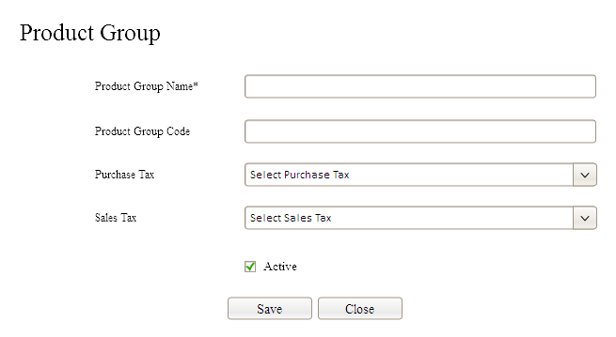**

* Must be check the corporate office is commodity maintained office or not .
* Visible purchase tax and sales tax on the basis of above checking.
* Listing entries must be restricted on the basis of numbers.
* There must be confirmation message before update if there is any change in the Sales or purchase tax.

### MAIN-CATEGORY SUB SYSTEM

**Feature**

Categorization of items is the major activity in the product managing division. Four level categorizationsare possible in the product management of this Application. This module will cover first level of categorization. This category should be selected while defining a product. Allow selecting Item Group also while defining item category.

**MAIN-CATEGORY SUB SYSTEM**

**MODIFYING MAIN CATEGORY**

**ADDING MAIN CATEGORY**

**SEARCH CATEGORY LEVEL**

**SEARCH ITEM GROUP**

**ACTIVATING / INACTIVATING MAIN CATEGORY**

**MAIN CATEGORY CANCELLATION**

* **AddingMain Category:** Prepare a list of main category and create the same in module.
* **Modifying Main Category:** There will be a provision for modifyingmain category by the authorized person. Same page will be used for defining all category levels. Main category can’t be changed to any other level if main category is selected for some other child category.
* **Search Category Type:** Category type (Main/Sub/Small) should be fetched from category-type list and updated to this module. This will also useful for filtering the categories for the selected level.
* **Search Item Group:**Allow searching the Item Groupand allocated toMain-Category.
* **Activating / Inactivating Main Category:** Authorized person could activate / inactivate Main Category. If it is inactivated, then the same will not be reflected in any other modules.
* **Main Category Cancellation:** Authorized person couldcancelMainCategory.Cancellation will be restricted if it is selected in some other modules or it is selected for some other child category.

### SUB-CATEGORY SUB SYSTEM

**Feature**

This is the second level of categorization. This category should also be selected while defining an item. Main category should also be selected for this sub-category. This is the flexible mechanism for maintaining multi-level categorization.

**SUB-CATEGORY SUB SYSTEM**

**ADDING SUB-CATEGORY**

**MODIFYING SUB-CATEGORY**

**SEARCH CATEGORY LEVEL**

**SEARCH MAIN CATEGORY**

**SUB-CATEGORY CANCELLATION**

**ACTIVATING / INACTIVATING SUB-CATEGORY**

* **AddingSub-Category:** Prepare a list of sub-category and create the same in module.
* **Modifying Sub-Category:** There will be a provision for modifyingsub-category by the authorized person. Same page will be used for defining all category levels. Sub-category cannot be changed to any other level if selected sub-category is selected for some other child category.
* **Search Category Level:** Category level should be fetched from category-level module and updated to this module. This will also useful for filtering the categories for the selected level.
* **Search Main Category:**Allow searching the Main Category and allocated to Sub-Category.
* **Activating / Inactivating Sub-Category:** Authorized person could activate / inactivate Sub-Category. If it is inactivated, then the same will not be reflected in any other modules.
* **Sub-Category Cancellation:** Authorized person couldcancelSub-Category.Cancellation will be restricted if it is selected in some other modules or it is selected for some other child category.

### SMALL CATEGORY SUB SYSTEM

**Feature**

This is the third level of categorization. This category should also be selected while defining an item. Sub-category should also be allocated for this Small-Category.

**SMALL-CATEGORY SUB SYSTEM**

**ADDING SMALL-CATEGORY**

**MODIFYING SMALL-CATEGORY**

**SEARCH CATEGORY LEVEL**

**SEARCH SUB-CATEGORY**

**SMALL-CATEGORY CANCELLATION**

**ACTIVATING / INACTIVATING SMALL-CATEGORY**

* **AddingSmall-Category:** Prepare a list of small-category and create the same in module.
* **Modifying Small-Category:** There will be a provision for modifyingsmall-category by the authorized person. Same page will be used for defining all category levels. Small-category cannot be changed to any other level if selected small-category is selected for some other child category.
* **Search Category Level:** Category level should be fetched from category-level module and updated to this module. This will also useful for filtering the categories in sub-category search field for the selected level.
* **Search Sub-Category:**Allow searching the Sub-Category and allocated to Small-Category.
* **Activating / Inactivating Small-Category:** Authorized person could activate / inactivate Small-Category. If it is inactivated, then the same will not be reflected in any other modules.
* **Small-Category Cancellation:** Authorized person couldcancelSmall-Category.Cancellation will be restricted if it is selected in some other modules or it is selected for some other child category.

### LEAST CATEGORY SUB SYSTEM

**Feature**

This is the last level of categorization. This category can also be selected while defining an item. Particular small-category should also allocate for this Least-Category.

**LEAST-CATEGORY SUB SYSTEM**

**ADDING LEAST-CATEGORY**

**MODIFYING LEAST-CATEGORY**

**SEARCH CATEGORY LEVEL**

**SEARCH SMALL-CATEGORY**

**LEAST-CATEGORY CANCELLATION**

**ACTIVATING / INACTIVATING LEAST-CATEGORY**

* **AddingLeast-Category:** Prepare a list of Least-category and create the same in the module.
* **Modifying Least-Category:** There will be a provision for modifyingLeast-category by the authorized person. Same page will be used for defining all category levels. Least-category can be changed to any other levels because it is the last level in category management structure.
* **Search Category Level:** Category level should be fetched from category-level module and updated to this module. This will also useful for filtering the categories in small-category search field for the selected level.
* **Search Small-Category:**Allow searching the Small-Category and allocated to Least-Category.
* **Activating / Inactivating Least-Category:** Authorized person could activate / inactivate Least-Category. If it is inactivated, then the same will not be reflected in any other modules.
* **Least-Category Cancellation:** Authorized person couldcancelLeast-Category.Cancellation will be restricted if it is selected in some other modules.

**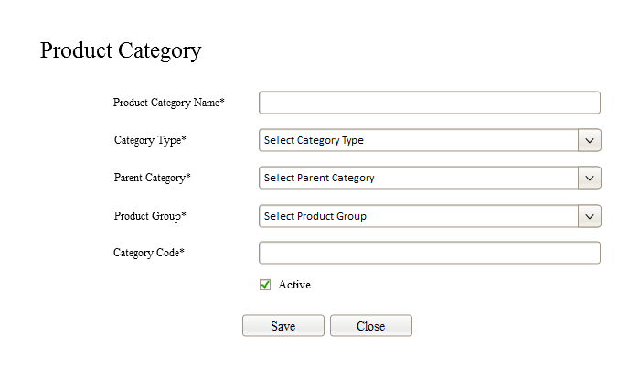**

* Must be check the corporate office is commodity maintained office or not .
* Visible category code on the basis of that.
* Listing entries must be restricted on the basis of numbers.
* Category code not compulsory

### PRODUCT BRAND MASTER SUB SYSTEM

**Feature**

This is the product brand definition module which will be selected in product master.

**PRODUCT BRAND SUB SYSTEM**

**MODIFYING PRODUCT BRAND**

**ADDING PRODUCT BRAND**

**ACTIVATING / INACTIVATING PRODUCT BRAND**

**PRODUCT BRAND CANCELLATION**

* **AddingProduct Brand:** Prepare a list of product brandsand create the same in the module.
* **Modifying Product Brand:** There will be a provision for modifyingproductbrandby the authorized person.
* **Activating / Inactivating Product Brand:** Authorized person could activate / inactivate Item group. If it is inactivated, then the same will not be reflected in any other modules.
* **Product Brand Cancellation:** Authorized person couldcancelProductBrand.Cancellation will be restricted if it is selected in some other modules.

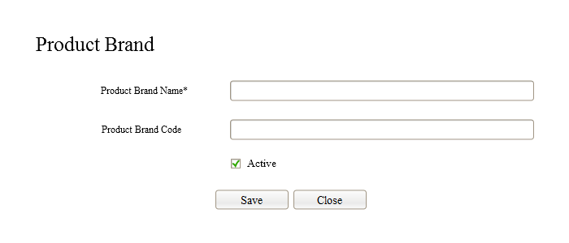

* Product brand name and product brand code must be unique.
* Must be check product brand code duplication through code before save.

### PRODUCT MASTER SUB SYSTEM

**Feature**

It is the important module in the inventory management. Administration team can feed product details through the module. Grouping and Categorization of items should also manage in the solution.

**Flow**

* Defining Items with Unique Item Name and Short Name.
* Item Code should be automatically generated or allow entering the same by user depends on the parameter specified in global parameter definition.
* Allow Cost Price Allocation on Item.
* There should be a field for Cost Price Linking from External Source.
* Provision for updating cost price updated user and date.
* While updating cost price, last cost price should be maintained as backup.
* Provision for importing .csv file with Product Information which will contain Product Code and Final Cost Price.
* Provision for selecting Tax where tax allocation should be managed with corporate global parameter. If it is the ‘Tax Enabled’ corporate office, then there should be an option for selecting tax. Otherwise this field should not be visible.
* In this solution, cost price will be updated in tally software by Accounts department. Accounts department will provide .csv file which contains final cost price of items. Authorized Personnel should import this information to Compzit.
* Allocating the items to Main Category, Sub Category, Small Category and Least Category
* There will be a Provision for Activating / Inactivating the Item

**PRODUCT MASTER SUB SYSTEM**

**MODIFYING ITEM MASTER**

**ADDING ITEM MASTER**

**SEARCH PRODUCT TYPE**

**SEARCH MAIN CATEGORY**

**ACTIVATING / INACTIVATING ITEM MASTER**

**SEARCH SMALL CATEGORY**

**SEARCH COUNTRY OF ORIGIN**

**SEARCH MULTIPLE UNITS**

**ITEM MASTER**

**CANCELLATION**

**SEARCH SUB CATEGORY**

**SEARCH LEAST CATEGORY**

**SEARCH ITEM GROUP**

**SEARCH DIVISION**

**SEARCH PRODUCT BRAND**

**COST PRICE ALLOCATION**

**SEARCH TAX MASTER**

* **Adding Item Master:** List out possible Items and create the same in Item Master module. The item can be 20AX SWT DP 1W PUSHSWT:735425, 240115V SHAVER SOCKETetc.
* **Modifying Item Master:** Generated Item Master can be modified by the Approved Person. Some information can’t be edited in item master, if it is used with some other modules.
* **Activating / Inactivating Item Master:** If Item Master is inactivated, then the same will not be reflected in any other modules.
* **Item Master Cancellation:** There will be a provision for cancelling Item Master by the authorized user. Cancellation will be restricted if it is selected in some other modules.
* **Search Item Type:** Allow searching the type from item type master and assigned to item master. This item type could be ‘Normal Product’ in the current solution. This type may be used for many aspects when product grows.
* **Search Item Group:** Allow searching the group from item group master and assigned to item master. This is the independent level of item categorization for easy identification and reporting. Eg: BUILDING MATERIALS / LEGRAND ELECTRICAL etc.
* **Search Item Main Category:** Allow searching the main category from category master with the type of ‘Main Category’ and assigned to item master. This is the top level of item categorization tree. This categorization will be varied depends on the retail sector.
* **Search Item Sub Category:** Allow searching the sub category under selected main category and assign sub category to item definition.This is the 2nd level of item categorization tree. This categorization will be varied depends on the retail sector.
* **Search Item Small Category:** Allow searching small category under selected sub category and assign small category to item definition.This is the 3rd level of item categorization tree. This categorization will be varied depends on the retail sector.
* **Search Item Least Category:** Allow searching the least category under selected small category and assign least category to item definition. This is the 4th level of item categorization tree. This categorization will be varied depends on the retail sector.
* **Search Country of Origin:** Allow searching Country of Origin and from List and allocate to Product.
* **Search Product Brand:** Allow searching Product Brand from List and allocate the same to Product.
* **Cost Price Allocation:** Cost Price of the product should be allocated.
* **Search Tax Master:** Allow searching the Tax and assigned to Product. First need to search the corporate office is a tax enabled corporate office or not. If yes give the provision for search and select the tax from tax master.Again check it is commodity maintained or not if yes then
* automatic fill the sales tax of selected item group ( if any ).
* Change the label caption of ‘Short Name’ to ‘Short/Print Name’.
* Remove the ‘PRODUCT TYPE’ from product master interface.
* Listing entries must be restricted on the basis of numbers.

**Change Request dated 29/03/2016**

* New field for Description to be included in the product master. This is the description about product. Purpose of this description is for Quotation. This field is not mandatory. If user updating this information in product master, then the same will be reflected in Quotation while selecting the Item. Maximum length for this field should be 4000.

**Change Request dated 29/03/2016**

**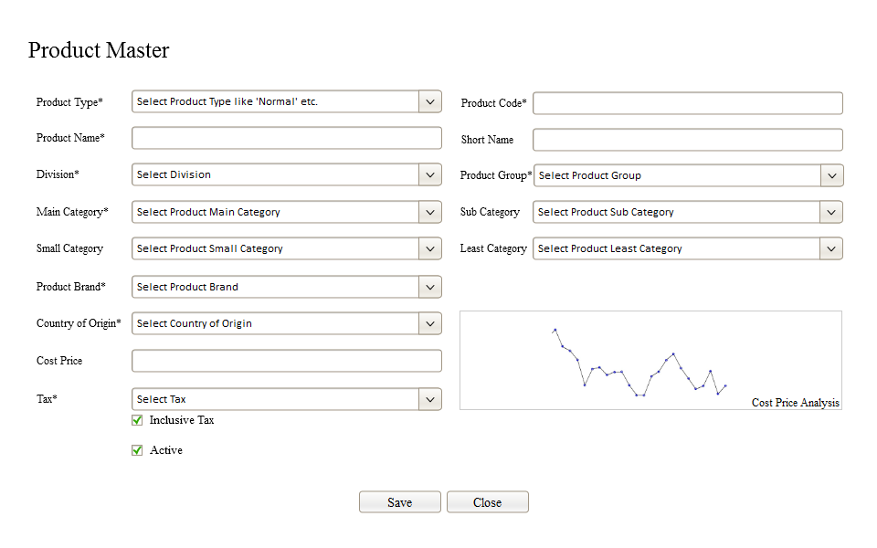**PRODUCT RATE UPDATION SUB SYSTEM

**Feature**

It is the tool that we provide for user to update the rate of products simultaneously on different seasons. User needs to upload a csv file to project.

**Flow**

* User needs to upload a csvfile, we analyze the first two columns of that file.
* First column must be product id and second column is product price.
* The interface will looks like,

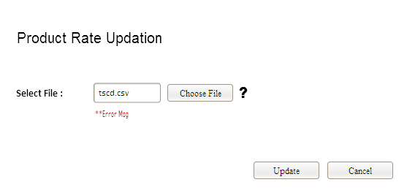

* On the time user choose csv file, we automatically process the csv file.
* Process means check the product id in database before execute.
* If is there any missing product id ( up normality ), then we fetch that row ( on the missing basis id ) and bind it in a new table.
* We show a interlink with the error message, that link redirect to a web page that shows the table contains missing product id.
* On the update button click, update the rate of products on the basis of product id. ( simultaneous process ).
* There is a question mark on the right side of the button in picture, it is indication that shows rules about to fetch a csv file. ( show through a textbox popup … like that).
* If there are lot of columns in that csv file then we consider first two columns only.
* After each product rate update , check the change through a trigger and update the details to the rate update table.
* The table in the database stores rate update have two ways data entry, one from product master and other from this module.
* Heading in the screen ‘PRODUCT RATE UPDATION’ changes to ‘PRODUCT RATE AMENDMENT’.

### CUSTOMER MANAGEMENT

### CUSTOMER GROUP SUB SYSTEM

**Feature**

Customer management is another module for defining customers in the solution. These customers are to be selected while entering the sales/quotation lead. We can add customers from enquiry new lead, but that customers will not go to the customer master directly, it will go to customer parking master initially. If quotation is finalized then the customer will directly go to customer master as company’s permanent customer.

Customer type can also maintain in this module. Customer type can be end customer / contractor / sub-contractor.

Total outstanding amount for this customer will also reflected while entering credit bills for that customer.

This is the categorization of customers for quick identification of various business categories.

**Flow**

* Customer Group should not be duplicated.
* List the groups and updated to this module.

**CUSTOMER GROUP SUB SYSTEM**

**MODIFYING CUSTOMER GROUP**

**ADDING CUSTOMER GROUP**

**CANCELLATION OF CUSTOMER GROUP**

**ACTIVATING / INACTIVATING CUSTOMER GROUP**

* **Adding Customer Group:** List out the possible customer groups and create each groupin module. Customer group can add only by approved person.
* **Modifying Customer Group:** Generated Customer Group could be modified by the Approved Person.
* **Activating / Inactivating Customer Group:** Authorized Person could activate / inactivate Customer Group. If it is inactivated, then the same will not be reflected in any other modules.
* **Cancellation of Customer Group:** There will be a provision for cancelling the customer group by the authorized user. Cancellation will be restricted if it is selected in some other modules.

**Entry screen for customer group sub system looks like**

**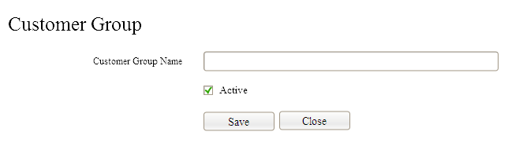**

### CUSTOMER TYPE SUB SYSTEM

**Feature**

It is the provision for creating different customer type, use full for create a customer. Customer type used to differentiate customers apart from customer group. Here no interface for adding customer type sub system, directly inserting customer type to the database table. Mainly customer types are Normal customer / contractor / sub-contractor.

### CUSTOMER SUB SYSTEM

**Feature**

It is the provision for creating a customer in MOS App and allow selecting these customerswhile preparing the sales bill and return bill. Outstanding payment from customer will also tracked in the software and future activities such as Payment Alert, Wishes etc. can be managed through MOS App.

**Flow**

* Identify customers and adding the details to this module.
* There will be a direct link between transaction tables and customer master.
* New customer can also be created from the link identified in transaction modules such as sales, sales return etc.
* Authorized personnel can cancel the customer with proper reason.

#### CUSTOMER CONTACT DETAILS

**Feature**

Customer contact information could be fetched from various sections of MOS. Sales department could generate mailing list from this contact information very easily. It is also useful for linking the customer while generating email during various occasions. There should be a provision for generating multiple customers in customer contact module. This should be directly linked with the customer master.

Here is the provision for creating customers in this module we collect essential details from users that related to customers.

**Flow**

* There should be a provision for attaching contact information while creating customer.
* Provision for adding multiple contact information from customer master itself through the friendly interface.
* Customer group and customer type selection needs for each customer.

**CUSTOMER SUB SYSTEM**

**ADDING CUSTOMER**

**MODIFYING CUSTOMER**

**STATE SEARCH**

**COUNTRY SEARCH**

**CUSTOMER GROUP SEARCH**

**CUSTOMER TYPE SEARCH**

**CUSTOMER CANCELLATION**

**ACTIVATING / INACTIVATING CUSTOMER**

**ADDING CUSTOMER CONTACT INFORMATION**

**MODIFYING CUSTOMER CONTACT INFORMATION**

**CANCELLATION OF CUSTOMER CONTACT INFORMATION**

**ACTIVATING / INACTIVATING CUSTOMER CONTACT INFORMATION**

* **Adding Customer:** List out possible customers and create each customer in the module. This customer should be common for organization and the same can be selected from corporate office also. User with organization control can create new customer from the MOS App.
* **Modifying Customer:** Generated Customer could be modified by the Approved Person.
* **Country Search:** Country should be fetched from country master and updated to this module. This will also useful for filtering the country-wise customers and generating appropriate customer report as per this country selection.
* **State Search:** State should be fetched from state master after filtering country master and updated to this module. This will also useful for filtering the state-wise customers and generating appropriate customer report as per this state selection.
* **Customer Group Search:** Customer groups will be fetching from customer group master table and each customer comes under of any of a customer group.
* **Customer Type Search:** Customer Type will be fetch from customer Type master table and each customer comes under of any of a customer Type.
* **Activating / Inactivating Customer:** Authorized Person could activate / inactivate Customer. If it is inactivated, then the same will not be reflected in any other modules.
* **Cancellation of Customer:** There will be a provision for cancelling the customer by the authorized user. Cancellation will be restricted if it is selected in some other modules.
* **Adding Customer Contact Information:** List out the possible customer contact information and create the same in customer master module. These contact information should be used for Printing Sales Bill etc.
* **Modifying Customer Contact Information:** Generated Customer contact information could be modified by the Approved Person.
* **Activating / Inactivating Customer Contact Information:** Authorized Person could activate / inactivate contact information while editing the Vendor master. If it is inactivated, then the same will not be reflected in any other modules.
* **Cancellation of Customer Contact Information:** There will be a provision for cancelling the customer contact information by the authorized user. Cancellation will be restricted if it is selected in some other modules.

Add Screen looks like,

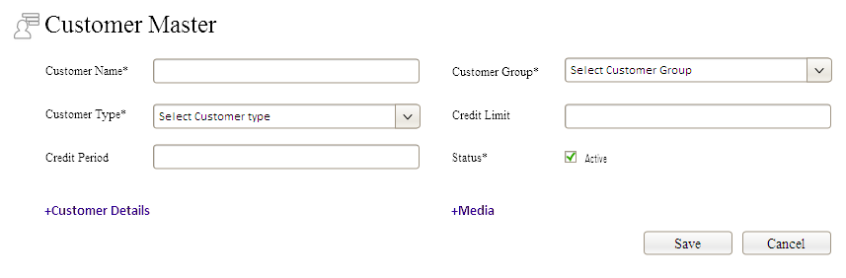

* In this form customer name , customer group, customer type are mandatory in this form.
* There is two links one for more customer details and other for media details ( media means social media details , it’s a common method will use in different modules ).
* After clicking customer details link then customer details entry will show,

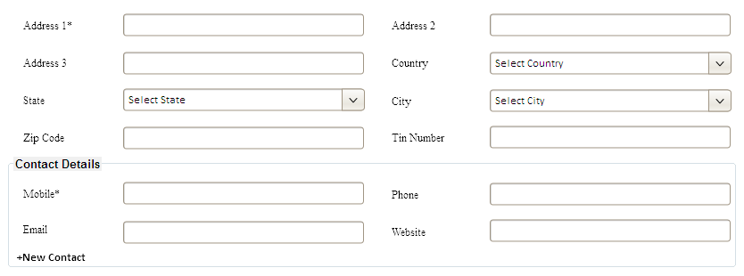

* This is the screen for adding customer details, in this Address 1 and Mobile details are mandatory.
* There is small separation for contact details.
* Tin Number only visible for Tax enabled corporate offices.
* Need to add customer payment terms.
* There is a provision for adding multiple contacts against each customers,after clicking new contact then

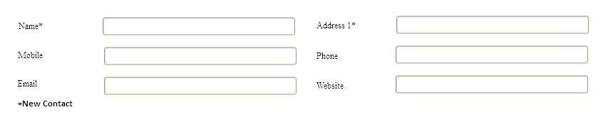

* Here mandatory fields are name and address 1 .
* User can create multiple contacts like this, this will go to separate table.
* Two buttons, Save and Cancel.
* Starting customer master with customer master list, looks like

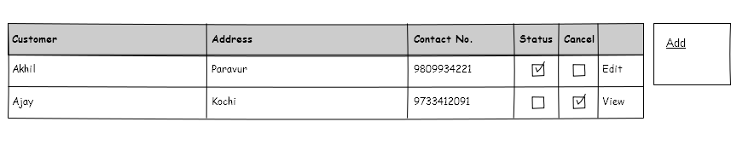

* After clicking add button it goes to customer master page.

ENQUIRY\LEAD MANAGEMENT

**Feature**

This is the major module in our project, process is making a enquiry based on requirement. User let company to know their requirements

through mail, phone, fax etc. in our system mail requirements we collect through project mail sub system. So we give direct link for generate enquiry through mail. If requirement came from any other media such as phone, fax etc then user must generate enquiry from separately and give details. If enquiry generate from mail, then source in enquiry form default fill as ‘Mail’ and description in enquiry form default fill with mail content. Provide provision for select source in enquiry form, sources are mail, phone, fax etc. must show user name of the current user on the left top of the screen also show enquiry created date and time. Another one is customer details in enquiry form. If the customer is already in customer master then provision for auto fill customer details in the database to corresponding columns. Then provision for enter description on customer basis and user ( may be sales executive basis ).

There some more activities that based on enquiry module. They are quotation, follow up, mail, task.

These activities will go on the basis of enquiries. We can generate multiple follow up, mail, task against one enquiry.

**Flow**

In this we classified enquiry\lead in two ways, one for insert and second for update, we do separate pages for these two. At the time of insertion we go to a page that contain enquiry/Lead details only, at the time of update redirect to a new page that have enquiry/lead basic details and all other subsidiary module details they are quotation, follow up, mail, task. This page have the provision for manually change the status of lead – Win / Loss.

Total flow was

**LEAD/ENQUIRY SUBSYSTEM**

**OTHER DEATILS**

**MEDIA**

**DETAILS**

**CUSTOMER DETAILS**

**LEAD SOURCE SEARCH**

**SAVING LEAD**

**CHANGE/UPDATING LEAD**

**PARTIALLY CLOSE LEAD**

**QUOTATION/MAIL/TASK/FOLLOW UP PREPARATION AGAINST LEAD.**

**STATUS CHANGE TO WIN/LOSS**

### 

### Here shows the flow of a lead. From

* Here shows the flow of a Lead generation to end.
* **Lead Source search:** selecting the source for the lead , like phone/fax/web…
* **Customer Details :** give customer based all details to the Lead. These customer based details will save on lead table. After quotation confirmation this customer details will go to the customer master table so made that customer is a permanent customer.
* **Media Details :**store media details about the customer, media related heads will store in database by developing team.
* **Other Details :**other lead related details will collect from user and save the lead.
* **Save Lead :**save the lead as first time, after that we can start subsidiary actions from that lead.
* **Change/Update Lead :**we can change the details in the lead and update the Lead.
* **PartiallyCancel :**we can change the status of the lead to temporary cancel, its for partially close the lead.
* **Quotation/Mail/Task/Follow up :**these are the after activities of a lead, these activities we can done only after lead is saved.
* **Status Change To WIN\LOSE :**this is the final status change of a lead. This status change only applicable of after quotation approval/rejection.

Lead management have 2 entry screens , one for save/edit Lead and other for do the sub works of a lead.

Page for lead generation,

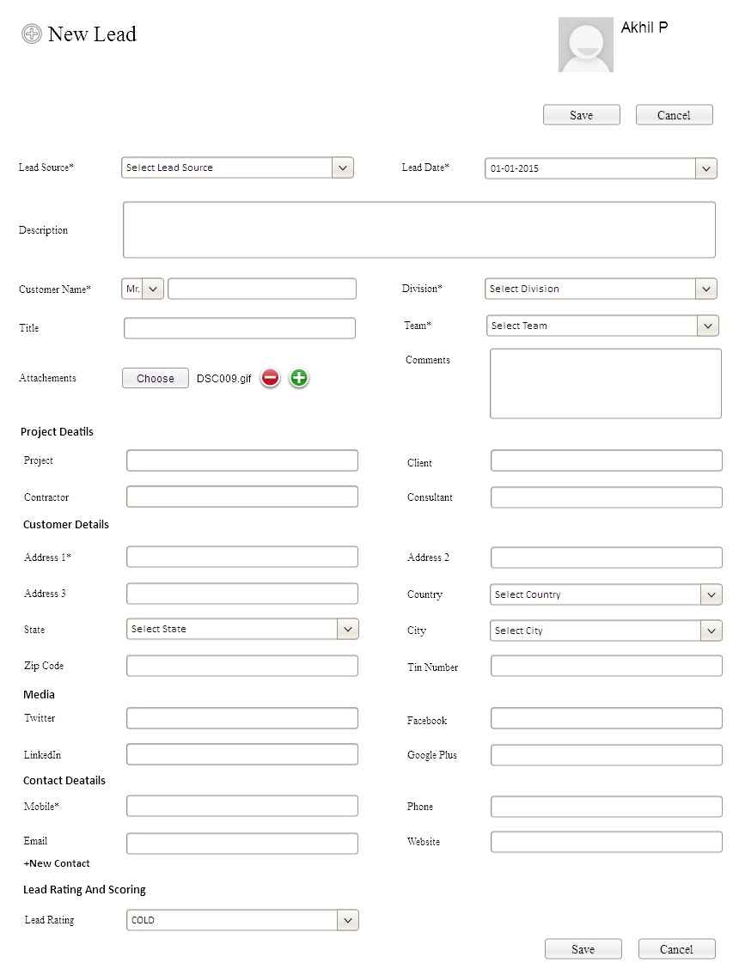

* User included on multiple divisions then user must select division from drop down list.
* If user have only one division then the corresponding division default fill in drop down list.
* User can browse multiple attachment against a enquiry entry.
* User can set the lead rating such as ‘cold, hot, warm..’ we can sort out the leads on the basis of these lead.
* It is the page for new lead entering.
* After new lead save, a reply mail must send to the customer if lead source is mail. This goes from division enquiry email id.
* If lead generation from email screen then lead source default fill as Email
* For creating lead generation user must have the provision for creating Lead   
  ( as user role ).
* Lead generation must be a menu as well as there is a link in enquiry email.
* If a lead generate and save then its status changed to ‘NEW’.
* User can manually change the status of the lead to ‘partially close’ if it have no quotation approval.
* If a lead have quotation approval then user can only change its status to ‘WIN’ or ‘LOSE’.
* User can not change the status of the Lead manually apart from above.
* In lead generation we create a Enquiry ID ( unique and mandatory ) , this enquiry id prefixed with division code of particular division.
* If any follow-up/task/mail generated from a enquiry then status of that particular enquiry will be ‘OPENED’.
* Final Status of an enquiry should be maintained in the Master table of Enquiry.
* There should be a separate table for tracking the status as like we done for 'Organization Status Tracking'
* Enquiry master can be edited any time till Closing the Enquiry. ( closing enquiry will be done as a status change, it can done after WIN/LOSE status change.)
* There is a another provision for partially close if no quotation set against the enquiry.
* While transferring, division for that enquiry should be linked while selecting corresponding sales person.
* Lead date can’t be change after any work done on this enquiry.
* Allow multiple drafts.
* You can’t do any sub activities on the draft enquiry before save.
* There is a special notation on drafts when enquiry listing in dash board.
* Provision for set comments against the lead.
* There is a space for add project details, project name, client, contractor, consultant…( not mandatory fields ).
* There is a provision for hide the project details tab for other clients.

**Lead Rating Sub System**

* Basically lead ratings are Hot, Cold, Warm….etc.
* On the first time developers insert data in the table, and select lead rate in Lead form is mandatory .
* On future we will do UI for lead rate, that time we need a default lead rate.
* we add default lead rate in table at the time of corporate global adding through trigger.
* Add a field in lead rate table for identify it is default or not. We add the value in default field when we enter the default row through trigger. User entered masters can’t add value to this field.
* Sequence use for this master entry will start from 2. Corporate office id+ sequence will be the primary key.
* When we add first row through trigger, Corporate office id+ 1 .
* The developer enter first row cant available for user in UI in any purpose.

The Lead view page looks like,

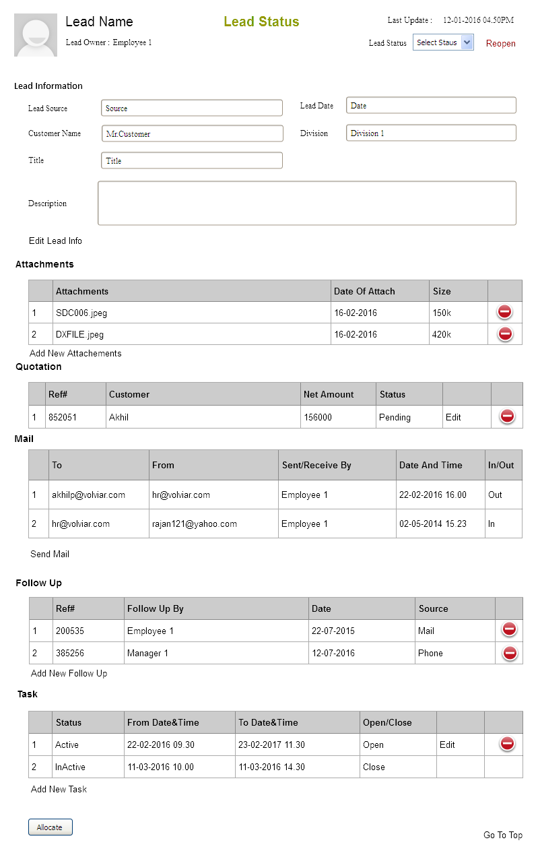

* In this page no editing activity .
* If user needs to edit lead information then click edit lead info and it will direct lead adding page.
* Add/edit quotation, follow up, Task, Attachment will lead to model forms.
* There should be a transaction tracking table for track all transaction that related to a Lead, but Lead master table only stores the final status.
* Customer details in the lead not going to parking table, it stores the lead table itself. if quotation approved against that lead then these customer details will go to the customer master table as a customer ( if the customer not a corporate office’s customer yet. ).
* Provision for set attachments on enquiry ( maybe multiple attachments ).
* There should be a checking whether file name size exceeded or not. Otherwise an error will be occurred.Filename size is very important, so this should be blocked if the file name size exceeded than allowed.
* Only one quotation can generate against one enquiry.
* Provision for set multiple follow-up, multiple enquiry details, multiple tasks against a enquiry.
* There is a provision for set manually delivered status against a Lead after its quotation get approved and it is not delivered through mail.
* If user needs to reopen the quotation then delivered status gone.
* If user need to give up a enquiry in between the change the status of the delivery as ‘Partially Close’.
* There is also a provision for transfer a Lead from one executive to another. These types of all works related a lead must be track in database.
* For this transfer there is a button ‘Allocate’, after button click must select employee on same division.
* There is a status selection in above the screen, available status are WIN/LOSS.
* All status are meaningful status , if user/executive needs to c lose the lead in between then he mark the status as Loss.
* Win/Loss status checking marked at the end of a Lead. ( set a field in the configuration table that allow corporate office to decide mark Win Status Before Quotation approval or not ).
* If after quotation approval a lead may go to the Lose then user can mark lose against that Lead.
* If user marked Loss, then

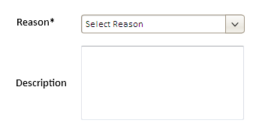

* User can’t change the Lead Status ( WIN/LOSE ) when the lead’s current status is ‘Quotation Approval Pending’ .
* This is the screen for marking loss Reason, select reason from reason master table, its mandatory, then user can a description too.
* After status change there no edit or update the Lead, but if needed then click ‘Reopen’ Link ( only the user with provision ), then can edit the lead as usual.
* Here is a provision for send mail directly to the customer mail id, if in Lead information there is no customer email id, then there is no facility for creating mail.
* mail goes from division mail id to lead mail id , mail subject will create our own with division code and mail subject will entered by user.
* Mail can’t be edited or deleted from list, only user can create new mails.
* In task only show their own tasks.
* Only inserted user(allocated user) can edit or update the entire lead.
* Division head only the permission for edit the quotation after the quotation confirm.
* Needs to change the status set ‘WIN/LOSS/PARTIALLY CLOSE’ to ‘SUCCESS/FAIL’ or something else.
* If any case a lost lead will reopen then immediate clear the lose reason and description when change the status.

**Mail**

* User can send direct mail to the lead customer. (if customer give their Email Address).
* User can only give the mail content, subject directly give by the developing team.
* Subject will create using the enquiry id.
* Mail send from division’s enquiry mail id.
* Can send mail with attachment ( one or more ).
* It is all happen if customer provide mail address.
* In this table have both mails ( means in and out) , out mails/receive mails attached with this mail then it will include the table.
* After click ‘Send Mail’ Link then the screen looks like,

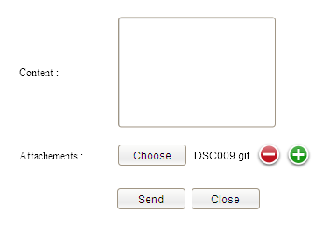

* User can enter content for the mail.
* May attach one or more files.
* There is no provision for edit/remove mails from the table.
* There is a modification on mail sending, in mail listing there need a additional column for view that mail named as ‘VIEW’.
* One more column for out mails name as ‘SET AS NEW’, after the click the model form fill the details and ready to send as a new mail.
* If any mail in draft , ‘SET AS NEW’ name changed as ‘RESEND’, after click resend the mail.

**Task**

Task is the process of define a particular activity on the basis of particular lead on a particular time.

* Here we define tasks on the basis of Leads.
* Anyone can create tasks on the basis of user roll privilege.
* User can see his own tasks.
* In lead details page task table contain login user tasks only.
* Can edit/delete tasks before lead’s status change.
* Tasks will also list on the dash board too.
* User can close the task any time .
* Task form looks like,

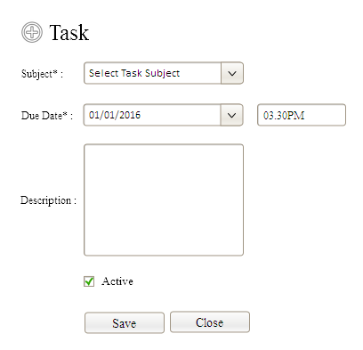

* In this we can select subject from a drop down list, drop down list load according to the database subject table.
* Developer can insert data into subject table.
* Here due date and time are mandatory fields.
* Description field is option.
* Can enable and disable ( Active checkbox ) the task
* Only enable task will work.
* Working of task is , on the time of Due date and time.it send a mail to the user who assign task against the lead and color of the row in the table will be changed.
* If user don’t have a email then there is no mail alert.
* After the task time it will present in the task table with a new color until it get closed.( only in database );
* User can close the task directly from the table.
* User can set time limit in the configuration table for the mail sending to the user .
* Task edit and save will be act as ‘close current task and create new task’.

**Follow Up**

Follow up is the process of take action against a lead, that may through different sources. ( mail, phone, fax)

* User can add lot of follow ups against a lead.
* Cancel the follow up through table.
* A user can see the total follow ups of their team.
* The add screen of follow up looks like,

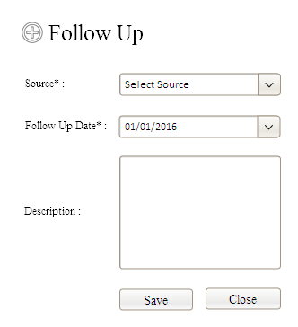

* Here select follow up sources from a master table, the data insert in the master table by development team.
* Choose date of follow up event.
* Add description to it.
* User can provision for edit and cancel all follow up that done by same team.
* Source and follow up date are mandatory.
* There is a provision for follow up edit. ( this must be decided through corporate global value, id edit is enable then show edit column in follow up table too ).

DASH BOARD DESIGNING

When a user login to the compzit after landing page , it shows dash board, in dash board we can show lot of use full things ,The dash board looks like,

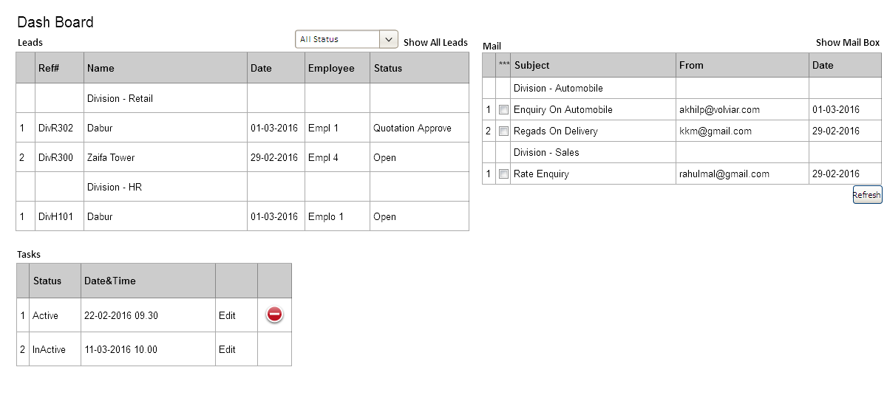

* Dash board we list out Leads, Mail, Tasks.

Leads

* Here we list out Leads that not yet closed – closed means WIN/LOSS marking or Partially Close Marking.
* A user can view his leads and his under employees lead.
* Customer name will show as the name of the lead in the table.
* There is a inter link on the name of the lead in the table , it redirects the ‘lead view page’ for view details about lead.
* Division based grouping on leads if the user include multiple divisions.
* Lead date will be visible in the place of date in table.
* Common status will be visible in the place of status in table.
* There is a flag for multiple rating against each lead – Hot, Warm, Cold.
* If the lead status is quotation related status then, there is a link on that status and this link navigate to current quotation page.
* There is a list on the top of the table that contains the status against the lead except WIN/CLOSE.
* Default ( at the time of Load ) it selected all status , so show all status leads .
* Then user select any status from the list then without any action show the leads against that status only.
* Order the leads on the basis of date and grouped by divisions.
* There is a label on the top of the table, that redirect to the page it shows all the leads on the basis of filter.
* The page looks like,

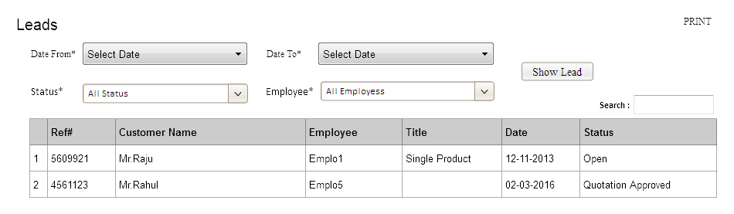

* At the time of load, from date and to date are current date ,status will be all status and employee will be all employee.
* Here also interlink on lead ref number and it redirects to the lead view page.
* Here shows all the lead status includes WIN and LOSS.

Tasks

* List out only their own tasks.
* Show only open tasks, ( means the tasks that not yet closed ).
* Link for edit on every task, this link will navigate to the current lead that include the task.
* Provision for cancel/remove task in table itself.
* Dash board table will reset on every time of page refresh.
* Color change for all tasks that exceeds time limit.

Mail

* Here shows the unread mail that comes under the division enquiry email id.
* If login user comes under multiple divisions the emails will be grouped on the basis of division.
* In table we show subject, sender email id, date.
* Allocation, is the process of assigning the mail/Work to other employee.
* User can allocate mail to anyone in his division.
* Show a special flag for allocated mails.
* User can make a lead against all mails.
* User can reject allocate mails to assigned ones.
* Use special flag for indicating reject mails.
* There is a refresh button for mails, to refresh mails.
* Mail list needs automatic refresh too. ( frequently )

MAIL SUB SYSTEM

Mail subsystem is the one of the fundamental system of customer relational management, it is a part of enquiry. In our system we use mail as a major tool for communicate with customers.

In common case, lot of enquiries comes through mails by customers (out source). These mails can managed by authorized persons ( the employee have user role provision for view out source mails ).

They can read all mails comes from customers, according to one mail, user can transfer that to trash ( it somewhat like removing ) or allocate to any other employee on his division ( assign a mail ), or attach that mail to any lead ( if it related any lead in the office ).

A user needs activity role permission for perform all these actions.

All mails will fed in mail box after any activity , but color change or put flag to indicate these changes.

If a mail comes from a customer but that is a reply mail for a enquiry mail that generated by a executive in that division then that reply mail will directly goes to the executive mail box. That user can reject that mail if needed, then the reject mail will fed into the common division mail box.

All allocated mail have the provision for reject by the employee to who allocate that mail. If a mail is allocated to someone , then all action on that mail denied for all users except that allocated one.

* After select mail from dash board table then it goes to the mail box
* Mail box will looks like,

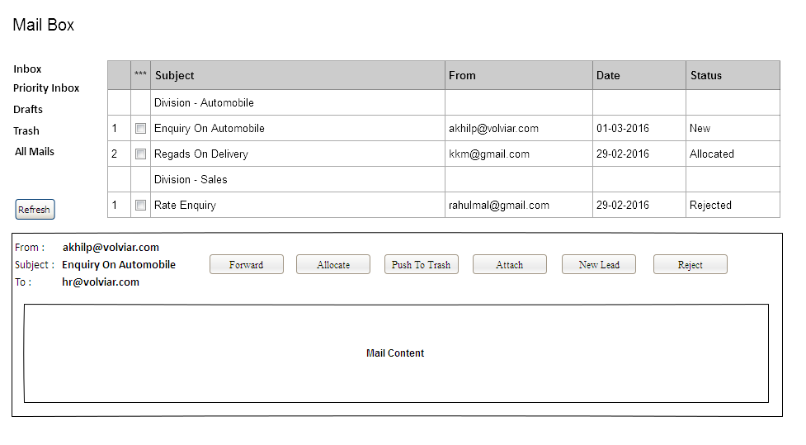

* In mail box visible mails listed on the basis of employee’s provision.
* If a employee have the provision for see out source mails then mail box filled with customers mails+ allocated mails.
* If a user don’t have the permission for view customers mails, then the mail box contain only the allocated mails.
* Here some classification on mail, as usual in normal mail clients , they are Inbox, Drafts, Trash….etc.
* There is a refresh button for refresh the mails in the mail box.
* Need automatic refresh for mail box also ( automatic refresh time must be same in everywhere in the project ).
* There is a provision for make reply against the mail.
* Nothing happens if the mail have a reply. It is have the same read status.
* In **Inbox** show all the received mails that not yet removed to trash. There is status for indicate mail current position.
* In **Trash**show the mails that pushed to trash before.
* In **Priority Inbox**show the mails that marked as ‘star’ in mail box or dash board list.
* In **All Mails**show all the mails that the user can view ( as per provision ).
* **A user can view the mails as per user role provision, division and user and team wise listing.**
* Next one is various action against a mail, on each mail there is a description side on the bottom side of the page in mail box. In that some action buttons they are allocate, push to trash, attach and reject.
* User need the provision for each action to do the action on that mail.
* Before visible the action button check the activity role as per the user.
* **Forward**
* If user needs forward the mail to any other section of multiple sections then click to forward and the screen looks like,

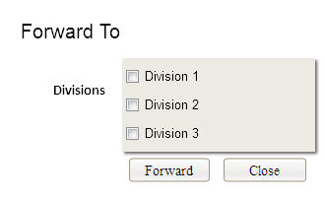

* After forward the mail, it remains active and readable in parent mail box.
* These mail will go to the forward division’s mail box.
* **Allocate**
* Allocate a mail to other one means assign a work to other. If a user have the provision for mail allocation then he can allocate a mail to anyone in same division/s.

**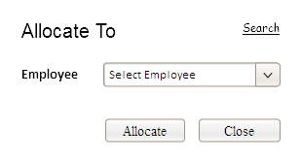**

* In drop down employees will listed as per division base if user have multiple divisions.
* In drop down list, list employee with employee code or employee icon …
* In case, if a mail allocation is on the basis of a lead, then user needs to find the employee on the basis of the particular lead. So need to redirect to another model form for that click the search link and that form looks like,

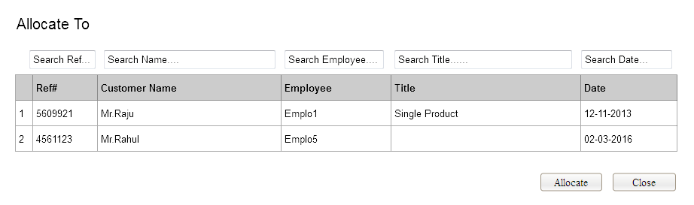

* In this allocation form, provision for search every field, that shown in picture.
* User select any row ( any lead ) and assign allocate then the current mail go to the current user’s mail box.
* **Push To trash**
* If a user have the provision for remove the mails to trash, then simply pass the mail to trash.
* There must be a reverse action for retake the mails from trash.
* **Attach**
* Attach the mail means attaching the mail to the existing Lead, if the user have provision for attach the mail then this action is enable.
* In attach drop down list, list leads with lead id or code etc.
* After attachment the mail will go to the user’s mail box that the lead generated/current privilege on that Lead.
* There must be a reverse action for these attachment, user have the provision for remove the attached mail to their parent inbox.
* Removed mails must get unread status as well as removed status.

**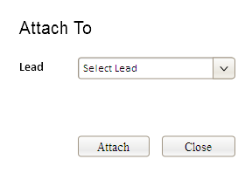**

* **New Lead**
* If the user have the provision for create new lead then click on new lead link it will redirect lead create page and content of the lead automatically fill with mail content. Lead Source will be automatically selected as Mail.
* **Reject**
* Reject action only allow for the allocated mail, after rejection it will go to user’s dash board who allocate the mail.
* If a mail ‘rejected’ then the mail gets unread status as well as reject status.

### QUOTATION

A quotation allows a prospective buyer to see what costs would be involved for the work they would like to have done. Here quotation is a important role in our system. Quotation preparation, quotation approval, quotation reopened are the main process against the quotation.Basically a quotation generate only on the basis of a lead. Quotation generation and quotation approval and quotation reopened are different activity roles. Only the authorized employees can do these works.

There is a separate page for quotation ( because it something important ). There is a direct link to that page from lead page or direct link from lead table in the dash board. Quotation preparation can do after generate the lead, it can save multiple times, when it get confirm then it goes to approval for the authorized person. After confirm approval authority can return the quotation or approve the quotation. After approve if authorized person can reopen the quotation and again confirm and approve.

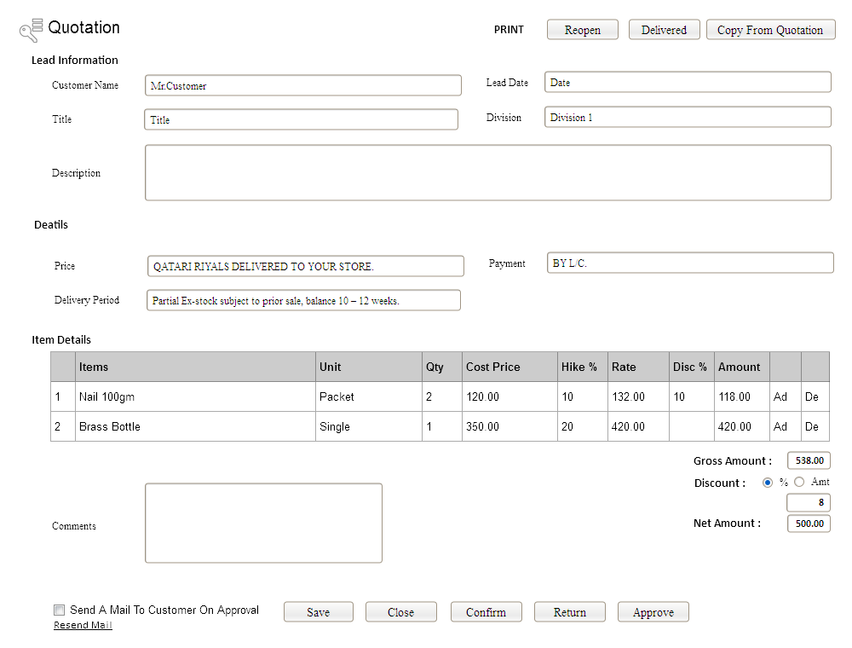

* This is the quotation page for add, edit, view.
* From lead view page , click on add quotation then redirect to this page.
* In dash board lead table , any lead have quotation based status then it also redirect to quotation page.
* In quotation page, top side shows some information about the parent lead of the quotation.
* No editing on the lead info from quotation page.
* User can edit items in item details , there is a selection of units against the items but it does not affect any other places.
* Here shows cost price against a item it fetches from product master .
* There is a hike % against each item , according to the hike % the rate is changed. Rate=cost price+ cost price\*hike %.
* If user needs to reduce the rate below the cost price then user can edit the rate directly in rate column. Automatically hike % calculated and show in hike % column ( if hike % is negative /below zero then the hike % column must be empty.
* Color change for the item row in quotation if Increase/Decrease the rate. ( both color for both rates ).
* Then another provision for give discount percentage against the items we can calculate the final amount after reducing the discount.
* Amount = (rate\*qty)- (rate\*qty)\*disc % / 100.
* Below shows the sum of total amount of all items, that is gross amount. Then another provision for give discount against the net amount ( both amount and percentage ).
* Bill wise discount text box must be hide if user did not give discount or user did not check any radio buttons.
* Net Amount = Gross Amount – Gross Amount\*Discount%/100.
* If the corporate office is a tax enabled office then ‘Tax Name’, ’Tax Percentage’ will be shown with the items in table.
* User can add quotation and save , but when quotation confirmed then only it goes for approve to a authorized one.
* If a executive save the quotation and confirmed it then this quotation will see in division manager lead box as quotation approval pending status.
* There is no one can edit other than entered user before confirm.
* Division manager can edit before approval.
* After confirm user can do nothing on it.
* If needed division manager can return instead of approval if any problem is there.
* After return entered user can edit and save, again user needs to confirm the quotation to go for another approval.
* There is a check box for send mails on customers on the time of approval, if check box checked and user have email id then send email to customer.
* Another link here for resend mail, it only enable after approval another condition is it visible only when user did not check the mail check box earlier.
* Whenever system send a mail to customer, the mail have the pdf file of quotation this will automatically done by the system.
* There is a button on top of the screen it for manually delivered , that enable only after quotation approval and user didn’t check mail check box and did not apply resend mail link.
* Quotation approval not a separate process, it done through quotation page by authorized user.
* In quotation print, show a alert disclaimer if the quotation not yet approved.
* There is a space for give comments against the quotation, comments can give executives as well as the approval authority.
* Quotation editing on the time of approval must be on the basis of User role.
* In quotation item listing on the basis of division only. If a user included lot of divisions then he can choose items from all the divisions. It is decided through the corporate global value.
* In this there is a button ‘Copy From Quotation’ , if user needs to create a quotation on the way of any existing quotation then click and fill that button.

**Change Request dated 29/03/2016**

* There should be a provision for entering description for each item. This field is not mandatory. Maximum length for this field should be 4000. This description should be selected from product master and allow amending in Quotation.

Purpose of Description Field: In some situation, BOQ for the project may not be selected from item list as the number of items in BOQ is more. User will select project name as item and will enter description for selected item. BOQ for that project will be attached for that item as PDF / Document / Excel etc. We cannot predict the file type. It may be depends on the project and other circumstances.

* Provision for attaching multiple files for quotation as like file attaching in Lead.

**Change Request dated 29/03/2016**

**Summarized Final Points**

* A Lead generated user (Active User) can only Edit/Add any in that Lead.
* Team leader can only view the details about the lead.
* Team leader have only the power for allocate the lead to other employee.
* Custom management on text ( mail, contents ).
* Checking the maximum size from configuration table for all image related places.
* Designing the user role arrangements( for allocate ).
* Lead allocation to next user must be a activity role.

**Total Status For Lead**

* New
* Open
* Quotation Prepared
* Quotation Approval Pending
* Quotation Approved
* Quotation Reopened
* Quotation Delivered
* Success/Lost.
* Need to track all activity about a lead on status to a status tracking table.

MODULE HEADING GENERALIZATION SUB SYSTEM

We use a method for generalization the module heading names especially that related to Lead. Maintain a table that contains the module names that separate for each corporate office. Now need a trigger that works after corporate office entry. In future we can do a interface for this.

MAIL CONSOLE SUB SYSTEM

This is mail console ( mail client ) settings. User can add email address , password, mail protocol, server and port based on the email address. Here there is no direct link to the division or employee etc…

* Email address must be unique.
* All fields are mandatory.
* Developer create a table for mail protocol in database. Initially we only give the POP3 protocol , there are 3 protocols – POP3, IMAP, SMTP.
* Will give a menu for this module.
* This will save to a separate table.
* Mail console directly took the mails from this table at the time of refresh and all.
* But we check all mails to the division table mail address, if there is no match then we will neglect the mail address. ( at mail console working for fetching mails ).

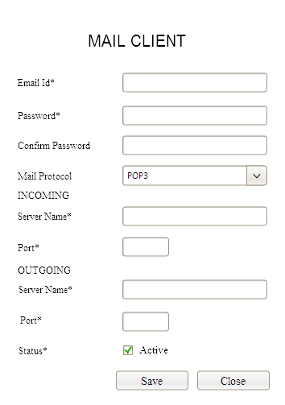

MUST ADD A CHECK BOX FOR HAVE THE SECURITY LAYER OR NOT IN THE INTERFACE.

**IMPORTANT DATABASE NOTES ABOUT MAIL CONSOLE**

* Mail box table needs a filed for storing lead id.
* We remove the trash mails as well as non used mails ( don’t have a lead link ) to a trash table on a particular time limit ( developer designed ).
* Set a time limit on the general configuration table for delete the pop3 messages from the server.
* Keep the unique id to the mail box table for identify the pop3 messages.
* There have another trash table for the mails in the database for deleted mails by application.
* Mail attachment table needs separate field for file name.
* Needs to design a table store bugs against the mail system.

# CONCLUSION

# INTELLECTUAL PROPERTY RIGHTS AND CONFIDENTIALITY ISSUES

Volviar intends to fully protect and preserve AL-BALAGH TRADING & CONTRACTING CO. WLL’s intellectual property rights. Further, privacy and confidentiality of its data are treated with utmost importance. Every employee of Volviar is bound by a non-disclosure agreement to protect the intellectual property of Volviar and any of its customers.

# ACCEPTANCE ACCORD

This Proposal is agreed to and acknowledged by:

|  |  |  |
| --- | --- | --- |
|  | **AL-BALAGH TRADING &CONTRACTING CO. WLL** | **VOLVIAR TECHNOLOGIES** |
| **Name** |  |  |
| **Designation** |  |  |
| **Signature& Date** |  |  |