**DESIGN & DEVELOPMENT**

**OF**

**AUTO WORKSHOP MANAGEMENT SOLUTION (AWMS)**

**SYSTEM ANALYSIS AND DESIGN**

DOCUMENT NUMBER: **VABG1/PRCT9/SAD/001**

C:\Downloads\01.png

**AKHIL P**

**01/09/2016**

**Release 1.0**

**Acceptance and Release Notice**

This is a managed document. All copies of this document preceding this release are obsolete and shall be destroyed. This document has not been released for use until authorized by the Project Manager or Business Analyst.

This is the Client Requirement Study Document Release 1.0

**Approved:** ........................................................................... Date: ....../......../........  
 Project Manager

**Authorized:** ......................................................................... Date: ......../........./........  
 Business Analyst

**Document History**

|  |  |  |
| --- | --- | --- |
| Release Number | Date | Reason for Release |
| 1 | 17/09/2016 | Initial Phase of WMS for review |
| 2 | 23/09/2016 | Modifications after initial review |
| 3 | 27/09/2016 | Modifications after second review |
|  |  |  |

**Distribution**

|  |  |  |  |
| --- | --- | --- | --- |
| Copy Number | Release Number | Date Issued | Issued To |
| 1 | 1 | 17/09/2016 | Mr.Faiz Abdu, Project Consultant |
| 1 | 2 | 23/09/2016 | Mr.Faiz Abdu, Project Consultant |
| 1 | 3 | 27/09/2016 | Mr.Faiz Abdu, Project Consultant |
|  |  |  |  |

**Amendments**

|  |  |  |
| --- | --- | --- |
| Amendment Number | Amendment Date | Issued To |
|  |  |  |
|  |  |  |

**Table of Contents**

1) SOLUTION SCOPE 3

2) SOLUTION AUDIENCE 3

3) SERVER HOSTING SPECIFICATION 3

4) TECHNOLOGY & TOOLS FOR SOLUTION 3

5) SYSTEM ANALYSIS & DESIGN 4

GENERAL ACTIVITIES 4

DESIGNATION SUB SYSTEM 4

LICENSE TYPE MASTER 4

ACCOMMODATION MASTER 4

EMPLOYEE SUB SYSTEM 5

WORKSHOP MANAGEMENT SECTION 8

VEHICLE CLASS SUB SYSTEM 8

FUEL TYPE SUB SYSTEM 8

INSURANCE PROVIDER SUB SYSTEM 8

VEHICLE SUB SYSTEM 9

# SOLUTION SCOPE

The scope of this project is to define the duty roster activities for the employees at auto workshop. Actual Fleet Management Solution is not considered as per the proposed solution. The purpose of this solution is to manage daily activities at Al-Balagh Auto Workshop by tracking the allotment of jobs, vehicles, fuel/water coupons etc. as the part of daily activities. Vehicles and employees are to be tracked in the duty roster scheduler. Daily duty roster should also generate from the scheduled roster without much effort by the workshop coordinator / authorized personnel. Monthly time sheet should be prepared from this duty roster and it will be useful for HR department for monthly salary preparation.

# SOLUTION AUDIENCE

|  |  |
| --- | --- |
| **Audience Category** | **Functional Areas** |
| Solution Administrator | Software Maintenance, updating metadata & hands-on training etc. |
| Workshop Manager / Coordinator | For doing all business activities related to duty roster in the solution. |
| HR Assistant | Helpful for generating monthly timesheet for the drivers |

# SERVER HOSTING SPECIFICATION

* ORACLE Server
* .NET Framework 4.5 and Above

# TECHNOLOGY & TOOLS FOR SOLUTION

|  |  |
| --- | --- |
| **Description** | **Technology / Tool Used** |
| Documentation | Microsoft Word |
| Design Diagram | Microsoft Word / Visio / UI Tool |
| Application Layer | Microsoft Visual Studio Express 2012 for Web |
| Database Layer | Oracle 11g |
| Windows Service | IIS 8.0 and Above |
| Development Framework | Microsoft .NET Framework 4.5 and Above |
| Project Management | Proprietary |

# SYSTEM ANALYSIS & DESIGN

This project will be implemented as an extension of COMPZIT. Following are the various modules to be included in the solution.

### GENERAL ACTIVITIES

### COMPZIT MODULES

Compzit modules means the different entities in the compzit project. If the application becomes big then we need to categorize the section under each module for easy functioning. Now the compzit have three modules they are Administration module and SFA(sales force automation ) and AWMS ( Auto workshop management system ). We can group the menu roles and activity roles ( technical terms ) on the basis of this modules. A database will contain the modules. But this have not a interface, application administrator manage the data.

### USER ROLES SUB SYSTEM

A small change apart from currently working user role master (menu maintaining master). Need a special field for maintain the compzit module against the roles. One or more modules will keep against the roles. Another one is add activity roles against the employee master module. ( these activity module will represent the each section module in the employee master like HR, login etc.).

### DESIGNATION SUB SYSTEM

We include a ‘Driver’ designation in the designation master for the AWMS. If need we can add more designations like workshop manager etc.

Change in designation page, include the compzit modules against the designation and the designation page looks like,

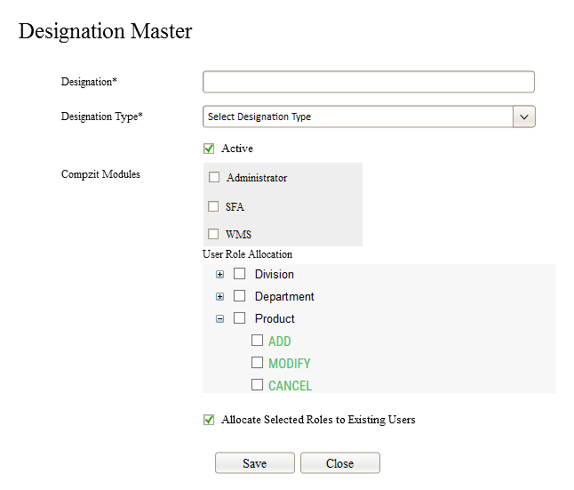

* Select the compzit modules against the designation and it is not mandatory .(can add more than modules ).
* The user roles will generate based on these modules. So get a control on the case of user role visibility too.
* The activity roles based on employee master different sections will be list under the employee master role, and activity role will generate on the basis of compzit module.

### LICENSE TYPE MASTER

A master module need for store the type of licenses. There is no interface for this module, the application administrator directly enter the master data to the table and these data will list out in other modules on the place of license type. The example for license types is LMV, Four-wheeler, Heavy etc.

Following are the license types to be used for better functionality.

1. EXCAVATOR
2. MOTOR CYCLE
3. CAR
4. BUS
5. MED. TRUCK
6. TRAILER
7. CRANE
8. LOADER
9. FORKLIFT

### ACCOMMODATION MASTER

In WMS employees staying different locations based on their work and convenience. So here we keep a master module for the employee’s accommodation. This will more helpful when we handover the daily duty slip to employees, this module have an interface in the application and it looks like,

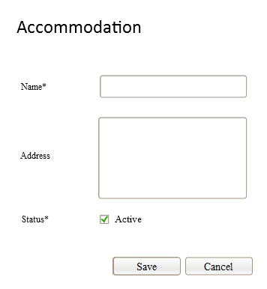

* User needs to provide accommodation premise and its address for easy identification, address is not mandatory in this module.
* Accommodation master have the list page that shows created accommodation premises where authorized user can amend the details.
* There will be a provision for cancelling the entry if it is not used anywhere in the system. This provision will also permitted by the allocated user role.

### EMPLOYEE SUB SYSTEM

**Feature**

The proposed WMS solution is the part of Compzit Application. Employee master is already included in Compzit. Additional fields in employee master related various sections will be included in the same compzit employee master. These separate sections grouped and highlight separately. The sections are act as activity role (sub role ) under the employee master. These roles define through the designation module as usual.

**Flow**

* Corporate admin can add multiple numbers of employees.
* Provision for Edit and update the employees.
* Provision for Active/Inactive the employees.
* Provision for cancel the employee (permanently remove from the application not from database).
* Provision for adding the employees on the basis of workshop management system. Adding screen looks like,

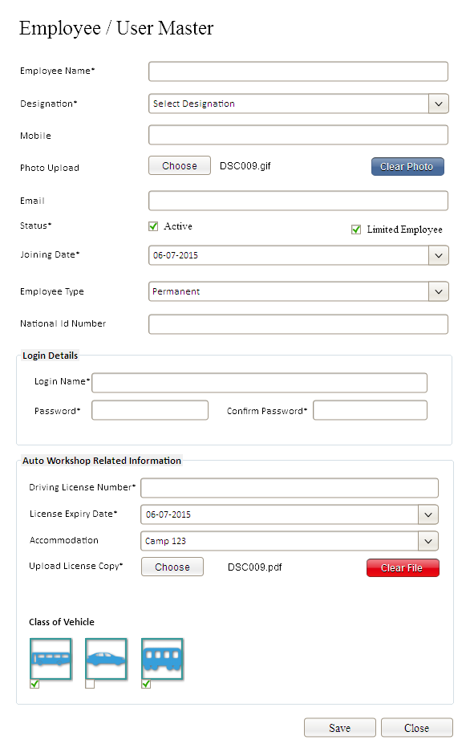

* There will be a provision sending mail to each employee while employee registration in compzit, if email id for that employee has been provided.
* There will be a provision for changing employee’s password from their login itself. Login and password is not mandatory in this module because many of the employees will not be having the provision for accessing the solution.
* Employee / user login activities (provision for activities) will be depending on selected designation for that employee. Both main and child user roles will be allocated for each designation and this will also assigned to each employee while their registration.
* Employee registration page will be divided into various sections and this categorization will be useful for restricting the visibility of various fields while accessing the employee module from different departments.
* There will be common fields available for all employees and these fields will be visible for all departments but section based fields will be visible for appropriate department users only.
* User can choose the employee type from the list and this will be the purpose of grouping the employees. The employee type ‘Permanent’ will be selected by default for employee registration.
* Following are the possible employee types as per current requirement analysis. But it will be possible to add more employee types by the development team.
* There will be a provision for adding multiple license types for an employee
* Solution will also provide separate field for expiry date for license.
* There will be a provision for getting employee joining date in the solution. This field will be helpful in future enhancements of compzit solution.
* ‘Limited Employee’ means the employee have the limited controls on the basis of user roles. If this employee add a designation then the menu roles generate in designation page as same as that employee have.
* Solution will give an easy method of employee importing from .csv file and the importing file format will also provide as separate link.
* There will be a provision for cancelling the master and this will be permanently vanished from all sections. But this entry will not be removed from database for the purpose of audit trail.
* The screen for import employee list looks like,

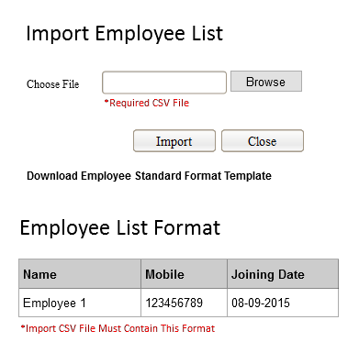

* In above screen, last section shows the format for the import file format. This format will also maintained as separate link and authorized user can download this format and used for importing employee list.
* This will also give basic three fields for importing into employee master.
* All others like designation, login name and password must be given by the system as a common and allow changing those fields by editing the employee.

### WORKSHOP MANAGEMENT SECTION

### VEHICLE CLASS SUB SYSTEM

This module is used for categorizing the vehicles that will used in workshop management solution. There will be no interface used for this module, development team creates the entries in the database and they will list in other modules. Vehicle types are Trucks, Car etc.

### FUEL TYPE SUB SYSTEM

This is the module for differentiating vehicles on the basis of fuel mode. It will helpful in the case of fuel management related activities in WMS solution. There will be no user interface for this module. Development team will create these entries in the database and they will list in appropriate sections.

Fuel types mainly are Petrol, Diesel, LPG, Methanol etc.

### INSURANCE TYPE SUB SYSTEM

For WMS, this will do. Insurance plays a bigger role when looking to the corporate office as a whole. There are so many types of insurance in whole, for easily differentiate we add insurance types. Types like vehicle insurance, labor insurance etc. this module don’t have an interface in the application, application administrator directly enter the data into the table.

### INSURANCE PROVIDER SUB SYSTEM

This is a master module for add insurance provider for vehicles by user. This module is almost same for our other master modules. There is one list page and the add page. The add page looks like,

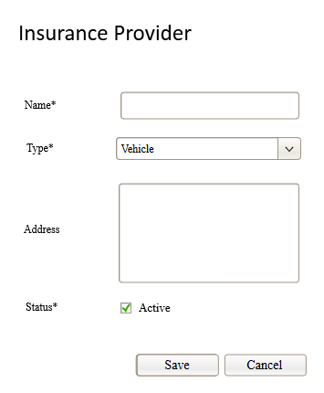

* Solution will not allow duplication in insurance provider name.
* There will be a provision for activating / inactivating the master for avoiding the visibility in other sections.
* There should be a provision for cancelling the master and this will be permanently vanished from all sections. But this entry will not be removed from database for the purpose of audit trail.

### VEHICLE SUB SYSTEM

This is the one of the major modules in workshop management solution. User can create all operational or non-operational vehicle owned by auto workshop. These vehicles may reflect in most of the areas in WMS. The interface for vehicle master looks like,

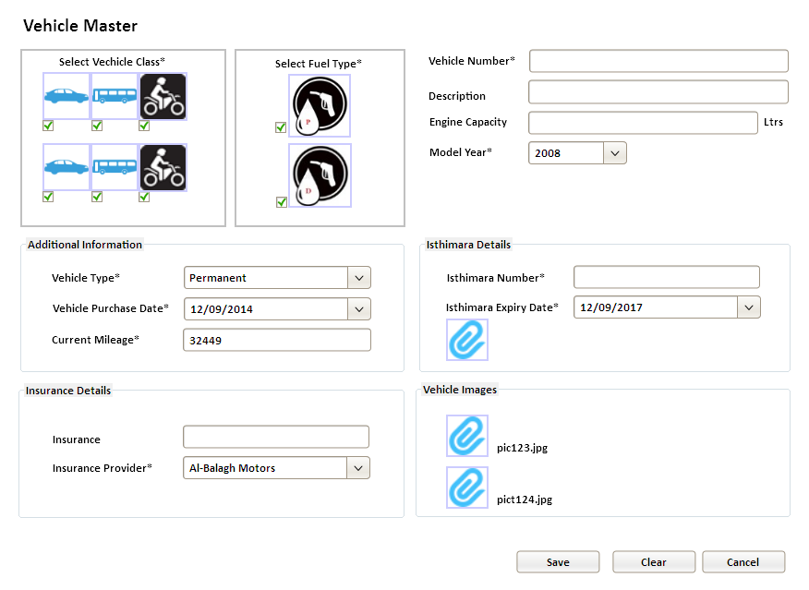

* Vehicle class will be selected from master list created from corresponding master module.
* Fuel type also to be selected from Fuel Type master.
* User needs to add insurance expiry date for all vehicles and this will helpful for getting the alerts before insurance get expired.
* There will be a provision for entering current mileage before WMS solution get operational. This will be reflecting in duty roster as well as duty allocation for that vehicle.
* There will be a listing page for displaying all vehicles under auto workshop. Cancellation is also allowed for the vehicle master if it is not used anywhere in the system.
* After selecting the vehicle in any other module then user cannot change initial kilometer of that vehicle.
* Provision for adding multiple images against a vehicle.
* Select an insurance provider against each vehicle and this parameter will be selected from insurance provider master.