Smart Contactless Switch

In present scenario, there is a notable shift towards health consciousness and a growing awareness of our surroundings. The people have noticed the important of maintaining a robust immune system and healthier life. After COVID-19 pandemic, it has become important to not touch surfaces of buttons and keys that have been frequently used by other people. So, the idea is about to design a contactless switch that works entirely on hand gestures.

Fig 1: CONTACTLESS SWITHCH

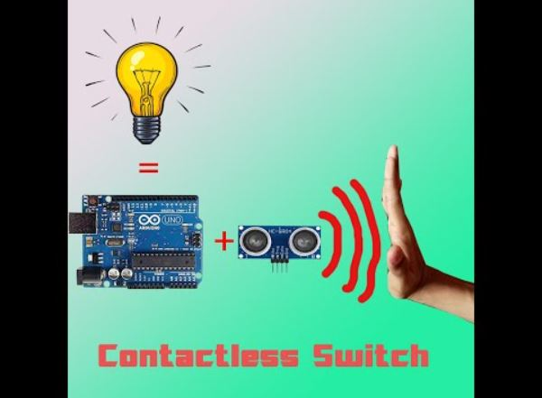

# The main theme of the project is to implement a contactless switch as in this pandemic situation by controlling without contact to any device. Multiple people come into contact with public objects in their daily lives like at hospitals, malls, hotels, transportations etc. As a result, spreading of various viruses and bacteria caused by the finger contact gradually increases, so to overcome it we are replacing the switches with contactless switches.

Here we are using the gesture technology to control the switching operation. This gesture technology can be used in various applications like smart home, smart security, indoor positioning etc.

Our smart contactless switch includes a sensor that is capable of detecting hand movements and translates them into commands for controlling lights, fans and various applications. Here this project works based on both hardware and software.

**Coding:**

First of all we need to install the require library into the Arduino. After installing the library, add it into the code and then define the pin numbers for the light and fan control. Next, we create a setup function for sensor and set the pin mode output for light and fan control. By using the loop functions the sensor can read and use the hand gestures as an input to control the pin. We use up, down, left, right command to operate.

Up: Lights ON

Down: Lights OFF

Left: Fans ON

Right: Fans OFF

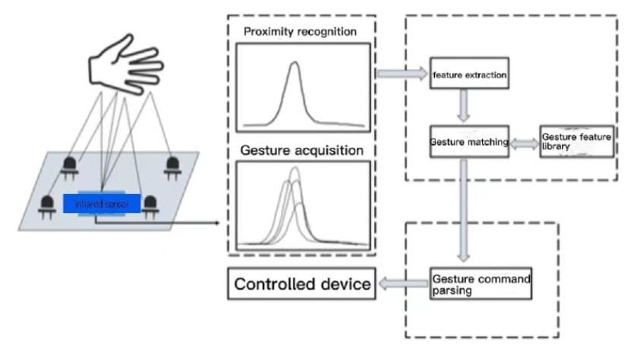

The above fig 2 shows that the input side of the sensor will works like this when we pass the commands.

# Connection:

# The below figure 3shows the connection of the components.

# 

# Here relay module is used to control the switch operation.

# Conclusion:

# Compared to direct contact control methods, gesture recognition is safer and more reliable, reducing the spread of viruses or bacteria caused by finger contact and contributing to public health safety. The contactless switch system based on gesture recognition has low power, long life, long response time, the ability to implement a variety of gesture recognition algorithm design and support a variety of gesture recognition, this solution has the advantages of low maintenance costs and long application time, so it is a better choice for the development of small switch systems.

# From:

# The team Visionary Touch