Summer Street Developmet

Proposal
MILANN PANDYA
QONSULT BUSINESS SOLUTION
Ahmedabad. India

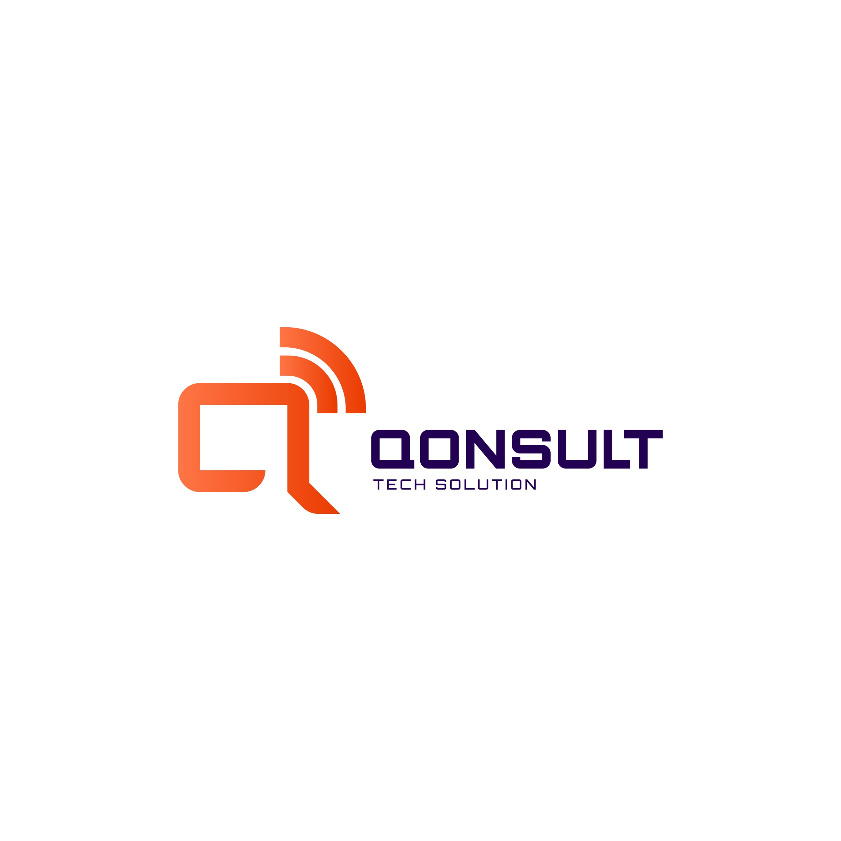
Division of Qonsult Business Solution
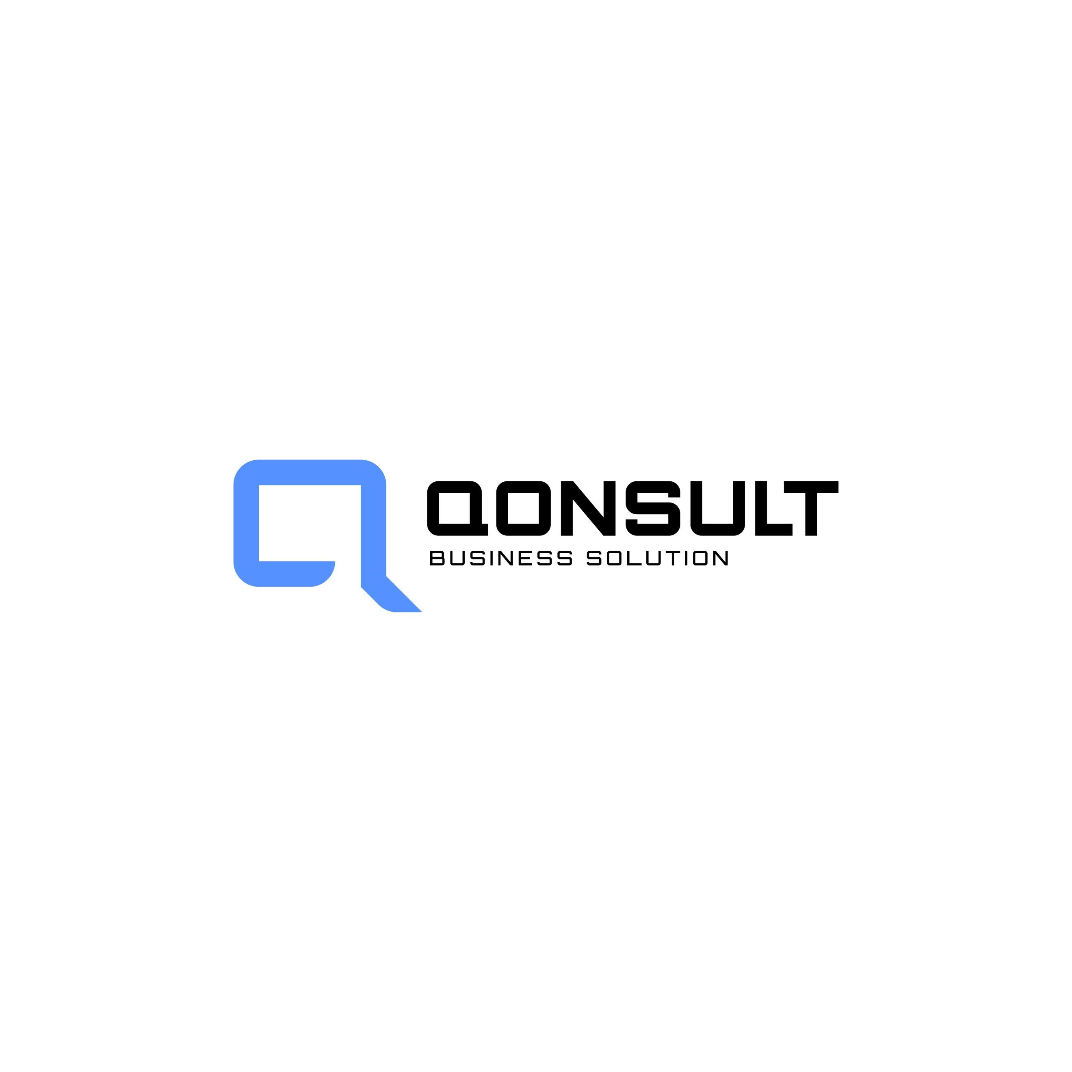

Add-On Service | Description | Cost (USD)
Ongoing quarterly Maintenance | Minimum of 40 hours per quarter at $15/hour, payable in advance. Any additional hours beyond 40 will be charged at $15 per hour. | $600/quarter
E-Commerce Activation | Activate WooCommerce for Social Enterprise online sales, payment gateway, and product setup. | $1000 (one-time)

Executive Summary
Date: 14 October 2026
To,
SceneShop / Miguel

Dear Miguel,
At Qonsult Tech Solution (A Division of Qonsult Business Solution), we believe technology should serve a clear mission. After a thorough review of the SceneShop v0.19 codebase and its architectural documentation, we are pleased to present this comprehensive proposal for rebuilding and scaling the SceneShop Universal Video Commerce Platform using modern, production-grade technologies.
SceneShop's vision is to create an invisible commerce layer for audiovisual content — enabling viewers to shop products seen in any video, on any screen, in real time. The current prototype demonstrates acoustic synchronization via ACRCloud, AI-driven product tagging via Google Gemini, real-time WebSocket companion pairing, and a multi-tenant commerce engine with community curation support.
We propose to re-engineer the entire platform with a Dual-Track Hybrid Architecture: Track A (Instant Acoustic Sync for known/partner content) and Track B (Universal Coverage via Camera Visual Search and Just-In-Time URL Processing for unknown content). This approach eliminates the need to pre-index millions of videos while delivering 100% universal compatibility to end users.
The platform will be rebuilt using Next.js for the web applications, React Native for cross-platform Android and iOS mobile apps, Node.js/Express for the backend API layer, and deployed exclusively on Amazon Web Services (AWS). AI-assisted development practices will be leveraged throughout to accelerate delivery timelines significantly.

Best Regards,
Milann Pandya
Chief technology officer

QONSULT Tech Solution
(Div. of Qonsult Business Solution)
Ahmedabad, Gujarat, India
Phone: +91-7600616160 | E-mail: business@qonaultbusinesssolution.com

Why Qonsult?
More Than a Development Company, A Strategic Technology Partner
At Qonsult, we don't just build applications — we build digital platforms that transform business models. We understand that SceneShop is not merely a mobile app or a website; it is a real-time commerce orchestration engine that bridges audiovisual content with e-commerce at the intersection of AI, acoustic recognition, and multi-screen synchronization.
We approach every project with a mission-first mindset, ensuring that the technology decisions we make today support the platform's growth for the next 3–5 years. Our experience with real-time systems, AI integration, multi-platform development, and AWS-native infrastructure makes us uniquely qualified to deliver SceneShop's ambitious vision.

Strategic Technology Mindset
We approach every project with:
• Mission-first thinking — every feature is evaluated against its impact on viewer conversion and creator revenue.
• User-centred design — the companion experience must feel invisible and magical, not intrusive or confusing.
• Long-term scalability planning — the architecture must handle millions of concurrent acoustic sync requests.
• Performance and accessibility optimization — sub-2-second recognition latency is a hard requirement.
• Security and reliability best practices — multi-tenant data isolation, RBAC, MFA, and GDPR/LGPD compliance.
Our focus is not just on delivering a working product but on creating a digital platform that supports SceneShop's commercial mission and scales with its user base.

Relevant Project Experience
Below are representative projects that demonstrate our direct experience with the scope SceneShop requires:
Real-Time Streaming Commerce Platform | E-Commerce Client (India)
We built a live-streaming e-commerce platform with real-time product overlay synchronization, WebSocket-based viewer sessions, and multi-vendor commission attribution. The platform handled 50,000+ concurrent viewers with sub-second product card rendering, directly relevant to SceneShop's companion sync architecture.
AI-Powered Visual Search & Catalogue Engine | Fashion Retail Client (UAE)
We developed a camera-based visual search system using Google Cloud Vision and custom ML models that allowed shoppers to photograph clothing items and find matching products across 200,000+ SKUs. This is directly analogous to SceneShop's proposed 'Snap & Search' Track B fallback solution.
Cross-Platform Media Companion App | Media & Entertainment Client (USA)
We delivered a React Native second-screen companion app for a streaming service, integrating QR code pairing, real-time content synchronization via Socket.io, and deep linking for iOS Universal Links and Android App Links.

Scope of Work
Given the complexity and multi-platform nature of the SceneShop platform, our delivery is structured into six focused phases spanning approximately 14–16 weeks. Each phase has defined entry criteria, deliverables, and sign-off gates. AI-assisted development (GitHub Copilot, Gemini Code Assist) will be leveraged across all phases to accelerate delivery while maintaining code quality through human review.
Phase 1: Discovery, Architecture & UI/UX Design (Weeks 1–3)
Business Analysis & Requirements Workshop
We will conduct structured discovery workshops with the SceneShop stakeholders to finalize the complete product requirements. This includes mapping all user journeys (Producer Studio, Viewer Companion, Community Curator, Moderator/Admin), defining the Dual-Track architecture specifications, and documenting API contracts. The output will be a comprehensive Product Requirements Document (PRD) with user stories, acceptance criteria, and architecture decision records (ADRs). Estimated: 2–3 workshop sessions with the client team.
UI/UX Design — Complete Design System & Screens
Our design team will create a complete, pixel-perfect design system in Figma covering all platform surfaces: the Producer Studio (video upload, AI analysis dashboard, scene timeline editor, product tagging, ACRCloud status), the Mobile Companion App (acoustic listening flow, QR scan, product cards, commerce timeline, 'While You Were Exploring' tray, Camera Snap visual search), the Marketplace/Storefront pages, the Admin/Moderator Dashboard, and the Desktop PWA shell. The design will include light/dark mode variants, responsive breakpoints, micro-interaction specifications, and a component library. The client will receive two rounds of revision before final design sign-off. Deliverable: approved Figma design files for all screens across all platforms.
Database Architecture & Schema Design
We will design the complete PostgreSQL relational schema covering multi-tenant organizations, content/work entities, commerce tracks (official + community), AI pipeline state, payment and financial journal, distribution bindings, RBAC/invites/MFA, ACRCloud fingerprint registry, and audit logs. The schema will be implemented as versioned SQL migrations. Redis data structures for real-time session state, Socket.io adapter, and cache coordination will also be designed. Deliverable: complete ERD documentation and initial migration scripts.
Phase 2: Backend API & Core Engine Development (Weeks 3–7)
Next.js API Routes & Express Middleware Layer
The backend will be built using Next.js API Routes for the web-facing endpoints and a dedicated Express.js service layer for WebSocket (Socket.io) real-time operations. This includes all RESTful API endpoints for authentication (JWT + refresh tokens + MFA), content/work CRUD, product catalog management, track creation and governance, commerce timeline resolution, session management, and the admin/moderation API. Every endpoint will include input validation, rate limiting (anti-fraud), tenant isolation middleware, and structured error responses. AI-assisted code generation will be used for boilerplate route scaffolding and test generation, with all output reviewed and refined by senior engineers. Deliverable: fully functional API with OpenAPI/Swagger documentation.
ACRCloud Acoustic Recognition Integration (Track A)
We will implement the complete ACRCloud integration pipeline: automatic audio extraction from uploaded videos via ffmpeg (mono 16 kHz), Console API registration for acoustic fingerprints, real-time identify endpoint for mobile companion sync requests, fallback to SceneShop's internal fingerprint engine when ACRCloud is unavailable, and status tracking per work. The integration will handle the full lifecycle: upload → fingerprint → register → identify → match → session creation. Deliverable: working acoustic sync pipeline with <2.5s recognition latency.
Google Gemini AI Vision Pipeline
We will build the AI analysis engine powered by Google Gemini 1.5 Flash/Pro multimodal vision. This includes video upload via the Gemini Files API, automated scene-cut detection, product identification in three modes (TARGETED, DISCOVERY, HYBRID), structured JSON response parsing, operator review queue for human verification, and AI redundancy with configurable fallback providers. The pipeline will support concurrent analysis jobs with progress tracking visible in the Studio UI. Deliverable: end-to-end AI analysis pipeline with Studio integration.
Camera Visual Search — 'Snap & Search' Engine (Track B, Solution 1)
We will develop a new visual search endpoint that accepts a camera-captured image from the mobile app, sends it to Google Gemini Vision for object detection and feature extraction (category, color, pattern, brand indicators), and resolves matching products against affiliate catalogs (Amazon Product Advertising API, Google Shopping API, and partner merchant catalogs). The system will return purchase-ready product cards with affiliate deep links within 2 seconds. This is the critical fallback that provides universal coverage for unregistered videos. Deliverable: /api/vision/search endpoint with affiliate catalog resolver.
Just-In-Time URL Processing Engine (Track B, Solution 2)
We will build an asynchronous background worker system that processes YouTube/Instagram/TikTok URLs shared by users via the mobile app's Android Share Sheet or iOS Share Extension. When a user shares an unregistered video URL, the worker will: validate and extract the public video stream, sample keyframes at configurable intervals, run Gemini 1.5 Flash vision analysis on the frames, match detected items against affiliate catalogs, generate a community track, and register the audio fingerprint for future acoustic recognition. The entire pipeline will execute in 30–90 seconds, after which the user receives a push notification that shopping results are ready. Deliverable: background processing queue with Bull/Redis, worker service, and notification system.
Real-Time WebSocket Synchronization Engine
We will implement the Socket.io-based real-time synchronization layer with Redis adapter for horizontal scaling. This includes session room management, player:tick heartbeat broadcasting (1Hz), scene:change event propagation, track:change dynamic switching, sync:resync acoustic re-correction, and commerce:live/browse head state management. The engine will support the decoupled Playback Head vs. Browse Head model, 'While You Were Exploring' missed-scene collection, and multi-device session persistence via Redis. Deliverable: production-ready WebSocket engine with Redis clustering support.
Multi-Tenant Commerce & Payment Engine
We will develop the complete commerce stack: multi-tier track governance (Official vs. Community), commercial policy engine with configurable commission splits, affiliate deep-link routing with attribution tracking, financial transaction journal with double-entry bookkeeping, reconciliation and payout calculations, and anti-fraud/AML screening. The payment gateway integration (Stripe/Razorpay) will handle checkout flows, refunds, and seller payouts. Deliverable: commerce engine with payment processing and financial reporting.
Phase 3: Web Application — Next.js Frontend (Weeks 5–9)
Producer Studio Web Application
The Studio will be built as a Next.js application with TypeScript and Tailwind CSS. It will include: secure authentication with role-based access (Producer, Community Author, Moderator, Admin), video upload with drag-and-drop and progress tracking, AI analysis launcher with real-time status updates, interactive scene timeline editor with visual product tagging, product/asset catalog manager, ACRCloud registration status and controls, commerce track publishing workflow, community track moderation queue, KYC/AML compliance dashboard, financial reporting and payout management, and organization/team management with RBAC and invites. The UI will be responsive and will leverage Next.js server-side rendering for optimal SEO and performance. Deliverable: complete Studio web application.
Marketplace & Partner Storefront Pages
We will build the consumer-facing marketplace using Next.js with dynamic routing for product pages, category browsing, search with filters, and partner brand storefronts. The marketplace will support server-side rendered product pages for SEO, dynamic pricing from the commerce resolver, campaign/offer display, and seamless checkout redirection to merchant partners. Partner storefronts will be white-labelled with brand colors and custom layouts. Deliverable: marketplace and partner pages with full SEO optimization.
Video Player & Companion Web Surface
We will build the web-based video player surface (assistir/watch page) with HTML5 video playback, QR code session generation, real-time scene overlay rendering, and the web-based mobile companion interface. The companion web surface will mirror the native app experience for users who access via browser: session joining, product timeline, scene browsing, and product cards with purchase links. Deliverable: player and companion web surfaces.
Admin & Moderation Dashboard
A comprehensive admin panel will be built within the Next.js application for platform operators. Features include: user and organization management, content moderation queue (flagged tracks, reported items), KYC verification workflow, AML alert review, system health monitoring, audit log viewer, and platform analytics. The dashboard will use role-based visibility to show appropriate controls based on the logged-in user's permissions. Deliverable: admin dashboard with full CRUD operations and moderation workflows.
Phase 4: Mobile Applications — React Native (Weeks 7–12)
React Native Cross-Platform Mobile App (Android & iOS)
We will develop a single React Native codebase that compiles to both Android and iOS, replacing the current native Kotlin/Swift WebView wrappers with a fully native UI experience. The mobile app is the primary consumer surface and will include: acoustic listening and sync via device microphone (MediaRecorder API with native modules for audio capture), QR code scanning via device camera (react-native-camera), Camera Snap visual search (capture photo → send to /api/vision/search → display product results), session management and WebSocket synchronization, commerce timeline with product cards and purchase deep links, 'While You Were Exploring' missed-scene tray, haptic feedback on scene changes, Android Share Sheet and iOS Share Extension integration for Just-In-Time URL processing, push notifications via Firebase Cloud Messaging (FCM), secure token storage via react-native-keychain, deep linking via Android App Links and iOS Universal Links, and offline capability with local state persistence. AI-assisted development will be used extensively for component scaffolding, test generation, and cross-platform compatibility testing. Deliverable: production-ready Android APK and iOS IPA from a single React Native codebase.
Native Bridge & Platform-Specific Modules
Certain features require native platform access beyond React Native's default capabilities. We will implement custom native modules for: high-quality audio capture with echo cancellation disabled (required for ACRCloud), background audio processing, iOS Share Extension for receiving shared URLs from Safari/YouTube, Android intent filters for receiving shared content, and platform-specific notification channels. These modules will be built using the React Native New Architecture (TurboModules/Fabric) for optimal performance. Deliverable: native bridge modules for both Android and iOS.
Phase 5: Desktop PWA & Distribution SDK (Weeks 10–13)
Desktop Progressive Web App (PWA)
We will package the Studio and Player web surfaces as an installable Progressive Web Application with service worker caching, offline fallback pages, web app manifest configuration, and desktop shortcut installers for Windows, macOS, and Linux. The PWA will support push notifications via the Web Push API and will be registered with appropriate app store listings if required. Deliverable: installable PWA with cross-platform desktop support.
SceneShop Partner SDK (Embeddable Widget)
We will build a lightweight, embeddable JavaScript SDK that content partners can integrate into their own websites and video players. The SDK will expose the Commerce Timeline, product overlay, and session synchronization capabilities as a drop-in widget. Partners retain their own UX and identity while SceneShop supplies governed commerce state and metadata. The SDK will be published as an npm package and served via CloudFront CDN. Deliverable: sceneshop-sdk.js with integration documentation and code samples.
Phase 6: Testing, QA, DevOps & Deployment (Weeks 12–16)
Comprehensive Testing Suite
We will implement a multi-layer testing strategy: unit tests for all business logic modules using Jest/Vitest, API integration tests for every endpoint, end-to-end tests using Playwright/Detox for web and mobile flows, load testing for WebSocket concurrent sessions (target: 10,000+ simultaneous connections), acoustic sync latency benchmarks, and cross-browser/cross-device compatibility testing. AI tools will assist in generating test cases and edge-case scenarios. The existing 286-test unit suite and 125-check API integration suite from the v0.19 prototype will be migrated and expanded. Deliverable: comprehensive test suite with CI/CD integration.
AWS Infrastructure Setup & CI/CD Pipeline
We will provision and configure the complete AWS production infrastructure: AWS Amplify for Next.js deployment with server-side rendering, Amazon CloudFront for global CDN delivery, Amazon S3 for media and asset storage, Amazon RDS (PostgreSQL) for the relational database with read replicas, Amazon ElastiCache (Redis) for session state and Socket.io adapter, AWS WAF for OWASP Top 10 and DDoS protection, AWS IAM for fine-grained access control, AWS Secrets Manager for API keys and credentials, AWS Certificate Manager (ACM) for SSL/TLS, Amazon Route 53 for DNS with health checks, Amazon CloudWatch for monitoring/alerting, and AWS Backup for automated daily backups. The CI/CD pipeline will use GitHub Actions deploying to AWS with staging and production environments. Deliverable: production-ready AWS infrastructure with automated deployment pipeline.
Production Launch & Go-Live Support
We will execute a structured go-live process including: staging environment validation, production data migration scripts, DNS cutover, SSL certificate provisioning, smoke testing on production, performance baseline establishment, and monitoring dashboard configuration. The team will provide dedicated support during the first 48 hours post-launch to address any production issues immediately. Deliverable: live production deployment with monitoring.

Technical Approach & Recommended Stack
The SceneShop platform will be rebuilt using a modern, scalable technology stack optimized for real-time commerce, AI integration, and cross-platform delivery:
• Frontend (Web): Next.js 15 with TypeScript and Tailwind CSS for the web application (Studio, Marketplace, Player, Admin)
• Frontend (Mobile): React Native with TypeScript for cross-platform Android and iOS mobile companion app
• Backend: Next.js API Routes + Express.js for RESTful APIs and Socket.io WebSocket services
• Database: Amazon RDS (PostgreSQL 16) for relational data, Amazon ElastiCache (Redis 7) for sessions and caching
• AI & Vision: Google Gemini 1.5 Flash/Pro for multimodal video analysis and visual search
• Audio Recognition: ACRCloud for acoustic fingerprinting and content recognition
• Real-Time: Socket.io with Redis adapter for real-time multi-screen synchronization
• AI-Assisted Development: GitHub Copilot and Gemini Code Assist for accelerated development with human review
• Cloud Infrastructure: AWS Amplify, CloudFront, S3, RDS, ElastiCache, WAF, IAM, Secrets Manager, ACM, Route 53, CloudWatch, AWS Backup
• CI/CD: GitHub Actions deploying to AWS with staging and production environments

Technical Features
• Dual-Track Hybrid Architecture: Acoustic Sync (Track A) + Visual Search & JIT URL Processing (Track B)
• Fully responsive, mobile-first web design across all surfaces
• Cross-platform React Native mobile app (single codebase → Android + iOS)
• Real-time WebSocket synchronization with <100ms latency
• Acoustic audio recognition with <2.5 second match latency
• AI-powered scene detection and product tagging (Google Gemini 1.5)
• Camera-based visual product search (Snap & Buy)
• Multi-tenant organization architecture with RBAC, invites, and MFA
• Multi-tier commerce tracks: Official (Producer) and Community (Affiliate)
• Configurable commission splits and financial journal with reconciliation
• Deep linking: Android App Links, iOS Universal Links, custom URI schemes
• Progressive Web App (PWA) with offline support and push notifications
• SEO-optimized server-side rendering via Next.js
• Embeddable Partner SDK for third-party video player integration
• Comprehensive security: AWS WAF, rate limiting, anti-fraud, AML screening, GDPR/LGPD compliance
• Automated CI/CD pipeline with staging and production environments
• Real-time monitoring and alerting via Amazon CloudWatch

Team
The SceneShop project will be delivered by a cross-functional team combining deep expertise in real-time systems, AI integration, mobile development, and cloud infrastructure. AI-assisted development tools (GitHub Copilot, Gemini Code Assist) will be used by all developers to accelerate coding velocity by approximately 30–40%, with all AI-generated code subject to mandatory human review and testing.

Hours by Team Member & Phase
Role | Ph 1  Discovery  & Design | Ph 2  Backend  & Engine | Ph 3  Web  Frontend | Ph 4  Mobile  Apps | Ph 5  Desktop  & SDK | Ph 6  Test &  Deploy | Total  Hrs
Project Manager | 30 | 40 | 30 | 30 | 16 | 24 | 170
UI/UX Designer | 80 | 16 | 24 | 24 | 8 | 8 | 160
Sr. Full-Stack Developer (AI) | 40 | 160 | 80 | 40 | 24 | 40 | 384
Sr. Full-Stack Developer | 24 | 120 | 120 | 40 | 40 | 40 | 384
React Native Developer | 8 | 16 | 16 | 200 | 16 | 24 | 280
DevOps / Cloud Engineer | 16 | 24 | 8 | 8 | 24 | 60 | 140
QA Engineer | 8 | 24 | 40 | 40 | 16 | 60 | 188
Total Hours per Phase | 206 | 400 | 318 | 382 | 144 | 256 | 1,706

Note: Hour estimates reflect AI-assisted development practices. Without AI tooling, the same scope would require approximately 2,400–2,800 hours. AI-assisted coding reduces total effort by approximately 35% while maintaining quality through mandatory human review.

Finance & Pricing
All pricing below is fixed for the initial term of any agreement executed with SceneShop. Prices are presented in USD and reflect AI-assisted development efficiencies.

Cost Estimation
Description | Cost (USD)
Discovery, Business Analysis & Architecture Design | $2,800
UI/UX Design — Complete Design System (All Platforms) | $3,200
Backend API, AI Pipeline, Acoustic Sync & Commerce Engine | $8,400
Camera Visual Search & JIT URL Processing (Track B) | $3,600
Web Application — Next.js (Studio, Marketplace, Player, Admin) | $6,400
Mobile Application — React Native (Android + iOS) | $7,200
Desktop PWA & Partner SDK | $2,400
Testing, QA & Performance Benchmarking | $3,000
AWS Infrastructure Setup, DevOps & CI/CD Pipeline | $2,800
Total Estimated Project Cost | $39,800

Hosting & domain charges are not included; if your organisation is looking for these services from us, we will provide you with a separate quote.
Optional Add-On Services (Not Included in Base Scope)
• Advanced Analytics Dashboard with real-time conversion tracking — $3,500
• Multi-language (i18n) support for PT, EN, ES across all surfaces — $2,800
• Custom payment gateway integration beyond Stripe/Razorpay — $1,800
• Dedicated AWS managed hosting service (monthly) — quoted separately

Milestone & Payment Schedule
Milestone | Payment
Project Initiation | 30%
UI Approval | 20%
Frontend Completion | 20%
Backend Completion | 20%
Final Deployment | 10%

Post-Launch Support
• 30 days of free support
• Bug fixes
• Minor content updates
• Admin training session
Notes
• For Product Development, we will follow a pure agile development process, and we will work with a sprint plan to develop it.
• The cost mentioned above for product development is a very high-level estimation, and it may vary based on the finalisation of the complete scope of the project.

Payment and General Terms
• This proposal is valid for two (3) weeks from the date mentioned in this agreement.
• Payment through PayPal will incur an additional 5% processing fee.
• Payment through crypto will incur an additional 30% taxes from India regulation.
• QONSULT Business Solution will raise invoices as per the phases mentioned in the payment schedule. The client will pay the invoice within 7 working days after receiving it.
• Change Request will be charged at 20 USD per hour. We will charge if the change request is not mapped within the signed-off scope document.
• The change requests will be executed based on resource availability and will impact the final delivery time, which QONSULT Business Solution will communicate.
• If, in any case, the change request is applied in the project, it will be counted in the Monthly/weekly Payment cycle.

Assumptions/Constraints/Comment
• We are assuming that it will be hosted under AWS, Azure or any other cloud services and store all documents/images/videos/files.
• The client will manage the cloud cost. / Optionally, QONSULT offers Cloud management and AWS management services.
• 3rd party API will be provided by the client, like payment gateway, escrow, whiteboard, etc.
• Data add, or migration, is out of scope for a one-time contract; QONSULT Business Solution will manage only sample data as per requirement.
• We will identify the exact scope after the Business analysis.

General Assumptions
• The client will provide the development license/access of third-party access tools, proprietary tools, and APIs. The client will also provide all the necessary security credentials/keys/tokens related to the hosting environment.
• QONSULT will host the product on its server before going LIVE. Once the product is ready to go LIVE, the client shall provide the server (AWS/Azure/GCP or any other).
• Content will be provided by the client, and QONSULT will do the sample content entry during the contract period.

Out of Scope
• Purchase of 3rd Party Tools or API
• Licenses
• Content/Data Entry
• Content Creation
• Multilingual web development

Important Notes
• All the deliverables will be a joint responsibility of both Client and QONSULT. Hence, it is expected from the client to sign off the deliverables in a timely manner as per the project plan.
• Whenever a technical limitation from the OS or specific device arises, it should be acceptable to the client. QONSULT will suggest the best possible workaround.
• QONSULT will do coding as per the respective framework standards for backend and MVC standards for Web development. QONSULT will follow development standards as per the technology.

Representations
• Each person who signs this Agreement represents that he/she is authorised to sign this document and bind his/her company to the terms stated in this Agreement.

Date: October 14, 2026

Service Provider: |  | Client:
QONSULT Business SolutionMilann Pandya (Chief technology officer) |  | SceneShop / Miguel
Authorized SignatureMilann Pandya (Chief technology officer) |  | Authorized Signature

