Import into CLIMSOFT (import-App)

Version 1.0

Rafael Posada

31st August 2017

Table of Contents

# Introduction

The Application *import-App* has been developed under the SASSCAL initiative (<http://www.sasscal.org>) through the Climate Task *Historical and ongoing climate data management* to facilitate the import of data from different sources into any CLIMSOFT database. CLIMSOFT (<http://www.climsoft.org>) is a Climate Data Management System (CDMS) developed in Africa and installed in the meteorological services of the SASSCAL-partners Angola, Botswana and Zambia.

The tool has been developed under Shiny, an open source R package that provides a powerful web framework for building web applications using R (<https://shiny.rstudio.com/>). Shiny helps turn data analyses into interactive web applications without requiring HTML, CSS, or JavaScript knowledge (RStudio, 2017)

This manual will give an overview of the Application, explaining how to install it, how to run it, and how to use it.

# Requirements

## Software requirements

The following programs are required for the installation of the App:

* Windows 7 or higher
* Java SE Runtime Environment 7 or higher (<http://www.oracle.com/technetwork/java/javase/downloads/index.html>)
* R v3.2.1 or higher (<https://cran.r-project.org/bin/windows/base/>)
* RStudio v0.99.467 or higher (<https://www.rstudio.com/products/rstudio/download/>)
* Rtools v.3.2 or higher (<https://cran.r-project.org/bin/windows/Rtools/>)
* A web-browser, such as Mozilla-Firefox, Chrome or Internet Explorer (v.11 or higher)

## R-Packages

The package is the fundamental unit of shareable code in R. A package bundles together code, data, documentation, etc. and is easy to share with others (Wickham, 2017).

The *import_App* requires a number of R-packages to run properly. They are available on-line and will be installed automatically by the App. These packages are:

## gdata  
## jsonlite  
## rhandsontable  
## rmarkdown  
## RMySQL  
## RODBC  
## shiny  
## shinyBS  
## shinyjs  
## uuid  
## XLConnect

The packages are saved in the following path:

## import_standalone/import_App/www/R_pkgs/win.binary/3.2.1

and the corresponding libraries are installed in:

## import_standalone/import_App/www/libraries/3.2.1

# Install and uninstall

## Install

The Application is stored as a .zip file to reduce the size of it. There are two different .zip files available:

* import_compact.zip (approx. ?? Mb): Contains the minimum information to install the App. The user will **require Internet connection** to complete the installation, since the App will have to download the R-Packages from a R-CRAN repository (typically the repository: <http://cran.us.r-project.org>)
* import_full.zip (approx. ?? Mb): Contains all the R-Packages and software required for the installation of the App. The user will **not require Internet connection**.

To proceed with the installation, the user has to follow these steps:

1. **Unzip file**: The user has to unzip the import_compact.zipor import_full.zip file and place the content in any folder (e.g. Desktop, Documents or any other).
2. **Open import_standalone folder**: This folder contains all the information to install and run the App.
3. **Edit file import.bat**: Right click on that file and select Edit. An editor will open the .bat file and the user can then modify the path where R is located. The default path is:

* ## C:/Program Files/R/R-3.2.1/bin/i386
* where R-X.X.X is the version of R, and i386 contains the 32bit version of R. Once the changes have been done, please save the changes and close the Editor.

1. **Run import.bat:** Double click on the file. A command window will pop-up.
2. **Select Meteorological Service**: The user will be asked to enter the meteorological service (either DMS, INAMET or ZMD). This information has to be entered only once.

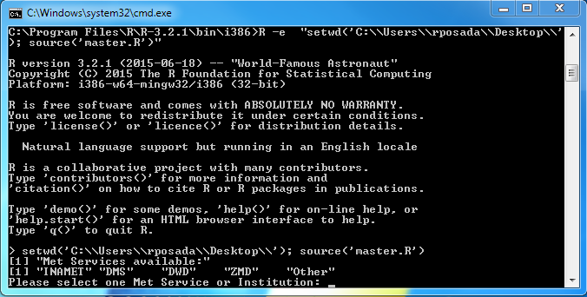

Figure 1. Select the Meteorological Service

1. **Download packages:** If the user uses the file import_compact.zip, then the App will download the required R-Packages automatically from an R-CRAN repository. Otherwise, the App will contain already the required packages. The packages will be saved in:

* ## import_standalone/import_App/www/R_pkgs/win.binary/3.2.1
* **Note:** This step may take some minutes. Please be patient.

1. **Unpack and install libraries:** Once the packages are saved locally, the App will proceed to unpack and install the packages as libraries. These libraries will be located in:

* ## import_standalone/import_App/www/libraries/3.2.1
* **Note:** This step may take some minutes. Please be patient.

Once the installation process is finished, the import-App will open automatically.

The App can be stopped at any time by closing the command window. To re-run the App, execute the file import.bat again. The import_App will then pop-up automatically.

## Uninstall

To uninstall the App, just remove the import_standalone folder.

# Connection to a database

If the import-App is going to be used to interact with a CLIMSOFT database, it is necessary to set up a connection to that database. This has to be done through the *Open Database Connectivity* Tool (ODBC), a standard programming language middleware API (Application Programming Interface) for accessing database management systems (DBMS). ODBC accomplishes DBMS independence by using an ODBC driver as a translation layer between the application and the DBMS.

The application uses ODBC functions through an ODBC driver manager with which it is linked, and the driver passes the query to the DBMS. An ODBC driver can be thought as analogous to a printer driver or other driver, providing a standard set of functions for the application to use, and implementing DBMS-specific functionality (Wikipedia, 2017).

The ODBC will allow the import-App to identify and connect to the database of interest. Therefore, an ODBC connection has to be set up. To do so, it is necessary to follow these steps:

* Make sure you have administrator rights, since the ODBC-Administration Tool can only be opened by the administrator.
* Open the "ODBC-Administrator" by:
  + Clickling on the Start menu button (bottom-left of the screen), Control Panel, then Administrative Tools and then Data Sources (ODBC) (Figure 1), or
  + Running the file called: odbcad32.exe located in the folder: C:/Windows/SysWOW64/

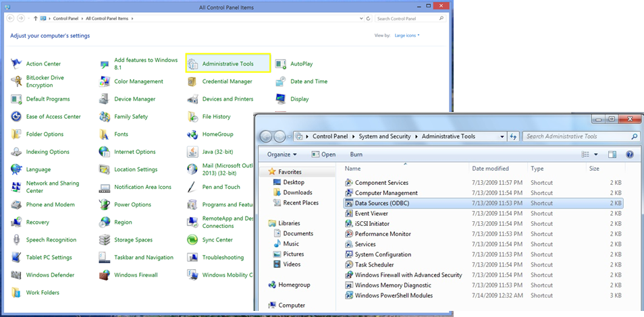

Figure 2. Selection of Administrative Tools and Data Sources (ODBC)

Once opened, a Window that looks like Figure 3 will pop-up.

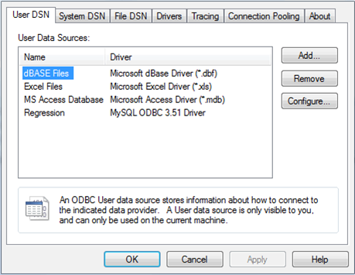

Figure 3. Window of Data Sources (ODBC)

* Click on the Add... option and select one of the drivers listed.

## Connect to MS-Access db

For connecting to MS-Access db, follow this steps:

* Select the driver Microsoft Access Driver (*.mdb, *.accdb) and press Finish. (Figure 4)

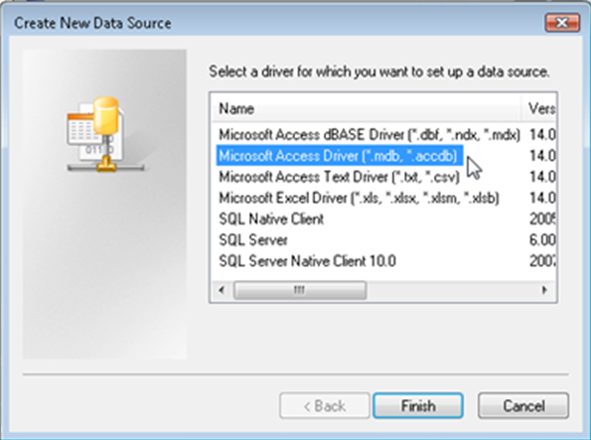

Figure 4. Window 'Create new data source'

* In the new Window (Figure 5), give a Data Source Name (DSN) to the connection and, if desired, add a description of such a connection. Please, make sure that the DSN contains the word **"CLIMSOFT"** (e.g. CLIMSOFT_db). After that, select the database to connect with by pressing the button Database: Select.

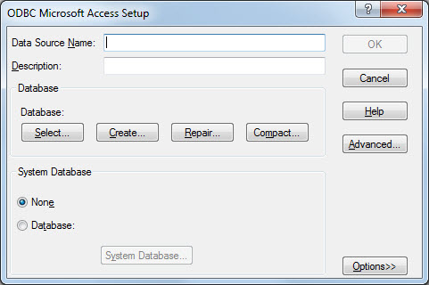

Figure 5. Window to Setup the ODBC for MS-Access database

* A new window pops-up (Figure 6) asks for the location of the database. Browse through your computer to find the location of the database (typically under C:/Program Files (x86)/CLIMSOFT/dbase/). Once the database has been selected, click OK.

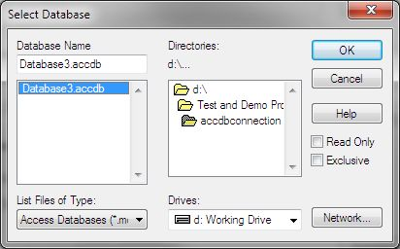

Figure 6. Window to select the MS-Access database

* Now it is necessary to set up the System database, since the CLIMSOFT databases join a Workgroup called climsoft. Therefore, it is necessary to locate the file climsoft.mdw that defines that Workgroup. For this, select the option Database within the System Database field. Then press the button System database.... This file is usually in the path C:/Windows/System32/ or C:/Windows/SysWOW64.

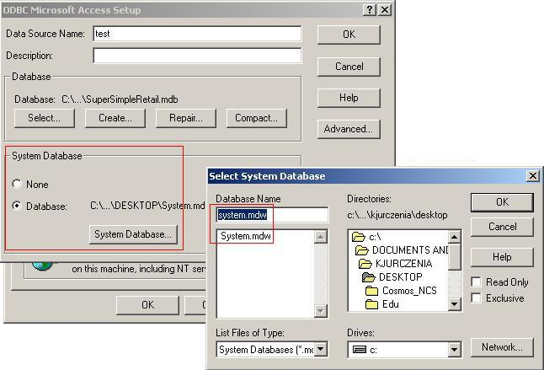

Figure 7. Select the System Database

* Once the file is selected, press OK to save changes and to close the Select System Database window, and press OK again to save the changes and close the ODBC Microsoft Access Setup Window.

**IMPORTANT:** Make sure that the Data base allows reading the relationship table 'MSysRelationship'. For this, please follow the steps described in: <https://dev.mysql.com/doc/workbench/en/wb-migration-database-access.html>

## Connect to mariadb db

For connecting to a mariadb db:

* Select the driver MySQL ODBC X.X ANSI Driver, where X.X refers to the version of the MySQL ODBC (e.g. 5.5). If the MySQL driver is not available in the computer, it is possible to download it in <http://dev.mysql.com/downloads/connector/odbc/>. 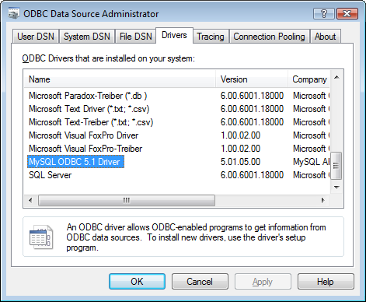
* Figure 8. Example of a MySQL ODBC driver.
* Fulfill the MySQL Connector Window (Figure 9) with the required information.
  + Data Source Name (DSN): Name of the connection. Please, make sure that the DSN contains the word **"CLIMSOFT"** (e.g. CLIMSOFT_db).
  + Description: A brief description of the connection (it is optional),
  + Server: Name of the server where the database is located. Usually it is localhost.
  + Port: Port in which mariadb server is installed.
  + User: User name that has to be used to connect to the mariadb db. (e.g. root).
  + Password: Password of the user.
  + Database: Select the database to which the connection should be done.
* It is possible to test the connection by pressing the Test button. A message will pop up to say whether this connection has been successfull.

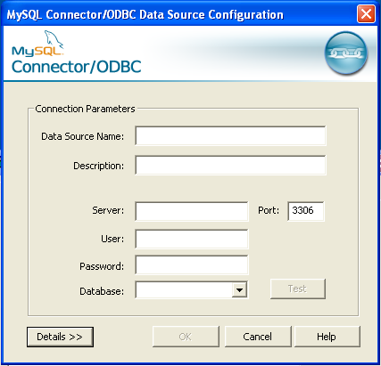

Figure 9. Window where to select the mariadb database

# Running the import-App

To run the application it is necessary to have *administrator rights* in the computer. For run the App as administrator, right click on the file import.bat and select Run as administrator. After a few seconds, a web browser opens. The import-App interface appears directly on the web-browser (see Figure 9) and the application is ready to use!

Once the App is running, it can also be accessed from other computers connected to the Intranet. To access to the import-App from another PC, open a browser (e.g. Mozilla) and type the following Address:

## http://172.21.254.239:3181

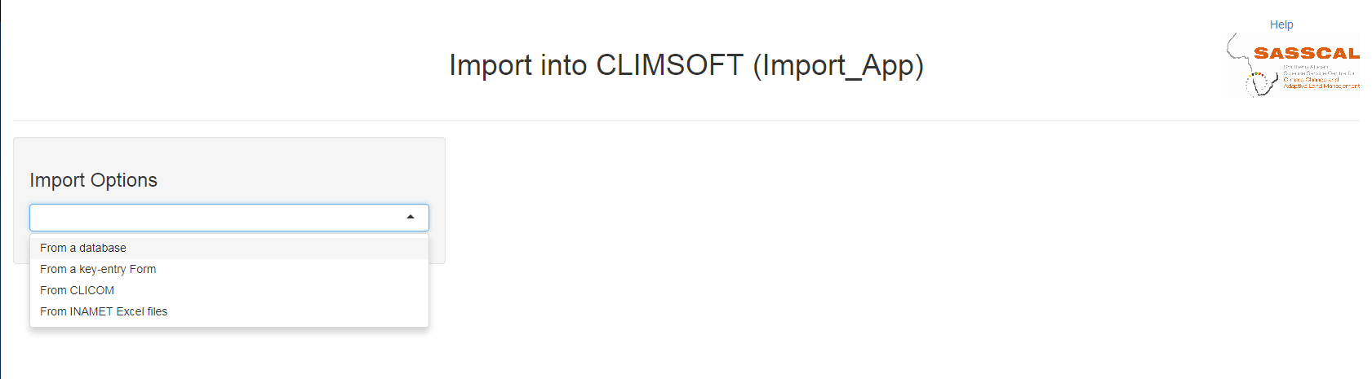

Figure 10. Data source available

# Import options

## From a database

This option is available for all the meteorological services. It will allow the user to import data from a CLIMSOFT database (either access or mariadb) into another CLIMSOFT database (either access or mariadb).

To accomplish the import the user has to follow these steps:

1. Select the database of origin. Select the database where the data to import are stored. Select which type of database is (access or mariadb) and then select one database from the drop down menu Data Name Source (DNS). Please note that the list of DNS refers to the ODBC connections available. Therefore, the database has to be previously defined in the *Open Database Connectivity* Tool (see Section Connection to a database)
2. Select the database of destination: Select the database where the data has to be imported. The user has to define first which kind of database it is (access or mariadb) . and then select one database from the drop down menu Data Name Source (DNS). Again, the list of DNS refers to the ODBC connections available. Therefore, the database has to be previously defined in the *Open Database Connectivity* Tool (see Section Connection to a database)
3. Once step 1 & 2 are completed, a new button called Start Import pops-up. Make klick on it.
4. Wait until the import is completed (may take some time, depending on the amount of data)

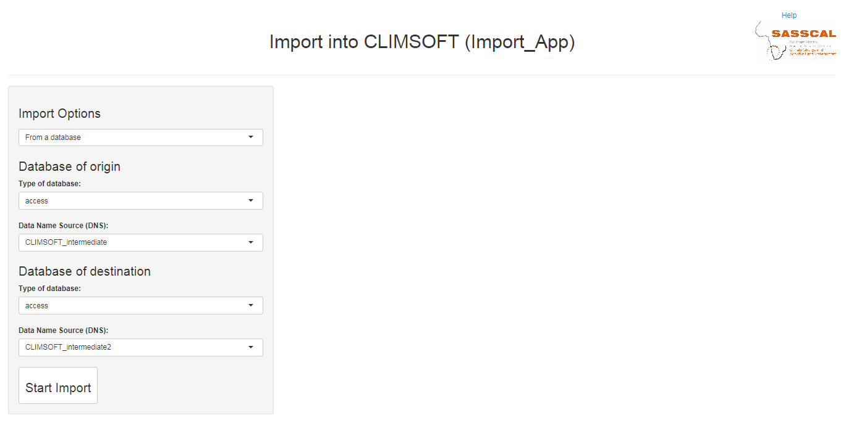

Figure 1. Example of an Import from a CLIMSOFT database to another.

## From a key-entry form

This option is available for all the meteorological services. It will allow the user to import data from a key-entry form into a CLIMSOFT database (either access or mariadb).

To accomplish the import the user has to follow these steps:

1. Browse to find the MS-Excel files containing the data key entered. Once the file is found, selected and click "Open".
2. Select the database of destination: Select the database where the data has to be imported. The user has to define first which kind of database it is (access or mariadb) and then select one database from the drop down menu Data Name Source (DNS). Note that the list of DNS refers to the ODBC connections available. Therefore, the database has to be previously defined in the *Open Database Connectivity* Tool (see Section Connection to a database)
3. Once step 1 & 2 are completed, a new button called Load Data pops-up. Make click on it. Once it is clicked, the data will be shown on the browser, so that the user can make a quick check of the data. If the data are not correct, please make the corrections in the original key-entry form through the keyEntry_App.
4. If the data are fine, then the user can click on Import to database. Wait until the import is completed (may take some time, depending on the amount of data)

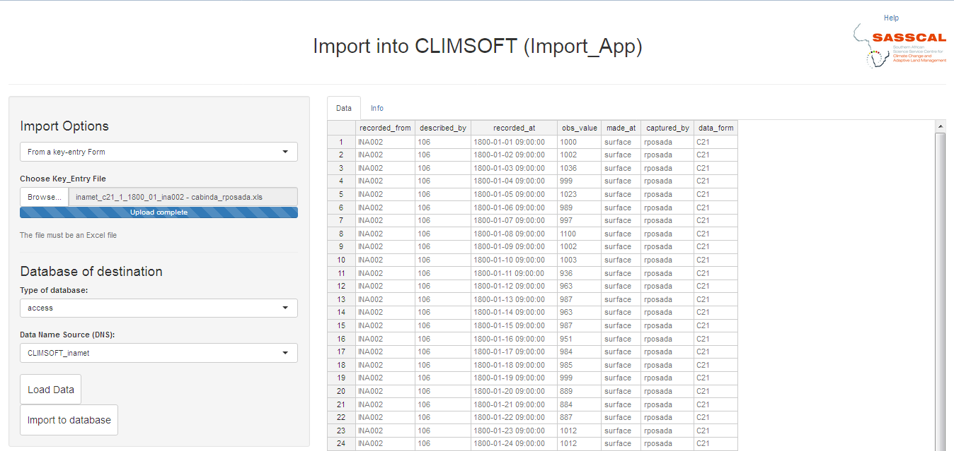

Figure 1. Example of an Import from a CLIMSOFT database to another.

## From CLICOM

This option is available for the Zambia Meteorological Service (ZMD). It will allow the user to import data from CLICOM into a CLIMSOFT database (either access or mariadb).

To accomplish the import the user has to follow these steps:

1. Select the Element Code. The user has to know previously which element he/she wants to import (e.g. Precipitation). Each element has a code number in CLIMSOFT. This number is the one that has to be entered in this field. As an example, the code of precipitation is 5.
2. Browse to find the '.DLY' file(s) containing the data. These files are those retrieved from CLICOM. Once the file(s) is found, selected it(them) and click "Open".
3. Select the database of destination: Select the database where the data has to be imported. The user has to define first which kind of database it is (access or mariadb) and then select one database from the drop down menu Data Name Source (DNS). Note that the list of DNS refers to the ODBC connections available. Therefore, the database has to be previously defined in the *Open Database Connectivity* Tool (see Section Connection to a database)
4. Once step 1 to 3 are completed, a new button called Start Import pops-up. Make click on it to start the import of the data.
5. Wait until the import is completed (may take some time, depending on the amount of data)

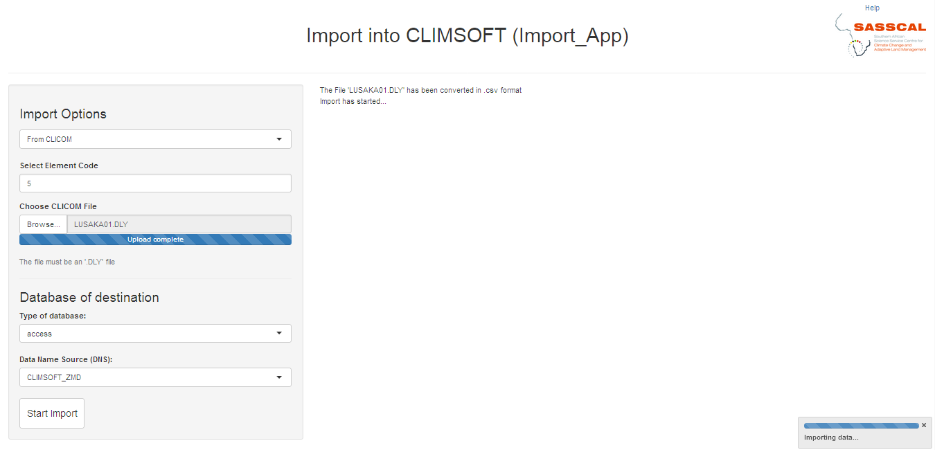

Figure 1. Example of an Import from a CLIMSOFT database to another.

## From old MS-Excel files

This option is available for the National Meteorological Service of Angola (Instituto Nacional de Meteorologia e Geofísica, INAMET). It will allow the user to import data from old Excel files used as key entry forms at INAMET, into a CLIMSOFT database (either access or mariadb).

To accomplish the import the user has to follow these steps:

1. Choose the inventory. The user has to browse for the inventory that contains metadata information about the station which data should be imported into CLIMSOFT. This inventory is an MS-Excel file.
2. Choose the forms. The user has to browse and select the MS-Excel file(s) with the old forms. There are two types of forms: daily and monthly (see Figures below)

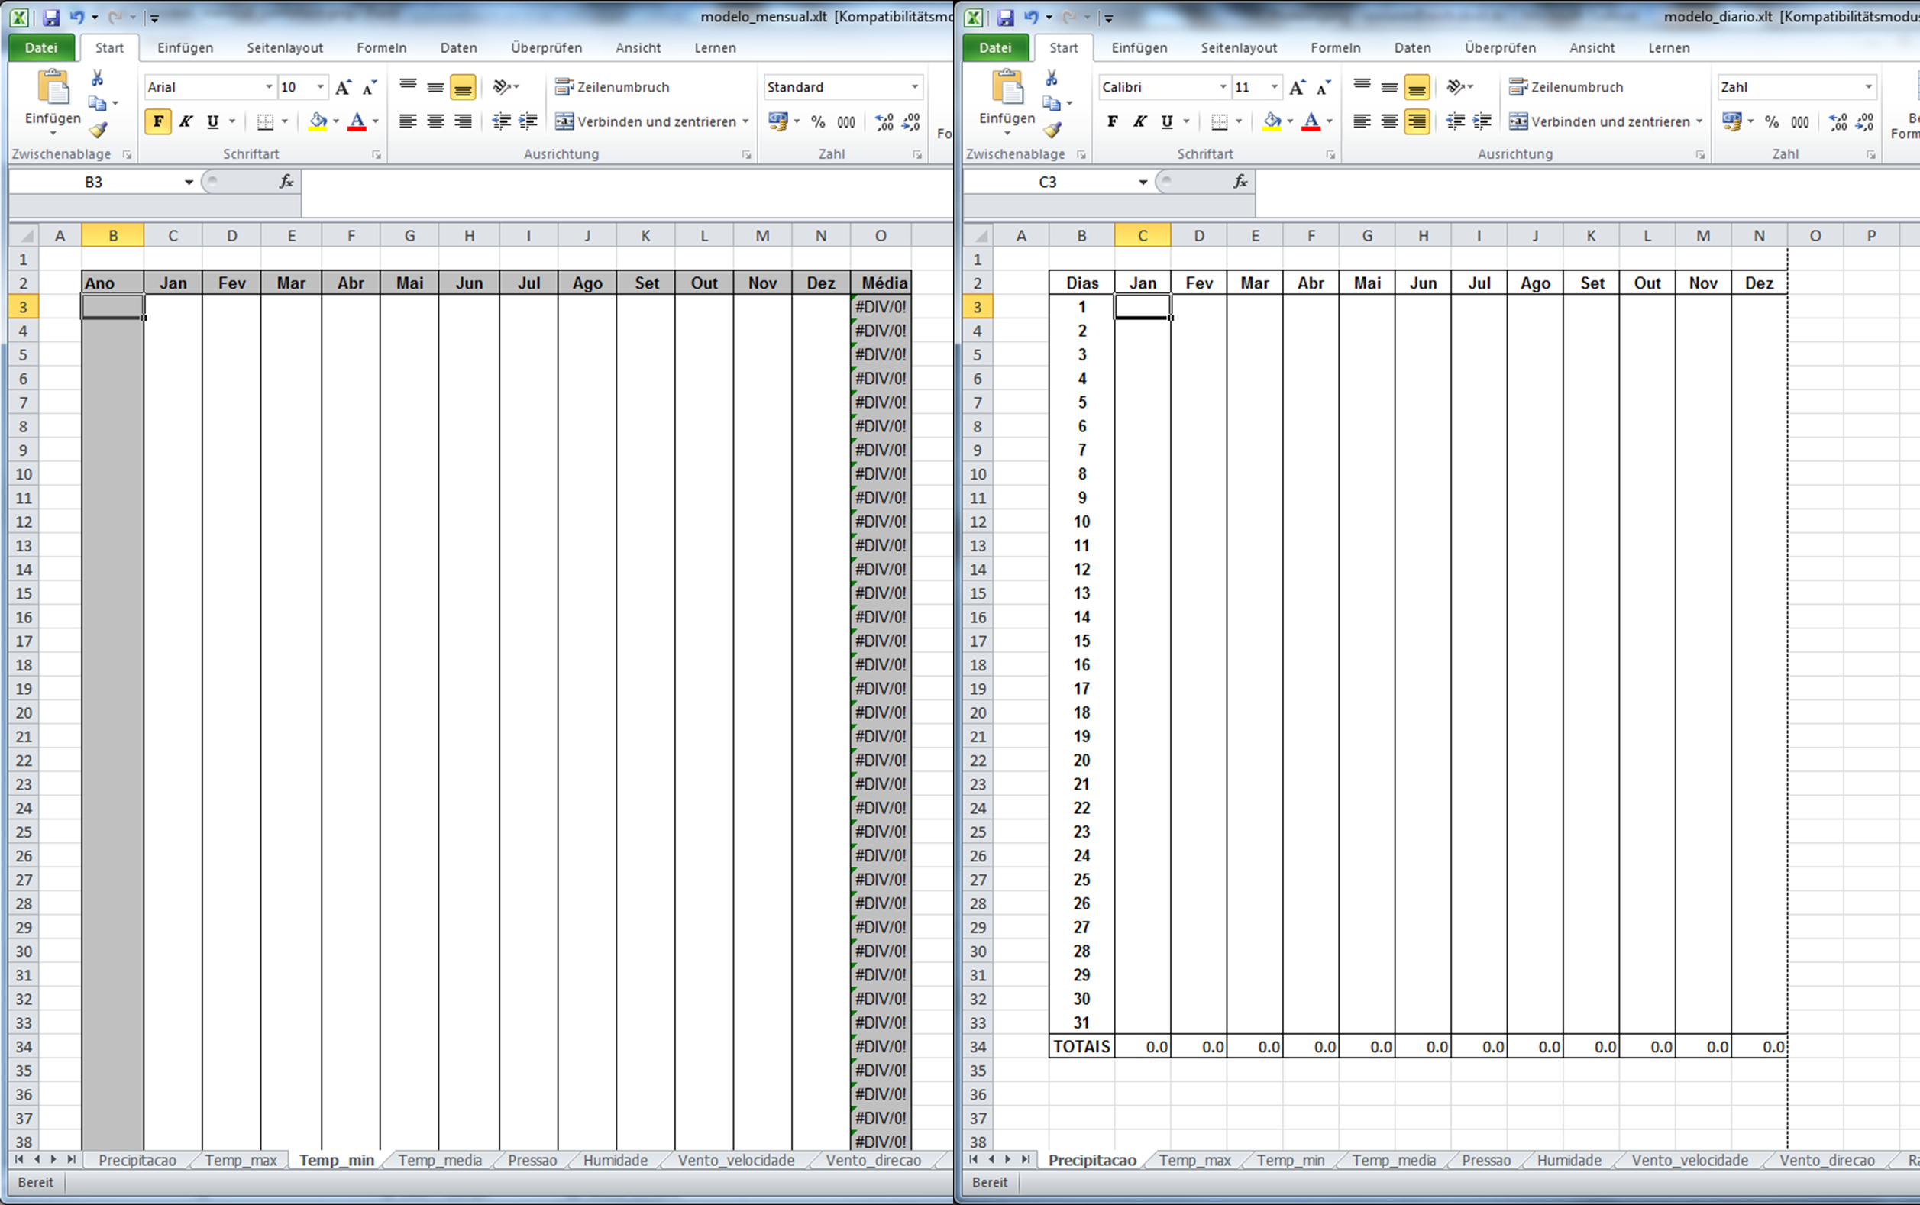

Figure XX. Screenshot of the (left) monthly and (right) daily form templates used in the past at INAMET

1. Select the database of destination: Select the database where the data has to be imported. The user has to define first which kind of database it is (access or mariadb) and then select one database from the drop down menu Data Name Source (DNS). Note that the list of DNS refers to the ODBC connections available. Therefore, the database has to be previously defined in the *Open Database Connectivity* Tool (see Section Connection to a database)
2. Once step 1 to 3 are completed, a new button called Start Import pops-up. Make click on it to start the import of the data.
3. Wait until the import is completed (may take some time, depending on the amount of data)

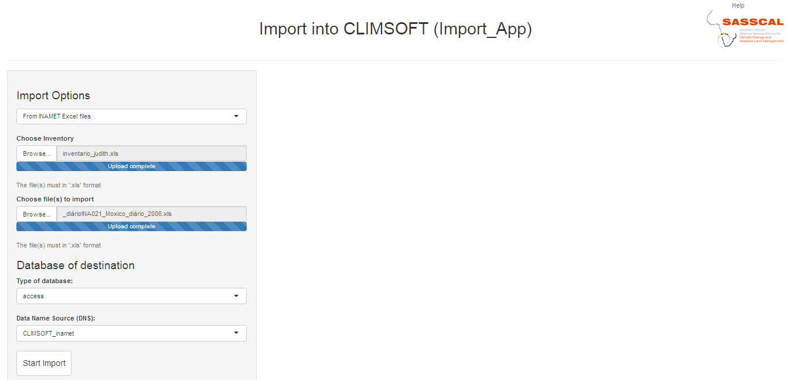

Figure 1. Example of an Import from a CLIMSOFT database to another.

# References

ETCCDI/CRD (2017). *ETCCDI/CRD Climate Change Indices. Software* <http://etccdi.pacificclimate.org/software.shtml> [last accessed: 24.04.2017]

RStudio (2017). *Easy web applications in R*. <https://www.rstudio.com/products/shiny/> [last accessed: 11.04.2017]

Wickham (2017). *R Packages*. <http://r-pkgs.had.co.nz/intro.html> [last accessed: 12.04.2017]

Wikipedia (2017). *Open Database Connectivity*. <https://en.wikipedia.org/wiki/Open_Database_Connectivity> [last accessed: 11.04.2017]