Hosting your Webpage

Terminal

How to open the terminal
> Press the Window Key
> Type ‘Terminal’ and you will see it appear in the search section
> Click on ‘Terminal’ or hit ‘Enter’
> This will open the Terminal Window
> It will look something like this:

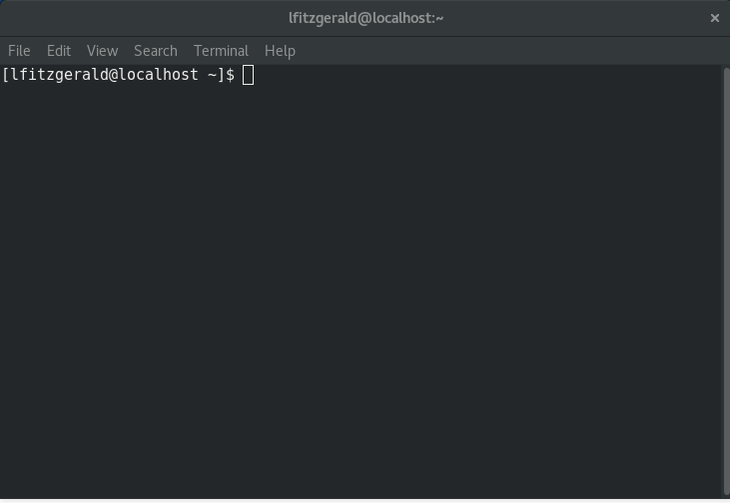

How to navigate around folders in the terminal

You will see C:\>User\<username>\ .This is your folder path.
This tells you what folder you are in.
To see what is the folder type ‘ls -al’ and hit enter. (see the image below for an example)

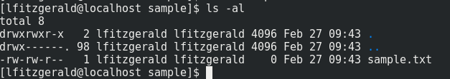

This will show you a list of all files and folders inside the folder you are currently in. To move to a different folder inside the folder you are currently in type: cd <folder> (see the image below for an example. cd=Change Directory

Your folder path will change to C:\User\<username>\<folder>

Using these you commands you should be able to get to the folder where your My-First-Website files are stored. This is where we want to initialise (create) our local git repository (project).

NOTE: If you go into a folder that you want to get out of type ‘cd ..’ and hit enter. This brings you back up one folder.
NOTE: You can use tab to complete folder names. E.g type ‘cd sam’ If you hit tab at this point
and there is a folder that matches like the sample folder, the terminal will complete it for you.

You can find a list of some Linux terminal commands here. Although you may not need them all for this task these are good commands to know.

Git and Github.com
Git is a program used to manage source code. Source code are the files and folders that make up your website (i.e. everything inside your My-First-Website folder)

First of all we need to install git. You can check if git is installed by running ‘git’ in the terminal. If you get output ‘git: command not found’ then you need to install it.
To do this follow the instructions @ https://git-scm.com/download/linux
If you get output with instructions on how to use git then it is already installed on your machine.
The image below shows how the local repository (your folder with your website code) and the remote repository (your project on github) relate to each other.
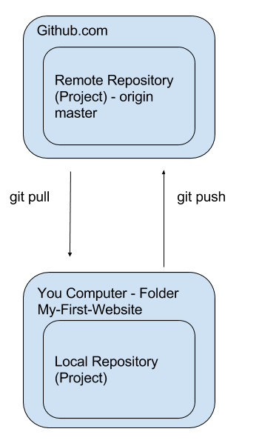
In order to set up the remote repository (project) on github we created an account on github.com.

In order for the website to be hosted we created a New Repository (Project) and named it using the following syntax <username>.github.io
This step is essential for the hosting to work.

Once the repo is created on github we go back to Command Prompt to get our files into that repository.

The git commands we used:

Inside your My-First-Website run the following commands:

- echo “# <reponame> “ >> README.md

The above command creates a README.md file and puts the name of your repository into the file.

- git init

The above command tells the folder we are in that we want it to be a git repository. (we only need to do this command once)

- git add README.md

The above command tells git to add the ‘README.md’ file to a ‘staging area’ (don’t worry about what this means right now). This tells git that we will ‘commit’ this file at some point.

- git commit -m “first commit”

The above command tells git to create a ‘commit’ (which bundles any files that we added previously together)

- git remote add origin https://github.com/<username>/<reponame>.git

The above command tells the folder where the remote repository (that we previously created) is. What’s important is to use your own username and reponame where it is indicated. So instead of <username> put your actual github username instead. And instead of <reponame> put the name of the repo instead.

- git push -u origin master

The above command tells git to push any commits we have created to the repository. The first time you do this you will be asked to sign in to github. Once you have done this you will see some output on the command line like the following:

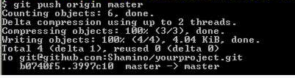
Once this command is complete go to github and see the files in your project. You should see a README.md file there.

Now that we have set up our folder to be able to push the local files to the remote github project it is now much simpler to push the rest of the files. Follow the below steps to get your other files up there.
NOTE: Make sure that you are in your My-First-Website folder and NOT any other folder on your computer when you do these commands

- Type ‘git status’ and press enter to see what files are in your folder
- Type ‘git add <filename>’ for each of the files that you want to add i.e. for your index.html file type ‘git add index.html’
- See your files by typing ‘git status’
- Any files in green are ready to be committed. Any files in red have not been added yet. If there are files in red that you want to add run the ‘git add <filename>’ for those files also.
- Once all the files that you want to add are green then carry on.
- To commit the files run ‘git commit -m “adding more files”’.
- The -m indicates the message we want to include with the commit.
- Run ‘git status’. There should be no more files in green. This means that they are now in the commit.
- Run ‘git push’
- This will push the files up to github.
- Once you have (at least) an index file in the github repo you can go to your website in your browser.
- The address should be : <github-username>.github.io/index.html

