Software Requirements Specification

Inventory Management System
Prepared by: Sassie Sarwar

1. Introduction

1.1 Purpose
This document specifies the software requirements for the Inventory Management System (IMS), a web-based application designed to help an organization track products, stock levels, suppliers, and purchase orders. It is intended to guide the design, development, and testing of the system from start to finish.

1.2 Scope
The IMS will allow staff to register and manage products and categories, maintain supplier records, record purchase orders, track incoming and outgoing stock, generate inventory reports, and support barcode-based product identification. The system will be accessible through a web browser and backed by a relational database.

1.3 Intended Audience
- Development team — for implementation reference
- Project reviewer — to evaluate the system against defined scope
- End users (Store staff, Admin) — to understand system capabilities

1.4 Definitions and Abbreviations
- SRS — Software Requirements Specification
- ERD — Entity Relationship Diagram
- SKU — Stock Keeping Unit
- CRUD — Create, Read, Update, Delete
- Admin — User role with full system access

2. Overall Description

2.1 Product Perspective
The IMS is a standalone, self-contained web application built as a new system. It follows a typical three-layer architecture: a browser-based front end, a Python (Flask) back end exposing application logic, and a MySQL relational database.

2.2 User Classes and Characteristics
- Admin — Full access: manage products, categories, suppliers, users, purchase orders, and view all reports.
- Staff — Limited access: record stock in/out transactions, view product and stock information, raise purchase requests.

2.3 Operating Environment
- Server: Python 3.x with Flask framework
- Database: MySQL 8.x
- Client: Any modern web browser (Chrome, Edge, Firefox)
- Frontend: HTML5, CSS3, Bootstrap, JavaScript

2.4 Design and Implementation Constraints
- Project is planned around a phased schedule: design, backend development, frontend development, and testing/documentation.
- Source code must be version-controlled using Git/GitHub with regular, meaningful commits.

2.5 Assumptions and Dependencies
- A single organization/store is assumed (no multi-tenant support).
- Barcode support refers to generating/reading SKU-style codes, not physical scanner hardware integration unless time permits.

3. System Features (Functional Requirements)

3.1 User Authentication
ID | Requirement | Description
FR-1 | User Login | Registered users (Admin/Staff) can log in with username and password. Passwords are stored hashed.
FR-2 | Role-based Access | System restricts pages/actions based on user role (Admin vs Staff).

3.2 Product Management
ID | Requirement | Description
FR-3 | Add Product | Admin can add a new product with name, category, SKU/barcode, unit price, and reorder level.
FR-4 | Edit / Delete Product | Admin can update or remove existing product records.
FR-5 | Category Management | Admin can create and manage product categories.
FR-6 | Search & Filter Products | Users can search products by name, SKU, or category.

3.3 Supplier Management
ID | Requirement | Description
FR-7 | Manage Suppliers | Admin can add, edit, and view supplier contact and address details.

3.4 Purchase Orders
ID | Requirement | Description
FR-8 | Create Purchase Order | Admin can create a purchase order for a supplier, listing products and quantities.
FR-9 | Track Order Status | Purchase orders have a status (Pending, Received, Cancelled).
FR-10 | Receive Stock | Receiving a purchase order automatically increases stock quantity for each product.

3.5 Stock Tracking
ID | Requirement | Description
FR-11 | Stock In / Stock Out | Staff can record manual stock movements with a reason/reference.
FR-12 | Low Stock Alerts | System flags products where quantity in stock is at or below the reorder level.

3.6 Reporting
ID | Requirement | Description
FR-13 | Inventory Report | Generate a current stock report, filterable by category.
FR-14 | Transaction History | View historical stock in/out transactions for a given product or date range.

3.7 Admin Dashboard
ID | Requirement | Description
FR-15 | Dashboard Overview | Admin dashboard shows total products, low-stock count, pending purchase orders, and recent activity.

4. Non-Functional Requirements
ID | Requirement | Description
NFR-1 | Usability | Interface should be simple and usable by non-technical store staff with minimal training.
NFR-2 | Performance | Common pages (product list, dashboard) should load within 2 seconds under normal load.
NFR-3 | Security | Passwords hashed; role-based access enforced on every protected route.
NFR-4 | Reliability | System should handle invalid input gracefully without crashing.
NFR-5 | Maintainability | Code should follow consistent naming conventions and be commented for readability.
NFR-6 | Portability | Application should run on any machine with Python and MySQL installed.

5. Database Design Overview (Entity Relationship Diagram)
The diagram below summarizes the core entities and relationships used by the Inventory Management System. Full field-level definitions and SQL scripts will be delivered as part of the Week 2 Database Scripts deliverable.
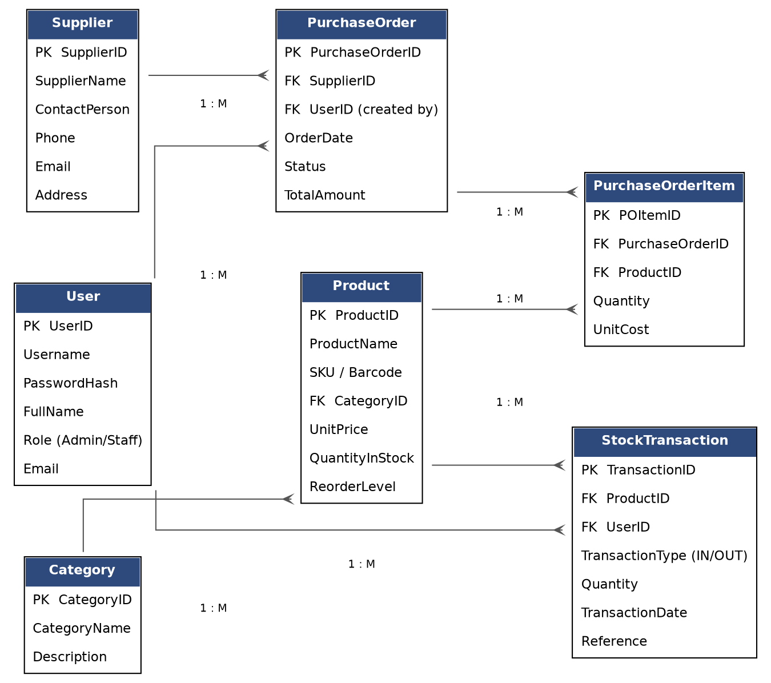

6. Appendix

6.1 Deliverables Checklist
- Software Requirements Specification (SRS) — this document
- Database Design (ER Diagram)
- User Interface Design
- Source Code
- Database Scripts
- User Manual
- Technical Documentation
- Final Presentation
- Project Demonstration
- GitHub Repository

