Using STP in CI 360
Create your segment map
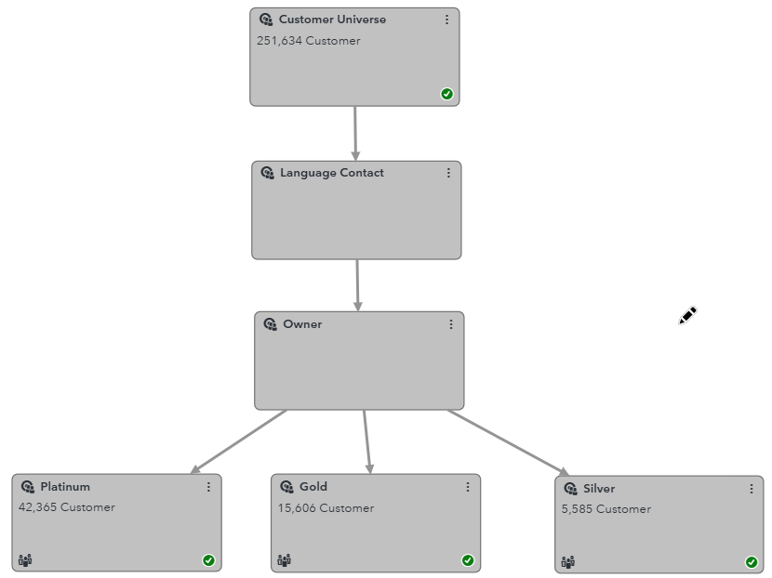
Add a Process Node
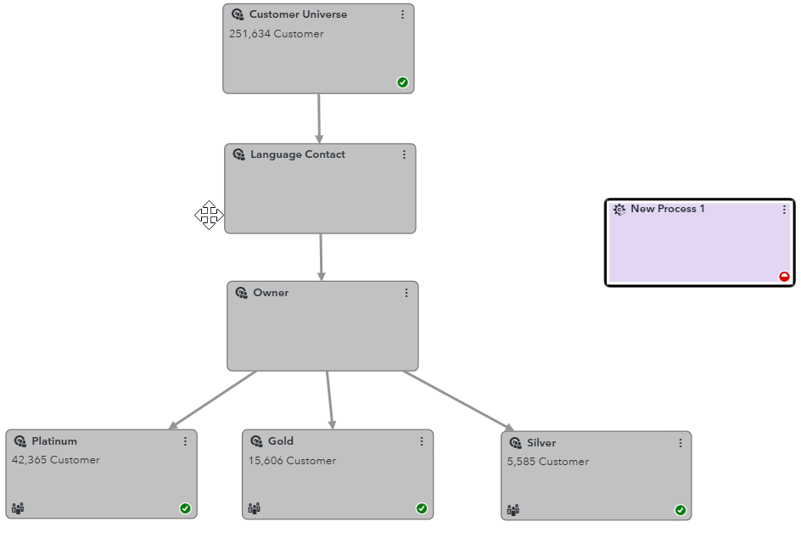

Connect the first node you want to analyze
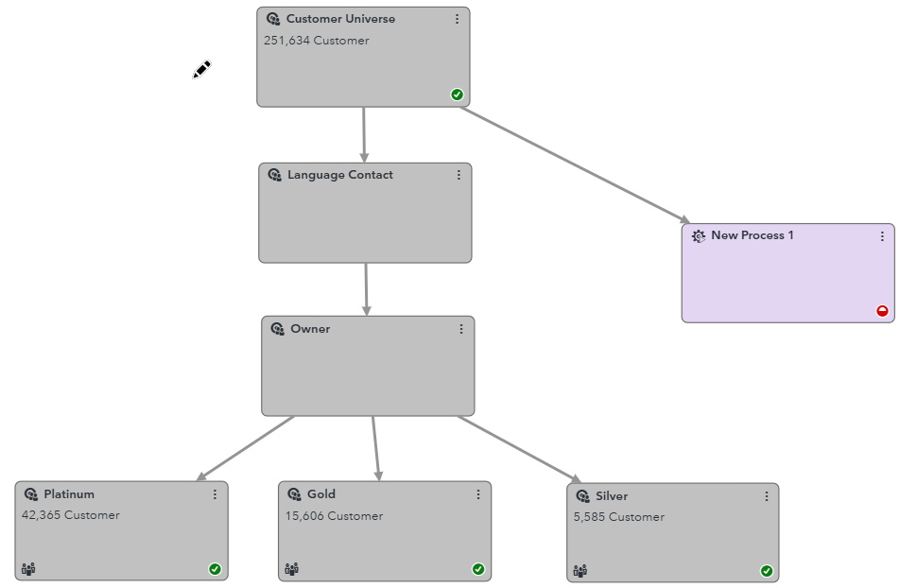
Connect the second node you want to analyze
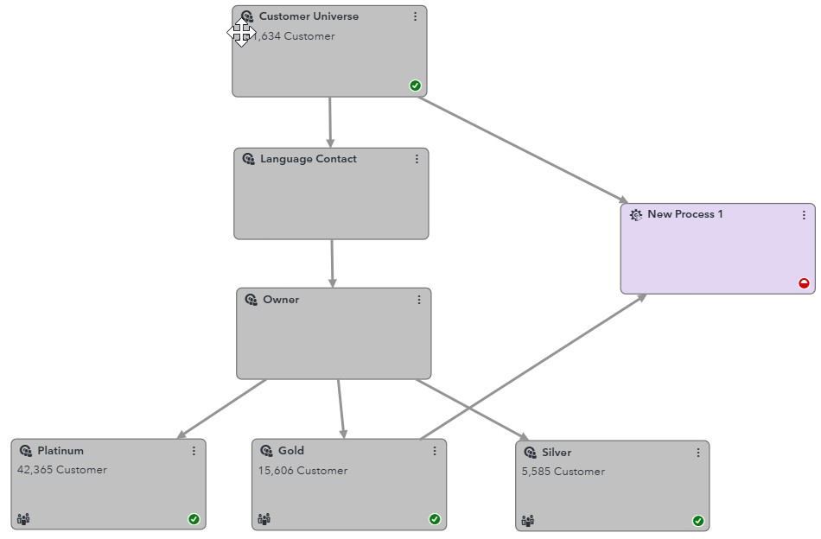

Configure the process node selecting the STP “CUSTOM AND with Waterfall report”
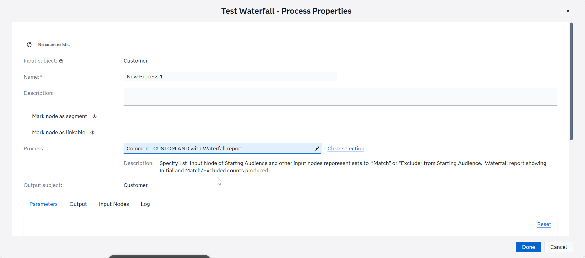
Configure the parameters and enter the email address where you want to receive the report file
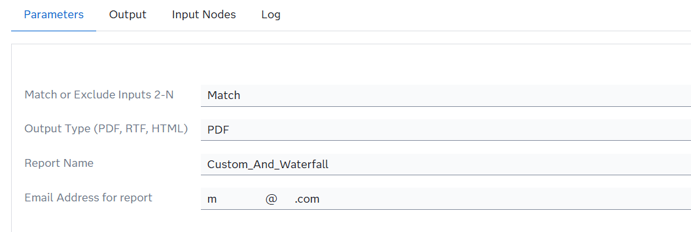

Click on button “Done” and execute de segment
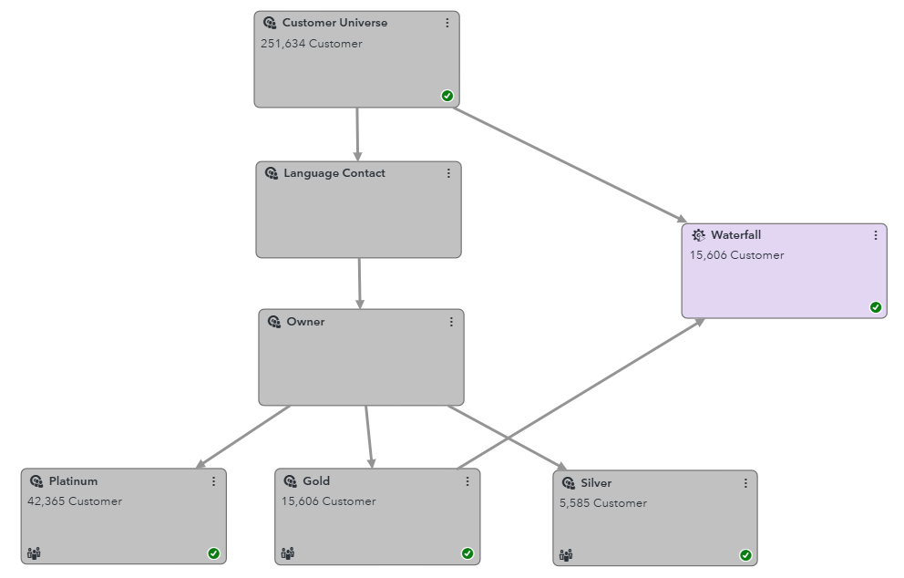
Finally, you’ll receive an email with the report attached!
