CI360 Event Download Agent

Table of Contents
1 Introduction 2
2 Requirements 2
2.1 Java 2
2.2 Database 2
2.3 JDBC Driver for your database 3
3 Installation/Configuration 4
3.1 CI360 Access Point 4
3.2 Agent setup 5
3.2.1 Update agent-custom-configuration.properties 6
3.2.2 Customize run.cmd 6
4 Run 7
5 Appendix A: Optional customization/recompilation of source 8

Introduction
This agent can stream/download any CI360 events into an on-premises database.

This document describes the process of installing and customizing the tool to your environment. Although, most of the description refers to MS-Windows, this tool can work on Linux too. The description below applies to both platforms (The path names need to be adjusted for Linux)

Download the tool and save it to a directory of your choice, for eg.
C:\SAS\Software\ci360-event-download-agent

Requirements

Java
Download and install Java JDK 17 (or JDK 21.09) from https://learn.microsoft.com/en-us/java/openjdk/download. A JRE will work, if you choose to use the jar file and choose not to compile. A portable installation is also sufficient. For example, on the Windows platform download microsoft-jdk-21.0.9-windows-x64.zip and unzip to create the directory
C:\SAS\Thirdparty\jdk-21.0.10+7

Database
This tool was tested with Microsoft SQLServer 2019 and sample scripts are either described or included here. It is expected to work with other databases and versions too in conjunction with the correct JDBC driver (described below).

Set up a new database or use existing and use the sample script to create three new tables. The sample script included config/table_ddl.sql can be customized to your database. This example is set up to use “CIDB” as the database and "agent" as schema name. The database/schema/table names can be customized to your installation standards.

For SQLServer the following settings may be needed. If you choose not to choose these settings, the JDBC url may need to be adjusted to your installation needs. The tool was tested with the following settings:
- Start the SQL Server Browser or specify the port number when using a SQL Server instance
- Open SQL Server Configuration Manager > SQL Server Network Configuration:
  - Protocols – Force Encryption: No
  - Protocol TCP/IP must be enabled
  - Protocol TCP/IP => Properties => Listen All = Yes
- Restart the services to ensure that the new options take effect

You may need enable the corresponding Windows service (SQL Server Browser)

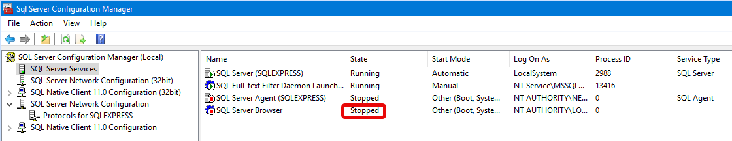

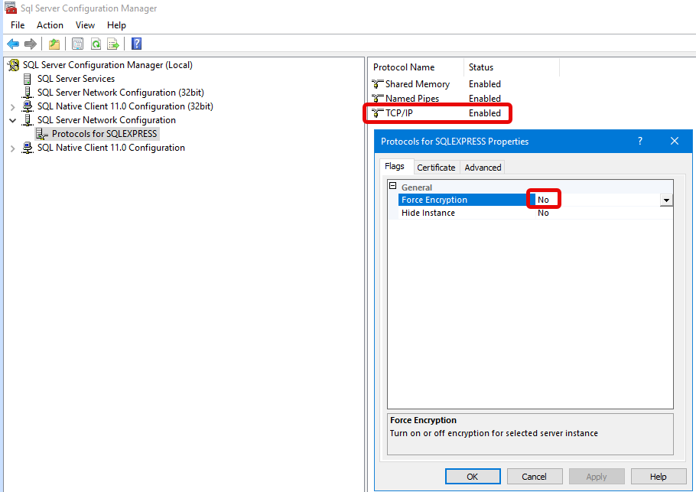

JDBC Driver for your database
Download the Java JDBC driver for the database version which will store the CI360 Events. Ensure the JDBC version is compatible with the Java version. The JDBC jar file needs to be placed in the libThirdParty directory.

As an example, for SQLServer 2019, you can download the JDBC driver here:

https://docs.microsoft.com/en-us/sql/connect/jdbc/download-microsoft-jdbc-driver-for-sql-server

(sqljdbc_12.6.4.0_enu.zip or sqljdbc_13.4.0.0_enu.zip). The most important file to unzip is mssql-jdbc-12.6.4.jre11.jar (or, mssql-jdbc-13.4.0.jre11.jar). This file will need to be copied to the libThirdParty directory as described in the next section.

JDBC authentication can be either via NT or SQL Server.

If using NT authentication, mssql-jdbc_auth-<version>.dll must exist in the Windows PATH and you must run the agent with the same user that can access the SQL Server tables. For simplicity, the dll can be placed in the agents root folder (For example: C:\SAS\Software\mkt-agent-sdk-3.2603.2603231009\) . mssql-jdbc_auth-12.6.4.x64.dll (or, mssql-jdbc_auth-13.4.0.x64.dll) was used for testing, newer versions may be available and applicable.

https://docs.microsoft.com/en-us/sql/connect/jdbc/download-microsoft-jdbc-driver-for-sql-server

jdbc url examples for use in custom configuration:

NT Auth
jdbc:sqlserver://sasbi.demo.sas.com;databasename=CIDB;integratedSecurity=true;encrypt=false;trustServerCertificate=true;

SQL Server Auth
jdbc:sqlserver://SAS-AAP\\SQLEXPRESS;databaseName=CIDB;encrypt=false;trustServerCertificate=true;

Installation/Configuration

CI360 Access Point
Login to CI360, and navigate to the Settings>Access Points. Record the “Gateway host” name for later use

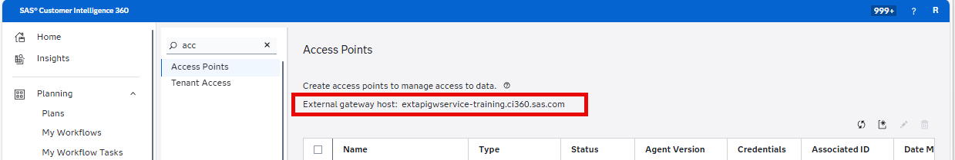

Set up a new General Access point and assign a name of your choice. Record the “Tenant ID” and “Client secret” for later use

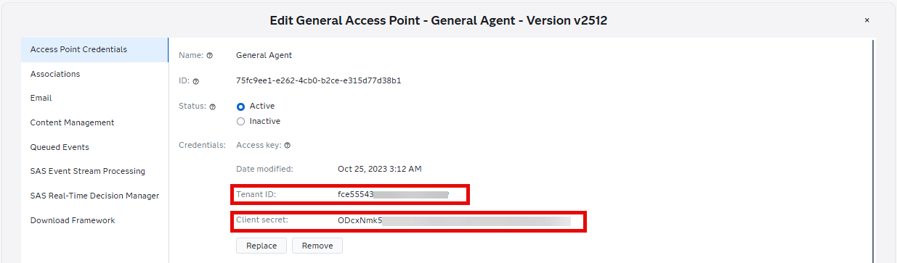

In the “Associations” tab select (for example) Contact and Response from standard events.

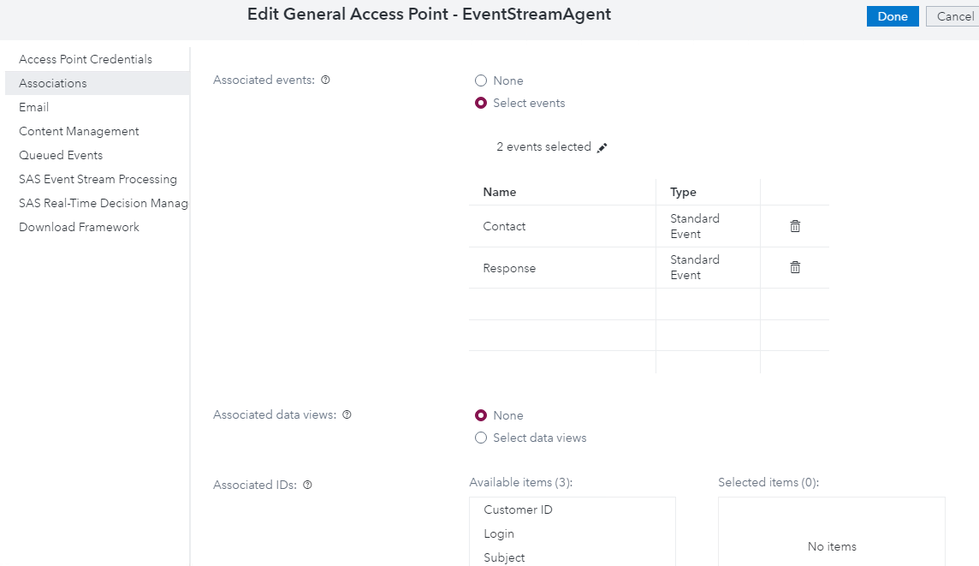

Agent setup
Use the “Download Framework” link in the access point setup (3.1 above) above to download the framework from within the access point and extract to a folder. E.g.

C:\SAS\Software\
mkt-agent-sdk-<version>\
config\
libThirdParty\
…
…
logs

Create the highlighted directory, if it does not already exist, underneath the agent home directory.

Update the config\agent-runtime.properties file to specify an available port for communication:
server.port=10090 (for example)

Copy the jdbc driver jar file downloaded in step 2.3 to libThirdParty\
If using NT authentication for SQL Server, you will also need to copy the mssql-jdbc_auth-<version>.dll from the JDBC download package, to the agent root folder. (for eg. C:\SAS\Software\mkt-agent-sdk-<version>\)

Copy the following files from this tools’ config folder (for eg. C:\SAS\Software\ci360-event-download-agent\config) to the corresponding config folder under the agent:
logback.xml
agent-custom-configuration.properties
Table_ddl.sql (Optional – for reference only)

Copy the following file from this tools’ folder (for eg. C:\SAS\Software\ci360-event-download-agent\) to agent root folder (for eg.)
C:\SAS\Software\mkt-agent-sdk-<version>\
EventStreamAgent-1.0-SNAPSHOT.jar
run.cmd

Update agent-custom-configuration.properties
This file is located (for eg.) in: C:\SAS\Software\mkt-agent-sdk-3.2603.2603231009\config

Name | Description
ci360.gatewayHost | See Section 3.1
ci360.tenantID | See Section 3.1
ci360.clientSecret | See Section 3.1
task.expiresMinutes | Reserved for future use
task.httpTimeoutSeconds | Reserved for future use
task.httpRetries | Reserved for future use
task.sql.user | Reserved for future use
task.sql.pw | Reserved for future use
task.sql.jdbcURL | Reserved for future use
task.sql.taskTable | Reserved for future use
task.sql.customPropertiesTable | Reserved for future use
event.sql.user | Database userid with access permissions to the event table
event.sql.pw | Database user password. This can be blank for SQLServer Integrated Security
event.sql.jdbcURL | JDBC URL to the target database/table
event.sql.table | Name of the event table, include schema qualifier
event.sql.poolSize | Number of threads/processes for inserting to table. Default: 5
event.sql.bufferSize | When the number of events reaches this size, we issue a commit. Default: 100000
event.sql.secondsBetweenSubmits | A commit is performed at this interval even when the buffer is not full. This is the minimum time to wait before all the events are downloaded. Default: 300 seconds
server.port | Choose an unused port for Agent communication with SAS CI360. Default: 10089

Customize run.cmd
- Update JAVA_HOME to the location where you installed Java (for eg. C:\SAS\Thirdparty\jdk-21.0.10+7)
- Update APP_HOME to the location of where you unzipped the Agent software that you downloaded from CI360 access point. Use forward slashes in the path (regardless of whether you are using Linux or Windows)

Run
To start the agent, simply execute run.cmd. Logging is directed to a file in the logs folder named “EventStreamAgent.log” (current days’ file). At the end of each day, the log file is renamed with a date suffix and a new log file is used for the new day.

Appendix A: Optional customization/recompilation of source
The following steps allow you to compile the JAVA source into an executable JAR file that you could use to replace the EventStreamAgent-1.0-SNAPSHOT.jar.

- Ensure that you have installed a valid JDK (See section on 2.1 JAVA in this document)
- Download Apache Maven 3.9.14 (apache-maven-3.9.14-bin.zip) from the binary distribution archive https://maven.apache.org/download.html (While other versions may work…this was the version that was used during testing)
- Copy/Unzip the zip file to (for eg.) C:\SAS\Thirdparty\apache-maven-3.9.14
- From the tool folder (for eg. (for eg. C:\SAS\Software\ci360-event-download-agent\) locate the file (EventStreamAgent_src.zip) and unzip it to a directory of your choice. For eg. C:\workspace\EventStreamAgent\
- Update the file build.cmd in the new directory: (C:\workspace\EventStreamAgent\build.cmd). (For Linux use the file “build.sh”…an untested version of the same file)
  - Ensure JAVA_HOME has the correct path
  - Ensure MVN_HOME corresponds to where you saved Maven software (step #3)
  - Ensure AGENT_HOME corresponds to the path where you saved the agent (See section 3.2)
  - Verify that the “call mvn” command refers to the correct jar version
- Use your favorite editor to customize any of the JAVA source files
- Navigate to the folder created in Step #4 and run the command: “build.cmd” (For Linux, build.sh)
- Successful completion of the step#6, will result in a new directory “target”
  - For eg. C:\workspace\EventStreamAgent\target\
  - The executable JAR file will be created: (C:\workspace\EventStreamAgent\target\EventStreamAgent-1.0-SNAPSHOT.jar)
  - Use the new JAR file in step 3.2 (instead of the one you downloaded as part of the tool software)

