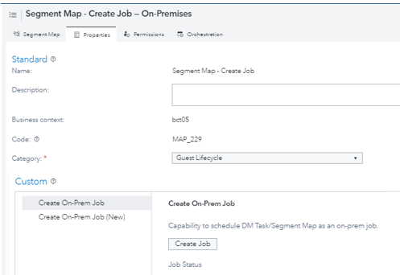
Overview
This application provides the 360 User to create
deployed jobs for a SAS Administrator to schedule
On-Prem.
Marketers click ‘Create Job’ from within the Custom Properties tab of a Segment Map or Direct Marketing Task to create an On-Premises job that is ready to be scheduled.
(This mimics the CI6.x “Send to Admin to Schedule” functionality.)
Users with scheduling capabilities can use the SAS Schedule Manager to:
- Create a time triggered schedule  - Create flows with dependencies between 360 deployed jobs  - Set up notifications for flow start,  success or failed end  - Monitor execution status of flow  Additional capabilities when SAS Schedule Manager leverages Platform LSF:  - File, multiple event triggers for flow  - Monitor job execution status within flow  - Pause, End, Start Flows from Platform Manager User Interface | 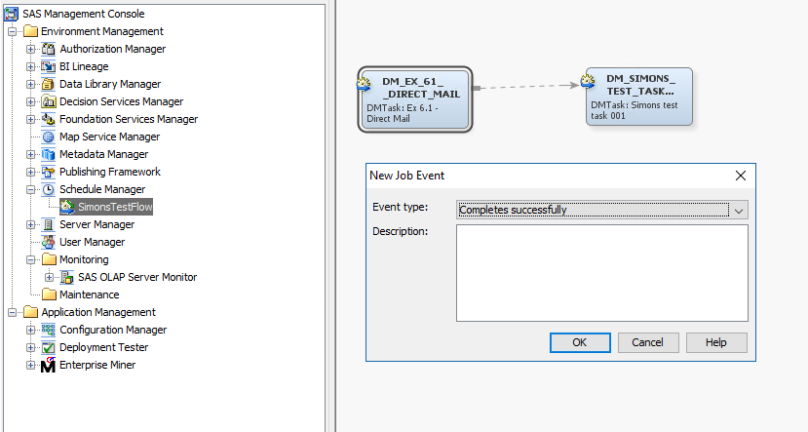  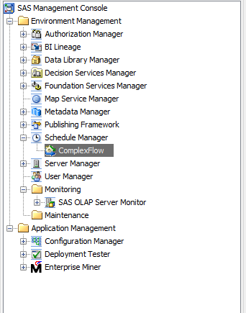

Pre-Requisites
- Java 1.8+
- Python (v3.7.0 +)
- After you have installed the latest Python version and set the appropriate value for ‘Path’ System Environment variable, you may want to open a command prompt (Windows) and run the following command: pip list
- Validate if the following modules are part of the list.
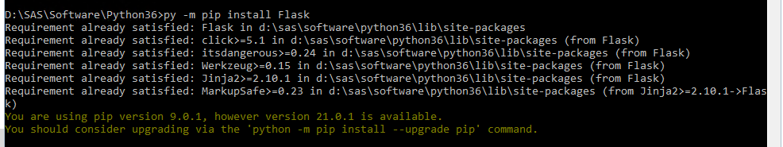
  - Flask
  - Jsonify
  - Configparser
  - Requests
- If not, install each of the missing modules using the
‘pip install’ command. For e.g. : pip install Flask
See https://docs.python.org/3/inhestalling/index.html or similar for information around installing Python Modules for your Python version
- To deploy a SAS 9.4 stored process as a web service, the SAS administrator needs to install one of the following:
  - SAS BI Web Services for .NET, which is part of SAS Integration Technologies
  - SAS Web Infrastructure Platform (WIP) and its associated components, which is included in the Engage: Direct on-premises installation
- Scheduling Server configured in SAS Management Console (Platform Process Manager or Operating System Scheduling Scheduler)
See About SAS 9.4 Scheduling Servers for more information
- User/PW for Scheduling Administrator
- SAS Users Group(s) defined that will act as Schedulers with appropriate capabilities and authorization
  - Schedule Manager capability assigned under Management Console 9.4 capabilities
  - Authorized for access to the Scheduling Administrator account

Included files
All files are found within the parent folder CI360Jobs
Name | Description
../Config/autoexec.sas | Autoexec file for the SAS Stored Process containing all environment variables
../Config/createJob.spk | SAS Stored Process Import Package; Contains createJob.SAS
../Config/createJobCustomProperties.xlsx | Custom Property Worksheet to add the connector to the 360 User Interface
../ConnectorPY/ConnectorProxy.py | Python program that is invoked by the agent to call the on-premises Web Service
../ConnectorPY/conf/serviceConfig.ini | Configuration details for the on-premises Web Service (Stored Process)
../Macros/check_syscc.sas | Checks the system return code.
../Macros/check_value.sas | Checks the validity of required macrovars.
../Macros/execute360object.sas | Uses the public scheduling API to execute the designated Segment Map or DM task.
../Macros/parseJobMetadata.sas | Reads SAS scheduling metadata for required inputs into the code to deploy the SAS jobs.
../Macros/prochttp_check_return.sas | Checks the return code of proc http for success.

Change History
Version | Date | Author | Amendments
0.01 | 11/11/2020 | GCI Consulting | Initial draft for Early Adopters.
1.00 | 2/10/2021 | GCI Consulting | Version 1 Release.

Contacts
Daniel Alvarez Daniel.Alvarez@sas.com
Amy Glassman Amy.Glassman@sas.com
Ronald Mascarenhas Ronald.Mascarenhas@sas.com
Simon Topp Simon.Topp@sas.com

General SetUp
Note: Highlighted text indicates where the actual values for your environment may vary from the example. provided.

Extract contents to On-Prem location
Extract the contents (including subfolders) into a new folder “CI360Jobs” within a directory on your compute tier where your other SAS configurations and code are stored.
A location for a standard CI implementation may be /SAS/software/CI360Jobs (at the same folder level of your CI360DirectAgent). | Example  D:\SAS\Software\CI360DirectAgent <-Direct Agent  D:\SAS\Software\CI360Jobs <-CI360 Jobs code and  related files
Ensure that your SAS Service account (e.g., sassrv) that will run SAS 9.4 stored processes and your scheduling user has full permissions to this parent CI360Jobs folder and all subfolders.
../CI360Jobs
../CI360Jobs/Config
Note: All setup and configuration instructions will use the folder name CI360Jobs throughout this file.
You can name this parent folder whatever you wish as all path names are parameterized in the autoexec.
../Config/autoexec.sas
../createJobCustomProperties.xls
../createJob.spk
../CI360Jobs/ConnectorPY
../ConnectorPY/ConnectorProxy.py
../CI360Jobs/ConnectorPY/conf
../ConnectorPY/conf/serviceConfig.ini
../CI360Jobs/ConnectorPY/logs
../CI360Jobs/DeployedJobs
../CI360Jobs/Jobs
../CI360Jobs/Macros
../Macros/check_syscc.sas
../Macros/check_value.sas
../Macros/execute360object.sas
../Macros/parseExecutionStatus.sas
../Macros/parseJobMetadata.sas
../Macros/prochttp_check_return.sas
../CI360Jobs/StoredProcesses

Create a General Access Point within 360 Tenant
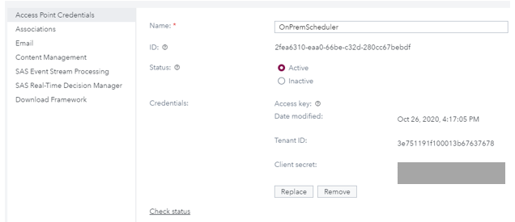
To use these methods, you must first create an Access Point.
Log into 360 and navigate to General Settings->External Access-> Access Points. If you do not already have a suitable access point, create one. Add and name the access point under Access Point Credentials and mark it as Active.
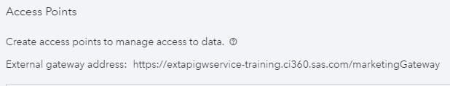
Note the Tenant ID, Access Point Name, Client Secret and the external gateway address displayed at the top of the page as you will provide them as environment parameters in several steps.
Example:

Scheduler Manager Configuration Tasks

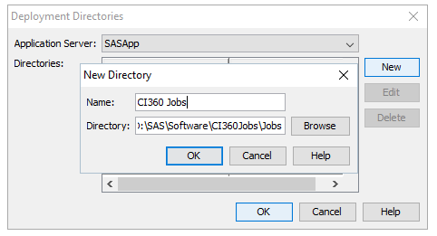
Create a new 360 Jobs Directory
Log into SAS Management Console as a scheduling administrator. Right Click on Scheduler Manager to select to manage Deployment Directories.
Click New to add a new directory. Navigate to the target directory created in step one of these instructions.:
Name: CI360 Jobs
Directory: /SAS/software/CI360Jobs/Jobs
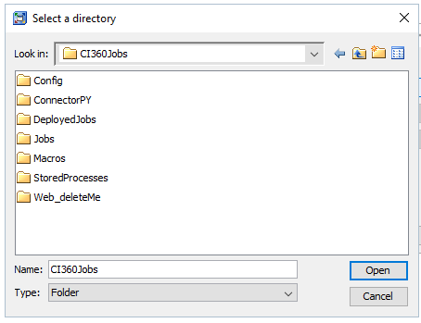
Click OK to accept the entry.

Create a new 360 DeployedJobs Directory
Repeat these steps to create the Click New to add a new directory for the CI360 Deployed Jobs.
Name: CI360 Deployed Jobs
Directory: /SAS/software/CI360Jobs/DeployedJobs
Click OK to exit managing deployed directories.

Stored Process Implementation Tasks

Enable Basic authentication for the STP web app
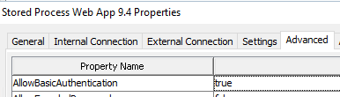
Log into SAS Management Console as an administrator. Navigate to Application Management\ Configuration Manager\SAS Application Infrastructure\Stored Process Web App 9.4.
Right-click to select Properties and select the
Advanced tab. Ensure that AllowBasicAuthentication
is set to true.

Import the Stored Process

6.1 Create Metadata Folders
Log into SAS Management Console as an administrator and create the following metadata folders.
Shared Data\Customer Intelligence\CI360Jobs\Stored Processes
Shared Data\Customer Intelligence\CI360Jobs\Jobs
Shared Data\Customer Intelligence\CI360Jobs\Deployed Jobs

Ensure that the user groups that will be granted scheduling capabilities have read/write metadata permissions to these folders.

In this example, members of the Customer Intelligence Scheduling Users group will be using the Scheduler Plug-in to submit the deployed jobs to Platform Scheduler.

This group has been granted access to the lsfadmin account.  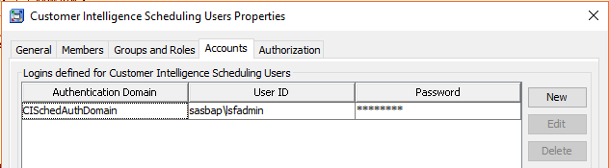 | This group has been granted full rights to the CI360Jobs metadata folder.  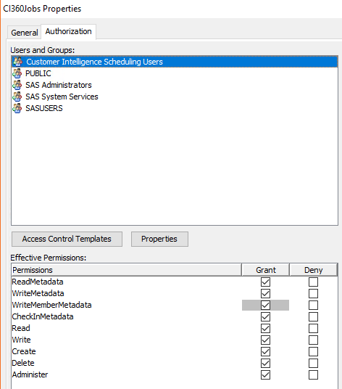

6.2 Import createJobv2.0.spk to SAS Management Console
Copy this file if needed to a location accessible to your SAS Management Console client.
Save the CreateJob SAS stored process in the new ..\CI360Jobs\Stored Processes folder.

Save the source createJob.sas file on your compute tier in the new ../CI360Jobs/StoredProcesses folder.

6.3 Remove Stored Process Macros

As written, the stored process code does not contain %stpbegin / %stpend statements. If you will be editing or reviewing this code from SAS Enterprise Guide, explicitly remove these macro inclusions from the editor so they will not be inadvertently added into the code.
In Enterprise Guide, navigate to ../CI360Jobs/StoredProcesses and open the createJob stored process.
Navigate to the SAS Code window and deselect the option to Include code for Stored process macros. Click Save to save these changes and exit.

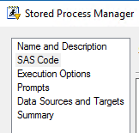
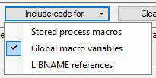
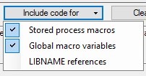

Configure autoexec.sas
This SAS program contains macrovar assignment statements to assign site and tenant specific details and credentials for authorization. Values <<IN BRACKETS>> must be edited for each site. All values should be confirmed for any deviation from the set step names/paths provided.

7.1 Set Tenant Information
Name | Description | Sample Value
ENDPOINT | External gateway address for Tenant from 360 | https://extapigwservice-training.ci360.sas.com
TENANT_ID | Tenant ID from 360 UI | 3e***678
SECRET_KEY | Tenant Secret | ABCDEFGHIJK
TENANT_NAME | Label for Logs – Tenant Name | GCIE Sample Tenant
ENVIRONMENT_NM | Label for Logs – Tenant Environment | 'DEV' (include single quotes)

  - Set Metadata Information

Name | Description | Sample Value
METAPARENT | SAS Metadata Folder where all Metadata for CI360Jobs lives | /Shared Data/Customer Intelligence/CI360Jobs
META_JOB_FOLDER | Metadata folder for Jobs | (inherits from METAPARENT)
META_DEPLOY_FOLDER | Metadata folder for Deployed Jobs | (inherits from METAPARENT)
META_COMPUTE_LOC | SAS Compute Tier for scheduling | SASApp
META_BATCH_SERVER | SAS Batch Server for scheduling | SASApp – SAS DATA Step Batch Server
META_JOB_DIR | Directory for jobs on the SAS Batch Server | 360 Jobs (set up step 3)
META_DEPLOY_DIR | Directory for deployed jobs on the SAS Batch Server | 360 Deployed Jobs (set up step 4)
META_RESPONSIBLE | Metadata User who will be creating, deploying jobs | sasdemo

Example Images from SAS Management Console:
METAPARENT | META_COMPUTE / META_BATCH_SERVER
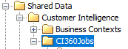 | 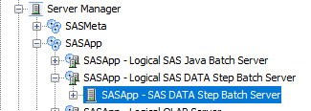

  - Set Jobs location
Name | Description | Sample Value
CI360_FOLDER | Full path of the CI360Jobs folder created in Step 1 | D:\SAS\Contexts\CI360Jobs
JOB_DIR | Folder name for the jobs created with the createJob stored process. | Jobs (set up step 1)
DEPLOY_DIR | Folder name for the deployed jobs created with the createJob stored process. | Deployed Jobs (set up step 1)
JOB_FOLDER | Full path of the CI360Jobs/Jobs folder for .sas jobs created by the stored process | (Inherited)
DEPLOY_JOB_FOLDER | Full path of the CI360Jobs/DeployedJobs folder for .sas jobs created by the stored process | (Inherited)
MACRO_FOLDER | Full path of the CI360Jobs/macros folder | (Inherited)
AUTOEXEC | Full path of the CI360Jobs/Config/autoexec.sas file | (Inherited)
SAS_LOG_REDIRECT | Indicate Y to redirect the log to &CI360_FOLDER.Logs | Y

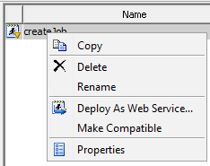
- Deploy the Stored Process as a Web Service
Within SAS Management Console, navigate to the folder where
the metadata for the stored process lives.
Right-click on createJob and select Deploy as a Web Service

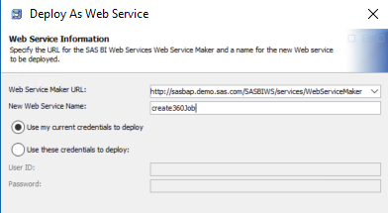
Select the Web Service Maker URL that has
been configured for the environment.
Check with your SAS Administrator if no
values are available, or you are unsure which
to select when one or more present.
Provide a name for the Web Service:
create360Job
Leave the default Use my current
credentials to deploy checked.
Click Next.

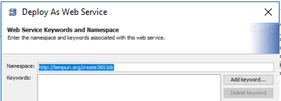
Note the Namespace. Click Next.

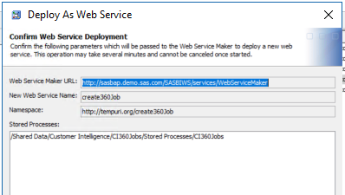
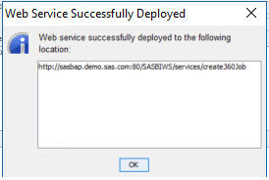
Review the values for the deployment. Click Finish and review the location
of your new web service. Click OK.

Connector Implementation Tasks
- Download Agent Framework
Download the general framework for the general access point found within General Settings->External Access->Access Points>Download Framework
It is recommended to save unzip and save the framework in a location accessible for common use, preferably near the Direct Agent. | Example  D:\SAS\Software\CI360DirectAgent <-Direct Agent  D:\SAS\Software\CI360GeneralAgent <-New General Agent
- Configure Agent
Follow the instructions contained within the zip file On Premise Agent Installation Guide.docx.

10.1 Configuring Agent Endpoint
For the on-premises agent to process events from SAS Customer Intelligence 360 an endpoint must be configured. When the on-premises agent starts up it will use this endpoint to connect to the SAS Customer Intelligence 360 marketing gateway.
Edit the ..\config\agent-endpoints.properties file and set the following property with the external gateway address gathered in step 2:
event.streaming.endPointNodeName= extapigwservice-training.ci360.sas.com:443

The port number should always be 443.

10.2 Configuring Event Streaming
For the on-premises agent to authenticate with the endpoint, the tenant ID and client secret must be added to the agent configuration. Edit the ..\config\event-streaming-configuration.properties file within the on-premises agent config folder and set the following properties with the TenantID and Secret gathered in step 2:
event.streaming.tenantID=<<your tenant id>>
event.streaming.clientSecret=<<your secret>>

Agent Start Up
From a command line navigate to the bin folder and run the respective script for Windows or UNIX. For Windows, the mkt-agent-sdk.bat file would be executed. This will start the agent shell.
Meanwhile, in the background the on-premises agent will have automatically connected to the SAS Customer Intelligence 360 endpoint configured earlier and will start sending those events to any enabled plug-in that needs to process it.
Type “help” from the on-premises agent console for assistance and type “agent stop” to stop the agent.
Additional information about running the agent as a service is available in the On Premise Agent Installation Guide.docx found within the downloaded agent framework.


Configure Connector
In the 360 UI, navigate to General Settings->External Access->Connectors. Click to create a new Connector.
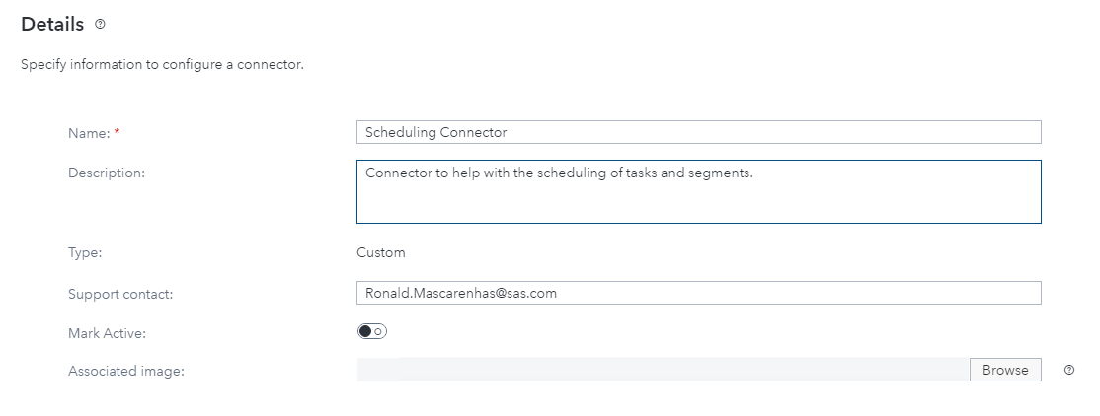
Enter a name and description in the Details Section. Enter your solution Admin for support contact.

Click New Endpoint and enter the details of the on-premises web service.
The URL should be as shown below:
http://##/SASStoredProcess/do1?_username=**&_password=^^&_program=/Shared+Data/Customer+Intelligence/CI360Jobs/Stored+Processes/createJob&OBJECT_TYPE=DMTask&Description=&OBJECT_ID={{$objectid}}&OBJECT_NAME={{$objectname}}
## SAS Server where the STP is hosted
** SAS MA Username
^^ SAS MA User password
For example: http://sasbap.demo.sas.com/SASStoredProcess/do1?_username=sasdemo&_password=12345&_program=/Shared+Data/Customer+Intelligence/CI360Jobs/Stored+Processes/createJob&OBJECT_TYPE=DMTask&Description=&OBJECT_ID={{$objectid}}&OBJECT_NAME={{$objectname}}
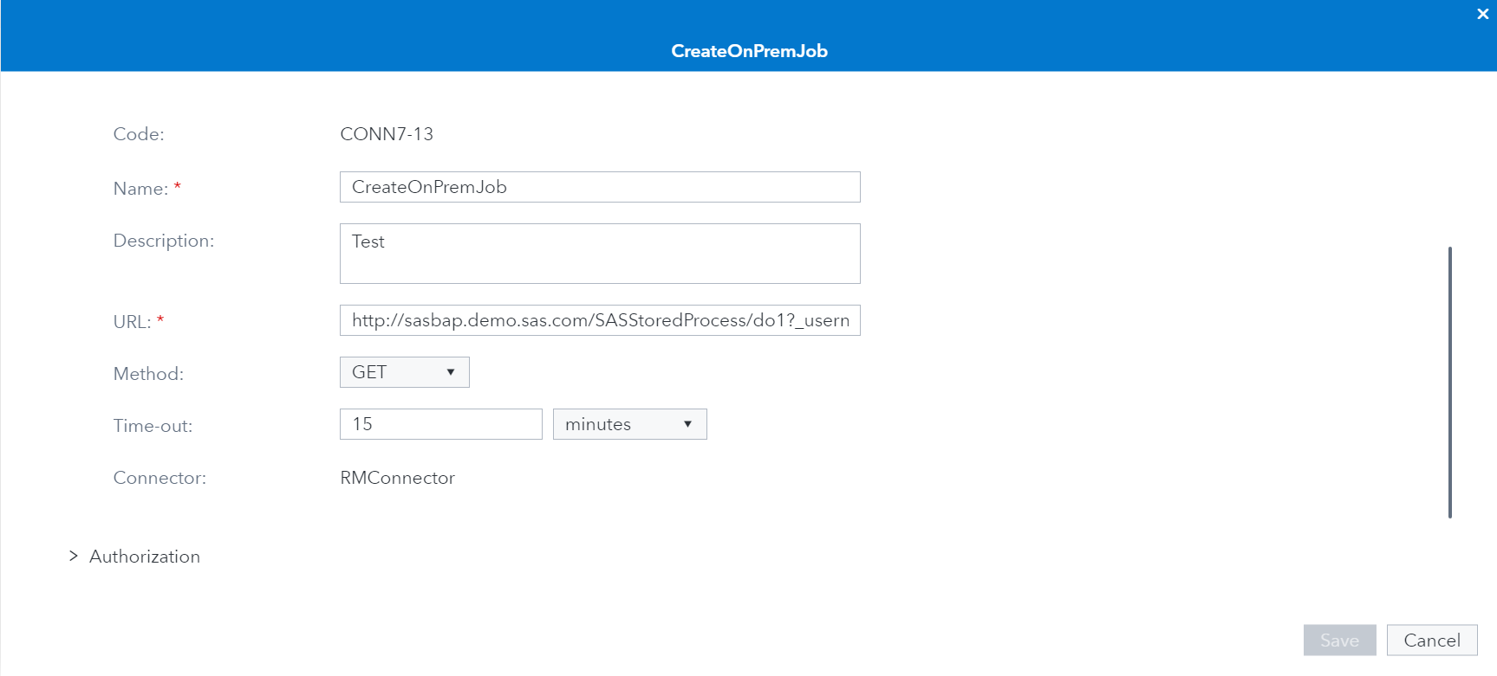
Once done, click on the ‘Define variable’ link on the upper right corner in the same window. Key in details as shown in the following screenshot:

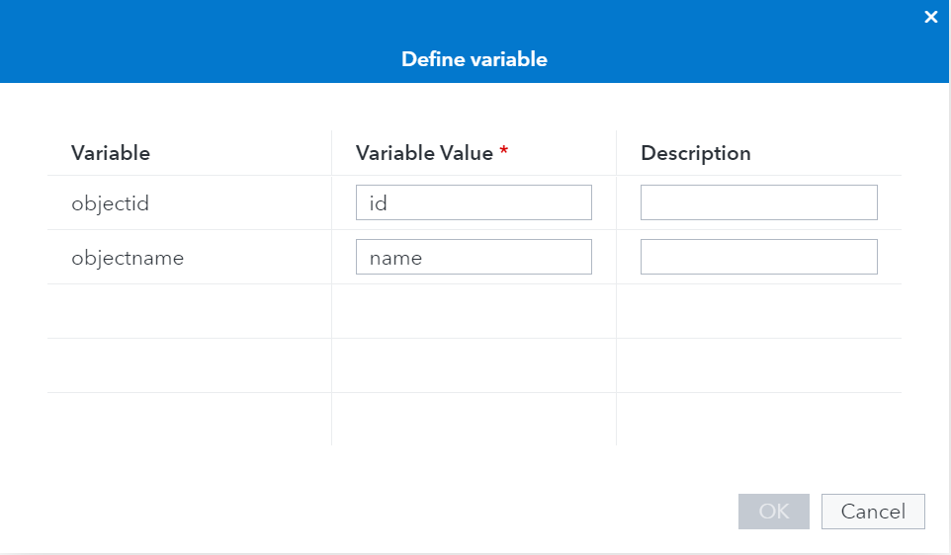
Leave the Authorization, Headers and Parameters sections unchanged.
Save the configuration by hitting the ‘Save’ button and you will come back to the Connector info screen.
Observe the Endpoints section and you will see the endpoint you just created. Note the ‘ID’ here. This will be required to configure Custom Properties later.
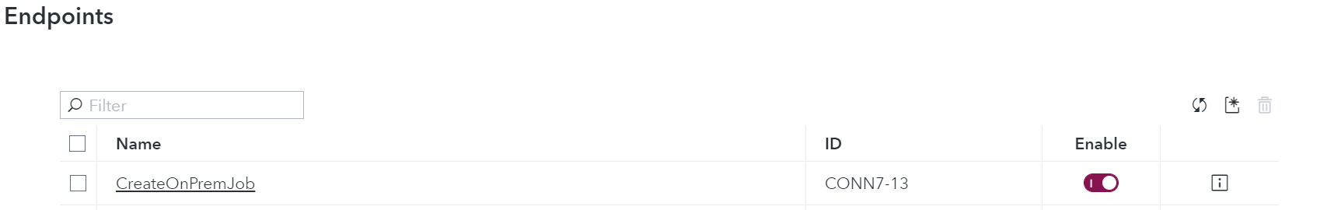
Click on ‘Apply’ to save your changes to this Connector.
Important: Once you are on the Connector List page, you may need to associate the Access Point you created in Step 9 with this Connector. To do so, scroll right on the Connector List until you see the ‘Access Point’ column. Click on the ‘Add’ link and select the apt Access Point from the dropdown list. Click Save and validate on the Connector list if the Access Point has been associated with your Connector. You will see a ‘View’ instead of ‘Add’ under the ‘Access Point’ column now.
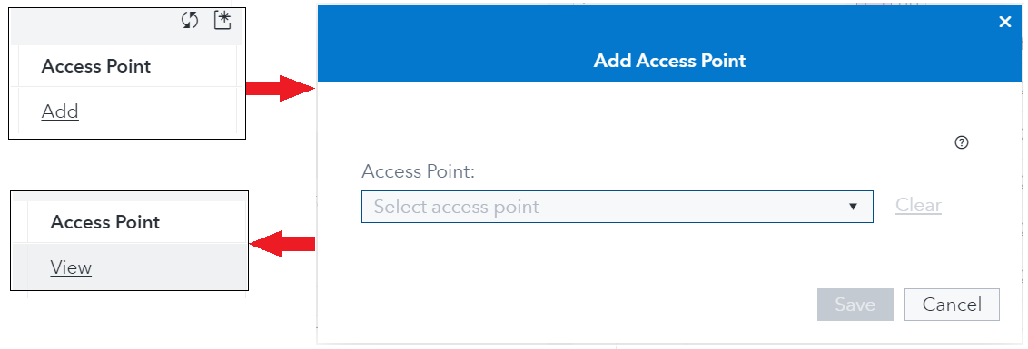

Configure Custom Properties

13.1 Edit CreateJobCustomProperties.xls
For the on-premises agent to process events from SAS Customer Intelligence 360 an endpoint must be configured. When the on-premises agent starts up it will use this endpoint to connect to the SAS Customer Intelligence Upload Custom Properties Template: CustomProperties.xlsx
Update Column Q-Data Values Source values in the Properties Tab to be the Connector ID for your implementation from Step 12. | 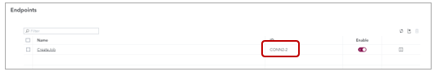

Once updated, the custom properties update can be applied to the Tenant.


13.2 Upload CreateJobCustomProperties.xls
Go to General Settings > Data Sources and click on Upload in the top right of the screen.
Select type Custom Properties
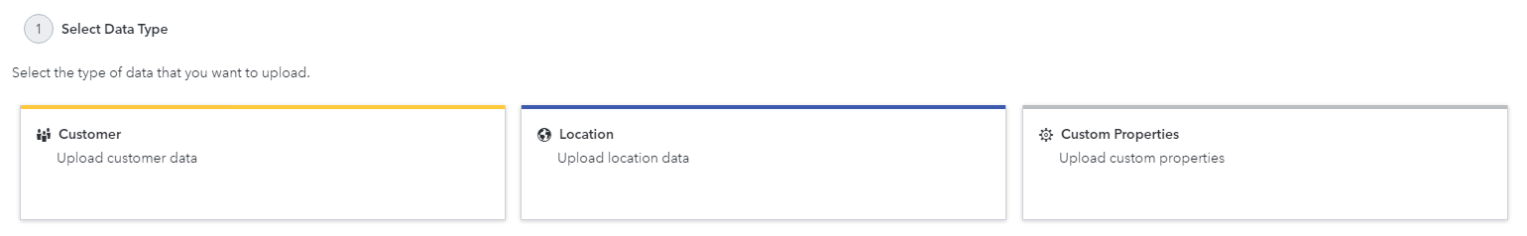

Choose the updated CreateJobCustomProperties.xls and select Upload Data.
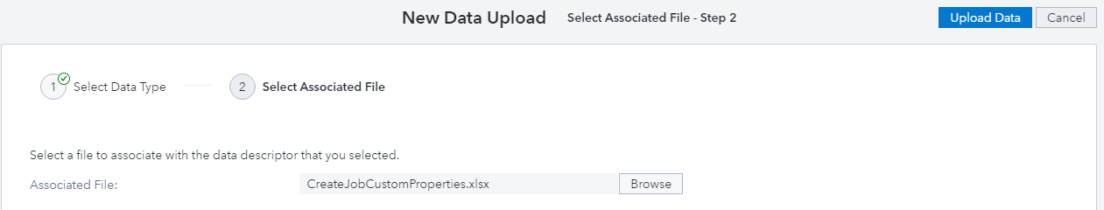

Check the job status and confirm that the Custom Properties were updated successfully.

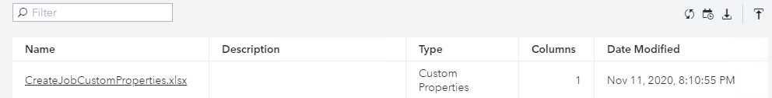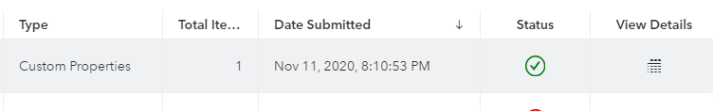
Open a new Direct Marketing Task or Segment Map to confirm the new Create On-Prem Job Custom Properties are present.
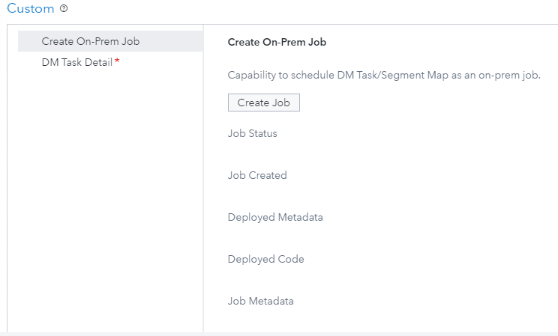

Validation
- Create a new Direct Marketing Task or Segment Map in 360.
- Configure and save the DM Task and/or Segment Map as per your requirements.
- On the Properties tab, locate the ‘Create On-Prem Job’ custom property.
- Click on the ‘Create Job’ button.
- Observe the Agent console window for logs.
- If the Integration is correctly setup, you will see a return response populates the custom property fields on the 360 UI as shown above.
- If not, revisit and affirm all steps in this document and perform this test use case again.

Troubleshooting
- Confirm that the stored process was deployed correctly and that the web services are running by navigating to http://sasbap.demo.sas.com/SASStoredProcess/do1 in your SAS 9.4 environment.
- If the agent fails to start, review the ..\logs\sas.mkt.apigw.sdk.log file.
A common reason will be that the port is already in use. Edit the port in ..\CI360GeneralAgent\config\agent-runtime.properties

***************************
APPLICATION FAILED TO START
***************************
Description:
Web server failed to start. Port 8080 was already in use.

Action:
Identify and stop the process that's listening on port 8080 or configure this application to listen on another port.

- If you are experiencing file in use errors, confirm you have correctly completed 6.3 to deselect the stored process macros from your code.
ERROR: File is in use, _WEBOUT .
ERROR: Due to the previous error, the JSON output file is incomplete and invalid, or in some cases, unable to be created. If created, the JSON output file is retained so that you can review it to help determine the cause of the error.

