Contents

Copy Files 2

View and Edit the Model 2

Viewing and Editing the Model Using SAS ESP Studio 2

Upload Project 3

Edit Input Data Connector on source_win Window 3

Edit User-Defined Function in comp_win Compute Window 5

Edit Retention Values of Copy Windows (Optional) 6

Add Field totalQuantity to Aggregate Windows (Optional) 7

Test the Model 8

Download Project 8

Viewing and Editing the Model with a Text Editor 9

Edit Input Data Connector on source_win Window 9

Edit User-Defined Function in comp_win Compute Window 9

Edit Retention Values of Copy Windows (Optional) 10

Add Field totalQuantity to Aggregate Windows (Optional) 11

Execute the Model and View the Output 13

Start the Model on the XML Server 13

Download and View csv Files Created 13

compute.csv 14

aggregate_5m.csv 15

aggregate_1h.csv 16

aggregate_24h.csv 17

Subscribe to the Output with SAS ESP Streamviewer 18

Edit Displayed Columns 20

Add Filters 21

Event Retention and Calculating Throughput Instructions

These instructions assume you have SAS Event Stream Processing 6.2 installed.

# Copy Files

All required files are included in the SAS Event Stream Processing Examples directory ($DFESP_HOME/examples). Create a server copy of the model.xml and Trades1M.csv files, and a local copy of model.xml for editing.

1. Copy the files from the SAS ESP Examples directory for this example ($DFESP_HOME/examples/xml/vwap_xml) to a directory to which you have write access. Example:

cp $DFESP_HOME/examples/xml/vwap_xml/*.* /home/sasdemo/vwap

1. Download the model.xml file to your local computer so it can be easily edited.

# View and Edit the Model

You must edit this model before it will execute without errors.

You can view and edit your local copy of the model.xml model in one of two ways:

* Upload the model.xml file to SAS ESP Studio
* Open the model.xml file with a text editor

## Viewing and Editing the Model Using SAS ESP Studio

**NOTE: Ensure the SAS ESP Server is running.**

Use the following steps to view and edit the model.xml model in SAS ESP Studio. You can skip this section and refer to the Viewing and Editing the Model with a Text Editor section for instructions on editing the model.xml model in a text editor.

### Upload Project

1. In the upper-right corner of SAS ESP Studio, click More actions to reveal the **More actions** menu and select **Upload projects**.  
   *The Upload Projects window appears.*
2. Click Upload project files.
3. Navigate to the file that contains the project that you want to upload and click **Open.**
4. Click **Upload**. The file is uploaded, and the **Upload Projects** window displays the file, project name, and a green checkmark if the upload was successful.
5. Click **Close** to close the **Upload Projects** window.

### Edit Input Data Connector on source_win Window

1. Double-click the project named **project** to open it.
2. Click the **source_win** window to select it and expand the **Input Data (Publisher)** **Connectors** parameter on the right side.
3. Click the connector to select it and then click Edit row to open the **Connector** **Configuration** window.

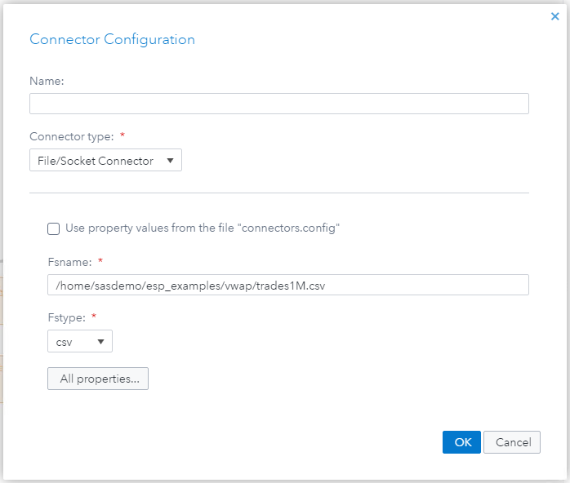

Figure -- Connector Configuration Window

1. Edit the **Fsname** field to include the full path to the Trades1M.csv file.
2. Click **All Properties**.  
   *The All Properties window appears.*

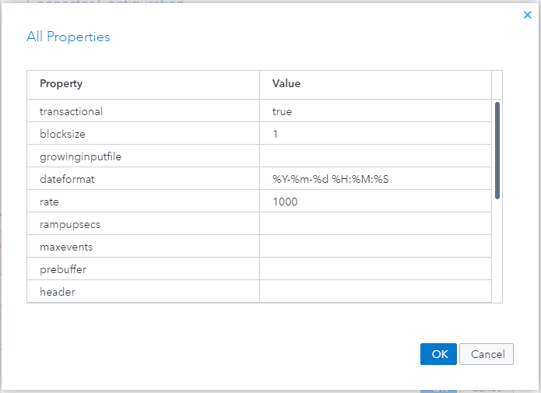

Figure -- All Properties Window

1. Set the **rate** property to have a value of **1000** and click **OK** to close the **All** **Properties** window.
2. Click **OK** to close the **Connector Configuration** window.

### Edit User-Defined Function in comp_win Compute Window

1. Click the **comp_win** window to select it and click Output Schema to display the output schema.
2. Click Edit row to open the **Edit** **Output Schema – Non-Key Fields** window.

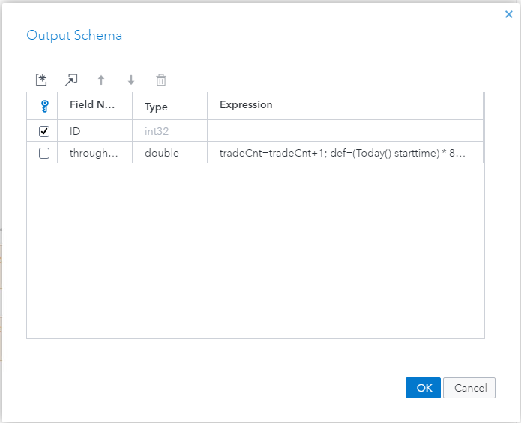

Figure – Output Schema Window

1. Click in the **Expression** field for **Field Name** throughputRate and edit the expression to be the following. The parts you need to add are highlighted.

tradeCnt=tradeCnt+1; def=(Today()-starttime) * 86400; if (def != 0) return tradeCnt/def;

1. Click **OK** to update the schema.

### Edit Retention Values of Copy Windows (Optional)

1. Click the **copyW5minRet** window to select it and click Properties to display the **Properties** pane.
2. Expand **Retention**.
3. In the **Time Limit** filed, type **1** to set the retention value to one second.
4. From the **Time field** selection list, select **(use system clock)**.
5. Click the **copyW1hourRet** window to select it and expand **Retention**.
6. Under **Type**, select **By row count, jumping**.
7. Type **100** in the **Row limit** field.

### Add Field totalQuantity to Aggregate Windows (Optional)

1. Click the **aggW5minRet** window to select it and, if necessary, click Output Schema to display the output schema. Click Edit row to open the **Output Schema** window in edit mode.
2. Click Create new ESP server to add a new field.
3. Type **totalQuantity** as the **Field Name** of the new field.
4. Select **double** as the **Type**.
5. Select **ESP_aSum** as the **Aggregate function**.
6. Select **quantity** as the **Parameter**.

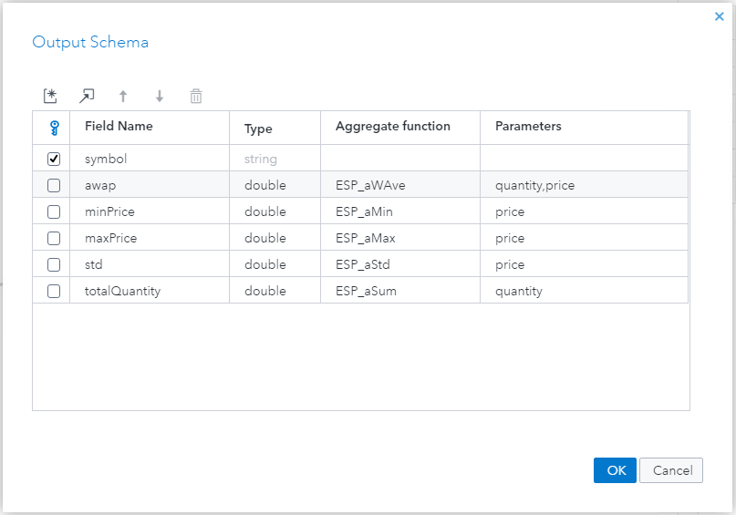

Figure -- Output Schema Window

1. Click **OK** to update the schema.
2. Repeat these steps for the aggW1hourRet and aggW24hourRet windows.

### Test the Model

1. Click Save to save your changes. A project must be saved before it can be tested.
2. Click Enter Test Mode to open the **Test** window.
3. Click Run Test to begin the test.
4. The **source_win** window is displayed initially. Click the **comp_win** tab to display the output.

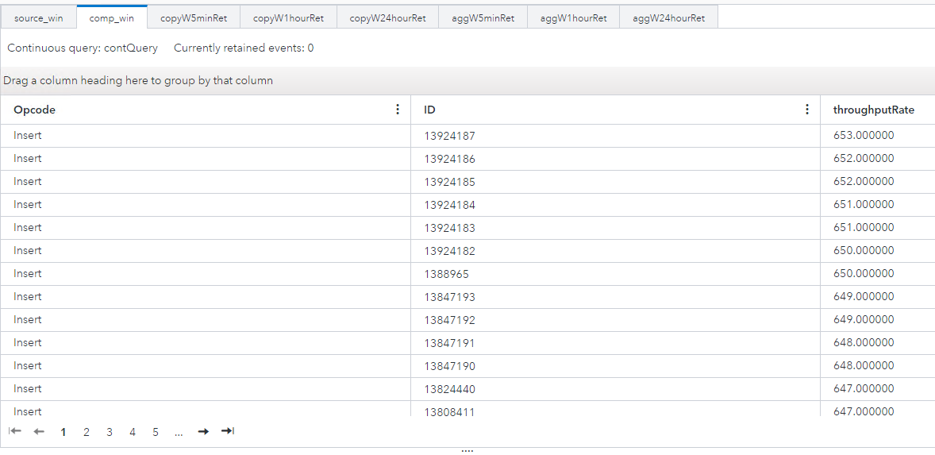

Figure -- Test Window

### Download Project

1. Close the project.
2. Ensure **project** is selected, click More actions to display the **More Actions** menu, and click **Download project**. A file named project.xml is downloaded to your local Downloads folder.

## Viewing and Editing the Model with a Text Editor

Use the following steps to view and edit the model.xml model in a text editor. If you edited the model using SAS ESP Studio you can skip this section. Refer to the section, Viewing and Editing the Model Using SAS ESP Studio, for instructions on editing the model.xml model using SAS ESP Studio.

### Edit Input Data Connector on source_win Window

1. Locate the **window-source** element and the go to the **connectors** element.
2. Edit the **fsname** property to include the full path to the Trades1M.csv file.
3. Add a property for **rate** and set the value to **1000**.

<connectors>

<connector class='fs'>

<properties>

<property name='type'>pub</property>

<property name='fstype'>csv</property>

<property name='fsname'>/home/sasdemo/vwap/trades1M.csv</property>

<property name='transactional'>true</property>

<property name='blocksize'>1</property>

<property name='dateformat'>%Y-%m-%d %H:%M:%S</property>

<property name='rate'>1000</property>

</properties>

</connector>

</connectors>

Figure -- Connector Element

### Edit User-Defined Function in comp_win Compute Window

1. Locate the **window-compute** element.
2. Go to the **output** element.
3. Edit the **field-expr** element as shown below. The changes are highlighted.

<window-compute name='comp_win' index='pi_EMPTY'>

<description>

This defines a compute window which will compute the

throughput rate from start time until current time.

</description>

<expr-initialize>

<initializer type='int32'>integer tradeCnt; tradeCnt=0; date starttime; integer def; starttime=Today()</initializer>

</expr-initialize>

<schema>

<fields>

<field name='ID' type='int32' key='true'/>

<field name='throughputRate' type='double'/>

</fields>

</schema>

<output>

<field-expr>tradeCnt=tradeCnt+1; def=(Today()-starttime)*86400; if (def != 0) return tradeCnt/def;</field-expr>

</output>

</window-compute>

Figure -- Window-Compute Element

### Edit Retention Values of Copy Windows (Optional)

1. Locate the **window-copy** element for the **copyW5minRet** window.
2. Go to the **retention** element and set the value to **1 seconds**.
3. Delete the **field=’time’** parameter from the **retention** element.

<window-copy name='copyW5minRet' index='pi_HASH'>

<description>

This defines a copy window which copies from source window

by retention as 5 minutes.

</description>

<retention type='bytime_sliding' >1 seconds</retention>

</window-copy>

Figure 8 -- Window-Copy Element

1. Locate the **window-copy** element for the **copyW1hourRet** window.
2. Go to the **retention** element and edit the **type=** parameter value to **bycount_jumping**.
3. Delete the **field=’time’** parameter from the **retention** element.
4. Set the value of the **retention** element to **100**.

<window-copy name='copyW1hourRet' index='pi_HASH'>

<description>

This defines a copy window which copies from source window

by retention as 1 hour.

</description>

<retention type='bycount_jumping' >100</retention>

</window-copy>

Figure 9 -- Window-Copy Element

### Add Field totalQuantity to Aggregate Windows (Optional)

1. Locate the **window-aggregate** element for window **aggW5minRet**.
2. Go to the **schema** element.
3. Add a **field** element for field **totalQuantity** with a **type=** value of **double**.
4. Go to the **output** element and add a **field-expr** element using function **ESP_aSum** for field **quantity**.

<window-aggregate name='aggW5minRet'>

<description>

This is an aggregate window with aggregation expression

in 5 minutes. One expression is calculating the VWAP. The second

expression is calculating minimum price. The third expression is calculating the

maximum of price. The fourth is calculating the standard deviation.

</description>

<schema>

<fields>

<field name='symbol' type='string' key='true'/>

<field name='awap' type='double'/>

<field name='minPrice' type='double'/>

<field name='maxPrice' type='double'/>

<field name='std' type='double'/>

<field name='totalQuantity' type='double'/>

</fields>

</schema>

<output>

<field-expr>ESP_aWAve(quantity,price)</field-expr>

<field-expr>ESP_aMin(price)</field-expr>

<field-expr>ESP_aMax(price)</field-expr>

<field-expr>ESP_aStd(price)</field-expr>

<field-expr>ESP_aSum(quantity)</field-expr>

</output>

</window-aggregate>

Figure 10 -- Window-Aggregate Element

1. Repeat the steps for aggregate windows **aggW1hourRet** and **aggW24hourRet**.
2. Save your changes.
3. Upload the model.xml file from your local computer to the server directory you are using.

# Execute the Model and View the Output

## Starting the Model on the XML Server

Use the following command line syntax to start the model.xml model on the XML server:

$DFESP_HOME/bin/dfesp_xml_server -model file:///*yourpath*/model.xml -http 61001 -pubsub 61002

## Downloading and Viewing CSV Files Created

Four of the windows include Output Data Connectors that create csv files through a file/socket adapter. The following table shows the files created:

|  |  |  |
| --- | --- | --- |
| Window Name | Window Type | CSV File Created |
| comp_win | Compute | compute.csv |
| aggW5minRet | Aggregate | aggregate_5m.csv |
| aggW1hourRet | Aggregate | aggregate_1h.csv |
| aggW24hourRet | Aggregate | aggregate_24h.csv |

You can download the files to your local computer for viewing. After downloading, open each of the files to view the operation of the model.

### compute.csv

Notice how there is no throughputRate until one second has passed.

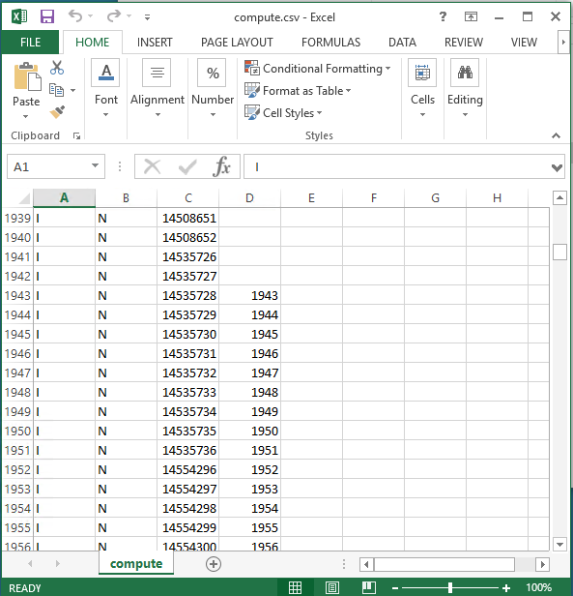

Figure -- compute.csv

### aggregate_5m.csv

The file has been filtered to display only update blocks for symbol BP. Notice how column H increases in value until the threshold is reached. From that point forward, the value represents the most recent second.

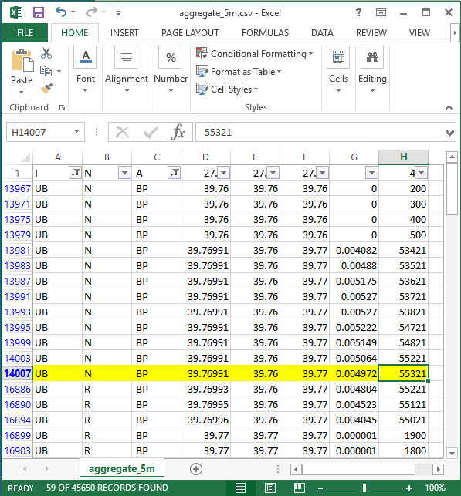

Figure -- aggregate_5m.csv

### aggregate_1h.csv

The file has been filtered to display only update blocks for symbol BP. Notice how column H increases in value until the threshold is reached. At that point, the value is cleared and aggregation begins again.

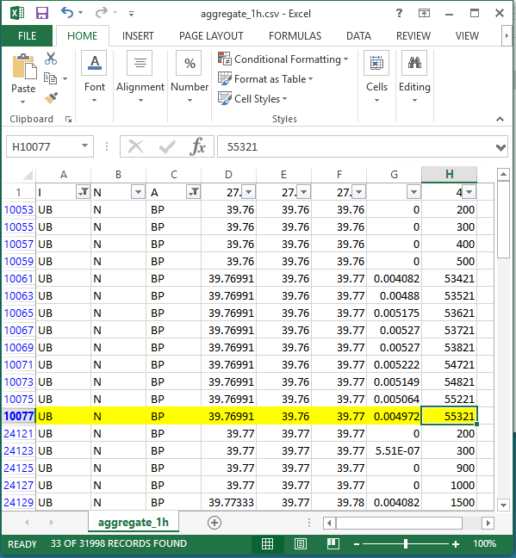

Figure -- aggregate_1h.csv

### aggregate_24h.csv

The file has been filtered to display only update blocks for symbol BP. Notice how the threshold is never reached, and the aggregation continues throughout the file.

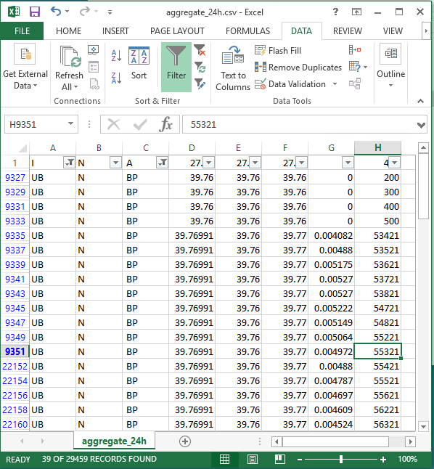

Figure -- aggregate_24h.csv

## Subscribing to the Output with SAS ESP Streamviewer

Use the following steps to subscribe to the **comp_win, aggW5minRet, aggW1hourRet,** and **aggW24hourRet** windows using SAS ESP Streamviewer.

1. Start ESP Streamviewer using the following URL:

https://*Streamviewer-host-name*/SASEventStreamProcessingStreamviewer

1. On the ESP Streamviewer dashboard, click Show Model to open the **ESP Model Viewer**.

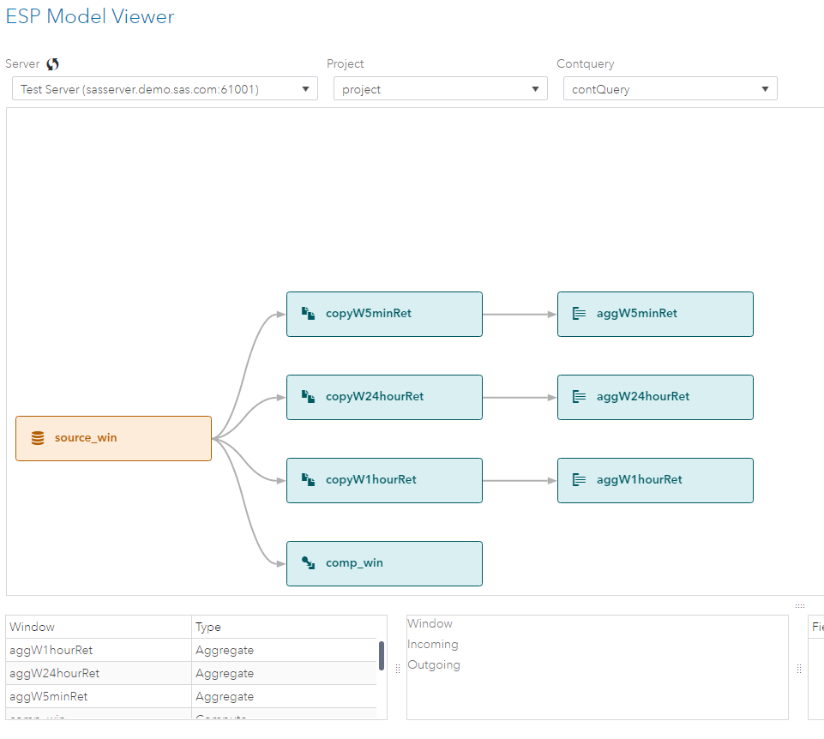

Figure -- ESP Model Viewer

1. Click the **aggW5minRet** window to select it, and then click Add Updating Subscriber to add an updating subscriber to the dashboard.
2. Click the **aggW1hourRet** window to select it, and then click Add Updating Subscriber to add an updating subscriber to the dashboard.
3. Click the **aggW24hourRet** window to select it, and then click Add Updating Subscriber to add an updating subscriber to the dashboard.
4. Click the **comp_win** window to select it, and then click Add Streaming Subscriber to add a streaming subscriber to the dashboard.
5. Click **Close** to close the **ESP Model Viewer**.  
   *The tables for the four windows appear on the dashboard.*
6. You can click and drag the windows to arrange them on the dashboard.

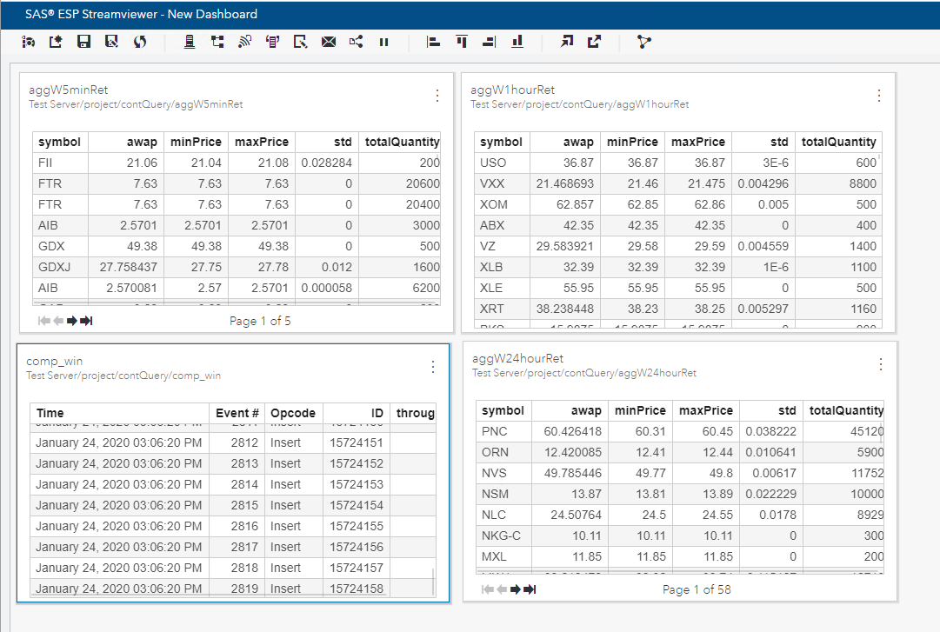

Figure -- SAS ESP Streamviewer Dashboard Elements

### Edit Displayed Columns

Use the following steps to edit the displayed columns on the comp_win streaming subscriber.

1. Click Window Menu at the top right of the **comp_win** table to display a menu of options and select **Edit**.  
   *The Modify Chart window appears.*

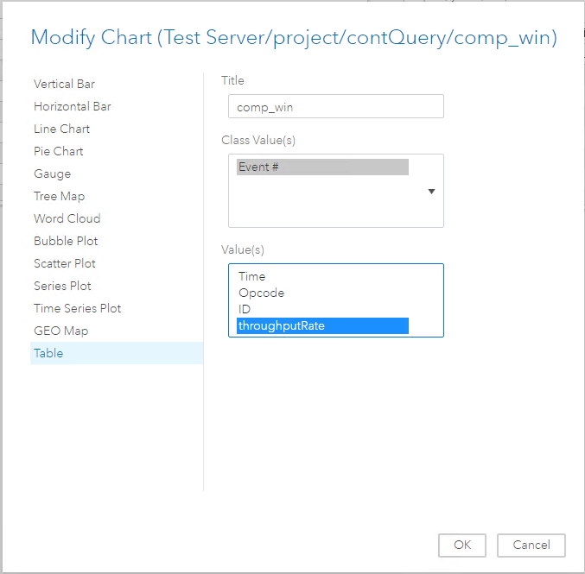

Figure -- Modify Chart Window

1. Under **Value(s)** click **throughputRate** to select it as the only non-class values displayed.
2. Click **OK** to close the **Modify Chart** window and display the edited table on the dashboard.

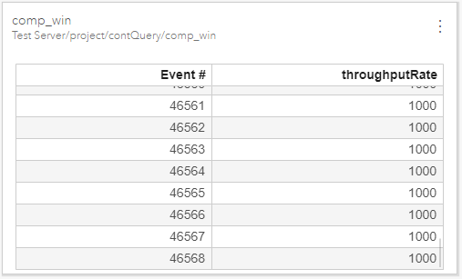

Figure -- SAS ESP Streamviewer Edited Table

### Add Filters

Use the following steps to filter the aggregate windows to display only the symbol value BP.

1. Click Window Menu at the top right of the **aggW5minRet** table to display a menu of options and select **Filter**.  
   *The Chart Filter window appears.*

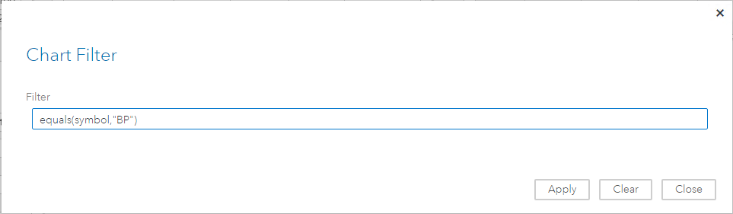

Figure -- Chart Filter Window

1. In the **Filter** field, type **equals(symbol,"BP")** to specify the function to display values for symbol BP only.
2. Click **Apply** and then click **Close** to close the **Chart Filter** window.  
   *The filter is applied to the table.*

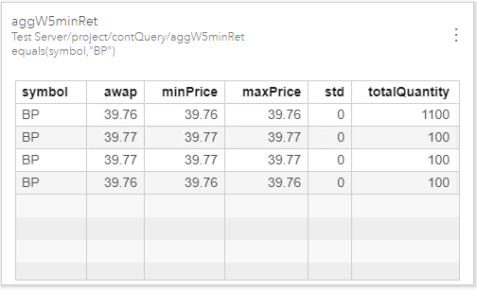

1. Figure 18 -- SAS ESP Streamviewer Filtered Table
2. Repeat these steps for the **aggW1hourRet** and **aggW24hourRet** windows.