**FITNESS TRACKING SYSTEM**

**MAJOR PROJECT REPORT**

Submitted by

# SAILENDHIRA SANKAR M

**21BCA045**

Under the Guidance of

# Dr. R. SUBHA, MSC., M.Phil., PhD.,

**Assistant Professor**

Department of Computer Applications

In partial fulfillment of the requirements for the award of the degree of

# Bachelor of Computer Applications

Of Bharathiar University



**PSG COLLEGE OF ARTS & SCIENCE DEPARTMENT OF COMPUTER APPLICATIONS**

An Autonomous College-Affiliated to Bharathiar University Accredited with ‘A++’grade by NAAC (4th Cycle)

College with Potential for Excellence (Status awarded by the UGC)

STAR College Status Awarded by DBT-MST An ISO 9001:2015 Certified Institution Coimbatore -641 014

**APRIL 2024**

**CERTIFICATE**

**PSG COLLEGE OF ARTS & SCIENCE DEPARTMENT OF COMPUTER APPLICATIONS**

An Autonomous College-Affiliated to Bharathiar University Accredited with ‘A’ grade by NAAC (3rd Cycle)

College with Potential for Excellence (Status awarded by the UGC)

STAR College Status Awarded by DBT-MST An ISO 9001:2015 Certified Institution Coimbatore -641 014

CERTIFICATE

This is to certify that this Project work entitled **FITNESS TRACKING SYSTEM** is a bonafide record of work done by

**SAILENDHIRA SHANKAR M**, 21BCA045 for the award of Degree of Bachelor of Computer

Applications of Bharathiar University.

Signature of the Faculty Guide

Signature of the HoD

Submitted for Viva-Voce Examination held on

Internal Examiner External Examiner

**DECLARATION**

**DECLARATION**

I, **SAILENDHIRA SHANKAR M**, 21BCA045, hereby declare that this Project work entitled **INDIVIDUALS STRUGGLING WITH EXCESS BODY FAT IN ACHIEVING THEIR WEIGHT LOSS GOALS**, is

submitted to PSG College of Arts and Science (Autonomous), Coimbatore in partial fulfillment for the award of degree is a record of original work done by me under the supervision and guidance of Dr**. R. SUBHA, MSC., M.Phil., PhD., Assistant Professor,** Department of Computer Application, PSG College of Arts and Science, Coimbatore.

This Project work has not been submitted by me for the award of any other Degree/ Diploma/ Associate ship/ Fellowship or any other similar degree to any other university.



**PLACE** : Coimbatore **SAILENDHIRA SHANKAR M**

**DATE** : 26.04.2024  **21BCA045**

**ACKNOWLEDGEMENT**

# ACKNOWLEDGEMENT

With great gratitude, I would like to acknowledge the help of those who contributed with their valuable suggestions and timely assistance to complete this work

First and foremost, I would like to extend my heartfelt gratitude and place my sincere thanks to **Thiru. L. Gopalakrishnann** Managing Trustee, PSG &Sons’ Charities, Coimbatore for providing all sorts of support and necessary facilities throughout the course.

I express my deep sense of gratitude to **Dr. T. Kannaian MSc., MTech., PhD** Secretary, PSG College of Arts & Science for infrastructure provided to undertake this work.

I whole heartedly express my gratitude to **Dr. D. Brindha MSc., MPhil., PhD, MA(Yoga)** Principal, PSG College of Arts & Science for her academic support and constant source of inspiration throughout the course.

I express my sincere thanks to **Dr. A. Anguraj, MSc., MPhil., PhD.,** Vice Principal (Self Financing Programmes) and **Mrs. M Umarani, MBA., MPhil.,** Faculty-In- Charge (Student Affairs), for their support.

I kindly and sincerely thank our Dean **Dr. T. Revathi MCA., MPhil., PhD.,** Department of Computer Science, PSG College of Arts & Science, Coimbatore for her whole hearted support to complete this project successfully.

I owe my deepest gratitude to **Dr. R. Sudha, MCA., MPhil., PhD.,** Associate Professor &Head of Department of Computer Applications for her advice and encouragement to complete the project.

My sincere thanks to **Dr. R. Subha, MSC., M.Phil., PhD., Assistant Professor**, Department of Computer Applications for the valuable suggestions, support and guidance as my Internal Guide, without which my work would not have reached the present form.

I am greatly indebted to my parents and God Almighty for showering their blessings to complete this immense task.

**ABSTRACT**

**ABSTRACT:**

The development of a comprehensive health and fitness website has been undertaken to provide users with a seamless experience integrating four essential applications: BMI calculation, maintenance calorie estimation, body fat percentage determination, and a fitness quiz for knowledge enhancement. This unified platform offers users quick and convenient access to crucial health metrics and educational resources, all within a single website interface.

The website aims to streamline the process of accessing essential health information and tools by consolidating multiple applications into one cohesive platform. By offering these diverse functionalities in a unified setting, users can easily navigate between different features without the need for multiple applications or websites. Additionally, the website prioritizes responsiveness, ensuring swift access and efficient performance across various devices and platforms.

The BMI calculator provides users with a straightforward tool to assess their body mass index, offering insights into their weight status and potential health risks. Meanwhile, the maintenance calorie estimator aids individuals in determining their daily caloric needs for weight maintenance, supporting their dietary and fitness goals. The body fat percentage calculator offers further insights into body composition, empowering users with a more comprehensive understanding of their physical health.

The inclusion of a fitness quiz enriches the user experience by providing an interactive way to enhance fitness knowledge and awareness. Through engaging quizzes and informative content, users can expand their understanding of various fitness concepts, from exercise techniques to nutrition principles.

**TABLE OF CONTENTS**

|  |  |  |
| --- | --- | --- |
| **S.NO** | **TABLE OF CONTENTS** | **PAGE NO** |
| 1 | INTRODUCTION | 1 |
| 2 | OBJECTIVE OF THE PROJECT | 2 |
|  | 2.1 MODULE | 3 |
|  | 2.2 MODULE DESCRIPTION | 3 |
| 3 | SYSTEM SPECIFICATION | 4 |
|  | 3.1HARDWARE CONFIGURATION | 4 |
|  | 3.2 SOFTWARE CONFIGURATION | 4 |
|  | 3.2.1 FRONT END | 5 |
|  | 3.2.2 BACK END | 7 |
| 4 | SYSTEM ANALYSIS | 8 |
|  | 4.1 EXISTING SYSTEM  4.1.1 DISADVANTAGES | 9  9 |
|  | 4.2 PROPOSED SYSTEM  4.2.1 FEATURES | 10  10 |
| 5 | SYSTEM DESIGN | 11 |
|  | 5.1 DATA FLOW DIAGRAM  5.2 ER DIAGRAM | 11  13 |
|  | 5.3 TABLE DESIGN | 14 |
|  | 5.4 INPUT DESIGN | 15 |
|  | 5.5 OUTPUT DESIGN | 17 |
| 6 | SYSTEM TESTING AND IMPLEMENTATION | 19 |
|  | 6.1 SYSTEM TESTING | 19 |
|  | 6.2 SYSTEM IMPLEMENTATION | 21 |
| 7 | SCOPE FOR FUTURE ENHANCEMENT | 22 |
| 8 | CONCLUSION | 23 |
| 9 | APPENDICES | 24 |
|  | 9.1 SCREEN SHOTS | 24 |
|  | 9.2 SAMPLE CODING | 26 |
|  | BIBLIOGRAPHY | 34 |

**INTRODUCTION**

1. **INTRODUCTION**

In an age where health and fitness are paramount, access to accurate information and tools for maintaining a healthy lifestyle is indispensable. With this in mind, our project aims to revolutionize the way individuals engage with their health and fitness goals through a comprehensive website. This website seamlessly integrates four essential applications: a Body Mass Index (BMI) calculator, a maintenance calorie calculator, a body fat percentage estimator, and an informative fitness quiz. By consolidating these tools into a single platform, our website offers unparalleled convenience and efficiency for users seeking to enhance their well-being.

Gone are the days of navigating multiple websites or applications to obtain crucial health metrics and insights. Our all-in-one platform streamlines the process, providing users with instant access to vital information at their fingertips. Whether an individual seeks to monitor their BMI, determine their maintenance caloric intake, assess their body fat percentage, or expand their fitness knowledge through an engaging quiz, our website offers a user-friendly solution tailored to their needs.

Moreover, the website's emphasis on simplicity and quick response times ensures a seamless user experience. Through intuitive design and efficient functionality, users can effortlessly navigate between the various applications, obtaining the information they need without unnecessary complexity or delay. This commitment to accessibility and responsiveness underscores our dedication to empowering individuals on their journey towards improved health and fitness.

In essence, our project represents a pioneering approach to health and fitness management, leveraging technology to provide users with a versatile and cohesive solution. By consolidating essential tools and information into a single, easy-to-use platform, we aim to democratize access to health metrics and knowledge, empowering individuals to make informed decisions and take proactive steps towards a healthier lifestyle.

**OBJECTIVE OF THE PROJECT**

1. **OBJECTIVE OF THE PROJECT**

The objective of our project is to create a unified digital platform that revolutionizes the way individuals engage with their health and fitness goals. By integrating four essential applications—namely, a Body Mass Index (BMI) calculator, maintenance calorie calculator, body fat percentage estimator, and fitness quiz—into a single website, we aim to provide users with unparalleled convenience and accessibility. Our primary goal is to eliminate the hassle of navigating multiple platforms by offering a comprehensive solution that caters to various health-related needs. We strive to ensure that users, regardless of their backgrounds or experience levels, can easily access vital health metrics and fitness insights within a user-friendly interface. Moreover, our objective encompasses optimizing the website's performance to deliver efficient functionality, minimizing response times, and maximizing user satisfaction. Beyond mere functionality, our project is driven by a commitment to education and empowerment. Through informative content and interactive quizzes, we aim to equip users with the knowledge and tools necessary to make informed decisions about their health and fitness journey. Ultimately, our project seeks to foster a culture of well-being and empowerment by leveraging technology to streamline health management processes and facilitate proactive lifestyle choices.

* 1. **MODULE**
     + User

# MODULE DESCRIPTION

# USER

Through an intuitive interface, users can access essential features such as BMI calculation, maintenance calorie estimation, body fat percentage assessment, and an informative fitness quiz. The module prioritizes accessibility, ensuring users of all backgrounds can navigate effortlessly. Additionally, robust security measures safeguard users' personal health information. By centralizing these tools into a unified platform, the user module empowers individuals to take proactive steps towards their wellness goals with ease and confidence.

**Home**: The Home page is the main landing page where users can access an overview of the platform, see recent updates, and access navigation options to different sections of the application.

**SYSTEM SPECIFICATION**

1. **SYSTEM SPECIFICATION**

# HARDWARE CONFIGURATION

* + - Processor : INTEL ® PENTIUM ® CPU P6100 @ 2.0 GHz
    - Ram : 512 MB
    - Hard Disk : 20 GB

# SOFTWARE CONFIGURATION

* + - Operating System : Windows or any equivalent OS
    - Language : PHP
    - Development Tool : Visual Studio Code
    - Backend : PHP
    - Backend Database : MySQL
    - Back End Tool : PHPMyAdmin
    - Web Server : Apache

# 3.2.1 FRONT END

### PHP (programming language)

In the PHP programming language, the source code is typically written in plain text files with the .php extension. These PHP files contain code written in PHP, HTML, CSS, and JavaScript, allowing for a dynamic and interactive user interface. Unlike compiled languages, PHP is an interpreted language, meaning the source code is directly executed by the PHP interpreter. The Birth Certificate Management System utilizes PHP for server-side scripting and dynamic content generation.

HTML (HyperText Markup Language) serves as the backbone of web content, providing the structure and layout of a webpage. It offers various elements like headings, paragraphs, forms, and more. PHP seamlessly integrates with HTML, enabling the dynamic generation of HTML content based on different conditions and data.

CSS (Cascading Style Sheets) complements HTML by controlling the presentation and style of the webpage. It allows for uniformity and aesthetic appeal across the site, defining aspects such as colors, fonts, layout, and responsive design. PHP often dynamically generates CSS, adapting styles based on user interactions or database-driven conditions.

JavaScript is a versatile programming language primarily employed for enhancing user interactivity and experience on the client side. It facilitates features like form validation, animations, asynchronous updates (Ajax), and more. PHP interacts with JavaScript to dynamically alter webpage elements, trigger events, and update content without requiring a complete page reload.

PHP acts as the bridge between the frontend (HTML, CSS, and JavaScript) and the backend, where data processing, database interactions, and application logic reside. It dynamically generates HTML content, incorporating data from databases or user inputs. PHP scripts are embedded within HTML, allowing seamless integration of server-side logic with the user interface. Additionally, CSS and JavaScript are employed for styling and interactivity, enhancing the user experience.

### Features

PHP is an open-source programming language, meaning it's freely available for use, modification, and distribution. It boasts cross-platform compatibility, capable of running on diverse operating systems like Windows, Linux, macOS, and others. One of its strengths lies in its simplicity and flexibility, featuring an uncomplicated syntax suitable for both beginners and seasoned developers, supporting procedural, object-oriented, or a blend of programming paradigms.

PHP enjoys a vast and active developer community globally, ensuring extensive support, comprehensive documentation, and a rich repository of libraries and frameworks. Primarily used for server-side scripting, PHP facilitates dynamic web page creation by processing code on the server before sending it to the browser. Furthermore, PHP seamlessly integrates with a variety of databases such as MySQL, PostgreSQL, Oracle, and more, enhancing data management and retrieval efficiency. It offers high performance, optimized for speedy processing and quick page loading. PHP is designed with built-in security features to aid developers in safeguarding against common security threats when implemented correctly. The availability of numerous frameworks like Laravel, Symfony, CodeIgniter, and others simplifies and accelerates the development process through pre-built modules and functionalities. Moreover, PHP's embeddability within HTML code streamlines the creation of dynamic and interactive web pages. Exception handling using structured error handling using exceptions contributes to code robustness and reliability. PHP also seamlessly operates with various web servers such as Apache, Nginx, IIS, among others, and supports an array of protocols like HTTP, SMTP, POP3, IMAP, enabling interaction with diverse web services.

# 3.2.1 BACK END

PHP, which stands for Hypertext Preprocessor, is a powerful server-side scripting language widely utilized in web development. It seamlessly integrates with various databases, making it an ideal choice for backend development. PHP enables dynamic content generation, form handling, session management, and more. Its simplicity, versatility, and extensive community support contribute to its popularity.

**Database:**

MySQL is a robust open-source relational database management system (RDBMS) that plays a crucial role in the backend of web applications. It efficiently manages the storage and retrieval of structured data. MySQL is known for its reliability, scalability, and ease of use. It supports SQL (Structured Query Language) for querying and managing databases. With features like transactions, indexing, and ACID compliance, MySQL ensures data integrity and optimal performance.

**Database Tool:**

.PHPMyAdmin is a valuable tool used for the administration of MySQL databases through a web-based interface. It simplifies database management tasks, allowing users to create, modify, and delete databases, tables, and records effortlessly. PHPMyAdmin provides an intuitive UI for executing SQL queries, importing and exporting data, optimizing database performance, and ensuring database security. It enhances the efficiency and productivity of database administrators and developers.

The backend of the application primarily relies on PHP for server-side scripting, enabling dynamic content creation and seamless interaction with the MySQL database. MySQL, as the backend database, efficiently stores and organizes data, ensuring the application's reliability and performance. PHPMyAdmin serves as a valuable tool for managing and administering the MySQL database, streamlining database-related tasks.

**SYSTEM ANALYSIS**

1. **SYSTEM ANALYSIS**

System analysis is a process of gathering the facts concerning the system breaking them into elements and relationship between elements. It provides a framework for visualizing the organizational and environmental factors that operate on a system. The quality of work performed by a machine is usually uniform, neat and more reliable when compared to doing the same operations manually.

# EXISTING SYSTEM

The existing system, your project offers a transformative solution by centralizing essential health and fitness tools into a unified platform. While the existing system often requires users to navigate multiple websites or applications.

# DISADVANTAGES

* Existing systems necessitate users to visit multiple websites or download separate apps for accessing health and fitness tools, leading to a fragmented user experience.
* Navigating through different platforms to perform tasks like BMI calculation, body fat estimation, calorie determination, and fitness quizzes consumes time, causing inefficiency and discouraging user engagement.
* Some existing applications lack user-friendly interfaces, hindering accessibility for users with varying technological proficiency and impeding widespread adoption.
* Dispersal of personal health information across various platforms raises concerns about privacy and security, as different applications may employ varying data protection measures.

# PROPOSED SYSTEM

The proposed Multi-Functional Fitness Website serves as a comprehensive solution for individuals seeking to streamline their fitness journey. By amalgamating four essential applications – the Body Mass Index (BMI) Calculator, Maintenance Calories Calculator, Body Fat Percentage Calculator, and Fitness Quiz – the system aims to offer users a centralized platform for accessing vital health and fitness tools.

# FEATURES

* The proposed system consolidates multiple fitness functionalities into a single platform, streamlining user access.
* It offers enhanced accessibility and a seamless user experience compared to navigating disparate applications.
* With comprehensive tools including BMI calculation, maintenance calorie estimation, body fat percentage analysis, and fitness quizzes, it addresses diverse fitness needs.
* Users benefit from time savings and increased efficiency by accessing all essential resources in one place.
* The system promotes educational engagement through interactive quizzes, empowering users with deeper fitness knowledge.

**SYSTEM DESIGN**

1. **SYSTEM DESIGN**

# DATA FLOW DIAGRAM

# LEVEL: 0

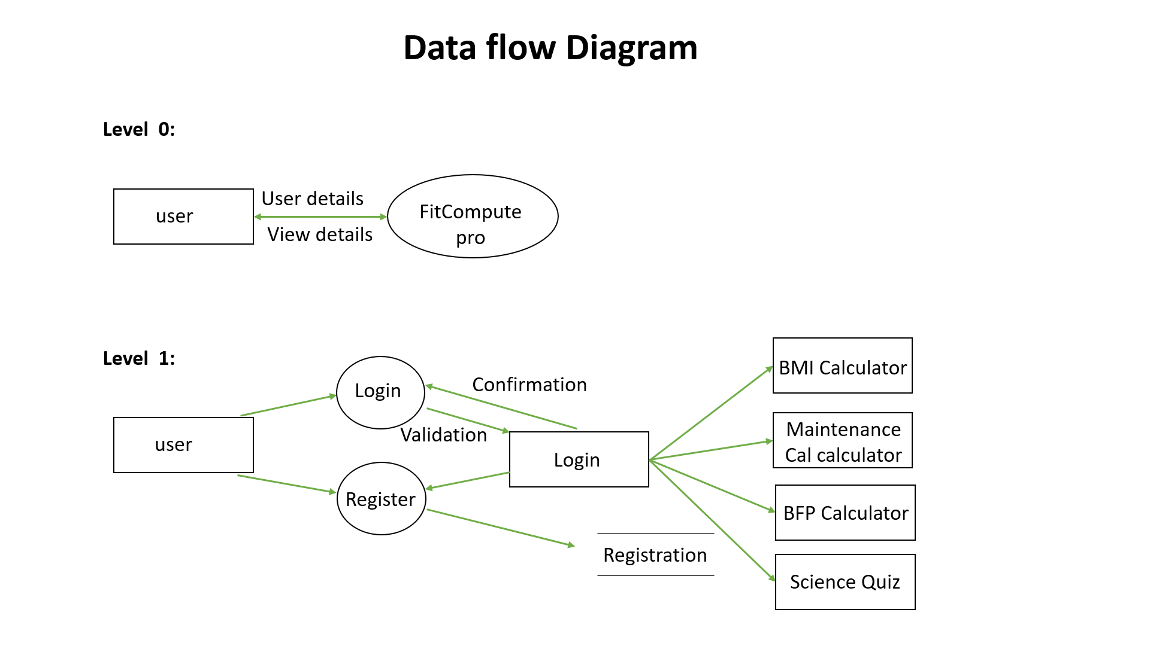

**LEVEL: 1**



**LEVEL: 2**

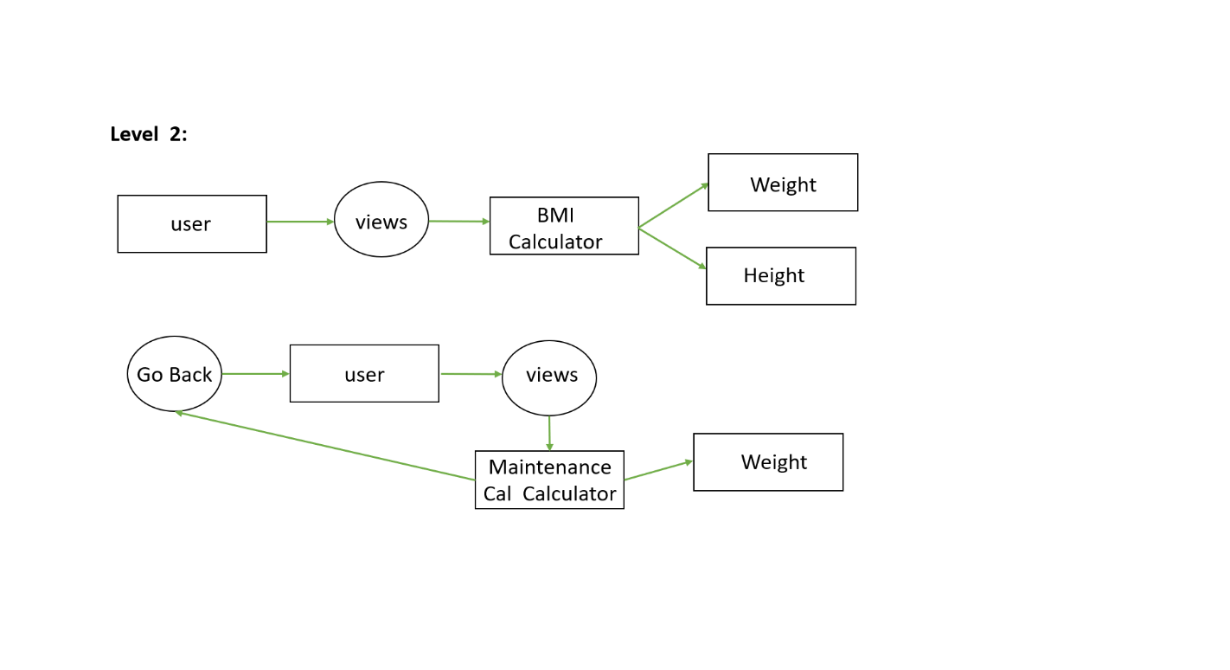

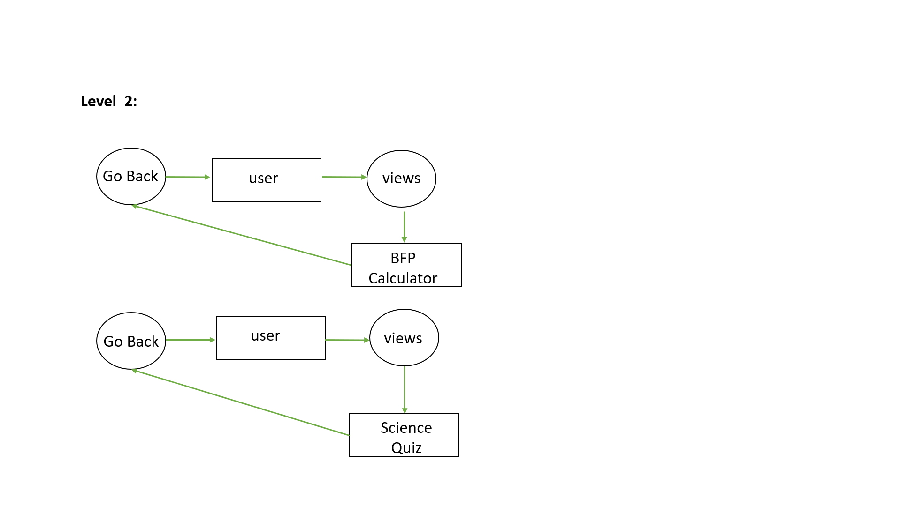

# ER DIAGRAM

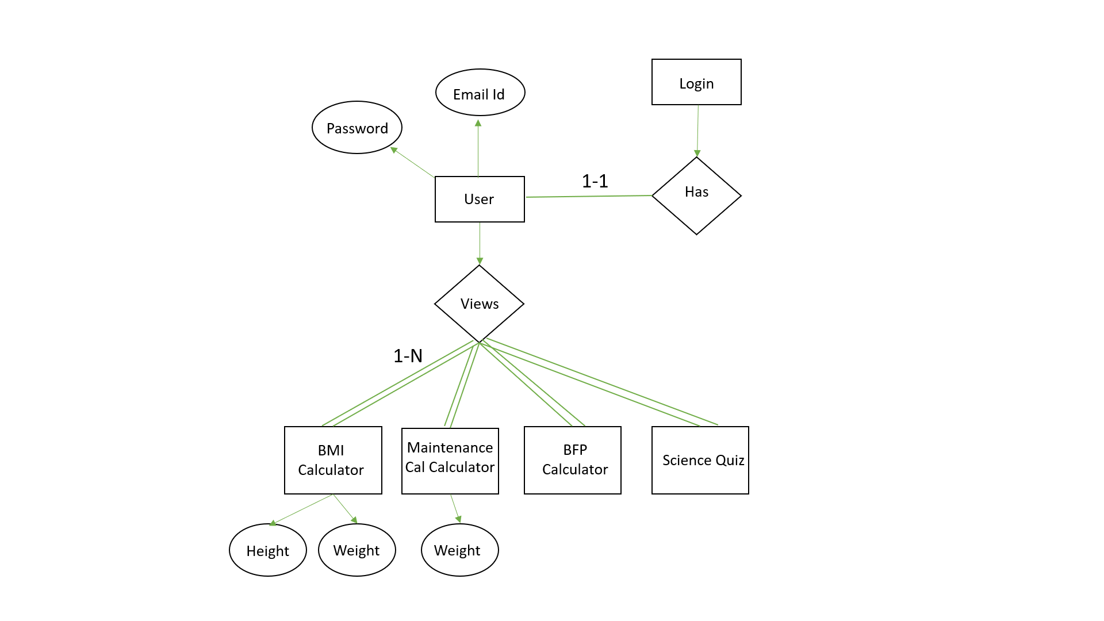

* 1. **TABLE DESIGN**

**TABLE NAME:**  Fitcompute Pro Table

|  |  |  |  |  |
| --- | --- | --- | --- | --- |
| **FIELD NAME** | **DATA TYPE** | **SIZE** | **CONSTRAINT** | **DESCRIPTION** |
| Email | Varchar | 25 | Not null | User uses their email as reference key by which they can login the webs application whenever they wanted |
| Password | Varchar | 8 | Not null | Password plays a vital role this was the unique key by using this they can login the web application |

# INPUT DESIGN

The Input design is the process of entering data to the system. The input design goal is to enter to the computer as accurate as possible. Here inputs are designed effectively so that error made by the operations are minimized. The inputs to the system have been designed in such a way that manual forms and the inputs are coordinate where the data elements are common to the source documents and to the input. The input is acceptable and understandable by the users who are using it. The quality of the system input determiners the quality for system output.

Input specification describes the manner in which data entered the system processing. Input design is the process of converting user - oriented inputs to a computer based format input data are collected and organized into group of similar data. Once identified appropriate input media are selected for processing.

The input design also determinate the user to interact sufficiently with the system. Input design is a part of overall system design that requires special attention because it is the common source for data processing error. The goal of designing input data is to make entry easy and from errors.

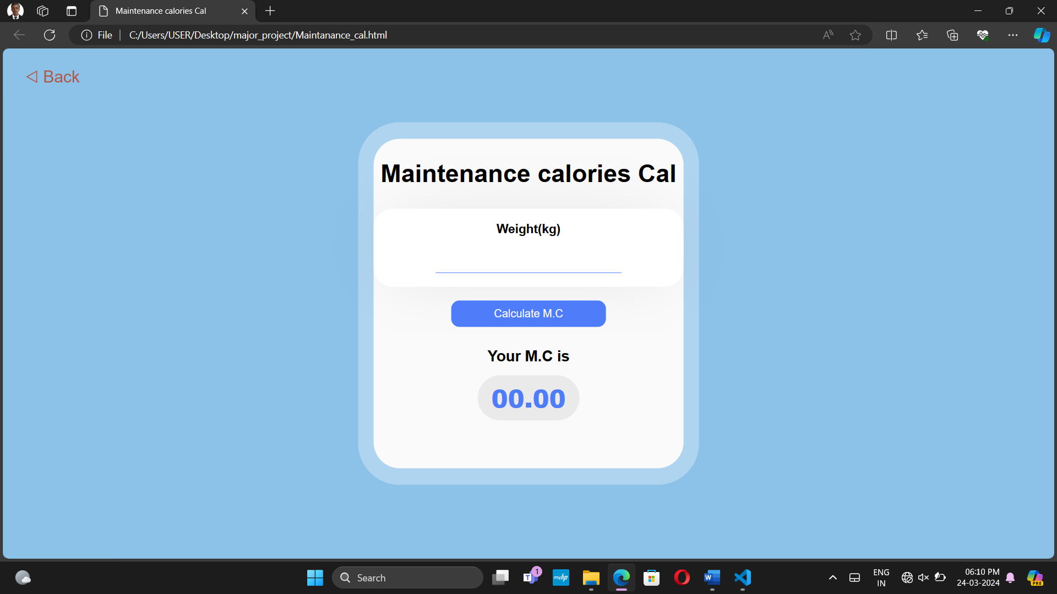

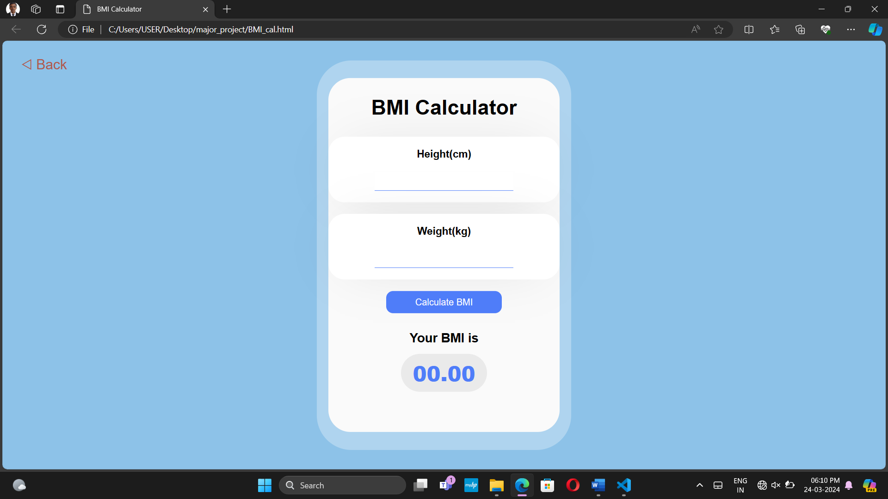

# OUTPUT DESIGN

The output design was done so that result of processing could be communicate to the users. The various output have designed in such a way that they represent the same format that the office and management. Computer output is the most important and direct source of information to the user efficient intelligible output design should improve the system relationship with the user and help in decision making. A major form of output is hardcopy form the printer. Output requirements are designed during system analysis.

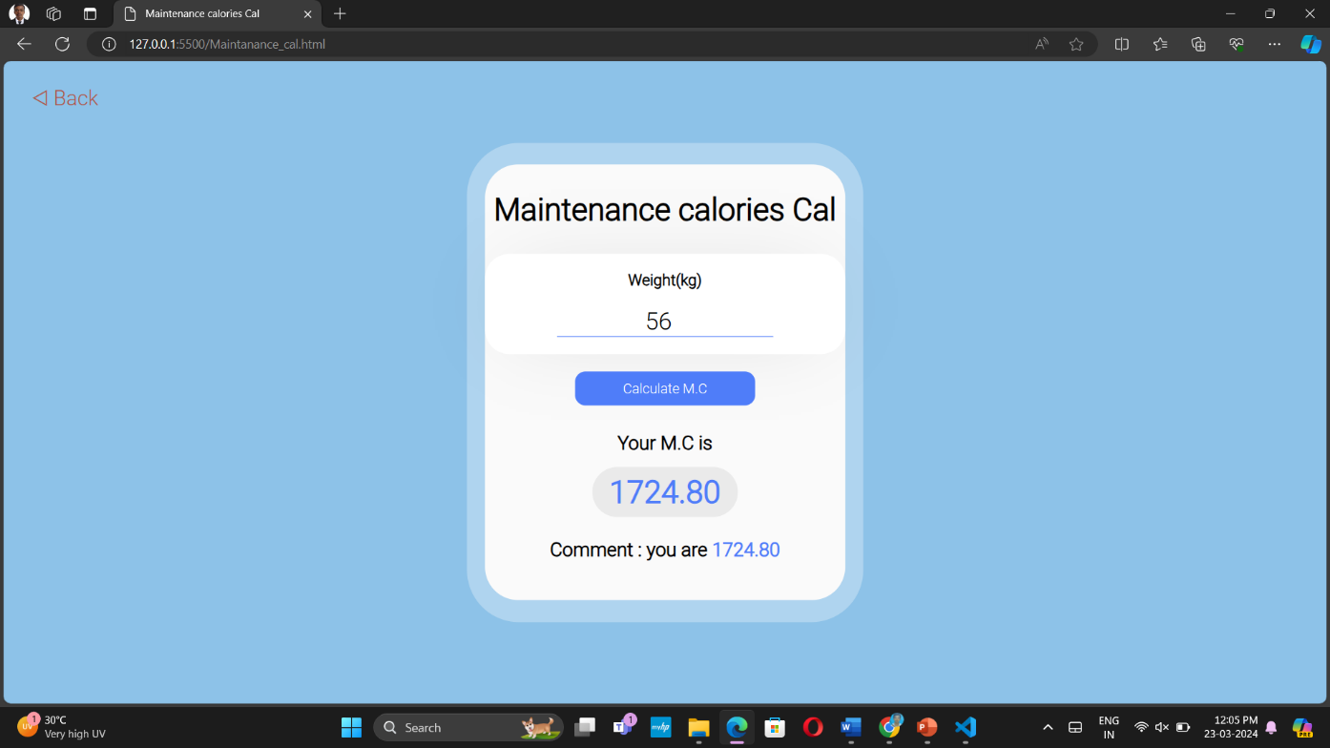

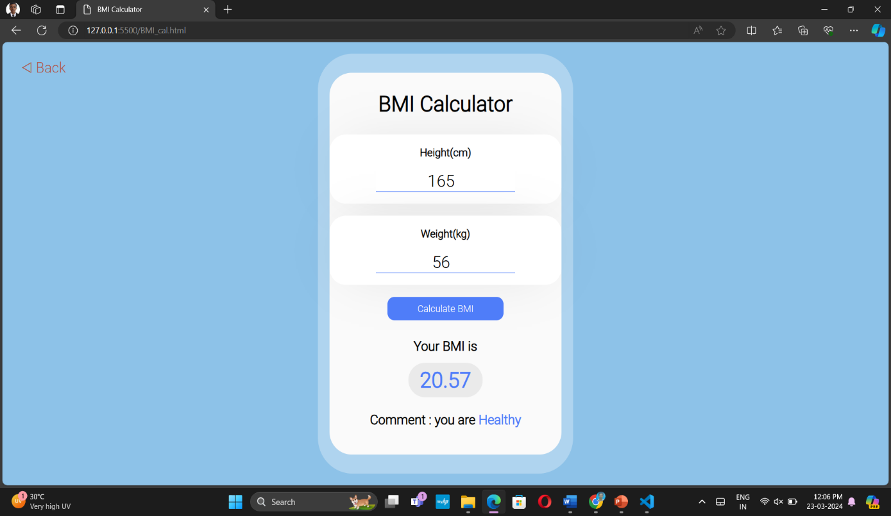

**SYSTEM TESTING AND IMPLEMENTATION**

1. **SYSTEM TESTING AND IMPLEMENTATION**

# SYSTEM TESTING

It is the stage of implementation, which ensures that system works accurately and effectively before the live operation commences. It is a confirmation that all are

correct and opportunity to show the users that the system must be tested with the text data and show that the system will operate successfully and produce expected results under expected conditions.

Web Application testing is a crucial element of applications quality assurance and represents the unlimited review of specification, design and coding. Testing represents an interesting anomaly for the software.

The testing phase is responsible for ensuring that the system performs the way that the detailed design documentation specifies. Testing involves testing of developed system using various test data. Preparation of test data plays a vital role in system testing. After preparing the test data, the system under study was tested using those test data. During this stage, the errors are detected and corrected.

Before implementation, the proposed system must be tested with raw data to ensure that the modules of the system work correctly and satisfactorily. The system must be tested with valid data to achieve its objective.

Testing is vital to the parts of the system are correct; the goal will be successfully achieved. Inadequate testing or non-testing leads to errors that may not appear until this months later.

This creates two problems:

* This time lag between the cause and appearance of the problem.
* The effort of system errors on files and records within the system. A small system error can conceivably exploded into much larger problem.

Effectively early in the process translates directly into long term cost savings from a reduced number of errors.

# Unit Testing

Unit testing, also known as Module Testing, focuses verification efforts on the module. The module is tested separately and this is carried out at the programming stage itself. Unit Test comprises of the set of tests performed by an individual programmer before integration of the unit into the system.

# Functional Testing

Functional test cases involve exercising the code with normal input values for which the expected results are known, as well as the boundary values.

# Performance Testing

Performance testing determines the amount of execution time spent in various parts of the unit, program throughput, and response time and device utilization of the program unit. It occurs throughout all steps in the testing process.

# Integration Testing

It is a systematic technique for constructing the program structure while at the same time conducting tests to uncover errors associated with in the interface. It takes the unit tested modules and builds a program structure. All the modules are combined and tested as a whole. Integration of all the components to form the entire system and a overall testing is executed.

# Validation Testing

Validation test succeeds when the software functions in a manner that can be reasonably expected by the client. The test is designed to uncover interface errors, is also used to demonstrate that software functions are operational, input is properly accepted, output are produced and that the integrity of external information is maintained.

# SYSTEM IMPLEMENTATION

System implementation is the stage of the project when the theoretical design is turned

into a working system. If the implementation stage is not correctly planned and controlled, it can be choice. The following are the main stages in the implementation:

* + - Planning
    - Training
    - Maintenance

## PLANNING

Planning plays an important role in the implementation. The planning should face any practical problems of controlling various activities of people out their own data processing department.

## TRAINING

Successful implementation needs trained computer staff. So some staff can

teach them about the computer implementation, which only then becomes a welldesigned

system.

## MAINTENANCE

Maintenance involves recovery on crash such as the backups and the end user should be given only executable format of the system.

**SCOPE FOR FUTURE ENHANCEMENT**

1. **SCOPE FOR FUTURE ENHANCEMENT**

* Enhanced Nutrition Insights: Future enhancements may include more detailed nutritional insights, helping users with meal planning and understanding macronutrient intake.
* Visual Progress Tracking: The system can incorporate data visualization tools to create graphical representations of users' fitness progress, aiding in goal tracking and motivation.
* Gamification Elements: Implement gamification features such as badges, challenges, and rewards to make the fitness journey engaging, motivating users to achieve their goals.
* Personalized Coaching Options: Providing users with the option to receive personalized coaching from certified fitness and nutrition experts, tailoring guidance to individual needs and goals.
* Health Monitoring Expansion: Expanding the system's capabilities to monitor additional health metrics, like heart rate and blood pressure, for a more holistic approach to wellness tracking.
* Community Building: Enhance social features to encourage user interaction and the formation of a supportive community, promoting motivation and accountability.

**CONCLUSION**

1. **CONCLUSION**

our project represents a groundbreaking initiative in the realm of health and fitness management. By consolidating essential tools such as BMI calculation, body fat percentage estimation, maintenance calorie determination, and fitness quizzes into a single, user-friendly platform, we have created a solution that enhances accessibility, efficiency, and user experience. Through our dedication to data security and privacy, we ensure that users can confidently engage with their personal health information. With this project, we aim to empower individuals of all backgrounds to take control of their well-being, making informed decisions and taking proactive steps towards healthier lifestyles. As we move forward, we envision our platform becoming an indispensable resource for those seeking to optimize their health and fitness journey.

**APPENDICES**

1. **APPENDICES**

# SCREEN SHOTS

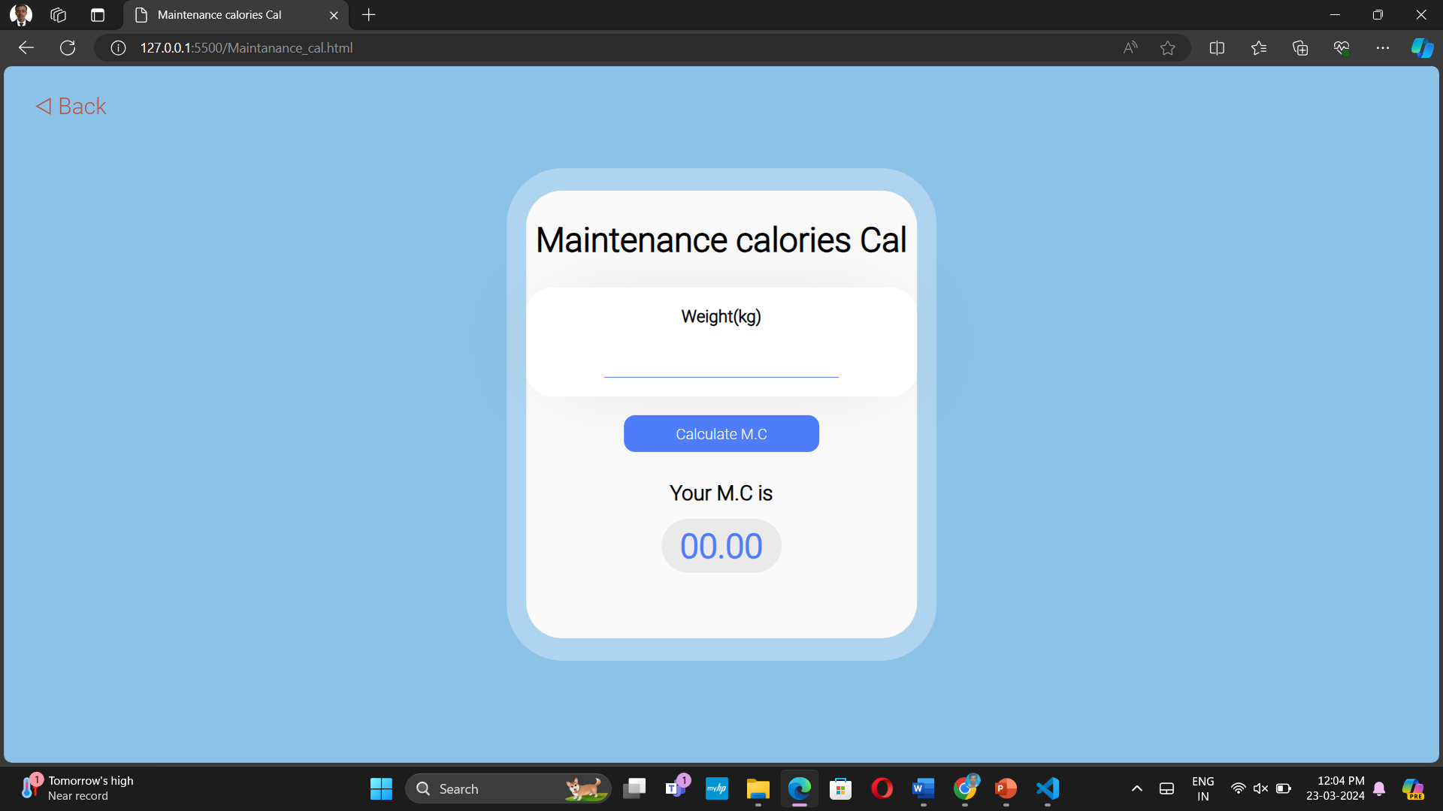



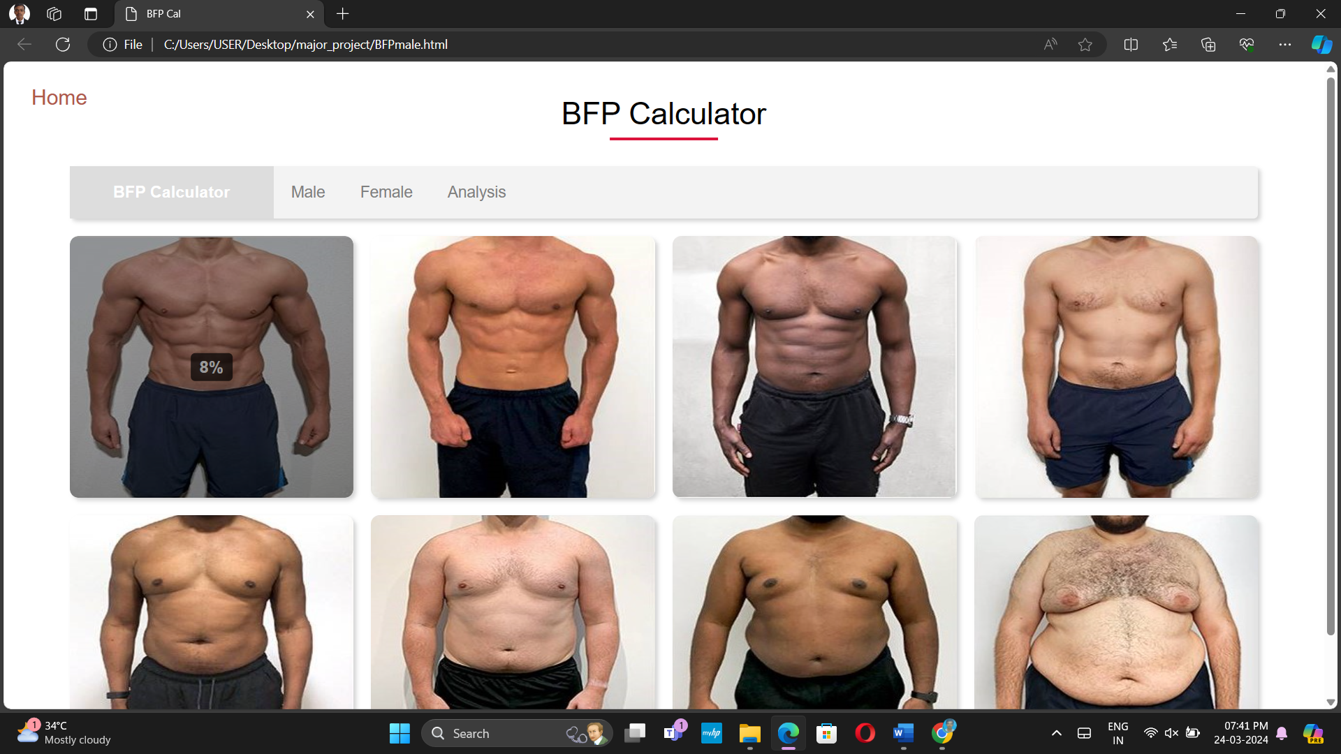

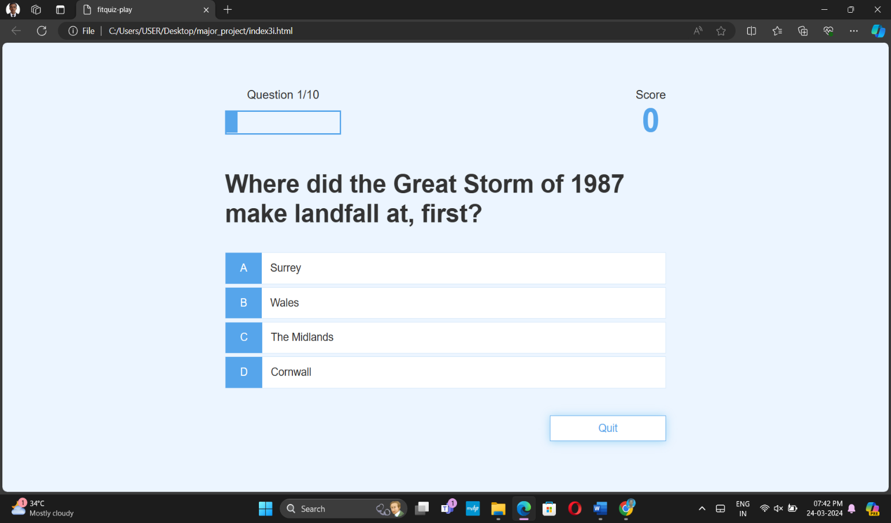

**9.2 SAMPLE CODING**

<!DOCTYPE html>

<html lang="en">

<head>

<meta charset="UTF-8">

<meta name="viewport" content="width=device-width, initial-scale=1.0">

<title>Fitness Quiz</title>

<link rel="stylesheet" href="style3.css">

</head>

<body>

<div class="container">

<div id="home" class="flex-center flex-column">

<h1> FitCompute Pro</h1>

<a class="btn" href="/Maintanance_cal.html">Maintanance Calories Calculator</a>

<a class="btn" href="/BMI_cal.html">BMI Calculator</a>

<a class="btn" href="/BFPmale.html">BFP Calculator</a>

<a class="btn" href="/index3.html ">Science Quiz</a>

</div>

</div>

</body>

</html>

<!DOCTYPE html>

<html lang="en">

<head>

<meta charset="UTF-8">

<meta name="viewport" content="width=device-width, initial-scale=1.0">

<link rel="stylesheet" href="style.css">

<link rel="preconnect" href="https://fonts.googleapis.com">

<link rel="preconnect" href="https://fonts.gstatic.com" crossorigin>

<link href="https://fonts.googleapis.com/css2?family=Nunito:wght@300&family=Roboto:wght@300&display=swap" rel="stylesheet">

<title>BMI Calculator</title>

</head>

<body>

<a href="#" class="back-link" onclick="goBack()">&#9665; Back</a>

<div class="container">

<div class="box">

<h1> BMI Calculator </h1>

<div class="content">

<div class="input">

<label for="height">Height(cm)</label>

<input type="number" id="height">

</div>

<div class="input">

<label for="weight">Weight(kg)</label>

<input type="number" id="weight">

</div>

<button id="calculate">Calculate BMI</button>

</div>

<div class="result">

<p>Your BMI is</p>

<div id="result">00.00</div>

<p class="comment"></p>

</div>

</div>

</div>

<script>

const btn = document.getElementById('calculate');

btn.addEventListener('click', function()

{

let height = document.querySelector('#height').value;

let weight = document.querySelector('#weight').value;

if(height == '' || weight =='')

{

alert('please fill out the input fields!');

return;

}

height = height /100;

let BMI = (weight / (height * height));

BMI = BMI.toFixed(2);

document.querySelector('#result').innerHTML = BMI;

let status = '';

if(BMI < 18.5)

{

status = "Underweight";

}

if(BMI >= 18.5 && BMI < 25)

{

status = "Healthy"

}

if(BMI >= 25 && BMI < 30)

{

status = "Overweight"

}

if(BMI >= 30)

{

status = "Obese"

}

document.querySelector('.comment').innerHTML=`Comment : you are <span id="comment">${status}</span>`;

});

function goBack() {

window.history.back();

}

</script>

</body>

</html>

<!DOCTYPE html>

<html lang="en">

<head>

<meta charset="UTF-8">

<meta name="viewport" content="width=device-width, initial-scale=1.0">

<link rel="stylesheet" href="style.css">

<link rel="preconnect" href="https://fonts.googleapis.com">

<link rel="preconnect" href="https://fonts.gstatic.com" crossorigin>

<link href="https://fonts.googleapis.com/css2?family=Nunito:wght@300&family=Roboto:wght@300&display=swap" rel="stylesheet">

<title>Maintenance calories Cal</title>

</head>

<body>

<a href="#" class="back-link" onclick="goBack()">&#9665; Back</a>

<div class="container">

<div class="box">

<h1> Maintenance calories Cal </h1>

<div class="content">

<div class="input">

<label for="weight">Weight(kg)</label>

<input type="number" id="weight">

</div>

<button id="calculate">Calculate M.C</button>

</div>

<div class="result">

<p>Your M.C is</p>

<div id="result">00.00</div>

<p class="comment"></p>

</div>

</div>

</div>

<script>

const btn = document.getElementById('calculate');

btn.addEventListener('click', function()

{

let weight = document.querySelector('#weight').value;

if(weight =='')

{

alert('please fill out the input fields!');

return;

}

let MC = (weight*2.2*14);

MC = MC.toFixed(2);

document.querySelector('#result').innerHTML = MC;

document.querySelector('.comment').innerHTML=`Comment : you are <span id="comment">${MC}</span>`;

});

function goBack() {

window.history.back();

}

</script>

</body>

</html>

<!DOCTYPE html>

<html lang="en">

<head>

<meta charset="UTF-8">

<meta name="viewport" content="width=device-width, initial-scale=1.0">

<title>BFP Cal</title>

<link rel="stylesheet" href="bfp.css">

</head>

<body>

<a href="#" class="back-link" onclick="gohome()">Home</a>

<input type="radio" name="photos" id="check1" >

<input type="radio" name="photos" id="check2">

<div class="container">

<h1>BFP Calculator</h1>

<div class="top-content">

<h3>BFP Calculator</h3>

<label for="check1" onclick="male();">Male</label>

<label for="check2" onclick="female()">Female</label>

<label for="check1" onclick="bfp();">Analysis</label>

</div>

<div class="photo-gallery">

<div class="pic places" onclick="showPercentage(8)">

<img src="images/8-1.jpg">

<div class="tooltip">8%</div>

</div>

<div class="pic places" onclick="showPercentage(10)">

<img src="images/10-1.jpg">

<div class="tooltip">10%</div>

</div>

<div class="pic places" onclick="showPercentage(15)">

<img src="images/15-1.jpg">

<div class="tooltip">15%</div>

</div>

<div class="pic places" onclick="showPercentage(20)">

<img src="images/20-1.jpg">

<div class="tooltip">20%</div>

</div>

<div class="pic places" onclick="showPercentage(25)">

<img src="images/25-1.jpg">

<div class="tooltip">25%</div>

</div>

<div class="pic places" onclick="showPercentage(30)">

<img src="images/30-1.jpg">

<div class="tooltip">30%</div>

</div>

<div class="pic places" onclick="showPercentage(35)">

<img src="images/35-1.jpg">

<div class="tooltip">35%</div>

</div>

<div class="pic places" onclick="showPercentage(40)">

<img src="images/40-1.jpg">

<div class="tooltip">40%</div>

</div>

</div>

</div>

<script>

function male() {

window.location = "BFPmale.html";

}

function female() {

window.location = "BFPfemale.html";

}

function bfp() {

window.location = "bfp.html";

}

function showPercentage(percentage) {

alert(percentage + '%');

}

function gohome()

{

window.location = "home.html";

}

</script>

</body>

</html>

<!DOCTYPE html>

<html lang="en">

<head>

<meta charset="UTF-8">

<meta name="viewport" content="width=device-width, initial-scale=1.0">

<title>fitquiz-play</title>

<link rel="stylesheet" href="style3.css">

<link rel="stylesheet" href="game1.css">

</head>

<body>

<div class="container">

<div id="loader"></div>

<div id="game" class="justify-center flex-column hidden">

<div id="hud">

<div id="hud-item">

<p id="progressText" class="hud-prefix">

Question

</p>

<div id="progressBar">

<div id="progressBarFull"></div>

</div>

</div>

<div id="hud-item">

<p class="hud-prefix">

Score

</p>

<h1 class="hud-main-text" id="score">

0

</h1>

</div>

</div>

<h2 id="question"></h2>

<div class="choice-container">

<p class="choice-prefix">A</p>

<p class="choice-text" data-number="1"></p>

</div>

<div class="choice-container">

<p class="choice-prefix">B</p>

<p class="choice-text" data-number="2"></p>

</div>

<div class="choice-container">

<p class="choice-prefix">C</p>

<p class="choice-text" data-number="3"></p>

</div>

<div class="choice-container">

<p class="choice-prefix">D</p>

<p class="choice-text" data-number="4"></p>

</div>

<input type="button" id="quit" value="Quit" onclick="gotohome()">

<script>

function gotohome()

{

window.open("index3.html")

}

</script>

</div>

</div>

<script src="game1.js"></script>

</body>

</html>

<!DOCTYPE html>

<html lang="en">

<head>

<meta charset="UTF-8">

<meta name="viewport" content="width=device-width, initial-scale=1.0">

<title>fitquiz-play</title>

<link rel="stylesheet" href="style3.css">

<link rel="stylesheet" href="game1.css">

</head>

<body>

<div class="container">

<div id="loader"></div>

<div id="game" class="justify-center flex-column hidden">

<div id="hud">

<div id="hud-item">

<p id="progressText" class="hud-prefix">

Question

</p>

<div id="progressBar">

<div id="progressBarFull"></div>

</div>

</div>

<div id="hud-item">

<p class="hud-prefix">

Score

</p>

<h1 class="hud-main-text" id="score">

0

</h1>

</div>

</div>

<h2 id="question"></h2>

<div class="choice-container">

<p class="choice-prefix">A</p>

<p class="choice-text" data-number="1"></p>

</div>

<div class="choice-container">

<p class="choice-prefix">B</p>

<p class="choice-text" data-number="2"></p>

</div>

<div class="choice-container">

<p class="choice-prefix">C</p>

<p class="choice-text" data-number="3"></p>

</div>

<div class="choice-container">

<p class="choice-prefix">D</p>

<p class="choice-text" data-number="4"></p>

</div>

<input type="button" id="quit" value="Quit" onclick="gotohome()">

<script>

function gotohome()

{

window.open("index3.html")

}

</script>

</div>

</div>

<script src="game1.js"></script>

</body>

</html>

<!DOCTYPE html>

<html lang="en">

<head>

<meta charset="UTF-8" />

<meta name="viewport" content="width=device-width, initial-scale=1.0" />

<meta http-equiv="X-UA-Compatible" content="ie=edge" />

<title>High Scores</title>

<link rel="stylesheet" href="style3.css" />

<link rel="stylesheet" href="highscores1.css" />

</head>

<body>

<div class="container">

<div id="highScores" class="flex-center flex-column">

<h1 id="finalScore">High Scores</h1>

<ul id="highScoresList"></ul>

<a class="btn" href="/index3.html">Go Home</a>

</div>

</div>

<script src="highscores1.js"></script>

</body>

</html>

**BIBLIOGRAPHY**

**BIBLIOGRAPHY**

* Robin Nixon, “**LEARNING PHP , MySQL & JAVA SCRIPT**”,O Reilly Media. Fourth Edition, 2014.
* John Smith, "**WEB DESIGN FUNDAMENTALS**", ABC Publishing, 2nd Edition, 2020
* Jane Doe, "**RESPONSIVE WEB DESIGN TECHNIQUES**", XYZ Books, 2018.
* Sarah White, "**HTML5 AND CSS3: MODERN WEB DESIGN**" WebTech Publications, 2021.

# WEBSITES

* [www.w3schools.com](http://www.w3schools.com)
* developer.mozilla.org
* www.smashingmagazine.com