**Algae**

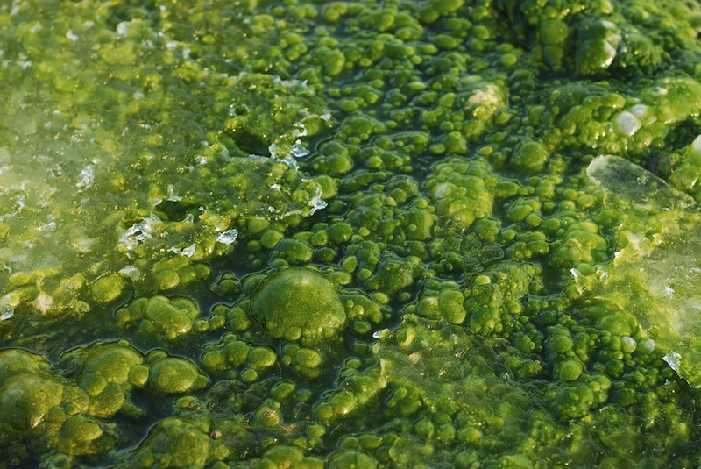

We originated from a Latin word (Algae - Seaweeds). We are chlorophyll-bearing, simple, and primitive plants. We are autotrophs. We belong to thallophyta and the plant body of us is called a thallus. ie. the plant body is not differentiated into root, stem, and leaf.

Most of us live in aquatic regions. We may be freshwater or marine water. Very few of us can survive in wet soil. Some of us are very minute and float on the surface of the water. We are called phytoplankton. Some of us are symbionts (Algae living with fungi and they both mutually benefit). Eg. Lichen. A few species of us are epiphytes. The branch of the study of algae is called phycology or algology.

**Classification of Algae**

We are classified based on the pigments we possess.

1)We are Bluegreen algae (Cyanophyceae) Eg of us is Oscillatoria and our pigment is Phycocyanin. Our reserve food is Cyanophycean Starch.

2)We are Green algae (Chlorophyceae) Eg of us is Chlamydomonas and our pigment is Chlorophyll. Our reserve food is Starch.

3)We are Brown algae (Phaeophyceae) Eg of us is Laminaria and our pigment is Fucoxanthin. Our reserve food is Laminarian starch and Mannitol

4)We are Red algae (Rhodophyceae)Eg of us is Polysiphonia and our pigment is Phycoerythrin. Our reserve food is Floridian Starch.

**Red Algae**

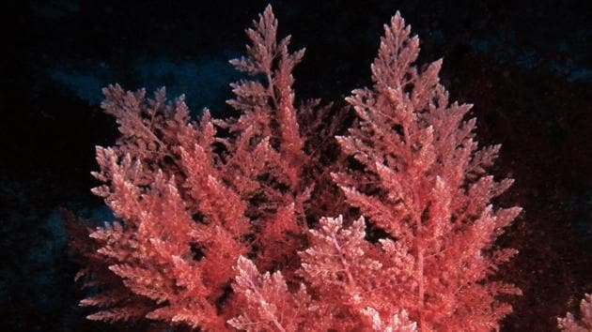

We are so-called Rhodophyta, we are distinctive species found in marine as well as freshwater ecosystems. The pigments phycocyanin and phycoerythrin are responsible for the characteristic red coloration of us. Other [pigments](https://byjus.com/biology/pigments/) that provide green coloration (such as chlorophyll a) are present. However, we lack chlorophyll b or beta-carotene.

**Green Algae**

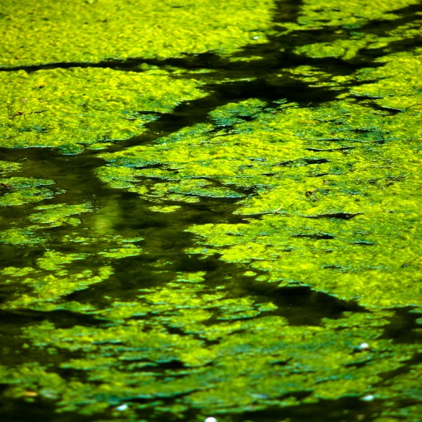

We are a large, informal grouping of algae having the primary photosynthetic pigments chlorophyll a and b, along with auxiliary pigments such as xanthophylls and beta carotene.

Higher organisms use green algae to conduct photosynthesis for them. Other species of us have a symbiotic relationship with other organisms. Members are unicellular, multicellular, colonial, and flagellates. Prominent examples of us include Spirogyra, Ulothrix, Volvox, etc.

**Blue Green Algae**

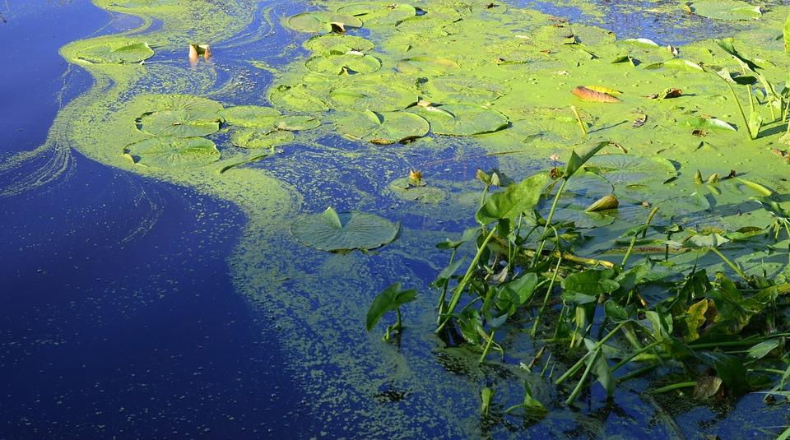

In the past, we were one of the most well-known types of algae. However, since we are prokaryotes, we are not currently included under algae (because all algae are classified as eukaryotic organisms).

We are also called cyanobacteria, we live in moist or aquatic environments like other algae. These include dams, rivers, reservoirs, creeks, lakes, and oceans. This class of bacteria obtains energy through the process of [photosynthesis](https://byjus.com/biology/photosynthesis/). Ecologically, some species of us are significant to the environment as it fixes the nitrogen in the soil. Hence, we are also called nitrogen-fixing bacteria. E.g. Nostoc, Anabaena, etc.

**Economic Importance**

**Food**

We are consumed as food by people in Japan, England, and also in India. E.g. Ulva, Spirulina, Chlorella etc. Some of us are used as food for domestic animals. E.g. Laminaria, Ascophyllum

**Agriculture**

Some of the blue-green algae are essential for the fixing of atmospheric nitrogen in the soil, which increases the fertility of the soil. E.g. Nostoc, Anabaena.

**Agar Agar**

Agar agar is extracted from some red algae, namely Gelidium and Gracillaria. It is used to prepare growth medium in laboratories.

**Iodine**

Iodine is obtained from brown algae like Laminaria

**Space travel**

Chlorella pyrenopsida is used in space travel to get rid of CO2 and to decompose human wastes.

**Single Cell Protein (SCP)**

Some of the single-cell algae and blue-green algae are used to produce protein. E.g. Chlorella, Spirulina.

**Algal Biofuel**

Recent developments in science and technology have enabled us to be used as a source of fuel. Global demand for petroleum products and declining environmental health have prompted the use of eco-friendly alternatives such as algal biofuel. Hence, algae fuel is an increasingly viable alternative to traditional fossil fuels. It is used to produce everything from “green” diesel to “green” jet fuel. It is similar to the other biofuels made from corn and sugar cane.