**Angiosperms**

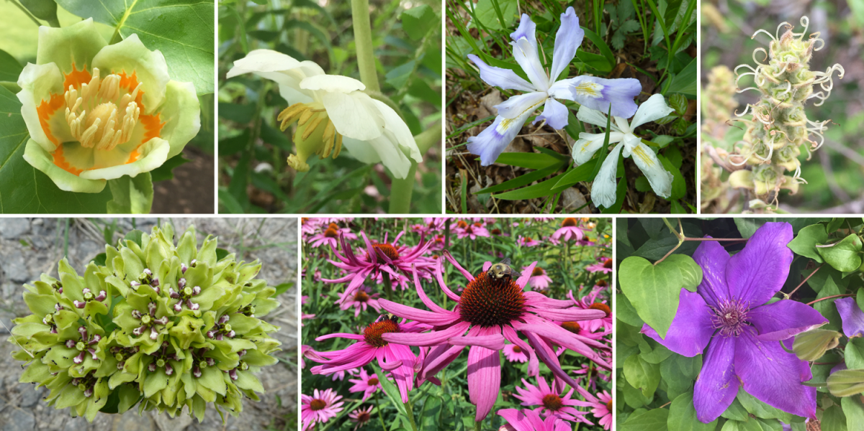

We derived from two Greek words, i.e. ‘Angio’ which means box or closed, and ‘Sperma’ which means seed. We are vascular plants with stems, roots, and leaves. Our seeds are found in a flower. These make up the majority of all plants on earth. Our seeds develop inside the plant organs and form fruit. Hence, we are also known as flowering plants.

We are the most advanced and beneficial group of plants. We can grow in various habitats as trees, herbs, shrubs, and bushes. We have well-developed vascular tissues called the xylem and phloem. The xylem contains vessels, tracheid, xylem parenchyma, and xylem fibre. Phloem contains sieve tubes, phloem parenchyma, companion cells, and phloem fibres.

**Classification of Angiosperms**

We are divided into two classes. They are

• Dicotyledons • Monocotyledons

**Dicotyledons**

**Our main features are**

• Our seed has two cotyledons.

• We have tap root systems and leaves with reticulate venation.

• Our flowers are tetramerous or pentamerous. Calyx and Corolla are well differentiated.

• Pollination occurs mostly by insects.

• Examples are: Bean, Mango, Neem

**Monocotyledons**

**Our main features are**

• Our seed has only one cotyledon.

• We have a fibrous root system, and leaves are with parallel venation.

• Our flowers are trimerous and not differentiated into calyx and corolla.

• Pollination occurs mostly by wind.

• Examples are Grass, Paddy, and Banana.

**Taxonomy**

I am the branch of biology that deals with the study of the identification, classification, description, and nomenclature of living organisms. The word taxonomy is derived from two Greek words (Taxis means arrangement and Nomos means laws). The word 'taxonomy' was first coined by Augustin) Pyramus de Candolle

**Classification**

Plants are arranged into different groups and categories on the basis of similarities and differences. It is called classification. There are four types of classification.

1. Artificial system of classification

2. The natural system of classification

3. The phylogenetic system of classification

4. The modern system of classification

**1. Artificial system of classification**

The artificial system is the earliest system of classification in plants. Plants are classified on the basis of one or a few morphological characteristics. The most famous artificial system of classification is Linnaeus classification which was proposed by Carolus Linnaeus in his book Species Plantarum

**2**. **Natural system of classification**

In the Natural system of classification, plants are classified on the basis of several characteristics. Bentham and Hooker’s classification is an example of the natural system of classification. This system of classification is based on the morphological and reproductive characteristics of the seeded plants. Bentham and Hooker published their natural system of classification in their book named General Plantarum in three volumes. This classification is widely used in many herbaria and botanical gardens all over the world. The herbarium is the collection of pressed, dried plants pasted on a sheet and arranged according to any one of the accepted systems of classification. The largest Herbarium in India is in Kolkata, which has more than 10,00,000 (one million) species of herbarium specimens.

**Binomial Nomenclature**

The naming of organisms with two words is known as Binomial Nomenclature. For example, the binomial name of mango is Mangifera indica. Here the first word Mangifera refers to the genus name and the second word indica refers to the species name. The binomial name was first introduced by Gaspard Bauhin in the year 1623. The binomial system was implemented by Linnaeus in his book, Species Plantarum. The system of naming plants on a scientific basis is known as Botanical nomenclature.

The rules and recommendations regarding binomial nomenclature were found in the ICBN (International Code of Botanical Nomenclature). Now it is known as ICN (International Code of Nomenclature).

**Uses of Medicinal Plants**

Plants are useful to us in many ways. Some plants along with their parts are used as medicines. The uses of some medicinal plants are given below

**Acalypha indica (Kuppaimeni)**

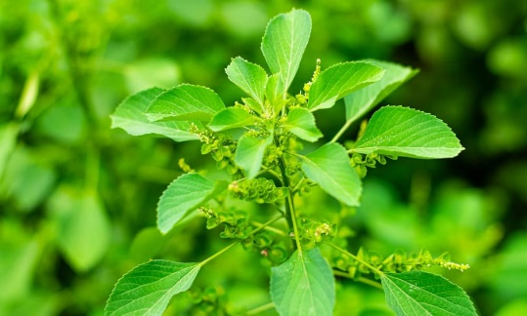

* We belong to the family Euphorbiaceae.
* The paste obtained from our leaves is used to cure burns on the skin.
* The juice is mixed with lemon juice to cure ringworm.

**Aegle marmelos (Vilvam)**

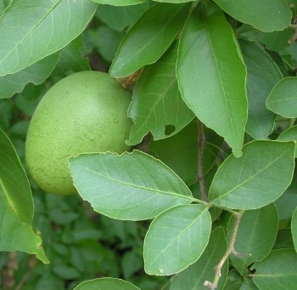

• We belong to the family Rutaceae.

• Our unripe fruit is used to treat indigestion.

• We are used for curing chronic diarrhea and dysentery.

**Solanum trilobatum (Thoodhuvalai)**

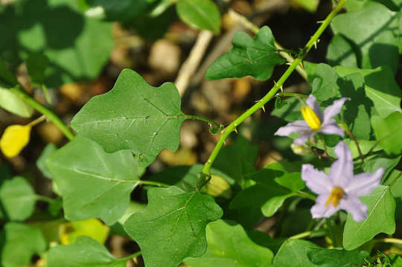

• We belong to the family Solanaceae.

• Our leaves and fruits cure cough and cold

. • We are widely used in the treatment of tuberculosis and bronchial asthma.

**Aloe vera (Sothu Katrazhai)**

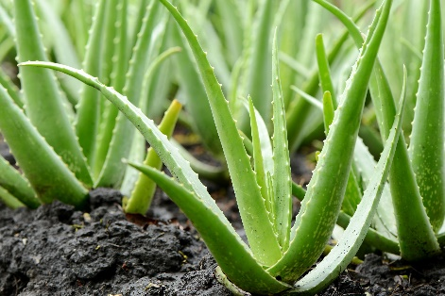

• We belong to the family Liliaceae.

• Our leaves are used to cure piles and inflammations on the skin.

• It cures peptic ulcer

**Phyllanthus amarus (Keezhanelli)**

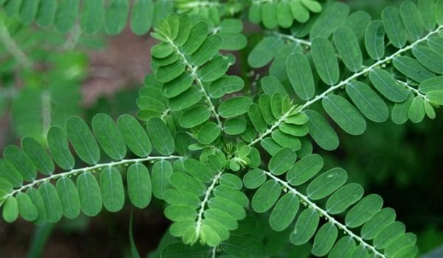

• We belong to the family Euphorbiaceae.

• Our entire plant is used for the treatment of jaundice.

• We give additional strength to the human liver and it is used to treat other liver disorders.