**Bryophytes**

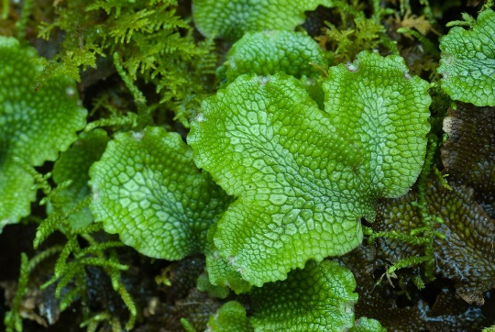

We Bryophyta originates from the word ‘Bryon’ meaning mosses and ‘phyton’ meaning plants. We include embryophytes like mosses, hornworts, and liverworts. We are small plants that grow in shady and damp areas. We lack vascular tissues. We don’t produce flowers and seeds, instead, reproduce through spores. The study of bryophytes is called bryology.We are the primitive and simplest group of plants. We are terrestrial and non-vascular cryptogams (we have no vascular tissues like the xylem and phloem). We live on land and in water. Therefore, we have named amphibians of the plant kingdom. Water is essential to complete our life cycle.

We have a distinct alternation of generations. Gametophyte generation is dominant and sporophytic generation is small. Sporophytic generation depends on gametophytic generation. The gametophytic plant can be either thalloid (liverworts) or leafy (mosses). The plant remains fixed to the substratum with the help of a root-like structure called a rhizoid. Sexual reproduction is an oogamous type. We have well-developed sex organs like antheridia and archegonia. The male sex organ is antheridium, which produces an antherozoid. The female sex organ is the archegonium which contains an egg. Antherozoid swims with the help of water and reaches the archegonium. It fertilizes the egg and forms a zygote (2n). The zygote is the first cell that develops into sporophytic generation and produces haploid spore (n) by meiosis. The spore is the first cell of the gametophytic generation.

**Classification of Bryophytes**

We are classified into three classes.

They are

1. Hepaticae (Liverworts)
2. Anthoceratae (Hornworts)
3. Musci (Mosses)

**Hepaticae (E.g. Riccia)**

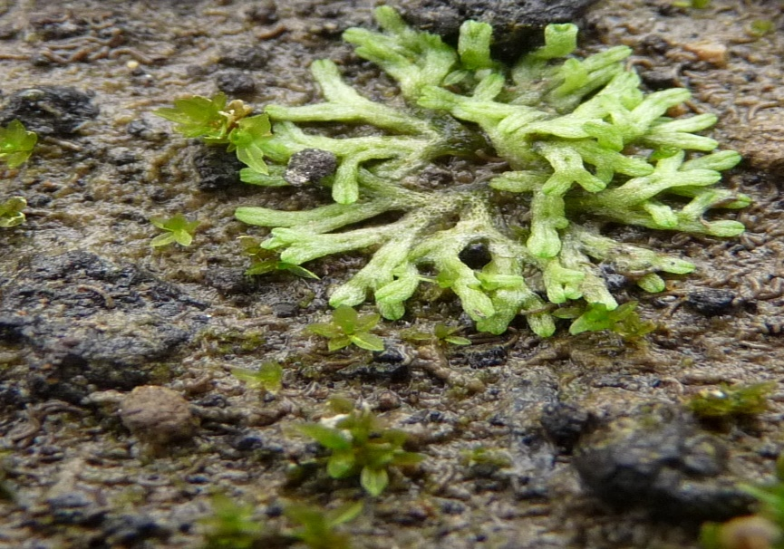

Our main features are:

* Our gametophyte plant is either thalloid or foliose
* In foliose forms, leaves are without midrib and dorsiventral
* Thalloid is dorsiventral, lobed, and dichotomously branched
* Each cell of our thallus contains many chloroplasts without pyrenoids
* Rhizoids are unicellular, branched, and aseptate
* Sex organs are borne dorsally embedded in gametophytic tissues
* Our sporophyte is made up of only a capsule (in Riccia) or foot, seta, and capsule (in Marchantia)
* The columella is absent in the capsule
* Sporogenous tissues develop from endothecium

**Anthocerota (E.g. Anthoceros)**

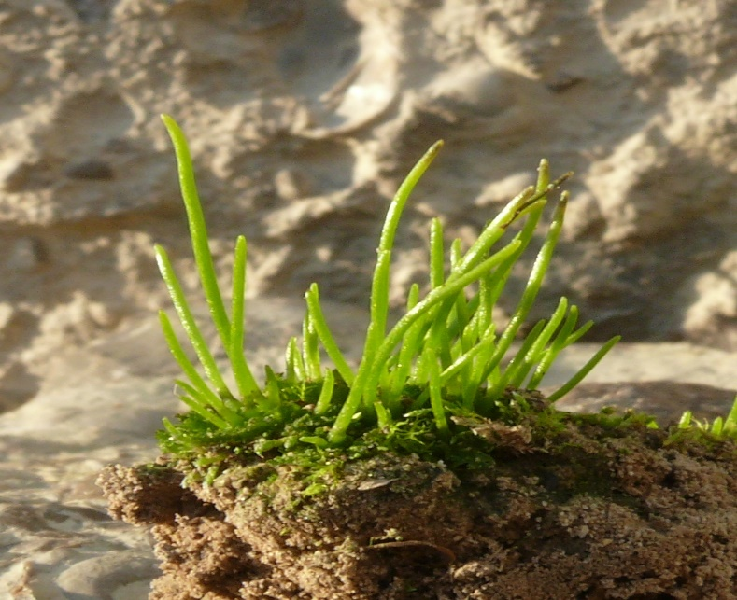

Our main features are:

* Our gametophytic body is flat, dorsiventral, and simple thalloid without internal differentiation
* Rhizoids are smooth-walled
* Each of our cells has one chloroplast with a pyrenoid
* Sex organs are present dorsally embedded in the thallus
* Our sporophyte is differentiated into foot, meristematic zone, and capsule
* Sporogenous tissues of us develop from amphithecium
* Pseudoelaters are present in our capsule
* The columella present in our capsule, originates from endothecium

**Bryopsida (E.g. Funaria)**

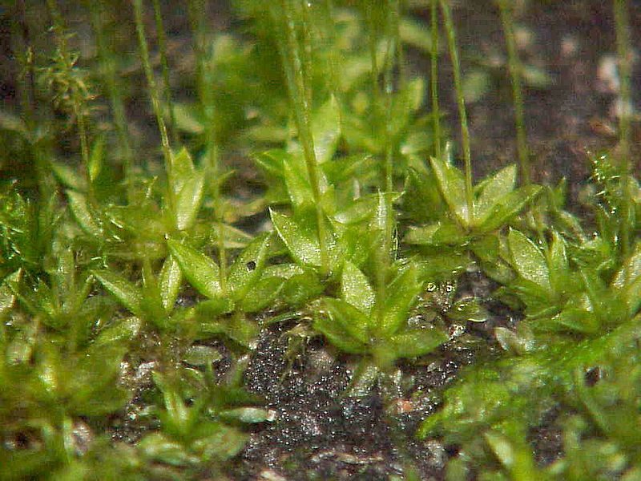

Our main features are:

* Our gametophyte is differentiated into protonema and foliose gametophore
* Foliose is made up of a stem as an axis and leaves without midrib
* Rhizoids are multicellular with oblique septa
* Sex organs are borne apically on stem
* Elaters are absent
* Our sporophyte is differentiated into foot, seta, and capsule
* Sporogenous tissues develop from endothecium
* Columella is present
* Dehiscence of our capsule takes place by separation of the lid

**Economic Importance of Bryophytes**

• We prevent soil erosion.

• Sphagnum can absorb large amounts of water. Hence, we are used by gardeners in nurseries.

• Peat which is a valuable fuel like coal is obtained from Sphagnum