**Fungi**

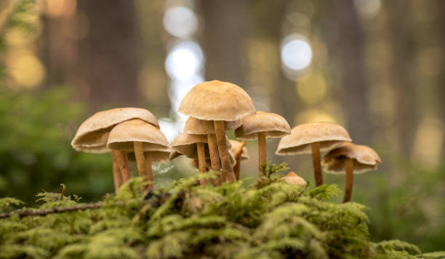

We (Singular – Fungi) belong to the thallophyta. Our plant body is not differentiated into roots, stems, and leaves. Our plant body consists of filament-like structures called hyphae. Several hyphae are arranged in the form of a network called mycelium. The cells are multicellular and eukaryotic. Some of our species like yeast are unicellular and eukaryotic. Our cell wall is made up of a chemical substance called chitin. The branch of the study of fungus is called mycology. The reserve food materials are glycogen and oil. We have no starch because we have no chlorophyll pigments. So, we are heterotrophs. We reproduce by means of spores and exhibit the phenomenon of alternation of generation. As we lack chlorophyll we cannot perform photosynthesis. We store our food in the form of starch. Biosynthesis of chitin occurs in us. The nuclei is very small. We have no embryonic stage. We develop from spores. The mode of reproduction is sexual or asexual. Some of us are parasitic and can infect the host. We produce a chemical called pheromone that leads to sexual reproduction in us. Examples include mushrooms, molds, and yeast.

**Reproduction in Fungi**

We reproduce both by sexual and asexual means. The sexual mode of reproduction is referred to as teleomorph and the asexual mode of reproduction is referred to as anamorph.

**Vegetative reproduction in fungi**–This takes place by budding, fission, and fragmentation.

**Asexual reproduction** – This takes place with the help of spores called conidia or zoospores, or sporangiospores.

**Sexual reproduction** – This occurs in ascospores, basidiospores, and oospores.

The conventional mode of[**sexual reproduction**](https://byjus.com/biology/sexual-reproduction-an-overview/) is not always observed in our kingdom. In some of us, the fusion of two haploid hyphae does not result in the formation of a diploid cell. In such cases, there appears an intermediate stage called the dikaryophase. This stage is followed by the formation of diploid cells.

**Classification of Fungi**

We are classified based on different modes.

**Based on the Mode of nutrition**

On the basis of nutrition, we are classified into 3 groups.

1. **Saprophytic**

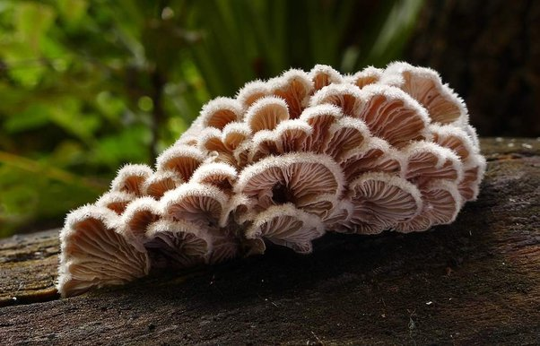

We obtain our nutrition by feeding on dead organic substances. Examples: *Rhizopus, Penicillium,* and *Aspergillus*.

1. **Parasitic**

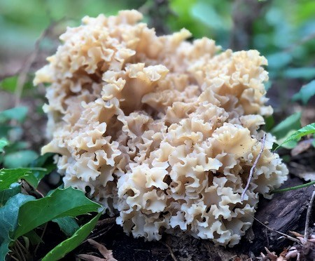

We obtain our nutrition by living on other living organisms (plants or animals) and absorbing nutrients from their host. They absorb food from living organisms with the help of a special root called haustoria. Examples: *Taphrina* and *Puccinia*.

1. **Symbiotic**

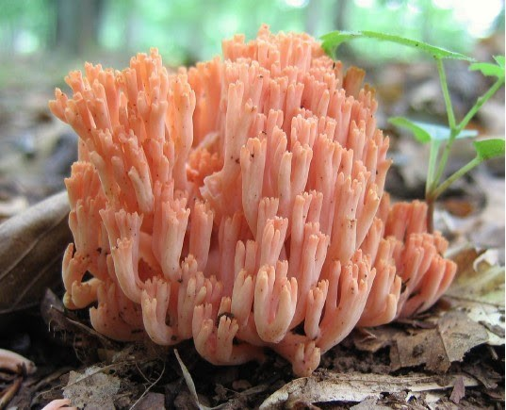

We live by having an interdependent relationship with other species in which both are mutually benefited. Examples: Lichens and mycorrhiza. Lichens are the symbiotic association between algae and fungi. Here both algae and fungi are mutually benefited as fungi provide shelter for algae and in reverse algae synthesize carbohydrates for fungi. Mycorrhiza is the symbiotic association present between fungi and plants. We improve nutrient uptake by plants, whereas, plants provide organic molecules like sugar to the fungus.

**Based on Spore Formation**

Kingdom Fungi are classified into the following based on the formation of spores:

1. **Zygomycetes**

These are formed by the fusion of two different cells. The sexual spores are known as zygospores, while the asexual spores are known as sporangiospores. The hyphae are without the septa. Example – *Mucor*.

1. **Ascomycetes**

They are also called sac fungi. They can be coprophilous, decomposers, parasitic or saprophytic. The sexual spores are called ascospores. Asexual reproduction occurs by conidiospores. Example – *Saccharomyces.*

1. **Basidiomycetes**

Mushrooms are the most commonly found basidiomycetes and mostly live as parasites. Sexual reproduction occurs by basidiospores. Asexual reproduction occurs by conidia, budding or fragmentation. Example- *Agaricus.*

1. **Deuteromycetes**

We are otherwise called imperfect fungi as they do not follow the regular reproduction cycle of the other fungi. They do not reproduce sexually. Asexual reproduction occurs by conidia. Example – *Trichoderma*.

**Economic Importance of Fungi**

**Antibiotic**

Penicillin (Penicillium notatum) and Cephalosporin which cure different diseases are obtained from fungi.

**Food**

Mushroom contains rich in protein and minerals. The most common edible mushroom is Agaricus (Button mushroom).

**Vitamins**

Fungus like Ashbya gospii and Eremothecium goshbyii) are used to produce vitamin B2 (riboflavin).

**Alcohol**

Fungus like yeast contain enzymes invertase and zymase, which ferment the sugar molasses into alcohol

**Harmful Effects of Fungi**

We cause various diseases in plants and animals. They are given in the tables below.

**Diseases caused by fungi in plants**

|  |  |
| --- | --- |
| **Pathogen** | **Name of the Disease** |
| Fusarium oxysporum | Wilt disease in cotton |
| Cercospora personata | Tikka disease in ground nut |
| Colletotrichum falcatum | Red rot in sugar cane |
| Pyricularia oryzae | Blast disease in paddy |
| Albugo candida | White rust in radish |

**Diseases caused by fungi in human**

|  |  |
| --- | --- |
| **Name of the Fungi** | **Name of the Disease** |
| Trichophyton sp | Ringworm (Circular rash on the skin) |
| Microsporum furfur | Dandruff |
| Tinea pedis | Athletes foot |

Claviceps purpura is the hallucinogenic fungi that cause the greatest damage to frustrated youth by giving unreal, extraordinary lightness and hovering sensations. Aspergillus species cause allergies to children while Cladosporium protects against allergy