**Pteridophytes**

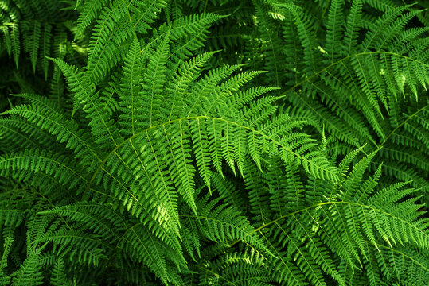

We ‘Pteridophytes’ comes from the Greek word Pteron meaning “feather” and Python meaning “plants.” We are the first true land plants with xylem and phloem. Hence, we are called vascular cryptogams. Our main plant body is differentiated into true roots, stems, and leaves.

We also exhibit an alternation of generations. The diploid sporophytic phase alternates with the haploid gametophytic phase. Our sporophyte is the dominant phase. Sporophytes reproduce by means of spores. Spores are produced in sporangium. The sporangia-bearing leaves are called sporophyll. Most of our plants produce only one type of spore either microspore or megaspore (homosporous). In some plants, both microspores and megaspores are produced (heterosporous). Spores give rise to a gametophytic generation called prothallus, which is short-lived and independent. Our gametophytes produce the multicellular sex organs, antheridium which produces an antherozoid (male gamete), and archegonium which contains an egg (female gamete). The antherozoid fertilizes with the egg and forms a diploid zygote. It develops into an embryo which is differentiated into the sporophyte

We are classified into four classes. They are:

1. Psilopsida (Eg. Psilotum)

2. Lycopsida (Eg. Lycopodium)

3. Sphenopsida (Eg. Equisetum)

4. Pteropsida (Eg. Nephroepis)

**Psilopsida**

### Psilopsida Images @ IPM Images

 Our main features are

* Most of us are new fossils. We include some of the oldest vascular plants.
* Our plant body does not have roots. The rhizome is subterranean and it has an aerial shoot.
* Our stem has dichotomous branches.
* Small rhizoids come out of the rhizome. They help in the absorption of water and salts.
* The leaves are arranged on either side as scale like in a spiral as in Psilotum and leaf-like appendages as in Tmesipteris.
* There is no secondary growth in our stem.
* The sporophyte is homosporous and they are similar.
* The sporangia is present either at the tip or laterally directly on the stem. (i.e) They are cauline in position.
* The gametophyte is not photosynthetic and grows as a sporophyte with the fungus.
* The antherozoids are flagellated and spirally coiled. Eg. Psilotum

**Lycopsida**

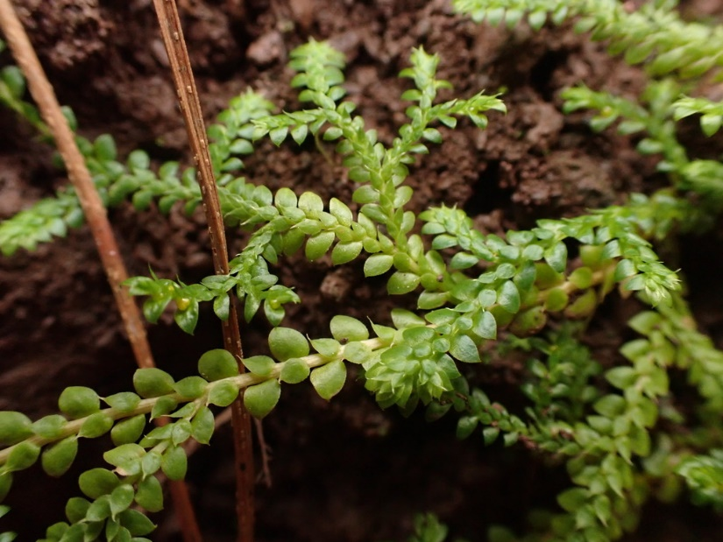

Our main features are

* Our plant body is differentiated into well-defined root, stem, and leaves
* Our leaves are small and are microphyllous.
* Branching is dichotomous.
* Sporangia are present in the axil of sporophylls.
* Sporophylls are arranged as strobila.
* Sporophyte is either homosporous as in Lycopodium or heterosporous as in Selaginella.
* The gametophyte develops independently. For example Lycopodium and Selaginella

**Sphenopsida**

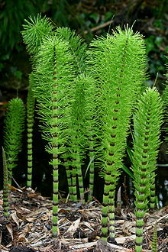

Our main features are

* We have only one living genus called Equisetum.
* Stem have distinct nodes and internodes.
* Branches are arranged in whorls.
* Very small leaves are arranged in whorls at the nodes of the stem and branches.
* The sporangia is formed on a special appendage called sporangiophore.
* Equisetum is homosporous.
* Gametophyte is photosynthetic.
* Multiple flagella are present on the antherozoids. Example Equisetum.

**Pteropsida**

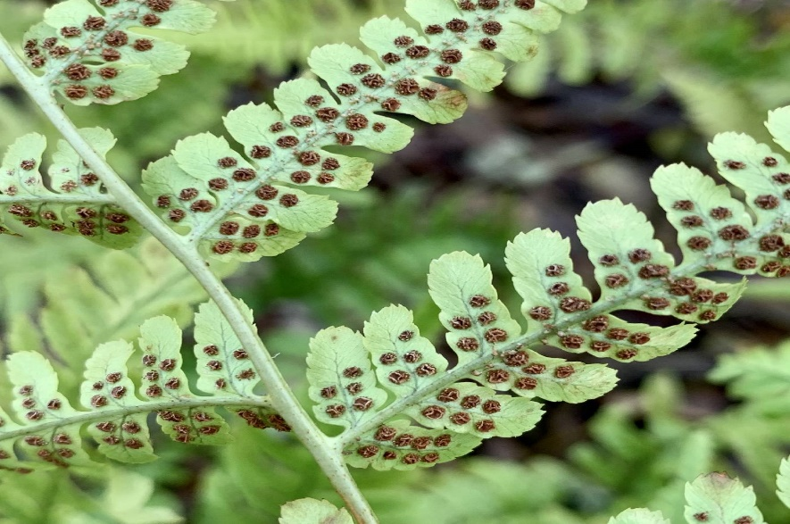

Our main features are

* Most prominent members of our class are ferns.
* Our plant body is differentiated into well-defined roots, stems, and leaves. The leaves are arranged spirally.
* Leaves are large in size (Megaphylls). They are pinnately compound and are called a frond.
* Young fronds are coiled.
* Rhizome is thick and short.
* Except for aquatic ferns others are homosporous.
* Sporangia are located at the ventral side and margins of the leaves (ventral side)
* They are present in clusters called sori. Example Dryopteris and Pteris.

**Economic Importance of Pteridophytes**

* Ferns are used as ornamental plants.
* Vermifuge drug is yielded by the rhizome and petioles of Dryopteris.
* Sporocarp of Marsilea is used as food by some people.