5. PROPOSED METHODOLOGY
5.1 Name of the Proposed Methodology
This work proposes the Fuzzy Lagrangian Proximal Policy Optimization Methodology for Reliable UAV Selection in Dynamic Internet of Vehicles, abbreviated as Fuzzy LP-PPO. The short name “Fuzzy LP-PPO” is used in algorithms, tables, graphs, and performance comparisons.
The methodology selects a suitable UAV for a moving vehicle by jointly considering vehicle–UAV distance, communication delay, packet delivery ratio (PDR), signal quality, and residual UAV energy. It combines fuzzy logic for gradual risk and urgency estimation, hard feasibility screening, adaptive Lagrangian multipliers, stable PPO learning, and scenario-specific training for urban-canyon, suburban-crossroads, and emergency-response environments.
5.2 Data Acquisition and Scenario Generation
The proposed system uses a simulation-based data-acquisition process. At the beginning of every episode, the vehicle position, UAV positions, UAV altitude, and residual UAV energy are initialized using a seeded random generator. The operational region is a 2000 × 2000 m² area containing eight candidate UAVs. UAV altitude is sampled between 80 and 200 m, while initial UAV energy is sampled between 30 and 50 internal units.
The urban-canyon scenario represents dense corridor movement and obstruction-sensitive links; the suburban-crossroads scenario represents sparse movement, longer links, and energy-aware operation; and the emergency-response scenario represents irregular mobility and non-stationary demand. At each step, the system acquires vehicle coordinates, UAV coordinates, relative position, distance, signal, delay, PDR, energy, scenario type, and current Lagrangian multipliers.
Table 4. Acquired data and preprocessing operations
Input variable | Raw range/unit | Preprocessing | Purpose
Vehicle coordinates | 0–2000 m | Divide by area size | Vehicle location
Relative UAV coordinates | −2000–2000 m | Clip and map to [0,1] | Relative geometry
UAV altitude | 80–200 m | Use in 3-D distance | Aerial geometry
Signal quality | 0.05–1.00 | Already normalized | Link strength
Delay | 0–100 ms | Threshold/fuzzy evaluation | Responsiveness
PDR | 50–100% | Percentage form | Reliability
UAV energy | 0–50 units | Multiply by two and clip | Energy percentage
Lagrangian multipliers | 0–10 | Clip after update | Constraint importance

5.3 Data Preprocessing
Let L = 2000 m denote the side length of the operational region. The normalized vehicle coordinates are defined by Equation (1). Relative UAV coordinates are clipped and mapped to [0,1] through Equations (2) and (3), while Equation (4) converts internal UAV energy into a percentage-compatible value.
x̄ᵥ(t)=xᵥ(t)/L, ȳᵥ(t)=yᵥ(t)/L (1)
x̄ᵤ,ᵥ(t)=½[clip((xᵤ(t)−xᵥ(t))/L,−1,1)+1] (2)
ȳᵤ,ᵥ(t)=½[clip((yᵤ(t)−yᵥ(t))/L,−1,1)+1] (3)
Eᵤ%(t)=min(100,max(0,2Eᵤ(t))) (4)
The processed PPO observation is given by Equation (5). It contains two normalized vehicle features and four features for each of eight UAVs, producing a 34-dimensional observation.
sₜ=[x̄ᵥ,ȳᵥ,{x̄ᵤ,ᵥ,ȳᵤ,ᵥ,Sᵥ,ᵤ,Eᵤ/50}ᵤ₌₁⁸] (5)
5.4 Proposed System Architecture
The complete Fuzzy LP-PPO architecture is presented in Figure 2. The communication module calculates link measurements, the hard mask removes clearly infeasible UAVs, the fuzzy module assigns continuous priority, the ranking module orders candidates, and PPO selects a ranked action. The reward and Lagrangian module then provides constraint-aware feedback.
PLACEMENT NOTE (remove after pasting): Insert Figure 2 immediately after the first architecture-description paragraph in Section 5.4.
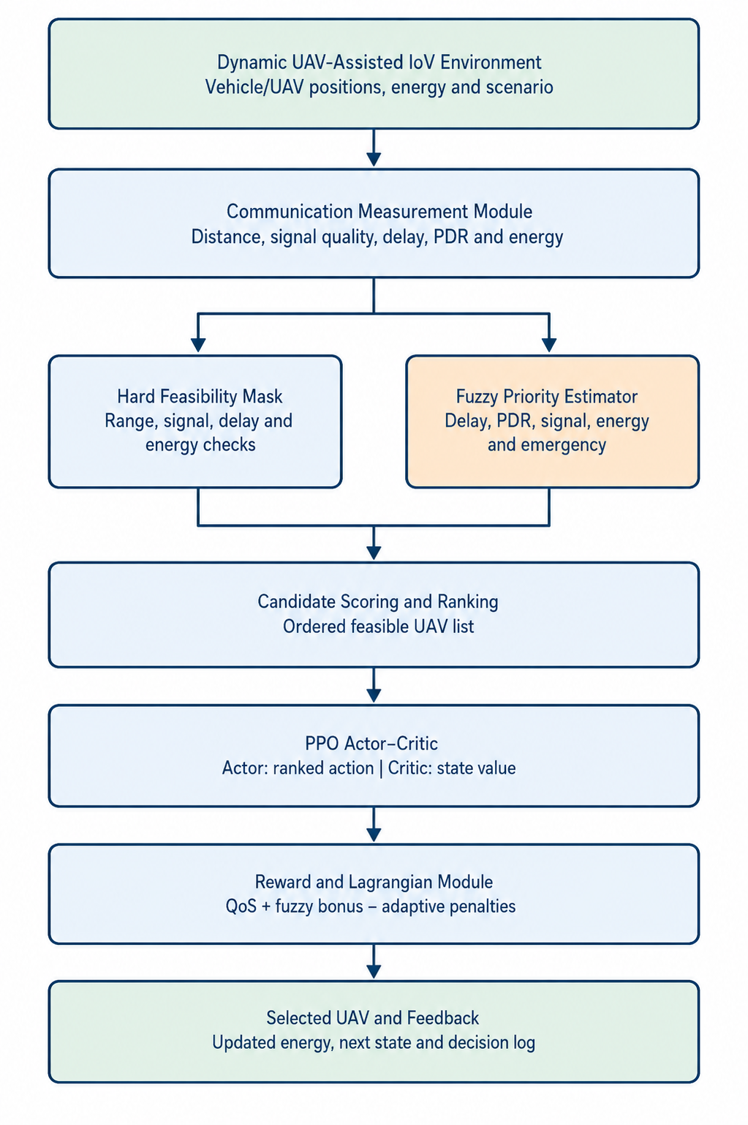
Figure 2. Proposed Fuzzy LP-PPO architecture for reliable UAV selection in dynamic IoV.
Table 5. Components of the proposed architecture
Component | Input | Processing | Output
Scenario generator | Scenario ID and seed | Initialize mobility and UAVs | Environment state
Communication module | Coordinates | Distance, signal, delay, PDR | Link measurements
Hard mask | Distance, delay, signal, energy | Apply thresholds | Feasible set
Fuzzy module | QoS, energy, scenario | Estimate gradual risk | Priority Fᵥ,ᵤ
Ranking module | Measurements and priority | Composite scoring | Ranked UAV list
PPO actor–critic | State sₜ | Action probability/value | Action and Vφ(sₜ)
Lagrangian module | Violations | Multiplier update | Adaptive penalty
Logging module | Action and metrics | Store records | Evaluation output

5.5 Fuzzy-Priority Estimation
The fuzzy-priority module converts delay, PDR, signal, energy, and emergency information into a continuous risk-aware priority. Equations (6)–(9) define the four normalized risk components, and Equation (10) combines them.
μᴰ(t)=clip((Dᵥ,ᵤ(t)−55)/45,0,1) (6)
μᴾ(t)=clip((55−Pᵥ,ᵤ(t))/7,0,1) (7)
μˢ(t)=clip((0.18−Sᵥ,ᵤ(t))/0.13,0,1) (8)
μᴱ(t)=clip((35−Eᵤ%(t))/35,0,1) (9)
Fᵥ,ᵤ(t)=clip[0.35μᴰ+0.25μᴾ+0.25μˢ+0.15μᴱ+0.10Iₑₘg,0,1] (10)
Table 6. Fuzzy-priority inputs
Fuzzy input | Low risk | Increasing risk | Maximum risk
Delay | D≤55 ms | 55–100 ms | D≥100 ms
PDR | P≥55% | 48–55% | P≤48%
Signal | S≥0.18 | 0.05–0.18 | S≤0.05
Energy | E%≥35% | 0–35% | E%=0
Emergency | Normal | — | Emergency

5.6 Feasibility Screening and Candidate Ranking
Each UAV is checked using Equation (11). If no UAV passes the conditions, the entire fleet is retained so that the action set never becomes empty. Feasible candidates are scored using Equation (12), and PPO selects a position in the ranked list as defined in Equation (13).
Mᵤ(t)=1 if dᵥ,ᵤ≤500, Eᵤ%≥20, Sᵥ,ᵤ≥0.10, and Dᵥ,ᵤ≤95; otherwise Mᵤ(t)=0 (11)
Cᵥ,ᵤ=240Sᵥ,ᵤ+2Pᵥ,ᵤ−1.3Dᵥ,ᵤ+2.5Eᵤ%+35Fᵥ,ᵤ−0.02dᵥ,ᵤ (12)
aₜ ∈ {0,1,…,7} (13)
Figure 3 traces the processing performed for each UAV. The procedure is repeated for all eight candidates before sorting.
PLACEMENT NOTE (remove after pasting): Insert Figure 3 after the feasibility and candidate-ranking equations in Section 5.6.

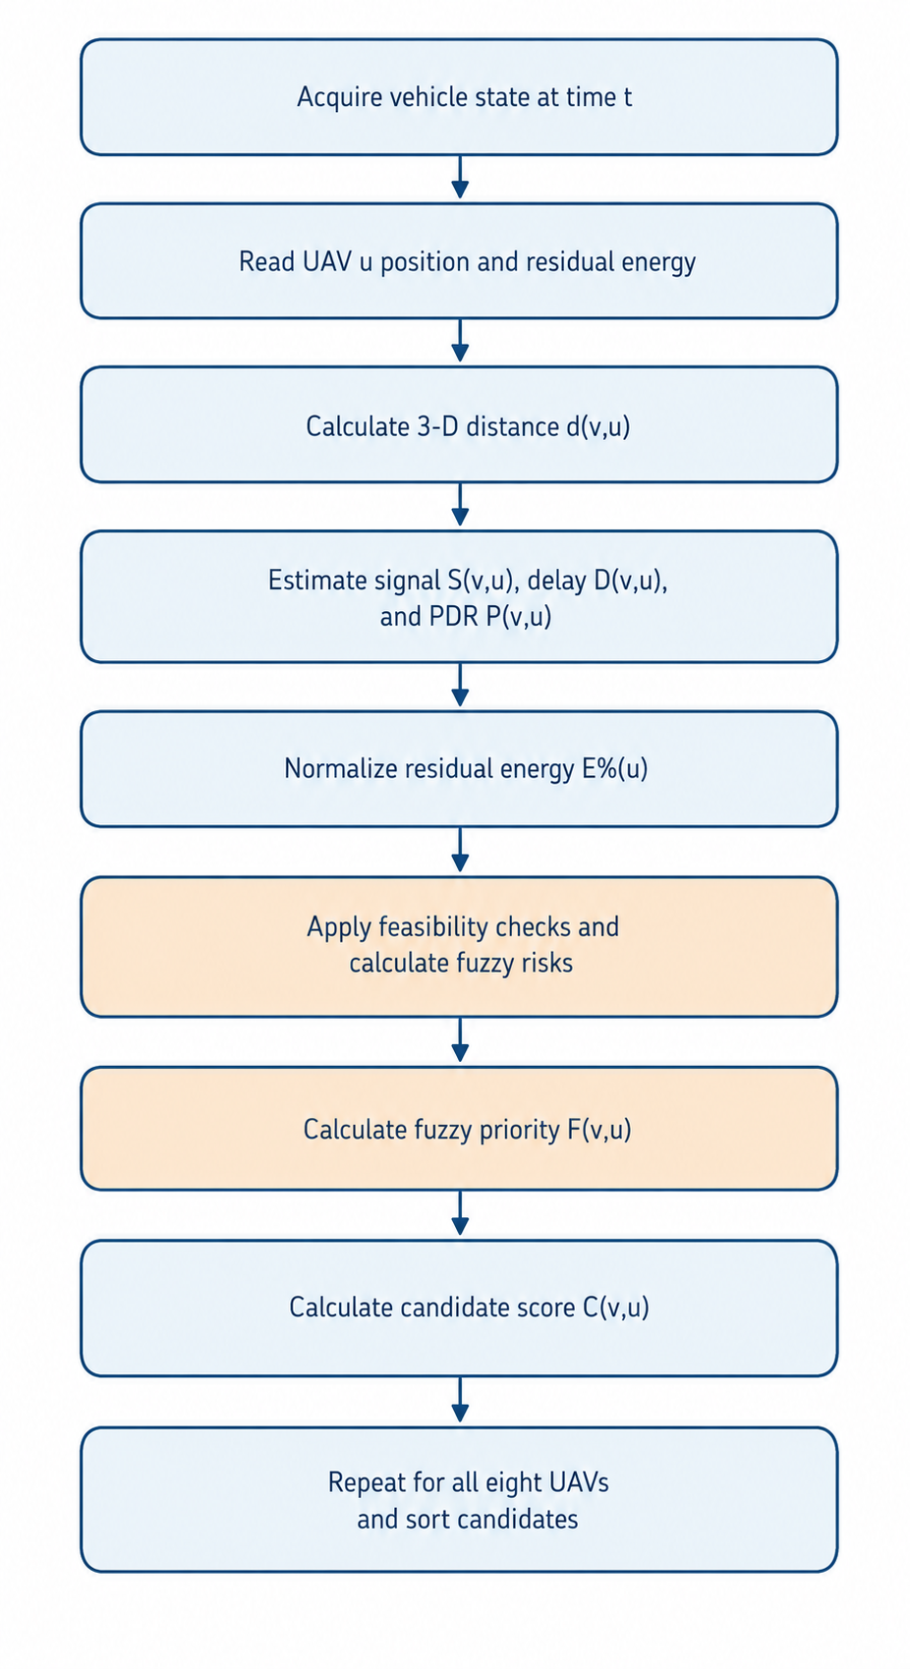
Figure 3. Trace-out diagram of communication measurement, fuzzy evaluation, and candidate ranking.
5.7 Reward and Adaptive Lagrangian Formulation
The QoS score, task-service reward, adaptive constraint penalty, and final reward are defined in Equations (14)–(17). Equation (18) gives the initial multipliers, while Equation (19) increases the multiplier associated with any observed violation.
Qᵥ,ᵤ(t)=190Sᵥ,ᵤ(t)+1.5Pᵥ,ᵤ(t)−1.2Dᵥ,ᵤ(t)+2.2Eᵤ%(t) (14)
Rₜₐₛₖ(t)=15N꜀(t)−0.002dᵥ,ᵤ(t)−0.08eᵤ(t)−0.05 (15)
Φ(t)=λᴰgᴰ(t)+λᴾgᴾ(t)+λᴱgᴱ(t)+λˢgˢ(t) (16)
rₜ=Rₜₐₛₖ(t)+Qᵥ,ᵤ(t)+20Fᵥ,ᵤ(t)−Φ(t) (17)
λ(0)=[0.35,0.20,0.60,0.35] (18)
λᵢ(t+1)=clip[λᵢ(t)+ηλgᵢ(t),0,10], ηλ=0.03 (19)
5.8 PPO Policy Learning and Warm Start
The actor probability and critic value are represented by Equations (20) and (21). PPO uses the probability ratio, TD residual, generalized advantage estimate, clipped objective, critic loss, and complete loss in Equations (22)–(27).
πθ(aₜ|sₜ) (20)
Vφ(sₜ)=E[Σₖγᵏrₜ₊ₖ | sₜ] (21)
ρₜ(θ)=πθ(aₜ|sₜ)/πθₒₗd(aₜ|sₜ) (22)
δₜ=rₜ+γVφ(sₜ₊₁)−Vφ(sₜ) (23)
Âₜ=Σₗ(γλGAE)ˡδₜ₊ₗ (24)
Lclip(θ)=E[min(ρₜÂₜ,clip(ρₜ,1−ε,1+ε)Âₜ)] (25)
LV(φ)=E[(Vφ(sₜ)−R̂ₜ)²] (26)
L(θ,φ)=−Lclip(θ)+cVLV(φ)−cH H[πθ(·|sₜ)] (27)
Before ordinary PPO learning, 800 states are sampled and the fuzzy-ranked best candidate is stored as action zero. Six behavior-cloning epochs minimize the warm-start loss in Equation (28), reducing unstructured initial exploration.
LWS(θ)=−(1/NWS)Σⱼ log πθ(aⱼF|sⱼ), aⱼF=0 (28)
5.9 Training Flowchart and Sequence of Operation
Figure 4 presents the complete training flow. Candidate evaluation and multiplier adaptation occur at every step, whereas PPO parameters are updated after rollout collection.
PLACEMENT NOTE (remove after pasting): Insert Figure 4 after the PPO and warm-start descriptions in Section 5.9.
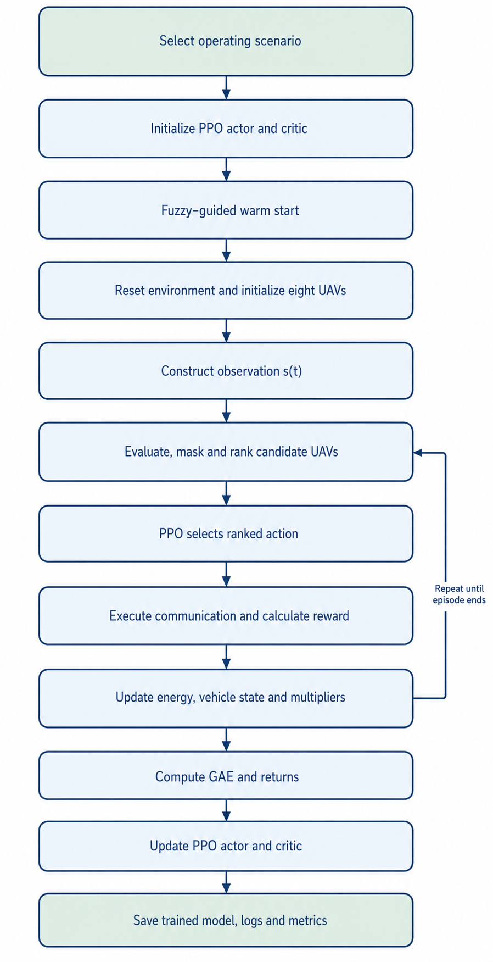
Figure 4. Training flowchart of the proposed Fuzzy LP-PPO methodology.

Figure 5 presents the sequence of messages and computations during one vehicle-to-UAV selection decision.
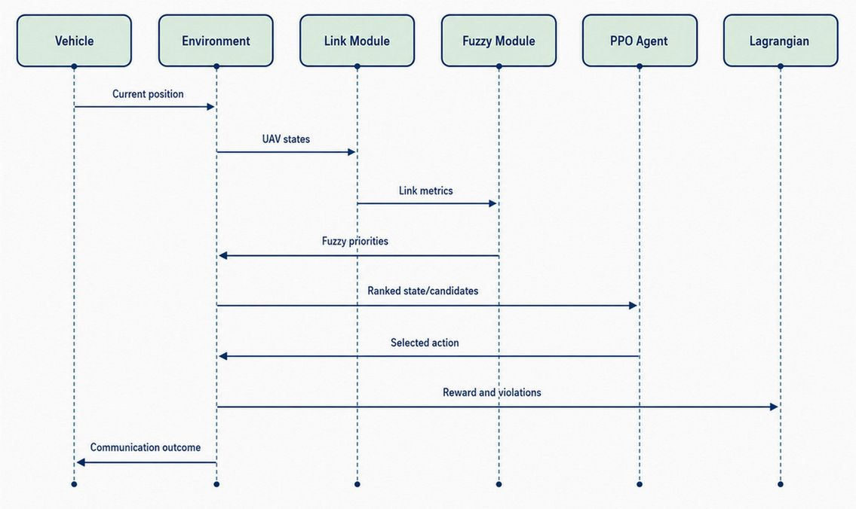
Figure 5. Sequence diagram of one Fuzzy LP-PPO UAV-selection decision.
5.10 Proposed Algorithms
Algorithm 1. Fuzzy-based candidate screening and ranking
Input: pᵥ(t), {pᵤ(t)}, {Eᵤ(t)}, Iₑₘg(t)
Output: Ranked candidate list Cₜ
1: Cₜ ← ∅
2: for each UAV u=1,…,8 do
3: Compute distance, signal, delay, PDR and normalized energy
4: Compute μᴰ, μᴾ, μˢ and μᴱ using Equations (6)–(9)
5: Compute Fᵥ,ᵤ using Equation (10)
6: Evaluate feasibility Mᵤ using Equation (11)
7: Compute Cᵥ,ᵤ using Equation (12) and store candidate
8: end for
9: If at least one candidate is feasible, remove infeasible candidates
10: Sort by score, energy, signal and lower delay
11: return Cₜ
Algorithm 1 evaluates all eight UAVs and guarantees a non-empty candidate list through its fallback rule.
Algorithm 2. Adaptive Fuzzy LP-PPO training
Input: scenarios Ω, episodes Nₑₚ, horizon H, actor θ, critic φ, ηλ
Output: trained policies {πθ*}
1: for each scenario ω∈Ω do
2: Initialize actor, critic and λ=[0.35,0.20,0.60,0.35]
3: Perform fuzzy-guided warm start
4: for episode=1,…,Nₑₚ do
5: Reset environment and rollout buffer
6: for t=0,…,H−1 do
7: Observe sₜ and execute Algorithm 1
8: Sample aₜ~πθ(aₜ|sₜ) and map it to the effective UAV
9: Execute communication and calculate rₜ
10: Compute violations and update λ using Equation (19)
11: Update energy, vehicle position and next state
12: Store transition in the rollout buffer
13: end for
14: Compute GAE and update actor and critic
15: Record episode metrics
16: end for
17: Save scenario policy
18: end for
Algorithm 2 describes the complete training process, including fuzzy warm start, Lagrangian adaptation, and PPO optimization.
Algorithm 3. Online UAV selection
Input: trained policy πθ* and current network state
Output: selected UAV u*
1: Construct normalized observation sₜ
2: Execute Algorithm 1 to obtain Cₜ
3: Compute πθ*(·|sₜ)
4: Select aₜ=arg maxₐ πθ*(a|sₜ)
5: Map aₜ to effective UAV u*
6: Establish communication and record QoS information
7: return u*
5.11 Computational Complexity and Implementation Parameters
Communication and fuzzy evaluation require O(NU) operations, while ranking requires Equation (29). If Wπ denotes the number of actor parameters, the total deployment-time complexity is given by Equation (30).
O(NU log NU) (29)
O(NU log NU + Wπ) (30)
Table 7. Principal implementation parameters
Parameter | Value
Candidate UAVs | 8
Observation dimension | 34
Actions | 8
Actor/Critic | 128–128 neurons
PPO learning rate | 3×10⁻⁴
γ / λGAE / ε | 0.99 / 0.95 / 0.20
Entropy coefficient | 0.02
Batch size / PPO epochs | 64 / 10
Warm-start samples / epochs | 800 / 6
Episodes / steps | 100 / 50 per scenario
Lagrangian step/range | 0.03 / [0,10]

5.12 Output of the Proposed Methodology
For every decision, the proposed methodology produces the requested PPO action, effective selected UAV, ranked candidate list, distance, signal quality, delay, PDR, remaining UAV energy, immediate reward, violation magnitudes, updated multipliers, and episode-level reward. These outputs support reliability, energy, convergence, scenario, and policy-comparison analyses.

