RESEARCH ARTICLE
Fuzzy Lagrangian Proximal Policy Optimization for Reliable UAV Selection in Dynamic UAV-Assisted Internet of Vehicles
Shubh Om · Pathireddi Vara Kalyan · K. Jairam Naik

Abstract

Dynamic vehicle mobility, time-varying links, and limited aerial energy make reliable unmanned aerial vehicle (UAV) selection difficult in the Internet of Vehicles (IoV). Fixed nearest-link, strongest-signal, and energy-greedy rules optimize only part of the quality-of-service (QoS) objective, while unconstrained reinforcement learning does not adapt the cost of repeated violations. This work proposes Fuzzy Lagrangian Proximal Policy Optimization (Fuzzy LP-PPO) for constraint-aware UAV selection. For each decision, the method acquires vehicle and eight-UAV positions, link signal, delay, packet delivery ratio (PDR), and residual energy. It normalizes the 34-dimensional observation, screens infeasible links, ranks retained candidates with clipped fuzzy-risk memberships, updates persistent Lagrangian multipliers, and learns a ranked action using PPO. The Python implementation uses synthetic urban-canyon, suburban-crossroads, and emergency-response datasets and trains one policy per scenario for 100 episodes of 50 steps. Under a common 20-episode evaluation, Fuzzy LP-PPO obtains a mean episode reward of 5415.31 versus 706.01 for the reward-aware heuristic, a 667.0% increase. It also reduces average delay from 81.81 to 75.78 ms (7.4%), increases PDR by 0.39 percentage points, and improves mean signal quality by 12.2%. The results demonstrate adaptive multi-QoS UAV selection under heterogeneous, non-stationary IoV conditions.

Keywords

Internet of Vehicles · Unmanned aerial vehicles · Fuzzy logic · Lagrangian optimization · Proximal policy optimization · Reliable communication

Introduction
The Internet of Vehicles (IoV) is an important part of intelligent transportation systems that enables communication among vehicles, roadside infrastructure, cloud servers, and traffic management services. By exchanging real-time information, IoV supports applications such as traffic monitoring, collision avoidance, route planning, emergency response, and autonomous driving (Kaiwartya et al., 2016). These applications require reliable communication with low delay because even a small interruption may affect the performance of safety-critical services. As the number of connected vehicles continues to increase, maintaining stable communication in highly dynamic traffic environments has become a major research challenge.
Unmanned Aerial Vehicles (UAVs) have recently been introduced to improve IoV communication by providing flexible wireless coverage in areas where terrestrial infrastructure is unavailable or overloaded (Shakhatreh et al., 2019). Compared with fixed roadside units, UAVs can quickly change their positions, extend communication coverage, and support temporary or emergency situations. These advantages make UAV-assisted IoV a promising solution for future intelligent transportation systems. However, UAVs operate with limited battery capacity, finite communication range, and continuously changing network conditions, making reliable communication management a challenging task (Cabreira et al., 2019).
One of the most important challenges in UAV-assisted IoV is selecting the most suitable UAV for each communication request. The selection process depends on several factors, including communication distance, signal strength, packet delivery ratio (PDR), communication delay, and the remaining energy of each UAV. These parameters often conflict with one another. For example, the nearest UAV may provide a strong communication link but have low residual energy, whereas another UAV may have sufficient energy but introduce higher communication delay. As vehicle mobility changes continuously, the communication quality also changes rapidly, making UAV selection a dynamic optimization problem rather than a simple decision based on a single parameter.
Several existing approaches have been proposed to address UAV selection. Traditional methods mainly use fixed strategies such as random selection, nearest-UAV selection, strongest-signal selection, or energy-aware greedy selection (Sun et al., 2023; Li et al., 2023). Although these methods are simple to implement, they usually optimize only one communication parameter and cannot adapt effectively to changing traffic conditions. Recent studies have applied Reinforcement Learning (RL) to improve decision making by allowing an agent to learn an optimal policy through interaction with the environment (Lowe et al., 2017). Among RL algorithms, Proximal Policy Optimization (PPO) has gained considerable attention because of its stable learning process and efficient policy updates (Schulman et al., 2017). However, existing RL-based methods still face difficulties in simultaneously satisfying multiple Quality of Service (QoS) requirements while adapting to different traffic scenarios.
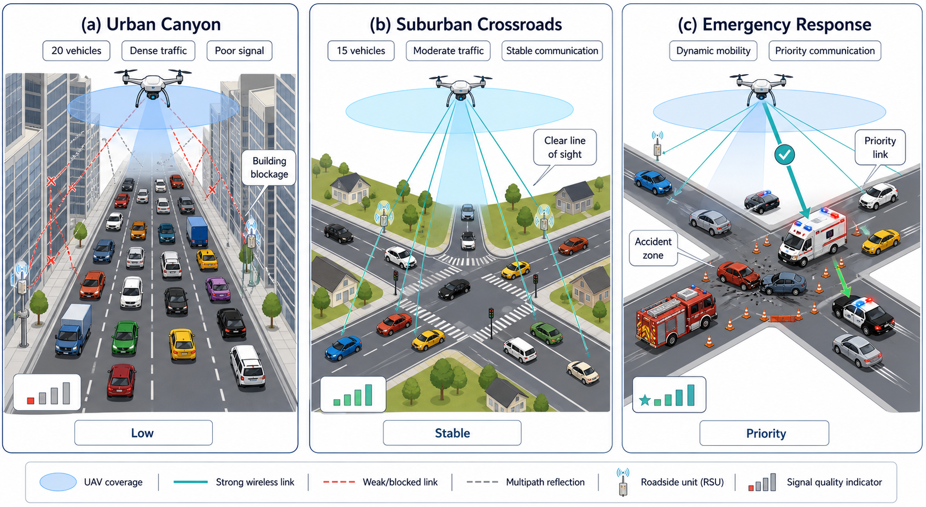
Figure 1 : Illustrative operating scenarios used to evaluate Fuzzy LP-PPO: urban canyon, suburban crossroads, and emergency response.
To overcome these limitations, this paper proposes a Fuzzy Lagrangian Proximal Policy Optimization (Fuzzy LP-PPO) framework for intelligent UAV selection in dynamic UAV-assisted IoV networks. Instead of selecting a UAV using a single communication metric, the proposed framework jointly considers signal strength, communication delay, packet delivery ratio, and residual UAV energy during the decision-making process. A hard feasibility screening stage removes unsuitable UAV candidates based on predefined communication constraints. The remaining candidates are prioritized using a clipped fuzzy-risk mechanism that evaluates their communication quality. An adaptive Lagrangian optimization strategy continuously updates constraint penalties according to the current network conditions, while a PPO-based learning agent identifies the most suitable UAV from the ranked candidates. By combining these components, the proposed framework aims to improve communication reliability while maintaining QoS requirements under dynamic vehicular environments.
The proposed framework is evaluated using three representative UAV-IoV scenarios, namely Urban Canyon, Suburban Crossroads, and Emergency Response, which represent different traffic densities and communication conditions. The performance of the proposed method is compared with several existing UAV selection strategies using common evaluation metrics, including episode reward, communication delay, packet delivery ratio, and signal quality. The experimental results demonstrate that the proposed framework achieves improved communication performance while effectively handling dynamic network conditions and multiple QoS constraints.
The objectives of this work are:
1. Develop Fuzzy LP-PPO to combine feasibility screening, clipped fuzzy-risk ranking, persistent Lagrangian penalties, and PPO for reliable UAV selection.
2. Model urban-canyon, suburban-crossroads, and emergency-response conditions with eight candidate UAVs and reproducible scenario-specific training.
3. Evaluate reward, delay, PDR, and signal quality against fixed UAV-selection baselines under identical environment dynamics and evaluation seeds.
The remainder of this paper is organized as follows. Section "Literature survey" reviews existing work on UAV-assisted IoV communication, intelligent UAV selection, fuzzy decision systems, and constrained reinforcement learning, together with the resulting research gaps and also fuzzy-priority estimation, adaptive Lagrangian reward formulation, and PPO-based policy optimization that together constitute the proposed Fuzzy LP-PPO framework.
The abbreviations used throughout this paper are listed in Table 1, while the principal variables employed in the system model and proposed Fuzzy LP-PPO formulation are summarized in the same table:
Table 1
List of symbols and abbreviations
Symbol | Description
t | Current communication decision step
H | Number of interaction steps in one episode
N_ep | Number of training episodes
V(t) | Set of active vehicles at decision step t; one representative active vehicle is served per selection decision
U | Set of eight candidate UAVs
p_v(t) | Position of vehicle v at decision step t
p_u(t) | Three-dimensional position of UAV u at decision step t
d_v,u(t) | Euclidean distance between vehicle v and UAV u
R_comm | Maximum UAV communication range
S_v,u(t) | Signal-quality value of the vehicle–UAV link
D_v,u(t) | Communication delay of the vehicle–UAV link
P_v,u(t) | Packet delivery ratio of the vehicle–UAV link
E_u(t) | Residual energy of UAV u
s_t | State observed by the PPO agent at step t
a_t | UAV-selection action chosen at step t
r_t | Immediate reward obtained after action a_t
π_θ(a_t | s_t) | PPO policy parameterized by θ
V_φ(s_t) | State-value function parameterized by φ
F_v,u(t) | Fuzzy priority assigned to candidate link (v,u)
g_i(t) | Violation magnitude of QoS constraint i
λ_i(t) | Adaptive Lagrangian multiplier for constraint i
η_λ | Learning rate used for Lagrangian multiplier updates
γ | Reward discount factor
ε | PPO clipping parameter
A_t | Generalized advantage estimate at step t
λ_GAE | Generalized advantage-estimation parameter

Literature survey
This section reviews 20 recent related studies on UAV-assisted IoV, vehicular edge computing, and learning-based offloading. Each study is summarized by its method, environment, reported attainment, merit, and limitation before the research gaps are identified.
Chen et al. (2026) proposed a traffic-aware asynchronous trajectory-planning framework combining spatial-temporal graph attention and GNN-enhanced PPO for UAV scheduling and data delivery. The method was evaluated in a simulated UAV-assisted wireless network using generated heterogeneous traffic and topology data. It improved throughput, scheduling efficiency and convergence over conventional DRL approaches. However, it does not integrate fuzzy QoS evaluation with adaptive Lagrangian constraints for reliable UAV selection.
Wang et al. (2026) proposed LC-MAPO, which integrates Lagrangian constraint handling with a multi-agent TD3 actor–critic framework for secure task offloading in drone-assisted IoV. It was tested in a simulated multi-drone vehicular network using generated mobility, communication task and battery data. The method improved offloading efficiency while reducing collision and battery-constraint violations against unconstrained learning methods. However, its main objective is task offloading rather than fuzzy communication-aware UAV selection.
Alagha et al. (2025) proposed a block-chain and reinforcement-learning-enabled framework for UAV relay selection and coordination in the Internet of Vehicles. The method was evaluated using simulated vehicle–UAV interactions, Quality-of-UAV and Quality-of-Vehicle information, with PPO used for decentralised UAV coordination. It achieved more stable relay selection and better vehicle coverage and connectivity than benchmark methods. However, it does not jointly optimise signal reliability, delay, PDR and UAV energy through fuzzy Lagrangian learning.
Goudarzi et al. (2025) proposed an SDN-based UAV-assisted vehicular edge-computing framework using Soft Actor–Critic for trajectory, user association and task-offloading decisions. It was evaluated in simulated dense and infrastructure-limited vehicular environments using generated network and task data. The method achieved up to 87.2% energy savings in energy-limited scenarios and a 50% reduction in time-sensitive scenarios. However, it focuses on AoI and offloading costs rather than fuzzy reliability-based UAV selection.
Zakaryia et al. (2025) proposed MADDPG-DTLCM for task offloading and resource allocation in multi-UAV-assisted edge computing. The framework was tested through simulations using generated UAV positions, user tasks, computational capacities and communication conditions. It achieved an 18% higher task-completion rate and 12% lower latency than MADQN, conventional MADDPG and greedy offloading. However, UAV selection depends mainly on distance and computational capability rather than fuzzy communication-reliability indicators.
Wu et al. (2025) proposed a MAPPO framework for jointly optimising service caching, content caching, computation offloading and UAV trajectories in UAV-assisted vehicular networks. It was evaluated using a simulated multi-UAV IoV environment with generated vehicle requests, channel states and task information. The method achieved an approximately 82% cache-hit rate and higher cumulative reward than representative baseline strategies. However, it does not incorporate fuzzy priority assessment or Lagrangian-based reliability constraints.
Xu et al. (2025) proposed MATD3-TORA for joint task offloading, UAV movement, CPU-frequency control and resource allocation in multi-UAV MEC systems. The method was tested in a simulated network of mobile devices and UAVs using generated mobility, channel and computational-task data. It achieved lower processing latency and UAV energy consumption than MADDPG and edge-only schemes while showing stable convergence. However, it does not perform fuzzy communication-quality-based UAV selection.
Su and Liu (2025) proposed an improved DDPG-based partial-offloading framework with task-priority modelling for cloud–edge collaborative IoV. The method was evaluated in a simulated vehicular environment using generated task, location, storage and computing-resource data. It reduced latency by 59.46% and 67.39% compared with DQN and DDPG, while reducing energy consumption by 18.37% and 11.76%, respectively. However, it does not include UAV coordination or communication-aware UAV selection.
Mustafa et al. (2025) proposed SQ-DDTO, combining Dueling DDQN, prioritised experience replay and Sequential Quadratic Programming for task offloading and resource allocation in vehicular edge networks. It was evaluated through simulations considering vehicle speed, location, channel quality and task characteristics. The method reduced system cost by 25.1% over DQN and 16.67% over DDQN and DDPG, while reducing task loss by up to 37.06%. However, it does not consider UAV-assisted selection or fuzzy constraint management.
Xue et al. (2025) proposed PORA-MATD3 for partial task offloading, resource allocation and task migration in vehicular edge-computing networks. The method was evaluated through simulations using generated vehicle mobility, RSU, communication-distance and computational-task data. It reduced long-term delay and energy overhead compared with conventional multi-agent and local-processing schemes. However, it focuses on vehicular resource allocation and does not evaluate UAV reliability using fuzzy signal, PDR and energy parameters.
L. Wang et al. (2025) proposed a Vehicle Deep Q-Network combined with Vehicle Adaptive Feedback for priority-aware task offloading in vehicular edge computing. The framework was tested through simulations considering vehicle position, speed, computation resources, connection interruption and maximum-delay constraints. It achieved lower cost consumption and higher user-service satisfaction than traditional offloading algorithms. However, it uses discrete DQN decisions and does not support PPO-based multi-UAV reliability optimisation.
Zhang et al. (2025) proposed a cloud–edge–device framework integrated with multi-agent deep reinforcement learning for dynamic task offloading and resource allocation in vehicular networks. It was evaluated in PyTorch using a simulated environment with one cloud server, four MEC servers and twenty vehicles per MEC server. The method reduced energy consumption by 11%, increased task completion by 23%, and reduced delay by 50% compared with local and static offloading. However, no UAV reliability or fuzzy constraint mechanism was considered.
Bo and Zhao (2025) proposed a multi-agent deep-reinforcement-learning task-offloading strategy for vehicular edge computing with queuing and NOMA-based communication modelling. The method was evaluated through a simulated IoV environment using generated vehicle tasks, queue states, channel conditions and edge-resource data. It improved offloading efficiency, resource utilisation and delay performance over conventional strategies. However, it does not address UAV coordination or fuzzy link-reliability evaluation.
Li et al. (2026) proposed a three-stage framework combining ST-FGCN demand prediction, collaborative caching and Genetic A3C task offloading for vehicular edge computing. It was evaluated through simulations using generated spatial-temporal task demands and edge-cache states . The method reduced long-term system cost and improved latency and energy efficiency over baseline caching and reinforcement-learning methods.
Deng et al. (2025) proposed FDRLGT, combining federated deep reinforcement learning with game theory for privacy-preserving task offloading in vehicular edge computing. The framework was tested through simulations with multiple vehicles, distributed local data, dynamic channels and edge servers. It reduced total system delay while protecting raw user data and avoiding homogeneous offloading decisions compared with baseline algorithms. However, it does not model UAV mobility, fuzzy communication reliability or adaptive safety constraints.
Pantaleon et al. (2025) proposed BRAVE and BRAVE-MARL for benefit-aware data offloading and UAV path planning in public-safety edge-computing environments. The framework was evaluated using simulated disaster areas containing multiple areas of interest, users and energy-constrained UAVs. It improved data collection, user QoS support and multi-UAV coordination compared with non-collaborative path-planning approaches. However, it targets disaster-response networks rather than high-mobility IoV and does not use fuzzy PPO-based selection.
Cui et al. (2025) proposed a two-phase cooperative offloading and migration framework using COMA-based multi-agent reinforcement learning for VEC and V2V environments. It was evaluated through simulations using generated vehicle mobility, link quality, RSU resources and computation-task data. The framework reduced latency by up to 54% and increased the task-completion rate by up to 15% compared with related schemes. However, the framework does not involve UAV-assisted communication or fuzzy reliability scoring.
Ye et al. (2025) proposed an opportunistic data-transmission approach for integrated UAV–intelligent connected vehicle networks containing selfish relay nodes. The approach was evaluated in simulated UAV–vehicle communications using generated mobility and forwarding-behaviour data. It improved transmission reliability and cooperation compared with conventional opportunistic methods. However, it does not provide reinforcement-learning-based UAV selection or fuzzy Lagrangian optimisation.
Zhang et al. (2026) proposed a Multi-Objective Decomposition Evolutionary Deep Reinforcement Learning (MODE-DRL) framework for computation offloading in UAV-assisted Mobile Edge Computing. The framework was evaluated in a simulated Internet of Vehicles environment using generated vehicular tasks and network data. It reduced task delay and energy consumption while improving task-completion performance compared with conventional DRL methods. However, it does not consider fuzzy communication reliability or adaptive Lagrangian-based UAV selection.
Yan et al. (2025) proposed a Deep Graph Reinforcement Learning (DGRL) framework for computation offloading in UAV-assisted Vehicular Edge Computing Networks. The method was evaluated in a simulated vehicular edge computing environment using generated mobility and computation-task data. It improved computation offloading efficiency and resource utilization compared with conventional DRL approaches. However, it does not incorporate fuzzy QoS evaluation or reliable UAV selection using Lagrangian optimization.
The 20 studies show that DRL, MARL, PPO, graph learning, and actor–critic methods can reduce delay and energy or improve throughput in simulated UAV-assisted vehicular systems. However, most optimize offloading, caching, trajectory, or resource allocation rather than reliable UAV selection, and few jointly represent uncertain link risk and adapt multiple QoS penalties. These limitations motivate the integrated Fuzzy LP-PPO method.
The main research gaps identified from the existing literature are listed as follows:
- Most existing methods focus mainly on latency reduction and energy optimization, while communication reliability is often overlooked.
- Current reinforcement learning approaches do not effectively handle uncertainty in dynamic UAV-assisted IoV environments.
- Existing frameworks lack fuzzy logic-based decision making for intelligent UAV selection under varying network conditions.
- Many studies optimize only a single objective or limited objectives, resulting in poor trade-offs among latency, energy, reliability, and QoS.
- Adaptive Lagrangian constraint optimization is rarely integrated to satisfy multiple system constraints simultaneously.
- Most approaches assume ideal or static network conditions, limiting their applicability in highly dynamic vehicular scenarios.
- Existing methods provide limited support for reliable and adaptive UAV selection during frequent topology and traffic changes.
- There is a lack of an integrated framework that combines Fuzzy Logic, PPO, and Lagrangian optimization for robust task offloading and resource allocation.

From the literature review, it is observed that several researchers have proposed different techniques to improve computation offloading, resource allocation, and communication performance in UAV-assisted IoV systems. However, existing approaches still face challenges in reliable UAV selection, handling dynamic network conditions, and satisfying multiple optimization objectives. These limitations motivate the need for a more effective and intelligent solution. Therefore, the proposed Fuzzy Lagrangian Proximal Policy Optimization (Fuzzy LP-PPO) framework is developed to address these challenges. The next section presents the proposed methodology, including its architecture, workflow, mathematical model, and algorithm in detail.

Proposed Fuzzy Lagrangian PPO Methodology for Reliable UAV Selection (Fuzzy LP-PPO)

The proposed Fuzzy LP-PPO methodology selects a reliable UAV in a dynamic UAV-IoV network. It combines clipped fuzzy-risk evaluation, PPO policy learning, and persistent Lagrangian penalties for delay, PDR, residual energy, and signal constraints. Figure 2 presents the topology, Figure 3 traces candidate screening and ranked action mapping, and Figure 4 shows the end-to-end network workflow.

Data acquisition
The input data required for the proposed Fuzzy LP-PPO methodology is obtained from a simulated dynamic UAV-IoV environment. The dataset consists of both vehicle and UAV communication parameters, including vehicle position, speed, UAV location, signal strength, communication delay, packet delivery ratio (PDR), energy consumption, and communication range. These parameters represent the real-time network conditions used to evaluate UAV reliability and support intelligent UAV selection during the decision-making process.

Data preprocessing
Table 2
Acquired data and preprocessing operations
Input variable | Model bound / unit | Preprocessing | Purpose
Vehicle coordinates | 0–2000 m | Divide by area size | Vehicle location
Relative UAV coordinates | −2000–2000 m | Clip and map to [0, 1] | Relative geometry
UAV altitude | 80–200 m | Used in 3-D distance calculation | Aerial geometry
Signal quality | 0.05–1.00 (nominal bound) | Already normalized | Link strength
Delay | 0–100 ms (capped model bound) | Threshold/fuzzy evaluation | Responsiveness
PDR | 50–100% (nominal bound) | Percentage form | Reliability
UAV energy | 0–50 units | Multiply by two and clip | Energy percentage
Lagrangian multipliers | 0–10 | Internal state; clip after update | Adaptive constraint importance; not part of the 34-dimensional PPO observation

To ensure that measurements expressed in different units and ranges contribute consistently to the learning agent, pre-processing is applied before the state vector is constructed. Let L = 2000 m denote the side length of the operational region. The normalized vehicle coordinates are computed as in Equation (12), relative UAV coordinates are clipped and mapped to [0, 1] through Equations (13) and (14), and Equation (15) converts internal UAV energy into a percentage-compatible value.
$x_{v}(t)=\frac{x_{v}(t)}{L}, y_{v}(t)=\frac{y_{v}(t)}{L}$ (12)
$x_{u,v}(t)=\frac{1}{2}[clip (\frac{x_{u}(t)-x_{v}(t)}{L},-1,1)+1]$ (13)
$y_{u,v}(t)=\frac{1}{2}[clip (\frac{y_{u}(t)-y_{v}(t)}{L},-1,1)+1]$ (14)
$E_{u}^{\%}(t)=min (100,max (0,2E_{u}(t)))$ (15)
The processed Fuzzy LP-PPO observation is given by Equation (16). It contains two normalized vehicle features and four features for each of eight UAVs, producing a 34-dimensional observation.
$s_{t}=[x_{v},y_{v},{\{x_{u,v},y_{u,v},S_{v,u},\frac{E_{u}}{50}\}}_{u=1}^{8}]$ (16)

System architecture and problem formulation

A UAV-assisted IoV communication network is considered over a square operational region having dimensions 2000 × 2000 m². The network contains multiple moving vehicles together with eight candidate UAVs that provide aerial communication support whenever terrestrial communication becomes unreliable or unavailable. The candidate UAV set is defined by Equation (1), where U denotes the set of available UAVs participating in the communication process.
$U=\{U_{1},U_{2},…,U_{8}\}$ (1)
At every communication decision instant, one representative active vehicle must be associated with one UAV from the candidate fleet. The objective is to maximize communication reliability while simultaneously reducing delay, improving packet delivery ratio, preserving UAV energy, and avoiding poor-quality communication links. Figure 3 illustrates the communication topology considered in the proposed framework — vehicles move inside the UAV-assisted IoV service region while observing multiple candidate aerial communication links. Dashed connections represent feasible vehicle-to-UAV (V2U) links, whereas the highlighted connection denotes the UAV selected by the proposed Fuzzy LP-PPO policy; after each communication decision, the measured QoS parameters are returned to the controller and used to update the learning policy.
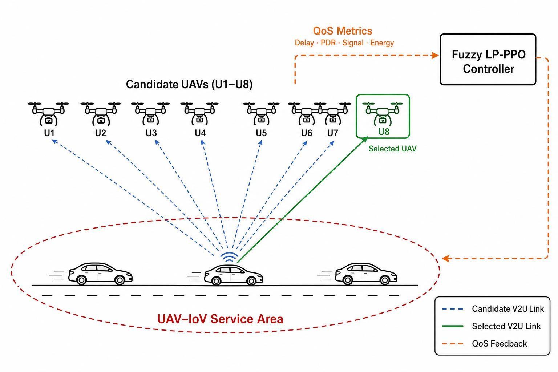
Figure 2 : UAV-IoV topology and communication-selection process of the proposed Fuzzy LP-PPO framework.
Let p_v(t) = [x_v(t), y_v(t)] represent the two-dimensional position of vehicle v at decision instant t, and p_u(t) = [x_u(t), y_u(t), z_u(t)] represent the three-dimensional position of UAV u. Initially, the horizontal positions of vehicles and UAVs are generated randomly inside the operational region. UAV altitude is initialized between 80 m and 200 m, while every UAV starts with a residual energy value randomly selected between 30 and 50 internal energy units. Throughout one training episode, UAV positions remain fixed, whereas vehicle locations change according to the mobility model described below; at the beginning of every new episode, all positions and UAV energy levels are regenerated.
The communication-selection problem is formulated as a Markov Decision Process (MDP). At each decision step t, the PPO agent observes the current state s_t, executes an action a_t, receives an immediate reward r_t, and then transitions to the next state s_(t+1). The observation vector contains normalized vehicle coordinates, relative UAV coordinates, signal-quality measurements, and normalized residual UAV energy, as given in Equation (2), producing a 34-dimensional observation consisting of two vehicle features and four communication features for each of the eight candidate UAVs. The action space of the proposed PPO agent is discrete, expressed as Equation (3), where every action corresponds to one position within the ranked list of candidate UAVs.
$s_{t}=[x_{v},y_{v},{\{x_{u,v},y_{u,v},S_{v,u},E_{u}\}}_{u=1}^{8}]$ (2)
$A=\{0,1,2,3,4,5,6,7\}$ (3)

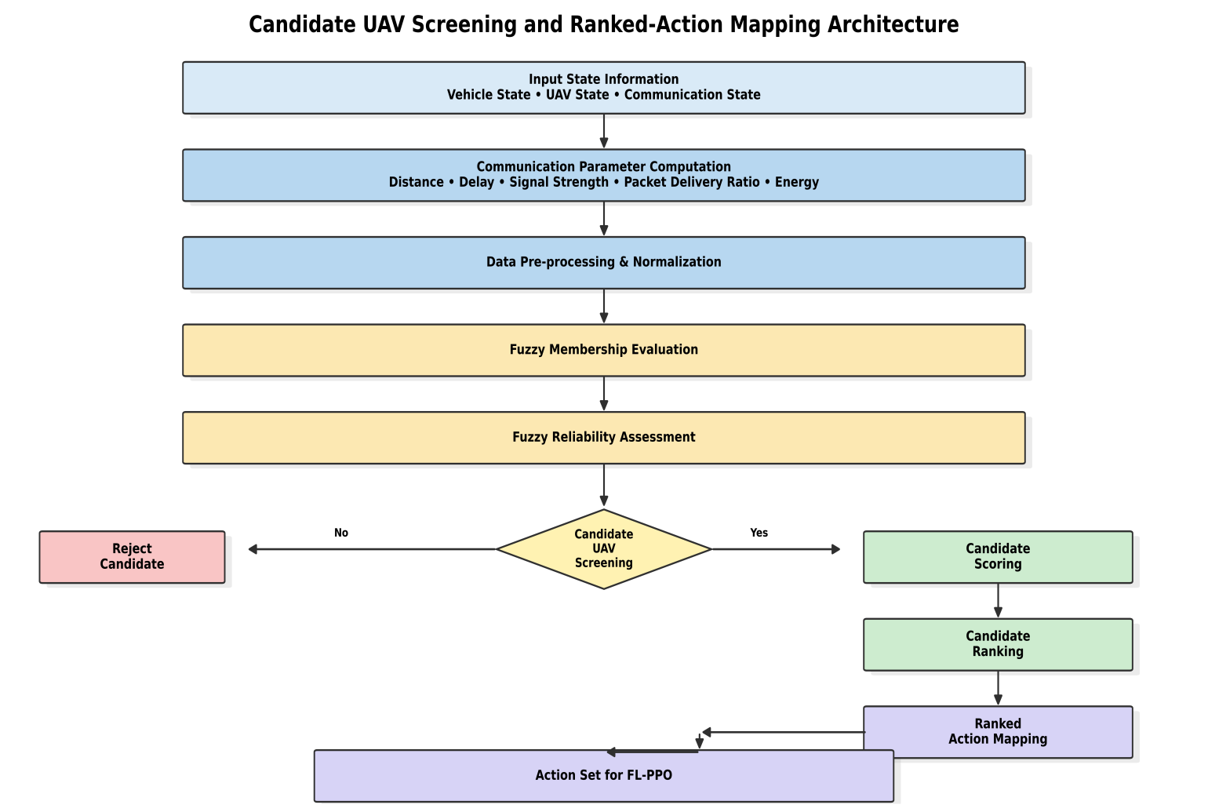
Figure 3 : Proposed Candidate UAV Screening and Ranked Action Mapping Architecture

The above Figure illustrates the overall workflow of the proposed Fuzzy LP-PPO framework for reliable UAV selection in dynamic UAV-IoV systems. Initially, vehicle, UAV, and communication state information are collected and used to compute important communication parameters such as distance, delay, signal strength, packet delivery ratio, and energy. These parameters are then pre-processed and evaluated using a fuzzy membership mechanism to estimate the reliability of each candidate UAV. Based on the reliability assessment, infeasible UAVs are rejected, while feasible candidates are forwarded for candidate scoring and ranking. Finally, the ranked action mapping module generates the action set that is provided to the Fuzzy LP-PPO agent for optimal UAV selection and reliable communication.

Vehicle mobility and scenario model

The proposed communication-selection framework operates in dynamic IoV environments where vehicle positions continuously change throughout the communication process; consequently, communication distance, signal quality, PDR, and transmission delay also vary with time. Unlike trajectory-planning approaches that optimize complete vehicle routes, the proposed framework focuses on communication-aware UAV selection, so only vehicle positions are updated at every communication decision step while UAV positions remain fixed throughout one training episode — reflecting practical emergency-communication and temporary-UAV-deployment scenarios in which aerial platforms hover over predefined service regions.
At the beginning of every episode, vehicle locations are initialized randomly inside the operational area. During each communication decision step, every vehicle performs a random movement whose magnitude depends on the current operating scenario. The vehicle position at the next communication instant is computed as in Equation (4), where Δp_v(t) denotes the random vehicle displacement during the current decision step, L represents the length of the simulation region, and clip(·) confines the updated position within the simulation boundaries. The displacement vector is generated independently for both horizontal coordinates at every decision instant, so the agent continuously observes changing communication conditions throughout one training episode.
$p_{v}(t+1)=clip (p_{v}(t)+Δp_{v}(t),0,L)$ (4)
Urban-canyon scenario: The urban-canyon scenario represents densely populated metropolitan road networks containing numerous buildings and frequent communication blockages. Approximately 20 moving vehicles are deployed within the simulation region; vehicle motion is relatively slow because of traffic congestion, intersections, and frequent stopping events, so communication links change gradually, although severe signal degradation may occur because of obstruction and multipath propagation. This scenario evaluates the capability of the proposed framework to maintain reliable communication in dense urban environments.
Suburban-crossroads scenario: The suburban-crossroads scenario models moderately populated road networks with lower vehicle density and fewer communication obstacles. Approximately 15 vehicles move throughout the operational region with moderate velocities, and communication quality generally remains more stable than in urban environments because line-of-sight conditions occur more frequently. This scenario primarily evaluates communication efficiency together with UAV energy conservation under moderate traffic conditions.
Emergency-response scenario: The emergency-response scenario represents disaster-relief or emergency communication situations in which communication demands vary rapidly and vehicle movement becomes less predictable. Approximately 15 vehicles are deployed inside the operational area, and their movement is generated using larger random displacements than in the previous scenarios, producing a rapidly changing communication topology that evaluates the adaptability of the proposed Fuzzy LP-PPO framework under highly dynamic operating conditions.

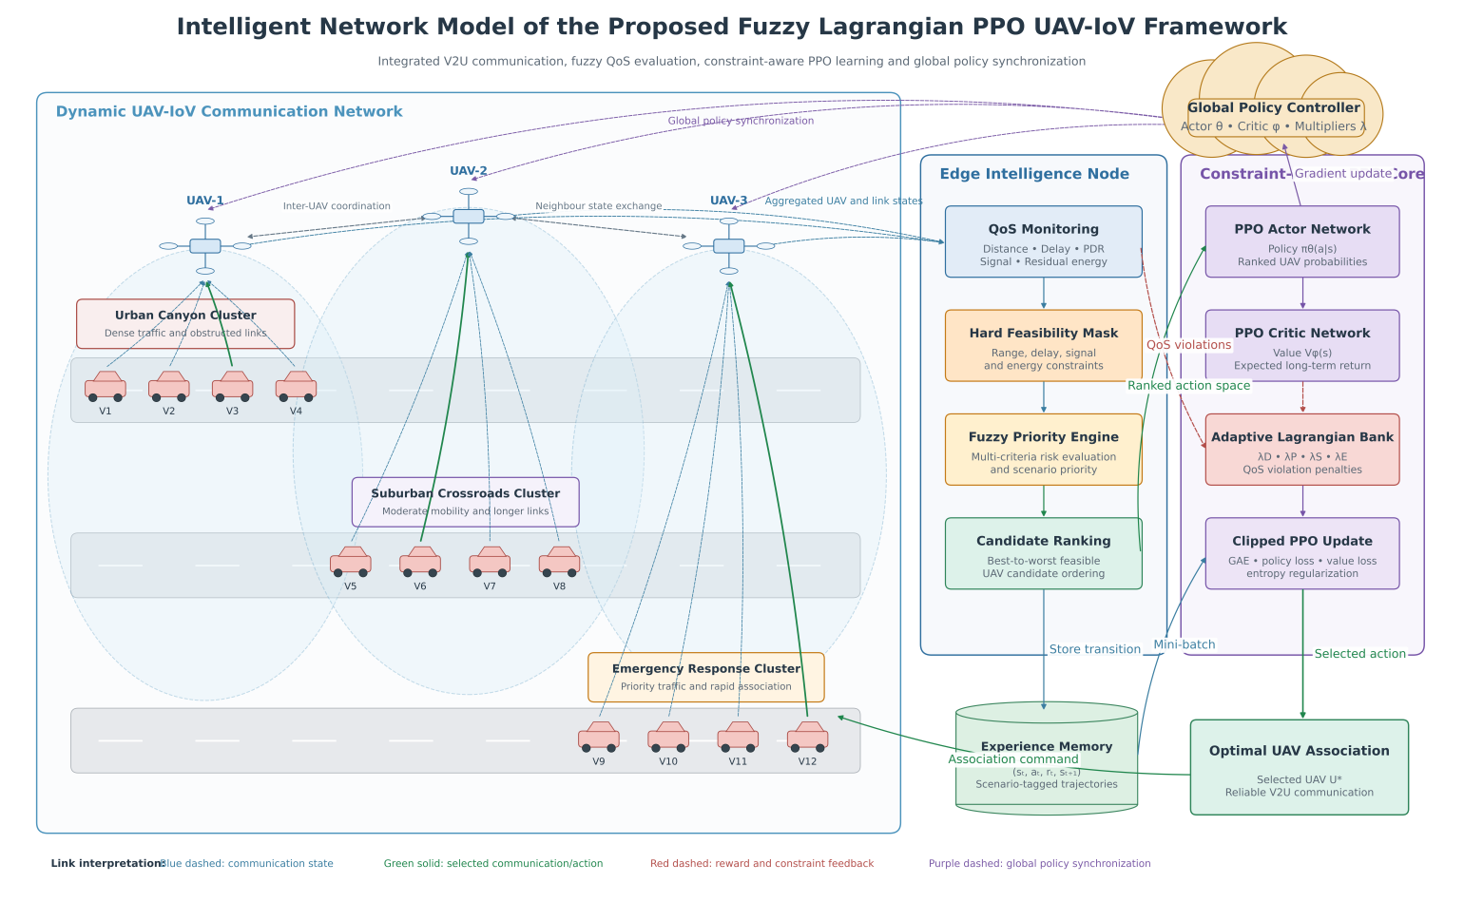
Figure 4 : Intelligent Network Model of the Proposed FLP-PPO Framework

This figure presents the intelligent network architecture of the proposed Fuzzy Lagrangian Proximal Policy Optimization (FLP-PPO) framework for reliable UAV selection in dynamic UAV-IoV environments. The communication network comprises three representative vehicular scenarios, namely Urban Canyon, Suburban Crossroads, and Emergency Response, where vehicles continuously exchange information with multiple UAVs through Vehicle-to-UAV (V2U) communication links. The collected communication information, including communication distance, transmission delay, signal strength, packet delivery ratio (PDR), and residual UAV energy, is forwarded to the Edge Intelligence Node for local decision making. The QoS Monitoring module continuously evaluates these communication parameters, while the Hard Feasibility Mask eliminates UAVs that violate predefined QoS constraints. The remaining feasible UAVs are prioritized by the Fuzzy Priority Engine, which performs multi-criteria decision making under uncertain network conditions, and the Candidate Ranking module sgenerates an ordered list of reliable UAVs. The ranked candidates are then supplied to the Constraint-Aware PPO Core, where the Actor-Critic networks and the Adaptive Lagrangian Constraint Bank jointly optimize the UAV selection policy while satisfying multiple QoS requirements. Communication experiences are stored in the Experience Memory and periodically sampled to improve learning stability through mini-batch optimization. Finally, the optimized policy is synchronized by the Global Policy Controller and distributed to all UAVs, enabling adaptive, scalable, energy-efficient, and QoS-aware communication through the selection of the optimal UAV for reliable vehicular connectivity.

Communication, energy, and constraint model

The communication model converts the positions of vehicles and UAVs into the communication measurements required for candidate selection, clipped fuzzy-risk evaluation, reward computation, and adaptive Lagrangian optimization. During every communication decision step, the environment evaluates communication distance, signal quality, communication delay, PDR, and residual UAV energy for each candidate UAV; these metrics collectively describe the instantaneous network state and serve as inputs to the proposed Fuzzy LP-PPO framework.
The three-dimensional Euclidean distance between vehicle v and UAV u is calculated as in Equation (5), where x_v(t) and y_v(t) denote the horizontal coordinates of vehicle v, x_u(t) and y_u(t) represent the horizontal coordinates of UAV u, and z_u(t) denotes the UAV altitude. The maximum nominal communication range is fixed at R_comm = 500 m, and communication signal quality decreases linearly with increasing distance while maintaining a small constant value for UAVs located outside the communication range, as expressed in Equation (6).
$d_{v,u}(t)=\sqrt{{(x_{v}(t)-x_{u}(t))}^{2}+{(y_{v}(t)-y_{u}(t))}^{2}+z_{u}^{2}(t)}$ (5)
$S_{v,u}(t)=\{\begin{matrix}max (0.1,1-\frac{d_{v,u}(t)}{R_{comm}}), & d_{v,u}(t)≤R_{comm}, \\ 0.05, & d_{v,u}(t)>R_{comm}.\end{matrix}$ (6)
Communication delay is modeled as a function of communication distance together with a small stochastic variation representing short-term channel fluctuations, as given in Equation (7), where D_v,u(t) denotes the communication delay in milliseconds and ξ_t is a uniformly distributed random variable introducing minor delay variations between communication links. The delay is limited to a maximum value of 100 ms, preventing unrealistic communication latency while maintaining consistent QoS evaluation throughout the learning process.
$D_{v,u}(t)=min (100,\frac{d_{v,u}(t)}{10}+ξ_{t}), ξ_{t}∈\{1,2,…,9\}$ (7)
Packet delivery ratio (PDR) is estimated using both communication signal quality and communication delay, as defined in Equation (8), where P_v,u(t) is expressed as a percentage. Higher signal-quality values increase successful packet delivery, whereas larger communication delays reduce overall transmission reliability; a lower bound of 50% prevents negative or physically unrealistic packet-delivery values and ensures numerical stability during reinforcement-learning optimization.
$P_{v,u}(t)=max (50,100S_{v,u}(t)-\frac{D_{v,u}(t)}{2})$ (8)
UAV residual energy evolves according to Equation (9), where E_u(t) denotes the residual energy of UAV u at decision step t and e_u(t) represents the communication energy consumed during that decision, randomly selected from 1–3 units to introduce moderate variability in battery depletion; UAVs that are not selected during the current step retain their existing energy values. Since internal energy values are not directly comparable with other QoS metrics, residual UAV energy is converted into a normalized percentage representation, as given in Equation (10), before being used by the clipped fuzzy-risk evaluation system and adaptive constraint optimization module.
$E_{u}(t+1)=max (0,E_{u}(t)-e_{u}(t)), e_{u}(t)∈\{1,2,3\}$ (9)
$E_{u}^{\%}(t)=min (100,max (0,2E_{u}(t)))$ (10)
Four active soft QoS constraints are monitored: delay ≤ 95 ms, PDR ≥ 55%, normalized residual energy ≥ 20%, and signal quality ≥ 0.10. Equation (11) defines non-negative violation magnitudes. Their multipliers persist across episode resets and are updated after every decision, so repeated violations receive progressively larger training penalties.
$g_{D}=max(0,D_{v,u}-95), g_{P}=max(0,55-P_{v,u}), g_{E}=max(0,20-E_{u}^{\%}), g_{S}=max(0,0.10-S_{v,u})$ (11)
At the completion of every communication decision, the selected UAV, communication measurements, PDR, signal quality, delay, remaining UAV energy, received reward, selected action, and updated constraint multipliers are stored within the environment information record, supporting subsequent communication-performance analysis, convergence evaluation, energy-consumption assessment, and comparison with existing UAV-selection methods.
Table 3
Main system and training parameters
Parameter | Value
Operational area | 2000 × 2000 m²
Number of candidate UAVs | 8
UAV altitude range | 80–200 m
Communication range | 500 m
Initial UAV energy | 30–50 internal units
Energy drain per selected step | 1–3 units
Observation dimension | 34
Action-space size | 8 discrete actions
Training scenarios | Urban canyon, suburban crossroads, emergency response
Default training episodes | 100 per scenario
Steps per episode | 50
PPO learning rate | 3 × 10⁻⁴
PPO batch size | 64
PPO epochs per update | 10
Discount factor (γ) | 0.99
GAE parameter (λ_GAE) | 0.95
PPO clipping parameter (ε) | 0.20
Entropy coefficient | 0.02
Actor network | Two hidden layers, 128 neurons each
Critic network | Two hidden layers, 128 neurons each
Lagrangian multiplier step size | 0.03
Lagrangian multiplier range | [0, 10]
PPO rollout length (n_steps) | 200
The complete Fuzzy LP-PPO architecture proceeds as follows: the communication module calculates link measurements, the hard mask removes clearly infeasible UAVs, the fuzzy module assigns continuous priority, the ranking module orders candidates, and PPO selects a ranked action.

Table 4
Components of the proposed architecture
Component | Input | Processing | Output
Scenario generator | Scenario ID and seed | Initialize mobility and UAVs | Environment state
Communication module | Vehicle/UAV coordinates | Compute distance, signal, delay, and PDR | Link measurements
Hard mask | Distance, delay, signal, and energy | Apply thresholds | Feasible set
Weighted clipped risk-priority module | Delay, PDR, signal, energy, and emergency indicator | Compute clipped linear risks and their weighted sum | Risk-aware priority F_v,u
Ranking module | Measurements and priority | Composite scoring | Ranked UAV list
PPO actor–critic | State s_t | Action probability/value | Action and V_φ(s_t)
Lagrangian module | Per-step delay, PDR, signal, and energy violations | Persist and update multipliers across episode boundaries | Training-wide adaptive penalty
Logging module | Action and metrics | Store records | Evaluation output

Fuzzy-priority estimation and candidate ranking

The fuzzy-priority module is the mechanism through which the proposed Fuzzy LP-PPO framework converts uncertain, gradually varying communication conditions into a single, actionable priority score — playing a role analogous to a composite risk index in other domains. Rather than assessing delay, PDR, signal quality, and residual energy independently through hard thresholds alone, the module estimates a continuous urgency value for every candidate vehicle–UAV link, allowing the ranking and reward mechanisms to distinguish between mildly degraded and severely degraded communication conditions.
Equations (17)–(20) define four normalized risk components for delay, PDR, signal quality, and energy, each mapped to the interval [0, 1] using a linear proximity measure between an acceptable operating value and a problematic threshold. Equation (21) combines the four components into the overall fuzzy priority F_v,u(t), with an additional additive boost applied whenever the scenario indicator I_emg signals emergency-response conditions, allowing such situations to receive greater attention during candidate ranking.
$μ_{D}(t)=clip (\frac{D_{v,u}(t)-55}{45},0,1)$ (17)
$μ_{P}(t)=clip (\frac{55-P_{v,u}(t)}{7},0,1)$ (18)
$μ_{S}(t)=clip (\frac{0.18-S_{v,u}(t)}{0.13},0,1)$ (19)
$μ_{E}(t)=clip (\frac{35-E_{u}^{\%}(t)}{35},0,1)$ (20)
$F_{v,u}(t)=clip [0.35μ_{D}+0.25μ_{P}+0.25μ_{S}+0.15μ_{E}+0.10I_{emg},0,1]$ (21)

Table 5
Fuzzy-priority inputs
Fuzzy input | Low risk | Increasing risk | Maximum risk
Delay | D ≤ 55 ms | 55–100 ms | D ≥ 100 ms
PDR | P ≥ 55% | 48–55% | P ≤ 48%
Signal | S ≥ 0.18 | 0.05–0.18 | S ≤ 0.05
Energy | E% ≥ 35% | 0–35% | E% = 0
Emergency | Normal | — | Emergency
Each UAV is checked using the hard-feasibility condition in Equation (22); if no UAV passes the conditions, the entire fleet is retained so that the action set never becomes empty. Feasible candidates are scored using the composite ranking function in Equation (23), which combines signal quality, PDR, delay, normalized energy, fuzzy priority, and a small distance penalty, and PPO selects a position within the resulting ranked list as defined in Equation (24). This design mirrors the labeling and weighted-scoring strategy commonly used to convert multiple raw indicators into a single, ordinally meaningful index for downstream decision-making, while remaining tailored to the communication-selection problem addressed in this work.
$M_{u}(t)=\{\begin{matrix}1, & d_{v,u}≤500, E_{u}^{\%}≥20, S_{v,u}≥0.10, D_{v,u}≤95, \\ 0, & otherwise,\end{matrix}$ (22)
$C_{v,u}=240S_{v,u}+2P_{v,u}-1.3D_{v,u}+2.5E_{u}^{\%}+35F_{v,u}-0.02d_{v,u}$ (23)
$a_{t}∈\{0,1,…,7\}$ (24)

Algorithm 1: Fuzzy-Based Candidate Screening and Ranking
Algorithm 1. Fuzzy-based candidate screening and ranking
Input: p_v(t), {p_u(t)}, {E_u(t)}, I_emg(t)
Output: Ranked candidate list C*
1: C* ← ∅
2: for each UAV u = 1, ..., 8 do
3: Compute distance, signal, delay, PDR and normalized energy
4: Compute μ_D, μ_P, μ_S and μ_E using Equations (17)–(20)
5: Compute F_v,u using Equation (21)
6: Evaluate feasibility M_u using Equation (22)
7: Compute C_v,u using Equation (23) and store candidate
8: end for
9: If at least one candidate is feasible, remove infeasible candidates
10: Sort candidates by score, energy, signal and lower delay
11: return C*
Algorithm 1 converts instantaneous vehicle–UAV measurements into a feasible, ordered candidate list. Its inputs are vehicle/UAV positions, residual energies, and the emergency indicator; its output is the retained list C*. For every UAV it computes link metrics, the four risks in Equations (17)–(20), fuzzy priority in Equation (21), feasibility in Equation (22), and score in Equation (23). It then filters, sorts, and maps the PPO rank through Equation (24). If all links fail screening, the full fleet is retained to prevent an empty action set.
The ranking gives PPO a stable ordinal action space while remaining responsive to the current physical UAV set. Candidate evaluation requires O(N_U log N_U) time because sorting dominates, and O(N_U) auxiliary space.

Reward and adaptive Lagrangian formulation

Although the fuzzy priority guides candidate ranking, the reward function used to train the PPO agent must remain scientifically grounded in the underlying communication objective rather than in the fuzzy score alone. The QoS score, task-service reward, adaptive constraint penalty, and final reward are defined in Equations (25)–(28); Equation (25) rewards high signal quality, high PDR, low delay, and high residual energy, Equation (26) rewards successful task service while penalizing distance and energy expenditure, and Equation (27) accumulates the adaptive Lagrangian penalty across the four monitored constraints. The final reward in Equation (28) combines the task-service reward, the QoS score, the fuzzy priority, and the adaptive constraint penalty, so that the agent is rewarded for both immediate communication quality and for avoiding constraint violations. The initial multipliers are given in Equation (29), and Equation (30) increases the multiplier associated with any observed violation through a dual-ascent update with step size η_λ = 0.03, so that repeated violations of a particular constraint become progressively more expensive during training while satisfied constraints do not accumulate additional penalty.
$Q_{v,u}(t)=190S_{v,u}(t)+1.5P_{v,u}(t)-1.2D_{v,u}(t)+2.2E_{u}^{\%}(t)$ (25)
$R_{task}(t)=15N_{t}(t)-0.002d_{v,u}(t)-0.08e_{u}(t)-0.05$ (26)
$Φ(t)=λ_{D}g_{D}(t)+λ_{P}g_{P}(t)+λ_{E}g_{E}(t)+λ_{S}g_{S}(t)$ (27)
$r_{t}=R_{task}(t)+Q_{v,u}(t)+20F_{v,u}(t)-Φ(t)$ (28)
$λ(0)=[0.35,0.20,0.60,0.35]$ (29)
$λ_{i}(t+1)=clip [λ_{i}(t)+η_{λ}g_{i}(t),0,10], η_{λ}=0.03$ (30)

Policy optimization with PPO
The proposed model leverages the state representation derived from vehicle and UAV measurements, together with the fuzzy priority and adaptive Lagrangian penalty, to learn a UAV-selection policy through actor–critic PPO training. The actor network outputs the policy π_θ(a_t | s_t) over the discrete action space, as in Equation (31), and the critic network estimates the state-value function V_φ(s_t), as in Equation (32). During training, the probability ratio between the current and previous policy is computed as in Equation (33), the temporal-difference residual is computed as in Equation (34), and the generalized advantage estimate (GAE) is computed as in Equation (35).
$π_{θ}(a_{t}∣s_{t})$ (31)
$V_{ϕ}(s_{t})=E [∑_{k=0}^{∞}γ^{k}r_{t+k}∣s_{t}]$ (32)
$ρ_{t}(θ)=\frac{π_{θ}(a_{t}∣s_{t})}{π_{θ_{old}}(a_{t}∣s_{t})}$ (33)
$δ_{t}=r_{t}+γV_{ϕ}(s_{t+1})-V_{ϕ}(s_{t})$ (34)
${A^}_{t}=∑_{l=0}^{∞}(γλ_{GAE})^{l}δ_{t+l}$ (35)
The clipped surrogate objective in Equation (36) limits the magnitude of each policy update by clipping the probability ratio to the interval [1 − ε, 1 + ε], preventing excessively large or destabilizing updates. The critic loss in Equation (37) minimizes the squared error between the estimated value and the empirical return, and the total loss in Equation (38) combines the negative clipped objective, the weighted critic loss, and an entropy bonus that discourages premature convergence to a deterministic policy.
$L_{clip}(θ)=E [min (ρ_{t}{A^}_{t},clip(ρ_{t},1-ε,1+ε){A^}_{t})]$ (36)
$L_{V}(ϕ)=E [{(V_{ϕ}(s_{t})-{R^}_{t})}^{2}]$ (37)
$L(θ,ϕ)=-L_{clip}(θ)+c_{V}L_{V}(ϕ)-c_{H}H[π_{θ}(·∣s_{t})]$ (38)
Before ordinary PPO learning begins, a fuzzy-guided warm start reduces unstructured initial exploration: 800 states are sampled and the fuzzy-ranked best candidate is stored as action zero, and six behavior-cloning epochs minimize the warm-start loss in Equation (39). This warm start allows the agent to begin training with informative UAV-selection behavior rather than fully random exploration, which is particularly beneficial given the discrete, ranked action space and the presence of multiple competing QoS objectives.
$L_{WS}(θ)=-\frac{1}{N_{WS}}∑logπ_{θ}(a_{t}^{F}∣s_{t}), a_{t}^{F}=0$ (39

Algorithm 2: Adaptive Fuzzy LP-PPO Training
Algorithm 2. Adaptive Fuzzy LP-PPO training
Input: scenarios Ω, episodes N_ep, horizon H, rollout length K=200, actor θ, critic φ, η_λ
Output: trained policies {π_θ*}
1: for each scenario ω ∈ Ω do
2: Initialize actor, critic and persistent λ = [0.35, 0.20, 0.60, 0.35]
3: Perform fuzzy-guided warm start using 800 samples and six epochs
4: Initialize the on-policy rollout buffer
5: for episode = 1, ..., N_ep do
6: Reset mobility, UAV positions and energy; retain λ
7: for t = 0, ..., H−1 do
8: Observe s_t and execute Algorithm 1
9: Sample a_t ~ π_θ(a_t | s_t) and map it to the effective UAV
10: Execute communication and calculate r_t
11: Compute violations and update persistent λ using Equation (30)
12: Update energy, vehicle position and next state
13: Store the transition in the on-policy rollout buffer
14: if K=200 rollout steps have been collected then
15: Compute GAE and update actor and critic for 10 PPO epochs
16: Clear the rollout buffer
17: end if
18: end for
19: Record episode metrics
20: end for
21: Save the scenario-specific policy
22: end for
Algorithm 2 trains one constraint-aware policy per scenario. It initializes the actor, critic, and persistent multiplier vector; performs the fuzzy-guided warm start; collects on-policy transitions; updates violations and multipliers at every step; computes GAE after each 200-step rollout; and applies ten clipped-PPO epochs. Its inputs and outputs are defined in the algorithm, and Equations (25)–(39) specify reward, dual ascent, advantage estimation, and optimization.
With N_ep episodes, horizon H, N_U candidates, PPO epochs E_PPO, and W actor–critic parameters, training requires O(E_WS N_WS W + N_ep H [N_U log N_U + E_PPO W]) time. Rollout, model, and candidate storage require O(K(d_s + 1) + W + N_U) space.

Algorithm 3: Online UAV Selection
Algorithm 3. Online UAV selection
Input: trained policy π_θ* and current network state
Output: selected UAV u*
1: Construct normalized observation s_t
2: Execute Algorithm 1 to obtain C*
3: Compute π_θ*(· | s_t)
4: Select a_t = argmax_a π_θ*(a | s_t)
5: Map a_t to effective UAV u*
6: Establish communication and record QoS information
7: return u*
Algorithm 3 performs online selection with the trained scenario-specific actor. It normalizes the current measurements using Equations (12)–(16), obtains C* from Algorithm 1, selects the highest-probability rank, maps that rank to a UAV through Equation (24), and records the resulting QoS. Its decision-time cost is O(N_U log N_U + W_π), with O(N_U + d_s + h_max) space.

Table 6
Principal implementation parameters
Parameter | Value
Candidate UAVs | 8
Observation dimension | 34
Actions | 8
Actor/Critic | 128–128 neurons
PPO learning rate | 3 × 10⁻⁴
γ / λ_GAE / ε | 0.99 / 0.95 / 0.20
Entropy coefficient | 0.02
Batch size / PPO epochs | 64 / 10
Warm-start samples / epochs | 800 / 6
Episodes / steps per scenario | 100 / 50
Lagrangian step / range | 0.03 / [0, 10]
PPO rollout length (n_steps) | 200

References
[1] C. Chen, B. Gu, B. Lyu, S. Gong, Z. Liu, and Y. Fang, “Traffic-Aware Asynchronous Trajectory Planning and Scheduling in UAV-Assisted Wireless Networks With Heterogeneous Traffic Demands,” IEEE Transactions on Mobile Computing, early access, 2026, doi: 10.1109/TMC.2026.3656507.
[2] Y. Wang, J. Wang, J. Chen, X. Hou, Z. Wang, and C. Jiang, “Drone-Aided Secure Task Offloading Optimization for Internet of Vehicles: Review, Challenges and Method,” IEEE Transactions on Network Science and Engineering, vol. 13, pp. 4596–4615, 2026, doi: 10.1109/TNSE.2025.3641579.
[3] A. Alagha, M. Kadadha, R. Mizouni, S. Singh, J. Bentahar, and H. Otrok, “UAV-Assisted Internet of Vehicles: A Framework Empowered by Reinforcement Learning and Blockchain,” Vehicular Communications, vol. 52, Art. no. 100874, 2025, doi: 10.1016/j.vehcom.2025.100874.
[4] S. Goudarzi, S. A. Soleymani, M. H. Anisi, A. Jindal, and P. Xiao, “Optimizing UAV-Assisted Vehicular Edge Computing With Age of Information: A SAC-Based Solution,” IEEE Internet of Things Journal, vol. 12, no. 5, pp. 4555–4569, 2025, doi: 10.1109/JIOT.2025.3529836.
[5] S. A. Zakaryia, M. Meaad, T. Nabil, and M. K. Hussein, “Task Offloading and Resource Allocation for Multi-UAV Asset Edge Computing With Multi-Agent Deep Reinforcement Learning,” Computing, vol. 107, Art. no. 126, 2025, doi: 10.1007/s00607-025-01472-5.
[6] Y. Wu, Y. Huang, Z. Wang, and C. Xu, “Joint Caching and Computation in UAV-Assisted Vehicle Networks via Multi-Agent Deep Reinforcement Learning,” Drones, vol. 9, no. 7, Art. no. 456, 2025, doi: 10.3390/drones9070456.
[7] S. Xu, Q. Liu, C. Gong, and X. Wen, “Energy-Efficient Multi-Agent Deep Reinforcement Learning Task Offloading and Resource Allocation for UAV Edge Computing,” Sensors, vol. 25, no. 11, Art. no. 3403, 2025, doi: 10.3390/s25113403.
[8] J. Su and Y. Liu, “Task Offloading Decision Making for IoV Based on Deep Reinforcement Learning,” Scientific Reports, vol. 15, Art. no. 38586, 2025, doi: 10.1038/s41598-025-22499-w.
[9] E. Mustafa, J. Shuja, F. Rehman, A. Namoun, M. Bilal, and K. Bilal, “Deep Reinforcement Learning and SQP-Driven Task Offloading Decisions in Vehicular Edge Computing Networks,” Computer Networks, vol. 262, Art. no. 111180, 2025, doi: 10.1016/j.comnet.2025.111180.
[10] J. Xue, L. Wang, Q. Yu, and P. Mao, “Multi-Agent Deep Reinforcement Learning-Based Partial Offloading and Resource Allocation in Vehicular Edge Computing Networks,” Computer Communications, vol. 234, Art. no. 108081, 2025, doi: 10.1016/j.comcom.2025.108081.
[11] L. Wang, W. Zhou, and L. Zhai, “Task Offloading Strategy of Vehicle Edge Computing Based on Reinforcement Learning,” Journal of Network and Computer Applications, vol. 239, Art. no. 104195, 2025, doi: 10.1016/j.jnca.2025.104195.
[12] P. Zhang, E. Wang, L. Tan, N. Kumar, J. Wang, and K. Liu, “Enhancing Task Offloading in Vehicular Networks: A Multi-Agent Cloud-Edge-Device Framework,” Vehicular Communications, vol. 53, Art. no. 100898, 2025, doi: 10.1016/j.vehcom.2025.100898.
[13] J. Bo and X. Zhao, “Vehicle Edge Computing Task Offloading Strategy Based on Multi-Agent Deep Reinforcement Learning,” Journal of Grid Computing, vol. 23, Art. no. 13, 2025, doi: 10.1007/s10723-025-09800-x.
[14] X. Li, J. Li, Y. Sun, A. Muthanna, A. Hawbani, and L. Zhao, “Cache-Assisted Task Offloading in Vehicular Edge Computing: A Spatio-Temporal Deep Reinforcement Learning Approach,” Computer Communications, vol. 246, Art. no. 108351, 2026, doi: 10.1016/j.comcom.2025.108351.
[15] M. Deng, W. Liang, B. Qiu, and X. Xie, “Federated Deep Reinforcement Learning-Based Task Offloading Strategy With Game Theory in Vehicular Edge Computing,” Physical Communication, vol. 72, Art. no. 102802, 2025, doi: 10.1016/j.phycom.2025.102802.
[16] O. D. Pantaleon, A. B. Rahman, and E. E. Tsiropoulou, “BRAVE: Benefit-Aware Data Offloading in UAV Edge Computing Using Multi-Agent Reinforcement Learning,” Simulation Modelling Practice and Theory, vol. 140, Art. no. 103091, 2025, doi: 10.1016/j.simpat.2025.103091.
[17] Y. Cui, H. Qiang, H. Li, and H. Zhao, “Multi-Agent Based Online Cooperative Computation Offloading and Migration Strategy for Vehicular Edge Computing,” IET Intelligent Transport Systems, vol. 19, no. 1, Art. no. e70083, 2025, doi: 10.1049/itr2.70083.
[18] M. Ye, Z. Zhou, L. Zhu, F. Huang, T. Li, D. Wang, Y. Jin, and Y. He, “Improving Transmission in Integrated Unmanned Aerial Vehicle–Intelligent Connected Vehicle Networks With Selfish Nodes Using Opportunistic Approaches,” Drones, vol. 9, no. 1, Art. no. 12, 2025, doi: 10.3390/drones9010012.
[19] L. Zhang, C. Tian, T. Liu, X. Li, S. Mumtaz, and W. U. Khan, “Multi-Objective Decomposition Evolutionary DRL for UAV-Assisted MEC in Internet of Vehicles,” IEEE Transactions on Vehicular Technology, vol. 75, no. 2, pp. 3133–3148, 2026, doi: 10.1109/TVT.2025.3602933.
[20] M. Yan, H. Guo, R. Xiong, C. A. Chan, A. F. Gygax, and E. Wong, “Deep Graph Reinforcement Learning-Enabled Computation Offloading for UAV-Assisted Vehicular Edge Computing Networks,” in Proc. IEEE Global Communications Conference (GLOBECOM), 2025, pp. 2132–2137, doi: 10.1109/GLOBECOM59602.2025.11432146.

