**Step 1:** Creating new template and enabling it

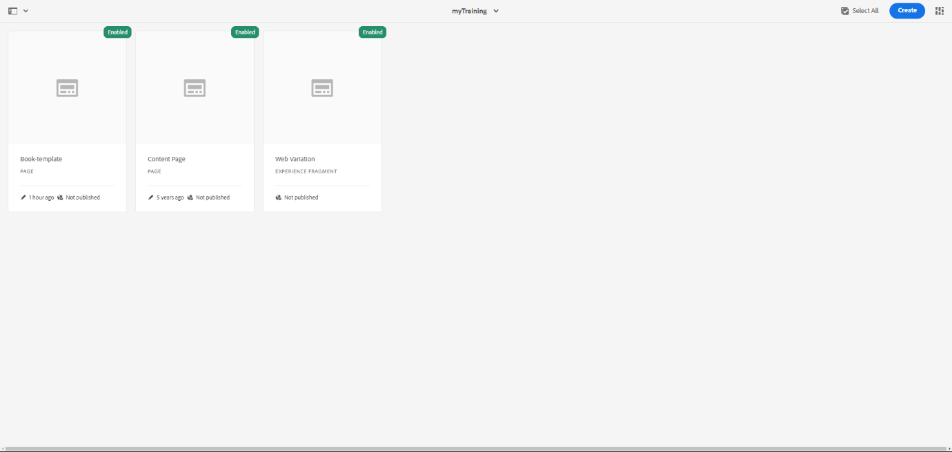

**Step 2:** Creating Book store information such as About us, Read me, and books for providing details about the site and Create 10 pages for books under book page to show the details of books availability

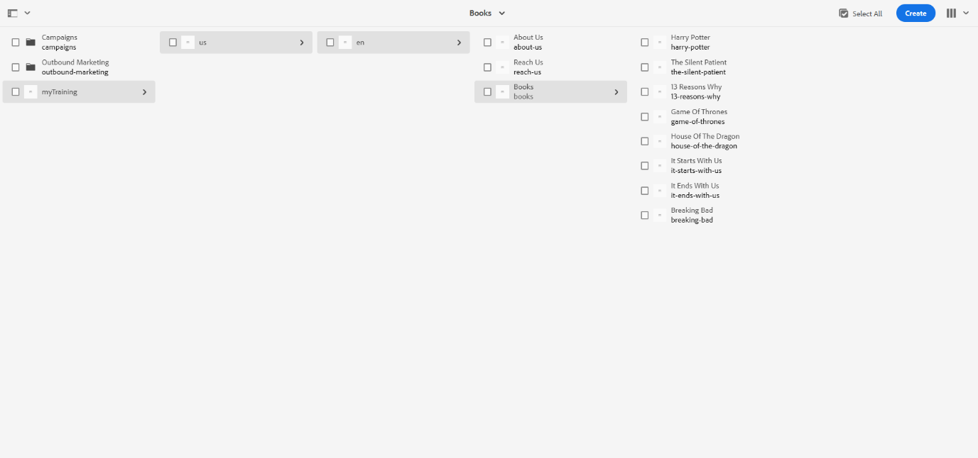

**Step 3:** After providing the content for required pages. Now opening each site.

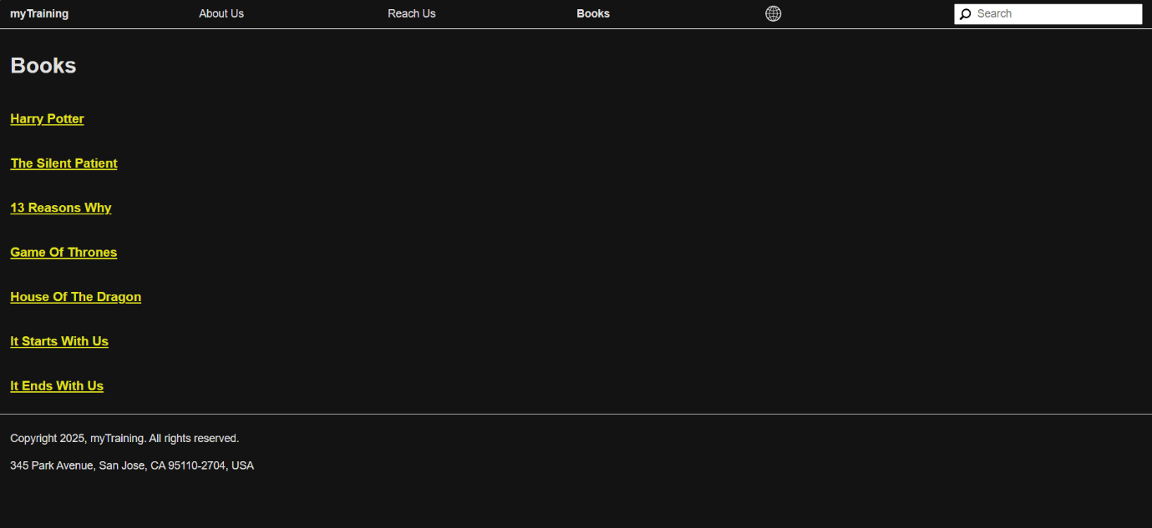

1. About us:

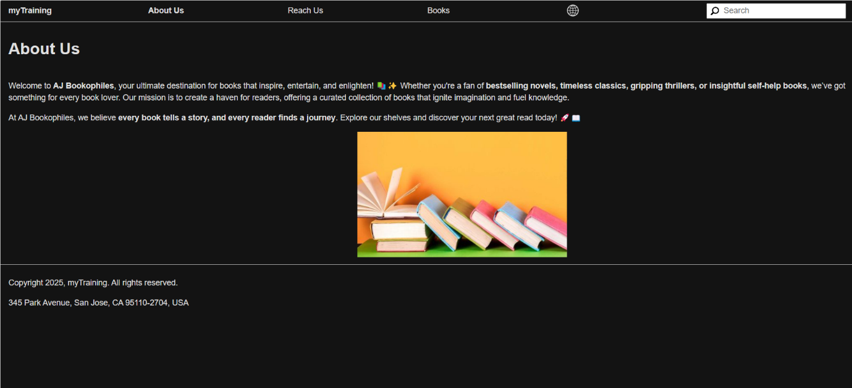

1. Reach us :

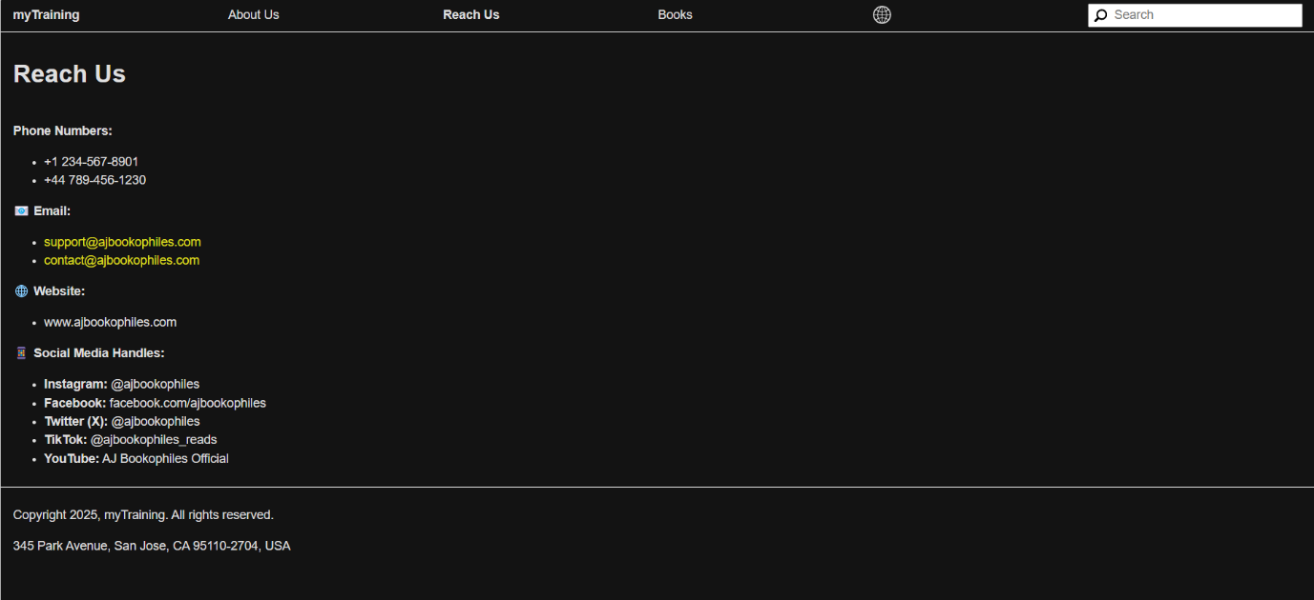

iii)Books

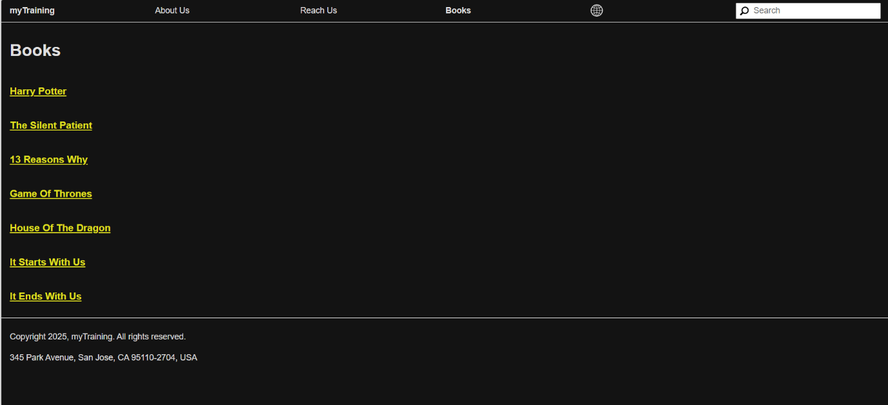

**Step 5:**

Book details-

1.Harry Potter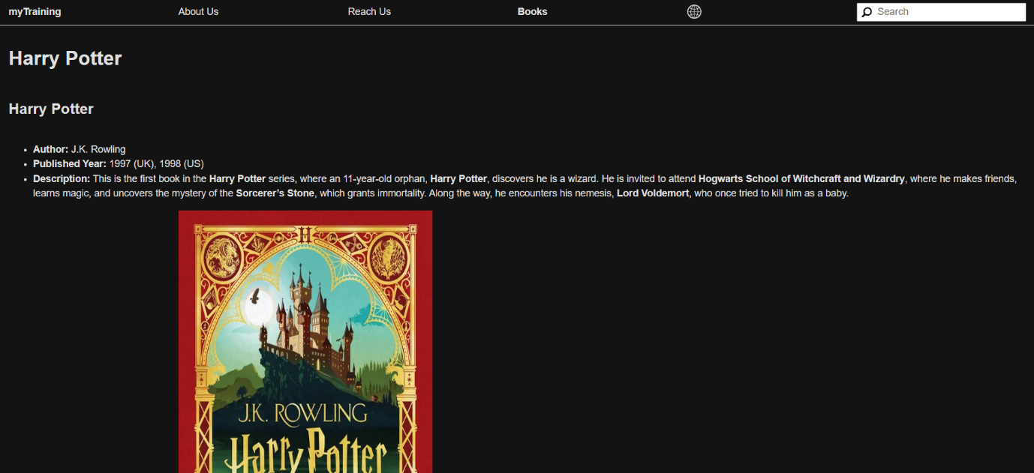

2.It Starts with us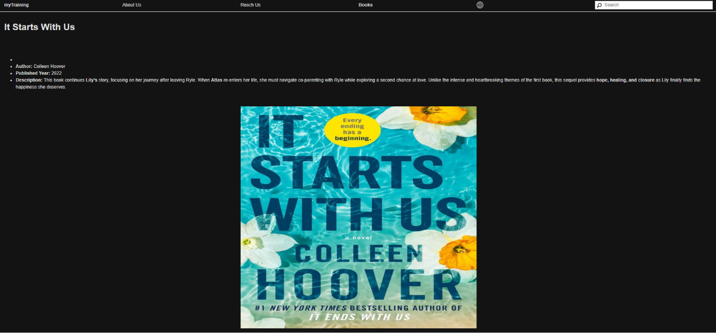

3. 13 Reasons why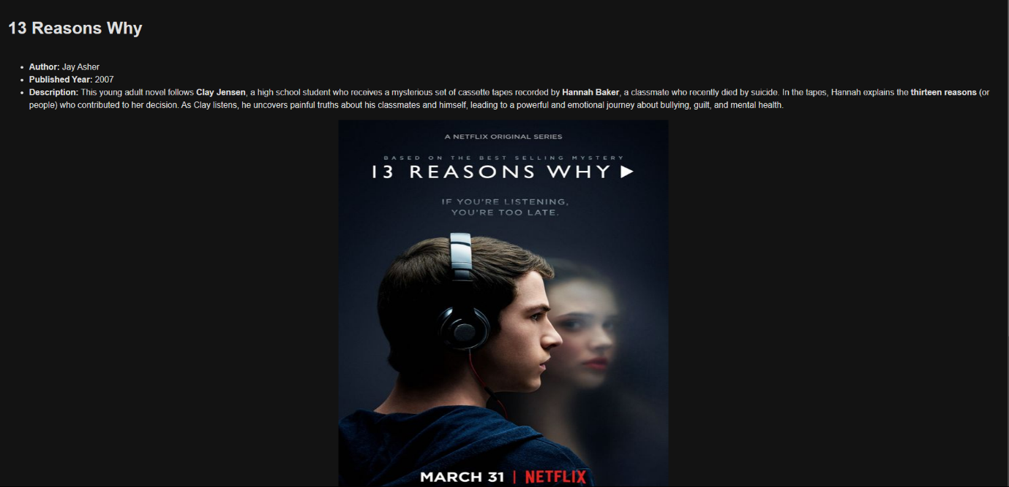

4.Game of Thrones