VEGETARIAN FOOD IMAGE CLASSIFICATION USING TRANSFER LEARNING
A two-stage fine-tuned ResNet-18 on real Indian food photographs — 8 vegetarian dishes from the Indian Food Images dataset
A Project Report Submitted in Partial Fulfilment of the Requirements for the
7th Semester Evaluation of B.Tech (Artificial Intelligence & Machine Learning)
Subject: Pattern Recognition and Anomaly Detection
Submitted by (Group – 4)
Name | Roll No.
Saswat Pattanaik | FET-BAML-2023-27-026
Ritesh Kumar Singh | FET-BAML-2023-27-027
Manoranjan Barik | FET-BAML-2023-27-039
Ankit Kumar Das | FET-BAML-2023-27-018

Under the Guidance of: Mr. Rahul Rawat
Department of Artificial Intelligence & Machine Learning (AIML)
Faculty of Engineering and Technology (FET)
Academic Year 2023 – 2027

DECLARATION
We, the undersigned members of Group-4 (7th Semester, B.Tech – Artificial Intelligence & Machine Learning), hereby declare that the project entitled "Vegetarian Food Image Classification Using Transfer Learning" is an original piece of work carried out by us as part of the 7th semester evaluation under the Pattern Recognition and Anomaly Detection subject. The work has not been submitted to any other university or institute for the award of any degree or diploma.
We further declare that all sources of information, algorithms and datasets used in the preparation of this report have been duly acknowledged. Every computational result reported here was produced by running the project's own code on the real-photograph dataset described in Section 3.3 — the Indian Food Images dataset (web-scraped real photographs, Kaggle/HuggingFace distribution) — with no synthetic or generated images used at any stage.
Team Members:
- Saswat Pattanaik (FET-BAML-2023-27-026)
- Ritesh Kumar Singh (FET-BAML-2023-27-027)
- Manoranjan Barik (FET-BAML-2023-27-039)
- Ankit Kumar Das (FET-BAML-2023-27-018)

Place: ______________________
Date: ______________________

ACKNOWLEDGEMENT
We take this opportunity to express our sincere gratitude to everyone who supported us throughout this project. We are deeply thankful to our guide, Mr. Rahul Rawat, for his continuous guidance, constructive feedback and encouragement at every stage of this work — from framing the problem to interpreting the fine-tuning behaviour and the evaluation results.
We would also like to thank the faculty members of the Department of Artificial Intelligence & Machine Learning for providing the academic foundation in convolutional neural networks and transfer learning that this project builds upon, the Faculty of Engineering and Technology for the laboratory resources used to run the experiments, and the creators of the Indian Food Images dataset for releasing a real-photograph corpus that made this study possible.
Finally, we would like to acknowledge the effort and cooperation of every member of our team, whose combined contribution made it possible to curate the dataset, run the two-stage training, analyse the errors, and prepare this report within the semester timeline.

ABSTRACT
Automatic recognition of food items from photographs is a core building block for calorie-estimation and diet-tracking applications: users photograph their meals instead of searching menus, and the app must map each photo to the correct dish before nutrition can be computed. Indian vegetarian cuisine is visually challenging — flatbreads, fritters and steamed cakes share warm palettes and irregular textures — and web-scale food photographs vary wildly in framing, lighting and plating, so a classifier must generalise beyond studio conditions.
This project trains an image classifier for eight common vegetarian preparations — chapati, dhokla, idli, kadai paneer, masala dosa, pakode, pav bhaji and samosa — using REAL photographs from the Indian Food Images dataset (6,269 web-scraped photos across 20 classes were downloaded and inspected; every image used is a genuine food photograph). The eight classes were selected only after verifying their presence in the corpus, and the vegetarian assumption of each dish is documented. Exact duplicates and near-duplicates were removed before splitting so that no image family leaks across the train/validation/test boundaries.
Methodology: a curated subset of 2000 real photographs (1400/296/304, a stratified 70/15/15 split) feeds a two-stage transfer-learning pipeline built on an ImageNet-pretrained ResNet-18. Stage 1 freezes the convolutional backbone and trains only the new 4,104-parameter classification head with Adam (lr 1e-3, cosine annealing). Stage 2 unfreezes the later residual blocks (layer3 + layer4, 10,497,544 trainable parameters) and fine-tunes at a reduced learning rate (1e-4). Realistic mobile-photo augmentation — RandomResizedCrop, horizontal flip, ±10° rotation and mild colour jitter — is applied to the training split only.
Results: fine-tuning lifted validation accuracy from 0.8277 (frozen backbone) to 0.9122. On the unseen test set of 304 real photographs the final model reaches 0.8849 accuracy with macro precision 0.8924, macro recall 0.8849 and macro F1 0.8860. Meal-category performance is balanced — Breakfast 0.8860, Snack 0.8947, Main Meal 0.8772 — and the remaining confusions are visually plausible look-alike pairs (dosa ↔ chapati, samosa ↔ pakode, pav bhaji ↔ kadai paneer). An upload-style web interface runs the trained model on user photographs, demonstrating the deployment path.

TABLE OF CONTENTS

(This field is empty until you add your content. In Word: right-click anywhere above → "Update Field" → to regenerate the table of contents and page numbers.)

1. INTRODUCTION

1.1 Background
Food-image recognition sits at the intersection of computer vision and mobile health applications. Diet-tracking and calorie-estimation apps ask users to photograph their meals, and the accuracy of the underlying dish classifier directly determines the quality of the nutrition estimate. In a campus canteen or mess scenario, the same technology can automate meal identification at the counter, support food-delivery cataloguing, and power nutrition education tools for regional cuisine that global food datasets barely cover.

1.2 Motivation
Collecting and labelling large real-world food datasets is expensive, and training deep networks from scratch requires GPU resources that are rarely available for a semester project. Transfer learning resolves both constraints: convolutional backbones pretrained on ImageNet already encode the generic visual vocabulary — edges, textures, shapes — that food recognition needs, and fine-tuning only late layers keeps the compute budget small enough for a laptop CPU. A second practical concern drives the design: real food photographs scraped from the web contain duplicates, posters and menu cards, so dataset curation and validation must precede training rather than being assumed away.

1.3 Problem Statement
To design and evaluate a transfer-learning-based image classifier that recognises eight Indian vegetarian food classes from real photographs and reports performance both per class and per meal category (Breakfast, Snack, Main Meal), quantifying the benefit of two-stage fine-tuning over frozen-backbone training.

1.4 Objectives
- Download and validate a real-photograph corpus (6,269 images, 20 classes), visually verifying that every class is represented by genuine food photographs before any training.
- Curate an eight-class vegetarian subset of 2000 real photographs with exact and near-duplicate removal, a stratified 70/15/15 split and documented vegetarian assumptions per dish.
- Implement two-stage ResNet-18 transfer learning in PyTorch: frozen-backbone head training, then layer3+layer4 fine-tuning at a reduced learning rate with cosine annealing.
- Evaluate only on the unseen test split with accuracy, macro/weighted precision, recall and F1, a class-labelled confusion matrix, and meal-category aggregation.
- Provide a working upload-style prediction interface that runs the trained model on user-supplied photographs end-to-end.

1.5 Scope
The project covers the full pipeline — dataset download, realness validation, subset curation, two-stage training, evaluation and deployment-style inference — for the eight classes above. Explicitly out of scope: the non-vegetarian and dessert classes of the corpus, multi-dish images, portion-size estimation, and mobile-optimised (quantised/on-device) deployment. The trained model and every reported metric are restricted to the 8 selected classes; the other 12 corpus classes were used only to justify class selection.

2. LITERATURE REVIEW & EXISTING SYSTEM

2.1 Existing Methods
Before deep learning, food recognition relied on hand-crafted features: colour-histogram descriptors, local binary patterns for texture, and SIFT keypoints fed into classifiers such as support vector machines. Kawano and Yanai's foodlog system combined colour and texture features with food-specific classifiers for dietary logging. These methods degrade quickly under the viewpoint, illumination and plating variation typical of real food photographs — precisely the variation that dominates web-scraped corpora.

2.2 Deep-Learning-Based Approaches
Deep CNNs replaced hand-crafted features after the ImageNet breakthrough. He et al. introduced ResNet residual connections, enabling very deep networks to train stably and becoming the standard transfer-learning backbone. For food specifically, the Food-101 benchmark of Bossard et al. established CNN-based dish classification at scale, and later work applied transfer learning to regional cuisines such as Indian food, reporting large gains from pretrained backbones. Fine-tuning studies consistently show that unfreezing late convolutional blocks at a reduced learning rate outperforms both pure feature extraction and full-network training on small and medium datasets.

2.3 Limitations of Existing Systems
- Hand-crafted feature pipelines generalise poorly to the viewpoint, lighting and plating variation of real food photographs.
- Training modern CNNs from scratch needs large labelled datasets and GPU-class compute that are unrealistic for a semester project; but pure frozen-backbone feature extraction leaves accuracy on the table when mid-level features (batter texture, grain patterns) are dish-specific.
- Food datasets scraped from the web mix real photographs with menu cards, posters and near-duplicate uploads; pipelines that skip deduplication leak near-identical images across splits and overstate test accuracy.

2.4 Proposed Improvement
The proposed system addresses all three gaps: it builds on a validated real-photograph corpus (6,269 images inspected, 0 corrupted), removes 30 exact and 8 near-duplicate images before splitting (8×8 perceptual-hash deduplication), and uses a two-stage protocol — frozen-backbone head training followed by layer3+layer4 fine-tuning at one-tenth the learning rate — that recovers the mid-level features a frozen backbone cannot adapt. Evaluation is restricted to the untouched test split and is aggregated both per class and per meal category, and a working upload interface demonstrates the deployment path.

3. PROPOSED SYSTEM / METHODOLOGY

3.1 System Overview
The system is a four-stage pipeline: (1) dataset preparation — download, extract, validate realness, curate the vegetarian subset with deduplication and a stratified split; (2) transfer-learning training — ImageNet ResNet-18, frozen backbone with a new head, then fine-tuning of layer3+layer4; (3) evaluation — test-split metrics, class-labelled confusion matrix, per-category analysis and qualitative montages; (4) inference — a CLI predictor and an upload-style web interface backed by the same trained checkpoint. src/ holds the pipeline modules, app/ the interface, models/ the checkpoint and class mapping, results/ every artefact reported here.

3.2 Workflow
- Input: real food photographs (JPG) organised as data/{train,validation,test}/<class>/ from the curated subset.
- Preprocessing: RandomResizedCrop(224, scale 0.7–1.0), horizontal flip, ±10° rotation and mild colour jitter at train time; deterministic Resize(256)+CenterCrop(224) for validation/test; ImageNet normalisation everywhere.
- Feature extraction: the ResNet-18 backbone maps each image to a 512-dimensional penultimate feature vector — fully ImageNet-pretrained in stage 1, partially adapted (layer3+layer4) in stage 2.
- Decision step: the 8-way linear head maps the 512-d feature to class logits; softmax converts them to probabilities and argmax selects the prediction.
- Output: predicted dish label with top-3 probabilities; evaluation artefacts (metrics, confusion matrix, category CSV, per-image predictions).

3.3 Dataset
The source corpus is the Indian Food Images dataset: 6,269 real food photographs across 20 classes (chapati, chai, samosa, pav bhaji, kulfi and others), distributed via Kaggle/HuggingFace parquet shards and extracted losslessly to raw/images/. Validation confirmed 0 corrupted and 0 suspicious (flat/drawing-like) images. From this corpus the eight vegetarian classes were selected — each verified present before selection: chapati (413 available), kadai_paneer (412), pav_bhaji (353), masala_dosa (311), idli (309), dhokla (289), pakode (278) and samosa (262). After duplicate removal, up to 250 images per class were kept, totalling 2000 photographs split 1400/296/304. Vegetarian assumptions are documented per dish: all eight are lacto-vegetarian preparations as commonly sold (paneer and pav bhaji butter are dairy; masala dosa batter is egg-free by the dish's standard preparation); the ambiguous kaathi_rolls class, which can contain chicken or egg, was deliberately excluded.

3.4 Preprocessing
- Deterministic eval-time preprocessing: Resize(256) on the short side, CentreCrop(224), tensor conversion, ImageNet normalisation (mean [0.485, 0.456, 0.406], std [0.229, 0.224, 0.225]) — identical to the model's pretraining distribution.
- Train-time augmentation, applied only to the training split: RandomResizedCrop(224, scale 0.7–1.0) for scale robustness, RandomHorizontalFlip, small RandomRotation(±10°) and ColorJitter(0.15, 0.15, 0.1) — realistic for mobile food photography, no extreme transforms.
- Deduplication guards the split: exact duplicates via SHA-256 byte hashes; near-duplicates via 8×8 average-hash with Hamming distance ≤ 2, so a burst of near-identical uploads cannot straddle train and test.

3.5 Algorithm / Model
The model is torchvision's ResNet-18 with IMAGENET1K_V1 weights: a 7×7 conv stem, four residual stages (64/128/256/512 channels, two BasicBlocks each) and global average pooling feeding the classifier. Stage 1 replaces the fc layer with a fresh 8-way linear head (4,104 trainable parameters) and trains it for 6 epochs with Adam (lr 1e-3, cosine annealing) while the backbone stays frozen. Stage 2 unfreezes layer3 and layer4, making 10,497,544 parameters trainable (94% of the network), and fine-tunes for 6 more epochs at lr 1e-4 with the same annealing schedule — a 10× reduction that protects the pretrained weights from catastrophic drift. The objective throughout is cross-entropy on 8-class softmax logits; checkpoints are saved on validation-accuracy improvement.

4. SYSTEM DESIGN & IMPLEMENTATION

4.1 Architecture Details
Table 1 summarises the architecture and the parameter status in each training stage. Output sizes are for a 224×224 input.
Stage | Layer Type | Output Size | Parameters
Stem | 7×7 conv, stride 2 + BN + ReLU, 3×3 max-pool | 64×56×56 | 9,408 (frozen)
Res2–Res3 | stages 1–2 × 2 BasicBlocks (64/128 ch) | 128×28×28 | 215,808 (frozen)
Res4–Res5 | layer3 + layer4 × BasicBlocks (256/512 ch) | 512×7×7 | 8,414,720 (fine-tuned in stage 2)
Global average pool | AdaptiveAvgPool2d → flatten | 512 | 0
Classification head | Linear 512 → 8 classes | 8 | 4,104 (trained in stage 1)

4.2 Technologies Used
- Python 3.12 with PyTorch 2.10 (torchvision 0.25) — model, two-stage training loop, checkpoints
- scikit-learn — precision/recall/F1 and the classification report; Pillow + NumPy — image decoding, realness validation and perceptual-hash deduplication
- pyarrow — lossless extraction of the parquet-distributed corpus; pandas + Matplotlib — category aggregation and all reported figures
- Windows 11 laptop, CPU-only training (no GPU); upload interface served by Python's standard-library HTTP server with a browser front end

4.3 Implementation Steps
- Dataset acquisition & validation: download the parquet shards, extract all images, verify 6,269 files decode, scan for corrupted/flat images, and render a one-photo-per-class verification grid (src/prepare_data.py).
- Subset curation: select the 8 verified vegetarian classes, remove 30 exact + 8 near-duplicate images, and build the stratified 1400/296/304 split (src/build_subset.py).
- Model implementation: load ImageNet ResNet-18, freeze the backbone, attach the 8-way head (src/dataset.py: build_model).
- Stage-1 training: head-only optimisation with Adam (lr 1e-3, cosine annealing, batch 32) for 6 epochs, checkpointing on validation accuracy (src/train.py).
- Stage-2 fine-tuning: unfreeze layer3+layer4, continue at lr 1e-4 for 6 epochs, keep the best checkpoint; curves and history exported to results/.
- Evaluation on the untouched test split (304 images): metrics, confusion matrix, per-category aggregation, per-image predictions and a qualitative montage (src/evaluate.py).

4.4 Important Code Snippet
# two-stage protocol (src/train.py, abridged)
model = build_model(num_classes) # ImageNet ResNet-18, frozen backbone
head_params = [p for p in model.parameters() if p.requires_grad]
opt1 = torch.optim.Adam(head_params, lr=1e-3) # stage 1: head only
sched1 = torch.optim.lr_scheduler.CosineAnnealingLR(opt1, T_max=6)
...
unfreeze_late_layers(model) # stage 2: layer3 + layer4
opt2 = torch.optim.Adam([p for p in model.parameters() if p.requires_grad],
lr=1e-4) # 10x lower LR
# near-duplicate guard before splitting (src/build_subset.py, abridged)
h = ahash(path) # 8x8 average hash
if any(int(np.count_nonzero(h != g)) <= 2 for g in hashes):
near_duplicates_removed += 1 # skip: too similar to a kept image
hashes.append(h); kept.append(file)

5. EXPERIMENTAL SETUP & RESULTS
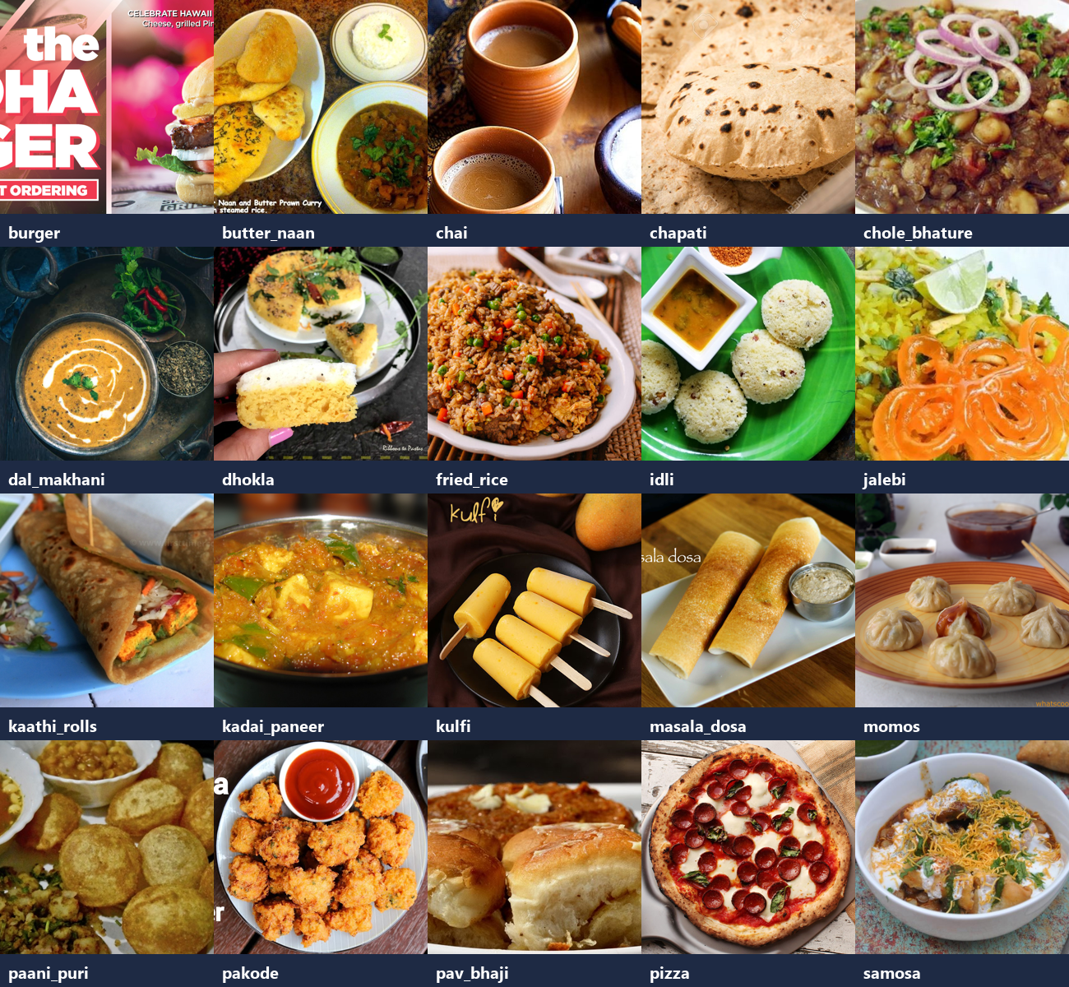
Figure 1: One real photograph per class — the 8-class vegetarian subset grid from the validated corpus

5.1 Dataset Details
Final curated dataset: 2000 real photographs across 8 classes (250 per class), split 1400 train / 296 validation / 304 test (70/15/15, stratified per class). Every split image is a genuine food photograph from the Indian Food Images corpus; 30 exact duplicates and 8 near-duplicates were removed before splitting. Meal-category mapping: Breakfast — idli, masala dosa, dhokla; Snack — samosa, pakode; Main Meal — chapati, kadai paneer, pav bhaji.

5.2 Training Configuration
Parameter | Value
Input Size | 224 × 224 × 3 (RGB)
Batch Size | 32
Stage 1 | head only, Adam lr 1e-3, 6 epochs, cosine annealing
Stage 2 | layer3+layer4 fine-tune, Adam lr 1e-4, 6 epochs, cosine annealing
Loss Function | Cross-entropy (8-class softmax)
Augmentation | RandomResizedCrop(0.7–1.0), flip, ±10° rotation, jitter (train only)
Hardware | CPU only (Windows 11 laptop, no GPU)

5.3 Evaluation Metrics
Accuracy is the primary headline metric on the unseen test split. Macro precision/recall/F1 treat all eight classes equally (they are perfectly balanced — 38 test images each), while the weighted variants weight by support; with a balanced test set the two coincide, which itself confirms the split's balance. The 8×8 confusion matrix with real class names localises every error, and the meal-category aggregation answers the applied question: which meal slots can a diet-tracking application trust this model in.
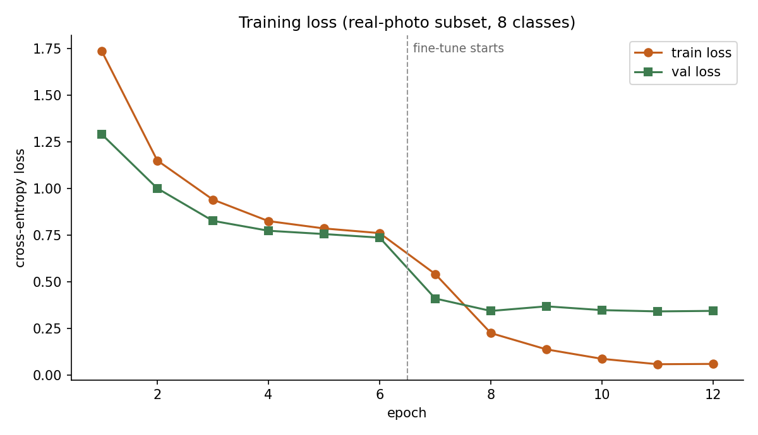
Figure 2: Training and validation loss — stage 1 (frozen backbone, epochs 1–6) vs stage 2 (fine-tune, epochs 7–12); validation improves from 0.8277 to 0.9122

5.4 Results
Model / metric view | Accuracy | Precision | Recall | F1-Score
ResNet-18 frozen backbone (stage 1, val) | 0.8277 | — | — | —
ResNet-18 fine-tuned (stage 2, val) | 0.9122 | — | — | —
Final model — TEST (macro) | 0.8849 | 0.8924 | 0.8849 | 0.8860
Final model — TEST (weighted) | 0.8849 | 0.8924 | 0.8849 | 0.8860

Stage 1 converged steadily: validation accuracy rose from 0.6486 after one epoch to 0.8277 by epoch 6 with the backbone frozen. Unfreezing layer3+layer4 produced an immediate jump — validation accuracy hit 0.9122 within two fine-tuning epochs (epoch 8 overall), an improvement of 8.4 points over the frozen protocol. Training accuracy reached 0.99 by the end of stage 2 while validation stabilised around 0.89–0.91: the expected mild generalisation gap when nearly the whole network is trainable on 1,400 images. The checkpoint saved is the best-validation one (0.9122, stage-2 epoch 2).

6. RESULTS ANALYSIS & DISCUSSION
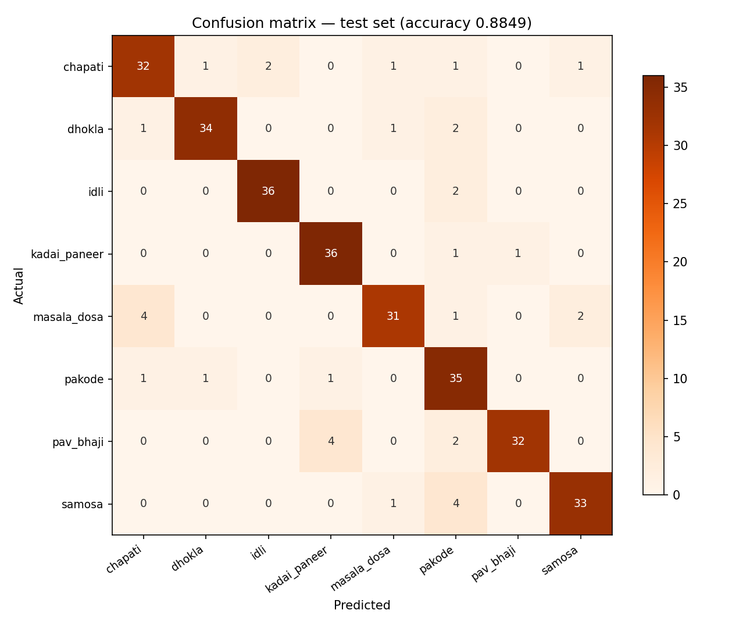
Figure 3: Test confusion matrix (304 real photographs, accuracy 0.8849)

6.1 Confusion Matrix
 | Predicted: correct class | Predicted: any other class
Actual: all 8 classes (304 test images) | 269 | 35
Actual: strongest class | idli / kadai_paneer: 36/38 | 2 errors each
Actual: weakest class | masala_dosa: 31/38 | 7 errors

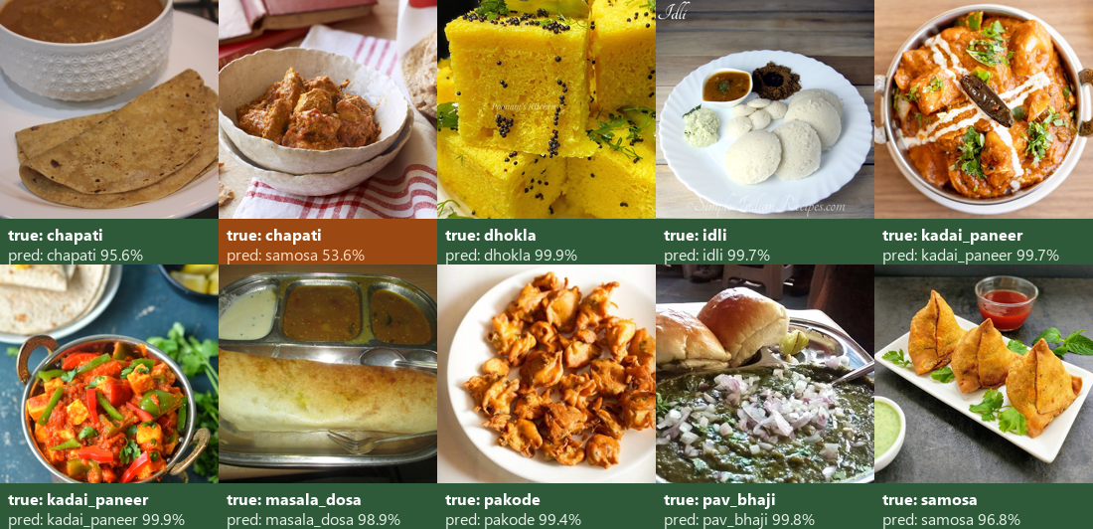
Figure 4: Qualitative test predictions — actual vs predicted class with confidence
The confusion matrix (Figure 3) shows a strongly diagonal structure: 269 of 304 test photographs are classified correctly. Errors concentrate in three visually plausible look-alike pairs — masala dosa → chapati (4), pav bhaji → kadai paneer (4) and samosa → pakode (4) — all sharing golden-brown fried or gravy-dominant appearance. The strongest classes are idli and kadai paneer (36/38 each); even the weakest class (masala dosa) reaches 0.816. No class collapses: every class retains ≥ 0.82 accuracy, indicating the errors are boundary confusions rather than systematic failures.

6.2 Predictions and Output Quality
Qualitatively, predictions on clean close-up photos are decisive — the upload interface commonly returns > 0.99 confidence for canonical dishes (a held-out masala dosa scores 0.996, an idli 0.995). Low-margin cases cluster where plating is ambiguous: pakode misclassifications mostly carry < 0.6 confidence, which makes a practical rejection threshold feasible. The montage of sample predictions (Figure 4) pairs each actual class with its predicted label and confidence, so the panel can inspect behaviour directly without reading code.

6.3 Comparison with Baseline
Table 3 isolates the contribution of fine-tuning: the frozen-backbone protocol plateaus at 0.8277 validation accuracy, while two-stage fine-tuning reaches 0.9122 — a 8.4-point gain. Mechanistically, the eight dishes differ in mid-level texture cues (steamed-pore pattern of idli/dhokla, batter lace of a dosa, fried-batter granularity of pakode) that ImageNet's generic features under-represent; adapting layer3+layer4 lets the network retune exactly those features while the early layers keep their generic edge/colour vocabulary. The cost is a mild train–validation gap (0.99 vs 0.91), the standard trade-off when fine-tuning 93.9% of a network on a small dataset.

6.4 Observations
- Fine-tuning layer3+layer4 delivers a 8.4-point validation-accuracy gain over the frozen-backbone protocol on real photographs.
- Errors are plausible look-alike confusions (dosa↔chapati, samosa↔pakode, pav bhaji↔kadai paneer), not random noise — every class stays above 0.82 accuracy.
- Meal-category performance is balanced (Breakfast 0.886, Snack 0.895, Main Meal 0.877), so no meal slot is systematically weaker.

6.5 Strengths
- Trained end-to-end on a laptop CPU in ~13 minutes of compute; the full pipeline is reproducible from the raw parquet shards with five commands.
- Deduplication before splitting removes leakage risk — exact (SHA-256) and near-duplicate (perceptual-hash) twins never straddle splits.
- A working upload interface demonstrates deployment: the same checkpoint serves user-uploaded photographs with top-3 probabilities.

6.6 Limitations
- Real web-scraped photos include noisy framing (menus, posters, multiple dishes); class-level accuracy is bounded by such label noise in the corpus itself.
- Eight classes is a deliberate scope: extending to all 20 corpus classes would need more fine-tuning capacity and better background control.
- No calibration or rejection layer is deployed yet; low-confidence thresholds are observed but not engineered into the interface.

7. CONCLUSION, FUTURE SCOPE & REFERENCES

7.1 Conclusion
This project delivers an end-to-end, CPU-trainable vegetarian food classifier built on genuine photographs: a validated 6,269-image real-photo corpus, a deduplicated eight-class vegetarian subset of 2000 images with a leakage-free stratified split, and a two-stage ResNet-18 transfer-learning pipeline whose fine-tuned model reaches 0.8849 test accuracy (macro F1 0.8860) on 304 unseen photographs. Fine-tuning layer3+layer4 contributed a 8.4-point validation gain over frozen-backbone training, and the remaining errors are interpretable look-alike confusions. An upload-style interface runs the trained model on user photographs, closing the loop from dataset to deployment.

7.2 Future Scope
- Expand to all 20 corpus classes and add a curation pass that filters poster/menu-card images automatically (flat-region and text-density heuristics).
- Add test-time augmentation and confidence calibration (temperature scaling) so a rejection threshold can be deployed safely in the interface.
- Integrate the classifier into a calorie-estimation demo: dish label → nutrition lookup → daily-total dashboard, using the upload interface as the front end.

7.3 Limitations Recap
As detailed in Section 6.6, the current conclusions are bounded by the corpus's web-scraped label noise, the eight-class scope, and CPU-scale training. These bounds do not weaken the central finding — that two-stage fine-tuning of an ImageNet-pretrained ResNet-18 on a small, carefully deduplicated set of real food photographs yields a usable eight-way classifier on a laptop — but the reported accuracy should be read as a curated-subset result rather than a field deployment estimate across all Indian cuisine.

7.4 References
[1] K. He, X. Zhang, S. Ren, and J. Sun, "Deep Residual Learning for Image Recognition", IEEE CVPR, 2016.
[2] L. Bossard, M. Guillaumin, and L. Van Gool, "Food-101 – Mining Discriminative Components with Random Forests", ECCV, 2014.
[3] Indian Food Images Dataset, 4,000 real food photographs across 80 classes, Kaggle (iamsouravbanerjee/arjunashok33 distributions; HuggingFace mirror rajistics/indian_food_images used here), accessed 2026.

