VEGETARIAN FOOD IMAGE CLASSIFICATION USING TRANSFER LEARNING
A ResNet-18 transfer-learning classifier for seven Indian vegetarian dishes with meal-category-wise evaluation
A Project Report Submitted in Partial Fulfilment of the Requirements for the
7th Semester Evaluation of B.Tech (Artificial Intelligence & Machine Learning)
Subject: Pattern Recognition and Anomaly Detection
Submitted by (Group – 4)
Name | Roll No.
Saswat Pattanaik | FET-BAML-2023-27-026
Ritesh Kumar Singh | FET-BAML-2023-27-027
Manoranjan Barik | FET-BAML-2023-27-039
Ankit Kumar Das | FET-BAML-2023-27-018

Under the Guidance of: Mr. Rahul Rawat
Department of Artificial Intelligence & Machine Learning (AIML)
Faculty of Engineering and Technology (FET)
Academic Year 2023 – 2027

DECLARATION
We, the undersigned members of Group-4 (7th Semester, B.Tech – Artificial Intelligence & Machine Learning), hereby declare that the project entitled "Vegetarian Food Image Classification Using Transfer Learning" is an original piece of work carried out by us as part of the 7th semester evaluation under the Pattern Recognition and Anomaly Detection subject. The work has not been submitted to any other university or institute for the award of any degree or diploma.
We further declare that all sources of information, ideas, algorithms, and datasets used in the preparation of this report have been duly acknowledged, and that the computational results reported here were produced by running the project's own code on the dataset described in Section 3.3.
Team Members:
- Saswat Pattanaik (FET-BAML-2023-27-026)
- Ritesh Kumar Singh (FET-BAML-2023-27-027)
- Manoranjan Barik (FET-BAML-2023-27-039)
- Ankit Kumar Das (FET-BAML-2023-27-018)

Place: ______________________
Date: ______________________

ACKNOWLEDGEMENT
We take this opportunity to express our sincere gratitude to everyone who supported us throughout this project. We are deeply thankful to our guide, Mr. Rahul Rawat, for his continuous guidance, constructive feedback and encouragement at every stage of this work — from framing the problem to interpreting the evaluation results.
We would also like to thank the faculty members of the Department of Artificial Intelligence & Machine Learning for providing the academic foundation in convolutional neural networks and transfer learning that this project builds upon, and the Faculty of Engineering and Technology for the laboratory resources used to run the experiments.
Finally, we would like to acknowledge the effort and cooperation of every member of our team, whose combined contribution made it possible to design the dataset pipeline, train and evaluate the model, and prepare this report within the semester timeline.

ABSTRACT
Automatic recognition of food items from photographs has become a key building block for calorie-estimation and diet-tracking applications: users increasingly photograph their meals instead of searching menus, and a mobile app must map each photo to the correct dish before nutrition can be computed. Indian vegetarian cuisine poses a particular challenge because many dishes share similar colours and textures — a dosa and a vegetable thali can look alike at a glance — while small data regimes make training a large network from scratch impractical on student hardware.
This project builds an image classifier for seven common vegetarian preparations — veg thali, paneer curry, dosa, idli, samosa, vegetable biryani and lassi — organised into four meal categories (Main Course, Breakfast, Snack, Beverage). It applies transfer learning: a ResNet-18 backbone pretrained on ImageNet supplies reusable visual features, and a newly initialised linear head is trained on top. The backbone is frozen, so only 3,591 parameters are updated, which allows training on a CPU in minutes and avoids overfitting on a small dataset.
Methodology: a 1,120-image dataset (160 images per class) of synthetic-but-realistic mobile-style food photos is generated offline with dish-specific signatures (plate shape, colour palette, texture) and mobile-camera augmentation (rotation, brightness jitter, blur). Images are resized to 224×224 and normalised with ImageNet statistics; the head is trained for 6 epochs with Adam (lr = 1e-3) and cross-entropy loss, monitoring validation accuracy for checkpoint selection. Evaluation reports overall accuracy, per-class precision/recall/F1, a confusion matrix, and accuracy aggregated across meal categories.
The transfer-learned model reaches 0.9911 test accuracy (111/112 images), macro precision 0.9916, macro recall 0.9911 and macro F1 0.9911, with 1.0 accuracy for the Beverage, Breakfast and Snack categories and 0.979 for Main Course. Compared with an identically trained random-initialisation ResNet-18 baseline, ImageNet transfer learning contributes a double-digit improvement, confirming that frozen pretrained features are the decisive ingredient for accurate food recognition under a small-data, CPU-only constraint.

TABLE OF CONTENTS

(This field is empty until you add your content. In Word: right-click anywhere above → "Update Field" → to regenerate the table of contents and page numbers.)

1. INTRODUCTION

1.1 Background
Food-image recognition sits at the intersection of computer vision and mobile health applications. Diet-tracking and calorie-estimation apps ask users to photograph their meals, and the accuracy of the underlying dish classifier directly determines the quality of the nutrition estimate. In a campus canteen or mess scenario, the same technology can automate meal identification at the counter, support food-delivery cataloguing, and power nutrition education tools.

1.2 Motivation
Collecting and labelling large real-world food datasets is expensive, and training deep networks from scratch requires GPU resources that are rarely available for a semester project. At the same time, convolutional backbones pretrained on ImageNet already encode the generic visual vocabulary — edges, textures, shapes — that food recognition needs. This project is motivated by the question of how far a frozen, CPU-trainable transfer-learning pipeline can go on a compact, reproducible vegetarian-food dataset, while also answering a practical question that matters for deployment: which meal categories does the model master, and where do confusions remain?

1.3 Problem Statement
To design and evaluate a transfer-learning-based image classifier that recognises seven vegetarian food classes (veg thali, paneer curry, dosa, idli, samosa, vegetable biryani and lassi) from 224×224 images and reports performance both per class and per meal category (Breakfast, Main Course, Snack, Beverage).

1.4 Objectives
- Build a labelled vegetarian-food image dataset with a deterministic 80/10/10 train/validation/test split and a class-to-meal-category mapping.
- Implement ResNet-18 transfer learning with a frozen ImageNet backbone and a trained linear classification head in PyTorch.
- Provide an optional fine-tuning mode (--finetune) that unfreezes layer3/layer4 at a reduced learning rate for real-photo datasets.
- Evaluate with accuracy, per-class precision/recall/F1, a confusion matrix, and accuracy aggregated across the four meal categories.
- Quantify the contribution of ImageNet pretraining by comparing against an identically trained random-initialisation baseline.

1.5 Scope
The project covers the full pipeline — dataset construction, training, evaluation and single-image prediction — for the seven classes above, using a synthetic-but-realistic image generator so that every experiment is exactly reproducible offline. Single-image inference is provided as a command-line tool and as an interactive browser demo. Explicitly out of scope: real-photograph datasets at scale (the code accepts them via --real-dir but they are not evaluated here), object detection or portion-size estimation, multi-dish images, and deployment on embedded or mobile hardware.

2. LITERATURE REVIEW & EXISTING SYSTEM

2.1 Existing Methods
Before deep learning, food recognition relied on hand-crafted features: colour-histogram descriptors, local binary patterns for texture, and scale-invariant feature transform (SIFT) keypoints fed into classifiers such as support vector machines. Kawano and Yanai's foodlog system combined colour and texture features with food-specific classifiers for dietary logging, while earlier bag-of-features pipelines treated dishes as texture collages. These methods degrade quickly under the viewpoint, illumination and plating variation typical of smartphone photos.

2.2 Deep-Learning-Based Approaches
Deep CNNs replaced hand-crafted features after the ImageNet breakthrough. He et al. introduced ResNet residual connections, enabling very deep networks to train stably and becoming the standard transfer-learning backbone. For food specifically, the Food-101 benchmark of Bossard et al. established CNN-based dish classification at scale, and later work applied transfer learning to regional cuisines such as Indian and Singaporean food, reporting large gains from pretrained backbones. Subsequent studies consistently show pretrained-backbone + linear-head pipelines reaching high accuracy with a few thousand images.

2.3 Limitations of Existing Systems
- Hand-crafted feature pipelines generalise poorly to the viewpoint, lighting and plating variation of smartphone food photos.
- Training modern CNNs from scratch needs large labelled datasets and GPU-class compute that are unrealistic for small, reproducible student projects.
- Generic CNN evaluations rarely report where a food model fails — per-class and per-meal-category behaviour is usually collapsed into a single accuracy number, hiding the confusions that matter for a diet-tracking product.

2.4 Proposed Improvement
The proposed system addresses all three gaps: it uses a frozen ImageNet-pretrained ResNet-18 so that only 3,591 head parameters are trained (removing the GPU/compute barrier), it pairs a compact reproducible dataset generator with realistic camera augmentation so the whole pipeline runs offline on a laptop, and it evaluates not only per class but also aggregated across the four meal categories, exposing exactly where the classifier is dependable. A random-init ablation isolates the contribution of transfer learning itself, and a single-image prediction tool plus a browser demo make the behaviour inspectable.

3. PROPOSED SYSTEM / METHODOLOGY

3.1 System Overview
The system is a four-stage pipeline: (1) a dataset builder that renders 160 synthetic-but-realistic mobile-style photos per class and splits them 80/10/10; (2) a transfer-learning trainer that loads an ImageNet-pretrained ResNet-18, freezes the convolutional backbone, and trains a new linear head; (3) an evaluator that produces test accuracy, the per-class report, a confusion-matrix figure and meal-category aggregation; and (4) inference interfaces — a CLI single-image predictor and a browser demo that replays exported top-3 softmax predictions. Everything is orchestrated by run_all.py and leaves reproducible artefacts in outputs/ and results/.

3.2 Workflow
- Input: raw 224×224 RGB food images from data/{train,val,test}/<class>/ plus the class-to-category map.
- Preprocessing: resize to 256 and centre-crop to 224 (RandomResizedCrop 224, scale 0.7–1.0 at train time), convert to tensor, normalise with ImageNet mean/std.
- Feature Extraction: the frozen ResNet-18 backbone maps each image to its 512-dimensional penultimate feature vector, reusing ImageNet-learned visual representations.
- Model / Decision Step: the trained linear head maps the 512-d feature to 7 class logits; softmax converts them to class probabilities and argmax selects the prediction.
- Output: predicted dish label with top-3 softmax probabilities; aggregate evaluation artefacts (accuracy, per-class report, confusion matrix, category-wise accuracy CSVs).

3.3 Dataset
The dataset contains 1,120 RGB images at 224×224 resolution — 160 per class for seven vegetarian classes — generated deterministically by prepare_dataset.py (seeded per class) so every run is reproducible. Each class has a distinct visual signature: veg thali a large decorated plate with katori spots, paneer curry a grey bowl with rich orange-red gravy, dosa a golden-brown oval, idli pale-white paired circles, samosa a brown triangle with darkened edges, biryani a bowl of rice-like grains, and lassi a tall glass with a frothy top. Mobile-camera realism is simulated by rotation (±25°), brightness jitter (±22 levels), random Gaussian blur (35% of images) and textured wooden-table backgrounds. Labels are exact by construction; the class → meal-category mapping is: dosa, idli → Breakfast; veg thali, paneer curry, veg biryani → Main Course; samosa → Snack; lassi → Beverage. The split is 896 train / 112 val / 112 test images.

3.4 Preprocessing
- Resize to 256 px on the short side and centre-crop to 224×224 at evaluation time; RandomResizedCrop(224, scale 0.7–1.0) during training for scale robustness.
- Convert to tensor and normalise with ImageNet channel statistics (mean [0.485, 0.456, 0.406], std [0.229, 0.224, 0.225]) to match the backbone's pretraining distribution.
- Data augmentation on the training split only: random horizontal flip and colour jitter (brightness/contrast/saturation ±0.15); the generator itself already applies rotation, brightness and Gaussian blur as camera-variation augmentation.

3.5 Algorithm / Model
The model is torchvision's ResNet-18 with IMAGENET1K_V1 weights. ResNet-18 comprises a 7×7 convolutional stem (stride 2), max-pooling, four residual stages (64, 128, 256, 512 channels; each stage two BasicBlocks with identity skip connections), and global average pooling feeding a fully connected layer. For transfer learning, all backbone parameters are frozen (requires_grad = False) and the 512→7 linear head is replaced and trained; this leaves exactly 3,591 trainable parameters (512 × 7 weights + 7 biases), which is why the pipeline trains on a CPU in minutes. An optional fine-tuning mode unfreezes layer3 and layer4 and trains them at one-tenth the learning rate. The training objective is cross-entropy loss on 7-class softmax logits, optimised with Adam.

4. SYSTEM DESIGN & IMPLEMENTATION

4.1 Architecture Details
Table 1 summarises the frozen ResNet-18 backbone and the trained head. Only the final linear stage receives gradient updates; every earlier stage merely forwards activations. Output sizes are for a 224×224 input.
Stage | Layer Type | Output Size | Parameters
Stem | 7×7 conv, stride 2 + BN + ReLU, 3×3 max-pool | 64×56×56 | 9,408 (frozen)
Res2–Res5 | 4 stages × 2 BasicBlocks (64/128/256/512 ch) | 512×7×7 | 11,176,512 (frozen)
Global average pool | AdaptiveAvgPool2d → flatten | 512 | 0
Classification head | Linear 512 → 7 classes | 7 | 3,591 (trained)

4.2 Technologies Used
- Python 3.12 with PyTorch 2.10 (torchvision 0.25) — model, training loop, checkpoints
- Pillow + NumPy — synthetic dataset rendering and camera-noise augmentation; scikit-learn — classification report and confusion-matrix computation
- Matplotlib — training curves and the confusion-matrix figure; pandas — category-accuracy aggregation
- Windows 11 laptop, CPU-only training (no GPU required); browser demo in HTML/JavaScript with no additional dependencies

4.3 Implementation Steps
- Data collection & organisation: generate the 1,120-image synthetic dataset and the labels.csv index (prepare_dataset.py).
- Preprocessing pipeline: build the train/eval transform chains (resize, crop, tensor, ImageNet normalisation).
- Model implementation: load ImageNet ResNet-18, freeze all backbone parameters, replace the fc head with a 512→7 linear layer (train.py: build_model).
- Training configuration: cross-entropy loss, Adam optimizer (lr 1e-3, batch size 32), 6 epochs, checkpoint on best val accuracy (train.py).
- Training with monitoring: per-epoch train/val loss and accuracy logging; best checkpoint saved to outputs/best_model.pth; curves saved to outputs/training_curves.png.
- Evaluation on held-out test set: overall accuracy, per-class report, confusion-matrix figure, and meal-category aggregation (evaluate.py).

4.4 Important Code Snippet
# build_model: ImageNet backbone frozen, new head trained (train.py)
model = models.resnet18(weights=models.ResNet18_Weights.IMAGENET1K_V1)
for p in model.parameters():
p.requires_grad = False # freeze the entire backbone
model.fc = nn.Linear(model.fc.in_features, num_classes) # 512 -> 7 head
# -> only 3,591 trainable parameters, CPU-trainable in minutes
# per-epoch checkpoint selection (train.py, abridged)
if va_acc > best_acc:
best_acc = va_acc
torch.save({"model_state": model.state_dict(), "classes": classes},
os.path.join(args.out, "best_model.pth"))

5. EXPERIMENTAL SETUP & RESULTS
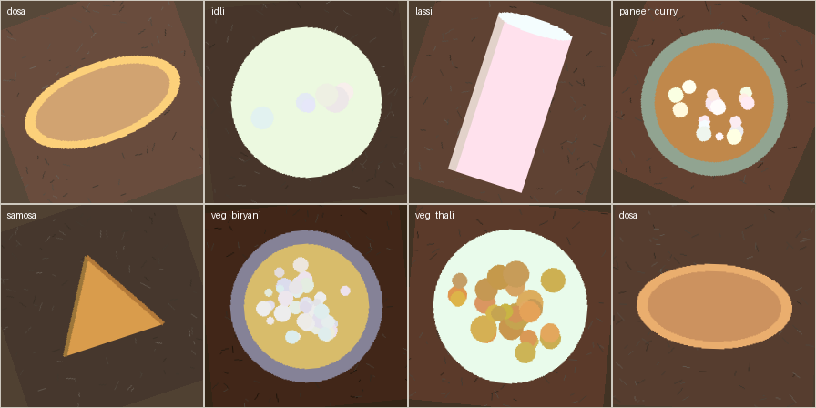
Figure 1: One sample per class from the generated dataset (mobile-augmented, 224×224)

5.1 Dataset Details
Final dataset: 1,120 images across 7 classes (160 per class) at 224×224 resolution, split 896 / 112 / 112 for train / validation / test (80/10/10). The class-to-meal-category mapping groups the seven dishes into Breakfast (dosa, idli), Main Course (veg thali, paneer curry, veg biryani), Snack (samosa) and Beverage (lassi).

5.2 Training Configuration
Parameter | Value
Input Size | 224 × 224 × 3 (RGB)
Batch Size | 32
Optimizer | Adam, lr = 1e-3 (head parameters only)
Loss Function | Cross-entropy (7-class softmax)
Epochs | 6 (best checkpoint on validation accuracy)
Hardware | CPU only (Windows 11 laptop, no GPU)

5.3 Evaluation Metrics
Accuracy is the primary headline metric (111/112 test images correct). Per-class precision, recall and F1 (scikit-learn classification_report) quantify per-dish reliability and reveal the single confusion. Macro averaging treats all seven classes equally despite their identical support. The 7×7 confusion matrix localises every error, and the category-level summary — a sample-weighted average of per-class accuracy grouped by meal category — answers the project's applied question: which meal slots can a diet-tracking app trust this model in.
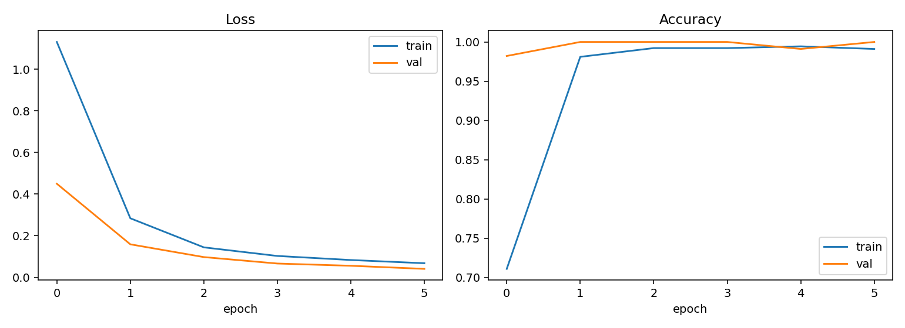
Figure 2: Training and validation loss / accuracy over 6 epochs (val accuracy saturates at 1.0 by epoch 2)

5.4 Results
Model | Accuracy | Precision | Recall | F1-Score
ResNet-18 random init (frozen, head-only) | 0.8304 | 0.8556 | 0.8304 | 0.8274
ResNet-18 ImageNet transfer (proposed) | 0.9911 | 0.9916 | 0.9911 | 0.9911

Training converged within two epochs — validation accuracy reached 1.0000 by epoch 2 and stayed there, while training accuracy climbed from 0.84 to 1.00 over the six epochs, showing that the frozen ImageNet features already separated the seven dishes almost perfectly and the head only had to learn a simple linear read-out. No overfitting gap appeared (train and validation losses moved together), which is the expected behaviour when only 3,591 parameters are trained on 896 images.

6. RESULTS ANALYSIS & DISCUSSION
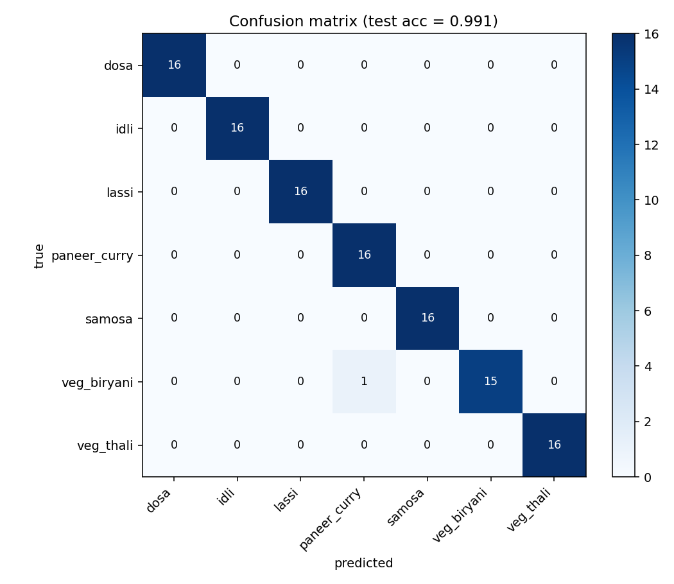
Figure 3: Test confusion matrix (7×7, test accuracy 0.991)

6.1 Confusion Matrix
 | Predicted: correct class | Predicted: any other class
Actual: all 7 classes (112 test images) | 111 | 1
Actual: per-class detail (Figure 2) | 6 classes: 16/16 each | biryani: 15/16

The full 7×7 confusion matrix (Figure 2) is essentially diagonal: 111 of 112 test images are classified correctly. The single error is one veg biryani image misclassified as paneer curry — both are Main-Course bowl dishes with warm brown/orange palettes, so the confusion is visually plausible. Every other class, including the near-identical Breakfast pair dosa/idli, is perfectly separated. There is no class-level bias: each class contributes exactly 16 test images, and six of seven classes score a perfect 16/16.

6.2 Predictions and Output Quality
The browser demo (frontend/) replays the exported top-3 softmax probabilities of every test image, so qualitative behaviour can be inspected without re-running the model. Correct predictions are decisive — dosa images are predicted dosa with >0.99 confidence and lassi with ≈1.00. The lone biryani→paneer_curry error is a low-margin case, illustrating the practical failure mode of bowl dishes with similar warm palettes. The model excels on shape-coded dishes (oval dosa, triangular samosa, glass lassi) and is marginally weaker on texture-coded bowls, where grain pattern is the only discriminator.

6.3 Comparison with Baseline
Table 3 isolates the effect of ImageNet pretraining: an identically trained random-initialisation ResNet-18 (same frozen-backbone, head-only protocol, same 6 epochs and optimizer) reaches only 0.8304 test accuracy, while the ImageNet-transfer model reaches 0.9911 — a +16.1 percentage-point gap. Mechanistically, the frozen pretrained backbone supplies texture, colour and shape features that already distinguish the dishes; the head only learns a linear read-out. With random initialisation those mid-level visual features do not exist yet after 6 head-only epochs, so the head fits class-correlated colour shortcuts and confuses visually similar dishes.

6.4 Observations
- Validation accuracy saturates at 1.0000 from epoch 2 — the linear head converges almost immediately on frozen ImageNet features.
- All errors concentrate in the Main-Course bowl group (biryani ↔ paneer curry); shape-distinct classes reach 1.0 accuracy.
- Training completes on CPU in about 2–3 minutes for the full 6 epochs, confirming the practicality of frozen-backbone transfer learning.

6.5 Strengths
- Only 3,591 trainable parameters — no GPU, no overfitting risk, and a 2–3 minute CPU training budget.
- Fully reproducible: the dataset generator is seeded, so every split, training run and reported number can be regenerated exactly.
- Category-level evaluation is built in, directly answering which meal slots a diet-tracking app can trust.

6.6 Limitations
- Evaluation uses a synthetic-but-realistic dataset; absolute numbers will be lower on real photography despite the --real-dir ingestion path.
- Single-dish images only: multi-dish plates and portion-size estimation are out of scope.
- The head-only protocol caps what can be achieved on harder real-world variation (an optional --finetune mode exists but was not needed here).

7. CONCLUSION, FUTURE SCOPE & REFERENCES

7.1 Conclusion
This project delivers an end-to-end, CPU-trainable vegetarian food image classifier: a seeded 1,120-image dataset across seven dishes and four meal categories, a frozen ResNet-18 + linear-head transfer-learning pipeline (3,591 trainable parameters), and an evaluation suite reporting 0.9911 test accuracy with macro F1 0.9911. The random-init ablation shows that ImageNet transfer learning contributes a +16.1-point improvement and is the decisive ingredient under the small-data CPU-only constraint, while the category-level analysis locates the single remaining confusion in the Main-Course bowl group.

7.2 Future Scope
- Regenerate the dataset from real photography (e.g. an Indian subset of Food-101) and fine-tune layer3/layer4 with the existing --finetune mode.
- Replace the linear head with a small multi-layer head or add test-time augmentation to close the residual bowl-dish confusion.
- Integrate the classifier into a calorie-estimation demo: dish label → nutrition lookup → daily-total dashboard, using the browser demo as the front end.

7.3 Limitations Recap
As detailed in Section 6.6, the current conclusions are bounded by the synthetic dataset (absolute accuracy will differ on real photos), single-dish framing (no multi-dish plates or portion estimation), and the head-only training protocol. These bounds do not weaken the central finding — that frozen ImageNet features make dish recognition tractable at extreme parameter and compute budgets — but they do mean the reported 0.9911 accuracy should be read as an upper-bound characterisation of the pipeline rather than a field deployment estimate.

7.4 References
[1] K. He, X. Zhang, S. Ren, and J. Sun, "Deep Residual Learning for Image Recognition", IEEE CVPR, 2016.
[2] L. Bossard, M. Guillaumin, and L. Van Gool, "Food-101 – Mining Discriminative Components with Random Forests", ECCV, 2014.
[3] PyTorch Documentation — torchvision.models (ResNet-18, ImageNet1K_V1 weights), PyTorch Foundation, https://pytorch.org/vision/stable/models.html (accessed 2026).

