**Obj-1**

1)

* The tracert utility is a network diagnostic tool used to trace the path that packets take from the source computer to a specified destination across an IP network. It helps in identifying the route taken by packets and pinpointing where delays or issues occur in the network.
* Syntax: tracert [options] <destination>

destination-The IP address or domain name of the host you want to trace the route to.

* **ex**:

Tracing the Route to a Website:

tracert google.com

Tracing the Route to a Local Host:

tracert 192.168.1.1

2)

-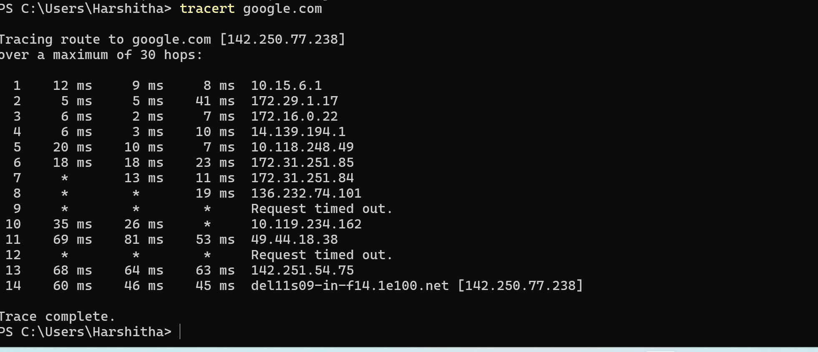

Tracing route to google.com [142.250.77.238] over a maximum of 30 hops:

* This line indicates that tracert is trying to trace the route to the domain google.com, which resolves to the IP address 142.250.77.238. The process will consider up to 30 hops (routers) to find the destination.
* **Hop Number:** 1 is the first hop in the route.
* **RTT (Round-Trip Time):** The three times (12ms,9ms,8ms) represent the round-trip time for three ICMP packets sent to this hop. The times are very low, indicating that this hop is likely a local router .
* **IP Address:** 10.15.6.1 is the IP address of the first router.
* 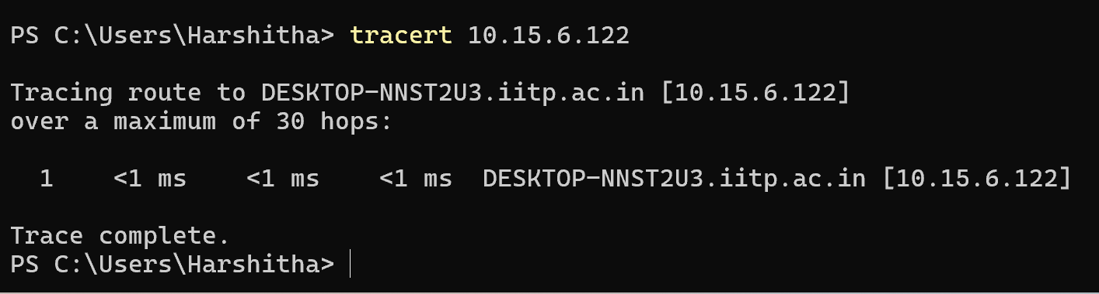

3)

**-d:** The -d option prevents tracert from resolving IP addresses to their corresponding hostnames. By skipping the DNS resolution process, the command runs faster since it doesn't have to convert each IP address into a domain name.

Ex: tracert -d google.com

**-h:** The -h option allows you to specify the maximum number of hops tracert should trace before stopping. By default, tracert will try up to 30 hops, but you can limit it to a lower number if you suspect the destination is closer or to reduce the time taken for the trace.

Ex: tracert -h 5 google.com

**-w:** The -w option sets the timeout for each reply in milliseconds. By default, tracert waits for 4,000 milliseconds (4 seconds) for each reply. You can reduce or increase this timeout based on the network conditions or requirements**.**

Ex: tracert -w 2000 google.com

4) Scenario: Slow Connection to a Website

Use Case: You're trying to access example.com, but it's slow compared to other sites.

Steps to Diagnose:

Run tracert:

* + Command: tracert example.com
  + Purpose: See the path your data takes to reach the website.

Check for Issues:

* + High Latency: Look for a big jump in the time it takes between hops (e.g., from 20 ms to 200 ms). This suggests a problem at that point.
  + Timeouts: If a hop shows "Request timed out," it might be a problematic router or network issue.

Use Options:

* + -d: Skip resolving hostnames to speed up the trace.
    - Example: tracert -d example.com
  + -h: Limit the number of hops if you expect the issue to be close by.
    - Example: tracert -h 10 example.com
  + -w: Increase the timeout if you're on a slow network.
    - Example: tracert -w 5000 example.com

Conclusion:

* If the problem appears at a specific hop or the final destination, it likely indicates where the issue is.

5) **tracert (Trace Route)** is a network diagnostic tool used to track the path packets take from your device to a destination server or IP address. It helps identify each hop (router or gateway) the packets traverse, along with the time it takes to reach each hop. This is useful for diagnosing network issues like delays, routing problems, or identifying where packets are being lost or slowed down.

**Applications of tracert:**

i)Identifying Network Bottlenecks:

* Helps locate the specific hop where network delays or packet losses occur.
* Useful in determining whether the issue is within your local network, at your ISP's level, or somewhere along the route to the destination.

ii) Understanding Network Path:

* Provides insight into the route that data takes across the internet, which can vary based on network congestion, routing policies, or geographical considerations.

iii) Verifying Routing:

* Ensures that packets are taking the expected path, which is crucial for troubleshooting routing issues, especially in large networks.

**Limitations and Potential Issues with tracert**

1. **ICMP Blocking:**
   * Some routers or firewalls block ICMP packets (used by tracert), causing hops to appear as "* * *" or unreachable. This can give an incomplete or misleading view of the network path.
2. **Asymmetrical Routing:**
   * The route that tracert shows may only represent the path in one direction. In some cases, the return path may differ, leading to potential inaccuracies in diagnosing issues.
3. **Delay Due to Processing:**
   * The time reported for each hop includes the time the router takes to process the ICMP request, which might not accurately reflect actual transmission delays.
4. **Intermediate Hops with High Latency:**
   * Occasionally, an intermediate hop may show high latency due to the way it handles ICMP requests, but this does not always indicate a problem with the actual data traffic.
5. **Limited Visibility:**
   * tracert may not always reveal the full path, especially in complex networks involving VPNs, NAT devices, or load balancers that do not respond to ICMP requests.

--------------------------------------------------------------------------------------------------------------------------------------

**Obj-2**

**1) Key Features:**

1. Basic Functionality:
   * Sends ICMP echo requests to each hop in the route to the destination IP.
2. Additional Features:
   * Number of Pings per Hop: Allows specifying how many pings are sent per hop to get an average RTT and packet loss.
   * Delay Between Pings: Adds a delay between each ping to avoid overwhelming the network or device.
   * Output to File: Option to save the output to a specified file.
3. Error Handling:
   * Handles invalid IPs, TTL values, packet sizes, timeouts, and source IP configuration using try-except blocks.
4. Output Formatting:
   * Displays hop number, IP address, RTT stats (min, max, average), and packet loss percentage for each hop.