
Islington College Research & Development
Research Idea Pitch
academic.research@islingtoncollege.edu.np
AY: Academic Year 2025/26
Student Name: Satyam Dulal
Research Title: Physics-informed generative models for unsupervised discovery of phase transitions
London Met ID: 23048597
College ID: NP01AI4A230023

GitHub Link | https://github.com/sat-yam-ln2/GenPhase

1. Introduction of the idea

1.1 Background
Phase transitions (classical and quantum) — e.g., liquid–solid, magnetic ordering, topological transitions — are central to condensed-matter physics and materials design. Traditional methods to map phase diagrams rely on (i) analytical theory for solvable models, (ii) numerical simulations (Monte Carlo, exact diagonalization), and (iii) experimental measurements. Recently, machine learning (ML) methods — including unsupervised learning, autoencoders, and generative models — have emerged as powerful tools to recognize known phases and accelerate the mapping of phase diagrams by extracting low-dimensional structure from high-dimensional observables (configurations, correlation functions, spectra) (Arnold, 2024) (Ng, 2023). Moreover, a generative-model approach can learn the underlying data distribution and therefore provide natural anomaly/novelty scores useful for discovering previously unknown regimes.

1.2 Gap in current knowledge
Most prior ML work focuses on (i) supervised classification of known phases, or (ii) unsupervised clustering of observables for benchmark models (Ising, Potts, topological chains). Far fewer works address autonomous discovery of previously unknown phases by combining generative density estimation with explicit physics constraints (symmetries, conservation laws, Hamiltonian consistency) and calibrated uncertainty estimation. The recent MIT/University of Basel work demonstrated the promise of generative AI to map phase diagrams but left open the question of how to (a) incorporate physics priors systematically into generative models, (b) quantify novelty reliably (so that flagged regimes merit physics validation), and (c) scale methods to richer quantum models with nontrivial entanglement (Zewe, 2024).

1.3 Research idea
This project will develop a physics-informed generative pipeline that (1) learns conditional data distributions of physical observables across control parameters, (2) imposes symmetry and Hamiltonian consistency in model architectures or loss terms, and (3) uses calibrated density/uncertainty measures in latent and data space to autonomously flag candidate novel phases or transition regimes. The pipeline will be validated on classical models (2D Ising, Potts, XY) and extended to small quantum systems (spin chains, small Hubbard clusters) using exact diagonalization / established quantum libraries. The deliverable is an open, reproducible framework that both recovers known phase diagrams and proposes, with quantified confidence, previously unidentified regimes for physics validation. Unlike previous works that only visualize known phases, this project combines conditional generative density modeling with explicit physics priors and uncertainty quantification for unsupervised discovery.

1.4 Expected impact
- Academic: advances unsupervised phase discovery methods by integrating physics priors with generative modeling and rigorous uncertainty quantification; potential for a peer-reviewed publication.
- Computational physics / materials: a tool to accelerate hypothesis generation for exotic materials or quantum phases without immediate experimental resources.
- Societal / technological: faster identification of candidate materials (e.g., insulators, superconductors, topological materials) shortens the cycle from theory to application in electronics or quantum devices.
Key recent demonstrations that motivate this work include generative phase mapping results (MIT) and the broad success of physics-informed ML in PDEs and many-body physics (Zewe, 2024).

2. Problem statement

2.1 Exact problem addressed
Current ML approaches seldom provide a reliable, automated mechanism to discover new phases from raw simulation or experimental observables. The central challenge is to design an ML system that autonomously identifies physically meaningful phase transitions from unlabeled observables, with calibrated uncertainty. The problem is to construct a methodology that (a) learns the probability distribution of observables conditional on control variables, (b) identifies statistically significant deviations or clusters that correspond to distinct physical regimes, and (c) returns physically interpretable metrics (order parameters, correlation lengths, spectral gaps) that confirm or refute novelty.

2.2 Why it is important
- Manual or supervised approaches require prior labeling and domain knowledge; they miss unexpected behavior.
- Automating discovery accelerates fundamental research and reduces missed opportunities in exploratory simulations or large experimental datasets.
- Rigorous uncertainty estimation prevents false positives and focuses experimental/analytical resources on the most promising candidates.

2.3 Who is affected and how
- Researchers (condensed matter, quantum many-body): receive a faster hypothesis generator and a reproducible analysis pipeline.
- Materials scientists / technologists: can prioritize computationally suggested candidate phases for experimental synthesis and measurement.
- Computational scientists / ML practitioners: receive methodological advances (physics-informed generative models, UQ methods).
- Society / industry: indirectly benefits through accelerated discovery of materials with improved electronic/thermal/optical properties.

2.4 Proposed solution
Design and implement a physics-informed conditional generative model (CGM) + discovery module: CGM learns $p\left(\text{observables} ∣ \text{control parameters}\right)$. The discovery module tracks latent geometry, likelihood drops, ensemble disagreement, and change-point detection across control parameters to flag novel regimes. Flagged regimes are validated via traditional physical diagnostics (order parameters, finite-size scaling, spectral gap computations).

3. Details of the proposed project

3.1 What is this project about?
A framework that uses conditional generative models (conditional VAEs, normalizing flows, or score-based models) augmented with physics constraints to map high-dimensional observables to a structured latent space. By sweeping control parameters, the method (i) visualizes emergent latent manifolds, (ii) computes novelty/uncertainty scores, and (iii) outputs candidate phase boundaries and candidate new phases for physics validation.

3.2 Why is it needed?
- Existing unsupervised techniques (PCA, t-SNE, clustering) are heuristic and often fail to quantify statistical significance of proposed phases.
- Generative models provide explicit density estimates enabling principled anomaly detection; physics constraints reduce unphysical model behavior and improve interpretability.
- The approach is implementable without laboratory hardware: simulation + open data suffice, which matches the resource constraints of the final-year project.

3.3 Motivation (personal & academic)
My combined expertise in ML and physics uniquely positions me to (i) design architectures that respect physical symmetries and (ii) interpret emergent behavior in latent space. The project also fills an academic gap by moving from classification to discovery, a natural next step after recent generative mapping works (Zewe, 2024).

3.4 Who benefits?
- Primary beneficiaries: condensed-matter and computational physics researchers.
- Secondary beneficiaries: materials design groups, graduate students, and the ML community interested in physics-guided generative methods.

4. Research objectives
All objectives are SMART (specific, measurable, achievable, relevant, time-bound).
- Develop a conditional generative model (CGM) architecture that incorporates key physics priors (symmetries, Hamiltonian consistency) for classical and small quantum systems — deliverable by Month 6.
- Implement a discovery module (latent clustering, novelty scoring, change-point detection) and validate it on benchmark models (2D Ising, Potts, XY) — deliverable by Month 4.
- Extend and validate the pipeline on small quantum systems (spin chains, Hubbard clusters) and demonstrate recovery of known phase boundaries and at least one candidate novel regime flagged with quantified confidence — deliverable by Month 9.
- Publish a reproducible codebase and write a conference/journal paper draft documenting methodology, experiments, and ablations — deliverable by Month 12.

5. Sources of information explored
Representative primary sources and tools that will be used in the project; each is relevant to methods or benchmarks.
Research papers / letters / reviews
- Arnold, J. (2024). Mapping out phase diagrams with generative classifiers. Phys. Rev. Lett. 132:207301 — demonstrates generative classifiers for phase mapping. link.aps.org
- Ng, K.K. et al. (2023). Unsupervised learning of phase transitions via modified autoencoders. Phys. Rev. B — unsupervised anomaly detection for phase transitions. link.aps.org
- Selected arXiv/preprint surveys on unsupervised ML for phase identification and diffusion-map approaches. arxiv.org+1
News / outreach (context & motivation)
- MIT News: “Scientists use generative AI to answer complex questions in physics” (May 2024) — recent motivating demonstration. news.mit.edu
Software / toolboxes
- NetKet, QuSpin: for neural quantum states and exact diagonalization of small quantum systems.
- PyTorch / JAX: for model implementation.
- scikit-learn / UMAP / t-SNE / Optuna / W&B: for analysis, visualization, and experiment tracking.
Datasets / simulation frameworks
- Self-generated Monte Carlo datasets (Ising, Potts, XY).
- Publicly available precomputed datasets from recent papers (where licensing allows) (McGibbon, 2024).

6. Feasibility of the idea

6.1 Technical feasibility — Tools & datasets
- Hardware: single NVIDIA GPU with 12 GB VRAM (your machine) and 32 GB RAM is sufficient for conditional VAEs / flows and small quantum exact diagonalization experiments when using mixed precision and careful batching.
- Software: PyTorch or JAX; NetKet / QuSpin for quantum cases; Monte Carlo samplers implemented in Python/C++ for classical models.
- Data: generated by the candidate (Monte Carlo, small exact diagonalization) and supplemented by published datasets (where available). Recent literature indicates similar studies were executed on modest compute budgets (Zewe, 2024).

6.2 Time feasibility
A 12-month timeline with the quartered milestones (detailed below) is realistic for an experienced ML/physics student working full-time on the project. (Detailed timeline provided in Appendix / Gantt below.)

6.3 Knowledge feasibility
You already have: ML expertise (deep learning + PyTorch), physics background (statistical/quantum mechanics). New learning required: hands-on NetKet/QuSpin use and specific generative model variants (normalizing flows / equivariant flows), which are readily learned via tutorials and code examples.

6.4 Cost feasibility — estimated budget (Nepali Rupees, Rs.)
Item | Unit cost (Rs.) | Qty | Total (Rs.)
Cloud GPU hours (optional overflow) | 200/hr | 50 hrs | 10,000
Storage (external HDD / SSD) | 8,000 | 1 | 8,000
Software subscriptions (if needed: W&B pro) | 0–5,000 | - | 0–5,000
Printing / binding thesis | 3,000 | 1 | 3,000
Misc. (conference fees / travel contingency) | 10,000 | 1 | 10,000
Estimated total (min–max) |  |  | 31,000 – 36,000 Rs.
Notes: most work can be done on local hardware, so cloud costs are optional for hyper-parameter sweeps. Institutional HPC (if available) can reduce any cloud costs.

7. Familiarity with the topic

7.1 Relevant courses / experience
- Deep learning (architectures, training, optimization), advanced ML engineering.
- Statistical mechanics & quantum mechanics (coursework / degree).
- Prior projects: experience building PyTorch models, segmentation/real-time ML pipelines (relevant engineering discipline). (See portfolio and repo links in appendices.)

7.2 Foundation of knowledge
- Strong background in the theoretical underpinnings of phase transitions and statistical/quantum many-body theory; practical experience in ML model design and experimentation.

7.3 Areas needing support
- Consultation with condensed-matter physicists for interpretation of complex quantum signatures (advisable).
- Possibly access to small HPC queue for larger quantum exact diagonalization runs if scaling beyond a handful of sites.

8. Expected challenges

8.1 Potential risks
- False positives: generative models flag regimes that are artifacts of sampling or model misspecification.
- Scaling quantum systems: exact diagonalization scales exponentially with system size, limiting quantum validation to small sizes.
- Model calibration: calibrating density estimates for high-dimensional data is hard; different models (flow vs VAE) may give incompatible likelihoods.

8.2 Impact of these challenges
- False positives reduce scientific value and may lead to wasted validation effort.
- Size limits restrict claims about thermodynamic limits for quantum systems.

8.3 Mitigation strategies
- Cross-validation: use multiple independent samplers and different model families; only flag regimes with consistent signals across methods.
- Physical diagnostics: require candidate phases to satisfy at least two physics tests (order parameter / correlation function / spectral gap) before reporting.
- Finite-size scaling: perform scaling studies to extrapolate trends; clearly report limitations.
- Expert consultation: involve a condensed-matter advisor for difficult interpretations.

9. Methods (detailed)

9.1 Data generation & preprocessing
- Classical models: implement Monte Carlo samplers (Metropolis, Wolff cluster where applicable) for 2D Ising, Potts, and XY models across grids of temperature and coupling. Save raw configurations, magnetization, structure factor, energy, and correlation functions.
- Quantum models: small spin chains / Hubbard clusters using NetKet or QuSpin to compute ground states and observables (entanglement entropy, gap, correlators) for sweeps of model parameters.

9.2 Model architectures
- Conditional generative models (CGMs): two complementary tracks:
A. Conditional VAE (cVAE) with a physics-informed prior: latent variables conditioned on control parameters and a Hamiltonian-consistency auxiliary loss (e.g., predicted energy from decoder matches computed energy).
B. Conditional normalizing flow (cFlow) that produces exact (invertible) density estimates for observables given control params; incorporate equivariance layers to enforce translation or rotation symmetries where appropriate.
- Use latent encoders for visualization (t-SNE/UMAP) and clustering and ensembles of models for calibrated uncertainty.

9.3 Physics-informed components
- Symmetry-equivariant layers: convolutional architectures with periodic boundary treatment for lattice models; group-equivariant nets for rotational invariance if needed.
- Physics losses: optional auxiliary losses enforcing energy consistency, conservation laws, or small-size solver residuals (for PINN-style constraints) depending on data type (Mengyun Xu, 2025).

9.4 Discovery module & novelty scoring
- Density drop: compare likelihood $p_{θ}\left(x ∣ λ\right)$across control parameter $λ$ and detect abrupt changes.
- Latent clustering: identify disconnected clusters in latent space using DBSCAN/HDBSCAN; compute cluster stability as a function of $λ$.
- Ensemble disagreement: measure variance across model ensemble predictions as an uncertainty measure.
- Change-point detection: apply statistical tests (CUSUM, Bayesian change-point) to sequences of latent statistics to determine transition points.

9.5 Validation
- For each flagged regime, compute: order parameters, two-point correlation functions, correlation length, susceptibility, and (for quantum models) entanglement entropy and energy gaps. Confirm whether the regime corresponds to a physically distinct phase by standard physics diagnostics and (if necessary) further solver runs.

10. Evaluation & success criteria
- Recovery of known benchmarks: the pipeline should recover known critical temperatures/phase boundaries of benchmark models within finite-size error bars. (Quantitative metric: absolute error in TcT_cTc​ estimation, ARI for clustering vs ground truth.)
- Novelty precision: among flagged candidate regimes on designed Hamiltonians with injected novel behavior, at least X% (target 70%) should correspond to physically distinct regimes validated by diagnostics.
- Calibration of uncertainty: reliability diagrams for ensemble-based novelty scores; false-positive rate below a target threshold (e.g., 10%) on test perturbations.
- Reproducibility: all code, data, and notebooks published and capable of reproducing key figures.

11. Timeline / Gantt (12 weeks)
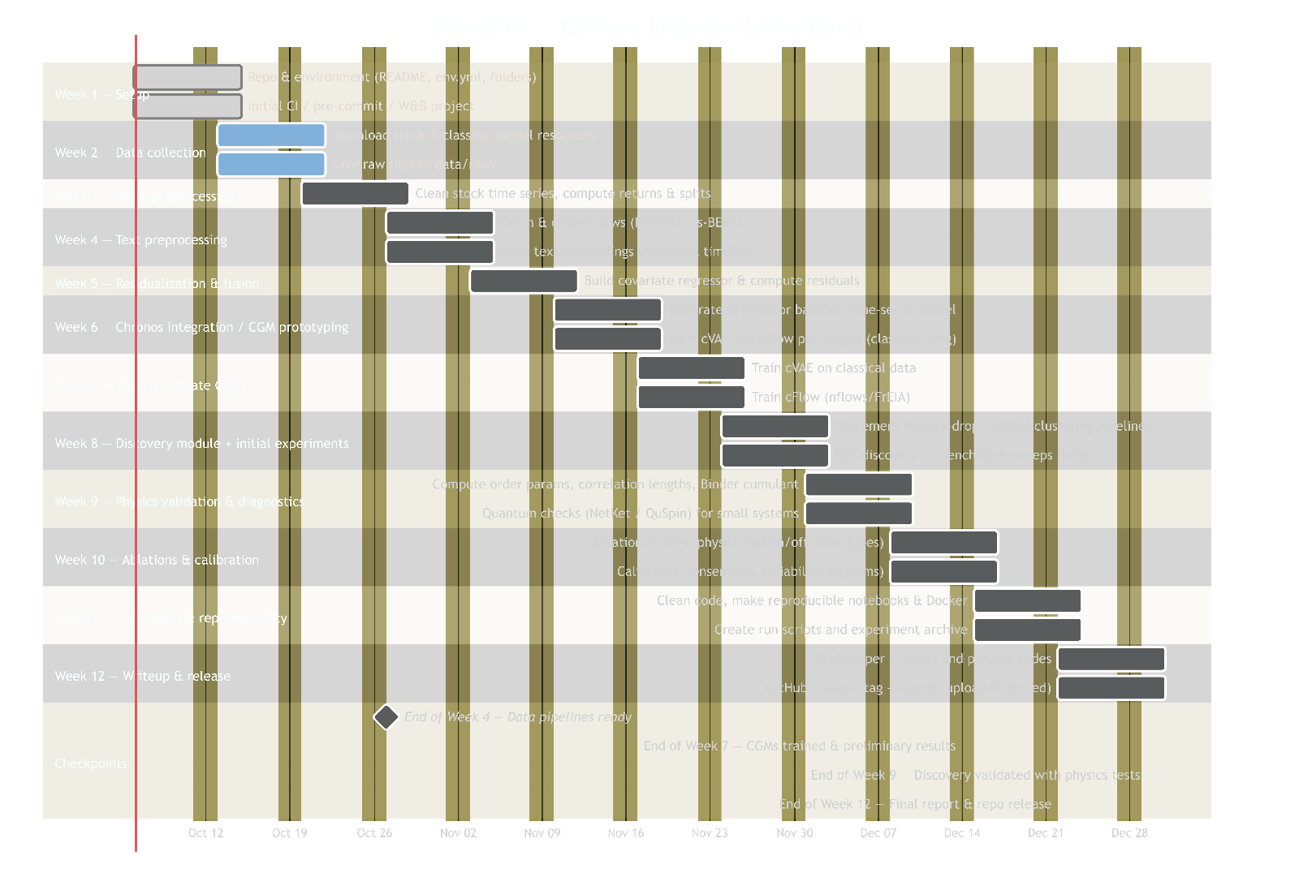
Figure 1: Gantt Chart for the Research Project

12. Compute & resource budget (detailed)
Local machine (primary)
- NVIDIA GPU, 12 GB VRAM (training cVAE/cFlow with batch sizes tuned), 64 GB RAM. (I got this one)
- Expected local storage: 1–2 TB for datasets, checkpoints, and results.
Optional cloud (overflow / hyperparameter sweeps)
- Cloud GPU (e.g., A10, T4, or comparable) at ~200 Rs/hr (estimated in budget). Estimated use: 20–50 hours for hyperparameter sweeps or larger runs.
Software stack
- Python 3.9+, PyTorch 2.x or JAX, NetKet / QuSpin for quantum parts, scikit-learn, Optuna/W&B for experiments.
Memory / runtime tips
- Use mixed precision (torch.cuda.amp) and gradient accumulation to work within 12 GB VRAM.
- Use checkpointing for very deep flows and small batches for large lattices.

13. References
- Arnold, J. (2024) Mapping Out Phase Diagrams with Generative Classifiers, Physical Review Letters, 132:207301. link.aps.org
- Ng, K.K. (2023) ‘Unsupervised learning of phase transitions via modified autoencoders’, Physical Review B. link.aps.org
- MIT News (2024) ‘Scientists use generative AI to answer complex questions in physics’, MIT News, 16 May 2024. Available at: https://news.mit.edu/2024/scientists-use-generative-ai-complex-questions-physics-0516 (Accessed: [date]). news.mit.edu
- McGibbon, R.T., Schwantes, C.R. et al. (2024) Inferring the Isotropic–nematic phase transition with generative machine learning, arXiv / Phys Rev preprint. arxiv.org
- Xu, M. (2025) ‘Physics informed deep generative model for vehicle trajectories’, Transportation Research Part C, [online]. sciencedirect.com

