Introduction :-

Steganography is an art of sending hidden data or secret messages over a public channel so that a third party cannot detect the presence of the secret messages. The goal of steganography is different from classical encryption, which seeks to conceal the content of secret messages; steganography

is about hiding the very existence of the secret messages. Modern steganography is generally understood to deal with electronic media rather than physical objects. There have been numerous proposals for protocols to hide data in channels containing pictures, video, audio and even typeset text. This makes sense for a number of reasons. First of all, because the size of the information is generally quite small compared to the size of the data in which it must be hidden (the cover text), electronic media is much easier to manipulate in order to hide data and extract messages.

Secondly, extraction itself can be automated when the data is electronic, since computers can efficiently manipulate the data and execute the algorithms necessary to retrieve the messages.

Electronic data also often includes redundant, unnecessary and unnoticed data spaces which can be manipulated in order to hide messages. The main goal of this paper is to find a way so that an

audio file can be used as a host media to hide textual message without affecting the file structure and content of the audio file. Because degradation in the perceptual quality of the cover object may leads to a noticeable change in the cover object which may leads to the failure of objective of steganography. For embedding data in digital media, two domains are generally considered, spatial domain and the transform domain. Though, there are many data hiding techniques, in this paper we consider the spatial domain of data hiding. We discuss the various data hiding techniques using bit manipulation of the lowest significant bit (LSB). We take a look at how the bit planes can be increased by various numberdecomposition methods without compromising on the three requirements of visibility, robustness and capacity.

Objective:-

It is our goal to design robust steganography technique which can hide more data with acceptable imperceptibility of stego media. Generating more bit planes using different technique of bit plane decomposition by which more bit planes could be use to conceal more data without causing significant distortion, providing greater security against steganalysis programs.

Brief Discussion on Problem :-

One of the simplest techniques for embedding digital data into a digital cover is the LSB method .In this scheme, the secret message is inserted into the least-significant bit plane of the cover audio either by directly replacing bits or by modifying bits according to a particular ‘inverse’ function. The frames of audio file can be decomposed into bit planes through the binary representation of the audio samples. The characteristic of this representation is that it is not redundant. This means that the binary decomposition of an integer is unique. The main advantage of such a technique is that the modifications of the LSB plane do not affect the human perception of the overall audio quality as the amplitude variation of the audio bit values is bounded by ±1. The drawback of such an easy and high capacity method is lack of security against stegoanalysis programs . In order to increase the robustness of LSB embedding schemes, new methods operating in different bit-planes or in a mixture of them have been proposed. In this paper we use multiple bit planes to hide the secret message into the cover media. We also use extra layer of abstraction by adding customized Here we look into various bit plane decomposition technique and analyses its advantages and disadvantages.

**LSB DATA HIDING USING FIBONACCI NUMBERS**

Battisti et al. proposed a method of embedding data into digital media by decomposition of Fibonacci number sequence which allowed different bit plane decomposition when compared to the classical LSB scheme. The Fibonacci sequence, named after Leonardo of

Pisa, also known as Fibonacci, is a sequence of numbers in the following integer sequence:

0, 1, 1, 2, 3, 5, 8, 13, 21, 34, 55, 89 ...

A generalized (p, r) − F ibonacci sequence Fp,r (n) is defined as follows:

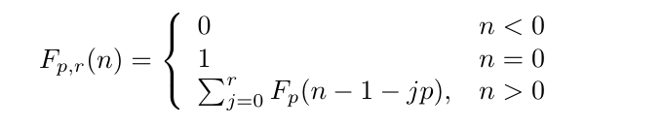

where Fp (n) is the p-numbers Fibonacci sequence defined by the following recursion:

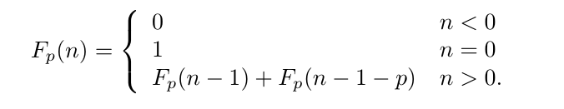

The bit planes are now decomposed based on theFibonacci sequence. The main drawback of thisapproach is that of redundancy and to counter that and obtain a unique representation, Zeckendorf theorem is used. To embed the intended message in the cover image, it is decomposed into bit planes by using Fibonacci p decomposition. The Zeckendorf condition is checked for each bit to be modified. If the condition is fulfilled, the bit is inserted otherwise the bit following it is considered.

**LSB DATA HIDING USING PRIME NUMBERS**

LSB data hiding using prime numbers is a data hitechnique proposed by Dey et.al as improvement over the Fibonacci numbers data hitechnique proposed by Battisti et. al. The main idethe work was to use the prime number decomposiand generate new set of bit planes and eminformation in these newly generated bit planes minimal distortion.

In this approach, the researchers took an image obits and increased the number of bit planes twhere the value of n was equal or greater thaequal to the number of bit planes of the image. was achieved by converting the bit planes of image to another number system using pnumbers as the weighted function. This resulted inincrease of number of bits and consequently it cbe used for hiding data in higher bit planes minimal distortion.

For decomposition, the weight function was defined as:

P (0) = 1, P (i) = pi ∀ i ∈ Z+ , pi = ith Prime

**LSB DATA HIDING USING NATURAL NUMBERS**

The approach of LSB data hiding by natural numbers was proposed by Dey et.al. In this approach, the researchers proposed data hiding by decomposition of a pixel value in sum of natural numbers. This resulted in generation of more bit planes than the Classical LSB data hiding, Fibonacci LSB data hiding and the Prime number data hiding . For decomposition, the weight function is defined as:

W (i) = N (i) = i + 1, ∀ I ∈ Z+ ∪ {0}

The researchers used the same concept in case of ambiguity which gave higher precedence to lexicographically higher number. For embedding the data into the k‐bit image, a

number n is chosen in a way such that all pixel values in the range of [0, 2k – 1] could be represented using first n numbers, which resulted in generation of n virtual bit planes . The value of n can be found out by the formula,

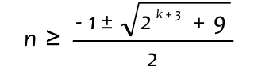‐

After finding the value of n, a k bit to n bit map is created and all valid representations in natural numbers system are marked. Now, for each pixel a virtual bit plane is chosen and the secret data is embedded. If the virtual bit plane matches the