# Column Definitions

* accession_number
  + A unique ID the SEC gives each filing uploaded to their EDGAR database
* cik
  + A unique number assigned to filers to the SEC.
  + <https://en.wikipedia.org/wiki/Central_Index_Key>
* company
  + Name of the filing company
* raw_url
  + Link to raw text filing
* ixbrl_url
  + Link to IXBRL filing
* raw_accession_number
  + Unformatted accession number
* item
  + Item Number. Each filing is separated into items with numbers like “8.01”. The filings correspond to the type of information they may contain. This dataset has been filtered to item numbers that may contain debt instrument information.
* text
  + The raw text of the item.
* contains_debt_instrument_information
  + True if the item contains details about a debt instrument. If the item just references a debt instrument, this column should still be false. There must be some details outside of the name (such as the start date, the amount, the lenders, etc.)

# Debt Instruments

We are interested in instances where a company raises capital (think money) by borrowing it from a single or collection of other companies or individuals. Here is a breakdown of some different types of debt instruments and how they contrast to equity instruments. A key difference is that with debt there is an expectation that the borrower must pay the lenders back.

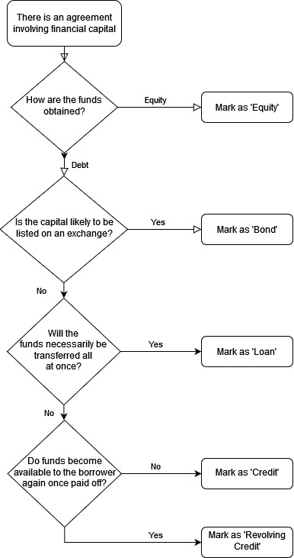

### How are the funds obtained?

When raising financial capital, companies choose between debt and equity. Equity financing involves a company giving up some portion of its ownership. This is usually done through the offering or sale of stocks or shares. Debt financing is when a company borrows money (or is given the right to borrow money) from a collection of lenders. This is primarily done through bonds, notes, loans, credit facilities. When the company borrows money, it must pay it back and pay interest. For more information, see this [article](https://www.investopedia.com/ask/answers/042215/what-are-benefits-company-using-equity-financing-vs-debt-financing.asp). For our current purposes, any mention of shares or stocks will qualify for a flag.

| Equity | Debt |
| --- | --- |
| **Share** Purchase Agreement, share repurchase program, “purchase and sale of an aggregate of 300,000 shares of common **stock**”, **Class A** Units, Series B**Warrant**, etc. | Term **Loan** Agreement, Amended and Restated **Credit** Agreement, Revolving Credit Agreement, Junior Subordinated **Notes**, **Bond, Debt** Settlement Agreement |

### 

### Is the capital likely to be listed on an exchange?

Companies have two main options for debt financing: they can go to public markets via an exchange and offer bonds (usually called a Note in 8-Ks) or privately negotiate a loan with a single lender or group of lenders (often banks). See ‘[Why Companies Issue Bonds](https://www.investopedia.com/articles/investing/062813/why-companies-issue-bonds.asp)’ for more information.

| Yes | No |
| --- | --- |
| Notes, Bonds, Debentures | Loan, Revolving Credit Agreement |

### Will the funds necessarily be transferred all at once?

Another significant division among debt agreements is whether the agreement entails the actual transfer of money. A credit agreement means that a company is given the ability to borrow up to a certain amount, but may or may not actually borrow that amount. A loan entails that the funds will be transferred (perhaps not at the time of the agreement).

| Credit | Loan |
| --- | --- |
| Credit Facility, Revolving Credit | Term Loan, Term Loan Facility |

### Will the funds become available to the borrower again once paid off?

A final division we are interested in is whether the borrower can reuse their line of credit. In a revolving credit agreement, the borrower is able to borrow up to a specified amount and can re-borrow money once they pay back. For example, a borrower with a $5 million revolving credit facility can borrow $5 million, pay $2 million back, and then borrow another $2 million.

| Credit | Revolving Credit |
| --- | --- |
| Credit Facility | Revolving Credit, Revolving Credit Facility |