CANKAYA UNIVERSITY
FACULTY OF ENGINEERING
COMPUTER ENGINEERING DEPARTMENT



CENG 407
Innovative System Design and Development I

SRS FOR PROJECT MANAGEMENT ASISTANT
Version 1.0

Hakan İREN 201411211
Selçuk ATAGÜN 201411204

Advisor: Prof. Dr. Erdoğan DOĞDU

Word Count: 3732

Preface

Software Requirement System includes to everything about project. The documentation is planned to develop of the Project Management Assistant. In this part, we researched to what needs to be done and how to do that. Especially, more details should exist in this step of Senior Project. All team members shared to titles of Software Requirement System. The aim of all members creates an explicit system at the end of this part.

Contents
Preface 2
1. Introduction 6
1.1. Purpose 6
1.2. Scope 6
1.3. Definitions, Acronyms & Abbreviations 7
1.3.1. Definitions 7
1.3.2. Acronyms 7
1.4. Overview 8
2. Overall Description 9
2.1. Product Perspective 9
2.2. Product Functions 11
2.3. User Characteristics 16
2.4. Constraints 16
2.5. Assumptions and Dependencies 16
3. Specific Requirements 17
3.1. External Interfaces 17
3.1.1. User Interfaces 17
3.1.2. Hardware Interface 17
3.1.3. Web Design Language 17
3.1.4. Operating System 17
3.1.5. High Ordered Language 17
3.2. Functional Requirements 18
3.3. Performance Requirements 23
3.4. Logical Database Requirements 24
3.5. Software System Attributes 24
3.5.1. Reliability 24
3.5.2. Availability 24
3.5.3. Security 24
3.5.4. Portability 25
3.5.5. Maintainability 25
4. Appendices 27
5. Gamification 26

List of Figures

Figure 1: Use case for admin………………………………………………………………….……………12
Figure 2: Use case for project manager and team member………………………………...…………....13
Figure 3: Use case for project manager……………………………………………………...…………….13
Figure 4: Project manager reaches cost information…………………………………….…….………….14
Figure 5: Updating personal information……………………………………………………….…………...14
Figure 6: Manager print the report about project……………………………………………………...…...15
Figure 7: Team member use case…………………………………………………………………………...15
Figure 8: Manager use case for risks……………………………………………………………………….16
Figure 9: Changing password……………………………………………………………………………….16

List of Tables

Table 1: Functional Requirements……………….……………………………………………………….19
Table 2 Functional Requirements ………………………………….…………………………………….20
Table 3 Functional Requirements …………………………………………….………………………….20
Table 4 Functional Requirements ……………………………………………………….……………….21
Table 5 Functional Requirements ………………………………………………………………….…….21
Table 6 Functional Requirements ………………………………………………………………………...22
Table 7 Functional Requirements ………………………………………………………………………...22
Table 8 Functional Requirements ………………………………………………………………………...23
Table 9 Functional Requirements ………………………………………………………………………...23

Introduction

Purpose
This documentation is written to clarify the Project Management System. The aim of this part includes to descriptions, functions, interfaces, and specific requirements. These mentioned titles are helpful for introducing the project.
Moreover, all explanatory information’s addresses to development team members and customers of Project Management Assistant when progresses of the project.

Scope
Project Management Assistant is a useful system for scheduling and management information systems, manufacturing, budgeting. It will be a guide for keeping essential information’s about projects. There exists a project console to acquaint user with status of the project. This system provides user to enter stated information’s about the project. Every project has important parts like that deadlines, task sequences, cost calculations, resources.
Moreover, calculations or modifies budgets can be made easily. The user will be able to enter these subjects to the console. The mentioned system allows user to produce reports. It enhances communication between the project manager and the project team. To facilitate problem solving and project collaboration. This system will be made to use web technologies. And, users can easily follow the project which stated parts are made. Although the project is planned these contents, it does not provide leadership skills.

Definitions, Acronyms & Abbreviations

Definitions

Acronyms

API : Application Programming Interface
ASP.NET : Web Application Framework
DFD : Data flow Diagram
HW : Hardware
IEEE : Institute of Electrical and Electronics Engineer
PMA : Project Management Assistant
PBS : Public Broadcasting Service
PSPEC : PISI Specification
SDK : Software Development Kit
SPMP : Software Project Management Plan
SRS : Software Requirements Specification
SW : Software
UI : User Interface

Overview
In SRS, PMA is planned to mention all details of the project. There are product perspective and functions, user characteristics, constraints, assumptions, and dependencies. Product perspectives constraint system interfaces, user, hardware, software, communication interfaces. System interfaces give information about program which relates with other programs. It shows that take or information to user. User interfaces is brought the interface for recently used the product. Hardware interface states the used hardware in the project. Software interface shows to be used software list in the project. Communication interfaces exist to need for protocol software. Project team gives the functions list. User characteristics say this project is developing for whom. Constraints include a different part from SPMP. Assumptions and Dependencies give information about training part and it constitutes different options.
Specific requirements show possible details with screenshots. External interfaces have all interfaces and a functional requirement includes every detail of the uses cases in PSPEC. Performance requirements mention how many user use the system at the same time. Class structures exist in the logical database requirements. Lastly, design constraints relate with architectural

Overall Description
In this part, product perspective, functions, constraints, and assumptions will be explained briefly. It will provide to understand the requirement of product.

Product Perspective
    - System Interface

In this part includes that project relates and integrations of the other programs. Moreover, it exists the examination about the project takes information or gives information. PMA is formed to project information’s of storage and updating via database system. Moreover, it requires using equipment which is a printer. The printer needs to give the output about reports. It provides to user given a feedback about general description of the project.

    - User Interfaces

For the PMA user are categorized three types. Those types are:
- Admin,
- Project Manager,
- Team Member (staff).
We use different interfaces for those three types. Some users can not to have access some interface. Such as a team member cannot the process projects pages which include all project and their information. Whole users can access your own personal information and update own information. Also, manager access all user information but cannot update anyone’s information.

      - Admin
Admin has more important functions. Admin define new projects, create new user, and assign project manager.
      - Project Manager
Project manager can access projects, tasks, risks, costs, reporting, personal information, and time sheet. Manager is very competent for all functions. For example, only the managers affirm the new risks in risks page.
      - Team Member (Staff)
Team member can access tasks, risks, personal information, and time sheet. A team member has very little authority.

    - Hardware Interfaces
For PMA, we do not any hardware and other products.

    - Software Interfaces
The system use Microsoft Operating system Windows 7-8-10 and use the Microsoft Visual Studio 2015 for web. MSSQL keep the all information about projects. When user send a query, database will send information.

    - Communication Interfaces
There is internet connection needed for using this software. This software also works with TCP/IP protocols. So, your Windows operating system’s web services should be opened.
    - Memory Constraints
On server side, the product can be run on a computer have minimum Pentium III-compatible processor or faster, 1GB Ram, 5 GB hard disk space and Ethernet card.
On user side, the product will be able to be run on a computer that have a Pentium III or better processor 512 MB Ram, Ethernet card and web browsers that are needed.
These are the minimum system requirements for the computers will be used. Any computer with better fragments may support better performance.

Product Functions
For Project Manager Assistant, we use some functions. Those functions are included user information, project information, task information, risk information and cost information. Also, we show the detail of those functions thanks to the use case diagram.

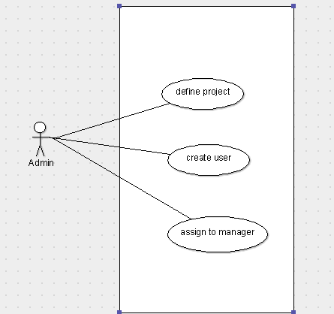
Figure 1. Use case for admin

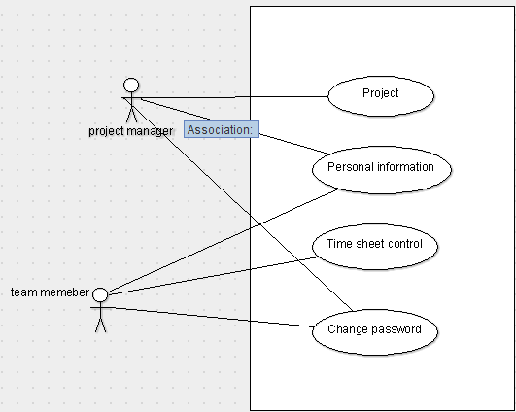
Figure 2. Use case for project manager and team member

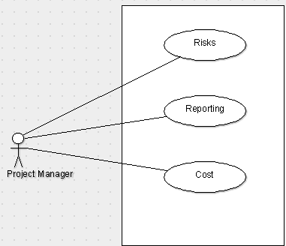
Figure 3. Use case for project manager
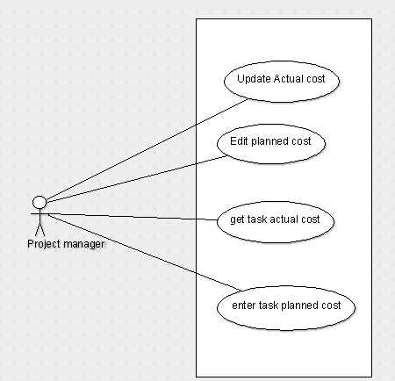
Figure 4. Project manager reaches cost information

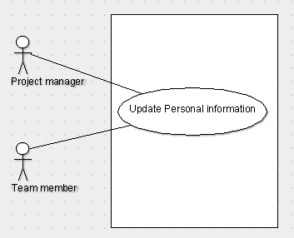
Figure 5. Updating personal information
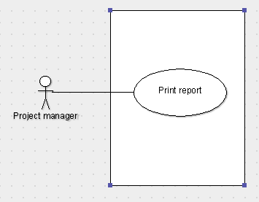
Figure 6. Maneger print the report about project.

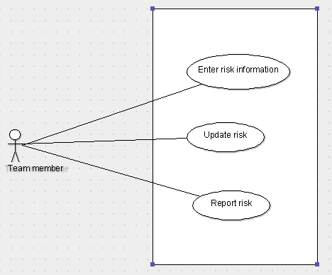
Figure 7. Team member use case

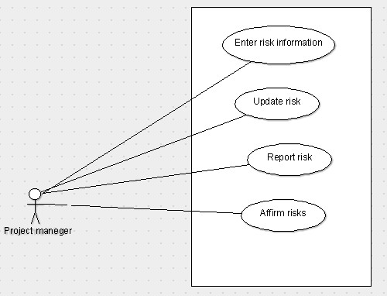
Figure 8. Manager use case for risks

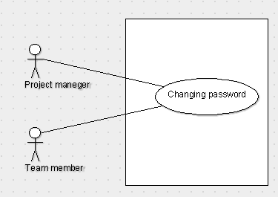
Figure 9. Changing password.

User Characteristics
No specific educational level is needed to use the product however the product is developed for companies to manage their projects, so all users should have familiarity with project plan discipline and management.
Users should also have moderate knowledge about network and Internet browsers usage.

Constraints
- Because of chosen software, product will be only able to be run on Microsoft Windows. (In other word, all the computers operating systems must be compatible with the specific software that are used in development of the product.
- Training time of team members on specific areas has a limited schedule.
- Temporary complexity and uncertainty of creating database for the product.
- Weakness in coding skills of team members.
- System requirements may change during the development.

Assumptions and Dependencies
It is assumed that;
- Users will have recommended hardware,
- Users will use recommended versions of software,
- Users will use the product via Internet,
- No more than 10 users will connect the system at the same time.

Specific Requirements
In this part of SRS document, we will briefly explain all product requirements, functional requirements and every I/O, data relationships of product.

External Interfaces
All external interfaces can be found in Appendices.

User Interfaces
User interfaces are explained in section 2.1.2 and some samples can be found in Appendices. Functions of interfaces are listed in section 2.1.2.

Hardware Interface
There are no hardware interfaces needed for using this software.

Web Design Language
Necessity of usage of the Internet requires TCP/IP Protocol usage between server and users. In addition, HTML codes and so HTTP will also be used for data exchanging between server and clients.
HTML codes will be written in ASP.NET format via C#.

Operating System
Our Project members use Windows 7, Windows 8 and windows 10, ASP.NET is not an independent platform; and, it still has to be configured on a server which uses Windows operating system.

High Ordered Language
Visual Web Developer Express platform is used to develop web applications. It is a part of the Microsoft Web Platform. Also, it provides free version for web developers. Visual Web Developers have ASP.NET web standards. Therefore, you will get work full featured web development environment.

Functional Requirements

 | Login
Actor: | Project manager, team member
Priority: | High
Trigger:
Precondition: | User must connect to the internet
Basic Path: | - User enters user name and password.  - The system verifies user name and password.  - Home page is displayed.
Alternate Path: | - User fails;  System is warned the user for wrong user name or password.  Gives 3 chances for reentering the information.
Post Condition: | Users in home page.
Exception Path: | If the internet connection lost the system goes into standby.
Table 1

Use Case Name: | Project defining
Actor: | Admin
Priority: | High
Trigger: | Click Projects button
Precondition: | User must log in the system.
Basic Path: | - Admin define the new project  - Admin assign a project manager for new project  - Admin create new user
Alternate Path: | N/A
Post Condition: | Manager access the all information about the project and task
Exception Path: | - If the internet connection lost manager will log in the system again.  - If admin cannot access the database, the system will send a message for re-trying.
Table 2

Use Case Name: | Personal Information
Actor: | Project Manager, Project team member.
Priority: | Medium
Trigger: | Click Personal Information
Precondition: | User must log in the system.
Basic Path: | User can refresh info which was changed
Alternate Path: | N/A
Post Condition: | Admin and manager access the personal information.
Exception Path: | - If wrong the information taken from the database, request will have sent again.  - If the information is not actual, information in the database will be refreshed by person.
Table 3

Use Case Name: | Change Password
Actor: | Project manager. Team member
Priority: | Low
Trigger: | Click change password button
Precondition: | User must log in the system
Basic Path: | - User enter the password  - User enter the new password  - Confirm the new password  - Password will be changed
Alternate Path: | System warned the user if new password and confirm password is not equal
Post Condition: | Admin or team member change the password
Exception Path: | If the internet connection lost the system goes into standby.
Table 4

Use Case Name: | Time Sheet
Actor: | Project manager and team member
Priority: | High
Trigger: | Click the time sheet button
Precondition: | User must log in the system
Basic Path: | - User fill the information  - If team member pay an extra payment, he/she will fill the specific cost.
Alternate Path: | NA
Post Condition: | Information which was refresh or fill, will be saved
Exception Path: | - If the database is not save the new information and sent an error message, user will be try again.
Table 5
Use Case Name: | Cost
Actor: | Project manager
Priority: | High
Trigger: | Click the cost button
Precondition: | User must login the system then click the project button.
Basic Path: | User will be fill the cost.
Alternate Path: | NA
Post Condition: | System shows actual cost, planned cost, task actual cost, task planned cost
Exception Path: | If the connection lost the system goes into standby.
Table 6

Use Case Name: | Reporting
Actor: | Project manager
Priority: | Medium
Trigger: | Click reporting button.
Precondition: | User must log in the system.
Basic Path: | 1. After login the system manager will choose a project.  2. After choosing the project, click to reporting button.
Alternate Path: | N/A
Post Condition: | The report is printed.
Exception Path: | If the data is not actual, the database will be refreshed.
Table 7

Use Case Name: | Tasks information
Actor: | Project manager and team member
Priority: | High
Trigger: | Click the tasks button
Precondition: | User must log in the system
Basic Path: | - User refreshes the information about how much task is completed.
Alternate Path: | NA
Post Condition: | Task information is refreshed.
Exception Path: | - If the internet connection lost the system goes into standby.  - User login the system again
Table 8

Use Case Name: | Risk information
Actor: | Team member and project manager
Priority: | High
Trigger: | Click the risk button
Precondition: | User must log in the system
Basic Path: | - If a new risk accrue team member will fill their new risk column  - If one of the potential risks accrue member will be denoted.  - If the project manager appropriates the new risks, manager will fill the acceptance part.
Alternate Path: | NA
Post Condition: | Risks follow up. And new risks upload the system.
Exception Path: | - If the internet connection lost user will log in the system again.
Table 9

Performance Requirements
No more than 10 users will connect the system at the same time. But also, it depends on server. There are many transactions are included by PMA. These transactions shall be processed less than one second but also this depends on internet speed and connectivity. Our software will not process big packets. So, performance requirements are not extraordinary. The simple PC which can using internet is enough for the system.

Logical Database Requirements

We show relationships between classes, their attributes, and candidates with Class diagram. When we start to create our database, we will use class diagram.

Software System Attributes

Reliability
In our system, the concept of reliability is one which can prove to be of paramount importance to the project management team and or the project management team leader, as errors in reliability can cause productivity to decline significantly. Specifically speaking, reliability refers to the probability and or the likelihood that a given product will perform in the way and or manner it was intended to perform in the efforts that have been deemed required of that given product within or under a specific period required.
Products that have high levels of reliability are preferred for a wide and varied number of reasons. One of the most significant reasons for this is that, when product reliability is higher and or greater it allows for less wasted energy and less redundancy, and allows more members of the project team to focus on additional aspects of the project sooner. Products with lower reliability will cause more wasted energy, and more redundancy.

Availability
The goal of the PMA Working group is to move the PMA speciﬁcation all the way to establishment. This requires extensive testing between different PMA implementations to iron out uncertain portions of the draft standard.

Security
Security of the system will be provided using some high developed security functions and programs that are provided by security companies. The server has several firewalls and anti-hack systems to prevent the attacks to database. In the database, there will be a unique table that can be reached only the user.
Denial-of-Service Attack
A denial-of-service (DOS) attack is something done to preclude someone from accomplishing useful work. Typically, a DOS attack takes one of two forms: nuisance packets or the preclusion of packets from flowing between two nodes. There is little that can be done to prevent this nuisance packet attack, and the sender can always spoof the source address. However, service providers can filter IP packets in their routers to assure the IP source address of a packet is genuine before it is forwarded.

Replay Attacks
It is feasible for an attacker to obtain a copy of a legitimate Registration Request, store it, and then replay it later to accomplish a forged care-of address for a mobile node. To avoid this replay attack from occurring, the mobile node produces a unique value for the identification field in each of the successive endeavors for registration. The identification field is made in such a way as to allow the home agent to ascertain what the subsequent value should be. The attacker is hampered because the identification field in his stored Registration Request will be known as being outdated by the home agent.
Session-Stealing Attack
An attacker performs a session stealing attack by waiting for a valid node to authenticate itself and initiate an application session, then captures the session by masquerading as the legitimate node. Typically, this requires the attacker to transmit numerous nuisance packets to thwart the legitimate node from recognizing that the session has been captured.

Portability
The PMA portal can be reached from any computer that has internet connection and web browser.

Maintainability
Maintenance will be provided for the system by team. If any update or change in the portal, the changes will be done by the team. Team members control the database updates done by server automatically.

Gamification
In addition to the similar programs we have compared above, there is a rewarding and punishment system in the project that we want to do. This system called gamification.
For business purposes: We can say that this is the most basic differentiator for the game. Enhancing the behavior of a system should be the realization of the primary business goals. Behaviors that are not directly directed at business goals can of course be found in the system. Such behavior serves, at least indirectly, to business goals, or at least meets the 'fun' requirement of the application. But it is very important for a successful application that the behaviors to be reinforced are directed towards the business golas.
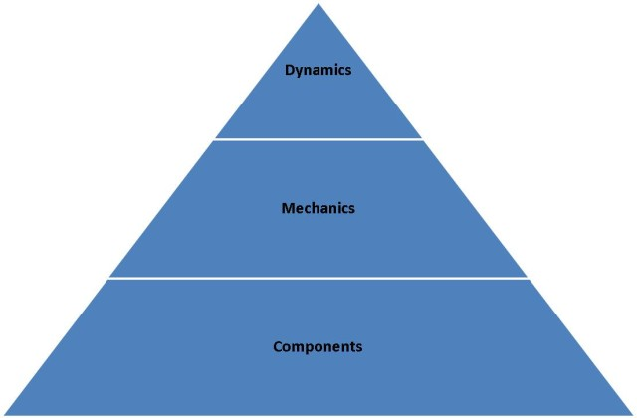

Dynamics: It consists of elements that determine the concept at the top level. If acting is thought of as a language, these elements correspond to the grammar of the language. Dynamics can be thought of as the hidden structure of the system. They provide integrity and consistency. Constraints in design are made up of elements that are not very easy to describe, such as emotion, progression, storytelling. The pyramid is in the metaphor. They are scarce in quantity but they are of the highest quality.
Mechanics: Elements that provide and regulate movement. If they look in terms of language metaphor they come together. Elements such as luck, competition, cooperation, shopping, challenges ... are elements of this group.
Components: Dynamic and mechanics describe the way a system works, while components represent the output of this work. If we look at the language metaphor again, their counterparts will be 'names'. Badges, avatars, levels, scores, leadership tables, teams, bosses, etc. There are many things like.
As a result, gamification we want to use in the project management assistant program, unlike other programs. We believe that employees will be more effective in reducing stress and achieving their goals.

Appendices
Welcome To Home Page
Admin & Manager Log In | Staff Log In
  Account Name | Password
  Log In Button
  Account Name | Password
  Log In Button

Home  Button | Home Page of  Admin & Manager | Logout  Button
Projects  Button | Home Page of  Admin & Manager | Logout  Button
Time Sheet  Button | Home Page of  Admin & Manager | Logout  Button
Personal Information  Button | Home Page of  Admin & Manager | Logout  Button
Change Password  Button | Home Page of  Admin & Manager | Logout  Button

Home  Button | Home Page of  Staff | Logout  Button
Tasks  Button | Home Page of  Staff | Logout  Button
Time Sheet  Button | Home Page of  Staff | Logout  Button
Personal Information  Button | Home Page of  Staff | Logout  Button
Change Password  Button | Home Page of  Staff | Logout  Button

Home  Button | Projects Page of  Admin & Manager | Logout
  Project Name
  Text Box
  Project Manager
  Text Box
  Start Day
  Text Box
  Finish Day
  Text Box
  Completeness
  Percentage
  Text box
Risks  Button |  | Logout
Report  Button |  | Logout
Cost  Button |  | Logout
Tasks  Button |  | Logout

Home  Button | Time Sheet Page of  Admin & Manager | Logout
  Name Surname of Staff
  Text Box
  Status
  Text Box
  Task Name
  Text Box
  Start Day
  Text Box
  Finish Day
  Text box
  # Hours Per Day
  Text Box
  Specific Cost
  Text Box
Projects  Button |  | Logout

Home  Button | Personal Information Page of  Admin & Manager | Logout
  Name
  Text Box
  Surname
  Text Box
  Phone Number
  Text Box
  E-mail
  Text Box
  Address
  Text box
  Graduate
  Text Box
  Under Graduate
  Text Box
Update  Button |  | Logout

Home  Button | Change Password Page of  Admin & Manager | Logout
  Current Password
  Text Box
  New Password
  Text Box
  New Password Confirm
  Text Box
Save Changes  Button |  | Logout

Home  Button | Tasks Page | Logout
  Staff Name
  Task Name
  Start Day
  Finish Day
  Task Definition
  Project ID
  Completeness Percentage
Risks  Button |  | Logout

Home  Button | Cost Page of Admin & Manager | Logout
  Project name
  Text Box
  Project actual cost Text Box
  Project planned cost Text Box
  Taskname Text Box
  Task actual cost Text Box
  Task planned cost Text Box

Home  Button | Risks Page of  Manager | Logout  Button
  Risk Table
Enter Risk Info  Button |  | Logout  Button
Update Risks  Button |  | Logout  Button
Report Risks  Button |  | Logout  Button
Confirm  Button |  | Logout  Button

Home  Button | Risks Page of  Staff | Logout  Button
  Risk Table
Enter Risk Info  Button |  | Logout  Button
Update Risks  Button |  | Logout  Button
Report Risks  Button |  | Logout  Button

Home  Button | Report Page | Logout
  Project name
  Text Box
  Task Name Text Box
  Start Date Text Box
  Finish Date Text Box
  Actual Cost Text Box
  Planned cost Text Box
  Completeness Percentage Text Box
  Resultant Risks Text Box

