CANKAYA UNIVERSITY
FACULTY OF ENGINEERING
COMPUTER ENGINEERING DEPARTMENT



CENG 407
Innovative System Design and Development I

SDD FOR PROJECT MANAGEMENT ASISTANT
Version 1.0

Hakan İREN 201411211
Selçuk ATAGÜN 201411204

Advisor: Prof. Dr. Erdoğan DOĞDU

Word Count: 3174
PREFACE
Software Design Document is a technical definition about the system. This documentation mentions that architecture and design of the project. Before preparing the SDD, Software Requirement System was examined by team members. SRS includes more information about the Project and SDD is an organization, behavior and collaborations between modules. Project Management Asistant has many requirements and they are mentioned in SRS. SDD includes technology of the requirements and its architecture. The documentation provides an understandable guide for developer. It was prepared acoocrding to IEEE 1016.

LIST OF FIGURES
Figure 1-System Overview……………………………………………………………...…11
Figure 2- Project Organization ………………………………….……………………..…12
Figure 3- Login………………………………………………………………………..…….15
Figure 4- Risk & Cost Management…………………………………………………..….16
Figure 5 –User Profiles …………………………………………………..………………..20
Figure 6 – Task Management ……………………………………………….……………22
Figure 7- Database Design ………………………………………………...……………. 28
Figure 8 – Cost-Follow up…………………………………………………………………30
Figure 9 –Cost-Task…………………………………………………………………..…...30
Figure 10- Project-Task…………………………………………………………..………..31
Figure 11- Risk-Cost…………………………………………………………...…………..31
Figure 12- Project-Risk ………………………………………………………….………..32
Figure 13- Project-Task ………………………………………………………………….32
Figure 14- Statu-Follow up…………………………………...……………………………33
Figure 15- Login Page…………………………………………………..…………………34
Figure 16- Admin Home Page……………………………………………………….……35
Figure 17- Admin Project Page……………………………………………………………36
Figure 18- Project Management Home Page…………………………….……………..37
Figure 19- Member Time Sheet Page…………………………………………….……...38
Figure 20- Project Management Project Page…………………………………..………39
Figure 21- Member Task Page………………………………………………………..…..40
Figure 22-Admin Login Module Activity Diagram………………………………...……..41
Figure 23-Task Assign Module Activity Diagram………………………………………..41
Figure 24-Risk Module Activity Diagram…………………………………………………42
Figure 25-Cost Module Activity Diagram…………………………………………………42
Figure 26-Time Schedule………………………………………………………………….47

LIST OF TABLES

Table 1 – User Responsibilities…………………………………..……………………..11
Table 2- Project Organization…………………………………………………………...13
Table 3 – New Project……………………………………………………………………13
Table 4 – Project Manager Assignment………………………………………….…….14
Table 5- Login……………………………………………………………………………..15
Table 6- Risk & Cost Management…………………………………..…………….……16
Table 7-Display of Risks……………………………………………………….…………17
Table 8- Risk Creation……………………………………………………………………18
Table 9- Risk & Cost Addition……………………………………………………………..18
Table 10-New Report Creation…………………………………………………….……..19
Table 11 – Profile……………………………………….………………………………….20
Table 12 – Profile Edition………………………………………………………...……..…21
Table 13- Display Profie……………………………………………………….….……….21
Table 14- Profile Creation………………………………………………………………….22
Table 15- Task Management………………………………………...……………………23
Table 16-Display Tasks…………………………………………………………….……...24
Table 17-Task Assignment………………………………………………………………..24
Table 18-Edit & Remove Task……………………………………………….……………24
Table 19 – Reporting……………………………………………………………………….25
Table 20- Rewarding…………………………………………………...…………..……...25
Table 21 – Project Information…………………………………………………………….26
Table 22-TasksInformation………..………………………………………………………26
Table 23- Risk Information…………………………………………………………….…..26
Table 24- Cost Information ….…………………………………………………………....26
Table 25- Personal Information…………………...………………...…………………….27
Table 26- Follow up Hours………………………………………………………………...27
Table 27- Statu Information …….………………………………………………………...29
Table28- IntermoduleDescription…………………………..………………………..…..30
Table 29- Cost Information .………………………………………………………………31
Table 30- Project Information ………………………...…………………………………..32
Table 31- Task Information ……………………………………………………………....32
Table 32- Follow-up Hours ..……………………………………………………………...41
Table 33- Project Information ………………………..…………………………………...41
Table 34- Task Information ………………………………………………………...…….42
Table 35- Risk Information …………………………………………………………….….42
Table 36- Cost Information ………….…………………………………………….……..42
Table 37- Personal Information ………………………………………………….……….43
Table 38- Role Information ……………………..…………………….…………………..43
Table 39- Follow-up Hours ……………………………………………….…………..45-46
Table 40- RTM………………………………..…………………………….………….…..47

TABLE OF CONTENTS
LIST OF FIGURES 3
LIST OF TABLES 4
TABLE OF CONTENTS 6
1. INTRODUCTION 7
1.1. Purpose 7
1.2. Scope 7
1.3. Definitions, Acronyms and Abbreviations 8
1.3.1. Definitions 8
1.3.2. Acronyms 8
1.3.3. Abbreviations 8
1.4 REFERENCES 9
2. SYSTEM OVERVIEW 10
3. SYSTEM COMPONENTS 11
3.1. Decomposition Description 11
3.1.1. Module Decomposition 11
3.1.2 Data Decomposition 25
3.2 Dependency Description 28
3.2.2. Data Dependencies 29
3.3 INTERFACE DESCRIPTION 33
3.3.2 User Interface 33
4 DETAILED DESIGN 40
4.1 Module Detailed Design 40
4.1.1 Class Diagram 40
4.1.2 Project Organization Activity Diagram 41
4.2 Data Detailed Design 43

INTRODUCTION

Purpose
Software Design Document describes the design and architecture of Project Management System. The aim of documentation examines decompositon of the system, Technologies and responsibilites into modules. SDD is an implementation for before coding. A person, who does not know anything about the project, can learn everything about Project Management System.

Scope
The system architecture and software design are details of the description in this documentation. Project Management System is like preparing to the implementation. When we look at the Softare Requirement System, we seperated simple parts according to individual who enters the system. This part contributes to the Project that some of them has only its own pages. It can be made some changes, updates, deleting with helping a database. Database is useful for holding the all information about the Project Management System. So that, this documentation brings user information which has more reality and more visual. And also, it is a contribution for software.

Definitions, Acronyms and Abbreviations

Definitions

Employee List: It is the document given by the senior management to the admin, including the company’s employee list.

Report: It is document formed by all of the users in order to inform senior personel about the costs, working hours and works that are done.

Acronyms

API: Application Programming Interface
DB: Database
GUI: Graphical User Interface
PM: Project Manager
RTM:Requirement Traceability Matrix
SRS: Software Requirement System
SDD: Software Design System
IEEE:Institute of Electrical and Electronics Engineers

Abbreviations

There is no abbreviation.

REFERENCES

1.IEEE SDD 1016 - IEEE Recommended Practice for Software Design Descriptions
2.Somerville, I., 2004. “Software Engineering”, USA: ADDISON-WESLEY, seventh edition.
3.Pressman, Roger S., Software Engineering, 4th edition, McGraw-Hill, 1997
For Project Management SDD Version1.0

4.Fairley, R. E.,Workbreakdown Structure, Software Engineering Project Management, IEEE CS Press, 1997

SYSTEM OVERVIEW

Figure 1: System Overview
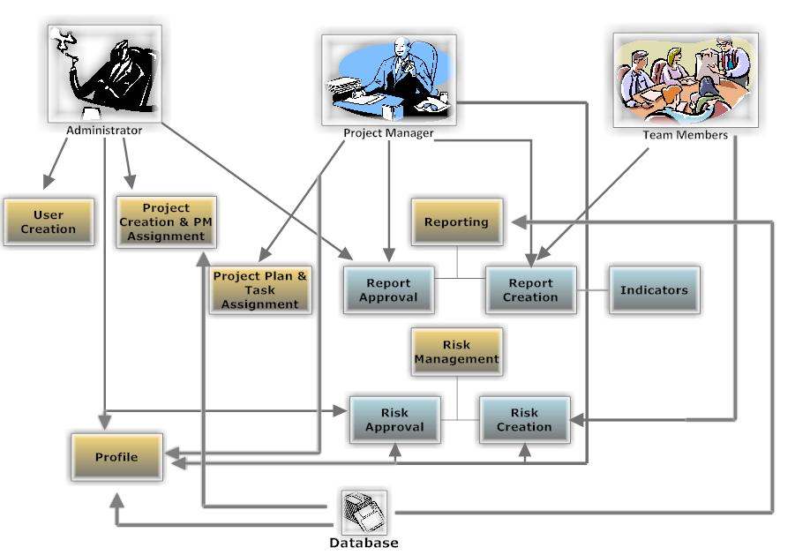
Figure 1: System Overwiew

Admin | Project Manager | Team Member
- Project Creation  - User Creation  - Assign project manager  - Rewarding | - Entering risks  - Reject or approve new risk  - Reporting risk  - Update personal information  - Task, role, time period assign.  - Updating cost and report  - Changing password. | - Report Creation & Forwarding  - Enter new risk  - Update cost information  - Update personal information.  - Change password

Table 1: User Responsibilities

SYSTEM COMPONENTS

Decomposition Description

Module Decomposition

Our project, the Project Management Assistant has following modules.
- Project Organization Module
- Login Module
- Risk & Cost Management Module
- Task Management Module
- Profile Module

3.1.1.1 Project Organization Module
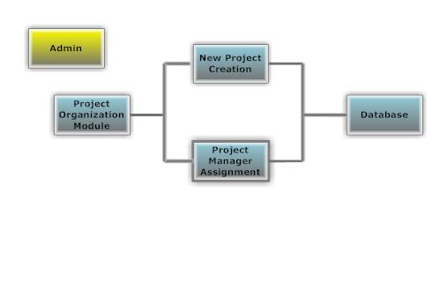
Figure 2: Project Organization

Identification: Project Organization Module
Purpose: Establishing new projects and administrative operations is mainly functions of this module. In addition, Project managers and team members assignments also will be done in this module.
Functions:
- New project is established by admin.
- Project manager is assigned to the projects by admin.
Sub-modules:
- New Project Creation
- Project Manager Assignment

Table 2: Project Organization

3.1.1.1.1 New Project Creation Sub-Module

Identification: New Project Creation Sub-Module
Purpose: Allowance of admin to create new projects.
Functions:
- New projects name is entered by admin.
- New project is added by admin.
Sub-ordinates: Connection to DB.

Table 3: New Project

Project Manager AssignmentSub-Module

Identification: Project Manager Assignment Sub Module

Purpose: Allowance of admin to assign Project managers to the projects:
Functions:
- Project is selected from list by admin.
- Project manager is selected from list by admin.
- Project manager is assigned to the project by admin.
Sub-ordinates: Connection to DB.

Table 4: Project Manager Assignment

      - Login Module
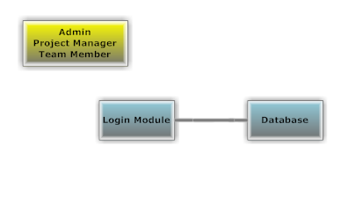
Figure 3: Login

Identification: Login Module
Purpose: Allowance of admin, Project managers and team members to log in the system.
Functions:
- Admin project managers and team members will be able to log in system.
- Users types username.
- User types password.
- Users checked in database whether they are authorized to log in or not.
Sub-ordinates: Connection to DB.

Table 5: Login

Risk & Cost Management Module

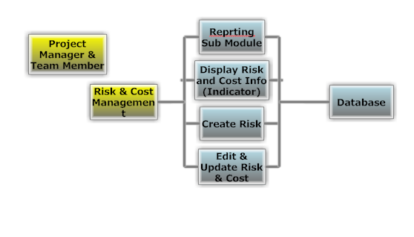
Figure 4: Risk & Cost Management
Identification: Risk & Cost Mangement Module
Purpose: Give permission to Project managers to creating new risks, editing & changing existing risks and displaying the same risks. In addition it also gives permission to team members to create new risks for their project managers approval.
Functions:
- Project Managers will be able to select a project from list to edit costs & risks of the project
- Monitoring existing risks and current both actual cost and planned cost will be provided.
- Project Managers will be able to approve or reject received risks from team members.
- Team members will be able to create and forward new risks.
Sub-modules:
- Display & Edit Risks & Costs
- Create New Risk Risk
- Approve Forwarded Risk (Only PM)

Table 6: Risk & Cost Management

Display Risks & CostsSub-Module
Identification: Display Risks Sub-Module
Purpose: Make Project managers and team members able to monitor actual risks and costs that have been recieved or sent.
Functions:
- Project manager will be able to see all risks and cost information for a specified project that is selected from a list. In addition they also will be able to see updated or newly created risks or changed cost of a project.
- Project Managers will be able to edit or terminate risks and update costs
- Team members will be able to see risk and cost updates that have been done by them
Sub-ordinates: Connection to DB.

Table 7: Display of Risk

Create Risk Sub-Module
Identification:Create Risk Sub-Module
Purpose: Make project managers and team members able to create new risks and forwarding and approving them.
Functions:
- Project managers will be able to create new risks, with their brief description for a specified project.
- Team members will be able to create new risks and forwarding them to project managers for approval.
Sub-ordinates: Connection to DB.

Table 8: Risk Creation

Edit & Update Risk Cost Sub-Module
Identification:Edit Risk Sub-Module
Purpose: Make Project managers and team members able to edit existing risks and update actual cost.
Functions:
- Project managers will be able to edit risks and update costs of a project that is selected from a list.
- Team members will be able to edit cost and risk information which will be invalid till project managers approval
Sub-ordinates: Connection to DB.

ReportingModule

Table 9: Risk & Cost Edition

Reporting Sub-Module
Identification:Create New Report Sub-Module
Purpose: Allow team members to create reports for briefly describing updates and changes about cost and risk done by them to Project managers.
Functions:
- Team members will be able to create new reports and forwarding them.
- Project Managers will be able to display forwarded reports
Sub-ordinates: Connection to DB.

Table 10: New Report Creation

Profile Module
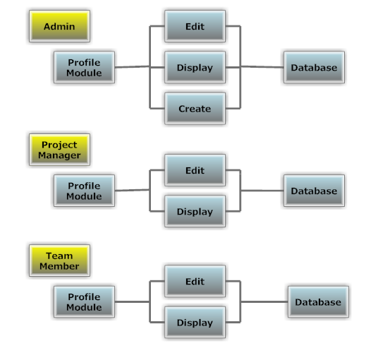
Figure 5: User Profiles
Identification: Profile Module
Purpose: Allow admin to create new accounts for Project managers and team members. In addition allow users to edit their personal profile pages.
Functions:
- Admin will be able to create new account.
- All users will be able to edit profile settings.
Sub-Modules:
- Edit Profile
- Display Profile
- Create Profile

Table 11: Profile

Edit Profile Sub-Module
Identification:Edit Profile Sub-Module
Purpose: Allow non-admin users to edit their personal profile page.
Functions:
- Edit address
- Edit phone number
- Edit e-mail
Sub-ordinates: Connection to DB.

Table 12: Profile Edition

Display Profile Sub-Module
Identification: Display Profile Sub-Module
Purpose: To allow users monitor other user sprofile page.
Functions:
- TC , name, surname, email, address, number, of user will be displayed.
- TC, name, surname, email, address, number, of a project manager or a team member selected from a list will be displayed.
Sub-ordinates: Connection to DB.

Table 13: Display Profile

Create Profile Sub-Module
Identification: Create Profile Sub-Module
Purpose: To allow admin create new user profile.
Functions:
- TC, name, surname of a user will be entered by admin
Sub-ordinates: Connection to DB.

Table 14: Profile Creation

Task Management Module

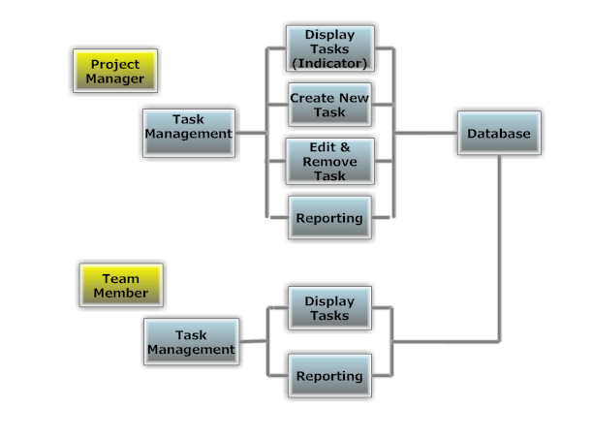
Figure 6: Task Management

Identification: Task Management Module
Purpose: To allow Project managers assign tasks to team members. In addition allow to team members to display received tasks.
Functions:
- Project manager assign tasks to team members
- Team members can display received tasks
Sub-Modules:
- Display Tasks
- Create New Task (only available for Project Managers)
- Edit & Remove Task

Table 15:Task Management

DisplayTasksSub-Module
Identification: Display Tasks Sub-Module
Purpose: To allow team members and Project managers monitor tasks.
Functions:
- Project manager and Team member will be able to see all taks in a list. In addition team members will be able to see recently added new tasks.
- Information about selected task is displayed.
Sub-ordinates: Connection to DB.

Table 16: Display Task

Create New TaskSub-Module
Identification:Create New Task Sub-Module
Purpose: To allow Project managers assign tasks to team members.
Functions:
- Project manager creates a task
- Project manager defines start and finish date for the task
- Project manager enters cost
- Project manager select a team member from a list
- Project manager assign task to team member
Sub-ordinates: Connection to DB.

Table 17: Task Assignment

3.1.1.5.3 Edit & Remove Task Sub-Module
Identification:Edit & Remove Task Sub-Module
Purpose: To allow Project managers edition and removal of tasks.
Functions:
- Project manager select a task from list
- Project manager sign selected task as cancelled or finished.
- Task is terminated.
Sub-ordinates: Connection to DB.

Table 18: Edit & Remove Task

3.1.1.5.4 Reporting Sub-Module

Identification: Reporting Sub-Module
Purpose: To allow team members create and send reports to their Project managers about a selected task.
Functions:
- Team Member selects a task form list
- Team member types definition and descriptions to
- Project managers will be able to see forwarded reports
Sub-ordinates: Connection to DB.

Table 19: Reporting

3.1.1.5.5 Rewarding Module
Identification: Rewarding Module
Purpose: Only the administrator can reward the team member with extra fee or permission.
Functions:
- The administrator selects a member form list
- Select member’s reward
- Project managers will be able to see rewarding team members
Sub-ordinates: Connection to DB.

Table 20: Rewarding

Data Decomposition
This section is about describing each data entity and its logical structure. All data are saved in the database. We will take information from the database thanks to the query. We described a data dictionary.

Column name | Type | Column statu
Project_name | Varchar(60) | Not null
Project_id | Number(6) | Not null (primary key)
Project_manager | Varchar2(60) | Not null
Start_day | Date | Not null
Finish_day | Date | Not null
%completed | Number(2) | Not nul
Planned_cost | Float | Not null
Actual_cost | Float | Not null
New_actual_cost | flaot | Not null
T_date | date | Not null
Table 21:project_information

Column name | Type | Column statu
Project_id | Number(6) | Not null(foreign key)
Task_name | Varchar2(60) | Not null
Task_id | Number(12) | Not null(primary key9
Person | Varchar2(80) | Not null
Start_day | Date | Not null
Finish_day | Date | Not null
%completed | Number(2) | Not nul
Specific_cost | Float(13) | Not null
Role | Varchar2(30)

Table 22:task_information
Column name | Type | Column statu
Project_id | Number(6) | Not null(foreign key)
Risk | Varchar2(255) | Not Null
Probability | Number(3) | Not Null
Impact | Varchar2(255) | Not Null
Mitigation | Varchar2(255) | Not Null
New_risk | Varchar2(255) | Null
Acceptance_of_new_risk | Varchar2(70) | Null

Table 23:risk_information
Column name | Type | Column statu
Project_id | Number(6) | Not null(foreign key)
Task_id | Number(12) | Not null(foreign key)
Actual_cost | Float(13) | Not null
Planned_cost | Float(13) | Not nul

Table 24:cost_information
Column name | Type | Column statu
Tc | Number(11) | Not null
Name | Varchar2(60) | Not null
b-date | date | null
Phone_no | Number(12) | Null
e-mail | Varchar2(30) | Null
undergraduate | Varchar2(100) | Null
Graduate | Varchar2(100) | Null
Experiences | Varchar2(100) | Null

Table 25:personal_information
Column name | Type | Column statu
Tc | Number(11) | Not null(foreign key)
Role | Varchar2(20) | Not null
Task_id | Number(15) | Not null
Hourly_cost | Float(13) | Not null

Table 26:follow_up_hours

Column name | Type | Column statu
Role_name | Varchar2(50) | Not null
role_id | Number(5) | Not null (primary key)

Table 27:ROLE_information

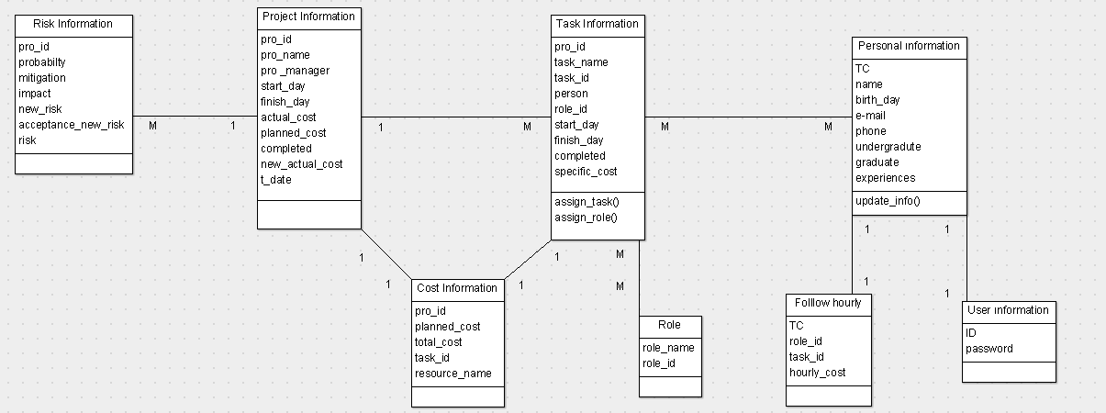

Figure 7: Database Design

Dependency Description
    - Intermodule Description
PMA Modules | Login Module | Project Organization Module | Task Management Module | Profile Module | Risk & Cost Management Module
Login Module | X1
Project Organization Module | X2 |  |  | X3
Task Management Module | X4 | X5
Profile Module | X6 |  |  | X7
Risk & Cost Management Module | X8 | X9 | X10
Table 28: Intermodule description

X1,X2,X4,X6,X8 means that user must be authorized to login to use all modules of the system.
X5,x9 means that task, risk and cost management cannot be done unless the project is created
X10 means risk & cost management cannot be done unless task management is planned
X3,x7 means that some functions in project organization module and profile module cannot be done unless user has some special authorization. Such as admin’s user creation or project organization.

Data Dependencies

There are relations between data entities. These relationships are provided in detail below.

Name | Type | Size
Project_id | number | 6
Task_id | number | 12
Planned_cost | float | 13
Actual_cost | float | 13

Table 29:cost_information

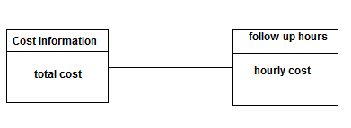
Attributes :project_id,task_id,planned_cost,actual_cost
RelationshipType:One - to – one
Figure 8:cost-follow up

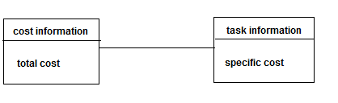
Attributes :project_id,task_id,planned_cost,actual_cost
RelationshipType:One - to – many
Figure 9:cost-task

Name | Type | Size
Project_name | Varchar2 | 60
Project_id | Number | 6
Project_manager | Varchar2 | 60
Start_day | Date | 8
Finish_day | Date | 8
Planed_cost | Float | 13
Actual_cost | Float | 13
%completed | Number | 3
New_actual_cost | float | 13
T_date | date | 8
Table 30:project_information

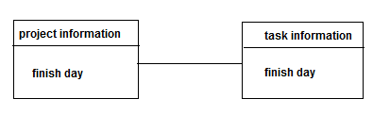
Attributes :project_id,project_name,project_manager, start_day, planned_cost,actual_cost, %completed
RelationshipType:One - to – one
Figure 10:Project-task

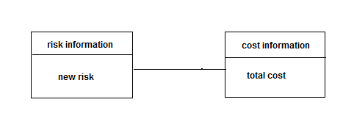
Attributes :project_id,task_id,planned_cost,actual_cost

RelationshipType:Many - to – one
Figure 11:risk-cost

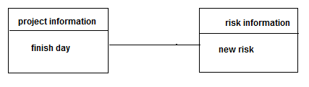
Attributes :project_id,project_name,project_manager, start_day, planned_cost,actual_cost, %completed

RelationshipType:One - to –many
Figure 12:Project - risk

Name | Type | size
Project_id | number | 6
Task_name | Varchar2 | 60
Task_id | number | 12
Person | Varchar2 | 60
Start_day | date | 8
Finish_day | date | 8
%completed | number | 3
Specific_cost | float | 13
Role | Varchar2 | 30
Table 31:task_information
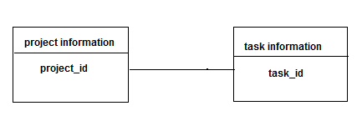
Attributes :project_id,task_name,task_definition, start_day,finish_day , %completed, specific_cost

RelationshipType:One - to – one
Figure 13:Project-task

Name | Type | Size
Tc | number | 1
Role | Varchar2 | 20
Hourly_cost | float | 13
Task_id | number | 15
Table 32: follow_up_hours

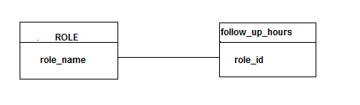
Attributes :task_id, hourly_cost,name,surname.

RelationshipType: Many - to – one
Figure 14:statu-follow up

INTERFACE DESCRIPTION

    - Module Interfaces

User Interface

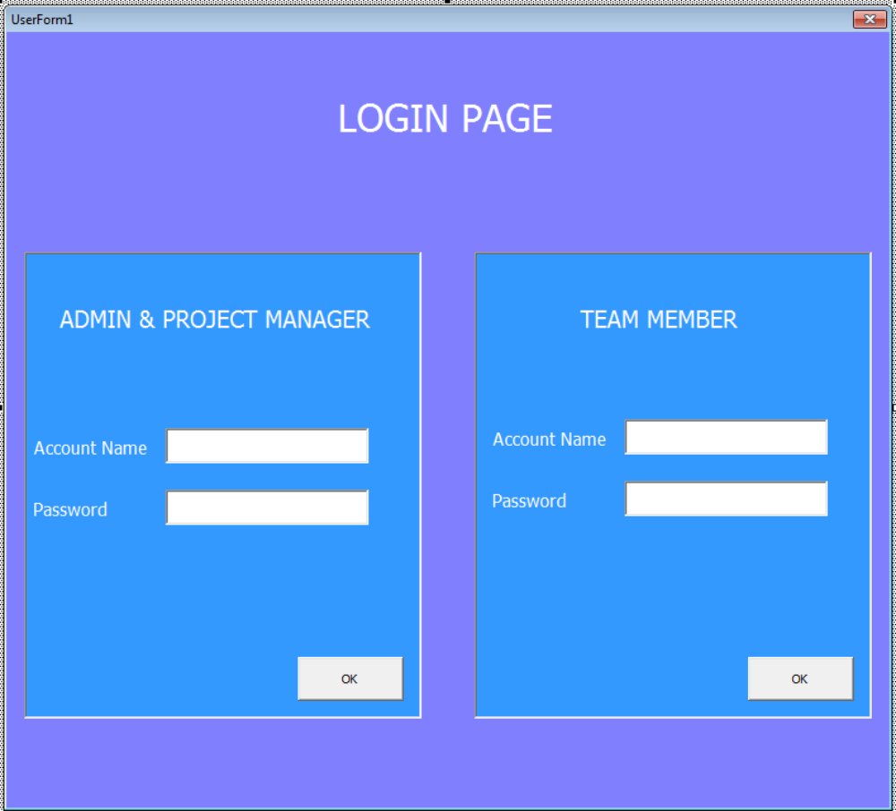
Figure 15: LoginPage

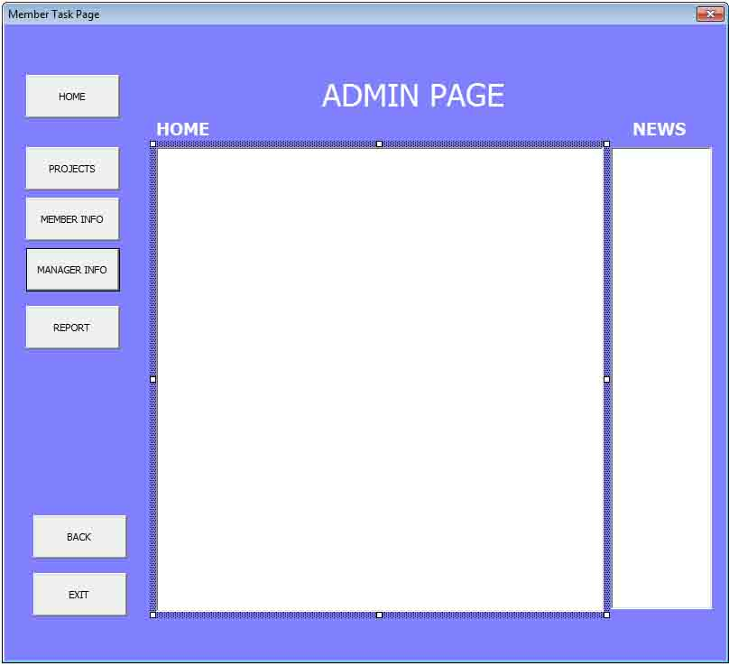
Figure 16: Admin Home Page

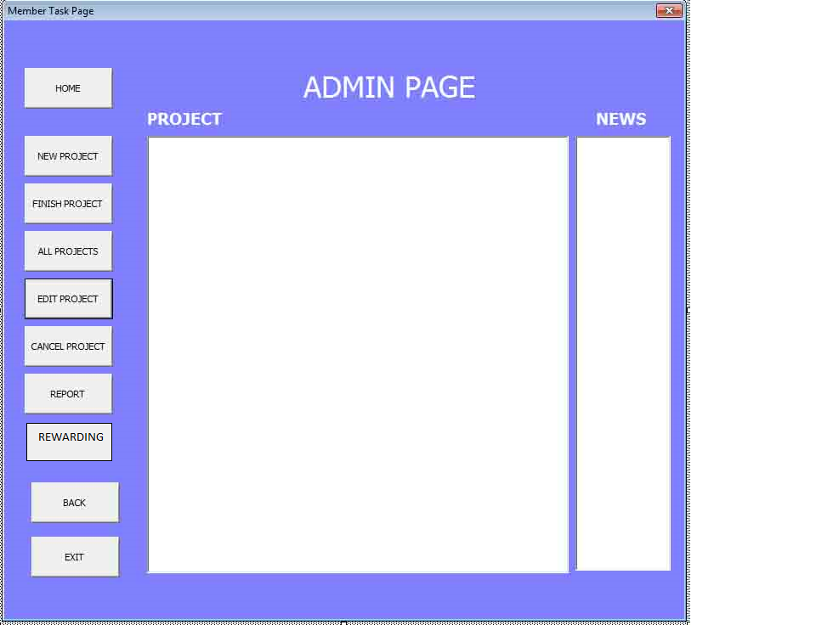
Figure 17 : Admin Project Page

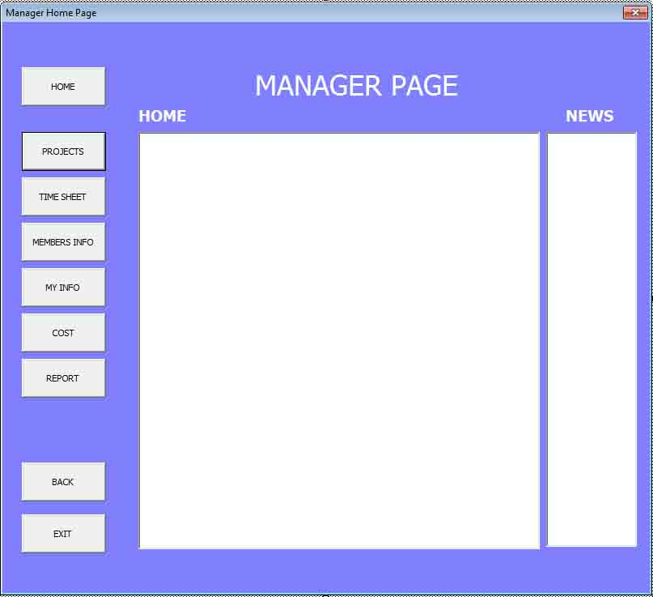
Figure 18: Project Manager Home Page

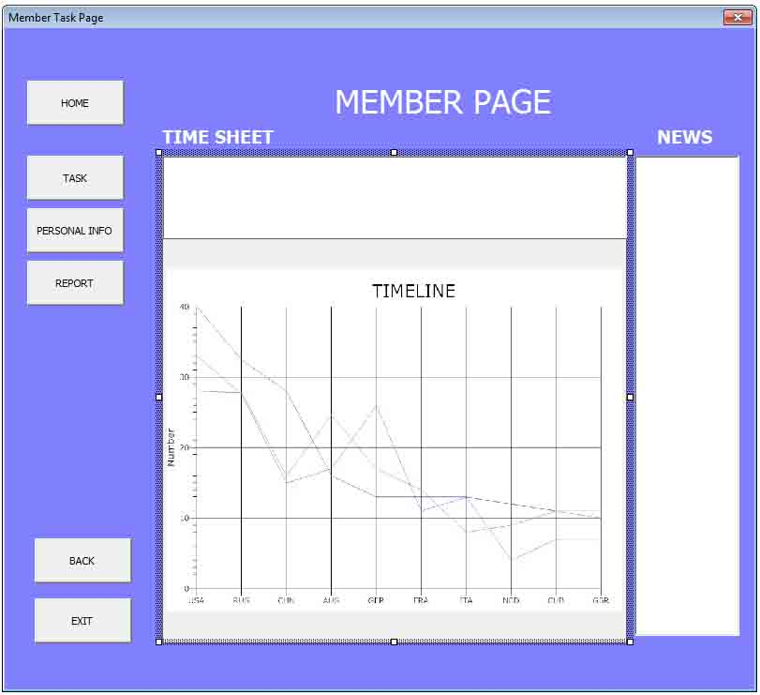
Figure 19 : Member Time Sheet

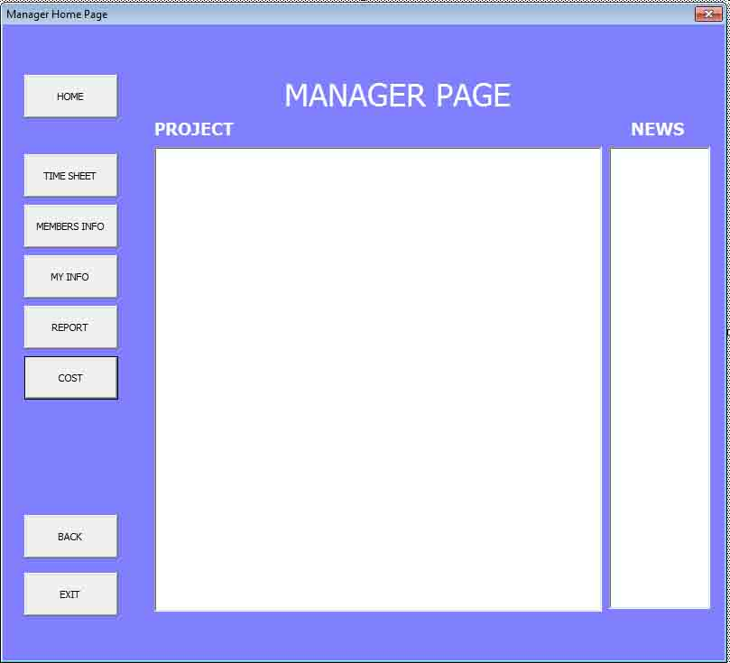
Figure 20: Project Manager Project Page

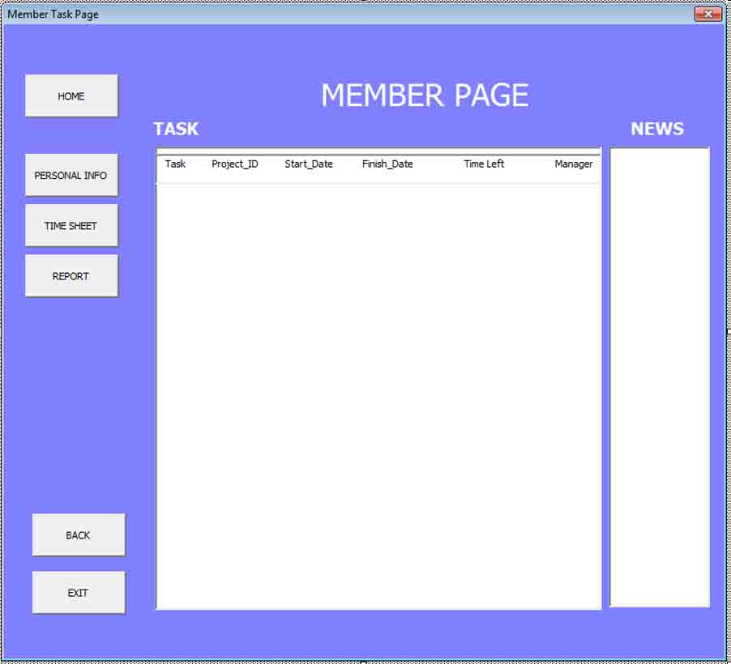
Figure 21 : Member Task Page

DETAILED DESIGN

Module Detailed Design

Class Diagram

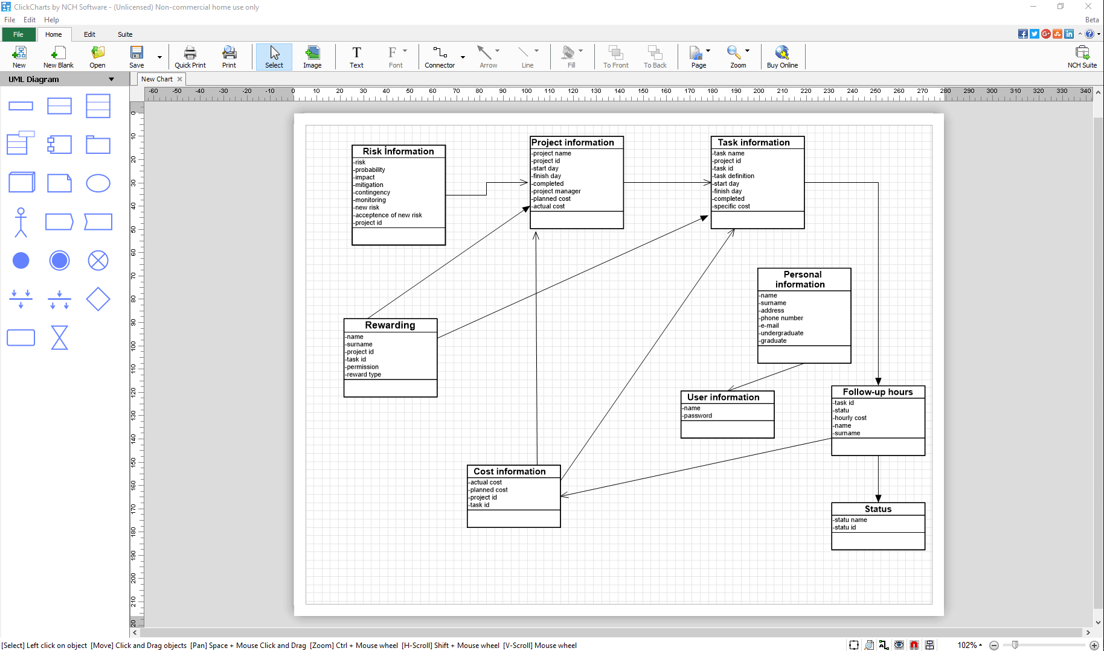
Figure 23: Class Diagram

Project Organization Activity Diagram
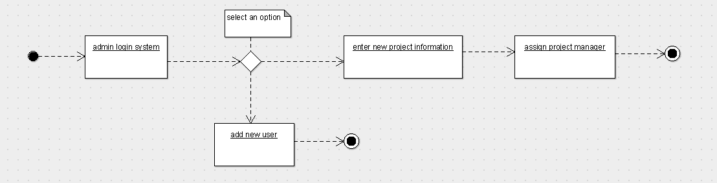
Figure 22 : Admin Login Module Activity Diagram

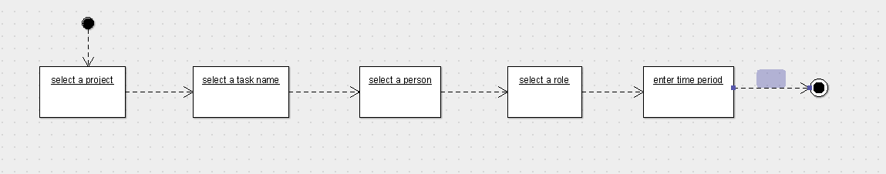
Figure 23:Task Assign Module Activity Diagram
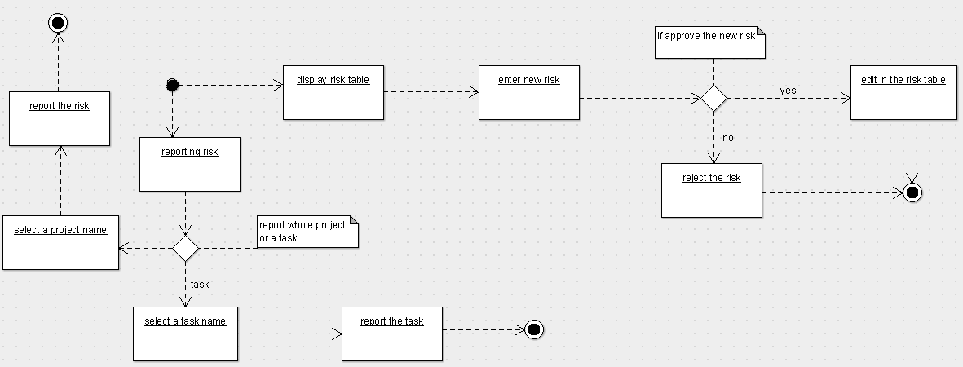
Figure 24:Risk Module Activity Diagram

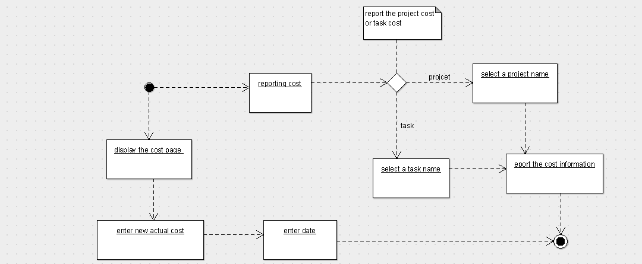
Figure 25:Cost Module Activity Diagram

Data Detailed Design

In this section, we show the type of the data and size of the data.

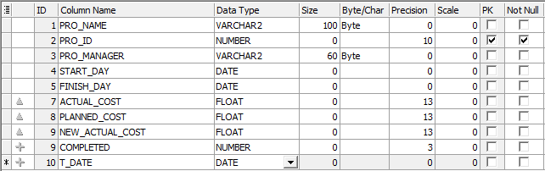
Table 33: Project_information

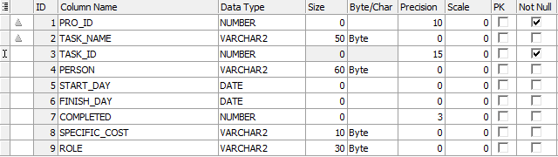
Table 34:Task_information

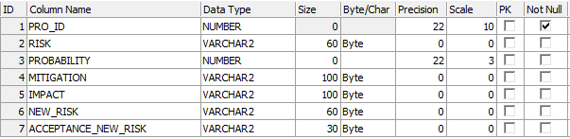
Table 35:Risk_information

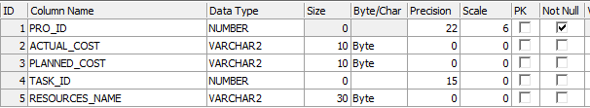
Table 36:Cost_information

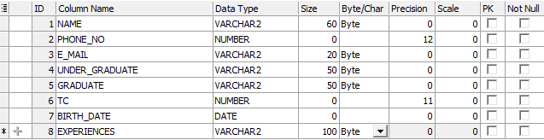
Table 37:Personal_information

Table 38:Role_information

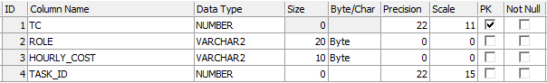
Table 39:Follow_up_hours
4.3 RequirementsTraceability Matrix(RTM)
RequirementsTraceability Matrix(RTM)
ID | REQUIREMENT | DESIGN SPECIFICATION | PROGRAM MODULE
1.1 | Admin, Project maneger and team member can login the system. | Project organization | Loginmodule
2.1 | Admin can createnewproject. | Project organization | Adminmodule
2.2 | Admincan assignprojectmanager. | Project organization | Adminmodule
2.3 | Admin can createnewuser | Project organization | Adminmodule
3.1 | Project manager can assigntask | Project plan | Taskassignmodule
3.2 | Project manager can assign role | Project plan | Taskassignmodule
3.3 | Project manager can enter time period | Project plan | Taskassignmodule
3.4 | Team member can updatetaskinformation | Project plan | Taskassignmodule
3.5 | Project manager can seeplannedcost, actualcost. | Project organization | Costmodule
3.6 | Project manager can reportthecost | Project organization | Costmodule
3.7 | Project manager canenternewactualcost | Project organization | Costmodule
3.8 | Team member can enternewactualcost | Project organization | Costmodule
3.9 | Project manager can see risk table . | Project organization | Risk module
3.10 | Project manager can enterrisks. | Project organization | Risk module
3.11 | Project manager can acceptorrejectthenew risk | Project organization | Risk module
3.12 | Project manager can reporttherisks | Project organization | Risk module
3.13 | Project manager can seeothersand his/her personalinformation. | Personalinformation | Profile module
3.14 | Project manager can change his/her personalinformation. | Personalinformation | Profile module
3.15 | Project manager can changepassword. | Personalinformation | Profile module
3.16 | Team member can changethepassword. | Personalinformation | Profile module
3.17 | Team member can see risk table. | Project organization | Risk module
3.18 | Team member can enternew risk | Project organization | Risk module
3.19 | Team member canseeplannedcostandactualcost. | Project organization | Costmodule
3.20 | Team member can enterextracost. | Project organization | Costmodule
3.21 | Team member can seeallpersonalinformation. | Personalinformaton | Profile module
3.22 | Team member can change his/her personalinformation. | Personalinformaton | Profile module
Table 40: RTM

