We need to maintain three points for the java full stack training that is 1)Focus, 2) Listening, 3) Don’t go for multitasking, 4) Concentrate on others

Most important points for Presentation:
Confidence on the subject, body language, eye contact, the way of presenting

Capgemini Advance JAVA Index

1.Junit
2.JDBC

1.Junit
Tesing: To test a product
BlackBox:
Tester does this test. They don’t have any knowledge about technology. They test based on Functional Specifications.
WhiteBox:
Developer does this test. Based on Functional Specifications only. They do the Unit Testing.

What is Unit Testing: Testing the code line by line
It has two types :
.

ORM
(Object Relational Mapping)
• ORM stands for object-relational mapping, where objects are used to connect the programming language on to the database systems

Hiberante Framework

Hibernate (ORM)

• Hibernate is a pure Java object-relational mapping (ORM) and persistence framework that allows you to map bean Java objects to relational database tables using (XML/Annotation) configuration files

Configuration
public class Configuration
extends Object
implements Serializable
- An instance of Configuration allows the application to specify properties and mapping documents to be used when creating a SessionFactory.
- Usually an application will create a single Configuration, build a single instance of SessionFactory and then instantiate Sessions in threads servicing client requests.
- The Configuration is meant only as an initialization-time object.
- SessionFactorys are immutable and do not retain any association back to the Configuration.
Author: Gavin King

SessionFactory

public interface SessionFactory
extends EntityManagerFactory, Serializable, Closeable

- A SessionFactory represents an "instance" of Hibernate: it maintains the runtime metamodel representing persistent entities, their attributes, their associations, and their mappings to relational database tables, along with configuration that affects the runtime behavior of Hibernate, and instances of services that Hibernate needs to perform its duties.
- This is where a program comes to get sessions.
- Generally, a program has a single SessionFactory instance, and must get a new Session instance from the factory each time it services a client request.
- It is then also responsible for destroying the session at the end of the client request.
- SessionFactory manages the lifecycle of pooled JDBC connections and transactions, or it can work as a client to a connection pool or transaction manager provided by the container environment.
- SessionFactory bbbbbbbbbbbbis threadsafe.
Session
public interface Session
extends Serializable
- The main runtime interface between a Java application and Hibernate.
- This is the central API class abstracting the notion of a persistence service.
- The lifecycle of a Session is bounded by the beginning and end of a logical transaction.
- The main function of the Session is to offer create, read and delete operations for instances of mapped entity classes.
- Instances may exist in one of three states:
transient: never persistent, not associated with any Session
persistent: associated with a unique Session
detached: previously persistent, not associated with any Sessionpipi
- Transient instances may be made persistent by calling save(), persist() or saveOrUpdate(). Persistent instances may be made transient by calling delete().
- Any instance returned by a get() or load() method is persistent.
- A Session instance is serializable if its persistent classes are serializable.
Session sess = factory.openSession();
Transaction tx;
try {
tx = sess.beginTransaction();
//do some work
...
tx.commit();
}
catch (Exception e) {
if (tx!=null) tx.rollback();
throw e;
}
finally {
sess.close();
}

Serializable | save(Object object)  Persist the given transient instance, first assigning a generated identifier.
Object | get(Class class, Serializable id)  Return the persistent instance of the given entity class with the given identifier, or null if there is no such persistent instance.
Object | load(Class theClass, Serializable id)  Return the persistent instance of the given entity class with the given identifier, assuming that the instance exists.
Object | merge(Object object)  Copy the state of the given object onto the persistent object with the same identifier.
void | evict(Object object)  Remove this instance from the session cache.
void | flush()  Force this session to flush.
Transaction
public interface Transaction
extends EntityTransaction

- In Hibernate, a transaction is linked to a Session and usually starts when beginTransaction() is called.
- One session can handle multiple transactions one after another, but at any given time, only one transaction can remain active (uncommitted) within a session.

Hibernate Caching
Hibernate caching
Hibernate ORM, caching is used to reduce repeated database access and improve application performance.
Hibernate mainly uses two types:
- first-level cache
- second-level cache.
The first-level cache :
- The first-level cache is automatically available and works at the session level.
- Whenever an object is loaded from the database in a session, Hibernate stores it in the session cache, so if the same object is requested again within the same session.
- Hibernate returns it from memory instead of hitting the database.
In Hibernate, the first-level cache is session-specific and enabled by default
- The first-level cache works within one session
- The first-level cache improves performance within a single session
- Cannot be disabled
- Faster, but limited to one session only

The second-level cache
- The second-level cache is optional and works at the session factory level.
- It allows data to be shared across multiple sessions, meaning once an object is loaded by one session, another session can reuse the same data without accessing the database again, provided second-level caching is enabled and configured.
- Not enabled by default
- Scope: SessionFactory-level (global cache)
- Requires external cache providers (Ehcache, Infinispan)
- Improves performance in multi-user applications

- The second-level cache improves performance across multiple sessions in an application.
- second-level cache is session-factory-specific and optional.
- The second-level cache allows data sharing between multiple sessions.

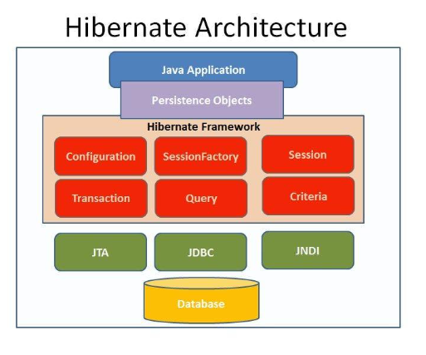
JDBC (Java Database Connectivity)
Java Objects -> JDBC API -> JDBC Driver -> Databse (MySQL/Oracle/PostgreSQL)

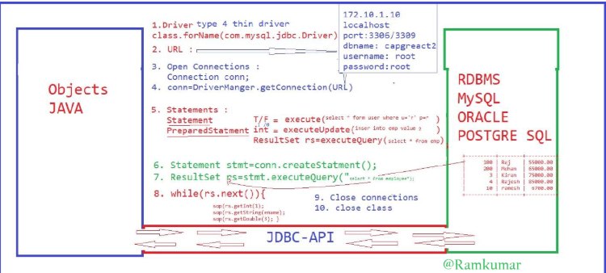

- Load & Register JDBC Driver
JDBC driver acts as a bridge between Java application and database.
It loads the database-specific driver into memory
Example:
Class.forName(Driver);
- Create Database URL:
URL contains database location and name
String url=” jdbc:oracle:thin:@localhost:1521:XE”;

- Open Connection
Connection object represents a physical connection to the database
Connection conn=null;
- Establish Connection:
Use DriverManager to connect Java with DB.
String url = "jdbc:oracle:thin:@localhost:1521:XE";
String userName = "scott";
Connection conn = DriverManager.getConnection(url, userName, password);

- Create Statement / PreparedStatement
Used to send SQL queries to the database
- Statement
Statement stmt = conn.createStatement();
- PreparedStatement
String query="insert into Employeeinfo2 values(?,?,?)";
//Step1 : Get PreparedStatement
PreparedStatement pstmt=conn.prepareStatement(query);
//Step2 : Set parameters

- Execute SQL Queries
Depending on the operation:
Method are used for:
executeQuery(): SELECT
executeUpdate():insert, update, delete
execute(): ANY SQL
Example (SeLECT):
ResultSet rs = stmt.executeQuery("select * from Employeeinfo1");
- Process ResultSet
ResultSet stores the data returned by SELECT query
rs.next() moves row by row
while (rs.next()) {
System.out.println(rs.getInt(1));
System.out.println(rs.getString("ename"));
System.out.println(rs.getDouble(3));
}
- Close ResultSet
Fresh memory used by result
rs.close();
- Close Connection
Always close connection after DB operations
- Close class
Statement
- Used when executing a SQL query only once
- In SQL, a “statement” is a single line or a group of lines representing a specific action or operation performed on a database.
- SQL statements are used to interact with the database, retrieve data, modify data, create or alter database structures, and more.
- There are different types of SQL statements, including SELECT (used to retrieve data), INSERT(used to add new data), UPDATE (used to modify existing data), DELETE(used to remove data), and DDL (Data Definition Language) statements like CREATE TABLE and ALTER TABLE( used to define or modify the database structure)
- Typically has lower performance
PreparedStatement
- Used when executing a SQL query multiple times
- A PreparedStatement in SQL is a precompiled SQL statement that allows you to execute the same SQL query with different parameter values repeatedly.
- It is a feature provided by database APIs like JDBC, which improves performance, and security by separating the SQL query from the user supplied paramaters.
- PreparedStatement helps prevent SQL injection attacks and enhances database query execution efficiency by reducing the need for query recompilation, making it a valuable tool for database interactions in applications.

In JDBC 4 types of Drivers:
- Type 1: JDBC-ODBC Bridge Driver
- Type 2: Native-API Driver (Partially Java)
- Type 3: Network Protocol Driver(Fully Java Middleware)
- Type 4: Thin Driver (100% Pure Java)
Type 1: JDBC-ODBC Bridge Driver
- It acts as a bridge between JDBC and Microsoft's ODBC (Open Database Connectivity).
- Useful when no other driver is available; connects to any database supporting ODBC.
- Low performance; requires ODBC binary code on every client machine; not supported since Java 8.
Type 2: Native-API Driver (Partially Java)
- Converts JDBC calls into native C/C++ API calls specific to the database (e.g., Oracle OCI).
- Better performance than Type 1 because it eliminates the ODBC overhead.
- Not fully portable (platform-dependent); requires vendor-specific client-side libraries to be installed on each machine.
Type 3: Network Protocol Driver (Fully Java Middleware)
- Uses a three-tier approach where a client communicates with a middleware application server, which then interacts with the database.
- Highly flexible; no client-side installation required; one driver can access multiple databases.
- Maintenance of the middleware server is required; performance may be affected by the extra network layer.
Type 4: Thin Driver (100% Pure Java)
- Communicates directly with the database using its native network protocol.
- Best performance among all types; fully portable (platform-independent); no special software required on client or server.
- Specifically designed for a single database; if the database changes, the driver must also change.

.

JPA (Java Persistence API)

- The Java Persistence API (JPA) is the Java standard for mapping Java objects to a relational database.

- Object-Relational Mapping (ORM) means connecting Java objects with database tables. In ORM, Java classes map to tables, and objects map to rows. ORM helps avoid writing complex SQL code.

- JPA (Java Persistence API) is a standard way to implement ORM in Java. JPA allows Java programs to store, read, update, and delete data from databases using objects.

- JPA the developer can map, store, update and retrieve data from relational databases to Java objects and vice versa.
- JPA can be used in Java-EE and Java-SE applications.

JPA is a specification and several implementations are available.
Popular implementations are:
- Hibernate,
- Toplink ,
- EclipseLink
- Apache OpenJPA.
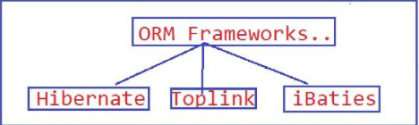

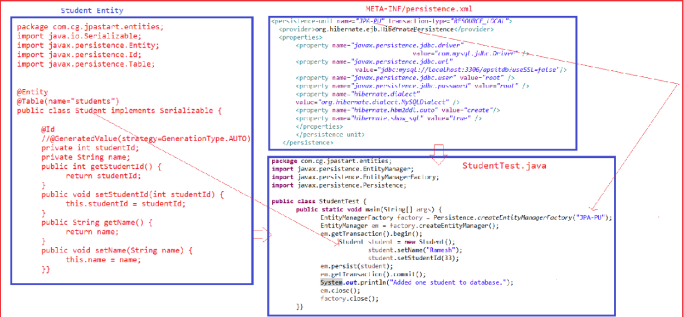

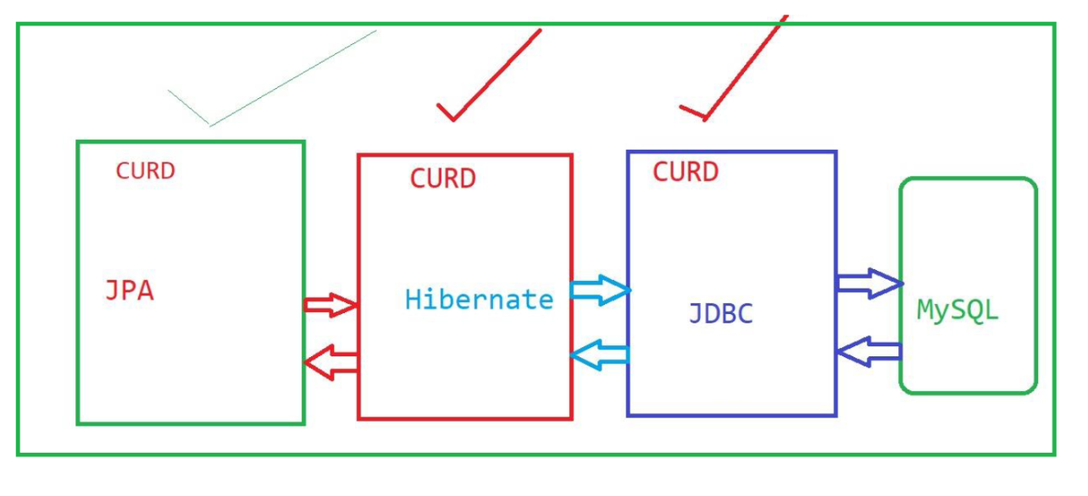

What is JPI
Java Persistence API (JPA)
JPA is a standard specification used to manage and store data in relational databases using Java.
It provides a common way for Java applications to perform database operations without depending on a specific ORM tool.

EntityManagerFactory
EntityManagerFactory is thread-safe and usually created once, while EntityManager objects are lightweight and created whenever database interaction is required.
EntityManagerFactory in JPA, providing a safe and efficient way to manage database connections and perform CRUD operations.

Entity Manager
In JPA, the EntityManager is the main interface used to interact with the database. It manages the lifecycle of entity objects and performs basic CRUD operations such as insert, update, delete, and fetch
1. EntityManager
- EntityManager is a JPA interface
- It is used to manage entity objects in a database.
- Entities cannot save themselves
- Entity classes (POJOs) cannot directly insert, update, or delete data.
- Annotations only define mapping (table, columns, relationships).
- EntityManager does database operations
- It is used to insert, update, delete, and find records in the database.
- EntityManager controls entity lifecycle
- It manages when an entity is:
- created
- saved
- updated
- removed
- EntityManager works with a Persistence Unit
  - A persistence unit is defined in persistence.xml.
  - One EntityManager works with entities of that persistence unit.
- Persistence Context
  - Each EntityManager has a persistence context.
  - It is a temporary memory area where entity objects are managed.
- Managed State
  - While an entity is inside the persistence context:
    - EntityManager tracks all changes automatically
    - No need to write update SQL
- Automatic synchronization
  - When a transaction is committed:
    - EntityManager flushes changes to the database
- Detached State
  - When EntityManager is closed:
    - Entities become detached
    - Changes are NOT saved to the database
- Detached entities are not tracked
  - EntityManager will not monitor or update detached objects.

Entities:
1. Entities An entity is a lightweight persistence domain object.
2. Typically, an entity represents a table in a relational database, and each entity instance corresponds to a row in that table.
4. The persistent state of an entity is represented through either persistent fields or persistent properties.
5. These fields or properties use object/relational mapping annotations to map the entities and entity relationships to the relational data in the underlying data store.

JPA ANNOTATIONS
@Entity
The @Entity annotation is used to specify that the currently annotate class represents an entity type.
@Table
The @Table annotation is used to specify the primary table of the currently annotated entity
@Id
In JPA the object id is defined through the @Id annotation and should correspond to the primary key of the object's table. An object id can either be a natural id or a generated id.
@Column
The @Column annotation is used to specify the mapping between a basic entity attribute and the database table column.
@GeneratedValue
The @GeneratedValue annotation specifies that the entity identifier value is automatically generated using an identity column, a database sequence, or a table generator.

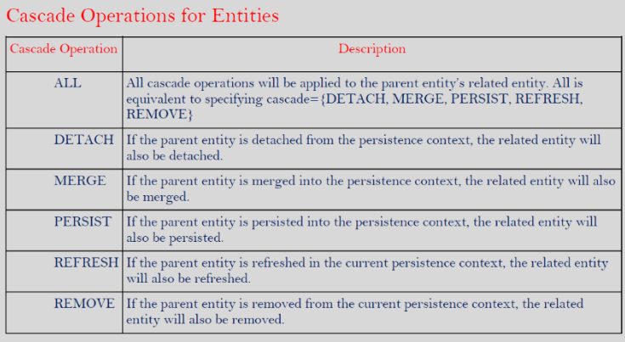

JPA Entity Relationships
In JPA, relationships define how one entity is connected to another entity. These connections are called multiplicities. JPA supports four main types of relationships: one-to-one, one-to-many, many-to-one, and many-to-many.
One-To-One: Each entity instance is related to a single instance of another entity. One-to-one relationships use the javax.persistence.OneToOne annotation on the corresponding persistent property or field.
• One student has only one address
• One address belongs to only one student
@Entity
public class Student {
@Id
private int studentId;
private String name;
@OneToOne
private Address address;
}

One-to-many:
- An entity instance can be related to multiple instances of the other entities.. One-to-many relationships use the javax.persistence.
OneToMany annotation on the corresponding persistent property or field.
- One teacher can teach many students
- Each student is taught by one teacher
One teacher handles many students in a class.

JPA Annotations Used
@OneToMany and @ManyToOne

Simple Code Example
@Entity
public class Teacher {
@Id
private int teacherId;
private String teacherName;

@OneToMany
private List<Student> students;
}

Many-to-one: Multiple instances of an entity can be related to a single instance of the other entity. This multiplicity is the opposite of a one-to-many relationship. Many-to-one relationships use the javax.persistence.ManyToOne annotation on the corresponding persistent property or field.

@Entity
public class Student {
@Id
private int studentId;
private String studentName;

@ManyToOne
private Teacher teacher;
}

Many-to-many: The entity instances can be related to multiple instances of each other. For example, each college course has many students, and every student may take several courses. Therefore, in an enrollment application, Course and Student would have a many-to-many relationship. Many-to-many relationships use the javax.persistence.ManyToMany annotation on the corresponding persistent property or field.

- One student can learn many courses
- One course can be learned by many students

Example :
Students can enroll in multiple courses like Java, Python, SQL,
and each course has many students.

JPA Annotation
@ManyToMany
@Entity
public class Student {
@Id
private int studentId;
private String name;
@ManyToMany
private List<Course> courses;
}
@Entity
public class Course {
@Id
private int courseId;
private String courseName;
@ManyToMany
private List<Student> students;
}

Spring Framework
Why Spring?
- Spring makes programming Java quicker, easier, and safer for everybody.
- Spring’s focus on speed, simplicity, and productivity has made it the world's most popular Java framework.
What is Spring Framework ?
- The Spring Framework is an open-source Java platform that provides comprehensive infrastructure support for building robust, modular, and easily testable enterprise-level applications.
- It simplifies the complexities of enterprise Java development, primarily through its core principles of Inversion of Control (IoC) and Dependency Injection (DI).
- POJOs: Allows building applications using lightweight Plain Old Java Objects, avoiding heavy application servers.
- Spring enables you to build applications from “plain old Java objects” (POJOs) and to apply enterprise services non-invasively to POJOs. This capability applies to the Java SE programming model and to full and partial Java EE.
- The Spring Framework is essentially a back-end framework designed for the development of robust server-side applications. It handles core back-end-related tasks, such as dependency injection, database integration, security, and API development.

- A Spring Framework container is the core component that manages the lifecycle of application objects (known as "beans") and their dependencies using the principle of Inversion of Control (IoC), also known as Dependency Injection (DI).

- Instead of the developer manually creating and wiring objects, the container handles this automatically based on configuration metadata

Modules :
- Core & MVC: Fundamental IoC/DI features and a robust framework for web applications/RESTful APIs.
- Data & Security: Streamlines database access (JDBC, JPA, NoSQL) and offers comprehensive authentication/authorization.

Types of Containers
- BeanFacotry
- ApplicationContext

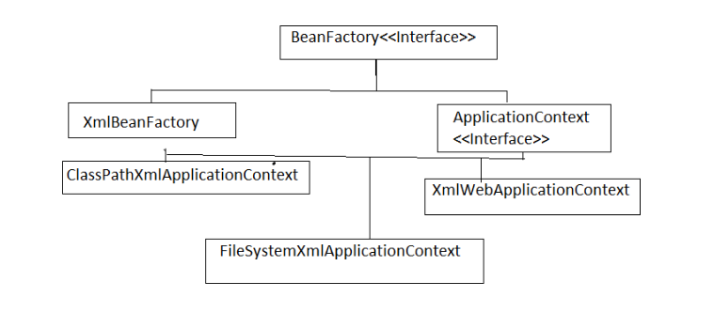
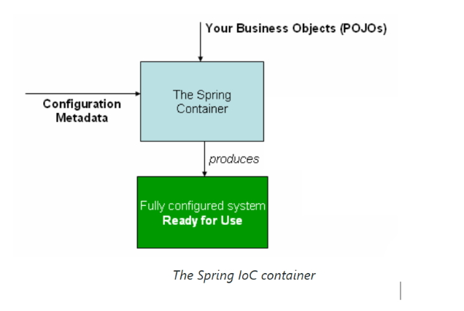

What is the Spring Container?
The Spring Container is the core of the Spring Framework responsible for creating, managing, and injecting the beans (objects) in a Spring application. It follows the principles of Inversion of Control (IoC) and Dependency Injection (DI) to manage the lifecycle and dependencies of the application objects.
The Spring container:
- Creates and manages beans based on the configuration.
- Resolves dependencies between the beans.
- Manages the lifecycle of beans (initialization, destruction).

Types of Spring Containers
Spring provides different types of containers, but the most common ones are:
Container Name | Description
Bean Factory | Basic container that provides basic support for dependency injection. It is lightweight and lazily initializes beans.
Application Context | Advanced container that extends BeanFactory. It provides additional features like event propagation, AOP, internationalization, and more.

How the Spring Container Works
- Configure Beans: You can configure beans using:
  - XML Configuration
  - Java-based Configuration using @Configuration and @Bean.
  - Annotation-based Configuration using annotations like @Component, @Service, @Controller.
- Bean Initialization: When the Spring container starts, it creates and initializes beans based on the configuration.
- Dependency Injection: The container automatically injects the required dependencies (using @Autowired, constructor injection, etc.).
- Lifecycle Management: The container manages the lifecycle of beans (e.g., initialization, destruction).
BeanFactory:
- This is the most basic container interface, providing fundamental IoC functionality, such as managing beans and their dependencies.
- It is lightweight and typically instantiates beans lazily (only when requested), making it suitable for resource-constrained environments.
ApplicationContext:
- This is a sub-interface of BeanFactory that adds more enterprise-specific functionality.
- Spring provides two primary interfaces for its IoC container, with the ApplicationContext being the one recommended for most enterprise applications:
- It includes features like easier integration with Spring's Aspect-Oriented Programming (AOP) features, message resource handling (for internationalization), event publication, and application-
- layer specific contexts for web applications. It generally pre-instantiates singleton beans by default when the application starts, which helps in detecting configuration issues early.

Container
- The org.springframework.context.ApplicationContext interface represents the Spring IoC container and is responsible for instantiating, configuring, and assembling the beans.
- The container gets its instructions on the components to instantiate, configure, and assemble by reading configuration metadata.
ApplicationContext is created and initialized, you have a fully configured and executable system or application.
Using the Container
- The ApplicationContext is the interface for an advanced factory capable of maintaining a registry of different beans and their dependencies.
- By using the method T getBean(String name, Class<T> requiredType), you can retrieve instances of your beans.
Spring Framework Architecture :
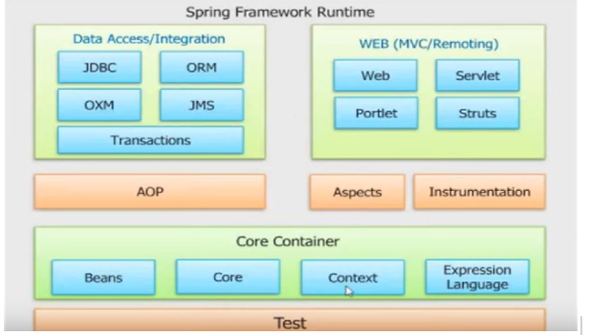
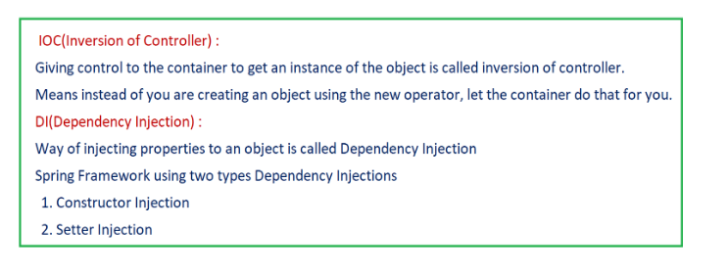
Types of Spring Bean Scopes

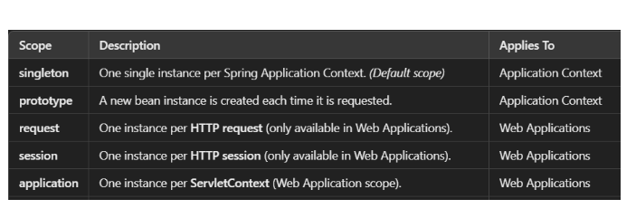

Bean Lifecycle in XML Configuration

In XML, you can also define lifecycle callbacks:

<bean id="user" class="User" init-method="init" destroy-method="cleanup">
<property name="name" value="Ram Kumar K." />
</bean>
- init-method: Called after the bean is fully initialized.
- destroy-method: Called before the bean is destroyed.

Advantages of XML Configuration
- Clear separation of configuration from code.
- Useful in legacy projects or when annotations aren’t allowed.
- Easier to visualize dependencies in one place.
Disadvantages of XML Configuration
- harder to maintain for large applications.
- Less flexible than Java-based or annotation-based configuration.

