Weak prompts:
- Explain regression
- Help me understand SQL
- Create a dataset

Improved prompts and screenshots:
- Explain regression to me as if you are talking to a 5-year-ol
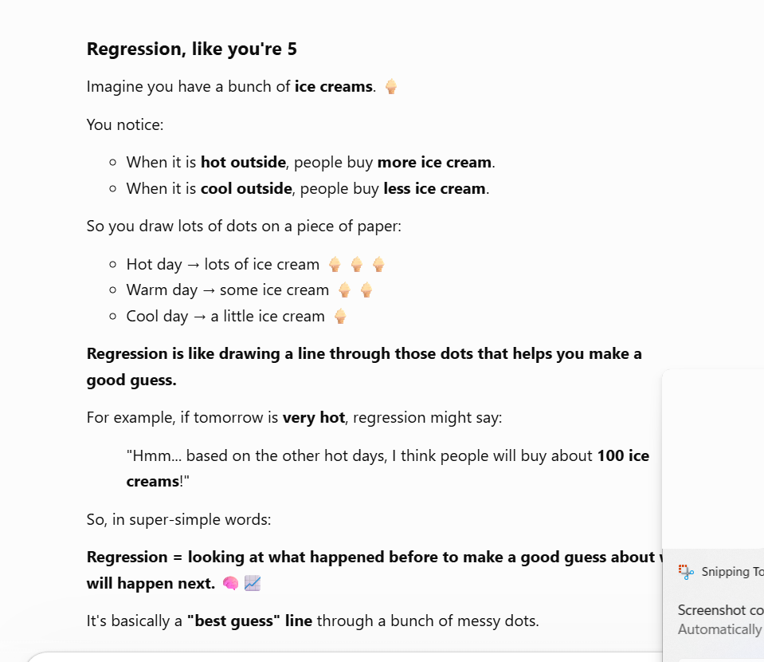
This is better than the weak prompts because I am asking how to explain it to a 5-year-old. It simply tells what regression is, with examples. I have the audience as 5-year-olds.

- Help me understand SQL and what data analysts use it for. Keep it simple.
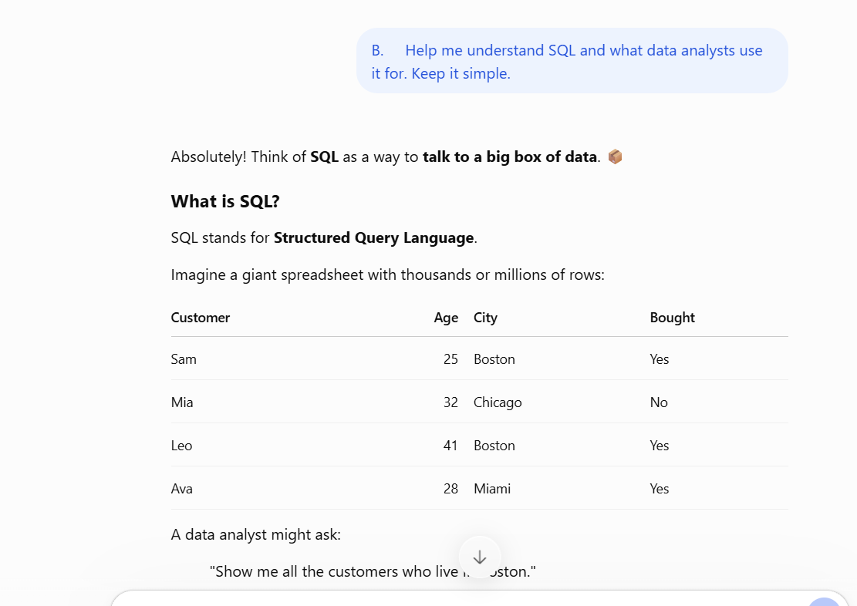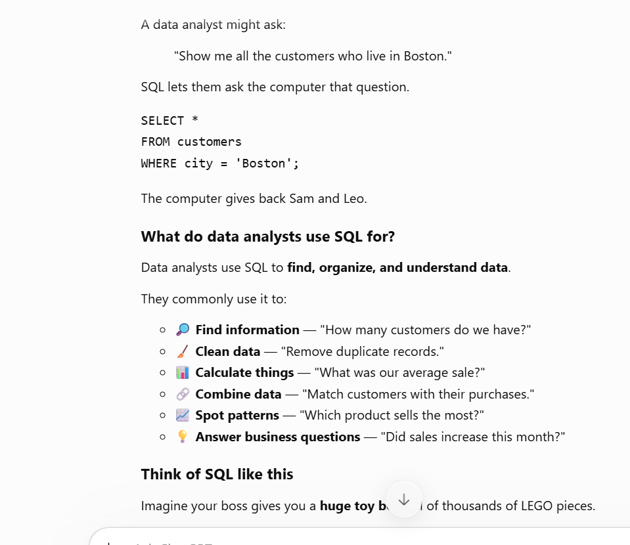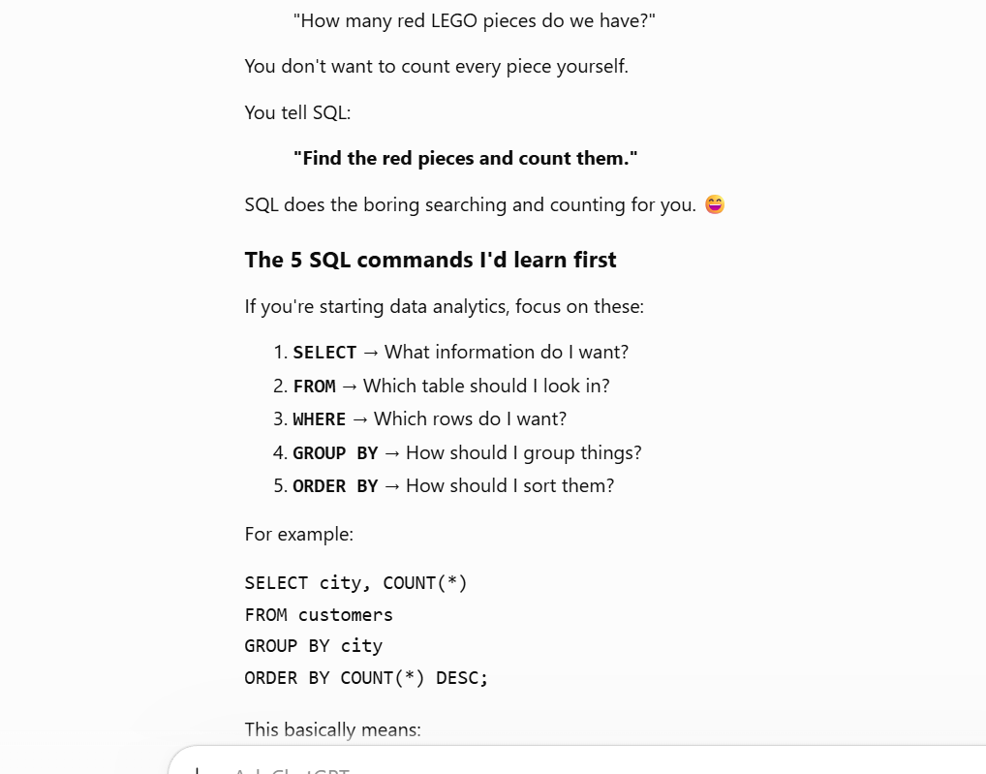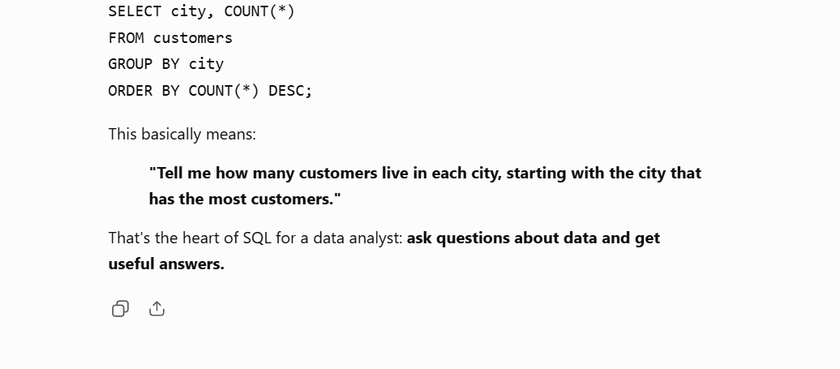
This one is better than the weaker prompt because it gives an idea of how SQL works for a data analyst. It gives examples for the audience, which are data analysts.

- Create a data set of the population of NYC from the last 10 years—from 2016-2026
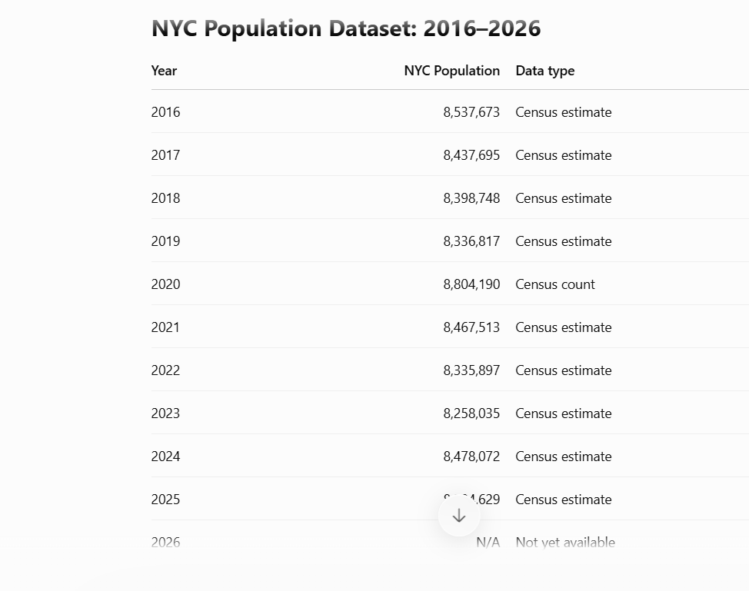
This prompt is better than the weak one because with my prompt, I give an idea of what I want for the data set.

