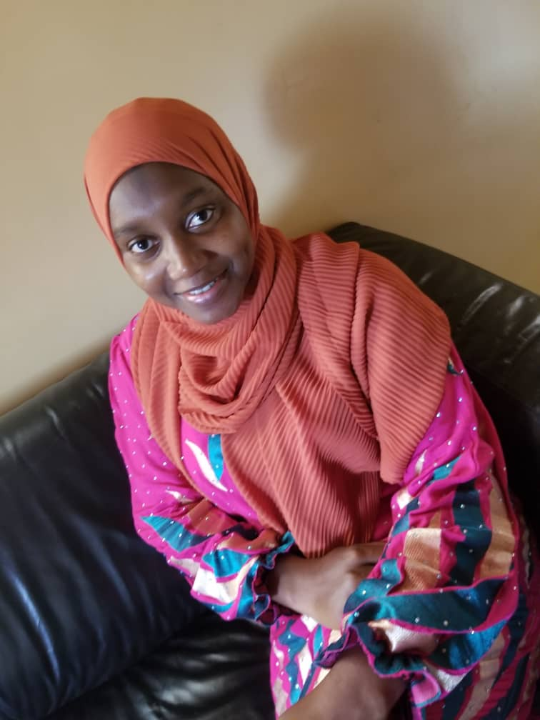

Satang Banja Sanyang | 3012233 | satang.com

# About me

I am a web developer

# Work Experience

**Xanda** *27th february 2015_2021*learn php and wordpress and improve my skills in css, html, programing, team work etc