School Management System
Principal | Teacher | Student
Login | Login | Login
Create teacher | View student | View attendance
Create student | Add attendance | View account
View teacher | Add marks | View notes
View student | Add notes | View marks
Manage timetable | Add assignment | Submit assignment
Add notes | View timetable | View timetable

Data Dictionary:
Principal login:
Field | Data type | Constrains
Id | Int | PK
Username | Varchar(20)
Password | Varchar(20)

Teacher reg.
Field | Data type | Constrains
Id | Int | PK
First name | Varchar(20)
Last name | Varchar(20)
Email | Varchar(50)
Password | Varchar(20)
PHNO | Varchar(20)
Education | Varchar(20)
Address | Varchar(20)
Exp. In month | Int
Salary | Double
Dob | Date
Joining date | Date
Gender | Varchar(20)
Photo | Varchar(20)
Role | Int | FK - Role

Role:
Field | Data type | constrains
Id | Int | PK
Role name | Varchar(20)

Student reg.
Field | Data type | Constrains
Id | Int | Pk
First name | Varchar(20)
Last name | Varchar(20) | Q
Email | Varchar(20)
Password | Varchar(20)
Phno1 | Varchar(20)
Phno2 | Varchar(20)
Gender | Varchar(20)
Dob | Date
Admission date | Date
Address | Varchar(20)
Photo | Varchar(20)
Std | Int | FK – slandered table

Standard
Field | Data type | constrains
Id | Int | PK
Std. name | Varchar(20)
Class Teacher | Int | FK – Teacher reg

Subject
Field | Data type | Constrains
Id | Int | PK
Subject name | Varchar(20)

Subject-teacher
Field | Data type | constrains
Id | Int | PK
Sid | Int | FK - subject
Tid | Int | FK- Teacher

Notes:
Field | Data type | constrain
Id | Int | PK
Title | Varchar(20)
Description | Varchar(20)
CREATED BY | Int | FK – teacher reg
Std | Int | FK – standard
Created date | date

Attendance
Field | Data type | constrains
Id | Int | PK
Attendance | Int
Date | Date
Sid | Int | FK - student

Timetable:
Field | Data type | Constrains
Id | Int | PK
Std | Int | FK-std table
Sid | Int | FK-subject
Tid | Int | FK-teacher
Time | Date and time

Marks:
Field | Data type | Constrains
Id | Int | PK
Tid | Int | FK-teacher
Sub | Int | FK-subject
Student | Int | FK-student
Total | Int
Marks | Int

Assignment master
Field | Data type | constrains
Id | Int | PK
Subject | Int | FK – subject
Topic | Varchar(20)
Created by | Int | FK-Teacher
File | Varchar(20)

Assignment assign
Field | Data type | Constrains
Id | Int | PK
assigned BY | Int | FK-teacher
Std | Int | FK-std
Date | Date
Assignment | Int | FK-Assignment

Use Case Diagram
Principal Module
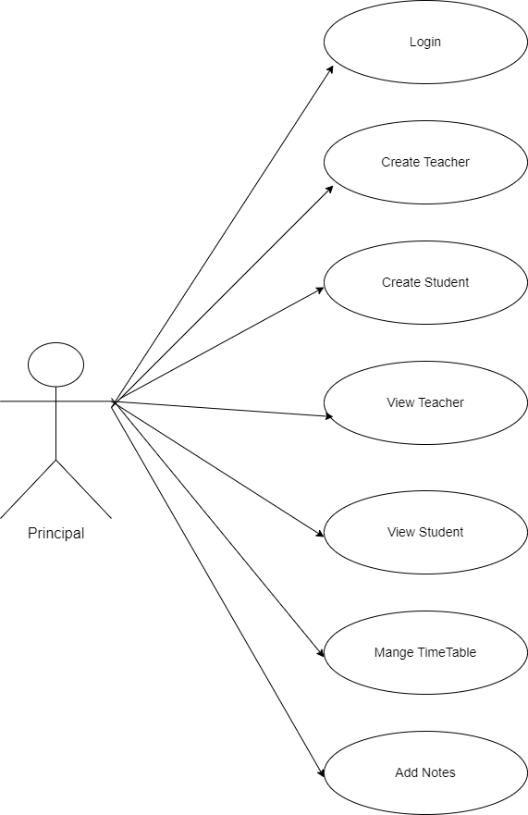
Teacher Module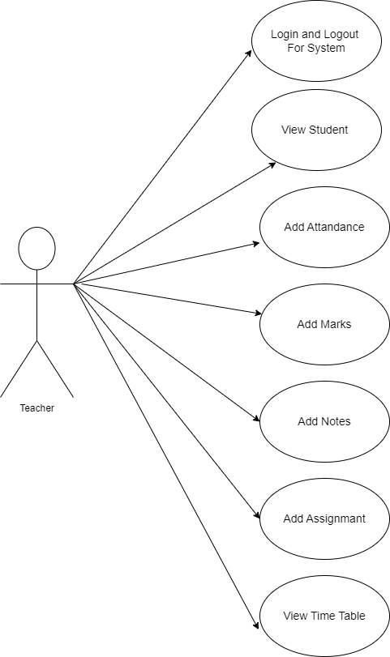

Student Module
