CHAOTAR UNIVERSITY OF SCIENCE AND TECHNOLOGY

Faculty of Technology and Engineering

Chandubhai S Patel Institute of Technology

M & V Patel Department of Electrical Engineering

EE284 Python Programming

University Elective-I

**Practical 3**

1. Write a python program to create a list of flowers and perform following task in single program.(List must have 5 element, and you should decide the elements.)
   1. Print List
   2. Print 2nd element of list
   3. Print 3rd and all elements after that
   4. Replace 2nd element with “Hibiscus” and print list

Code:

'''

1. Write a python program to create a list of flowers and perform following task in single program.

(List must have 5 element, and you should decide the elements.)

a. Print List

b. Print 2nd element of list

c. Print 3rd and all elements after that

d. Replace 2nd element with “Hibiscus” and print list

23AIML062_SMITSATANI '''

flowers = ["Rose", "Lily", "Tulip", "Sunflower", "Daisy"]

print("Flower List:", flowers)

print("2nd Element:", flowers[1])

print("3rd Element onwards:", flowers[2:])

flowers[1] = "Hibiscus"

print("Updated Flower List:", flowers)

Output:

`

1. Use the list you have created in previous problem and print all the elements of the same one by one. (Use for loop)

Code:

'''

2. Use the list you have created in previous problem and print all

the elements of the same one by one. (Use for loop)

23AIML062_SMITSATANI '''

flowers = ["Rose", "Lily", "Tulip", "Sunflower", "Daisy"]

for i in range(0,len(flowers)):

print(flowers[i])

Output:

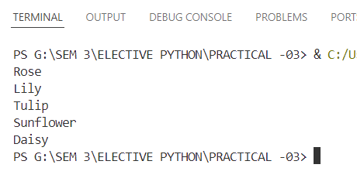

1. Write a python program to create list in which user will enter elements of list. (Print list after each new entry)

Code:

'''

3. Write a python program to create list in which user will

enter elements of list. (Print list after each new entry)

23AIML062_SMITSATANI

'''

list1 = []

while True:

input1 = input("Enter a new element (or type 'stop' to finish): ")

if input1 == 0:

break

list1.append(input1)

print("Current List:", list1)

Output:

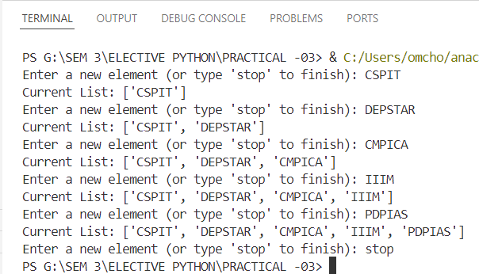

1. Write a python program to create list of integers and then sort them in ascending order. Print list before and after sorting. (Do not use inbuilt sort function, develop your logic with help of for/while/if)

Code:

'''

4. Write a python program to create list of integers and then sort them in ascending order.

Print list before and after sorting. (Do not use inbuilt sort function, develop your

logic with help of for/while/if)

23AIML062_SMITSATANI

'''

list1 = []

while True:

data = input("Enter element (type 'NO' to stop): ")

if data == "NO":

break

list1.append(int(data))

print("Before Sorting.....")

print(list1)

for i in range(0, len(list1)):

for j in range(i + 1, len(list1)):

if list1[j] > list1[i]:

list1[i], list1[j] = list1[j], list1[i]

print("After Sorting.....")

print(list1)

Output:

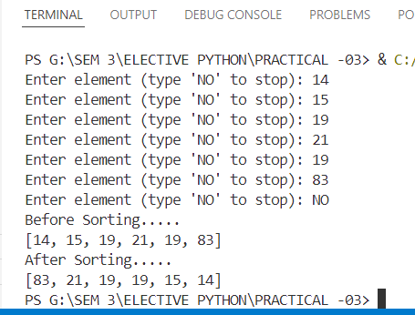

1. Write a python program to find first n prime numbers. (Where n is decided by user)

Code:

'''

5. Write a python program to find first n prime numbers.

(Where n is decided by user)

23AIML062_SMITSATANI '''

def is_prime(num):

if num < 2:

return False

for i in range(2, int(num ** 0.5) + 1):

if num % i == 0:

return False

return True

n = int(input("Enter how many prime numbers you want: "))

primes = []

num = 2

while len(primes) < n:

if is_prime(num):

primes.append(num)

num += 1

print(f"First {n} prime numbers:", primes)

Output:

