CHAOTAR UNIVERSITY OF SCIENCE AND TECHNOLOGY

Faculty of Technology and Engineering

Chandubhai S Patel Institute of Technology

M & V Patel Department of Electrical Engineering

EE284 Python Programming

University Elective-I

**Practical 1**

1. Write a python program to greet yourself.

**Code / Output :**

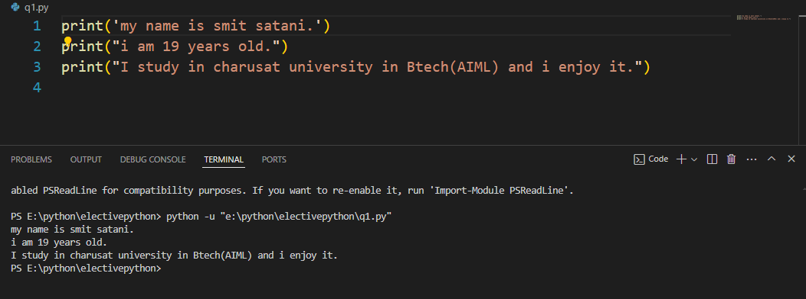

1. Write a python program to input user name and greet the user.

**Code / Output :**

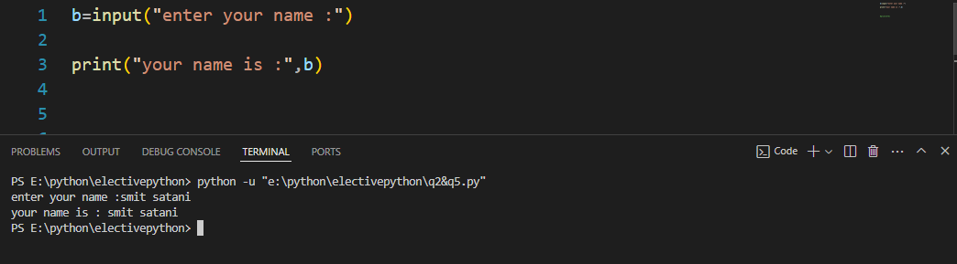

1. Write a python program to create four variable namely university, establish_in, location_lat, and location_log , also store values “CHARUSAT”, 2009, 22.5996, 72.8205 to respective variable. Print each variable type.

**Code / Output :**

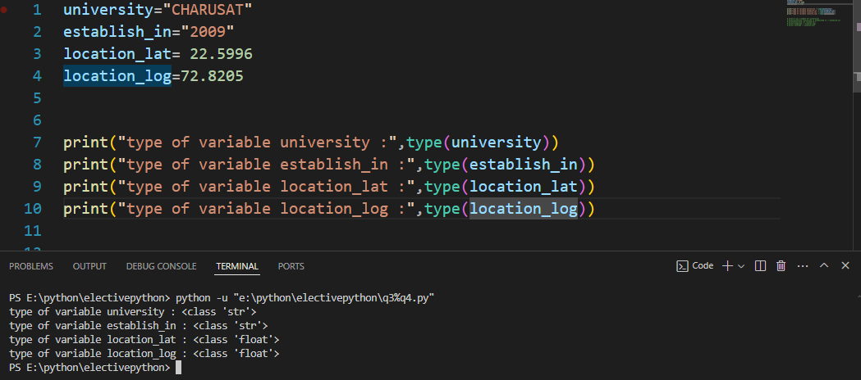

1. Write a python program to print following output. (Use variables and values from example 3)

**Code / Output :**

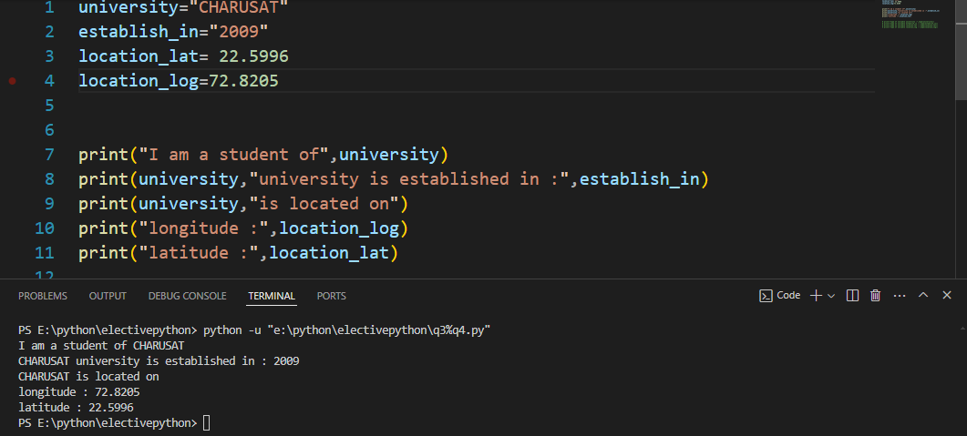

1. Write a python program to perform addition of two numbers. (Two number here are 4 and 5)

**Code / Output :**

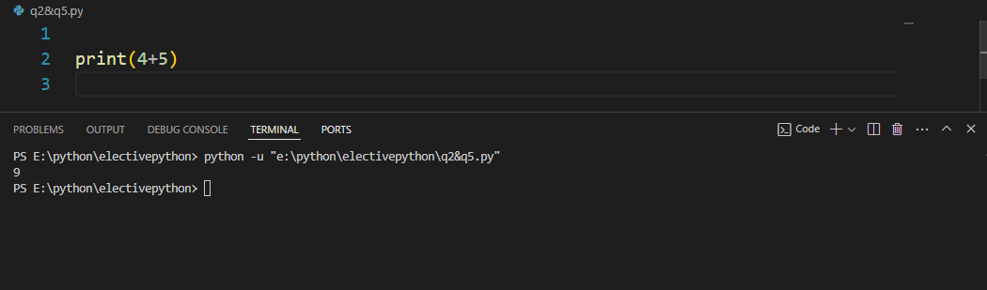

1. Write a python program to input a number by user, print data type of variable in which you have stored the number.

**Code / Output :**

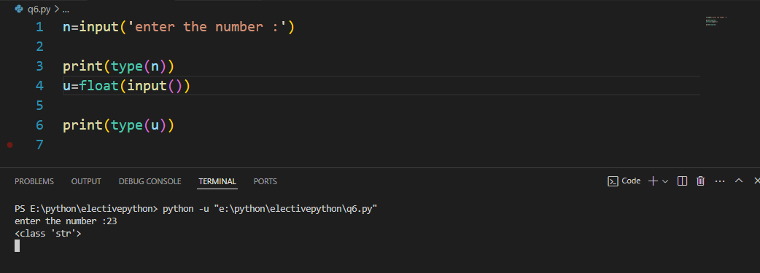

1. Write a python program to ask user for two numbers and perform addition, subtraction, division and multiplication of that numbers and store in separate variables. Print output of all arithmetic operations and print all data types of output.

**Code / Output :**

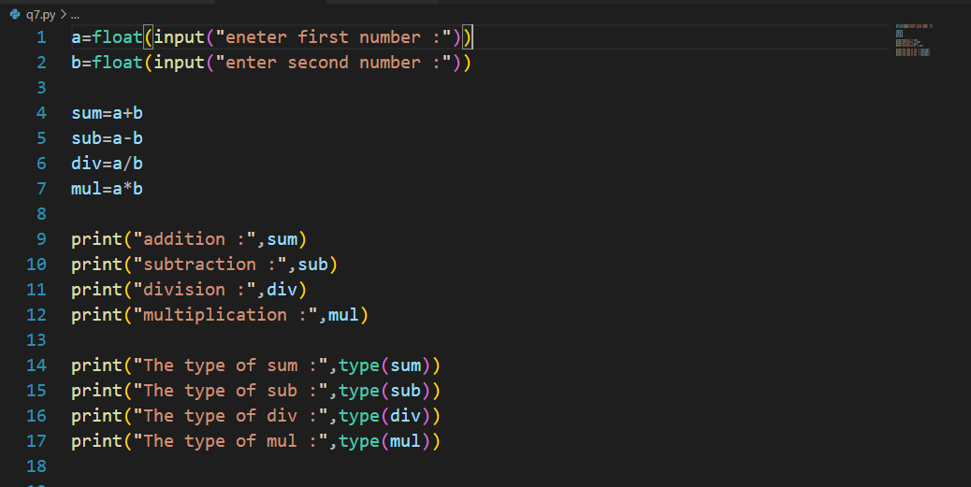

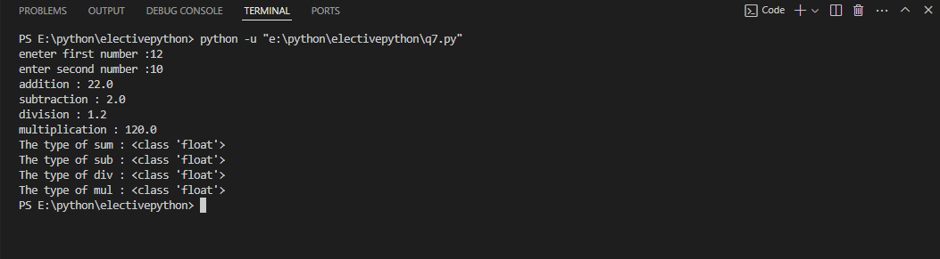

1. Write a python program to calculate fixed deposit return(simple interest) based on fixed deposit amount, tenure and interest rate.

**Code / Output :**

