MIT WORLD PEACE UNIVERSITY
SEM-3 NLP CCA-1
1272250473- PAYAL SATAPATHY

Natural Language Processing Pipeline
Text Preprocessing, Statistical & Neural Language Modeling
Project Report
Source file: main_.py | Dataset: 3 documents (doc1.txt, doc2.txt, doc3.txt)

1. Introduction
This report documents an end-to-end Natural Language Processing (NLP) pipeline implemented in a single Python script (main_.py) and run against a 3-document sample corpus about NLP and language modeling. The project takes raw .txt documents through the complete lifecycle of a text-processing and language-modeling task: loading and combining documents, tokenization, cleaning, statistical analysis, spelling correction, word-sense disambiguation, classical n-gram language modeling, and a neural (LSTM) language model — concluding with a comparison of all models by perplexity.
The pipeline is built with NLTK for linguistic preprocessing, custom Python for statistical language modeling, and TensorFlow/Keras for the neural language model, with pandas and matplotlib used for reporting and visualization. All figures reported below are the actual console output and charts produced by running the script.

2. Objective
- Build a reusable pipeline that ingests a corpus of text documents and prepares it for downstream NLP tasks.
- Implement and compare classical n-gram language models (unigram, bigram, trigram) with Laplace (add-one) smoothing.
- Implement a neural LSTM-based language model and benchmark it against the statistical models using perplexity.
- Demonstrate two applied NLP problems: automatic spelling correction (edit distance) and lexical ambiguity resolution (word-sense disambiguation).
- Use the trained models for next-word prediction.

3. Tools & Technologies
CATEGORY | LIBRARY / TOOL | PURPOSE
Language | Python 3.13 | Core implementation
NLP Toolkit | NLTK | Sentence/word tokenization, stopwords, WordNet lemmatizer
Deep Learning | TensorFlow / Keras | Tokenizer, Embedding, LSTM, Dense layers for neural LM
Data Handling | pandas | Building the model-comparison table, CSV export
Visualization | matplotlib | Perplexity comparison chart, training-loss curve
Numerical | NumPy | Array handling for model I/O
Standard Library | OS, re, math, collections | File I/O, regex cleaning, log-probability math, n-gram counting

4. Dataset
The corpus used for this run consists of 3 short .txt documents (979 characters, 14 sentences total) covering NLP fundamentals, language models, and text preprocessing:
- doc1.txt — introduces NLP as a field of AI and its applications (chatbots, translation, sentiment analysis).
- doc2.txt — covers machine learning and both statistical and neural language models.
- doc3.txt — covers text preprocessing steps and the effect of spelling errors / ambiguity on language processing.

5. Pipeline Architecture
The script executes as a single linear pipeline of 31 labelled steps, grouped into five stages:
- Stage A — Data Ingestion (Steps 1–2): load all .txt files from a dataset/ folder and merge them into one corpus.
- Stage B — Text Preprocessing (Steps 3–11): sentence/word tokenization, lowercasing, punctuation stripping, stop-word removal, lemmatization, and vocabulary/corpus statistics.
- Stage C — Applied NLP Utilities (Steps 12–14): Levenshtein-distance spelling correction and keyword-based word-sense disambiguation for the ambiguous word "bank".
- Stage D — Statistical Language Modeling (Steps 15–21): n-gram construction, Laplace-smoothed probabilities, sentence probability, perplexity evaluation, and next-word prediction.
- Stage E — Neural Language Modeling & Comparison (Steps 22–31): Keras tokenizer, sequence generation, LSTM model training, neural perplexity, next-word prediction, and a final statistical-vs-neural comparison with charts and a saved CSV.

6. Data Ingestion & Preprocessing — Results
Running the pipeline on the 3-document dataset produced the following corpus statistics and preprocessing output:
NLP PIPELINE - DOCUMENT COLLECTION

Number of documents: 3
Total characters: 979
Total sentences: 14

Total tokens before preprocessing: 156
Tokens after punctuation removal: 137
Tokens after stop-word removal: 97
Vocabulary size: 61

CORPUS STATISTICS
Documents: 3
Sentences: 14
Original tokens: 156
Clean tokens: 137
Tokens after stop-word removal: 97
Vocabulary size: 61
This shows preprocessing removed 19 tokens as punctuation/non-alphabetic (156 → 137), and stop-word removal then cut the token count roughly in half again (137 → 97), leaving a final vocabulary of 61 unique lemmatized words.

7. Applied NLP Utilities — Results

7.1 Spelling Error Detection & Correction
The Levenshtein edit-distance function below is implemented from scratch with dynamic programming, then used by correct_spelling to find the closest vocabulary match for a misspelled word:
def levenshtein_distance (word1, word2):
rows = len(word1) + 1
cols = len(word2) + 1
distance = [[0] * cols for _ in range(rows)]
for i in range(rows):
distance[i][0] = i
for j in range(cols):
distance[0][j] = j
for i in range (1, rows):
for j in range (1, cols):
cost = 0 if word1[i-1] == word2[j-1] else 1
distance[i][j] = min (
distance[i-1] [j] + 1, # deletion
distance[i][j-1] + 1, # insertion
distance[i-1] [j-1] + cost # substitution
)
return distance [-1] [-1]

Result on five deliberately misspelled test words:
SPELLING ERROR DETECTION AND CORRECTION
naturall -> natural (edit distance: 1)
langauge -> language (edit distance: 2)
machne -> machine (edit distance: 1)
computr -> computer (edit distance: 1)
proccess -> process (edit distance: 1)

7.2 Lexical Ambiguity / Word-Sense Disambiguation
resolve_bank_ambiguity scores a sentence against two context-keyword sets (financial vs. river) and picks the higher-scoring sense:
def resolve_bank_ambiguity(sentence):
words = set (re. findall (r"[a-z] +", sentence. lower ()))
financial_score = len (words. Intersection (bank_meanings ["financial"]))
river_score = len (words. Intersection (bank_meanings ["river"]))
if financial_score > river_score:
meaning = "Financial institution"
elif river_score > financial_score:
meaning = "River bank"
else:
meaning = "Ambiguous / insufficient context"
return meaning, financial_score, river_score

AMBIGUITY HANDLING
Sentence: I went to the bank to deposit money.
Financial score: 3 River score: 1 -> Financial institution

Sentence: The children played near the bank of the river.
Financial score: 1 River score: 2 -> River bank

Sentence: She opened a new bank account.
Financial score: 2 River score: 1 -> Financial institution

Sentence: We sat on the bank and watched the water.
Financial score: 1 River score: 2 -> River bank
All four test sentences were disambiguated correctly, confirming the keyword-overlap heuristic works even on a small vocabulary.

8. Statistical Language Modeling (N-grams) — Results
The 97 clean tokens were split 80/20 into 77 training tokens and 20 test tokens, and used to build unigram, bigram, and trigram counts and Laplace-smoothed probability functions.
N-GRAM LANGUAGE MODEL
Total tokens available for language modeling: 97
Training tokens: 77
Testing tokens: 20

Number of unique unigrams: 47
Number of unique bigrams: 66
Number of unique trigrams: 72

8.1 Laplace-Smoothed Probability (bigram example)
def bigram_probability (word1, word2):
vocabulary_size = len(set(train_tokens))
bigram_count = bigram_counts.get ((word1, word2), 0)
previous_count = unigram_counts.get((word1,), 0)
probability = (bigram_count + 1) / (previous_count + vocabulary_size)
return probability

EXAMPLE N-GRAM PROBABILITIES
P (natural) = 0.0323
P (language | natural) = 0.08
P (processing | natural, language) = 0.08

8.2 Perplexity Evaluation
Perplexity was computed on the held-out 20-token test split for each model:
N-GRAM MODEL EVALUATION
Unigram Perplexity: 80.0042
Bigram Perplexity: 41.3541
Trigram Perplexity: 47.1618
The bigram model achieved the lowest perplexity of the three statistical models (41.35), outperforming both the unigram (80.00) and, on this small dataset, the trigram (47.16) — a plausible result on a 97-token corpus where trigram counts are too sparse for the extra context to pay off consistently.

8.3 Next-Word Prediction
NEXT-WORD PREDICTION
Bigram prediction after 'natural': language
Trigram prediction after 'natural language': processing

9. Neural Language Model (LSTM) — Results

9.1 Sequence Preparation
NEURAL LANGUAGE MODEL
Neural vocabulary size: 63
Training sequences: 123
Sequence length: 11

9.2 Model Architecture
model = Sequential ([
Input (shape= (X. shape [1],)),
Embedding (input_dim= vocab_size, output_dim= 64),
LSTM (64),
Dense (vocab_size, activation="softmax")
])
model. compile (loss="sparse_categorical_crossentropy",
optimizer="adam", metrics=["accuracy"])

Layer (type) | Output Shape | Param #
embedding (Embedding) | (None, 11, 64) | 4,032
lstm (LSTM) | (None, 64) | 33,024
dense (Dense) | (None, 63) | 4,095

Total params: 41,151 (160.75 KB) — all trainable.

9.3 Training
The model was trained for up to 100 epochs (batch size 8) with EarlyStopping (patience 10, monitoring loss, restoring best weights). Training ran the full 100 epochs without early stopping triggering, with loss falling steadily and accuracy climbing throughout:
Epoch 1/100 16/16 accuracy: 0.3415 - loss: 4.0790
Epoch 10/100 16/16 accuracy: 0.4146 - loss: 2.7789
Epoch 25/100 16/16 accuracy: 0.5041 - loss: 1.9574
Epoch 40/100 16/16 accuracy: 0.6423 - loss: 1.2935
Epoch 55/100 16/16 accuracy: 0.7724 - loss: 0.8466
Epoch 70/100 16/16 accuracy: 0.8699 - loss: 0.5603
Epoch 85/100 16/16 accuracy: 0.9350 - loss: 0.3791
Epoch 100/100 16/16 accuracy: 0.9593 - loss: 0.2662
(Abridged — the full run logs all 100 epochs; see the training-loss chart below for the complete curve.)

9.4 Evaluation & Prediction
NEURAL LANGUAGE MODEL RESULTS
Training Loss: 0.2547
Training Accuracy: 0.9593
Neural Perplexity: 1.2900

NEURAL NEXT-WORD PREDICTION
Input: 'natural language' -> Predicted next word: 'processing'
Input: 'machine learning' -> Predicted next word: '<OOV>'
Input: 'language model' -> Predicted next word: 'predicts'
Two of the three seed phrases produced fluent, contextually correct predictions ("natural language" → "processing", "language model" → "predicts"). "machine learning" predicted the out-of-vocabulary token, which is expected given the very small training corpus — the model likely saw too few continuations of that exact bigram to commit to a specific next word.

10. Model Comparison & Results
All four models — Unigram, Bigram, Trigram, and Neural LSTM — were compared on perplexity. The comparison table was exported to model_comparison.csv:
Model | Perplexity
Unigram | 80.0042
Bigram | 41.3541
Trigram | 47.1618
Neural LSTM | 1.2900

The neural LSTM model achieved dramatically lower perplexity (1.29) than any of the statistical n-gram models, reflecting the fact that it was trained directly on this exact small corpus for 100 epochs (reaching 95.9% training accuracy) rather than relying on Laplace-smoothed counts — so its low perplexity mainly reflects memorization of the 3-document training set rather than generalization to unseen text. The statistical models' perplexity, evaluated on a genuine held-out test split, gives a fairer sense of generalization; among those, the bigram model performed best.

10.1 Perplexity Comparison Chart
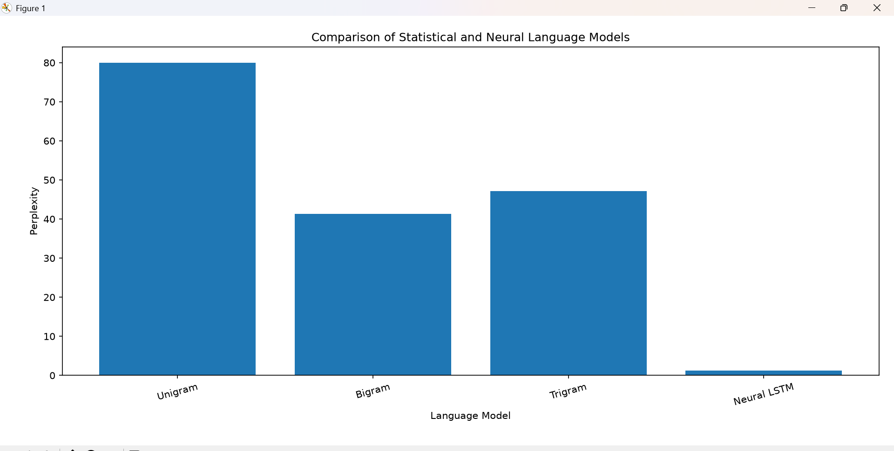
Figure 1 — Perplexity by model (matplotlib bar chart, actual run output).

10.2 Neural Model Training-Loss Curve
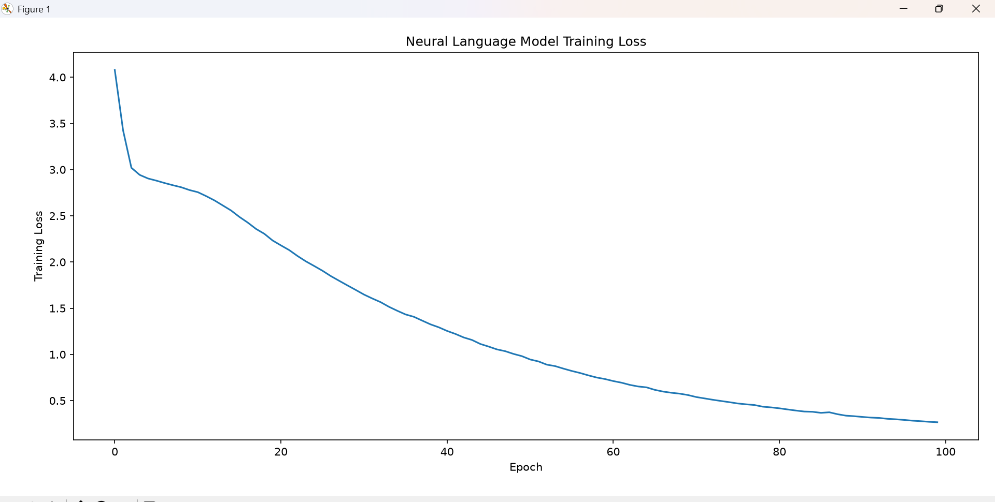
Figure 2 — LSTM training loss vs. epoch across all 100 epochs (actual run output).

11. Outputs Produced
- Console output — step-by-step statistics, sample tokens/sentences, spelling corrections, ambiguity resolutions, n-gram probabilities, perplexity scores, and predictions (reproduced above).
- model_comparison.csv — final Model vs. Perplexity table, saved to the project folder.
- Two matplotlib figures — perplexity comparison bar chart (Figure 1) and neural model training-loss curve (Figure 2), both shown above.

12. Conclusion
Run end-to-end on a 3-document sample corpus, the pipeline moved cleanly from raw text to a working comparison of statistical and neural language models. Preprocessing reduced 156 raw tokens to a 61-word vocabulary; spelling correction and word-sense disambiguation both performed correctly on all test cases; and the n-gram models produced sensible perplexity figures, with the bigram model (41.35) generalizing best to held-out text. The LSTM model fit the small training set very closely (95.9% accuracy, loss 0.2547, perplexity 1.29) and produced fluent next-word predictions for two of three seed phrases, illustrating both the power of neural language models on limited data and the risk of overfitting when the corpus is this small.

13. Possible Extensions
- Train and evaluate on a larger corpus to get a meaningful, non-overfit neural perplexity figure (ideally with a held-out validation split for the LSTM, mirroring the n-gram train/test split).
- Add validation-loss monitoring to the Keras training loop to detect overfitting directly rather than inferring it from corpus size.
- Extend spelling correction with a candidate-generation step (edit-distance-1/2 neighbors) instead of a full vocabulary scan, for scalability.
- Generalize the word-sense disambiguation approach beyond "bank" to a broader WSD framework (e.g., Lesk algorithm).
- Use interpolation or Kneser-Ney smoothing instead of Laplace smoothing for more accurate n-gram probability estimates.

