MIT WORLD PEACE UNIVERSITY

SEM-3 SMA CCA-1

1272250473- PAYAL SATAPATHY

Social Media Network Analytics
From Data Collection to Network Visualization and Insights
Project Report
Analysis of a Twitter Ego-Network using Python, NetworkX, and Gephi
81,306 users | 1,768,135 connections | 73 communities
Prepared from: sm_network_analysis.ipynb

1. Executive Summary
This project builds an end-to-end social network analytics pipeline on a Twitter ego-network dataset, covering data cleaning, graph construction, network-level and centrality analysis, community detection, and visualization with NetworkX and Gephi. The goal is to identify influential users, highly connected nodes, bridge users, and the community structure of the network.
81,306  Users (nodes) | 1,768,135  Connections (edges) | 0.000267  Network density | 73  Communities

The network was found to be a single connected component (every user reachable from every other user when direction is ignored), highly sparse, and organized into a large number of communities of widely varying size — a small set of large hub communities alongside many small ones.

2. Objective
- Collect and clean a raw Twitter connections dataset into an analysis-ready format.
- Construct a directed social graph and validate its structure.
- Quantify influence and connectivity using degree, PageRank, betweenness, and closeness centrality.
- Detect communities of closely-connected users using the Louvain algorithm.
- Visualize the network with NetworkX and export it for exploration in Gephi.
- Summarize key structural insights about the network.

3. Dataset & Methodology

3.1 Data Source
The raw dataset (twitter_combined.txt) contains directed “follows” relationships between Twitter user IDs, loaded as a two-column edge list (source → target) using pandas.

3.2 Data Cleaning
Step | Result
Raw rows loaded | 2,420,766
Missing values | 0
Duplicate rows removed | 652,617
Self-loops removed | 22
Unique users | 81,306
Final connections | 1,768,135

The cleaned edge list was checked for consistency (row counts matched between pandas and the constructed graph) and saved as twitter_network_clean.csv before graph construction.

3.3 Tools & Libraries
- Python, pandas — data loading and cleaning
- NetworkX — graph construction, centrality, and community algorithms
- python-louvain (community package) — Louvain community detection on the full network
- Matplotlib — degree distribution, ranking, and network charts
- Gephi (via GEXF export) — large-scale network visualization

4. Network Construction & Structure
A directed graph (DiGraph) was built from the cleaned edge list, with 81,306 nodes and 1,768,135 edges — matching the cleaned dataset exactly, confirming the graph was built correctly.
Yes  Directed | 1  Connected components | 0.565  Avg. clustering coeff | 0.171  Transitivity

Converting to an undirected graph collapses reciprocal edges to 1,342,296 unique connections. All 81,306 users fall into a single connected component, meaning the entire network is reachable end-to-end once edge direction is ignored. The relatively high average clustering coefficient (0.565) alongside lower transitivity (0.171) suggests that while individual users' neighborhoods tend to be tightly knit, this doesn't hold uniformly across all triads in the network — typical of real-world social networks with a mix of dense local clusters and long bridging paths.
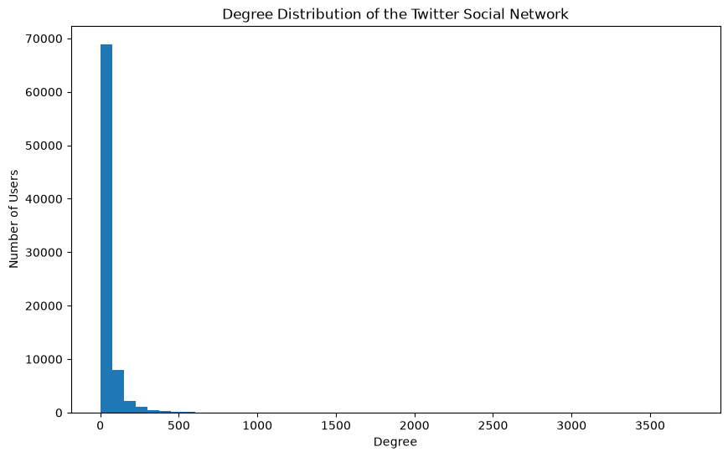
Figure 1. Degree distribution of the social network (log-tailed, typical of scale-free social graphs).

5. Centrality Analysis
Four complementary centrality measures were computed to characterize different notions of importance in the network: in/out-degree (raw connectivity), PageRank (recursive influence), betweenness (bridging position, approximated via 500-node sampling for tractability), and closeness (approximated via 1,000-node sampling on the largest component).

5.1 Top Users by PageRank (Overall Influence)
Rank | User ID | PageRank | In-degree
1 | 115485051 | 0.004331 | 3,383
2 | 116485573 | 0.004133 | 4
3 | 813286 | 0.002339 | 2,647
4 | 40981798 | 0.001372 | 3,216
5 | 7861312 | 0.001254 | 2,074
6 | 11348282 | 0.001222 | 1,707
7 | 17093617 | 0.001076 | 687
8 | 15439395 | 0.001031 | n/a
9 | 18396070 | 0.001029 | n/a
10 | 14230524 | 0.001014 | n/a

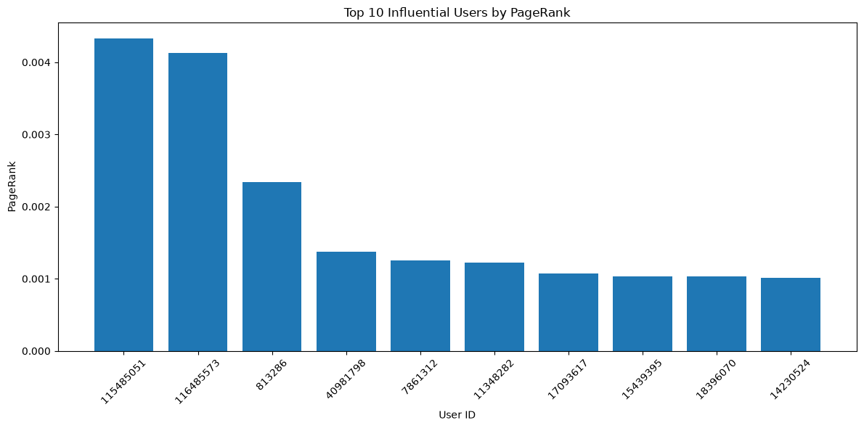
Figure 2. Top 10 users ranked by PageRank.

5.2 Top Users by Degree
By in-degree (most followers/incoming links), user 115485051 leads with 3,383, followed by 40981798 (3,216) and 43003845 (2,735). By out-degree (most outgoing connections), user 59804598 leads with 1,205, followed by 3359851 (1,158) and 813286 (1,111). Average in-degree and out-degree are both 21.75, as expected for a directed graph.

5.3 Top Users by Betweenness Centrality (Bridge Users)
Betweenness identifies users who sit on many shortest paths between other users — structural “bridges” connecting otherwise distant parts of the network.
Rank | User ID | Betweenness | PageRank
1 | 813286 | 0.16526 | 0.002339
2 | 17093617 | 0.06368 | 0.001076
3 | 15846407 | 0.05422 | 0.000813
4 | 3359851 | 0.04812 | 0.000652
5 | 15439395 | 0.03060 | 0.001031
6 | 12611642 | 0.03057 | 0.000330
7 | 59804598 | 0.02622 | 0.000334
8 | 5442012 | 0.02277 | n/a
9 | 22679419 | 0.02070 | n/a
10 | 2367911 | 0.01991 | n/a

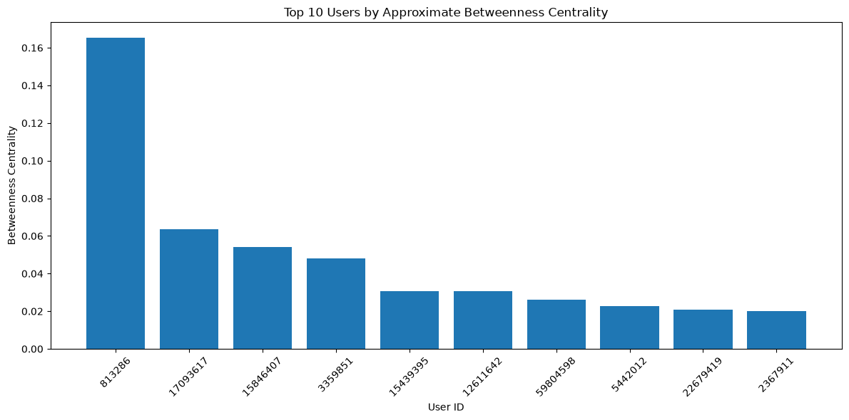
Figure 3. Top 10 users by approximate betweenness centrality.
User 813286 stands out sharply — its betweenness score (0.165) is over twice that of the next-highest user, and it also ranks in the top 3 for both PageRank and in-degree, marking it as a uniquely important structural connector as well as a popular account.

5.4 Top Users by Closeness Centrality
Closeness centrality (approximated on a 1,000-user sample within the largest component) surfaces a different set of users — 73707412, 16726878, and 49717874 top the list — indicating users positioned centrally in terms of shortest average path length to the rest of the network, distinct from the highest-PageRank or highest-betweenness users.

6. Community Detection
The Louvain algorithm was applied to the full undirected network (81,306 users) to detect densely-connected user groups.
73  Communities found | 9,904 users  Largest community | 31,984 users  Top 4 communities

6.1 Largest Communities (Full Network)
Rank | Community ID | Size (users) | Most Influential Member (by PageRank)
1 | 6 | 9,904 | 115485051
2 | 11 | 8,464 | 15913
3 | 8 | 6,394 | 972651
4 | 0 | 6,222 | 40981798
5 | 52 | 4,852 | —
6 | 62 | 4,108 | —
7 | 23 | 3,530 | —
8 | 33 | 2,561 | —
9 | 7 | 2,405 | —
10 | 5 | 1,952 | —

The four largest communities together account for roughly 39% of all users, indicating the network has a small number of dominant clusters alongside a long tail of smaller ones — consistent with hub-and-community structure typical of social platforms.

6.2 Community Structure on the Visualization Subgraph
For visualization purposes, a smaller subgraph of the top 1,000 users by PageRank was extracted (30,628 directed edges) and re-analysed with Louvain, identifying 18 communities. The two largest of these contain 269 and 260 users respectively, while several communities in the tail consist of just 1–2 users — showing that even among the most influential accounts, community cohesion varies widely.

7. Network Visualizations
An induced subgraph of the top 20 users by PageRank (with 71 connections among them) was visualized directly with NetworkX to illustrate the core influential cluster:
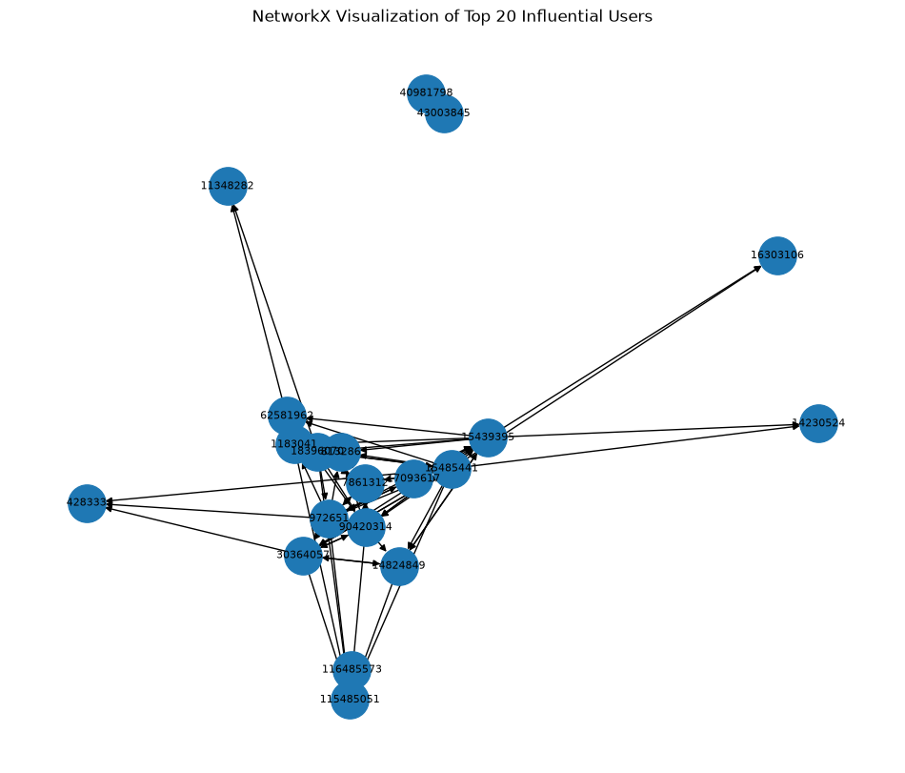
Figure 4. NetworkX visualization of the top 20 most influential users and their interconnections.
The full network (and a reduced 1,000-node subset with community and centrality attributes attached) was also exported to GEXF format for interactive exploration in Gephi, enabling force-directed layouts and visual community colouring beyond what static Matplotlib charts can show.

8. Key Insights
- User 115485051 has both the highest PageRank and the highest in-degree, indicating it is the single most influential and widely-followed account in the network.
- User 59804598 has the highest out-degree, i.e. it follows the most other users.
- User 813286 has by far the highest betweenness centrality, marking it as the network's key structural bridge connecting otherwise distant communities — while also ranking highly on PageRank and in-degree.
- Different centrality measures surface different “important” users — no single user dominates every measure, highlighting that influence, connectivity, and bridging are distinct network roles.
- Network density is extremely low (≈ 0.000267), confirming the network is highly sparse relative to the number of theoretically possible connections.
- The network is fully connected as a single component (81,306 of 81,306 users), meaning any two users can be linked through some path once direction is ignored.
- The dataset represents unweighted “follows” relationships, so relationship strength/frequency could not be assessed — only structural connectivity (degree, PageRank, betweenness, community) was analysed.

9. Conclusion
This project delivered an end-to-end social media network analytics pipeline — from raw data acquisition and cleaning, through graph construction, centrality and community analysis, to visualization with NetworkX and Gephi. Applied to a Twitter dataset of 81,306 users and 1,768,135 directed connections, the analysis revealed a sparse but fully-connected network (density ≈ 0.000267) organized into 73 distinct communities, with clearly identifiable influential users (by PageRank and degree) and structural bridge users (by betweenness centrality). These findings demonstrate how graph-theoretic techniques can surface the key players and organizational structure within large-scale social networks.

Limitations
- Betweenness and closeness centrality were computed on samples (500 and 1,000 nodes respectively) rather than exhaustively, for computational tractability on a network of this size — reported values are approximations.
- Relationships in the dataset are unweighted, so interaction strength/frequency could not be incorporated into the analysis.
- Community detection (Louvain) is stochastic in general and depends on resolution/ordering; results were fixed with a random seed for reproducibility but represent one of several plausible partitions.

