PART A – THEORY

1. Two Components of the Analyst OS and Their Role in Producing Stakeholder-Ready Artifacts
a) Problem Framing Component
The Problem Framing component helps analysts clearly define the business problem, objectives, scope, constraints, and success criteria. It ensures that the analyst understands what stakeholders actually need before proposing solutions. By clearly structuring the problem, this component helps produce stakeholder-ready artifacts such as problem statements, business requirement documents (BRD), and scope definitions that are easy to understand and aligned with organizational goals.
b) Requirements & Documentation Component
The Requirements & Documentation component focuses on gathering, structuring, and formalizing requirements in a clear and organized manner. It transforms raw information from discussions into structured artifacts such as requirement specifications, user stories, use case diagrams, and process models. This ensures that stakeholders, developers, and project managers have a common understanding, reducing ambiguity and improving decision-making.

2. Elicitation and Two Suitable Elicitation Techniques
Definition of Elicitation: Elicitation is the process of gathering information from stakeholders to understand their needs, expectations, and real-world problems. It helps analysts uncover both explicit and hidden requirements to ensure that the final solution addresses the actual business challenge.
Two Elicitation Techniques:
1) Interviews – Conducting one-on-one discussions with stakeholders to gather detailed insights about their problems, expectations, and constraints. Interviews allow analysts to ask follow-up questions and clarify doubts in real time.
2) Workshops – Facilitated group sessions where multiple stakeholders collaborate to discuss requirements, resolve conflicts, and build consensus. Workshops are useful for understanding complex real-world problems from different perspectives.

3. Two Responsible AI Controls an Analyst Must Follow
1) Data Privacy and Confidentiality – Analysts must ensure that sensitive business or personal data is not improperly shared with AI tools. Confidential information should be anonymized or removed before using AI systems

2) Human Oversight and Validation – Outputs generated by AI tools must be reviewed and validated by the analyst before sharing with stakeholders. This ensures accuracy, reduces bias, and prevents the spread of incorrect or misleading information.
PART A – TECHNICAL
Real-World Problem Identified

Problem: Detecting student attention level in a classroom. In many classrooms, teachers cannot continuously monitor whether students are attentive or distracted. An automated observation-based system can help identify engagement levels in real time.

Objective:
Build an Image Classification model that detects student attention levels using webcam input.

Type of Model Used: Image Classification Model

Why Image?
Because attention level can be visually observed through posture, facial orientation, and activity (looking at teacher, using phone, sleeping, etc.).

We created 3 classes: 1.Attentive – Student looking forward, focused posture 2.Distracted – Looking sideways or using phone 3.Sleepy – Head down or eyes closed

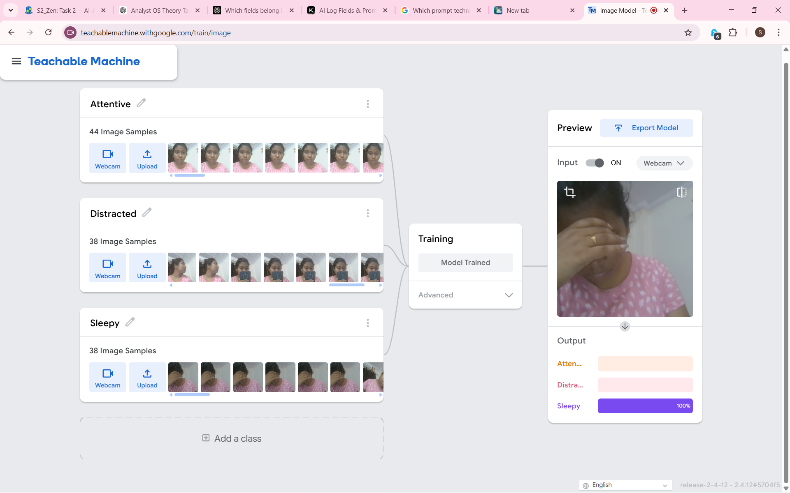
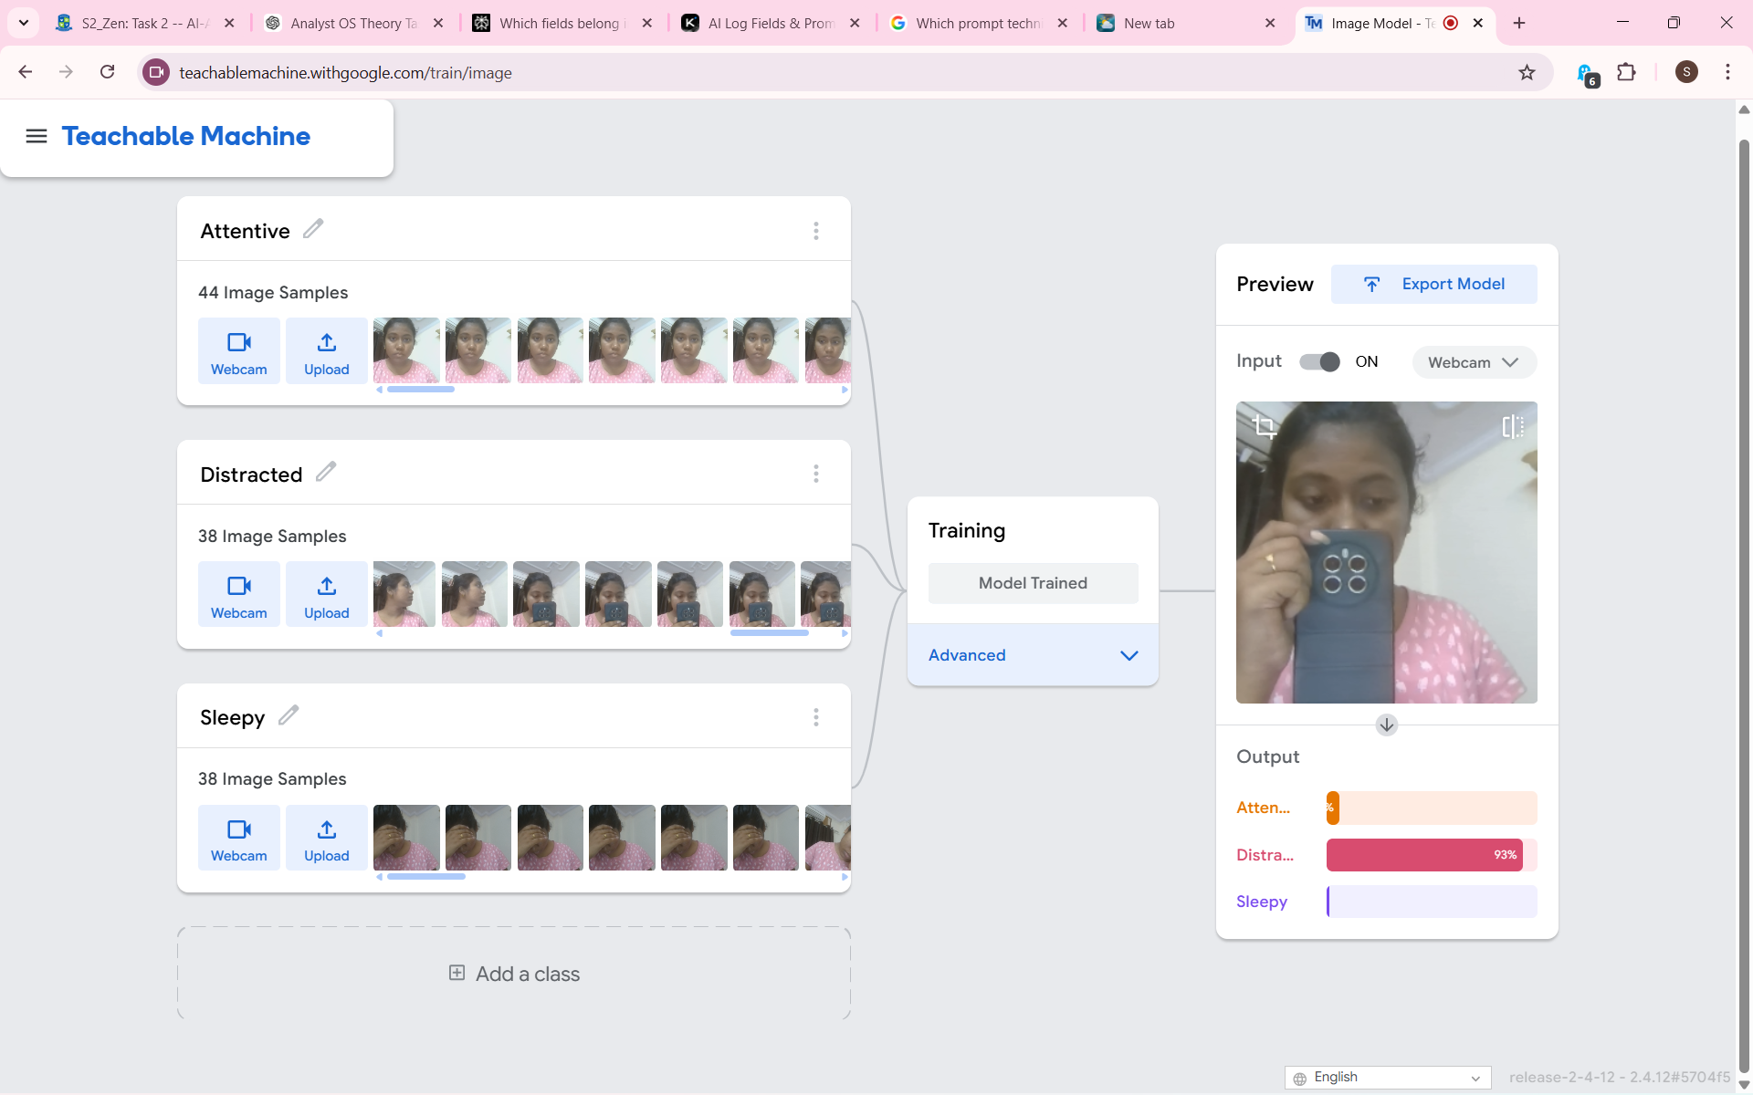
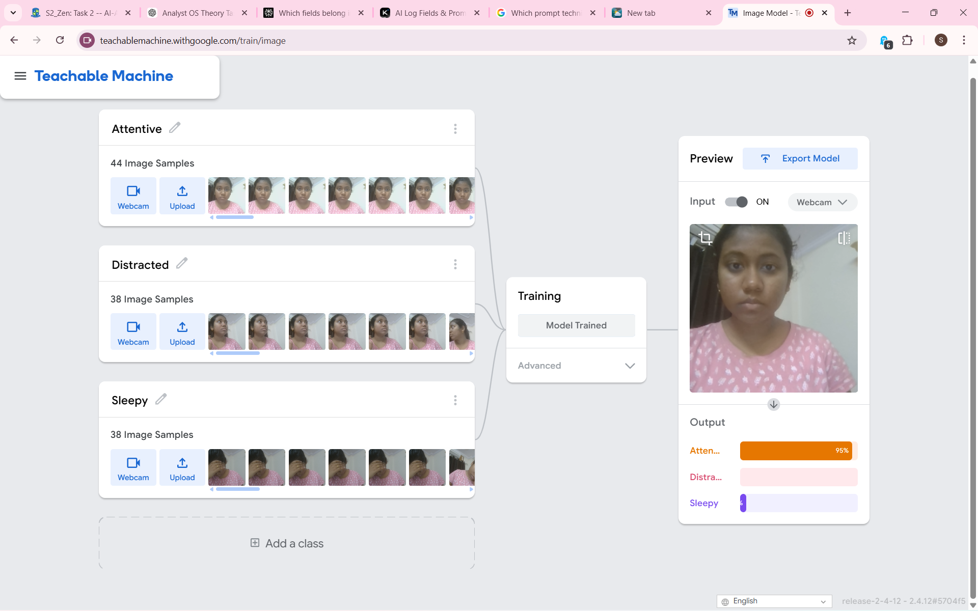
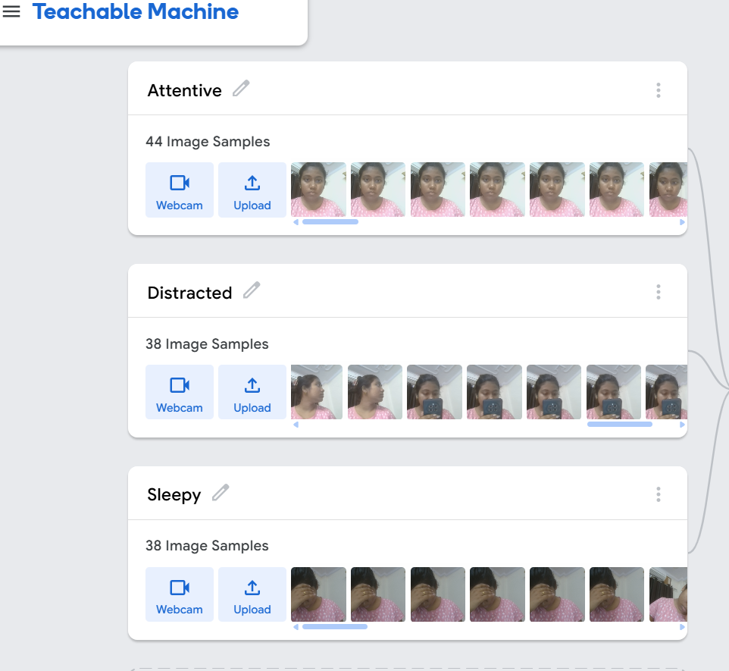

Training Process
- Collected 35-40 images per class using webcam.
- Trained model using built-in neural network.
- Tested using live preview mode.
Results
Model successfully classified the three behaviors with 85–95% confidence.
How It Supports Observation-Based Elicitation
Observation-based elicitation involves understanding real-world problems by observing user behavior . This model helps convert classroom behavior into measurable AI predictions, supporting data-driven decision-making.

