ID number : 22ce114

Faculty of Technology and Engineering

U & P U. Patel Department of Computer Engineering

**Practical Performa**

|  |  |  |  |  |  |
| --- | --- | --- | --- | --- | --- |
| Academic Year | : | 2024-25 | Semester | : | 6 |
| Course code | : | CE365 | Course name | : | Compiler Construction |

**Practical 3**

**Aim:**

**Screen Shot of Output:**

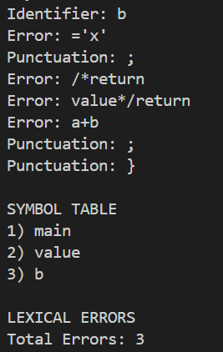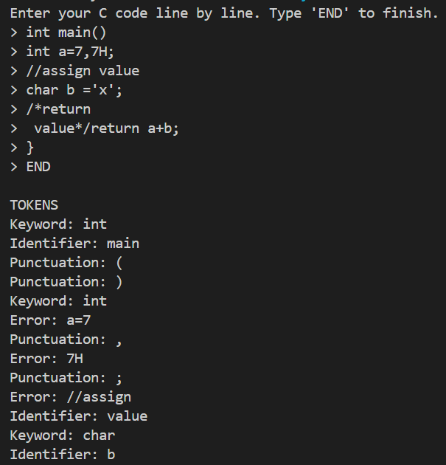

**Conclusion:**