ID number : 22ce114

Faculty of Technology and Engineering

U & P U. Patel Department of Computer Engineering

**Practical Performa**

|  |  |  |  |  |  |
| --- | --- | --- | --- | --- | --- |
| Academic Year | : | 2024-25 | Semester | : | 6 |
| Course code | : | CE365 | Course name | : | Compiler Construction |

**Practical 4**

**Aim:**

**Screen Shot of Output:**

**4.1 String validation using Lax Tool**

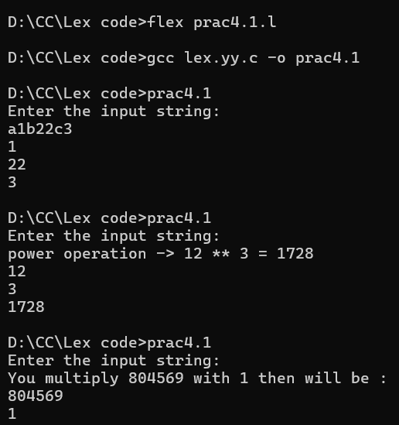

**4.2 Write a Program to replace the word “Charusat” with “University” in the input text.**

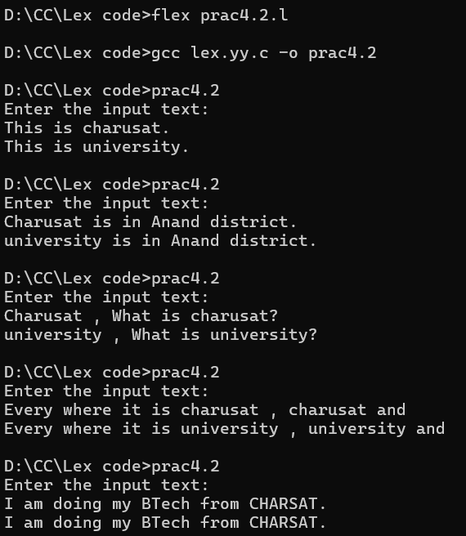

**4.3 Write a program to count number of characters, word and line from the input file.**

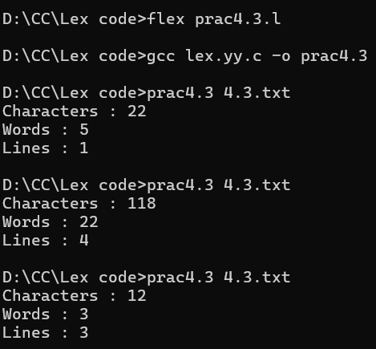

**4.4 Write a Program which validate password.**

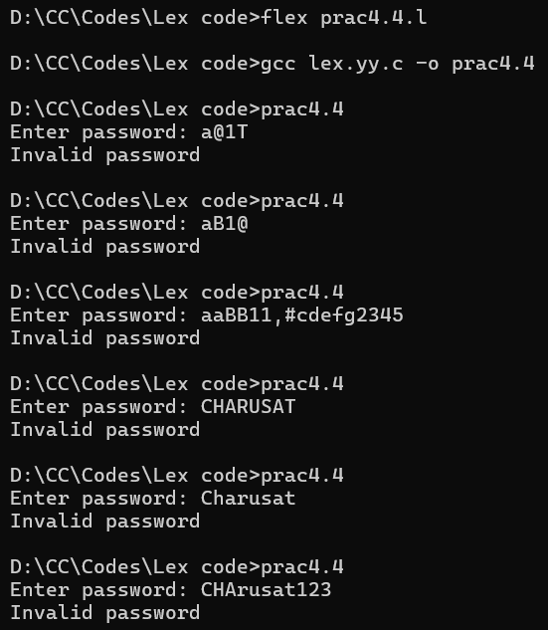

**Conclusion:**