AriOme Application
Screen Documentation with Screenshots

1. Welcome Screen
Route: /
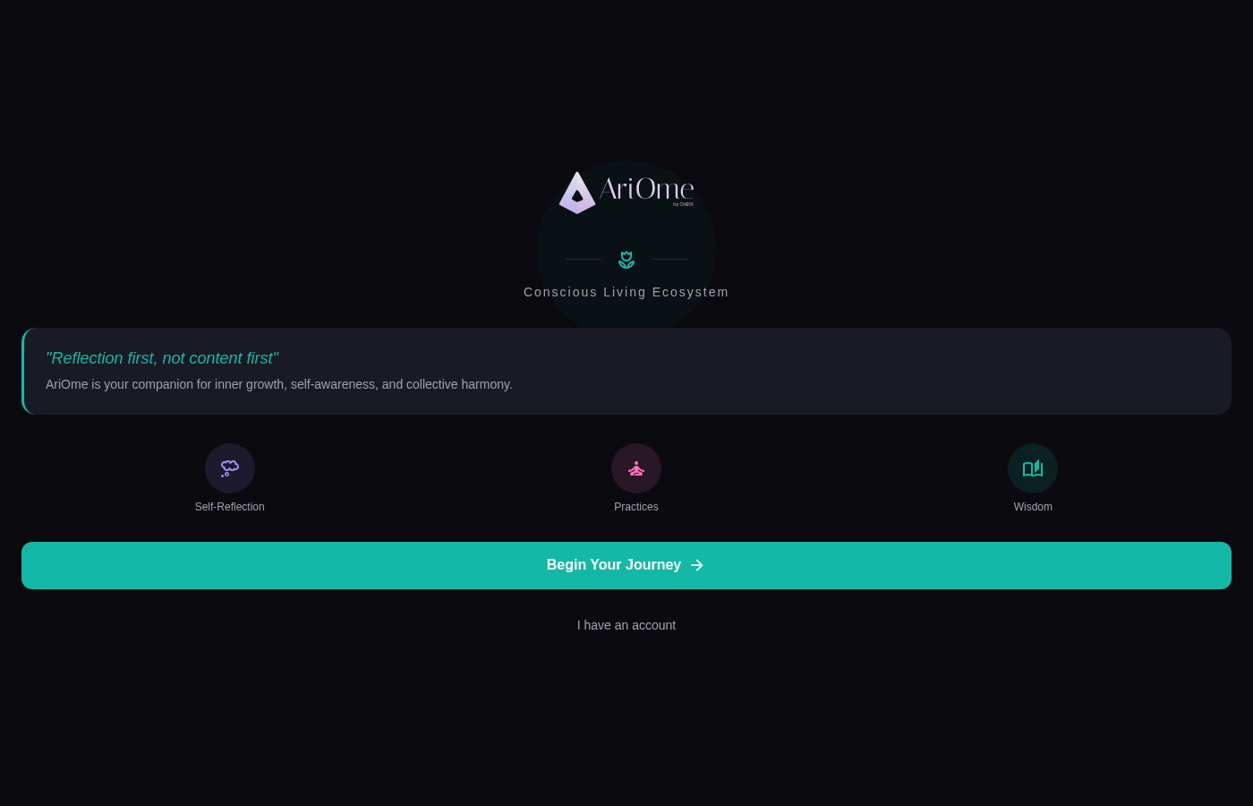

2. Onboarding - Welcome
Route: /onboarding
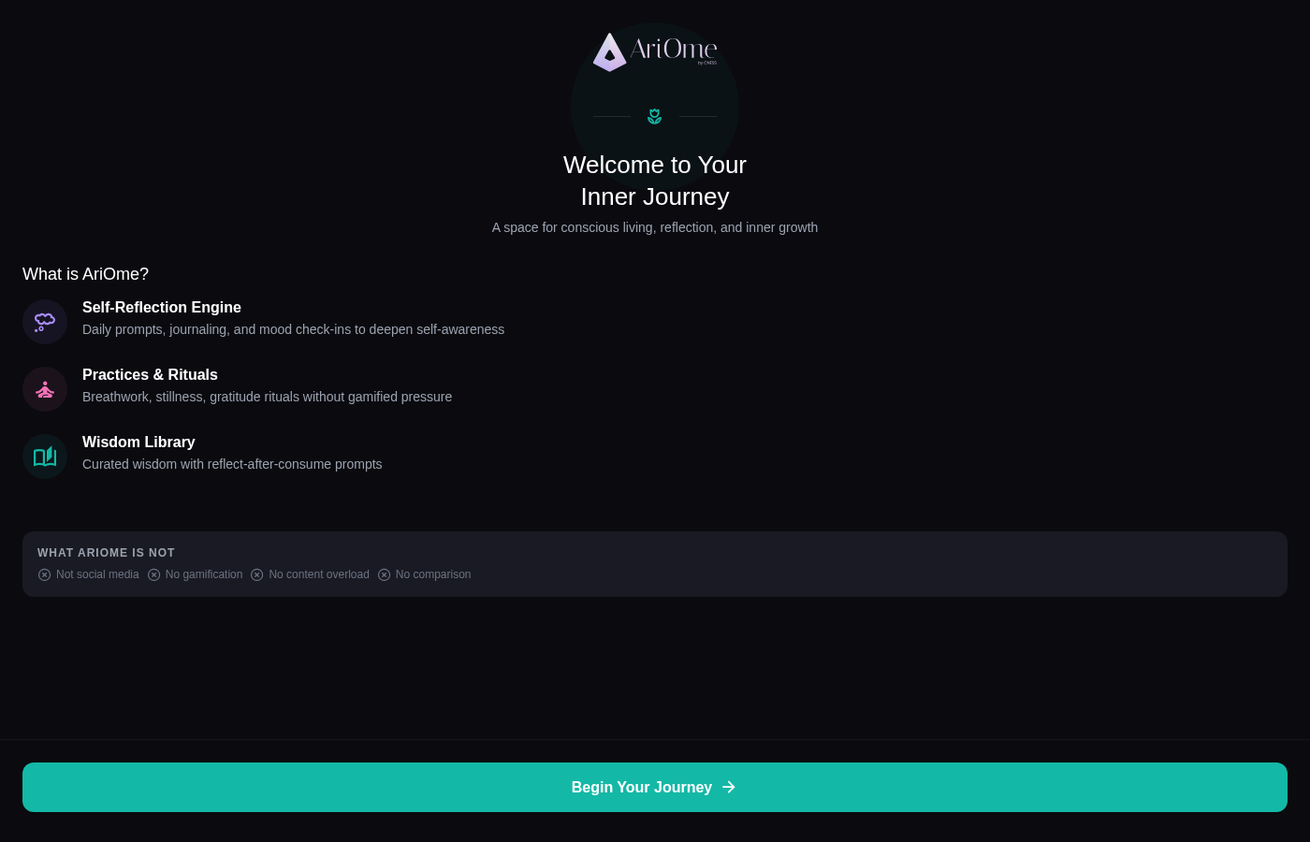

3. Onboarding - Intention Selection
Route: /onboarding (Step 2)
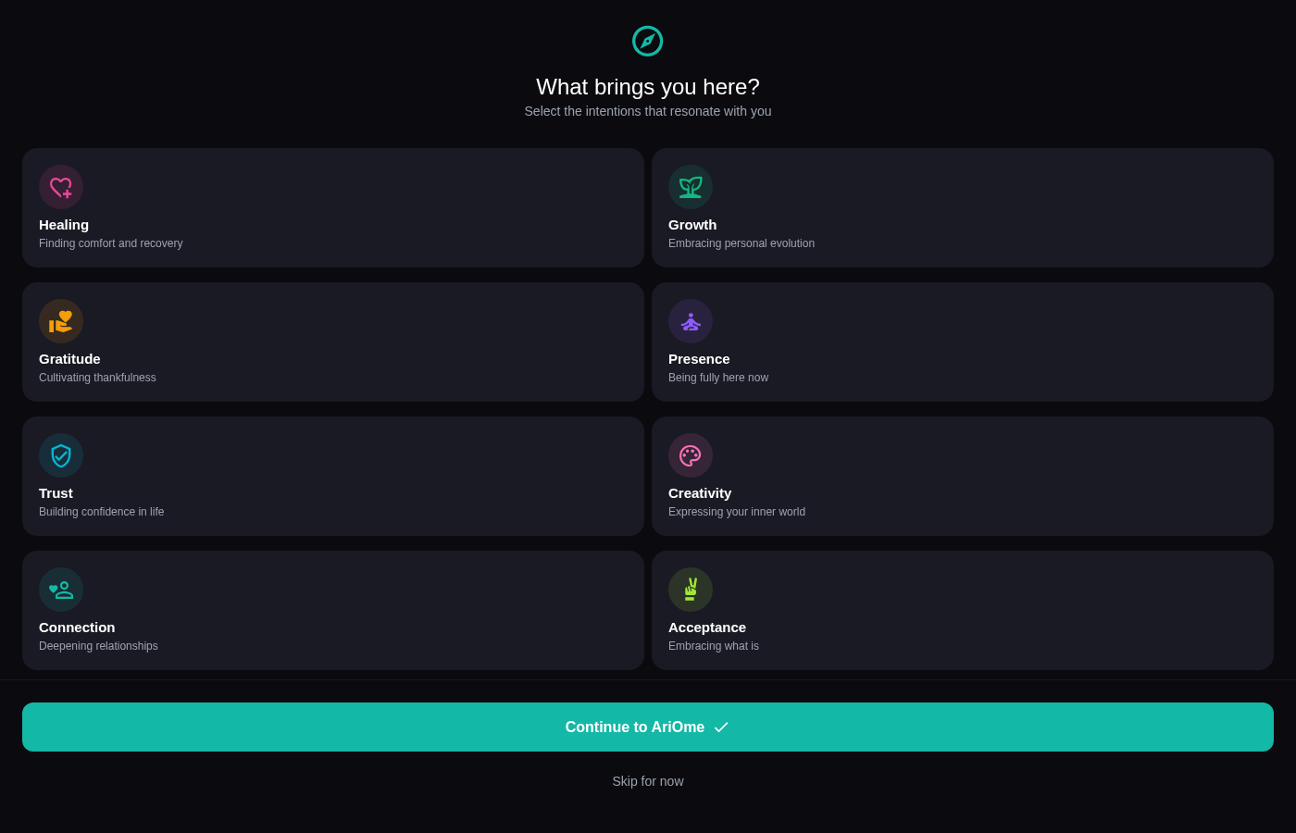

4. Authentication - Login
Route: /auth
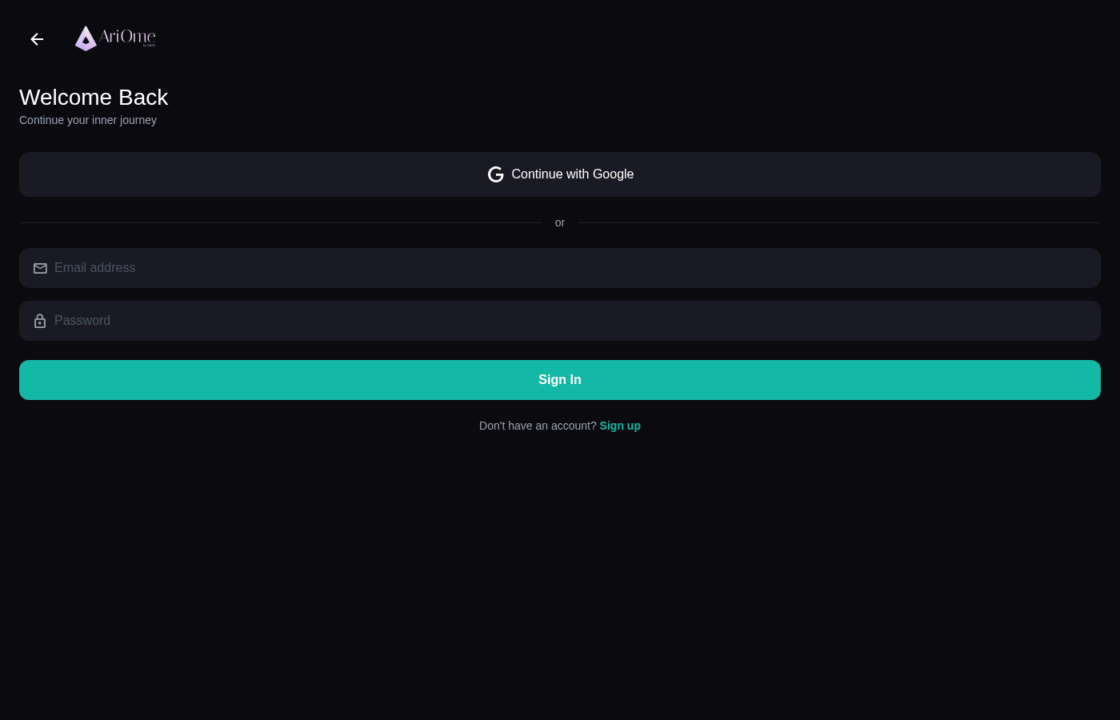

5. Authentication - Register
Route: /auth (Register mode)
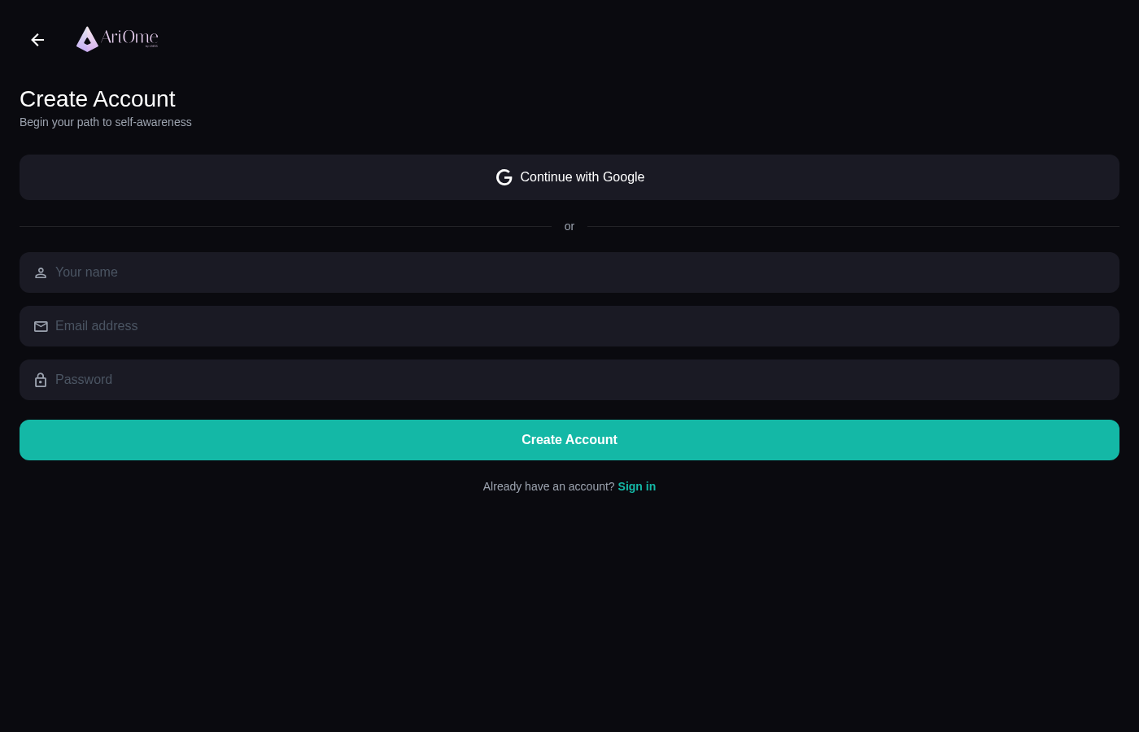

6. Reflect Screen (Self-AriOme)
Route: /(tabs)/reflect
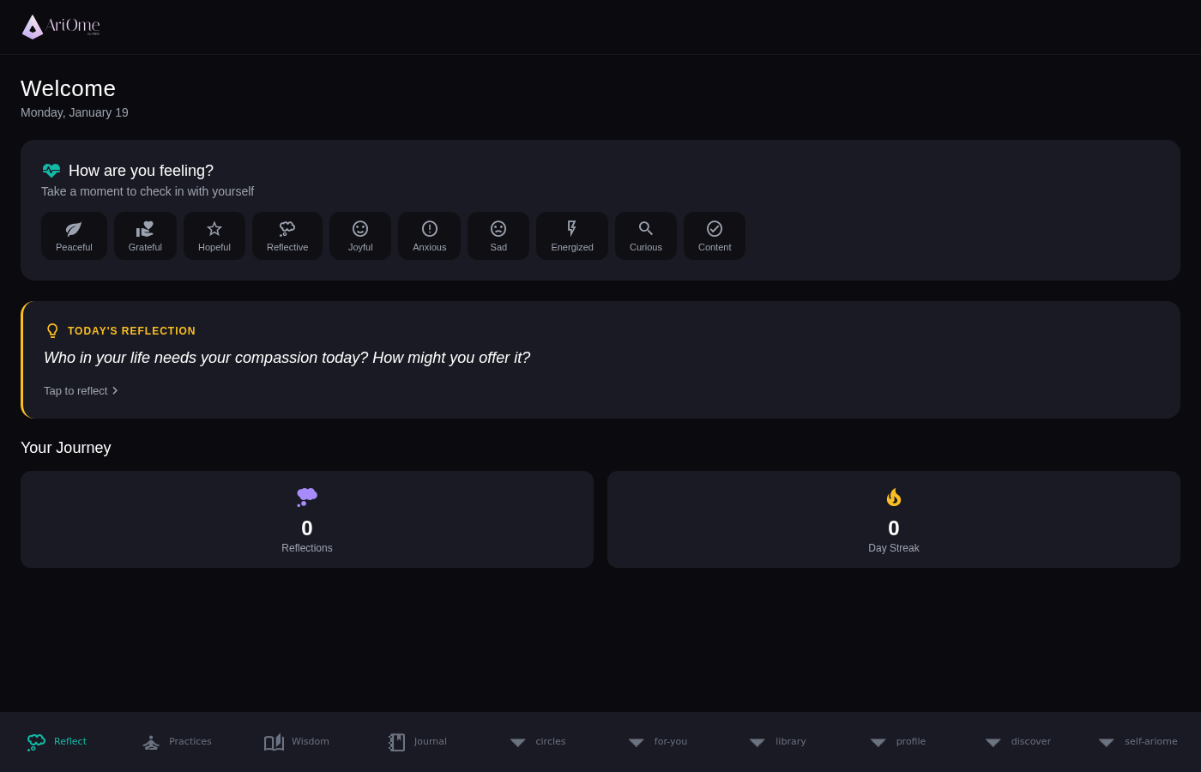

7. Practices Screen
Route: /(tabs)/practices
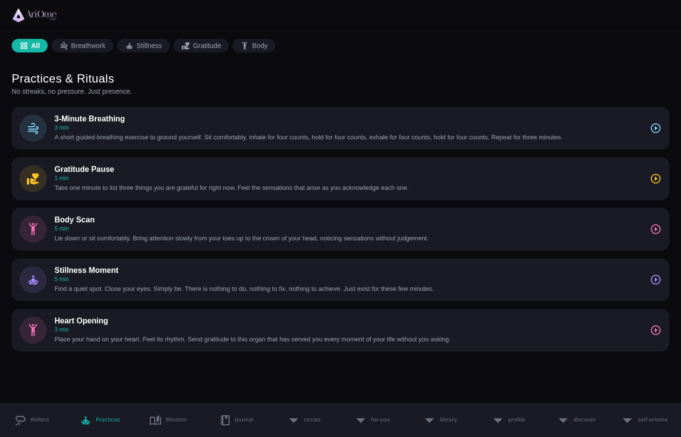

8. Wisdom Library
Route: /(tabs)/wisdom
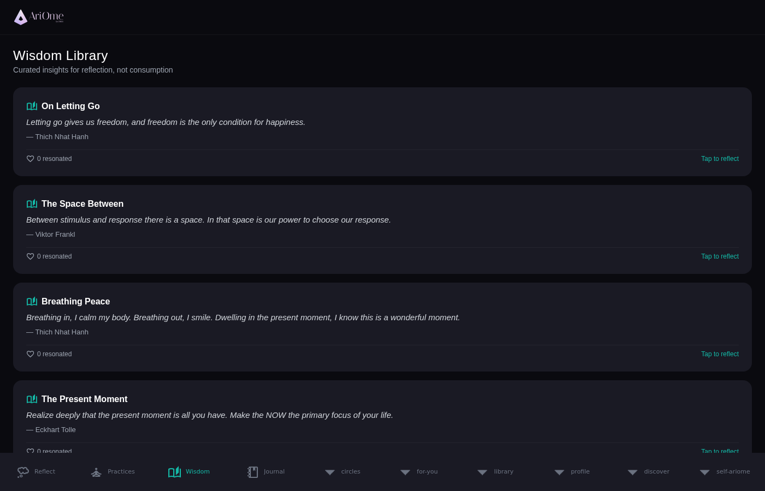

9. Journal Screen
Route: /(tabs)/journal
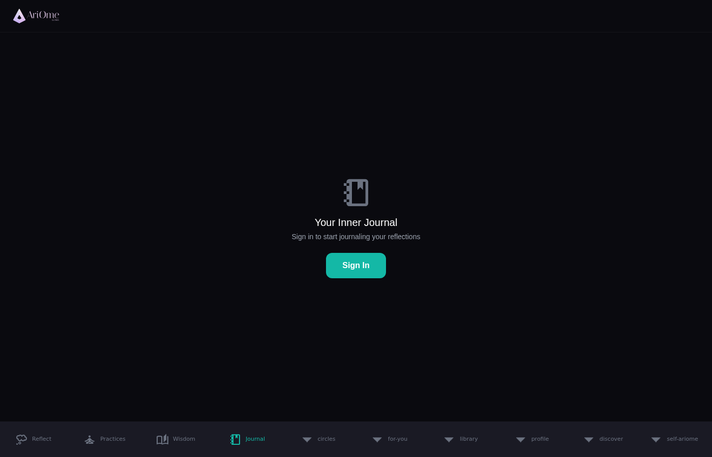

10. Circles (Community)
Route: /(tabs)/circles
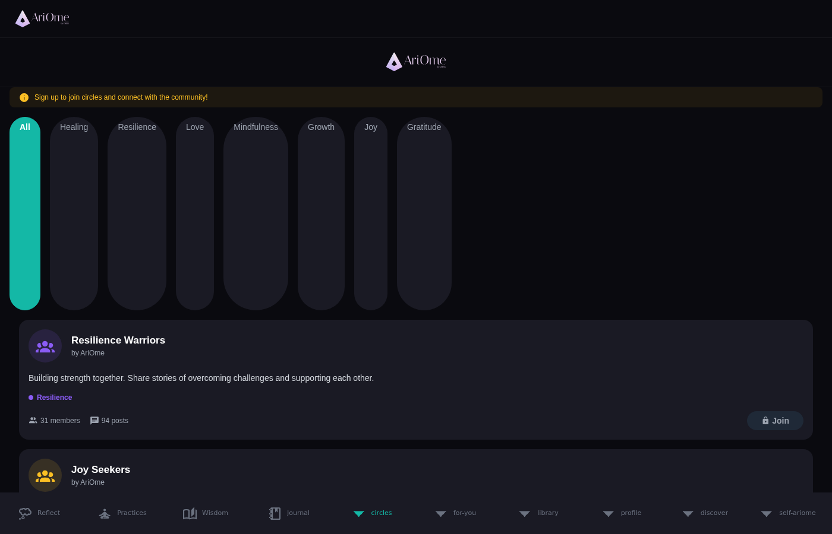

11. Profile Screen
Route: /(tabs)/profile
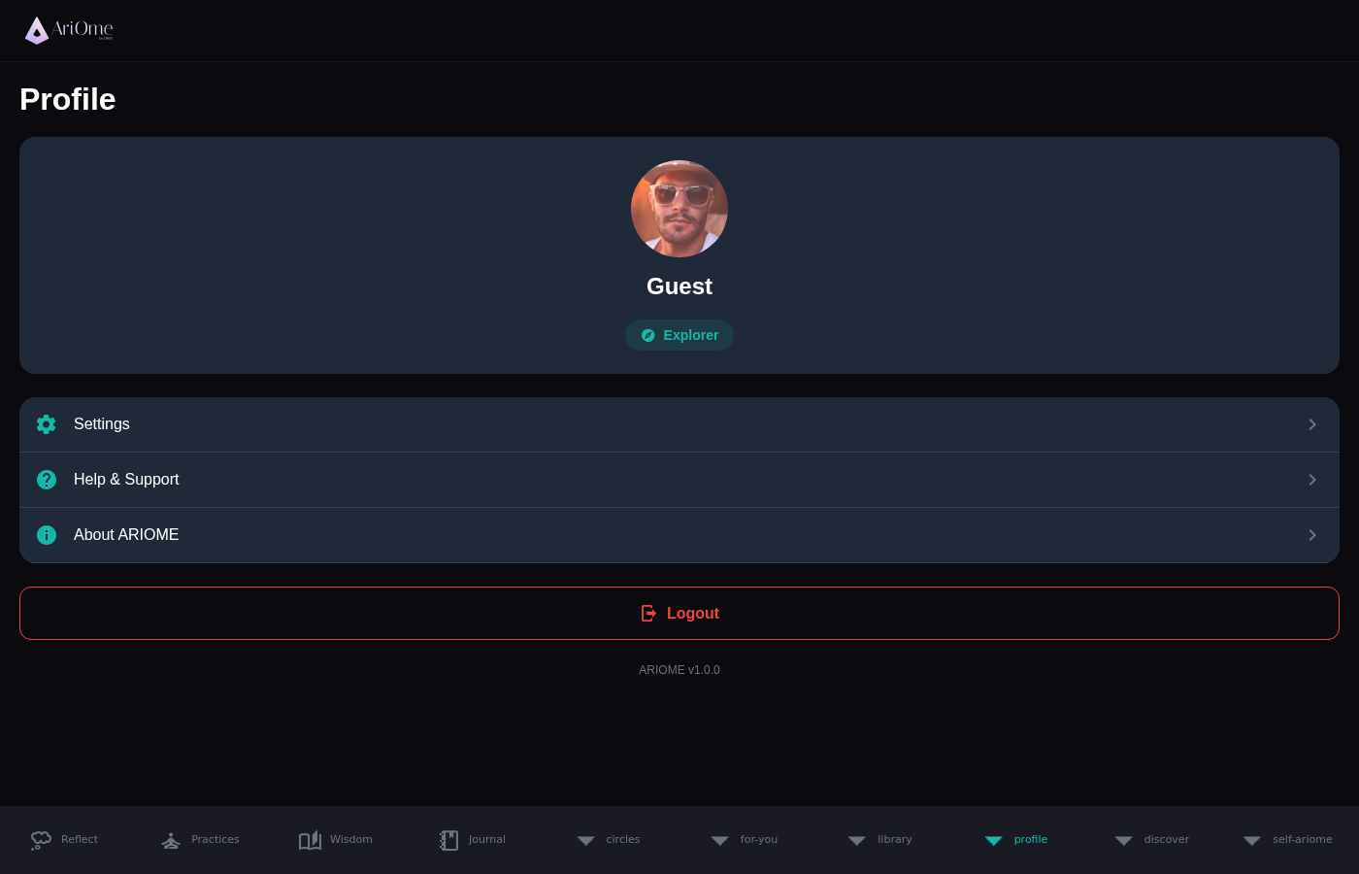

──────────────────────────────────────────────────
Document generated: January 2025
AriOme - Your Path to Inner Peace

