1. Endpoint

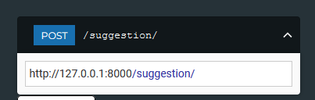

1. Request Body Shema

This version clarifies that the Body schema contains elements that act as dynamic placeholders specifically for use within the Inge prompt. 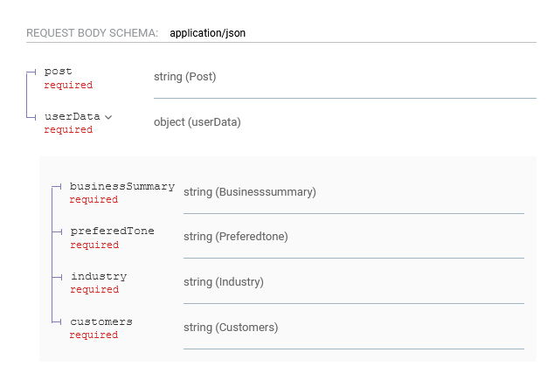

1. Responses

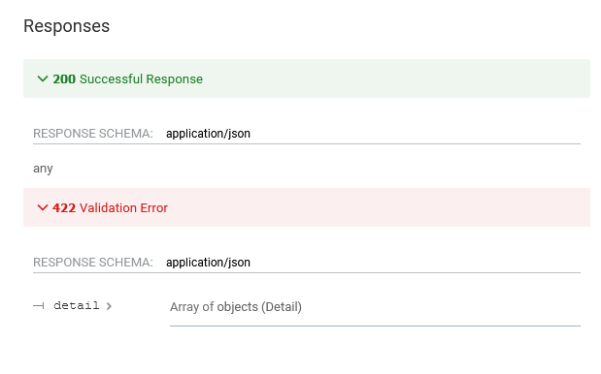

1. Input sample

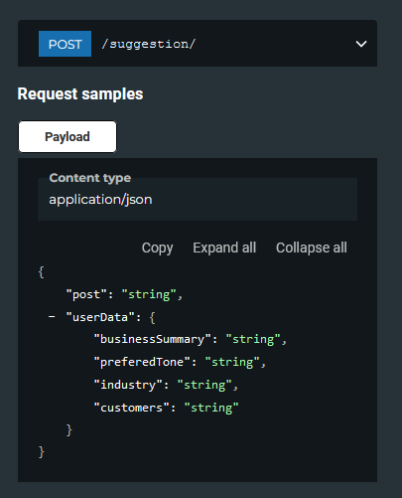

1. Responses

* 422 Status code

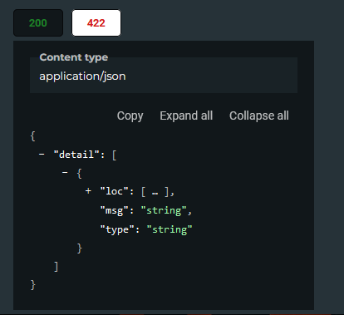

* 200 Status code

