Honours College Project
Max. 2A4

Topic/Title: Predicting the Evolution of Mythological Symbols

Student name(s): Satchit Chatterji (S3889807)

Name first supervisor (FSE): Dr Martijn Hammers e-mail address: m.hammers@rug.nl

Research group: Conservation Ecology Group / Groningen Institute for Evolutionary Life Sciences

Credits: (5, 8, 10, 13, 15, 18 or 20 ECTS): 5 ECTS

Description and goal of the project:
Symbols are something that cultures all over the world have relied upon to pass down and communicate their ideas and beliefs. Their real-world representations change over time due to numerous factors, such as change in ideology, taste, and available technology, with some symbols remaining unchanged for centuries and others changing often. These are analogous to traits in nature, following tenants of Darwinian evolution.
Evolutionary modelling has thus far been successful in the fields of biology and economics, but not much research has been done yet into studying how culture (art, in particular) changes, using this method. The primary goal of this project is to take the lens of evolutionary biology to the field of historical art in order to create a computational model of how symbols change over time, and create a prediction of what these symbols may look in the future.

Strategy and tools:
The focus of the study will be on derivatives of the Löwenmench, a half-lion, half-human figure. The visual artist Daan Paans (who we have been in close contact with) has collated photographs of dozens of examples from over thousands of years of this concept, from which data will be collected. The model itself will be implemented in software, primarily programmed in Python, alongside any other suitable software required as the project progresses.

Milestones:
There are three main steps to accomplish the goals of this project:
- Data collection from photographic catalogue, selecting traits to focus on.
- Study, conceptualise, and evaluate evolutionary models based on data.
- Implement an evolutionary model, and predict how traits may change over time.
The final deliverables will include a poster presentation at the closing symposium.

Period: 2A (February-April 2021)

Signature first supervisor: 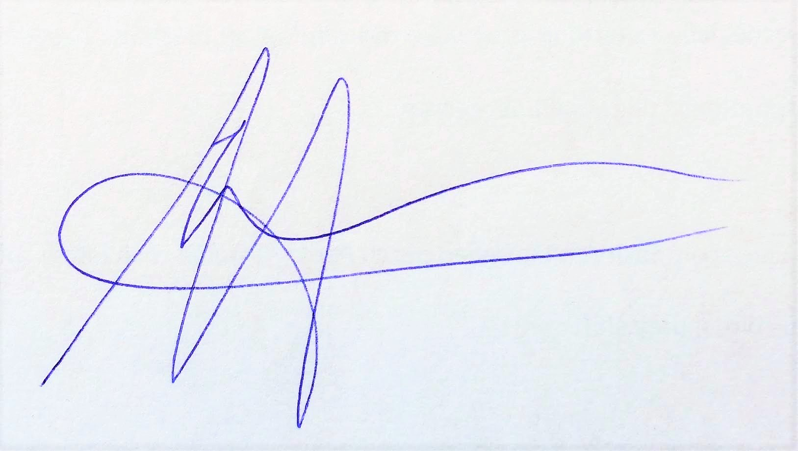Date: 16/2/2021

Part of this project is presenting a poster at the closing symposium (in June 2021). Your supervisor is also heartily invited to visit this symposium.

Please send in the signed project form via email to honours.fse@rug.nl

