Highly Useful Commands :-

- 1. How to search entire project (it will open All tab)

Please click on shift two times.

- How to open classes tab for searching

Please click Ctrl + N

- How to open files table for search

please click Ctrl + shift + N

- How to search in entire project

Ctrl + shift + f

- How open settings page

Please click on Ctrl + Alt + s

- How to show all methods in a class.

Please click on Ctrl + F12

- How do you know particular method called in which places?

Please type Ctrl + Alt +H

- How to open project structure?

Type Alt + 1

- How to restory default layout?

Type the command Shift + f12

- How to create a new class ?

Type Ctrl + alt + insert

- How to generate setters and getters?

Type Alt + insert

- How to duplicate line?
Press Ctrl + D

- How to open test case file
Ctrl + Shift + T
- How to extend selection
Ctrl + W
- How to shrink selection
Ctrl + shift + w
- How to comment
ctrl + /
- How to comment multiple lines
ctrl +shift + /
- How to format code
Ctrl + Alt +L
- How to remove unwanted imports
Ctrl + Alt + O
- How to rename file?
Shift + F6

How to open file from left hand side?
Click on Alt+1 to open project structure.
Now click on Enter to open specific file.

How to move cursor from project sturcture to file ?
> Click on ESC (i.e escape) to move mouse pointer from project structure to file.

1. How to select multiple lines at the same time?

https://www.vojtechruzicka.com/intellij-idea-tips-tricks-multiple-cursors/ ****

> We can use Alt + Shift + mouse key to select multiple lines

How to delete a line from file?
Type Ctrl+Y to delete a line from file.

How to reformat the code ?
Ctrl + Alt + L
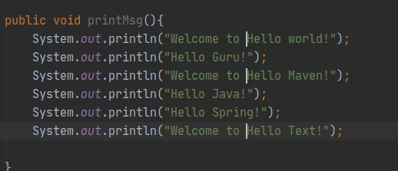

> In ubuntu type

Alt + Shift + Ins on Linux or Windows and then press shift key to select columns
- ⇧ + ⌘ + 8 on Mac.
Eg:

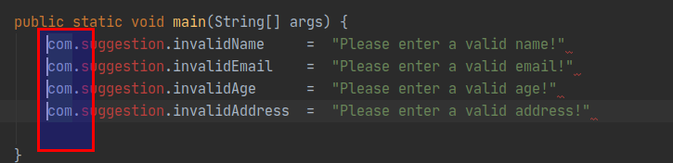
At the end of line, event if the columns are not are not in same line it will work by clicking on END button.

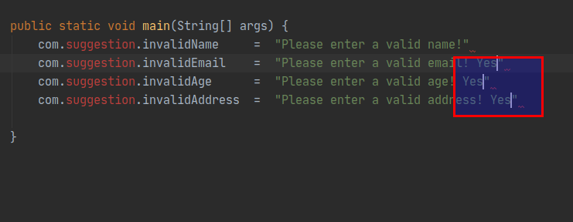

You can then move the cursor, as usual, using the arrow keys and even commands like Home or End. Note that after I used End key (go to the end of the line), the cursor was properly placed at the end of each line even if the cursors were no longer vertically aligned.
This feature can be toggled using Edit → Column selection. The shortcut is:
- Alt + Shift + Ins on Linux or Windows
- ⇧ + ⌘ + 8 on Mac.
You can exit column selection mode by using Esc key.
Column selection mode can be also used with keyboard only. When in column selection mode and holding Shift, you can extend cursor to the line above/bellow by using ↑ or ↓ keys.

Installed Plugins

https://itnext.io/intellij-idea-plugins-which-every-java-developer-need-to-have-6017ef5c3de4

1. Grep Console
2. Key Promoter
3.String Manipulation
4. Extra Icons
5.Maven Helper
6. Rainbow Brackets
7. Lombok

To open current project structure

either click on Ctrl+Shift+Alt+s

or

Please click on 3rd item from right side.

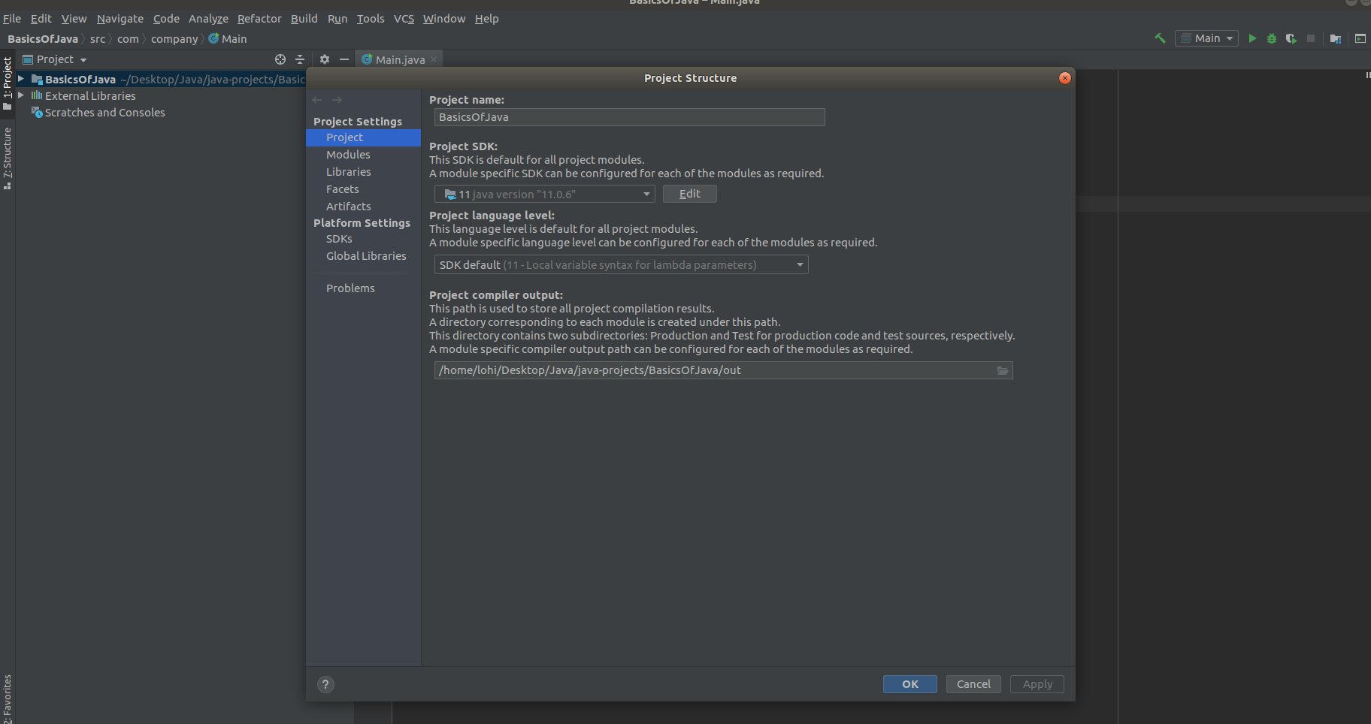

> sout (Short cut for System.out.println)

Increasing Font Size :-

Press Ctrl+Alt+s (For opening Settings)

We neet to go to File -> Settings -> Editor -> click on Font

> How to increase the font size for console :-

Press Ctrl+Alt+s (For opening Settings)

We neet to go to File -> Settings -> ColorScheme -> Console Font

> Key Mappings :-

Press Ctrl+Alt+s (For opening Settings)

We neet to go to File -> Settings -> Keymap -> keymap dropdown -> InellijClassic

> Color Themes

We need to go to View -> QuickSwichScheme -> pick Edit Color scheme

Suggestion: If we are working hours and hours then it is better to swith to Darcua color scheme which is good for eyes compared to Light colour theme.

> How to install Material Theme UI

https://plugins.jetbrains.com/plugin/8006-material-theme-ui

We can also select colour themeses from this

http://color-themes.com/?view=index

> Presentation Asistant

We are installing a plugin in intellij

Press Ctrl+Alt+s (For opening Settings)

We neet to go to File -> Settings -> Plugins -> Presentation Asistant

it will be useful when you want to give demo for some one.

To do further settings in Presentation Assistant Please go to

File -> Settings -> Appearance & Behaviour -> Presentation Asistant.

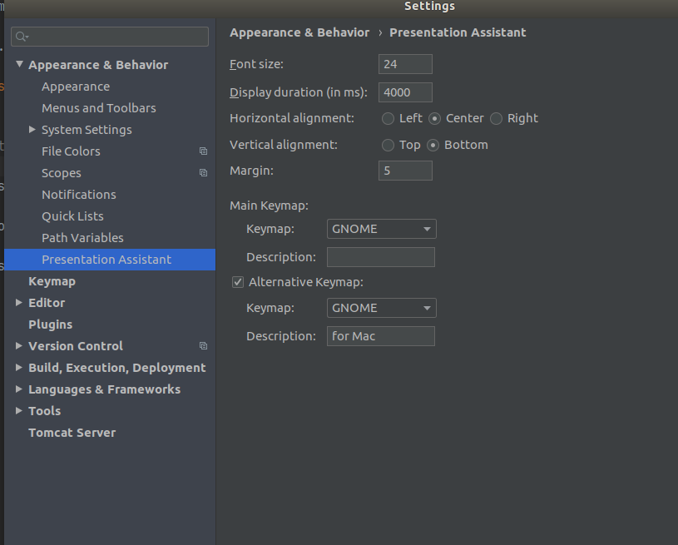

Cloning Project :-

Please go to this url

https://github.com/amigoscode/spring-boot-react-fullstack

How to download project

Click on VCS -> Get from version control

> Searching class files and Every where

if you want to open All tab on Search box then you need to do

1. Press Shift two times.

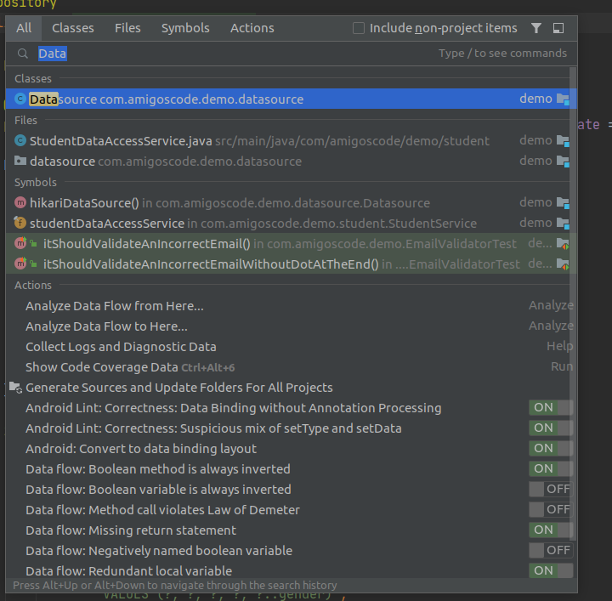

2. command for opening classes :-

You need to use ctrl+ N to open classes

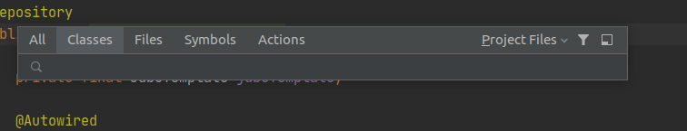

3. command for opening files

You need to use ctrl+shift+N to open files

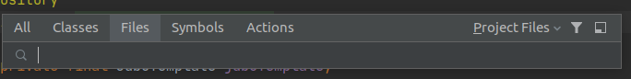

Important :--

Intellij can also search based on upper case letters. It is using CamelCase Pattern

If the file name is StudentAccessLayer

then you can give sal it will work.

2. If the file name is ApiExceptionHandler then you can do search using AEH

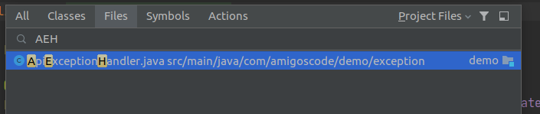

4. Command for moving between above tabs in search box

open search box by using ctrl+N

You need to use ctrl+tab button to move from one tab to another tab.

5. To search for all sql files in the project :-

open files tab by using ctrl+shift+N

You need to use *.sql in search box.

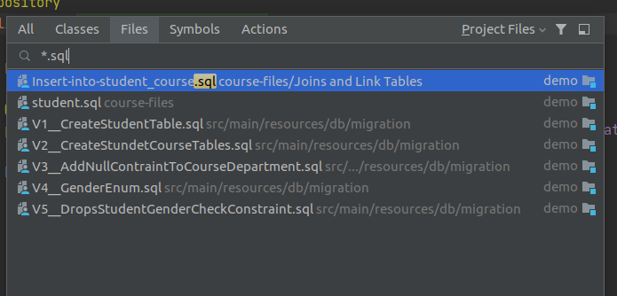

Search with Find In a Path :-

Another powerful way for searching words, regular expressions and patterns is by using command

ctrl+shift+N

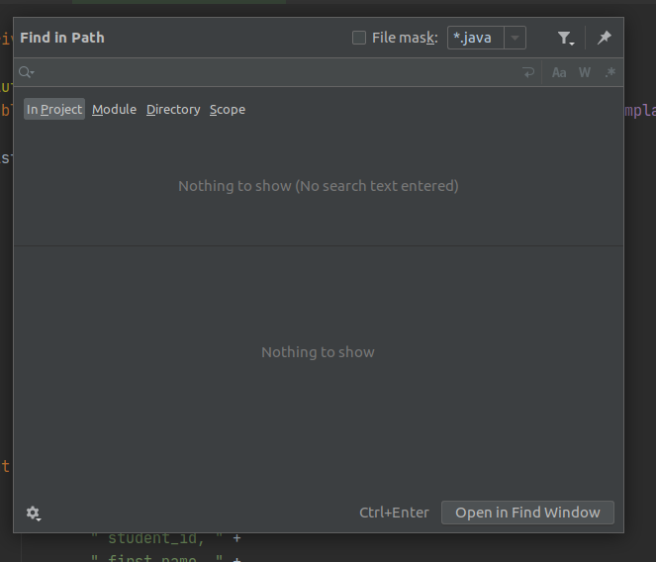

We can search for any word by typing word name like below in search box

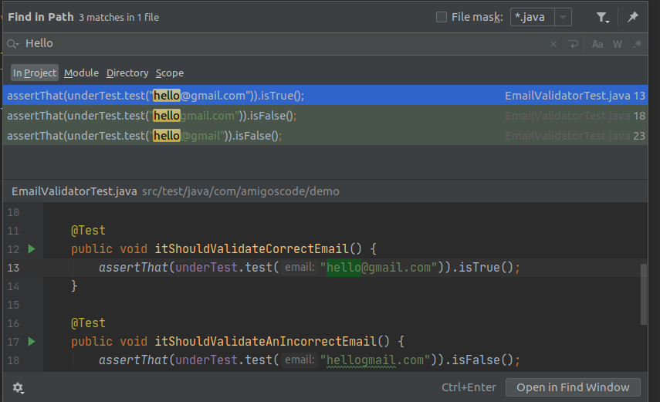

We can also use regular expression searching like below

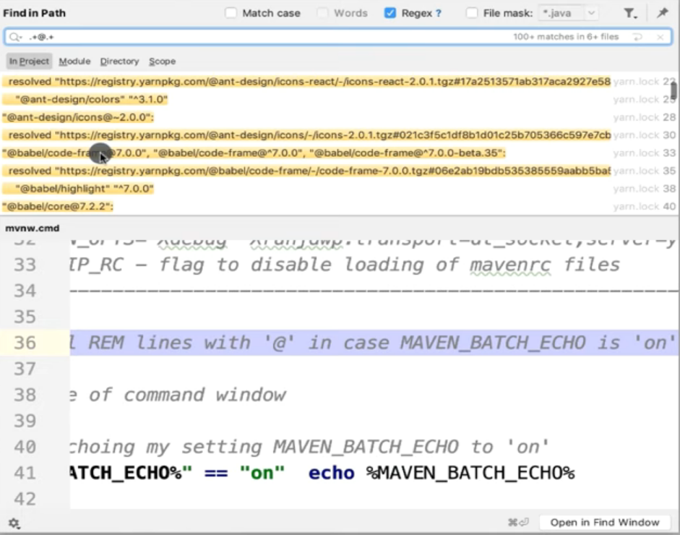

We can use File Mask to select only java files / jsp files.

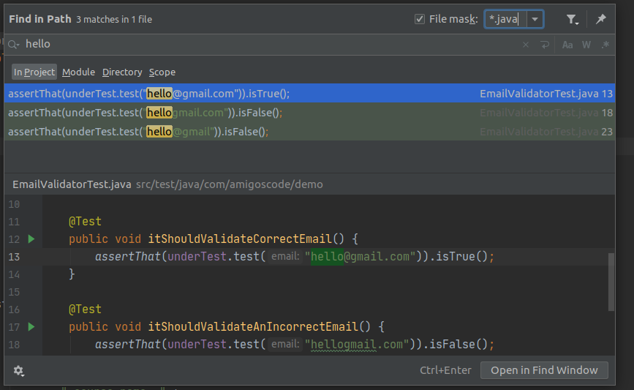

> How to search for specific content in specifi folder.

Option 1 :-

Step1 : Please select the folder name by using mouse click.

Step2: Now click on ctrl+shift+F to search for content

Now it will search for content in this folder

Example :

1. first I have selected Exception folder
2. I have clicked on ctrl+shift+f
3. Now you type words which you want.

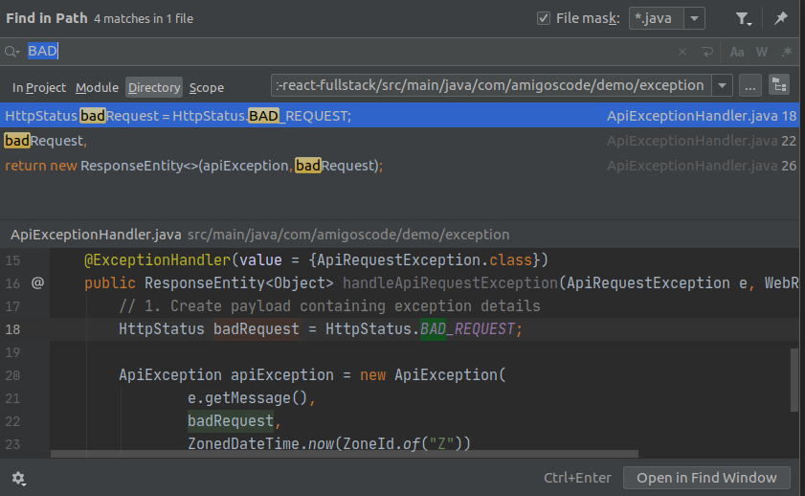

Now its doing search by using directory

Option 2 :-

step 1: Please select specific folder by using mouse option
step 2: Now click on ctrl+shift+f

3. Now select for specific content.

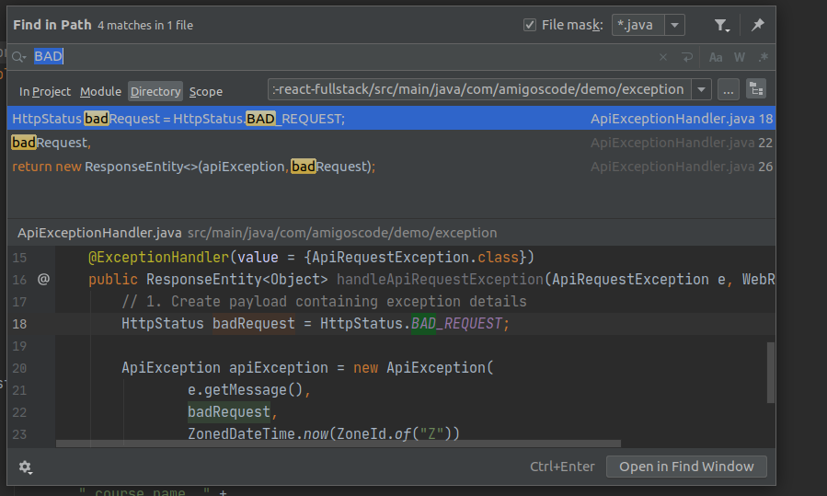

> File Structure :-

We can view all methods declared in a file by uisng two options.

Option 1 :-

1. Please select specifi file.
2. By clicking on structure tab which is on left side of panel.

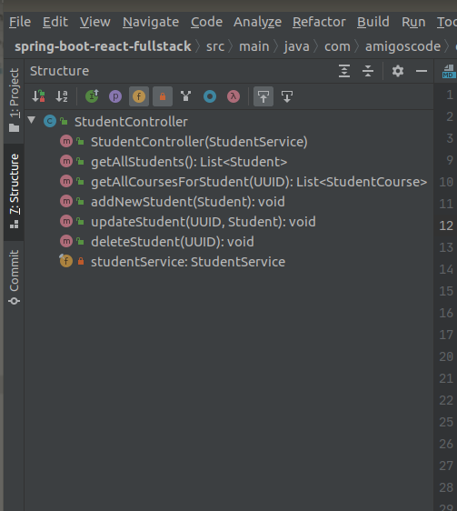

2. We can open File Strucutre better way by using below steps

We can Ctrl + F12 top open file structure

or

step 1: click on Navigate tab which is on top.

Step 2: Click on File structure option

it will show methods in a nice way and we can also go to specific method

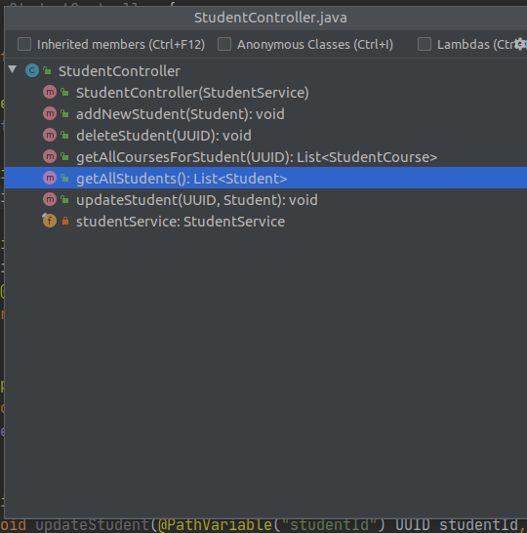

Important: We can also able to select

1. Anonymous Classes.

2. Lambdas

3. Inherited Members

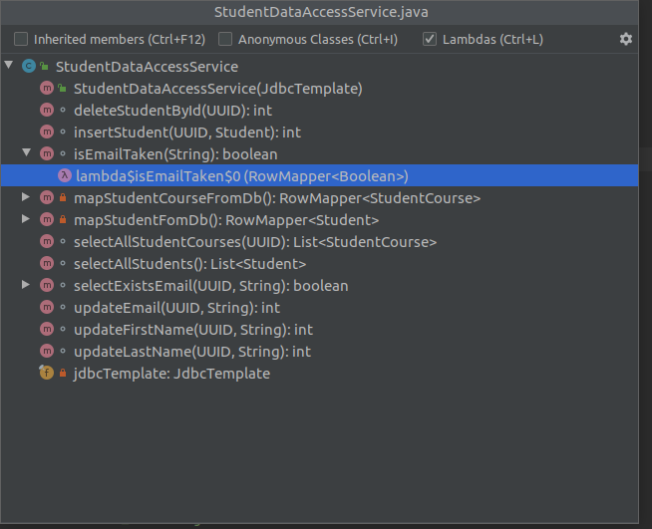

> Call Hierarchy :-

1. We can use keyboard shortuct

1. Please select the method name by using cursor.
2. click by using Ctrl+Alt+H

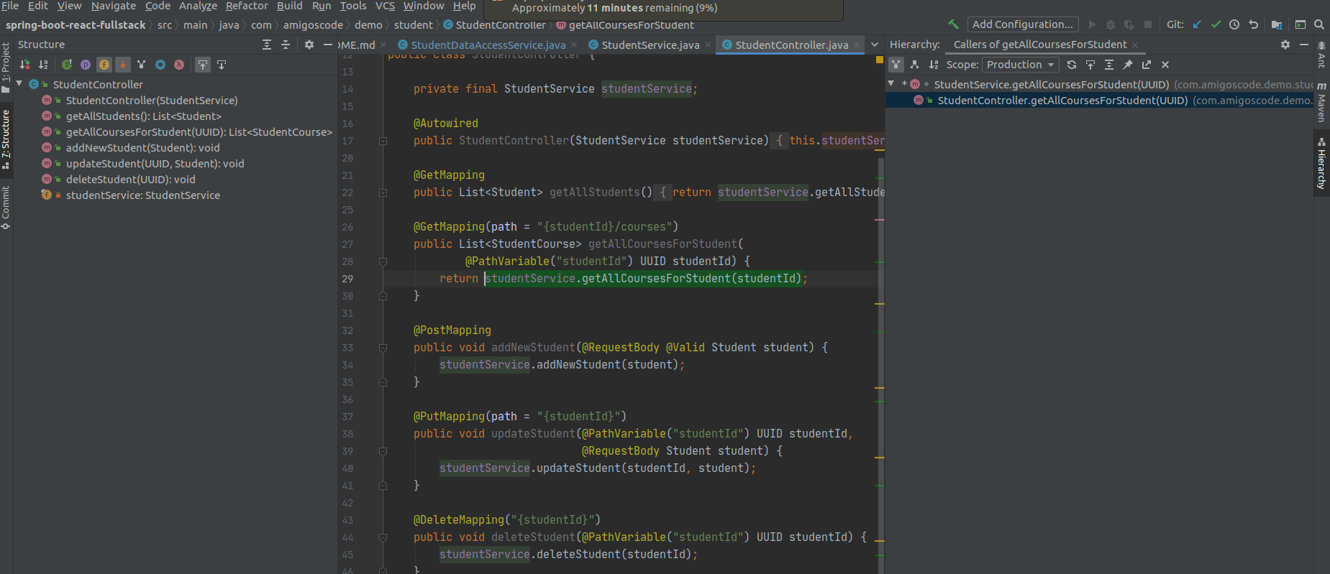

2. We can check in which files given method is called by using

Step 1: Please select particular method by using mouse.
Step 2: Please click on Navigate -> Call Hierarchy
Step 3 : We can also select Scope i.e

1. production: to show method usages in src folder
2. test: to show method usages in test folder.

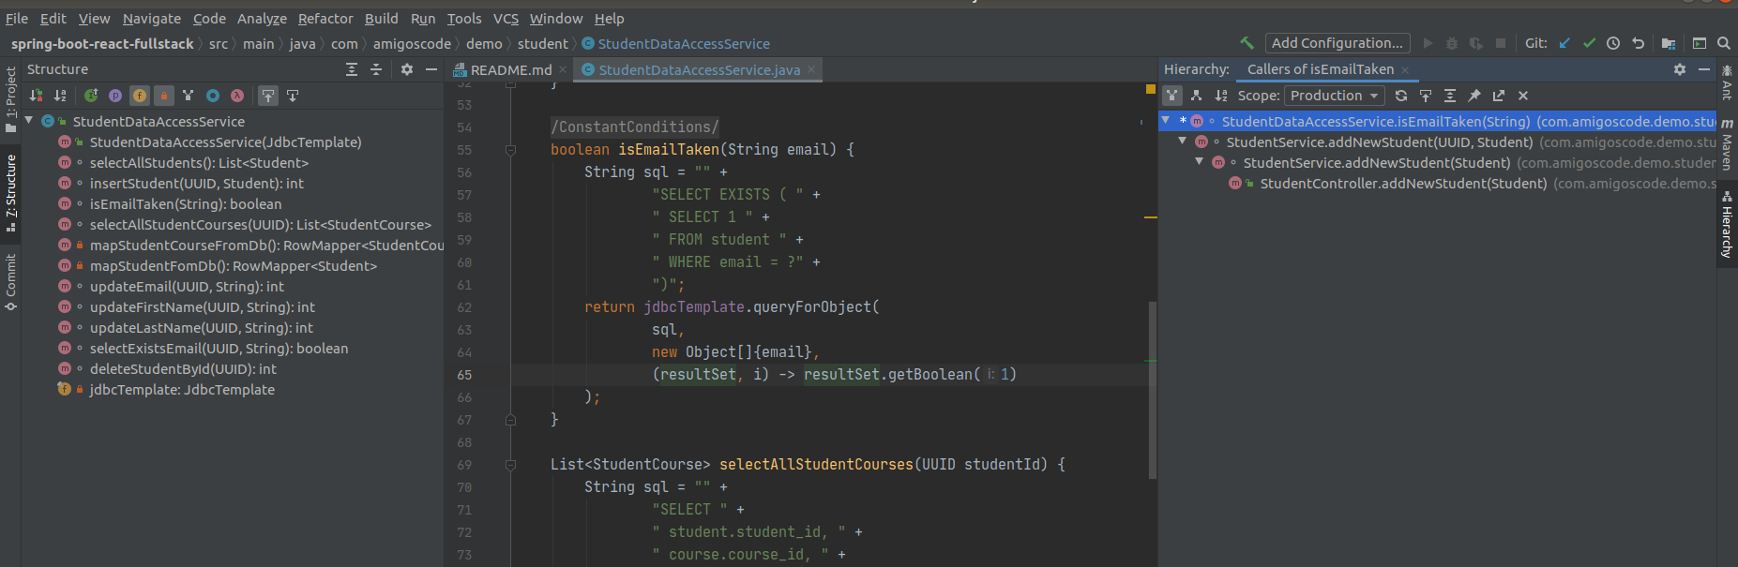

>The importance of keyboard shortcuts :-

if you are using keybaords shortcuts you are becoming better developer and much more productive.

If you dont know how to use right tool then you need to waste lot of time.its very very important to learn keyboard shortcuts to become much more productive.
If you are using keyboard short cuts then you can memorize them.

In Intellij for for project they have given number as 1.
for favorates they have given number as 2
for todo they have given number as 6
for structure they have given number as 7
for give they have given numbers as 9

How to open project structure :

type Alt + 1

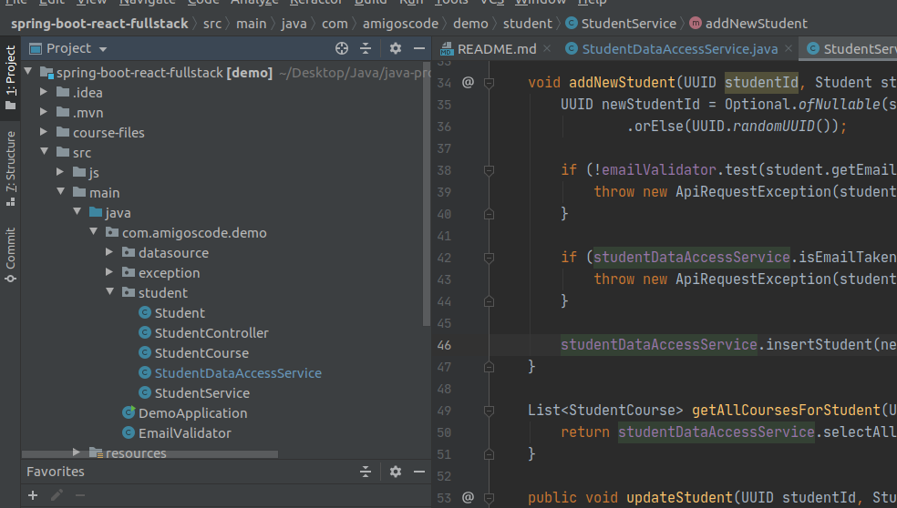

type Alt+2 for opening favorate

type Alt+6 for todo

How to open structure :-

type Alt+7 for structure

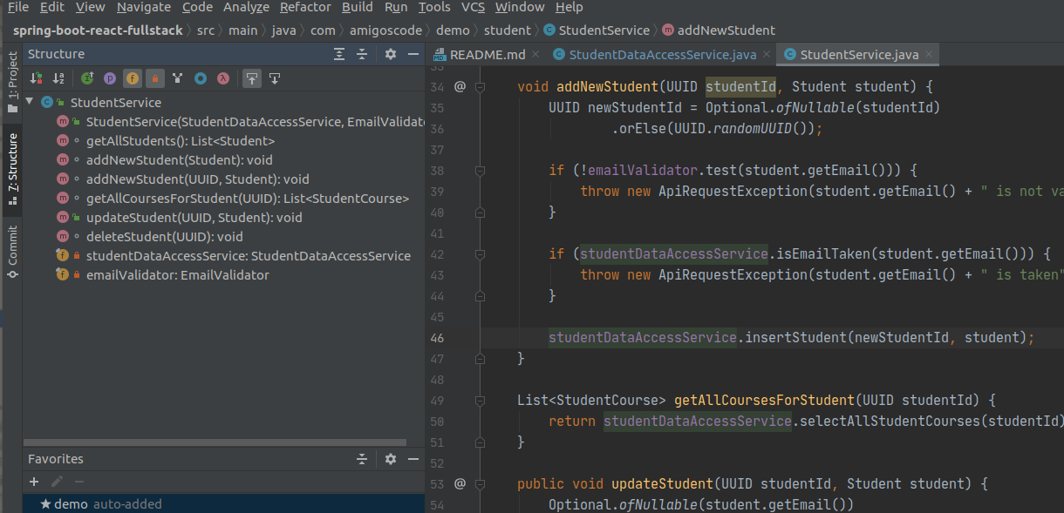

How to open git :-

type Alt+9 for git.

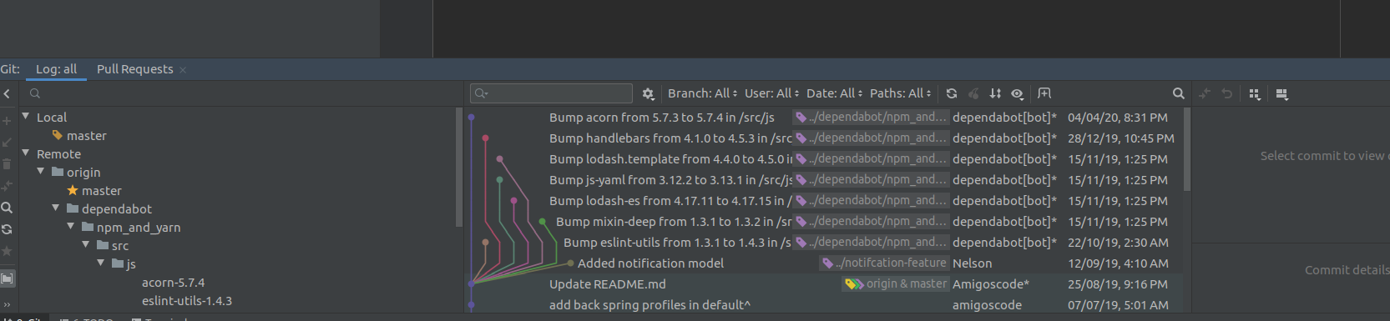

> To restore default layout

Type the command Shift+f12

Using Intellij without Mouse :-

We dont need mouse to work with intellij.

How to open/close package on the left hand side?

To open project structure

you need to type Alt+1

How to expand the folder / package?

Click on Right Arrow to open package

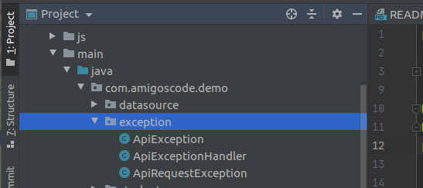

Click on Left Arrow to close the package.

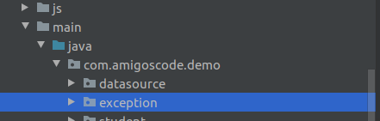

How to open file from left hand side?

Click on Alt+1 to open project structure.

Now click on Enter to open specific file.

How to move cursor from project sturcture to file ?

> Click on ESC (i.e escape) to move mouse pointer from project structure to file.

How to delete a line from file?

Type Ctrl+Y to delete a line from file.

How to reformat the code ?

Ctrl + Alt + L

AceJump Plugin :-

Install AceJump Plugin.

Press Ctrl+; so AceJump will be activate

1. Press Up Arrow to Up :-

Now type Up Arrow so that it will show one character per each line.
If you click particular letter then it will go to that particular line.

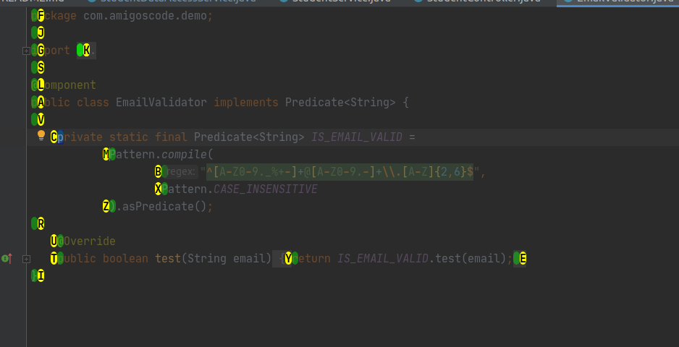

Now press A so that it will go to public class .

2. Press Right Arrow to go to right :

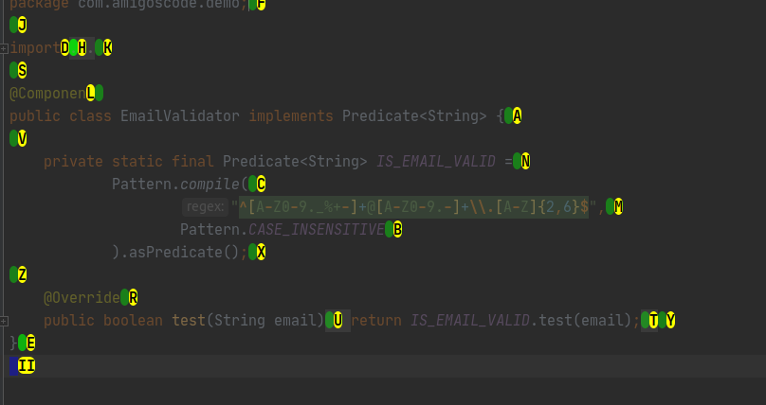
3. Press Left Arrow to go to left side :-

How to disable AceJump :-

Just click Esc(Escape) to disable it.

How to go to specific position :-

Activate AceJump by clicking on Ctrl+;

To go to = symbol just type =

then it will show charaacter at That symbol

now click that charaacter

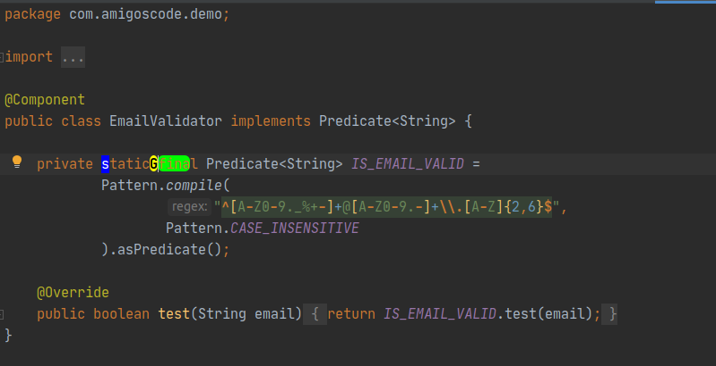

Generating Code :-

Using this section we can boost productivity

> How to create new classs/package ?

Please go to project structure by using Alt+1
please click down arrow to go to specific package
Now using Ctrl+Alt+insert command to create new file

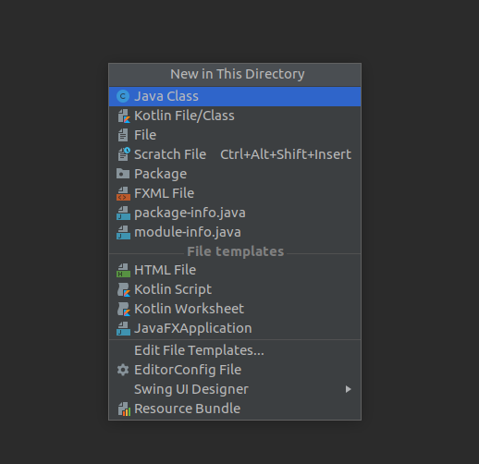

> How to generate Getters and Setters?

> press Alt+Insert command to open dialog box

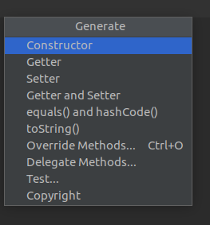

Now click on Getter and Setter button

it will show below box

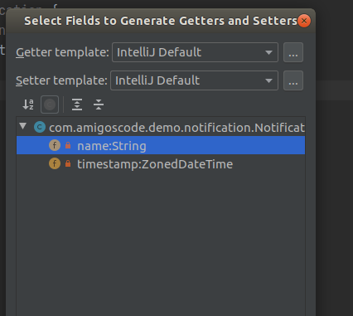

Now select both fields and then click Tab and then press OK.

It will generate getters and setters code.

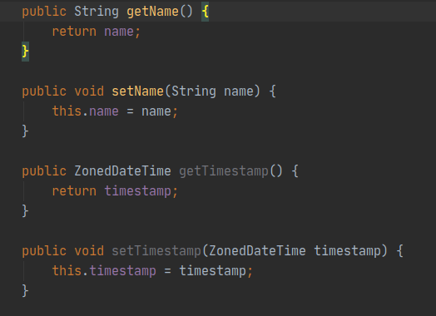

> We can also generate toString method

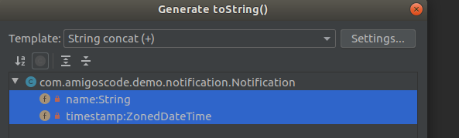

@Override
public String toString() {
return "Notification{" +
"name='" + name + '\'' +
", timestamp=" + timestamp +
'}';
}

> We can also generate constructors by selecting field names

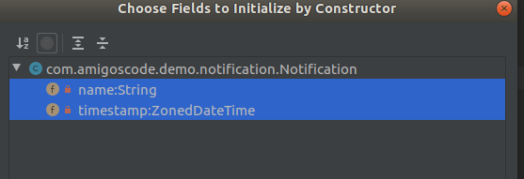
its generating below code.

public Notification(String name, ZonedDateTime timestamp) {
this.name = name;
this.timestamp = timestamp;
}

> How to expand code in method? / How to compress code in method ?

You need to expand code by using Ctrl + + and

to compress code by using Ctrl + -

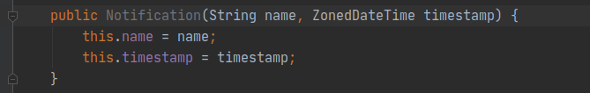

> sout to display System.out.println(message) :-

Type sout to print System.out.println(message);

> Create variable by copying string

Type Ctrl+Alt+V to create variable. (Here V stands for variable)

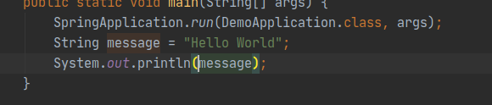

> To remove variable reference and mention it directly we will use

Ctrl + Alt + N

This will remove String message variable and copy its data to system.out.println like below

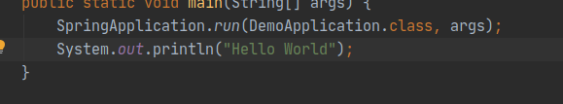

> How to select entire big string?

To select entire big string we can use Ctrl + W

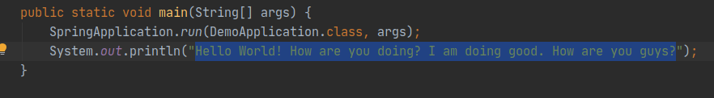

> How to replace multiple occurrances of common data with variable Name?

public static void main(String[] args) {
SpringApplication.run(DemoApplication.class, args);
System.out.println("Hello World! How are you doing? I am doing good. How are you guys?");
System.out.println("Hello World! How are you doing? I am doing good. How are you guys?");
}

I would like to crate one variable to store the message.

1. selecte entire big string by using Ctrl+W
2. Now press Ctrl + Alt + V it will ask to copy multiple occurancce

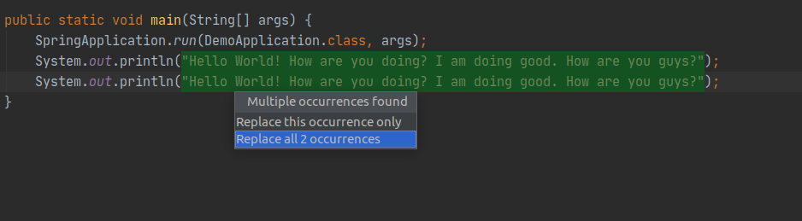

if we click entre then it will create variable like below

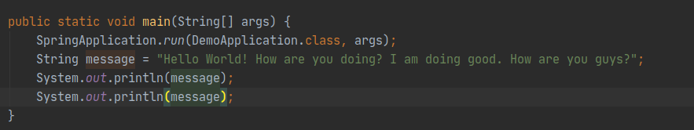

> How to create a method from selected data ?

Select data for which you want to create method like below

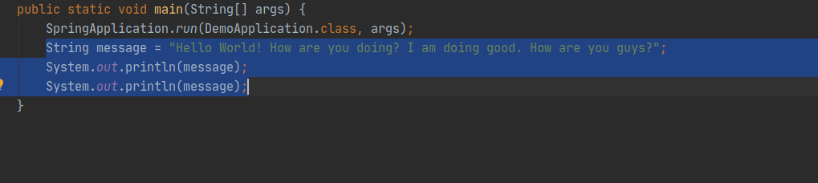

> Now press Ctrl + Alt + M (for creating a new method)

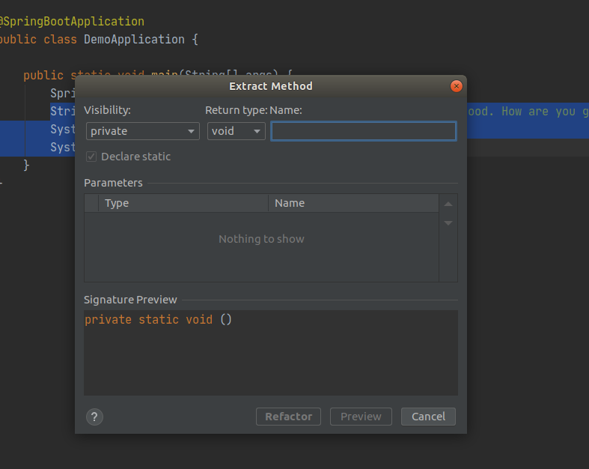

> Please enter the method name and then click enter.

Its creating a new method like below.

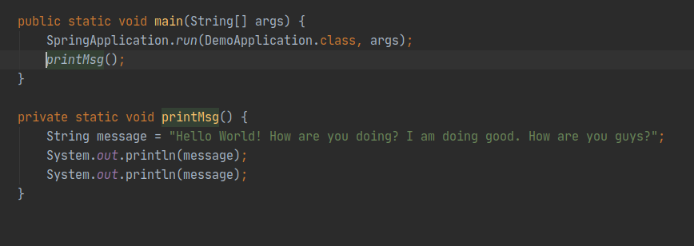

> How to create Parameter from inside method variable Name?

Let us say you have below method

private static void printMsg() {
String message = "Hello World! How are you doing? I am doing good. How are you guys?";
System.out.println(message);
System.out.println(message);
}

Now you would like to move meesage as method parameter/argument. To do this

1. select variable name first

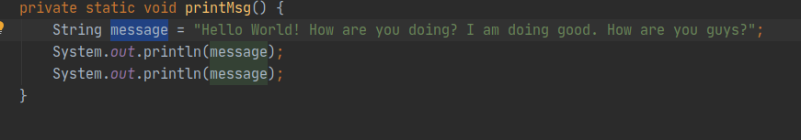

2. Now click Ctrl+Alt + P (p stands for parameter, v stands for variable, M stands for method)

Now I have clicked Ctrl+Alt+p.

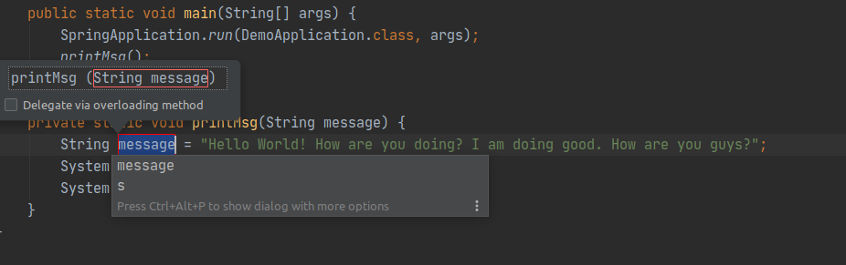

Now I clicked on enter. Here is the output

public static void main(String[] args) {
SpringApplication.run(DemoApplication.class, args);
printMsg("Hello World! How are you doing? I am doing good. How are you guys?");
}
private static void printMsg(String message) {
System.out.println(message);
System.out.println(message);
}

> How to remove line?

Press Ctrl + Y

> How to duplicate line?

Press Ctrl + D

> Tests :-

> How to open existing file?

Type Shift + ctrl + T

> if the test file is already exists then it will show popup like below

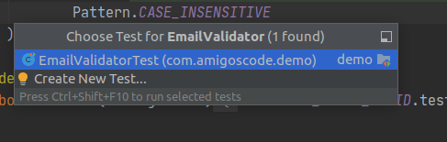

> How to create new test file ?

Now click enter to go to specific file.

> Just pres Ctrl + shift + T

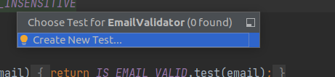

> Now click Enter

It will show below screen

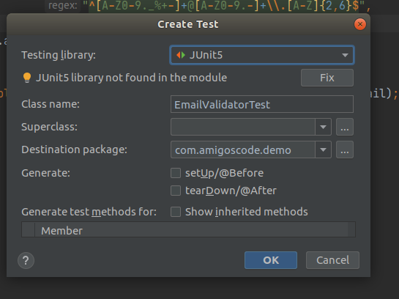

Now selecte Generate options and then click enter.

Now it will generate file.

> How to run tests?

Option 1: Just type Ctrl + Shift + F10

Option 2 :

To run all tests click arrow button which is in green color on left hand side of file name

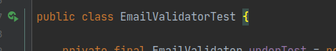

> How to select only failed tests ?

Please click on Correct symbol shown below

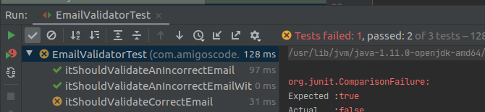

So that it will show only failed tests. It will be very helpful when your file has 100’s of tests.

Now I am clicking on Correct symbol. So that it will show only failed tests.

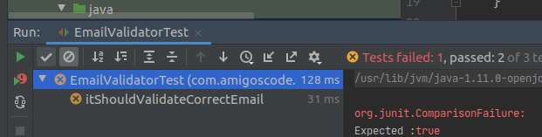

> How to filter out ignored tests ?

To filter out only ignored tests we need to click on block circle symbol shown below

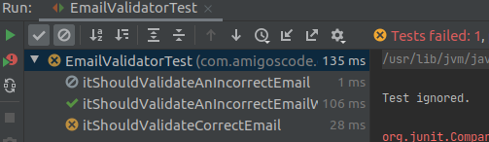

> Now I am clicking on block circle symbol to filter only ignored tests. So that it wont show ignored test.

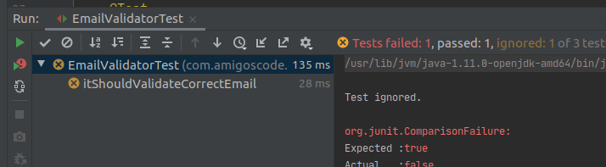

> How to rerun only failed tests ?

I am going to show symbol with red color and green arrow to run only failed tests below.

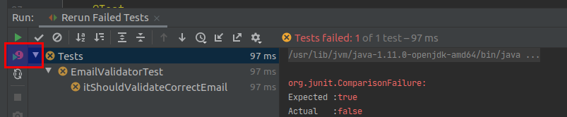

> How to go back to main file from test file.

Just press Ctrl + Shift + T

> How to add break point ?

Just press Ctrl + F8 to add break point

> How to debug failed test ?

Please add break point at failed test and main source code

Now go to failed test and click on Debug failed test.

It will show below list of options

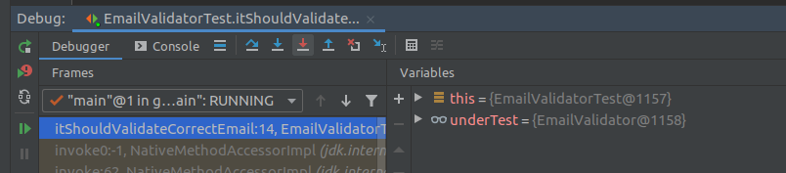

1. F8 (step over) -> it will go to next debug statement.

2. F7 (it will step into test)

3. Shift + F8 ( it will step out)

Now you can evaluate expression like below

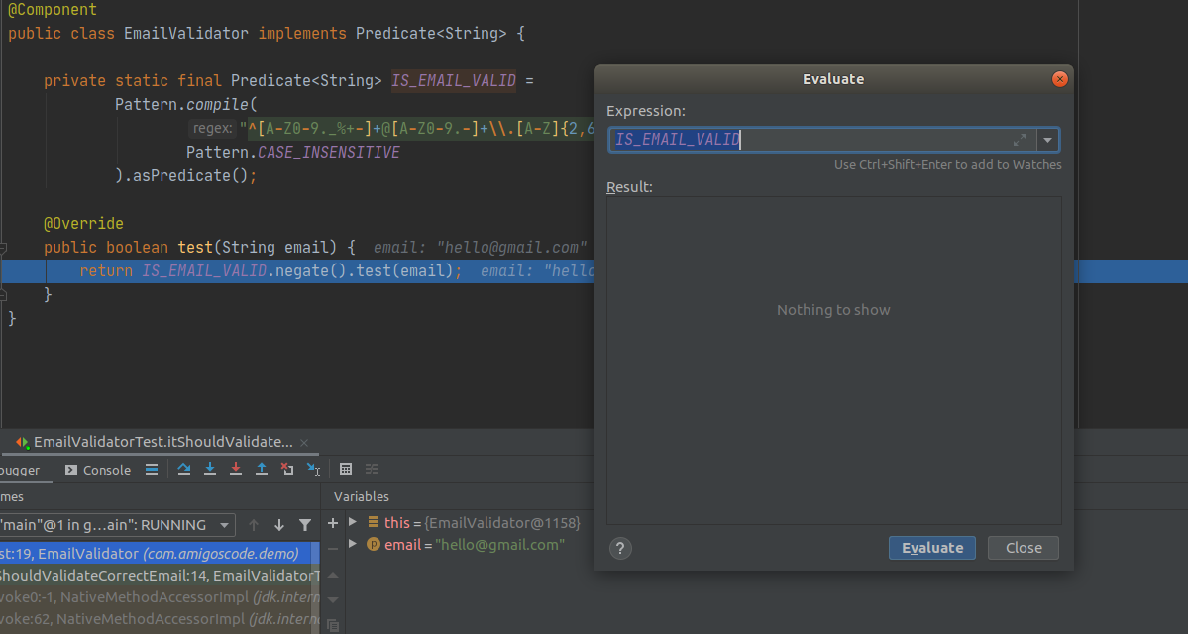

Git and Github integration :-

1. if the file is in Red color then its a new file and its not pushed.

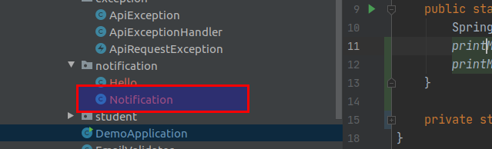

2. if the file is in blue color then this file has some changes.

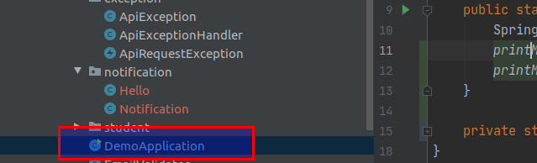

3. If you open file then it will highlight changes like below

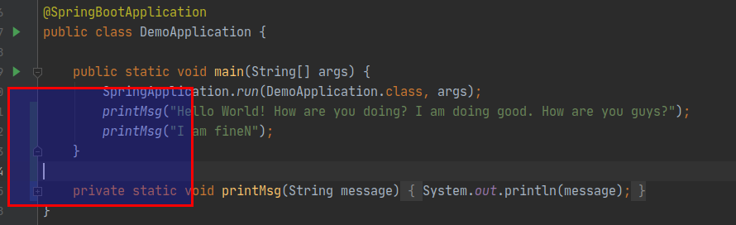

4. if you want to rollback changes then just click on that area then it will show rollback symbol

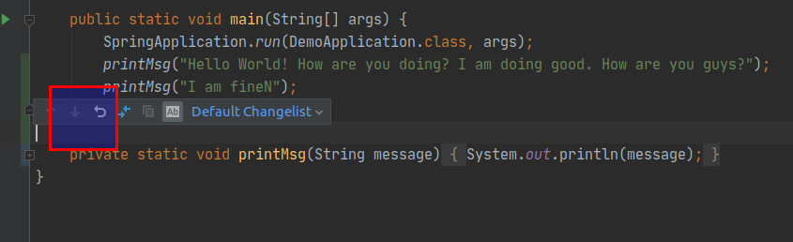

5. if you right click on any line number then it will show annotate symbol.

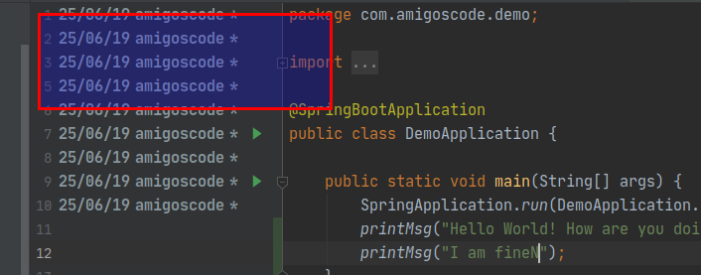

6. if you click on any commit then it will show all changes related to project like below

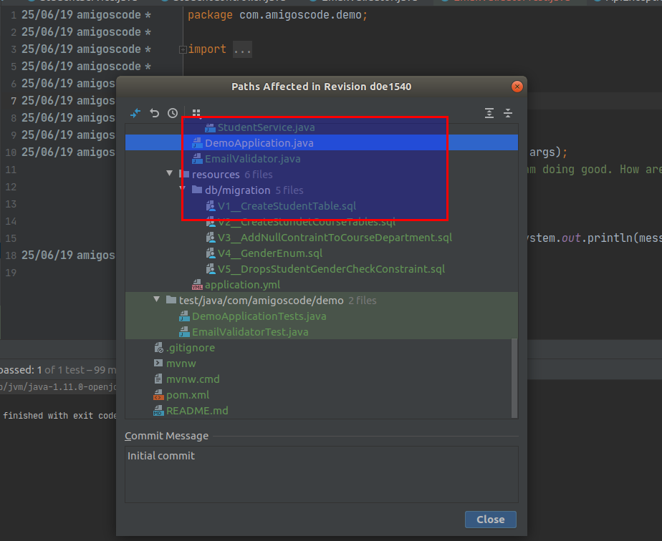

7. you can see lot of options related to version control under Vcs tab

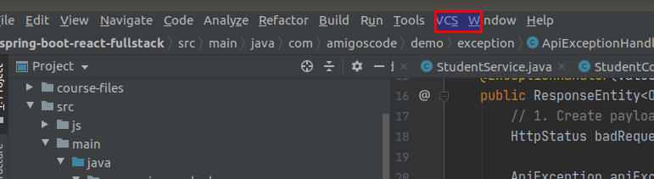

8. VCS Operators popup also list lot of options all git operations under VCS

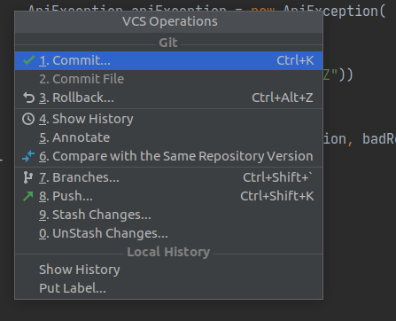

> How to commit changes :-

1. Please press Ctrl + k To commit files. So it will open popup with list of changes.

It will list newly added code in green color.
It will show deleted code in red color.

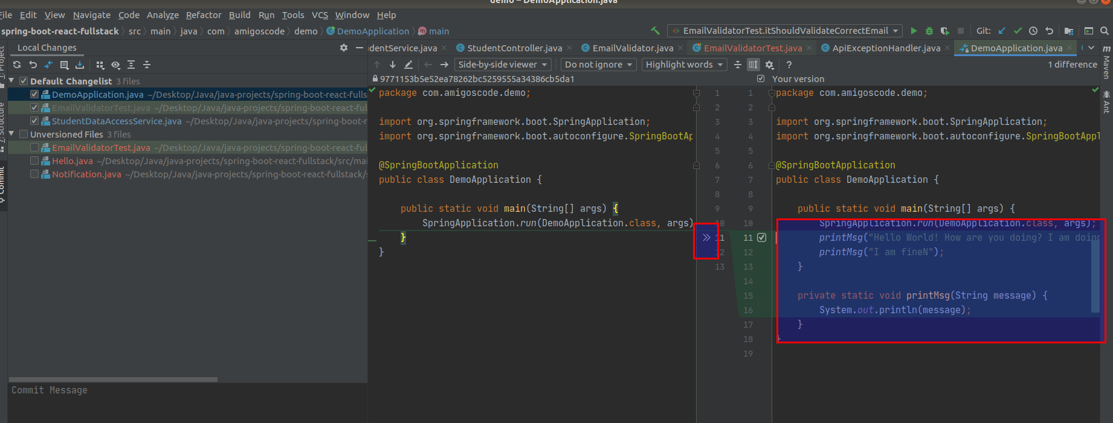

2. It will show newly added file code in green color

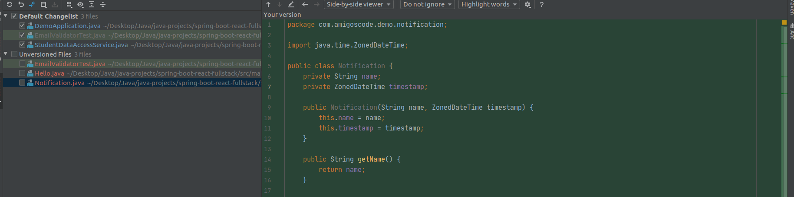

> How to view existing branches in git? And How can I create new branch?

1. You can type command Ctrl + Shift + ` to list all branches

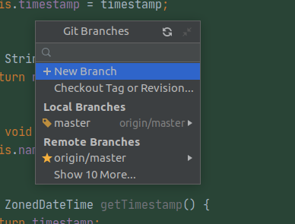

2. You can also go from Vcs -> git -> Branches

3. You can see this option at bottom right corner like below also

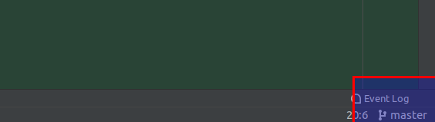

> What is optimize imports checkbox before commiting code?

Its going to remove ununsed import startements from the code.

Example :-

You have added List import at the begining but now you changed your code to use ArrayList.

So its going to remove unused List statement.

> How to create a pull requests?

1. You can push the code to remote branch and then create the pull request manually.
2. We can also create the pull request from intellij.

How to create the pull request from Intellij?

Go from Vcs -> Git -> Create pull request

at the first time it will ask login credentials.

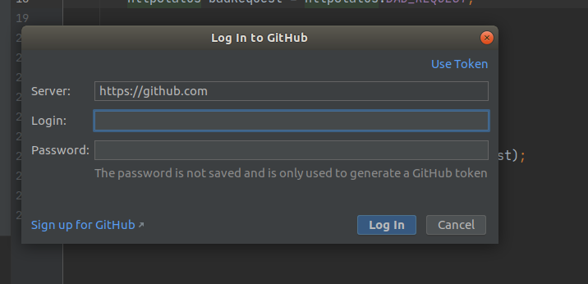

> once you entered credentials. It will show popup box with title and description. You can enter those details there.

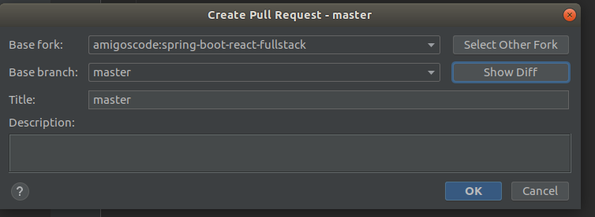

> There is a show Diff button which will show list of changes in this pull request.

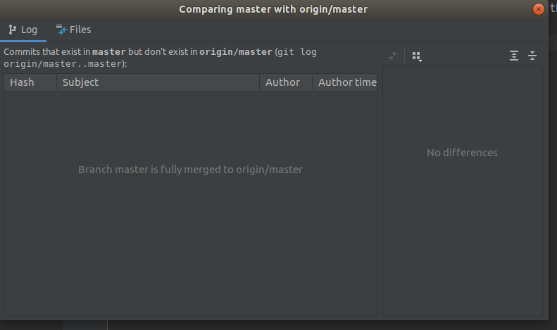

> It will also the actuall link for pull request. So just you can click on that link and you see changes.



> if you open that link it will take to you git page like below.

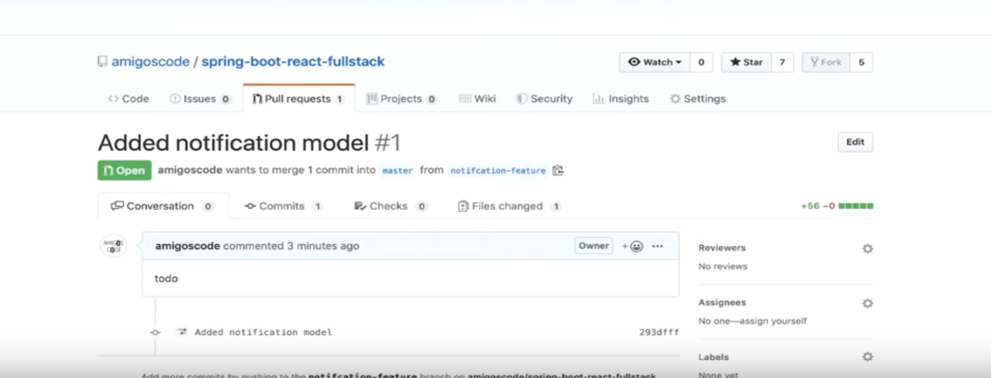

>> How to use intellij for other languages like Kotlin

> How to convert java file to Kotilin file?

You can type Ctrl+Alt+shift+K

or

You can convert java file to kotil by using below option

Right click on file name then you can see last option saying

convert java file to kotilin, once you click on enter

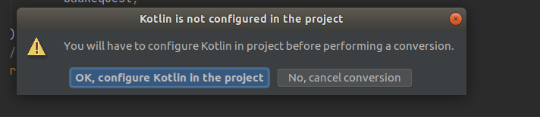

>> How to use Intellij Ultimate Edition

> Once you installed Ultimate Edition it will detect spring beans and it will show there.

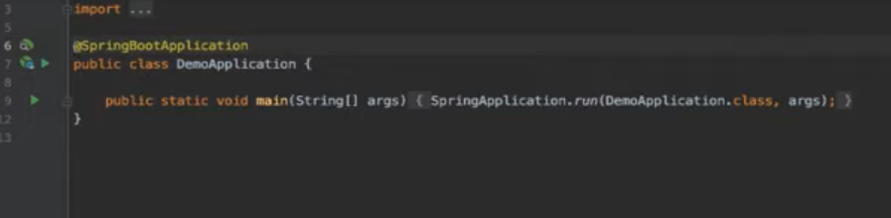

> Learn how to connect to database / Database Integration

on the right hand side it will show database section

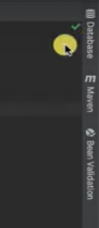

> You are going to create databases by using data sources.

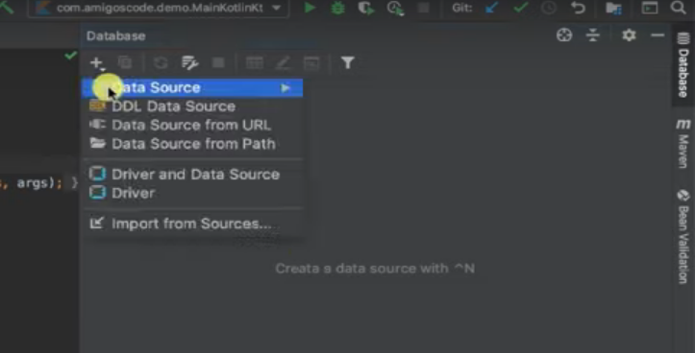

> Now click on Datasource it will show list of supporterd databases

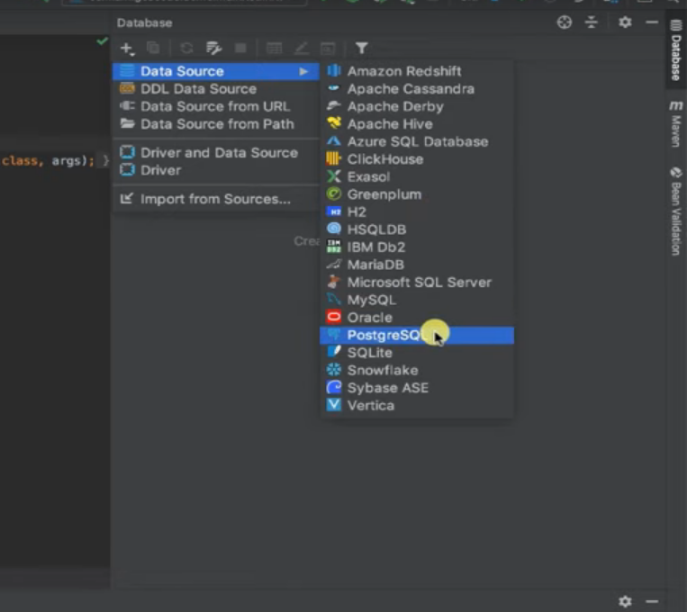

> You can give db configuration details

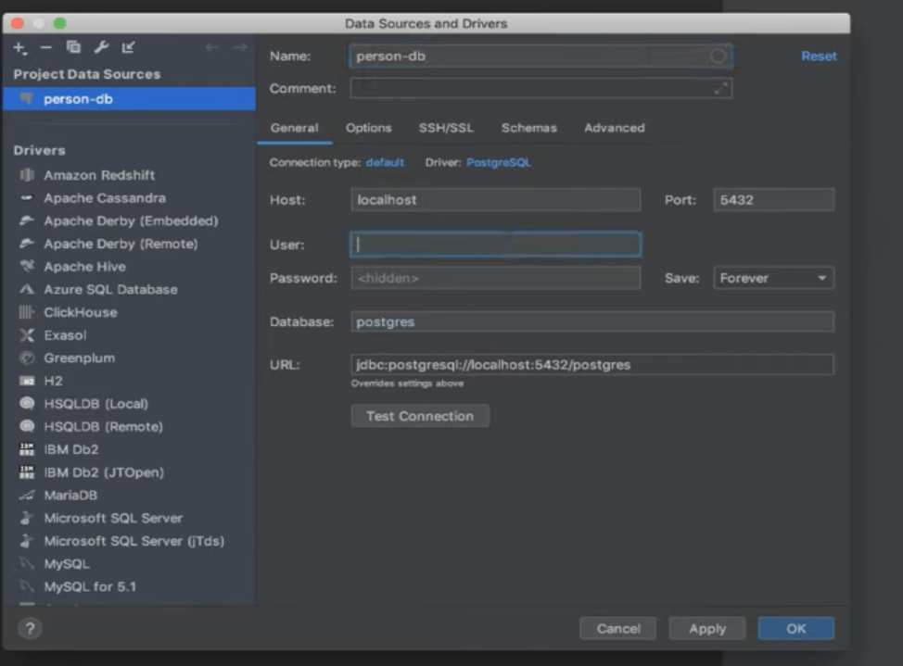

> You can enter all the details and test the connection

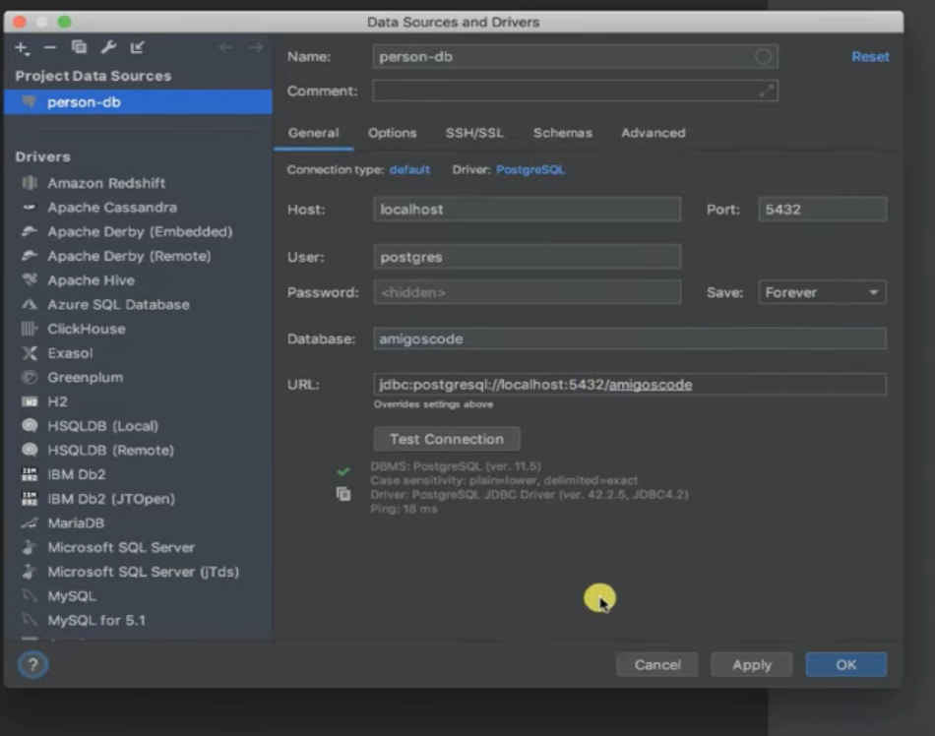

> You can do all operations on database by using below

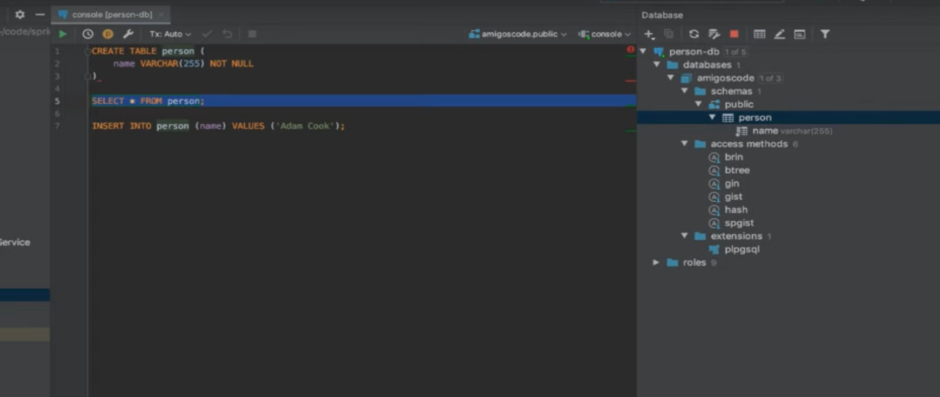

> How to use Maven

