User Records



Note Records

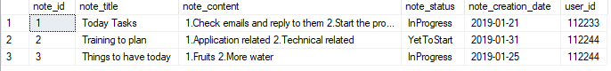

Category Records

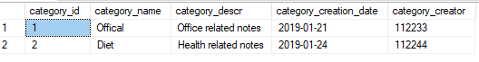

Reminder Records

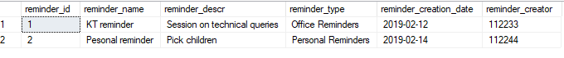

NoteCategory

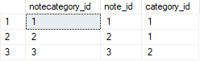

NoteReminder

