**VPC-Peering**

VPC- Virtual Private Cloud

* Each region has default VPC
* With default VPC DHCP option set, main route table, main network acl get created.
* VPC creates a private network in public cloud.

VPC-Peering

* VPC Peering is used to communicate between 2 VPC’s
* Communicated within same network
* It is used to route traffic and transfer files.
* We can communicate in different aws region as well as different aws account using inter-region peering.

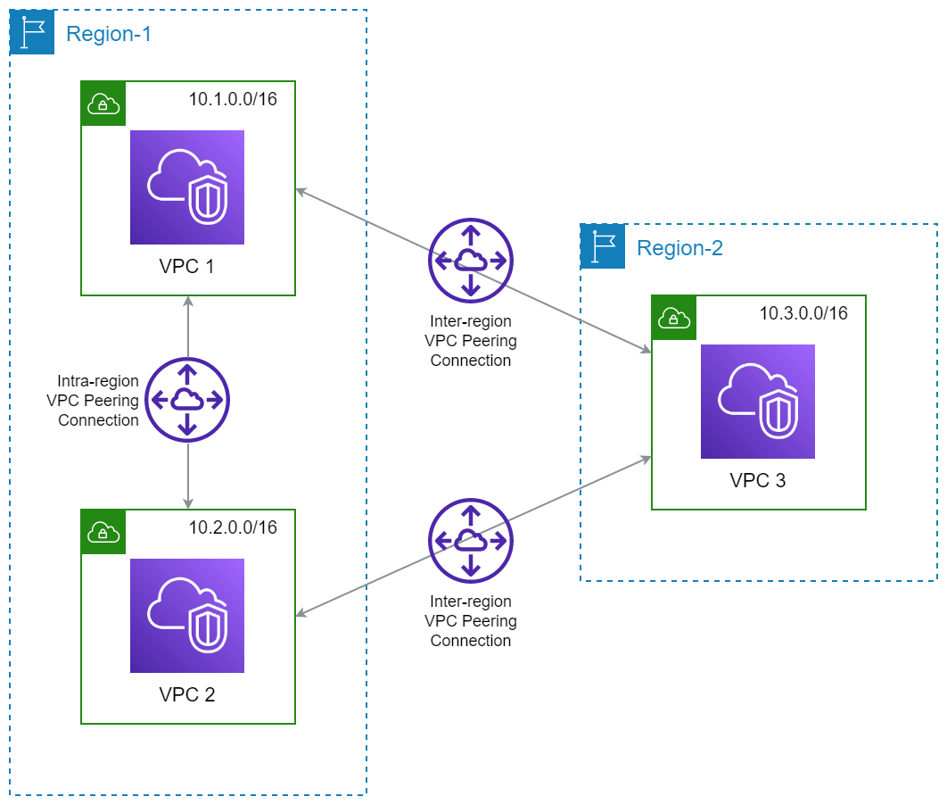

**Steps to Create VPC-Peering**

1. Create 2 VPC’s.
2. Create Subnet using particular VPC [VPC1🡪subnet1 || VPC2🡪subnet2] *{Here we can create multiple subnets in one vpc using different IP address}.*
3. Create Internet gateway and attach it to particular VPC.
4. Go to specific route table and edit inbound rule and add IGW rule.
5. Create Peering Connection [Select requester vpc id 🡪 select option for peering{same region, other region or other aws acc} 🡪 select receiver vpc id].
6. Go to receiver Peering VPC region select VPC click on attach and accept request.
7. Go to route table of VPC-1 edit inbound rule and add peering connection and attach VPC-2 IP address. {as vpc2 ip is destination to reach while communicating with each other}.
8. Same as step 8 assign VPI-1 IP in VPC-2 route table.
9. Launch 2 instances one with VPC1 & one with VPC2 & assign public IP also.
10. Do ssh between both servers.
11. Ping each server with their public IP’s {it will not work}.
12. Now edit inbound rule of security groups attached to instances and add ICMP protocol.
13. Now ping both server with each other.
14. This above all steps are used to setup peering connection in same region.

**VCP-NAT GATEWAY**

* NAT gateway is used to communicate with outside source from private instances
* Private servers don’t have public ip’s so they are not able to connect with outside source
* Using Nat gateway private ip can connect to other resource but other resource cannot connect to private machine until we disclose private ip.
* In best practice we don’t disclose private ip.
* Let’s take one example where public machine can install any service using apt install as public ip is used to hit domain or used for internet connectivity.
* Now here using Nat gateway we take access of our private server on public server where our private server reaches to the internet but using public servers ip.

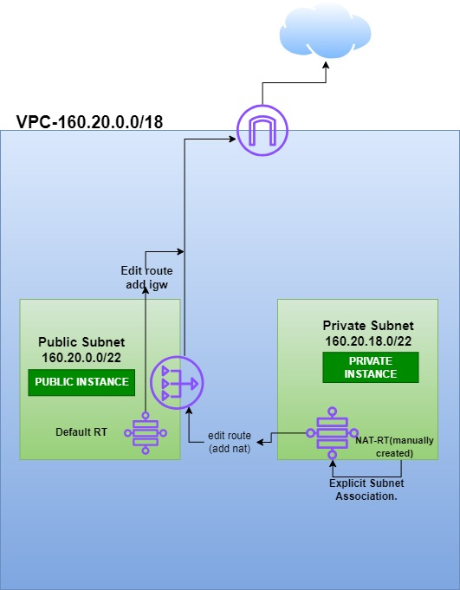

**Steps to configure VPC-NAT GATEWAY**

1. Create one VPC.
2. Create 2 subnets named as Private Subnet and Public Subnet.
3. Attach IGW to VPC.
4. Edit route and add IGW to default RT.
5. Launch 2 instance one with public ip using public subnet and one without public ip using private subnet.
6. Take ssh of public ip and ping 8.8.8.8 then take ssh of private server in public server and try to ping {it will not work}.
7. Create NAT-Gateway for public subnet.
8. Create Route table named as NAT-ROUTE.
9. Edit route and add nat gateway.
10. Select NAT-RT and do explicit subnet associate.
    1. Means add Private Subnet in explicit association.
11. Then take ssh of private server on public server and try to ping private server gets connected to internet.