This should be clickable. When you click the wallet, should show the following info.

[Address 0x94750771b13886bef8f595b67ff982daf5f2839b | Etherscan](https://etherscan.io/address/0x94750771b13886bef8f595b67ff982daf5f2839b)

[Address 0x94750771b13886bef8f595b67ff982daf5f2839b | Etherscan](https://etherscan.io/address/0x94750771b13886bef8f595b67ff982daf5f2839b#tokentxns)

Need a timestamp

Make a button like a launchpad and faucet

**Search doesn’t work and you need to add contracts to search.**

Two words Contract Details

Contract Details need to show all this info here…Follow the links here

[ATAI | Address 0xdbfd10f8c32f96470eeef40f2d1dcda5dfe497bc | Etherscan](https://etherscan.io/address/0xdbfd10f8c32f96470eeef40f2d1dcda5dfe497bc)

Token Tracker

[ATAI | Address 0xdbfd10f8c32f96470eeef40f2d1dcda5dfe497bc | Etherscan](https://etherscan.io/address/0xdbfd10f8c32f96470eeef40f2d1dcda5dfe497bc)

Contract creator (deployer)

[Address 0x94750771b13886bef8f595b67ff982daf5f2839b | Etherscan](https://etherscan.io/address/0x94750771b13886bef8f595b67ff982daf5f2839b)

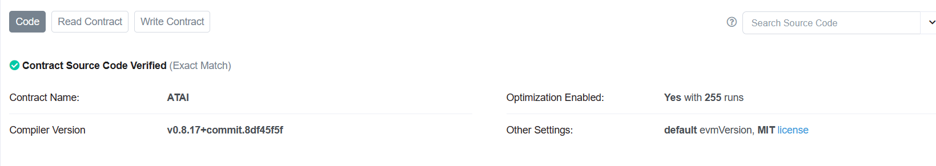

Read/Write a contract. Don’t want people to use remix. Want an intuitive solution…Launchpad feature? (This can be used with Remix)