1 . First google page speed for desktop version  
  
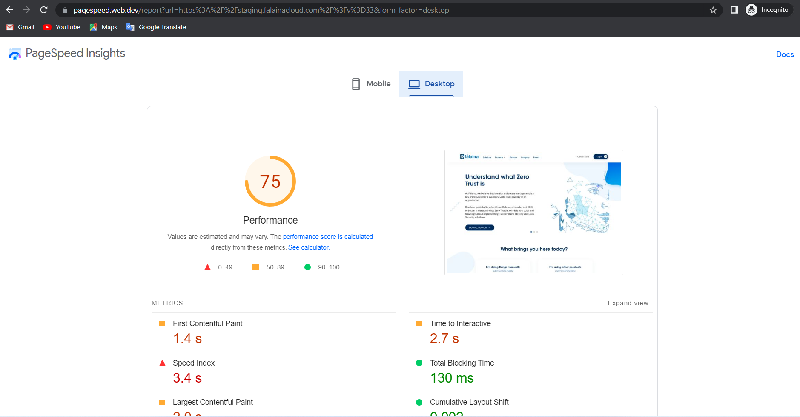

2 . Mobile version page speed before

