2 Advanced Stata skills, econometrics skills
2.1 Introduction
The task of this project is to estimate models and predict the log of consumption for those observations with missing values.

2.2 Data
The data used in this project is a household survey data stratified by region and a primary sample unit (psu). It contains two part of information, the log of household consumption and a set of 20 household characteristics (x1- x20). Table 1 displayed the summary statistical. We need to pay attention to three aspect: first, the dataset contains 4,566 observations in 8 regions and 30 psu; Second. there are 8 dummies and 12 continues variables for explanatory variables; third, there is 1,383 missing value in dependent variables (4,566-3,183). The target of this project is to predict the missing value, then I will separate the that into training group and text group, where test group contains the observations with missing dependent variables.

2.2 Models
First, I simply include all 20 x variables into regression (Model 1). The results of Model 1 displayed in the table below.
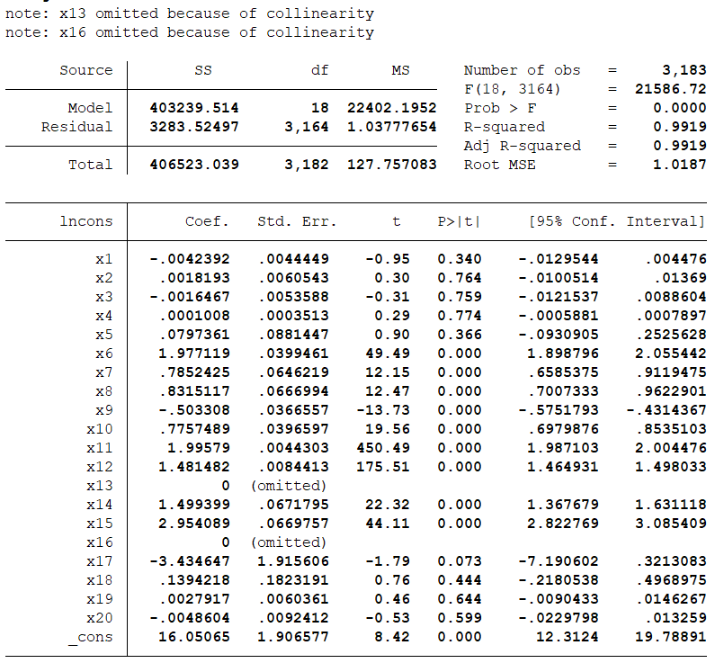
One thing needs to be noticed is that two variables (x13 and x16) are omitted due to collinearity. Hence, this issue should be well handled in the later studies.
Instead of directly analysis the result, I will drop the variable x13 and x16 and re-run the regression. The results for the new model (Model 2) are:
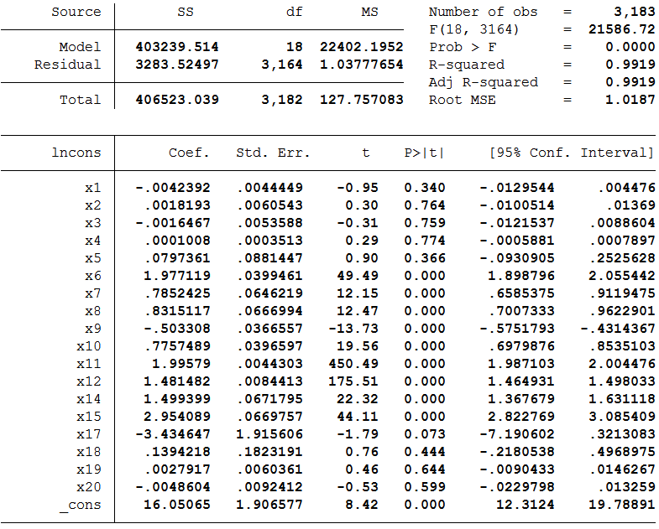

  - regression diagnostics
Before explaining the result, it needs to verify the validation of the model. In particular, I will check the multicollinearity and model specification and make sure there is no such issue that may cause great concern to data analysts. Then, I will also test the normality of residual and homoscedasticity and confirm that the data have met the assumptions underlying OLS regression.

    - multicollinearity
Due to the collinearity issue in the Model 1, we need to double check the linear relationship among the predictors, because it will lead to the inflation of standard errors for coefficients. Here, we use variance inflation factor (VIF) to test the degree of collinearity. VIF of every variable indecate the level of explanation ability by other variables. The results below look fine and implies that multicollinearity is no longer an issue. (As a rule of thumb, a variable whose VIF values are greater than 10 may merit further investigation)

VIF (Model 2)
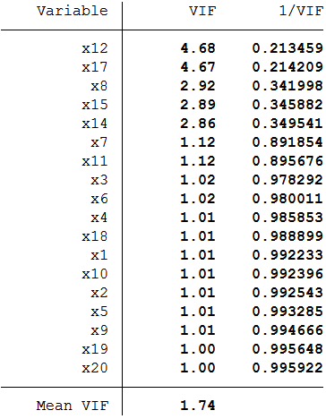

    - Model specification
I would like to confirm the model is well specified, especially with multicollinearity issue in the model 1. In other words, the model should include all relevant variables and exclude all irrelevant variables, since model specification errors can substantially affect the estimate of regression coefficients.
Link Test (Model 2)
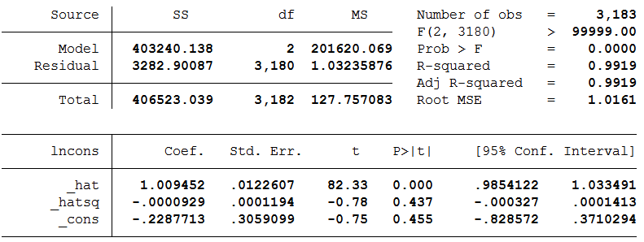
From above link test, the coefficient for the prediction (_hat) is significant, but coefficient for the extra squared prediction variable (_hatsq) is insignificant. It indicates that the linktest failed to reject the null hypothesis that the model is correctly defined.
Secondly, a regression specification error test (RESET) is also applied in this section.

ovtest (Model 2)

The results failed to reject the assumption that the model has no omitted variables.
Therefore, the model has no significant specification errors.

    - Normality
A key assumption of the OLS is that the error terms are normally distributed. To test that, three graphs will be utilized.
First, a kernel density plot with the normal option shows that two densities are almost overlaid each other on the plot.
Kernel density plot (Model 2)
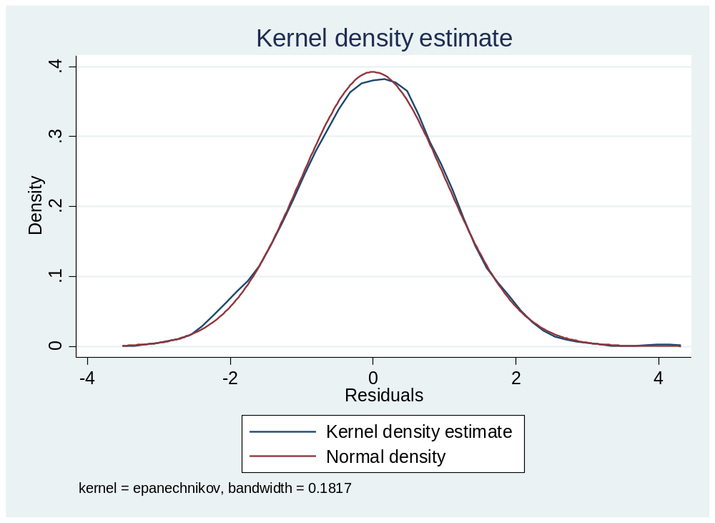
Second, a standardized normal probability (P-P) plot and quantiles of a variable against the quantiles of a normal distribution are presented below. On one hand, P-P plot is sensitive to non-normality in the middle range of data and quantiles plot is sensitive to non-normality near the tails. As you see below, the results from P-P plot show no indications of non-normality, while the quantiles of a normal distribution plot find a deviation from normal at the upper tail. Nevertheless, this seems to be a minor and trivial deviation from normality.
To further test this non-normality, I include a numerical test: the Shapiro-Wilk W test. The results confirm that the normal assumption is rejected at 5% significance level. In this case, we can’t verify the normality of the error terms in model 2.

Pnorm (Model 2)
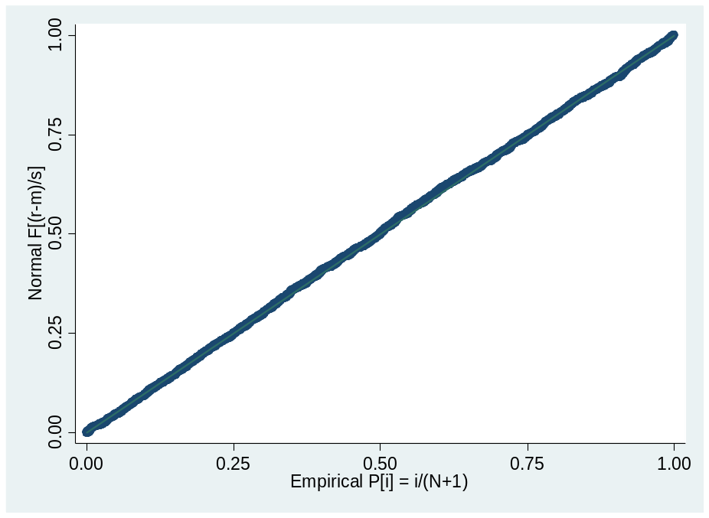
Qnorm (Model 2)
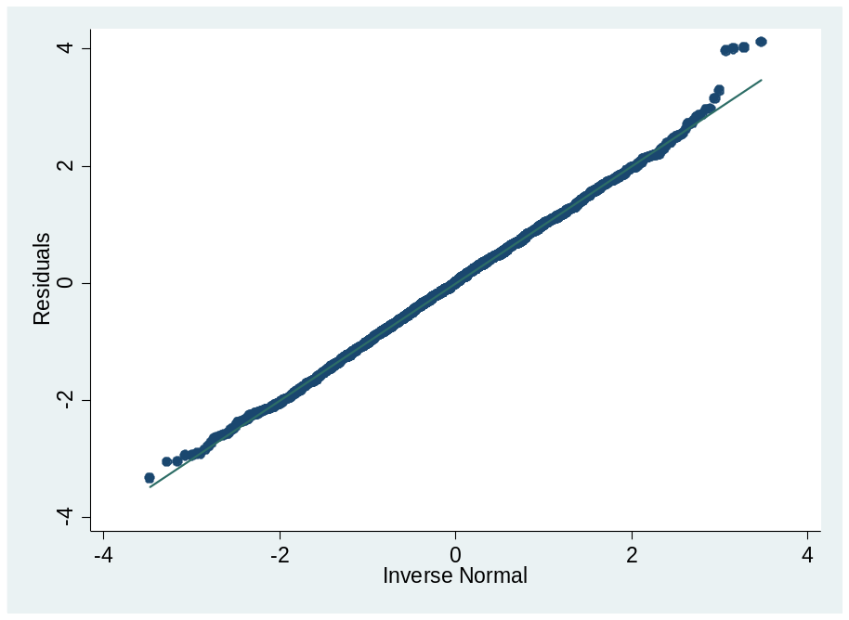
swilk (Model 2)
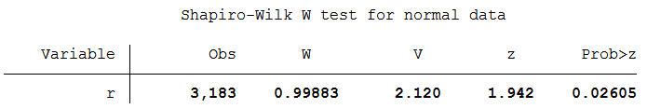

    - Checking Homoscedasticity of Residuals
Another assumption in OLS regression that can be tested is the homoscedasticity of residuals, which assume a constant variance in error terms. I conduct a Breusch-Pagan test in stata.
hettest (Model 2)
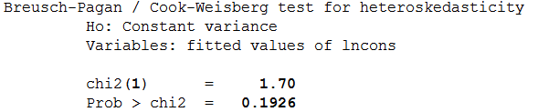
With a relatively large p-value (comparing to significant level), the test fails to reject null hypothesis that the variance of the error term is homogenous.

  - Alternative models
Since the residual in the modified model (Model 2) above deviated from normally distributed assumption. I would like to consider an alternative specification. Since x13 and x16 are dropped due to collinearity, other variables may linear correlated with x13 or x16. Hence, we can test VIF for all 20 explanatory variables first.
VIF
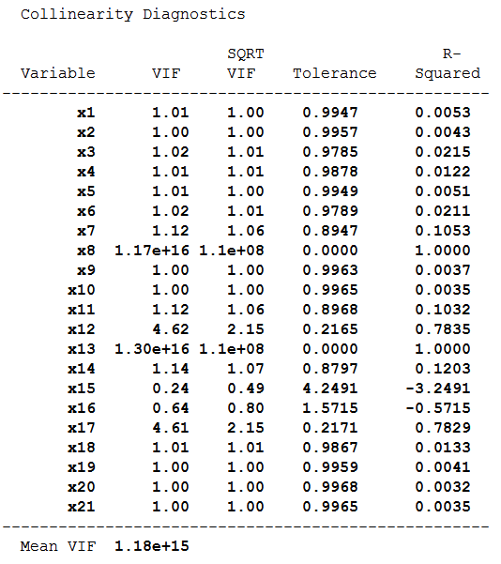
The collinearity diagnostics shows that x8 and x13 have extremely large VIF. For the next model, I will drop these two variables.

    - Regression of Model 3 (trial 1)

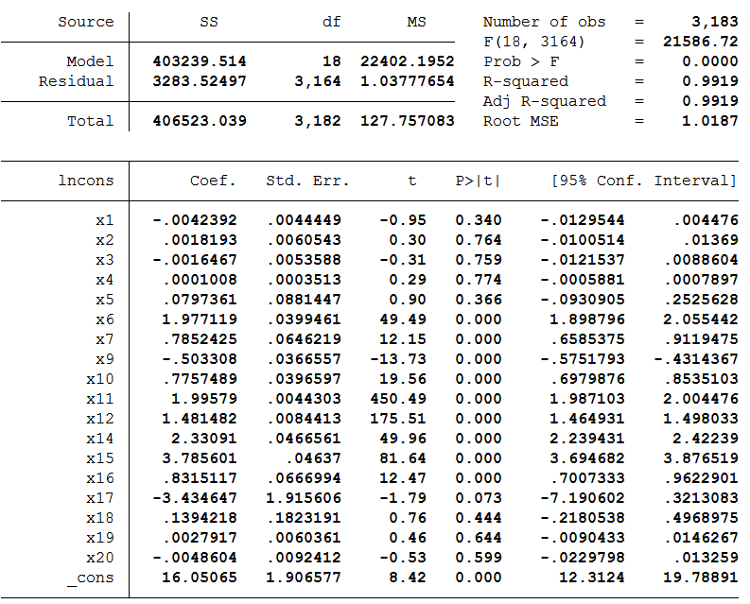
VIF (Model 3)
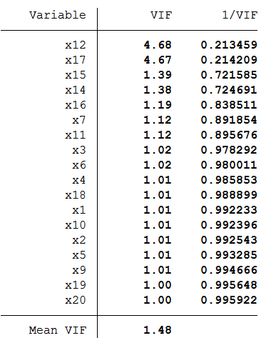
The regression results and VIF table did not show any sign for collinearity.

      - Regression diagnostics
Once again, I would run the diagnostics process mentioned in section 2.3 and test the performance of the new model.
Linktest (Model3)
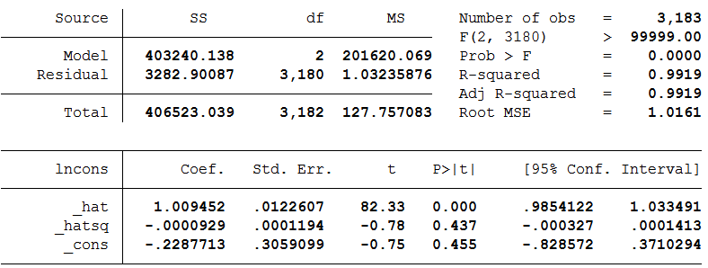
ovtest (Model 3)
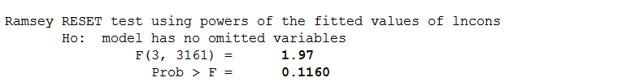
hettest (Model 3)
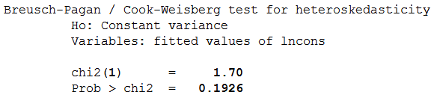
swilk (Model 3)

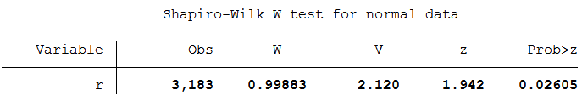
The results listed in the table above implies that there is no significance improvement from Model 3 to Model 2. Inversely, Model 2 and 3 have very similar test results. (Some indicators are even identical). That may lead another concern of correlation between three variables. Therefore, in the next trail, I will omit all three variables (x8, x13 and x16).

    - Regression of Model 4 (trial 2)
Model 4 will exclude x8, x13 and x16. The regression results and validation process will be displayed below.
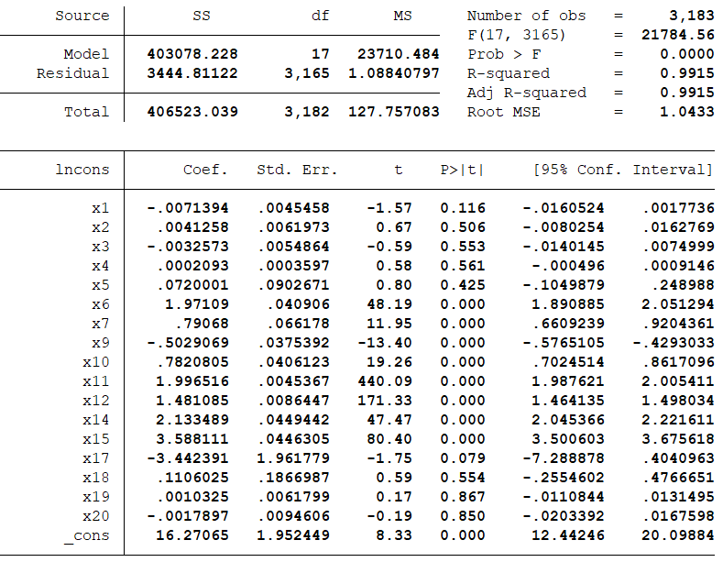
VIF (Model 4):
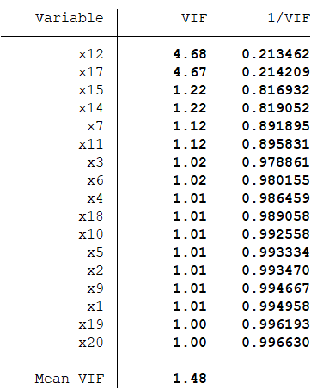
Linktest (Model 4)
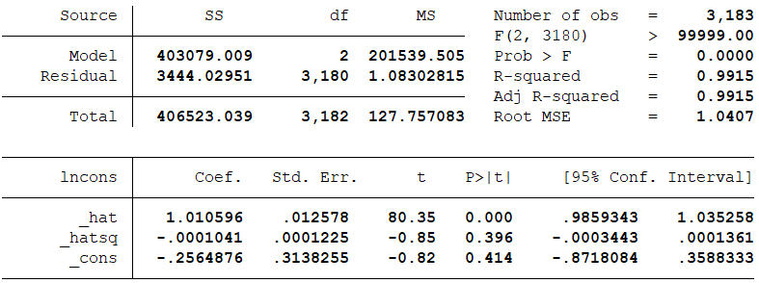
ovtest (Model 4)

hettest (Model 4)
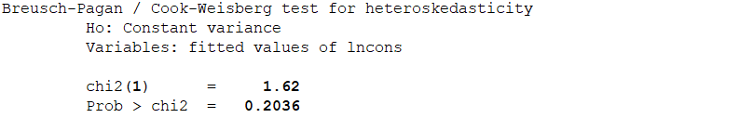
swilk (Model 4)
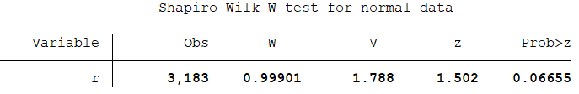
The results prove that the model is well specified and met all the assumption of the OLS regression

  - Model compared
Model 2
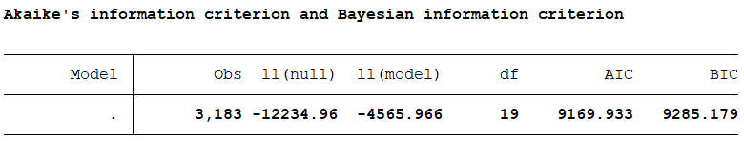
Model 3
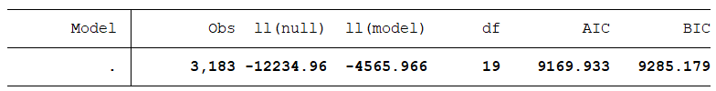
Model 4
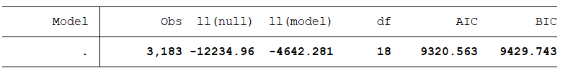
By comparing the AIC and BIC for three models, I find that model 2 and model 3 have the lowest AIC and BIC. On the other hand, the RMSE for model 2 and 3 is 1.0187, but for model 4 is 1.0433. Furthermore, Model 2 and 3 shows a relatively larger r-square. Even so, the different of these indicators among three models are not very large. Combing with the fact that Model 2 and 3 does not have normally distributed error term, I preferred Model 4 to predict the missing value.

  - Prediction
In this section I will program in mata to predict the missing value in the dataset. Totally, 1,383 log of consumption are estimated with Model 4. The details of the results can be calculated in do files.

